Task 1

Description: To upload, organize, and manage objects in an Amazon S3 bucket. This task demonstrates how to use Amazon S3 to create a bucket, organize data using folders, upload files, view object properties and metadata, download objects, and delete objects.

Prerequisites
- Access to AWS Learner Lab
- AWS Management Console access
- Amazon S3 service
- Sample files (CSV, JSON, Image)

Process
- Logged into AWS Management Console.

- Opened the Amazon S3 service.

- Created a new S3 bucket.
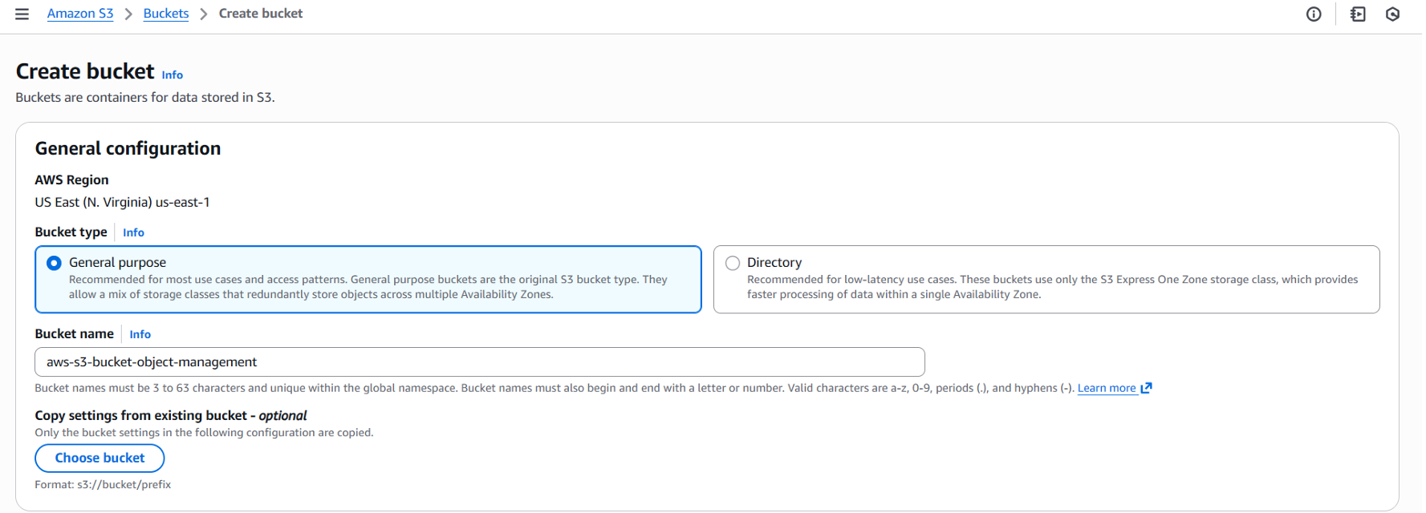

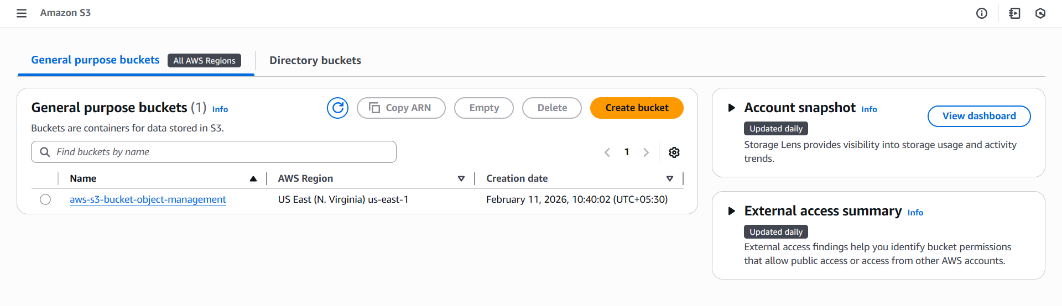
- Opened the created bucket.

- Created folders inside the bucket to organize files.

- Uploaded CSV, JSON, and image files into their respective folders.
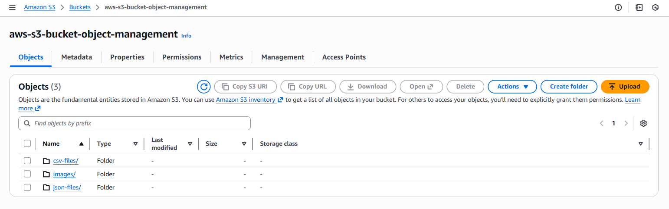

- Opened an uploaded file to view its object properties.
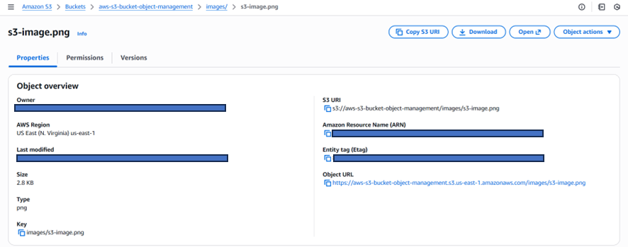

- Viewed the metadata of the selected object
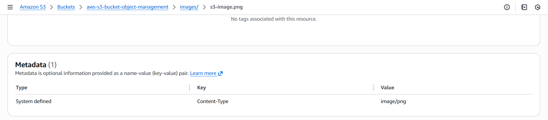

- Downloaded one file from the bucket.
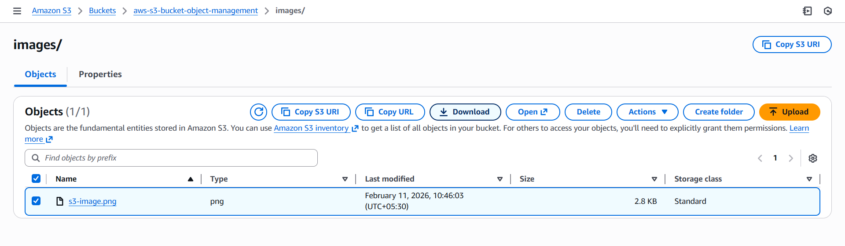

- Deleted one file from the bucket and confirmed deletion.
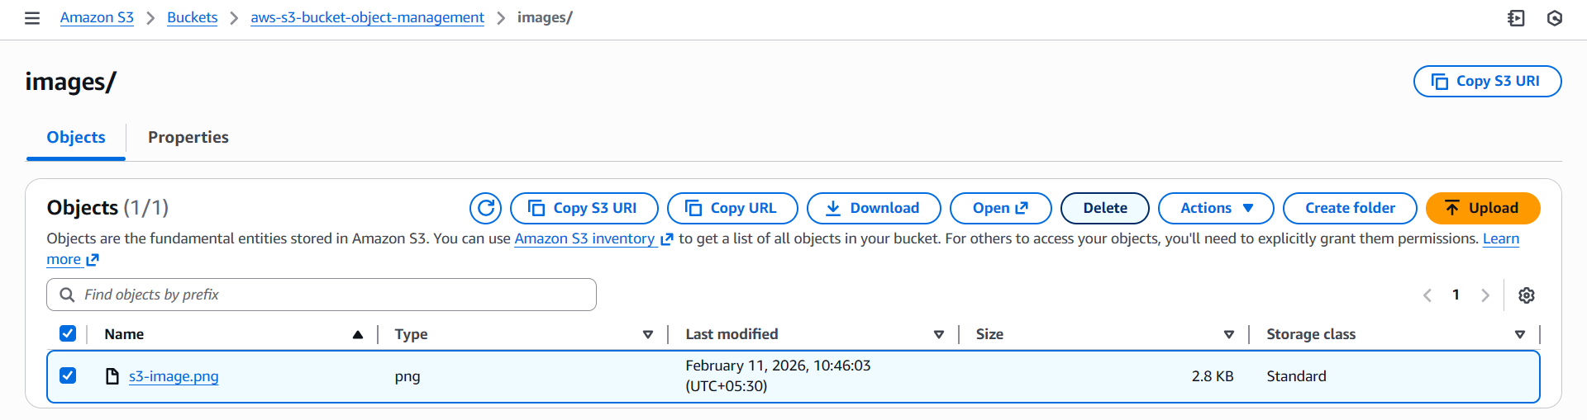

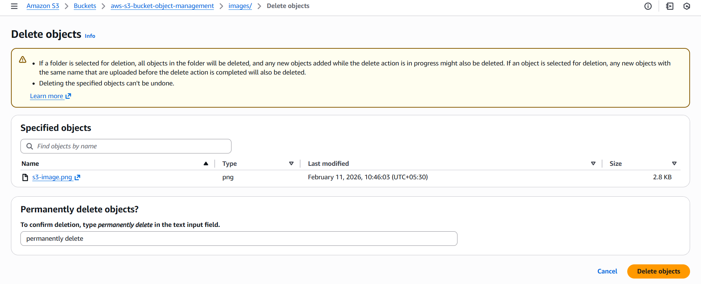

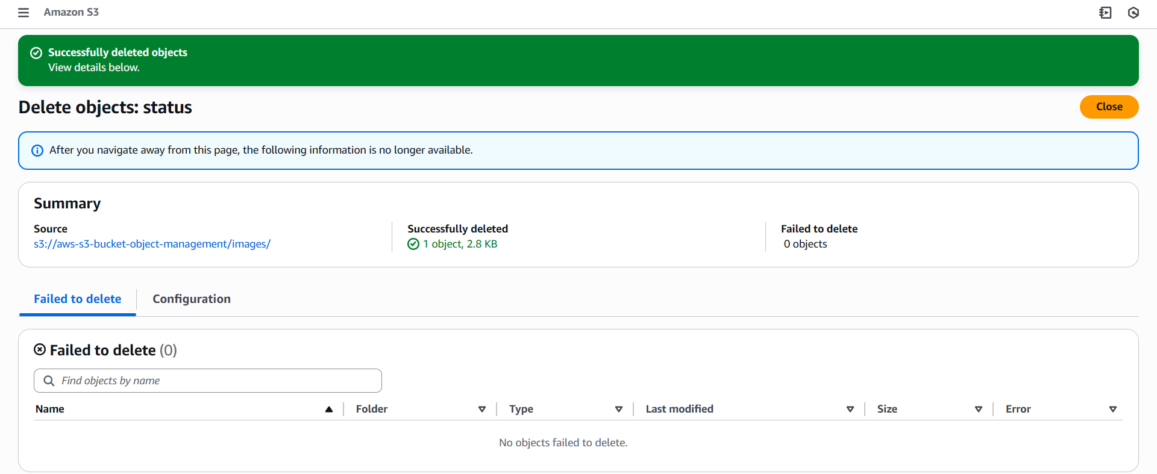

Output:
- S3 bucket created successfully.
- Folders created inside the bucket.
- Files uploaded successfully.
- Object properties and metadata displayed.
- File downloaded successfully.
- Object deleted successfully.

