Task 1

Description: To store and retrieve data from Amazon S3 using AWS CLI in AWS CloudShell. This task demonstrates how to perform S3 operations such as listing buckets, uploading files, downloading files, and deleting objects using command-line interface.

Prerequisites:
- Access to AWS Learner Lab
- Access to AWS Management Console
- Existing S3 bucket
- AWS CloudShell enabled

Process:
- Logged into AWS Management Console.

- Opened AWS CloudShell from the console.

- Verified AWS CLI installation using:
aws --version

- Verified authentication using:
aws sts get-caller-identity

- Listed all available S3 buckets using:
aws s3 ls

- Created a sample file inside CloudShell using:
echo "CloudShell S3 Test File" > testfile.txt

- Uploaded the file to the S3 bucket using:
aws s3 cp testfile.txt s3://aws-s3-bucket-object-management/

- Verified the upload by listing bucket contents:
aws s3 ls s3://aws-s3-bucket-object-management/

- Downloaded the file from S3 using:
aws s3 cp s3://aws-s3-bucket-object-management/testfile.txt downloaded.txt

- Deleted the file from S3 using:
aws s3 rm s3://aws-s3-bucket-object-management/testfile.txt

- Verified deletion by listing bucket contents again.
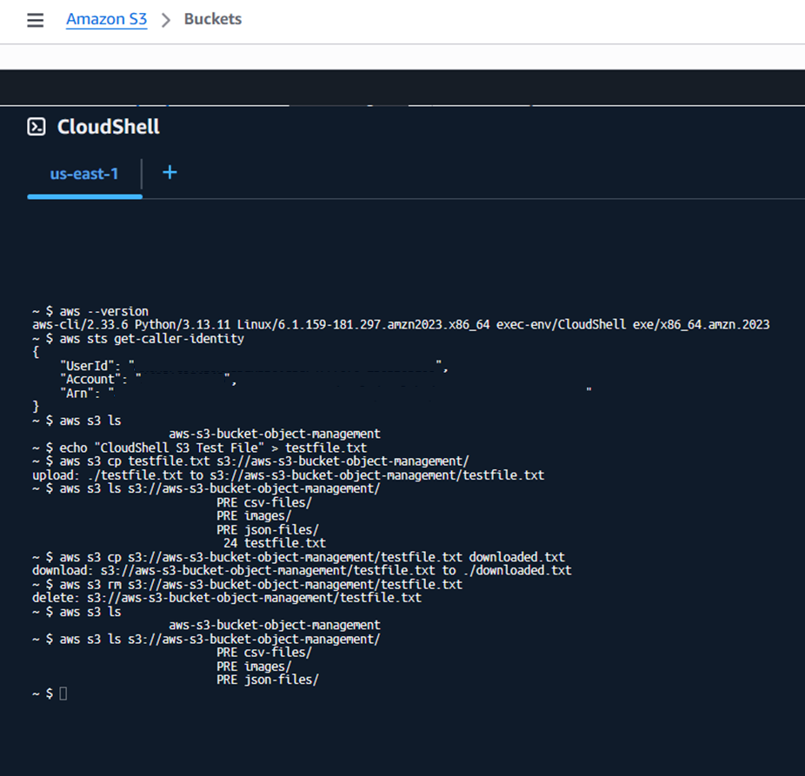

Output:
- AWS CLI verified successfully in CloudShell.
- S3 buckets listed successfully.
- File created in CloudShell environment.
- File uploaded to S3 bucket successfully.
- File downloaded successfully from S3.
- File deleted successfully using AWS CLI.

