Task 1

Description: Mobile Health Monitoring App

- Using Crazy 8s technique, sketch 8 different interface ideas for the "Daily Health Logging" screen in 8 minutes.
- From your 8 sketches, select the best 2 concepts based on usability and simplicity.
- Create a paper prototype (using paper, sticky notes, markers) for the complete flow:
"Log glucose → Add notes → View confirmation" (5–7 paper screens).
- Test your paper prototype with a classmate (5-minute think-aloud test) and document 3 key observations.

Process:

1. Crazy 8s Ideation (Theoretical Exercise)
The Crazy 8s ideation technique was conceptually applied to generate eight different interface ideas for the “Daily Health Logging” screen. This method encourages rapid exploration of multiple design possibilities within a limited time.
The following eight conceptual layouts were developed:
- Simple Vertical Form Layout
A structured form with a glucose input field at the top, notes section below, and a save button at the bottom. This layout emphasizes clarity and familiarity.
- Card-Based Layout
Information grouped into separate cards for glucose entry, notes, and action buttons. This improves visual organization.
- Floating Action Button (FAB) Layout
A dashboard screen with a “+ Log” button that opens a modal for entering glucose and notes. This keeps the main interface clean.
- Stepper (Multi-Step) Layout
A guided process divided into steps:
  - Step 1: Enter glucose
  - Step 2: Add notes
  - Step 3: Confirm entry
This reduces cognitive load by dividing tasks.
- Slider-Based Entry Layout
A slider control for selecting glucose values with optional quick note tags for faster input.
- Voice-Input Supported Layout
Includes a microphone icon allowing users to dictate glucose readings and notes.
- Minimalist Quick-Entry Layout
A large numeric input in the center of the screen with minimal additional elements.
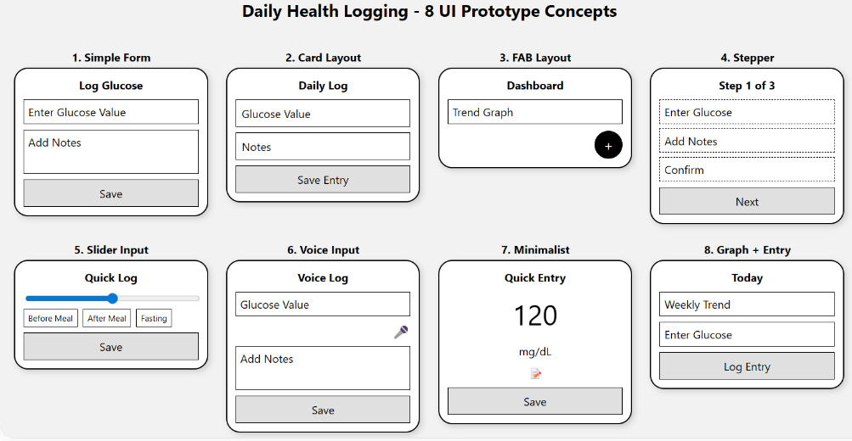
- Graph + Entry Layout
A small trend graph at the top with quick-entry options below to provide contextual information.

2. Selection of Best Two Concepts
Based on theoretical evaluation of usability and simplicity, the following two concepts were selected:
Concept 1: Simple Vertical Form Layout
This design is intuitive and follows common mobile interaction patterns. It minimizes confusion and supports straightforward task completion.
Concept 2: Stepper Layout
The guided step-by-step structure ensures clarity and reduces user errors. It is especially suitable for healthcare applications where accuracy is important.
These concepts were chosen because they prioritize ease of use, clarity, and structured task flow.

3. Paper Prototype Design (Conceptual Representation)
A conceptual paper prototype was designed to simulate the flow:
Log Glucose → Add Notes → View Confirmation
The assumed prototype included the following screens:
- Home Screen
Contains a “Log Glucose” button.
- Enter Glucose Screen
Numeric input field and “Next” button.
- Add Notes Screen
Text input area and “Save” button.
- Review Screen
Displays entered glucose value and notes for verification.
- Confirmation Screen
Displays a success message indicating that the entry has been saved.
- Weekly Trend Screen (Optional)
Displays a simplified graphical representation of glucose data.
This conceptual prototype demonstrates the logical flow and interaction sequence.

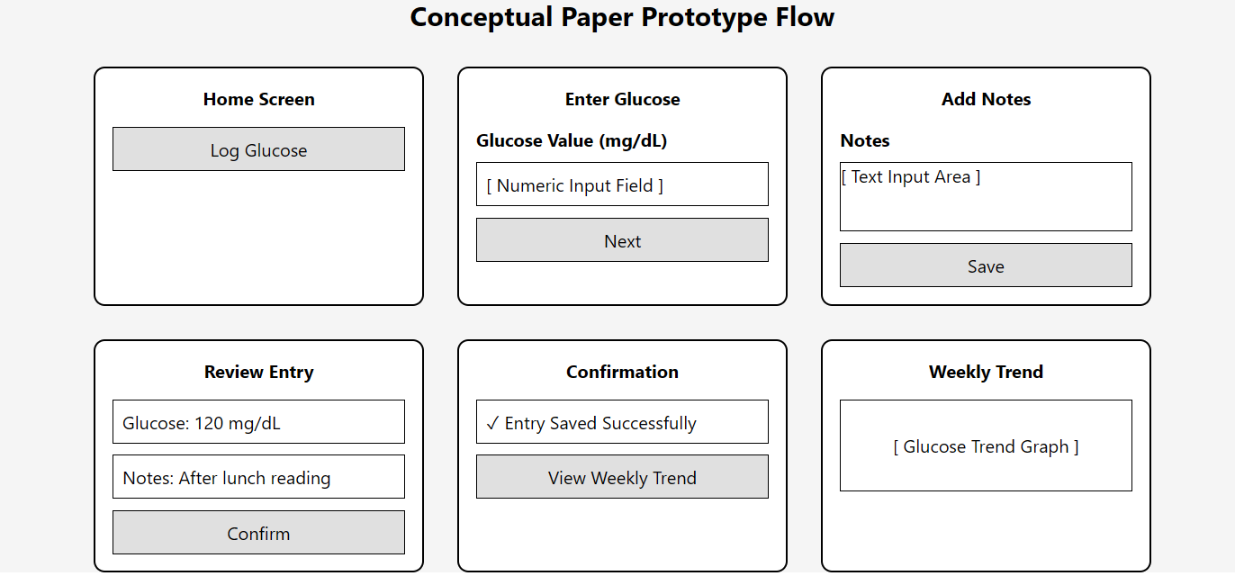

4. Usability Testing (Hypothetical Think-Aloud Study)
A hypothetical 5-minute think-aloud usability test was assumed for evaluation purposes. In this scenario, a participant would be asked to log a glucose reading and add notes while verbalizing their thoughts.
The following observations were theoretically identified:
- Users may hesitate if button labels are unclear (e.g., “Next” vs. “Continue to Notes”).
- Users expect consistent navigation controls such as a visible back button.
- Confirmation feedback is important to reassure users that data has been successfully saved.
These observations highlight the importance of clarity, feedback, and navigation consistency in health applications.

Task 2

Description: University Course Registration System

- Sketch multiple interface ideas for the "Course Search and Filter" functionality using rapid sketching (10 minutes, 5+ sketches).
- Create a paper prototype for the flow:
"Search course → Filter results → View details → Add to cart" (6–8 paper screens).
- Conduct a quick usability test with a peer and note:
  - 1 point of confusion
  - 1 aspect that worked well
  - 1 suggestion for improvement

Process:

1. Rapid Sketching (Theoretical Exploration)
Multiple interface concepts were theoretically explored for the “Course Search and Filter” functionality:
- Search bar with sidebar filters
- Horizontal dropdown filter bar
- Modal popup filter panel
- Tag-based filter chips
- Toggle switches for course type
- Grid and list view options
Each layout explored different methods of presenting search results and filtering mechanisms.

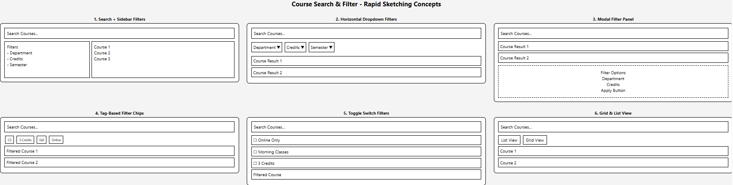

2. Paper Prototype Flow (Conceptual)
A conceptual paper prototype was assumed for the following flow:
Search Course → Filter Results → View Details → Add to Cart
The prototype included:
- Homepage with search bar
- Search results page
- Filter panel interface
- Filtered results display
- Course detail page
- Add to cart confirmation screen
- Cart page overview
This theoretical prototype demonstrates structured interaction and progressive disclosure of information.

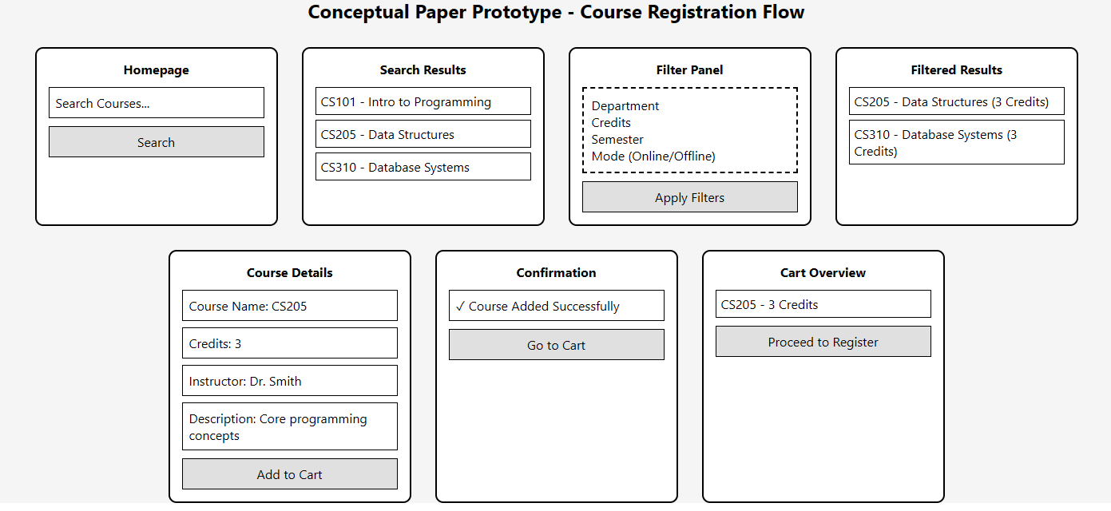

3. Hypothetical Usability Test
A peer-based usability test was theoretically assumed where a user searches for a 3-credit course and adds it to the cart.
Theoretical findings:
- Point of Confusion: The filter option may not be immediately visible if not prominently placed.
- Aspect that Worked Well: The search bar is easily recognizable and intuitive.
- Suggestion for Improvement: Display active filter tags to improve visibility and control.

Task 3

Description: Documentation & Digital Translation

- Photograph or scan your paper prototypes from Tasks 1 and 2.
- Create digital low-fidelity wireframes in Figma based on your refined paper prototypes.
- Annotate your wireframes with:
  - User actions (what the user does)
  - System responses (what happens)
  - Design decisions (why you designed it this way)
- Save and export your Figma file and annotations.

Prerequisites: Figma

Process:

1. Prototype Documentation
The conceptual paper prototypes would be photographed or scanned for documentation purposes.

2. Digital Low-Fidelity Wireframes
The selected prototype concepts would be recreated in Figma using grayscale shapes and minimal styling to maintain low-fidelity standards.

3. Wireframe Annotations
Each screen would include annotations describing:
- User Actions: What the user clicks or inputs.
- System Responses: How the system reacts (validation, confirmation, filtering results).
- Design Decisions: Justification for layout structure, button placement, and navigation flow

