Task 1

Description: Design the initial UX planning for an Education App - improving student learning outcomes.
- Create a new project in Figma and name it appropriately.
- Choose an education-related theme (e.g., online courses, exam preparation, virtual classroom).
- Define the project scope:
  - Purpose of the app
  - Core features (minimum 5)
- Identify the primary user group:
  - Age group
  - User goals
  - Technical proficiency

Create one low-fidelity wireframe (home screen) in Figma.

Prerequisites: Figma

Process:
- A new project was created in Figma and named “Exam Prep App - UX Planning”.
- An education-related theme was selected as Exam Preparation Mobile Application.
- The project scope was defined as follows:
  - Purpose of the App:
To improve student learning outcomes by providing subject-wise study materials, mock tests, and progress tracking through a simple and user-friendly mobile interface.
  - Core Features:
    - Subject-wise course selection (Maths, Science, English)
    - Search functionality for courses and topics
    - Mock tests and practice examinations
    - Progress tracking and performance monitoring
    - User profile and learning history management
- The primary user group was identified as:
  - Age Group: 16–25 years
  - User Goals:
    - Prepare for examinations
    - Practice mock tests
    - Improve subject knowledge
    - Track learning progress
  - Technical Proficiency:
Medium to high, as users are familiar with smartphones and mobile applications.
- A low-fidelity home screen wireframe was created using Figma. The wireframe includes the app title, a search bar, subject category cards, and a bottom navigation bar for easy navigation, focusing on layout and usability without detailed visual design.

Output:
The low-fidelity home screen wireframe of the Exam Prep App was designed using Figma. The wireframe illustrates the basic layout and navigation of the application, including the app title, search bar for courses, subject category sections (Maths, Science, English, Mock Tests), and a bottom navigation bar with Home, Tests, Progress, and Profile options. The design focuses on structure and usability without detailed visual styling.

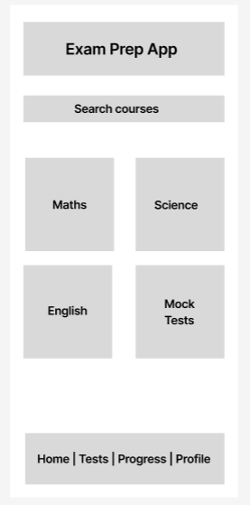

Task 2

Description: Plan and structure a Healthcare Portal interface using Figma.
- Setup a new project in Figma.
- Select a health care use case (e.g., appointment booking, medical records, tele-medicine).
- Define the project scope:
  - Problem being solved
  - Key functionalities (minimum 5)
- Identify the initial user group:
  - Type of users (patients, doctors, caregivers)
  - Accessibility considerations
Design a basic home screen wireframe using Figma components.

Prerequisites: Figma

Process:
- A new project was created in Figma and named “Healthcare Portal - UX Planning”.
- The selected healthcare use case is Appointment Booking System.
- The project scope was defined as follows:
  - Problem Being Solved:
Patients often face difficulty in booking doctor appointments and managing healthcare information efficiently through existing systems.
  - Key Functionalities:
    - Doctor search and selection
    - Online appointment booking
    - Patient profile management
    - Appointment history and reminders
    - Notifications and alerts
- The initial user group was identified as:
  - Type of Users: Patients
  - Accessibility Considerations:
    - Simple and clear navigation
    - Large buttons for easy interaction
    - Readable font sizes
    - High-contrast layout for better visibility
- A basic home screen wireframe was designed using Figma components. The wireframe includes options for booking appointments, viewing upcoming appointments, and accessing patient profile information. The design focuses on usability and accessibility.

Output:
The basic home screen wireframe of the Healthcare Portal was designed using Figma. The wireframe represents a desktop-based layout with a top navigation bar and clearly structured sections for appointment booking, doctor search, appointment management, and notifications. The design focuses on usability, accessibility, and layout planning without detailed visual styling
