Task 1

Description: Mobile Health Monitoring App
User Goal: "As a patient, I want to log my blood glucose reading, add notes, and view a weekly trend chart so I can share meaningful data with my doctor."

1. Perform a Hierarchical Task Analysis (HTA): Decompose the main goal into at least 3 sub-tasks and 8 specific actions. Present your analysis in a visual hierarchy diagram (use Figma shapes or a drawing tool).
2. Digital Card Sorting: You are organizing the app's main navigation. Sort the following 12 items into logical categories (e.g., "Tracking," "Insights," "Communication") and label each group. Use a Figma plugin or a simple table.
Items:
- Log Glucose
- View History
- Weekly Report
- Medication Reminder
- Doctor Chat
- Set Goals
- Alert Settings
- Profile
- Data Export
- Family Access
- Educational Articles
- Appointment Calendar

3. Create a Sitemap: Based on your card sorting results, create a high-level sitemap in Figma that shows the primary pages/sections of the app and their relationships.

Prerequisites: Figma

Process:
1. Hierarchical Task Analysis (HTA)
Main Goal: Manage Blood Glucose Data
Sub-Tasks and Actions:
1. Log Glucose Reading
- 1.1 Open application
- 1.2 Tap “Log Glucose”
- 1.3 Enter glucose value
- 1.4 Save reading
2. Add Notes
- 2.1 Select saved reading
- 2.2 Tap “Add Note”
- 2.3 Enter note text
- 2.4 Save note
3. View Weekly Trend
- 3.1 Navigate to Reports section
- 3.2 Select Weekly View
- 3.3 Review visual trend chart
4. Share Data with Doctor
- 4.1 Tap Share option
- 4.2 Select doctor contact
- 4.3 Send report
The HTA is presented visually in Figma using hierarchical boxes connected with lines.

2. Digital Card Sorting
The following items were grouped into logical navigation categories:
Tracking
- Log Glucose
- View History
- Weekly Report
- Set Goals
Reminders & Alerts
- Medication Reminder
- Alert Settings
Communication
- Doctor Chat
- Family Access
Account & Data
- Profile
- Data Export
Resources
- Educational Articles
- Appointment Calendar
These categories were organized visually using Figma components.
3. Sitemap Creation
Based on the card sorting results, the sitemap structure includes:
- Home Dashboard
  - Tracking
    - Log Glucose
    - View History
    - Weekly Report
    - Set Goals
  - Reminders
    - Medication Reminder
    - Alert Settings
  - Communication
    - Doctor Chat
    - Family Access
  - Resources
    - Educational Articles
    - Appointment Calendar
  - Profile
    - Data Export
The sitemap was created in Figma using a hierarchical layout diagram.

Output:

- HTA visual hierarchy diagram
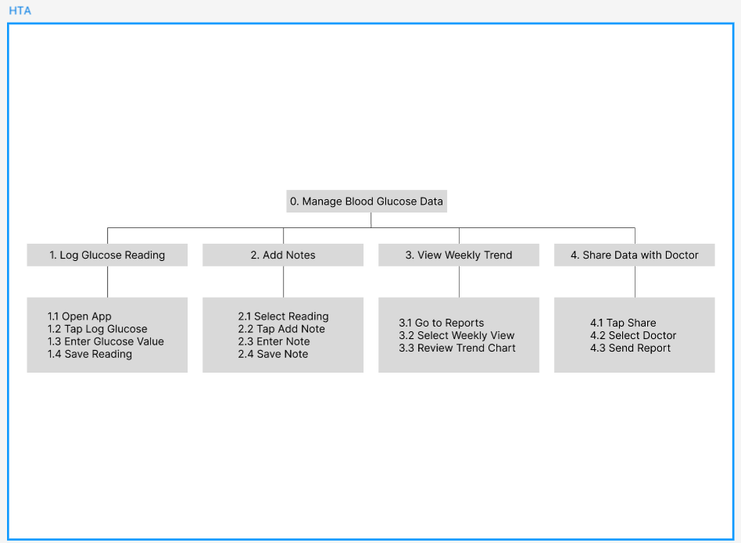

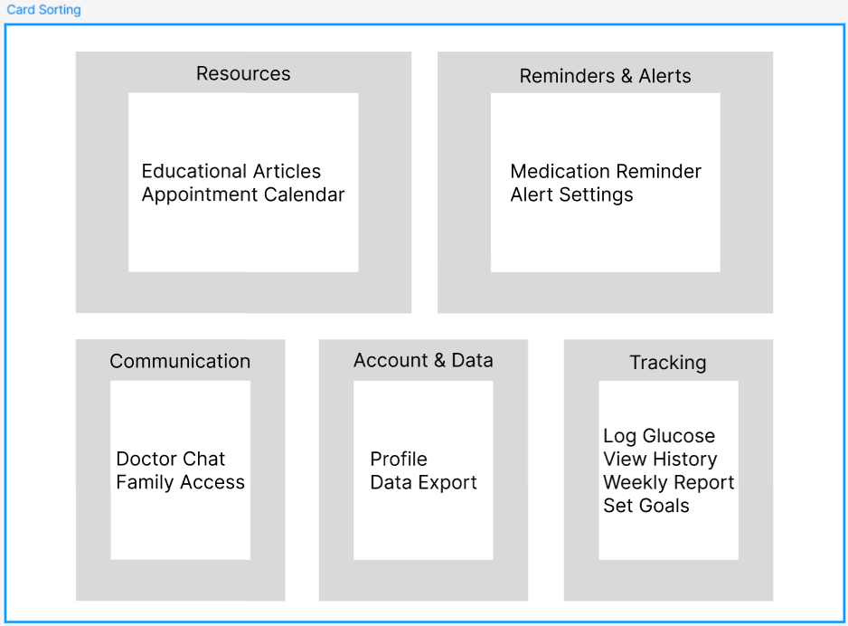
- Digital card sorting layout

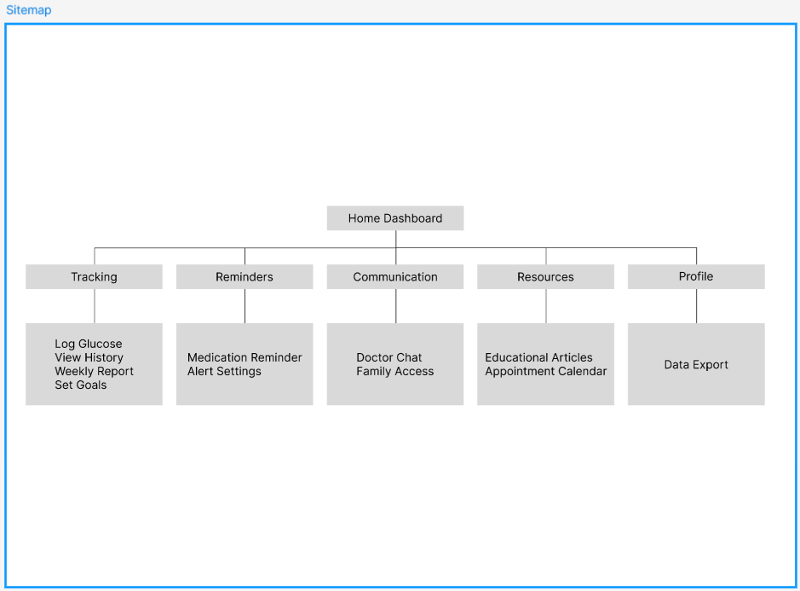
- High-level sitemap structure

Task 2

Description: Digital Government Services Portal
User Goal: "As a citizen, I want to apply for a new passport, upload my documents, pay the fee, and track the application status without visiting an office."

1. Perform a Hierarchical Task Analysis (HTA): Decompose the main goal into at least 4 sub-tasks and 10 specific actions. Present your analysis in a visual hierarchy diagram.
2. Digital Card Sorting: You are organizing the portal's service menu. Sort the following 15 items into intuitive categories (e.g., "Applications," "Payments," "Help") and label each group.
Items:
- New Passport
- Status Check
- Fee Payment
- Document Upload
- Download Form
- Find Office
- Schedule Appointment
- Change Address
- Grievance
- FAQs
- Chat Support
- Check Eligibility
- Track History
- Notifications
- User Guide
3. Create a Sitemap: Based on your card sorting results, create a sitemap in Figma that structures the portal's main services and sub-pages for citizen access.

Prerequisites: Figma

Process:
1. Hierarchical Task Analysis (HTA)
Main Goal: Apply for New Passport
Sub-Tasks and Actions:
1. Check Eligibility
- 1.1 Access portal
- 1.2 Select Passport Service
- 1.3 Click “Check Eligibility”
- 1.4 Review criteria
2. Complete Application Form
- 2.1 Enter personal information
- 2.2 Enter address details
- 2.3 Submit form
3. Upload Documents
- 3.1 Select document type
- 3.2 Upload required files
- 3.3 Confirm upload
4. Pay Application Fee
- 4.1 Select payment method
- 4.2 Enter payment details
- 4.3 Confirm transaction
5. Track Application Status
- 5.1 Access dashboard
- 5.2 Select “Track Status”
- 5.3 View progress indicator
The HTA was visually structured in Figma using hierarchical blocks.

2. Digital Card Sorting
The following items were grouped into logical service categories:
Applications
- New Passport
- Change Address
- Download Form
- Check Eligibility
Tracking & Payments
- Status Check
- Track History
- Fee Payment
- Notifications
Support & Help
- FAQs
- Chat Support
- Grievance
- User Guide
Services & Appointments
- Document Upload
- Schedule Appointment
- Find Office
These categories were organized in Figma to represent structured portal navigation.

3. Sitemap Creation
Based on the card sorting:
- Home
  - Applications
    - New Passport
    - Change Address
    - Download Form
    - Check Eligibility
  - Tracking & Payments
    - Status Check
    - Track History
    - Fee Payment
    - Notifications
  - Services
    - Document Upload
    - Schedule Appointment
    - Find Office
  - Help
    - FAQs
    - Chat Support
    - Grievance
    - User Guide
The sitemap was created as a structured diagram in Figma.

Output:

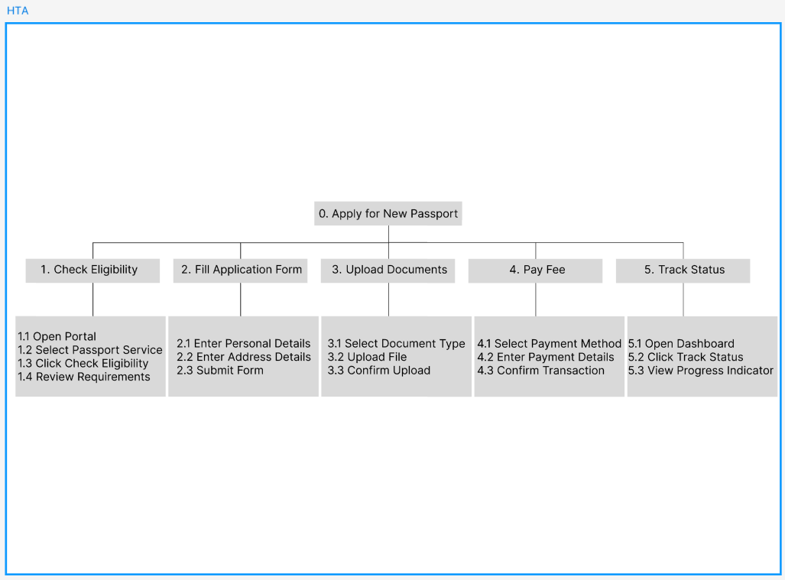
- HTA visual diagram

- Card sorting layout
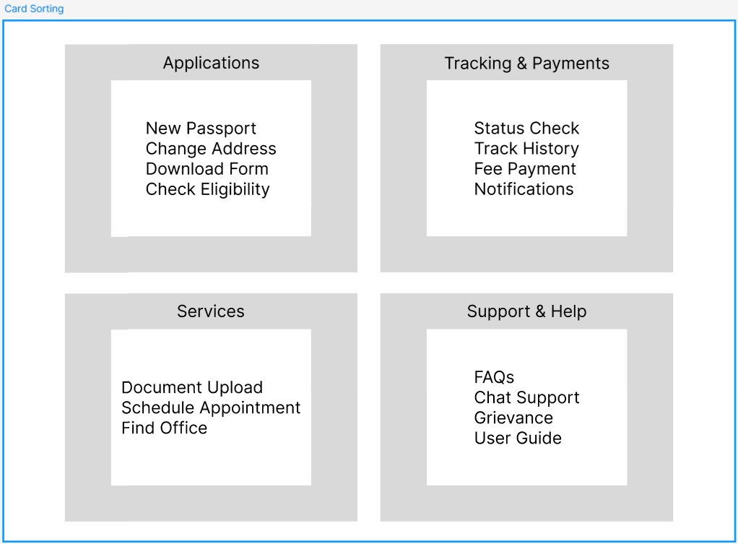

- Structured sitemap diagram
