Task 1

Description: You are designing a (Mobile Health Monitoring App) mobile application for patients with chronic diseases (e.g., diabetes or hypertension) to track health parameters and communicate with doctors.

After interviewing 12 diabetic patients (ages 28-70) and 4 caregivers, key findings include (Mock Research Data):
- 8 patients forget to log glucose levels daily
- 10 patients want one-tap logging
- 7 elderly users struggle with small buttons
- 9 users need clear visual trends
- 6 users want automated doctor alerts.

- Synthesize the data to identify 2 distinct user types and their core needs.
- Create 1 primary persona in Figma representing the most frequent user type.
- Write 1 detailed user scenario (story) showing how this persona uses the app to log data and interpret weekly reports.

Process:
1. User Types and Core Needs (Data Synthesis)

User Type 1: Elderly Chronic Disease Patients
- Age group: 55 - 70
- Core Needs:
  - One-tap glucose logging
  - Large buttons and readable text
  - Clear visual trends for weekly data
  - Automated alerts to doctors
User Type 2: Younger Patients / Caregivers
- Age group: 28 - 45
- Core Needs:
  - Fast and efficient data entry
  - Detailed health reports
  - Reliable notifications and reminders

2. Primary Persona (Theoretical - Created in Figma): The primary persona represents an elderly chronic disease patient with low to medium technical proficiency. This user requires simple interaction mechanisms to log health data regularly and understand health trends without confusion. The persona highlights key needs such as one-tap data logging, large and readable interface elements, clear visual representations of health data, and automatic alerts to doctors. The persona was created in Figma based on the provided mock research data.
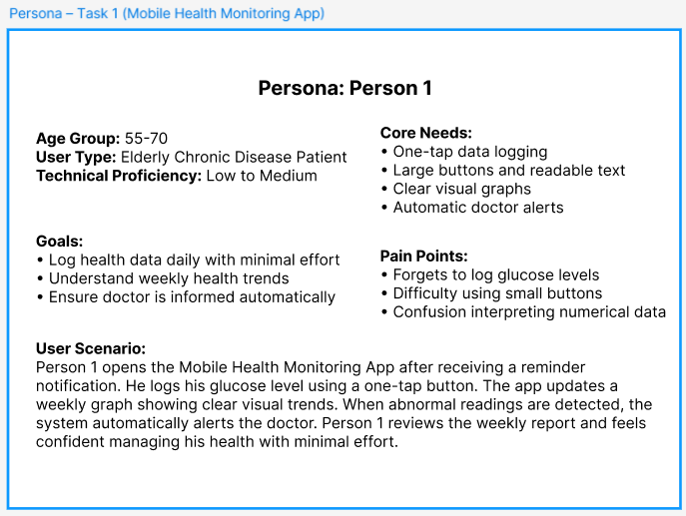
3. User Scenario (Story): Person 1 opens the Mobile Health Monitoring App after receiving a reminder notification. He logs his glucose level using a one-tap button. The application updates a weekly graph showing clear visual trends of his health data. When abnormal readings are detected, the system automatically alerts the doctor. Person 1 reviews the weekly report and feels confident managing his health with minimal effort.

Task 2

Description: You are evaluating a (Digital Government Services Portal) government service portal used for certificates, bill payments, or applications.

Mock Research Data from 18 citizen interviews:
- 13 citizens find form navigation confusing
- 10 citizens cannot locate application status
- 12 citizens need multilingual support
- 9 citizens with disabilities face accessibility barriers
- 14 citizens want simplified document upload.

- Synthesize the data to define 2 citizen profiles and their primary challenges.
- Create 1 primary persona in Figma (include age, occupation, accessibility needs).
- Write 1 scenario where the persona applies for a birth certificate, uploads documents, and tracks application status.

Process:
1. Citizen Profiles and Primary Challenges (Data Synthesis)

Citizen Profile 1: Digitally Limited Citizens
- Age group: 40 - 65
- Primary Challenges:
  - Confusing form navigation
  - Difficulty locating application status
  - Language barriers
  - Accessibility issues

Citizen Profile 2: Working Professionals
- Age group: 25 - 45
- Primary Challenges:
  - Time-consuming document upload
  - Poor status tracking visibility

2. Primary Persona (Theoretical - Created in Figma): The primary persona represents a citizen with limited digital literacy who requires a simple, accessible, and language-friendly government service portal. This user aims to complete essential services independently without confusion. The persona highlights key needs such as step-by-step forms, clear application status indicators, multilingual support, and easy document upload functionality. The persona was created in Figma based on the provided mock research data.
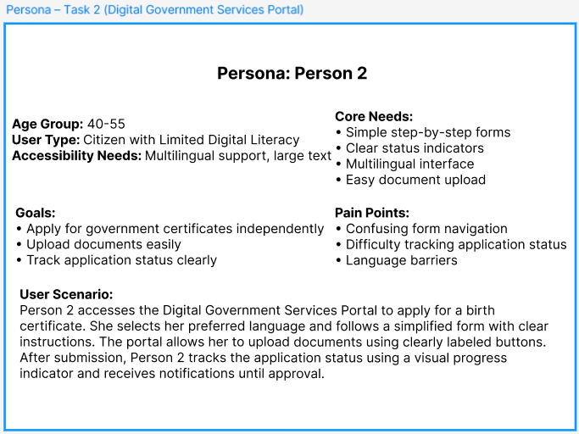

3. User Scenario (Story): Person 2 accesses the Digital Government Services Portal to apply for a birth certificate. She selects her preferred language and follows a simplified, step-by-step form with clear instructions. The portal allows her to upload documents using clearly labeled buttons. After submission, Person 2 tracks the application status using a visual progress indicator and receives notifications until approval.

