TCP Congestion Control – Complete Lab Task

Q1. LAB TASK: TCP Congestion Control Simulation
Question:
Using a TCP congestion control simulator (Python or any tool of your choice), simulate and analyze TCP Reno under three different packet-loss conditions:
- 0.1% loss
- 1% loss
- 2% loss
For each case:
- Plot the Congestion Window (cwnd) vs Time for at least 20 seconds of simulation.
- Compute the average throughput (in MSS/second or Mbps).
- Explain how packet loss affects the behavior of TCP Reno, specifically discussing:
  - Slow Start
  - Congestion Avoidance
  - Multiplicative Decrease (cwnd halving)
- Compare the three cases and write a short conclusion on how increasing loss impacts network performance.
Reference:
# tcp_sim.py
# Simple discrete-time TCP congestion control simulator (Reno-like)
# Usage: python tcp_sim.py
import numpy as np
import matplotlib.pyplot as plt
import random

# --- Simulation parameters ---
RTT = 0.05 # seconds (50 ms)
sim_time = 20.0 # seconds
mss = 1.0 # normalized MSS (units)
loss_prob = 0.01 # per-packet loss probability (Bernoulli)
packets_per_seg = 1 # one packet per MSS in this model

# TCP behavior params
algorithm = "reno" # "reno", "tahoe"
initial_cwnd = 1.0 # in MSS
ssthresh_init = 64.0 # in MSS
rto = 1.0 # simplified timeout (s)

# --- State variables ---
t = 0.0
cwnd = initial_cwnd
ssthresh = ssthresh_init
time_steps = []
cwnd_trace = []
sent_packets_total = 0
acked_packets_total = 0

# For throughput measurement
bytes_acked = 0.0

# Helper: simulate sending cwnd-sized window; return True if loss detected
def send_window(cwnd):
# we model loss per packet with independent Bernoulli trial
segs = int(max(1, round(cwnd / mss)))
lost = False
acks = 0
for _ in range(segs):
sent_packets_total_local = 1
if random.random() < loss_prob:
lost = True
else:
acks += 1
return lost, acks

# Main loop: step in RTT-sized intervals
while t < sim_time:
# record
time_steps.append(t)
cwnd_trace.append(cwnd)

# determine phase: slow start or congestion avoidance
in_slow_start = (cwnd < ssthresh)

# send window, get ack/loss (this is simplification; real TCP tracks per-packet ACKs)
lost, acks = send_window(cwnd)

# update bytes acked
bytes_acked += acks * mss

# Simple Reno behavior
if lost:
# If Tahoe: go to slow start with cwnd = 1
if algorithm == "tahoe":
ssthresh = max(cwnd / 2.0, 2.0)
cwnd = 1.0
elif algorithm == "reno":
# Reno: multiplicative decrease, enter congestion avoidance
ssthresh = max(cwnd / 2.0, 2.0)
cwnd = max(cwnd / 2.0, 1.0)
# assume loss consumed this RTT
else:
# no loss -> increase cwnd
if in_slow_start:
cwnd = cwnd * 2.0 # exponential growth (per-RTT doubling)
else:
cwnd = cwnd + 1.0 # 1 MSS per RTT (additive increase)
# Cap cwnd to a reasonable value to avoid runaway in this simple sim
cwnd = min(cwnd, 1000.0)

# advance time by one RTT
t += RTT

# Convert to throughputs: bytes_acked / sim_time (in MSS units)
throughput = bytes_acked / sim_time

# Plot cwnd trace
plt.figure(figsize=(10,4))
plt.step(time_steps, cwnd_trace, where='post')
plt.xlabel("Time (s)")
plt.ylabel("cwnd (MSS)")
plt.title(f"TCP {algorithm} simulation: loss={loss_prob}, RTT={RTT}s, throughput={throughput:.2f} MSS/s")
plt.grid(True)
plt.show()

print(f"Sim done. Throughput (MSS/s): {throughput:.3f}")

Code:
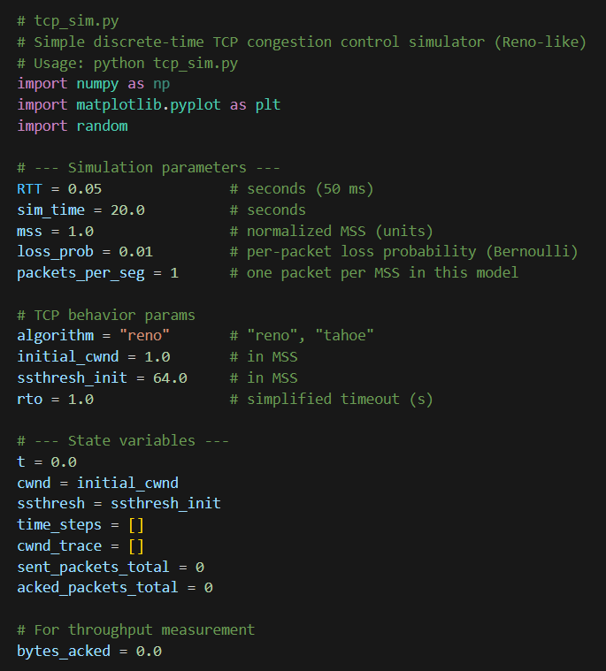
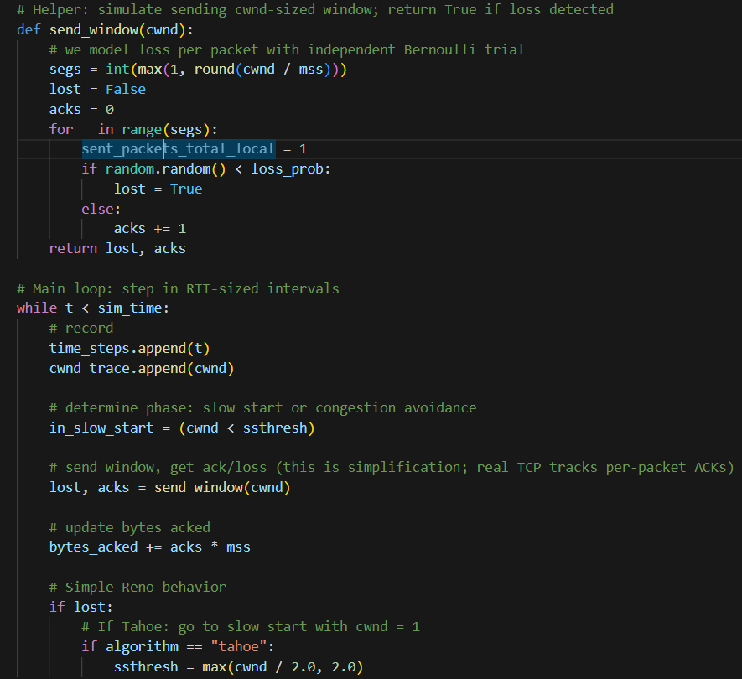

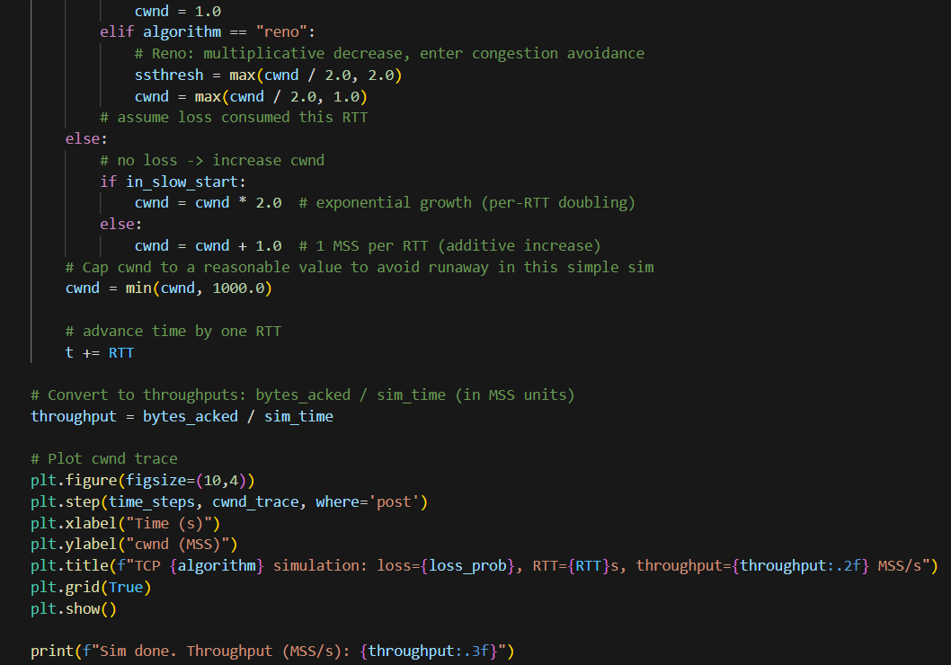

Output:
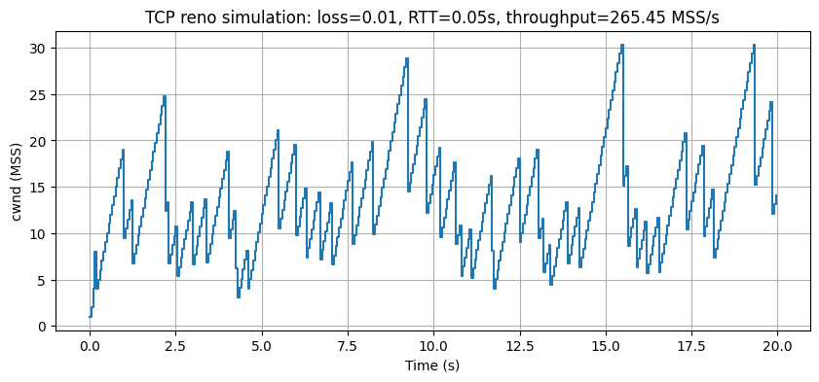
Sim done. Throughput (MSS/s): 265.450

