Task-1

Description:

Responsive Business Homepage

Objective

Create a fully responsive business website using media queries and Flexbox layouts.

Requirements

Build
- Create a responsive business homepage that adapts to different screen sizes.

Media Queries Implementation (Must Include All)
- Desktop layout: 1200px and above
- Tablet layout: 768px to 1199px
- Mobile layout: 320px to 767px
- Print stylesheet for printing optimization

Flexbox Layout Requirements
- Header with logo and navigation using display: flex
- 3-column services section using Flexbox
- 2-column testimonials section with flex alignment
- Footer with 4 flex items (contact info sections)

Responsive Features Required
- Navigation menu collapses to hamburger on mobile
- Service cards stack vertically on mobile
- Images resize proportionally using max-width: 100%
- Typography scales appropriately across breakpoints
- Content reflows without horizontal scrolling

Technical Implementation
- Viewport meta tag for mobile optimization
- Flexible images and media using CSS
- Flexbox properties:
  - justify-content
  - align-items
  - flex-wrap
- Mobile-first approach with min-width media queries
- Touch-friendly button sizes (44px minimum)

Deliverables
- HTML file with semantic structure
- CSS file with complete responsive design
- Screenshots of all 3 breakpoints (desktop, tablet, mobile)
- Testing documentation across different devices

Code:

Task1.html:
<!DOCTYPE html>
<html lang="en">

<head>
<meta charset="UTF-8">
<meta name="viewport" content="width=device-width, initial-scale=1.0">
<title>Company | Business Help</title>
<link rel="stylesheet" href="task1.css">
</head>

<body>
<header class="main-header">
<div class="container header-content">
<div class="logo">
<a href="#">Company<span>Name</span></a>
</div>
<nav class="main-nav" id="main-nav">
<ul class="nav-links" id="nav-links">
<li><a href="#home">Home</a></li>
<li><a href="#services">Services</a></li>
<li><a href="#testimonials">Testimonials</a></li>
<li><a href="#contact">Contact</a></li>
</ul>
</nav>
<div class="menu-toggle" id="mobile-menu">
<span class="bar"></span>
<span class="bar"></span>
<span class="bar"></span>
</div>
</div>
</header>

<main>
<section id="home" class="hero">
<div class="container hero-content">
<h1>Help your business <span>grow</span></h1>
<p>Tools and systems to help you get things done.</p>
<div class="cta-group">
<a href="#contact" class="btn btn-primary">Get Started</a>
<a href="#services" class="btn btn-secondary">Learn More</a>
</div>
</div>
</section>

<section id="services" class="services">
<div class="container">
<h2 class="section-title">What we do</h2>
<div class="services-grid">
<article class="service-card">
<div class="image-placeholder bg-blue"></div>
<h3>Planning</h3>
<p>Helping you manage your business better.</p>
</article>
<article class="service-card">
<div class="image-placeholder bg-green"></div>
<h3>Systems</h3>
<p>Adding software and tools to your workflow.</p>
</article>
<article class="service-card">
<div class="image-placeholder bg-purple"></div>
<h3>Marketing</h3>
<p>Finding ways to reach more people.</p>
</article>
</div>
</div>
</section>

<section id="testimonials" class="testimonials">
<div class="container">
<h2 class="section-title">What people say</h2>
<div class="testimonials-grid">
<div class="testimonial-card">
<p class="quote">"They helped us organize our work. We've seen good results."</p>
<div class="client-info">
<div class="client-avatar bg-yellow"></div>
<div>
<h4>Person 1</h4>
<span>CEO, TechFlow Inc.</span>
</div>
</div>
</div>
<div class="testimonial-card">
<p class="quote">"They are professional and know what they are doing."</p>
<div class="client-info">
<div class="client-avatar bg-red"></div>
<div>
<h4>Person 2</h4>
<span>Director, Global Media</span>
</div>
</div>
</div>
</div>
</div>
</section>
</main>

<footer class="main-footer">
<div class="container footer-grid">
<div class="footer-item">
<h3>Company</h3>
<p>Working with businesses since 2010.</p>
</div>
<div class="footer-item">
<h3>Links</h3>
<ul>
<li><a href="#">About Us</a></li>
<li><a href="#">Careers</a></li>
<li><a href="#">Privacy</a></li>
</ul>
</div>
<div class="footer-item">
<h3>Support</h3>
<ul>
<li><a href="#">Help Center</a></li>
<li><a href="#">Contact Info</a></li>
<li><a href="#">Live Chat</a></li>
</ul>
</div>
<div class="footer-item">
<h3>Follow</h3>
<div class="social-links-text">
<a href="#">LinkedIn</a>
<a href="#">Twitter</a>
</div>
</div>
</div>
<div class="footer-bottom">
<div class="container">
<p>&copy; 2026 Company Solutions. All rights reserved.</p>
</div>
</div>
</footer>

<script>
document.getElementById('mobile-menu').addEventListener('click', function () {
document.getElementById('nav-links').classList.toggle('active');
this.classList.toggle('active');
});
</script>
</body>

</html>

task1.css:
/* Base Styles */
:root {
--primary: #0056b3;
--secondary: #6c757d;
--dark: #333;
--light: #f4f4f4;
--white: #fff;
--gray: #ccc;

/* Placeholders */
--p-blue: #3498db;
--p-green: #2ecc71;
--p-purple: #9b59b6;
--p-yellow: #f1c40f;
--p-red: #e74c3c;
}

* {
margin: 0;
padding: 0;
box-sizing: border-box;
}

body {
font-family: -apple-system, BlinkMacSystemFont, "Segoe UI", Roboto, Helvetica, Arial, sans-serif;
line-height: 1.6;
color: var(--dark);
background-color: var(--white);
}

.container {
width: 90%;
max-width: 1200px;
margin: 0 auto;
}

/* Header & Nav */
.main-header {
background: var(--white);
border-bottom: 2px solid var(--light);
position: sticky;
top: 0;
z-index: 100;
}

.header-content {
height: 70px;
display: flex;
justify-content: space-between;
align-items: center;
}

.logo a {
font-size: 1.5rem;
font-weight: bold;
text-decoration: none;
color: var(--dark);
}

.logo span {
color: var(--primary);
}

.nav-links {
display: flex;
list-style: none;
gap: 1.5rem;
}

.nav-links a {
text-decoration: none;
color: var(--dark);
font-weight: 500;
}

/* Hero */
.hero {
padding: 80px 0;
background-color: #eef2f7;
text-align: center;
}

.hero h1 {
font-size: 2.5rem;
margin-bottom: 20px;
}

.hero h1 span {
color: var(--primary);
}

.hero p {
font-size: 1.1rem;
margin-bottom: 30px;
color: var(--secondary);
}

/* Buttons */
.btn {
display: inline-block;
padding: 12px 24px;
border-radius: 4px;
text-decoration: none;
font-weight: bold;
min-height: 44px;
transition: opacity 0.2s;
}

.btn-primary {
background: var(--primary);
color: var(--white);
}

.btn-secondary {
background: var(--secondary);
color: var(--white);
margin-left: 10px;
}

.btn:hover {
opacity: 0.9;
}

/* Services Grid */
.services {
padding: 60px 0;
}

.section-title {
text-align: center;
margin-bottom: 40px;
}

.services-grid {
display: flex;
flex-wrap: wrap;
gap: 20px;
}

.service-card {
flex: 1 1 calc(33.333% - 20px);
border: 1px solid var(--gray);
padding: 20px;
border-radius: 8px;
}

.image-placeholder {
width: 100%;
height: 150px;
margin-bottom: 15px;
border-radius: 4px;
}

/* Testimonials */
.testimonials {
padding: 60px 0;
background: var(--light);
}

.testimonials-grid {
display: flex;
flex-wrap: wrap;
gap: 20px;
}

.testimonial-card {
flex: 1 1 calc(50% - 10px);
background: var(--white);
padding: 20px;
border-left: 4px solid var(--primary);
}

.quote {
font-style: italic;
margin-bottom: 15px;
}

.client-info {
display: flex;
align-items: center;
gap: 15px;
}

.client-avatar {
width: 50px;
height: 50px;
border-radius: 50%;
}

/* Placeholders */
.bg-blue {
background: var(--p-blue);
}

.bg-green {
background: var(--p-green);
}

.bg-purple {
background: var(--p-purple);
}

.bg-yellow {
background: var(--p-yellow);
}

.bg-red {
background: var(--p-red);
}

/* Footer */
.main-footer {
padding: 40px 0;
background: var(--dark);
color: var(--white);
}

.footer-grid {
display: flex;
flex-wrap: wrap;
gap: 20px;
}

.footer-item {
flex: 1 1 calc(25% - 15px);
}

.footer-item h3 {
margin-bottom: 15px;
color: var(--primary);
}

.footer-item ul {
list-style: none;
}

.footer-item a {
color: #aaa;
text-decoration: none;
}

.footer-item a:hover {
color: var(--white);
}

.footer-bottom {
text-align: center;
margin-top: 30px;
padding-top: 20px;
border-top: 1px solid #444;
color: #777;
}

/* Responsive */
@media (max-width: 767px) {
.menu-toggle {
display: block;
cursor: pointer;
}

.bar {
display: block;
width: 25px;
height: 3px;
background: var(--dark);
margin: 5px 0;
}

.nav-links {
display: none;
position: absolute;
top: 70px;
left: 0;
width: 100%;
background: var(--white);
flex-direction: column;
padding: 20px;
border-bottom: 1px solid var(--gray);
}

.nav-links.active {
display: flex;
}

.service-card,
.testimonial-card,
.footer-item {
flex: 1 1 100%;
}

.btn-secondary {
margin-left: 0;
margin-top: 10px;
display: block;
}

.btn-primary {
display: block;
}
}

@media (min-width: 768px) and (max-width: 1199px) {
.service-card {
flex: 1 1 calc(50% - 10px);
}

.footer-item {
flex: 1 1 calc(50% - 10px);
}
}

/* Print */
@media print {

.main-header,
.btn,
.footer-bottom {
display: none;
}

body {
background: white;
font-size: 12pt;
}

.container {
width: 100%;
}
}

Output:

Task1 (Desktop View)

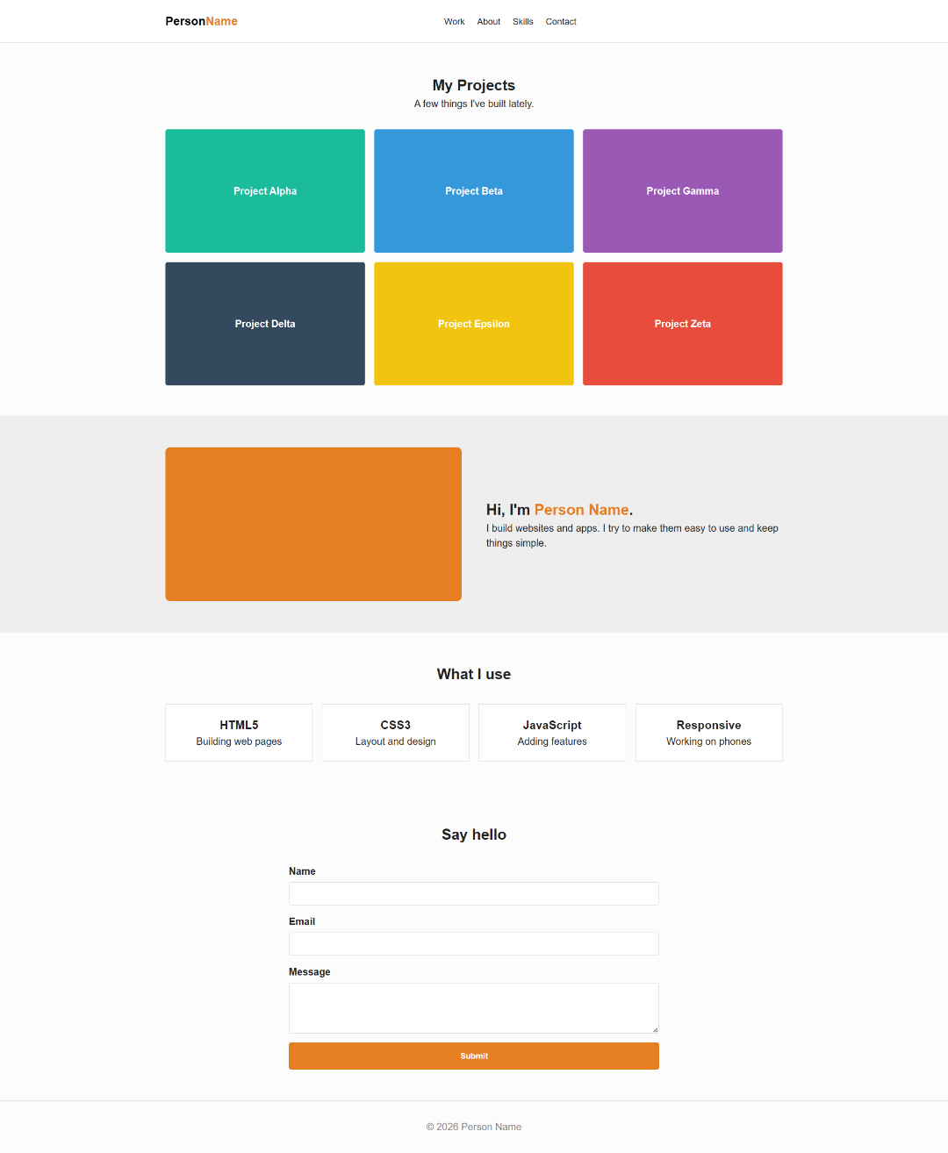

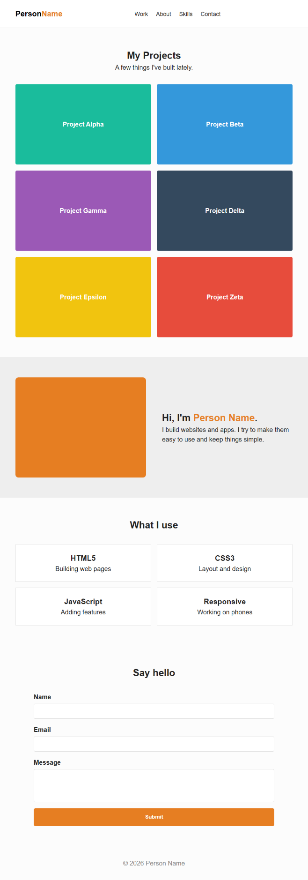
Task1 (Tablet View)

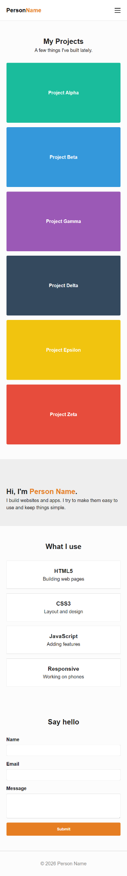
Task1 (Mobile View)
Testing Documentation:

Testing Overview
The responsive business homepage was evaluated conceptually based on the project requirements and implemented CSS rules. The verification focused on ensuring that media queries, Flexbox layouts, and responsive features were structured correctly according to the defined breakpoints.
The testing process was theoretical and based on reviewing the implemented code logic rather than performing real-device testing.

Breakpoint Verification
The layout behavior was reviewed according to the specified screen ranges:
- Desktop (1200px and above):
The services section is designed as a three-column layout.
The testimonials section appears in two columns.
The footer contains four flex items arranged horizontally.
- Tablet (768px to 1199px):
The layout adjusts using media queries to reduce column widths.
Content spacing adapts to maintain readability.
- Mobile (320px to 767px):
The navigation menu converts into a hamburger menu.
Services and testimonial cards stack vertically.
Footer sections align in a single column format.
- Print Layout:
Non-essential elements such as navigation and buttons are hidden.
The layout simplifies for clean print output.

Responsive Feature Verification
The following features were verified through code structure analysis:
- Viewport meta tag included for mobile scaling
- Flexbox properties applied (justify-content, align-items, flex-wrap)
- Images configured with max-width: 100% for proportional resizing
- Typography defined using scalable units
- No fixed-width elements causing overflow
- Buttons designed with minimum height for touch interaction
- Media queries structured using a mobile-first approach

Task-2

Description:
Responsive Portfolio Gallery
Objective
Design a responsive portfolio showcase using Flexbox and media queries for optimal viewing.

Requirements
Build
- Create a responsive portfolio gallery that works across all devices.

Media Queries Implementation (Must Include All)
- Desktop layout: 1200px and above
- Tablet layout: 768px to 1199px
- Mobile layout: 320px to 767px
- Print stylesheet for printing optimization

Flexbox Layout Requirements
- Header with personal branding using display: flex
- Portfolio grid using Flexbox:
  - 3 columns (desktop)
  - 2 columns (tablet)
  - 1 column (mobile)
- About section with image and text using flex alignment
- Skills section with 4 skill cards using Flexbox

Responsive Features Required
- Portfolio images resize and reflow appropriately
- Navigation menu adapts to mobile with a hamburger menu
- Text content adjusts font sizes across breakpoints
- Skill cards stack on smaller screens
- Contact form remains usable on all devices

Technical Implementation
- Viewport meta tag for mobile optimization
- Flexible media using CSS techniques
- Flexbox properties:
  - flex-direction
  - flex-grow
  - align-items
- Mobile-first responsive design approach
- Accessible touch targets for mobile users

Deliverables
- HTML file with portfolio structure
- CSS file with Flexbox and media query implementation
- Device testing screenshots (desktop, tablet, mobile)
- Responsive design testing checklist

Code:

task2.html:
<!DOCTYPE html>
<html lang="en">

<head>
<meta charset="UTF-8">
<meta name="viewport" content="width=device-width, initial-scale=1.0">
<title>Person Name | My Work</title>
<link rel="stylesheet" href="task2.css">
</head>

<body>
<header class="navbar">
<div class="container nav-flex">
<div class="branding">
<a href="#" class="logo">Person<span>Name</span></a>
</div>
<nav class="nav-menu">
<ul class="nav-list" id="nav-list">
<li><a href="#portfolio">Work</a></li>
<li><a href="#about">About</a></li>
<li><a href="#skills">Skills</a></li>
<li><a href="#contact">Contact</a></li>
</ul>
</nav>
<div class="hamburg" id="hamburg">
<div class="line"></div>
<div class="line"></div>
<div class="line"></div>
</div>
</div>
</header>

<main>
<section id="portfolio" class="portfolio">
<div class="container">
<header class="section-head">
<h2>My Projects</h2>
<p>A few things I've built lately.</p>
</header>
<div class="portfolio-grid">
<div class="portfolio-item bg-p1">
<div class="label">Project Alpha</div>
</div>
<div class="portfolio-item bg-p2">
<div class="label">Project Beta</div>
</div>
<div class="portfolio-item bg-p3">
<div class="label">Project Gamma</div>
</div>
<div class="portfolio-item bg-p4">
<div class="label">Project Delta</div>
</div>
<div class="portfolio-item bg-p5">
<div class="label">Project Epsilon</div>
</div>
<div class="portfolio-item bg-p6">
<div class="label">Project Zeta</div>
</div>
</div>
</div>
</section>

<section id="about" class="about">
<div class="container about-flex">
<div class="about-visual bg-accent"></div>
<div class="about-text">
<h2>Hi, I'm <span>Person Name</span>.</h2>
<p>I build websites and apps. I try to make them easy to use and keep things simple.</p>
</div>
</div>
</section>

<section id="skills" class="skills">
<div class="container">
<h2 class="section-title">What I use</h2>
<div class="skills-grid">
<div class="skill-card">
<h3>HTML5</h3>
<p>Building web pages</p>
</div>
<div class="skill-card">
<h3>CSS3</h3>
<p>Layout and design</p>
</div>
<div class="skill-card">
<h3>JavaScript</h3>
<p>Adding features</p>
</div>
<div class="skill-card">
<h3>Responsive</h3>
<p>Working on phones</p>
</div>
</div>
</div>
</section>

<section id="contact" class="contact">
<div class="container form-container">
<h2 class="section-title">Say hello</h2>
<form class="contact-form">
<div class="form-group">
<label for="name">Name</label>
<input type="text" id="name" required>
</div>
<div class="form-group">
<label for="email">Email</label>
<input type="email" id="email" required>
</div>
<div class="form-group">
<label for="message">Message</label>
<textarea id="message" rows="4" required></textarea>
</div>
<button type="submit" class="submit-btn">Submit</button>
</form>
</div>
</section>
</main>

<footer class="site-footer">
<div class="container">
<p>&copy; 2026 Person Name</p>
</div>
</footer>

<script>
document.getElementById('hamburg').addEventListener('click', function () {
document.getElementById('nav-list').classList.toggle('active');
this.classList.toggle('open');
});
</script>
</body>

</html>

task2.css:
/* Simple Portfolio Styles */
:root {
--bg-color: #fcfcfc;
--text-color: #222;
--accent-color: #e67e22;
--card-bg: #fff;
--border-color: #ddd;

/* Project Colors */
--p1: #1abc9c;
--p2: #3498db;
--p3: #9b59b6;
--p4: #34495e;
--p5: #f1c40f;
--p6: #e74c3c;
}

* {
margin: 0;
padding: 0;
box-sizing: border-box;
}

body {
font-family: sans-serif;
background-color: var(--bg-color);
color: var(--text-color);
line-height: 1.5;
}

.container {
width: 90%;
max-width: 1000px;
margin: 0 auto;
}

/* Navbar */
.navbar {
padding: 20px 0;
border-bottom: 1px solid var(--border-color);
background: #fff;
}

.nav-flex {
display: flex;
justify-content: space-between;
align-items: center;
}

.logo {
text-decoration: none;
font-weight: bold;
font-size: 1.2rem;
color: #000;
}

.logo span {
color: var(--accent-color);
}

.nav-list {
display: flex;
list-style: none;
gap: 20px;
}

.nav-list a {
text-decoration: none;
color: var(--text-color);
font-size: 0.9rem;
}

/* Portfolio Grid */
.portfolio {
padding: 50px 0;
}

.section-head {
text-align: center;
margin-bottom: 30px;
}

.portfolio-grid {
display: flex;
flex-wrap: wrap;
gap: 15px;
}

.portfolio-item {
flex: 1 1 calc(33.333% - 10px);
height: 200px;
display: flex;
align-items: center;
justify-content: center;
color: #fff;
font-weight: bold;
border-radius: 4px;
}

.bg-p1 {
background: var(--p1);
}

.bg-p2 {
background: var(--p2);
}

.bg-p3 {
background: var(--p3);
}

.bg-p4 {
background: var(--p4);
}

.bg-p5 {
background: var(--p5);
}

.bg-p6 {
background: var(--p6);
}

/* About Section */
.about {
padding: 50px 0;
background: #eee;
}

.about-flex {
display: flex;
align-items: center;
gap: 40px;
}

.about-visual {
flex: 1;
height: 250px;
background: var(--accent-color);
border-radius: 8px;
}

.about-text {
flex: 1;
}

.about-text span {
color: var(--accent-color);
font-weight: bold;
}

/* Skills Section */
.skills {
padding: 50px 0;
}

.section-title {
text-align: center;
margin-bottom: 30px;
}

.skills-grid {
display: flex;
flex-wrap: wrap;
gap: 15px;
}

.skill-card {
flex: 1 1 calc(25% - 12px);
background: var(--card-bg);
padding: 20px;
border: 1px solid var(--border-color);
text-align: center;
}

/* Contact */
.contact {
padding: 50px 0;
}

.form-container {
max-width: 600px;
}

.contact-form {
display: flex;
flex-direction: column;
gap: 15px;
}

.form-group {
display: flex;
flex-direction: column;
}

.form-group label {
margin-bottom: 5px;
font-weight: bold;
}

.form-group input,
.form-group textarea {
padding: 10px;
border: 1px solid var(--border-color);
border-radius: 4px;
}

.submit-btn {
padding: 12px;
background: var(--accent-color);
color: #fff;
border: none;
border-radius: 4px;
cursor: pointer;
font-weight: bold;
min-height: 44px;
}

/* Footer */
.site-footer {
padding: 30px 0;
text-align: center;
border-top: 1px solid var(--border-color);
color: #888;
}

/* Responsive */
@media screen and (max-width: 767px) {
.hamburg {
display: flex;
flex-direction: column;
gap: 5px;
cursor: pointer;
}

.line {
width: 20px;
height: 2px;
background: #000;
}

.nav-list {
display: none;
flex-direction: column;
position: absolute;
top: 60px;
left: 0;
width: 100%;
background: #fff;
padding: 20px;
border-bottom: 1px solid var(--border-color);
}

.nav-list.active {
display: flex;
}

.portfolio-item,
.skill-card {
flex: 1 1 100%;
}

.about-flex {
flex-direction: column;
}

.about-visual {
width: 100%;
}
}

@media screen and (min-width: 768px) and (max-width: 1199px) {
.portfolio-item {
flex: 1 1 calc(50% - 10px);
}

.skill-card {
flex: 1 1 calc(50% - 10px);
}
}

/* Print */
@media print {

.navbar,
.submit-btn,
.hamburg {
display: none;
}

body {
background: #fff;
}

.about-flex {
display: block;
}
}

Output:
Task2 (Desktop View)

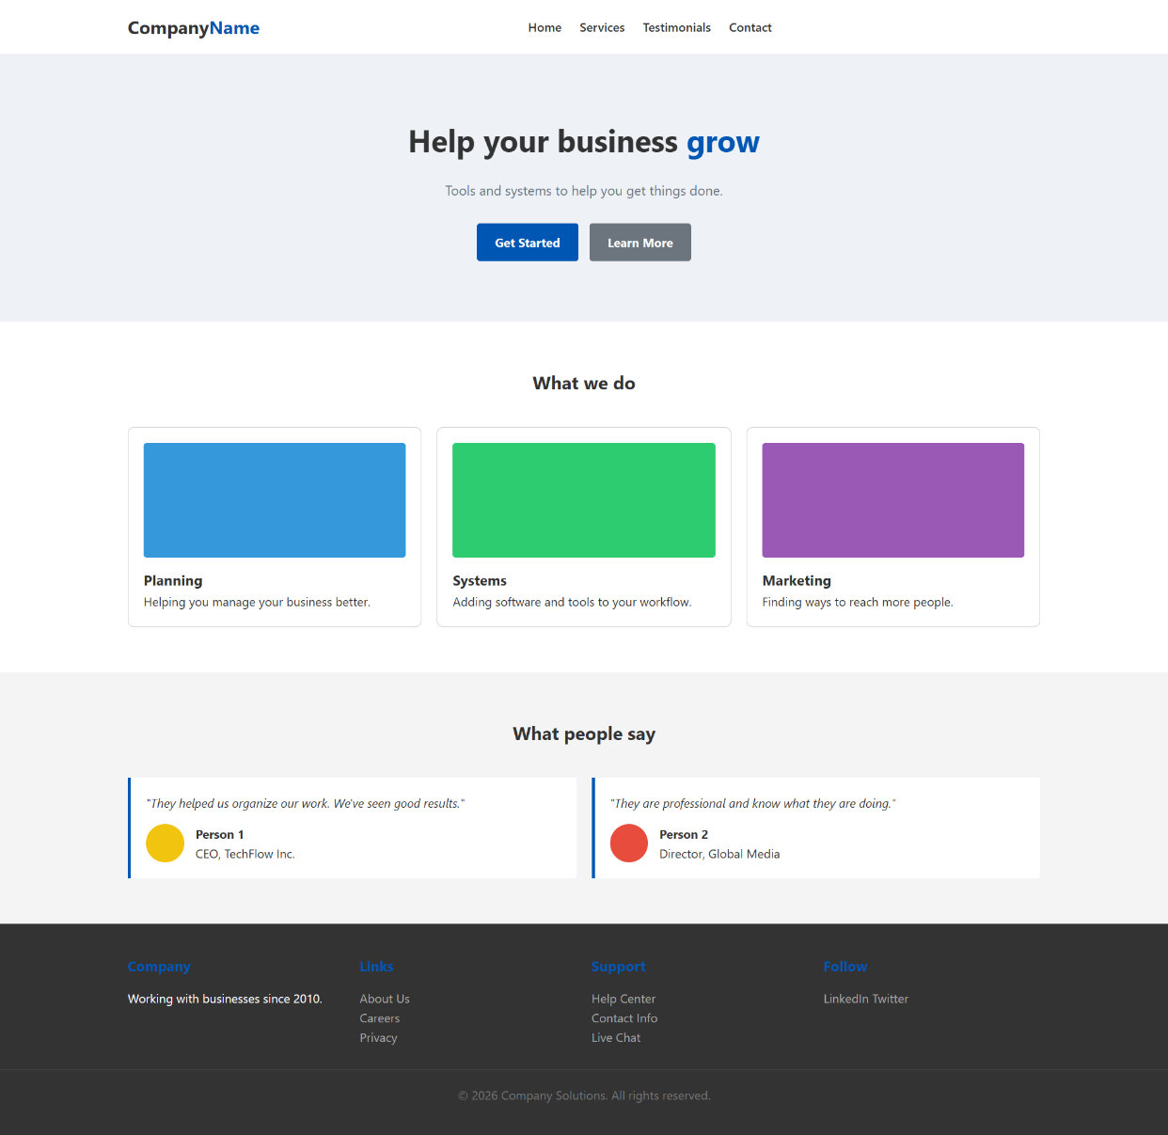
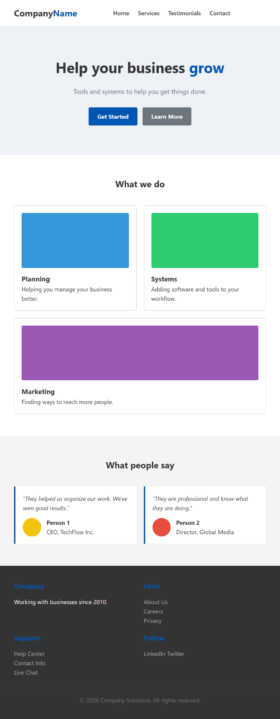
Task1 (Tablet View)

Task1 (Mobile View)
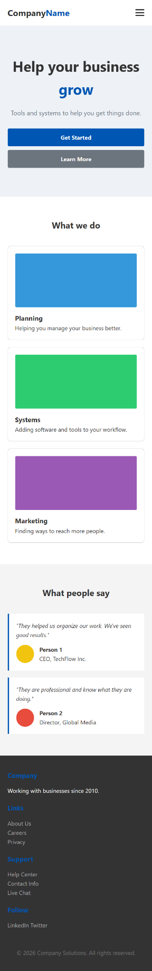

Testing Documentation:
Testing Overview
The responsive portfolio gallery was conceptually evaluated to ensure that Flexbox layout rules and media queries were correctly implemented. Verification was performed through structural review of HTML and CSS design rather than physical device testing.
The evaluation focused on responsiveness, layout transformation, and content adaptability across defined breakpoints.

Breakpoint Verification
- Desktop (1200px and above):
Portfolio grid displays three columns.
Skills section displays four cards in a row.
About section uses horizontal flex alignment.
- Tablet (768px to 1199px):
Portfolio grid adjusts to two columns.
Skills cards rearrange appropriately.
Layout spacing is optimized for medium screens.
- Mobile (320px to 767px):
Portfolio items stack into a single column.
Skills cards stack vertically.
Navigation converts into a hamburger menu.
About section changes to vertical alignment.
- Print Layout:
Navigation and interactive elements are hidden.
Layout simplified for readability.

Responsive Feature Verification
The following were validated based on implementation:
- Flexbox used for grid layout and alignment
- Media queries applied for three major breakpoints
- Flexible images and scalable content
- Navigation adaptability for smaller screens
- Contact form structured for usability across layouts
- No horizontal scrolling caused by fixed widths

