Task-1

Basic HTML5 Page Structure: A college wants to create a simple webpage to welcome students and display a short introduction message using proper HTML5 structure. Design an HTML5 program that displays a heading “Welcome to HTML5” and a paragraph describing the page.

Code:
<!DOCTYPE html>
<html>
<head>
<title>College Welcome Page</title>
</head>
<body>
<h1>Welcome to HTML5</h1>
<p>This is a simple HTML5 webpage designed to introduce students to basic web structure and welcome them to the course.</p>
</body>
</html>

Output:
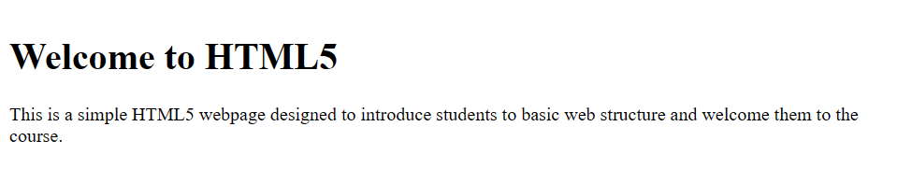

Task-2

HTML5 Form with New Input Types: A university is developing an online student registration system. The form should collect the student’s name, email address, date of birth, and age. Create an HTML5 form using appropriate new input types and ensure mandatory fields are validated.

Code:
<!DOCTYPE html>
<html>

<head>
<title>Student Registration</title>
</head>

<body>
<h1>Student Registration System</h1>
<form action="#" method="post">
<label for="name">Student Name:</label>
<input type="text" id="name" name="name" required><br><br>

<label for="email">Email Address:</label>
<input type="email" id="email" name="email" required><br><br>

<label for="dob">Date of Birth:</label>
<input type="date" id="dob" name="dob" required><br><br>

<label for="age">Age:</label>
<input type="number" id="age" name="age" min="15" max="100" required><br><br>

<input type="submit" value="Register">
</form>
</body>

</html>

Output:
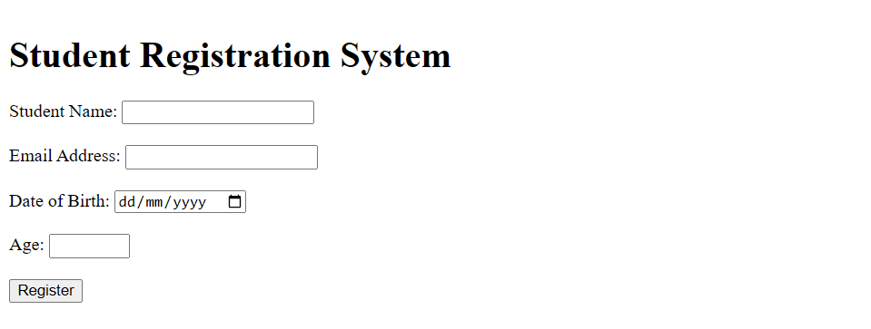

Task-3

Audio and Video in HTML5: An e-learning platform wants to embed audio lectures and video tutorials on its website without using external plugins. Write an HTML5 program to embed one audio file and one video file with playback controls.

Code:
<!DOCTYPE html>
<html>

<head>
<title>Audio and Video Platform</title>
</head>

<body>
<h1>E-Learning Multimedia Content</h1>

<section>
<h2>Audio Lecture</h2>
<p>Listen to the introductory lecture below:</p>
<audio controls>
<source src="#" type="audio/mpeg">
Your browser does not support the audio element.
</audio>
</section>

<br>
<hr><br>

<section>
<h2>Video Tutorial</h2>
<p>Watch the step-by-step tutorial video:</p>
<video width="480" height="270" controls>
<source src="#" type="video/mp4">
Your browser does not support the video element.
</video>
</section>
</body>

</html>

Output:
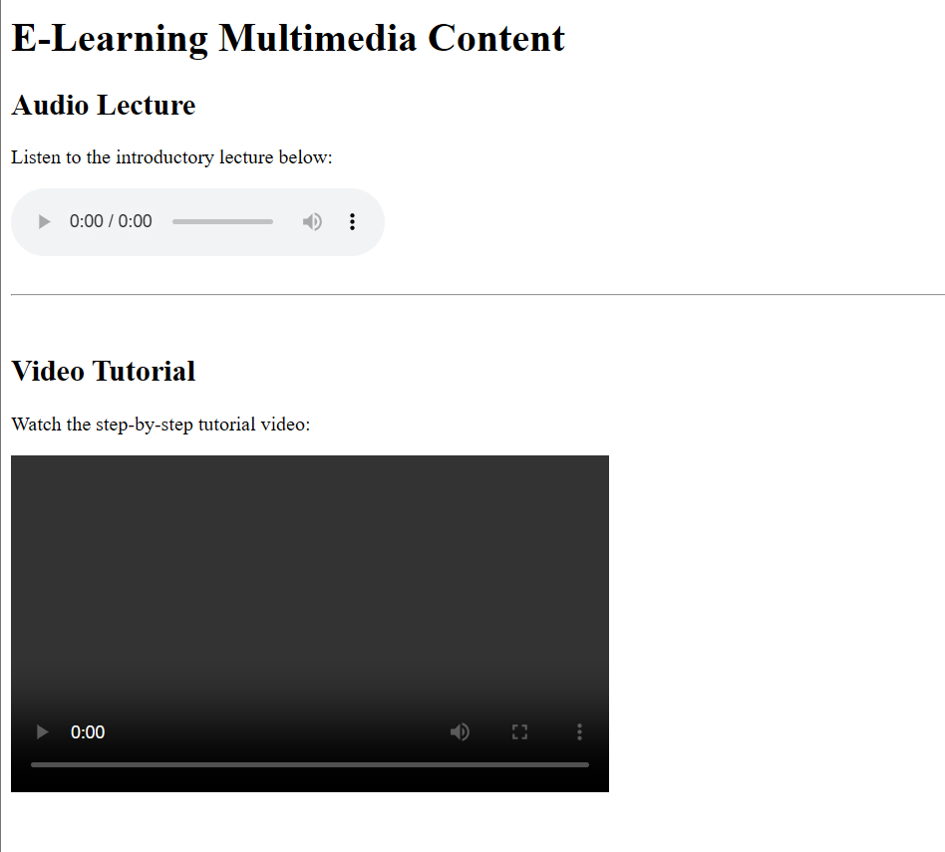

Task-4

HTML5 Semantic Elements: A website developer wants to improve SEO and readability of a webpage by using HTML5 semantic elements. Design a webpage using <header>, <nav>, <section>, and <footer> to display a website title, navigation links, introduction content, and copyright information.

Code:
<!DOCTYPE html>
<html>

<head>
<title>Semantic Page Structure</title>
</head>

<body>

<header>
<h1>My Educational Website</h1>
</header>

<nav>
<ul>
<li><a href="#home">Home</a></li>
<li><a href="#about">About</a></li>
<li><a href="#contact">Contact</a></li>
</ul>
</nav>

<section id="home">
<h2>Introduction</h2>
<p>This is a sample section for the "Home" page. You can add more content here as needed.</p>
</section>
<section id="about">
<h2>About</h2>
<p>This is a sample section for the "About" page. You can add more content here as needed.</p>
</section>
<section id="contact">
<h2>Contact</h2>
<p>This is a sample section for the "Contact" page. You can add more content here as needed.</p>
</section>

<footer>
<p>&copy; 2026 Student Learning Portal. All rights reserved.</p>
</footer>

</body>

</html>

Output:
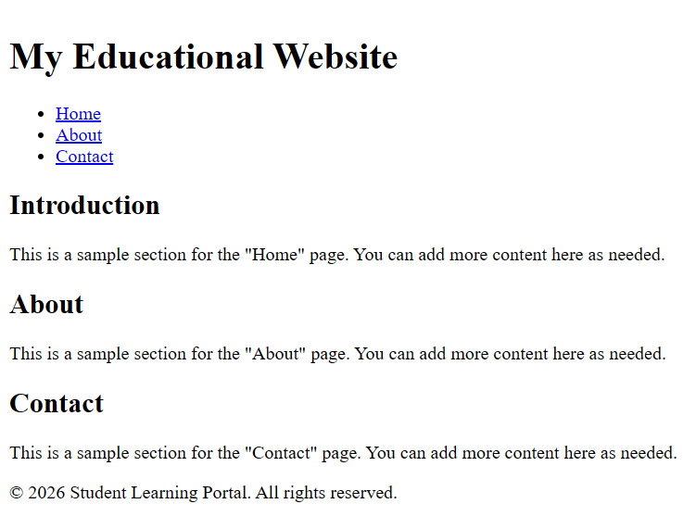

Task-5

HTML5 Canvas: A graphics teacher wants to demonstrate basic drawing using HTML5 without images. Write an HTML5 program using the canvas element and JavaScript to draw a blue rectangle inside the canvas area.

Code:
<!DOCTYPE html>
<html>

<head>
<title>HTML5 Canvas Drawing</title>
</head>

<body>
<h1>Drawing with HTML5 Canvas</h1>
<p>Below is a blue rectangle drawn inside a canvas element using JavaScript:</p>

<canvas id="myCanvas" width="400" height="200" style="border:1px solid #000000;">
Your browser does not support the HTML5 canvas tag.
</canvas>

<script>
// Get the canvas element by ID
var canvas = document.getElementById("myCanvas");
// Get the 2D drawing context
var ctx = canvas.getContext("2d");
// Set the fill color to blue
ctx.fillStyle = "blue";
// Draw a filled rectangle (x, y, width, height)
ctx.fillRect(50, 50, 150, 100);
</script>
</body>

</html>

Output:
