Task-1

A student is required to design a Personal Portfolio Landing Page using HTML5 semantic elements.
The webpage should follow proper HTML5 document structure and include sections such as header, navigation menu, main content, sidebar, and footer. The page should display an introduction, technical skills, project details, and contact information using semantic and accessible HTML5 tags.

Code:
<!DOCTYPE html>
<html lang="en">

<head>
<title>Personal Portfolio</title>
<meta charset="UTF-8">
</head>

<body>

<header>
<h1>Personal Portfolio</h1>
<nav>
<ul>
<li><a href="#about">About</a></li>
<li><a href="#skills">Skills</a></li>
<li><a href="#projects">Projects</a></li>
<li><a href="#contact">Contact</a></li>
</ul>
</nav>
</header>

<main>

<section id="about">
<h2>About Me</h2>
<img src="https://via.placeholder.com/300x200"
alt="Abstract workspace representing a software developer">
<p>
I am a motivated computer science graduate with a strong interest in
software development, web technologies, and modern programming practices.
I enjoy building scalable applications and continuously learning new tools
and frameworks.
</p>
<p>
I aim to apply my technical skills to real-world problems while growing
as a professional software developer in collaborative environments.
</p>
</section>

<section id="skills">
<h2>Technical Skills</h2>
<ul>
<li>HTML5 and CSS3</li>
<li>JavaScript</li>
<li>Python Programming</li>
<li>Java Fundamentals</li>
<li>SQL Databases</li>
<li>Git Version Control</li>
</ul>
</section>

<section id="projects">
<h2>Projects</h2>

<article>
<h3>Offline AI Assistant</h3>
<p>
A privacy-focused application designed to function without
internet connectivity using local processing.
</p>
<time datetime="2025-04">April 2025</time>
</article>

<article>
<h3>E-Commerce Web Application</h3>
<p>
A full-stack shopping platform with secure authentication
and database integration.
</p>
<time datetime="2024-09">September 2024</time>
</article>

<article>
<h3>Data Analytics Dashboard</h3>
<p>
An interactive dashboard that visualizes data to support
informed decision-making.
</p>
<time datetime="2025-03">March 2025</time>
</article>

</section>

</main>

<aside>
<h2>Additional Information</h2>
<img src="https://via.placeholder.com/250x150"
alt="Abstract illustration representing technology and innovation">
<ol>
<li>Strong problem-solving skills</li>
<li>Interest in emerging technologies</li>
<li>Experience with teamwork</li>
</ol>
</aside>

<footer id="contact">
<h2>Contact</h2>
<address>
<p>Email: <a href="mailto:example@email.com">example@email.com</a></p>
<p>
<a href="#">LinkedIn</a> |
<a href="#">GitHub</a>
</p>
</address>
<p>&copy; <time datetime="2026">2026</time> Personal Portfolio</p>
</footer>

</body>

</html>

Output:

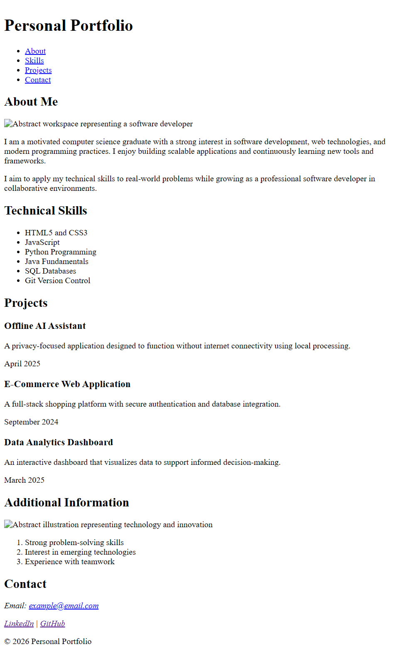

VS Code Setup:

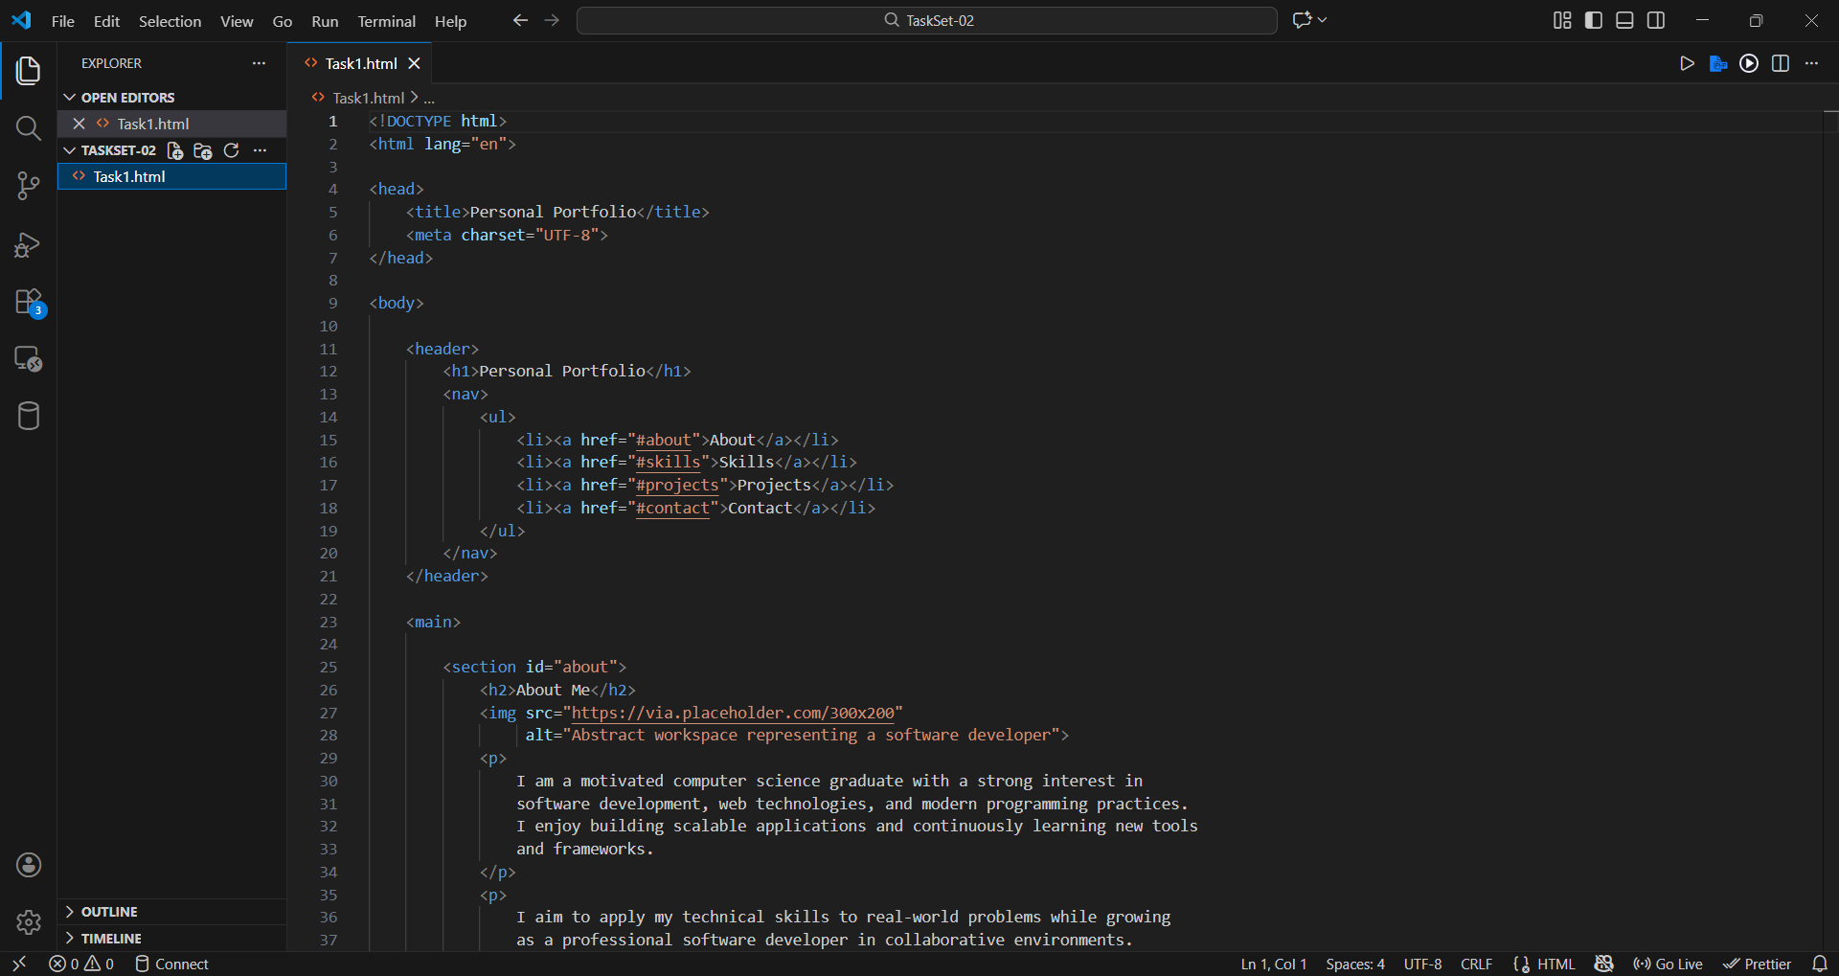

W3C HTML Validation Report:

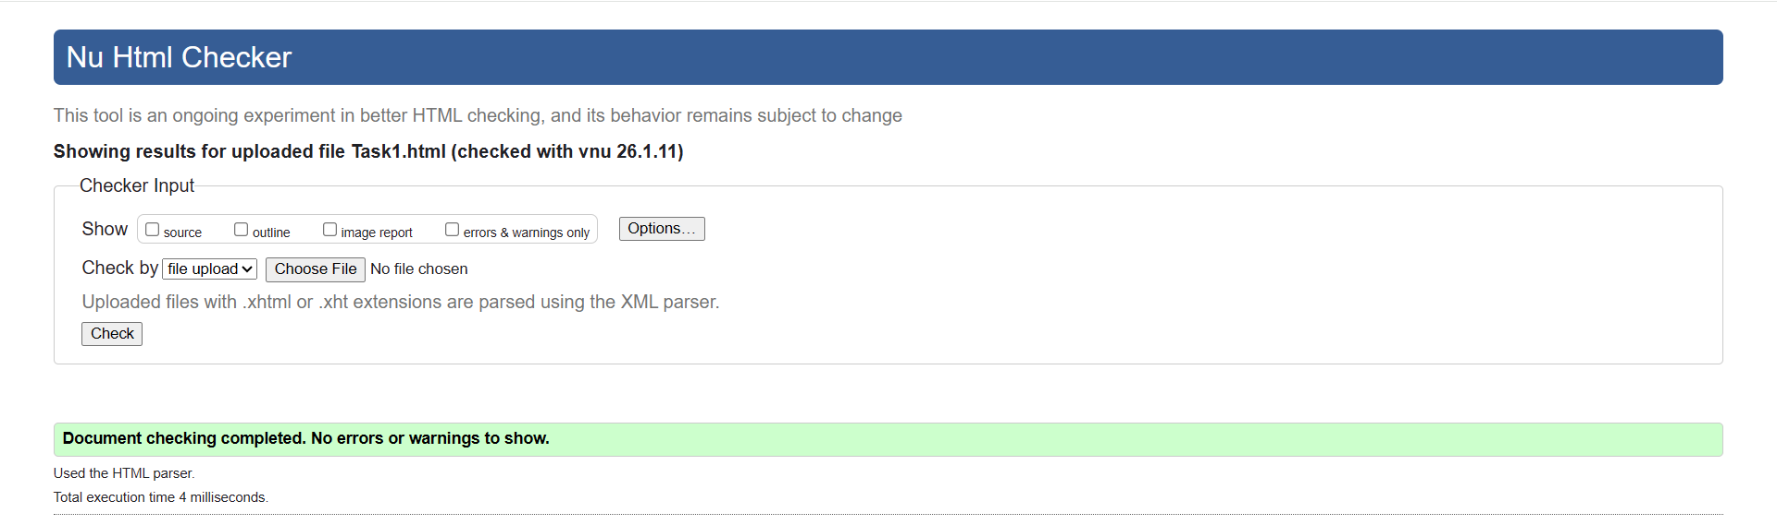

Development Environment Documentation:

Component | Details
Code Editor | Visual Studio Code
Extension Installed | Live Server
Programming Language | HTML5
Browser Used for Testing | Google Chrome
Validation Tool | W3C Markup Validation Service

