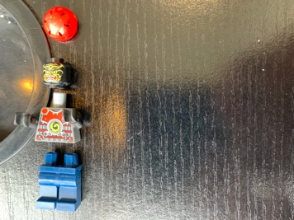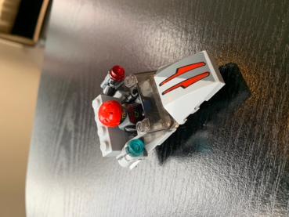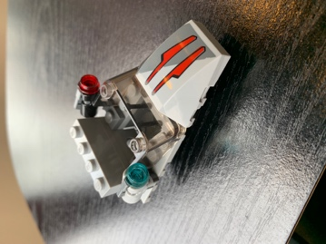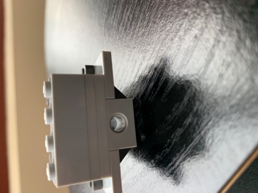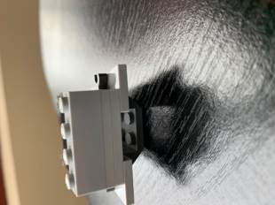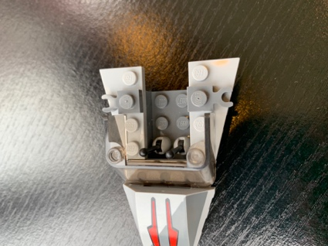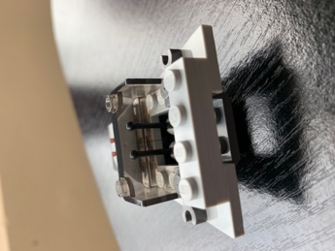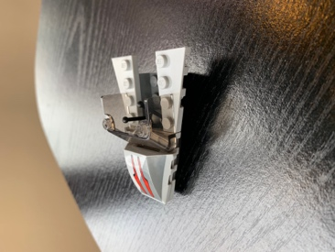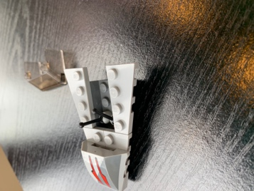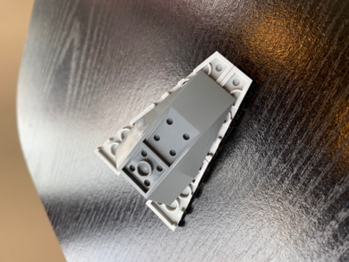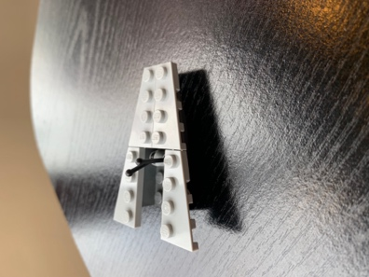

10. Follow picture instructions

3. Place windshield behind the hood.

4. Place pieces with the C shaped handles accordingly.

5. Place Two thin 1 by 4 pices onto very back of light gray pieces.

9. Place LEGO guy into his seat on the ship.

8. Place two guns into the two C shaped holders on each side of the ship

7. Place tall 1 by 2 piece with hole in the open gap below the three 1 by 4 pieces.

6. Place tall 1 by 4 piece on top of two thin 1 by 4’s.

2. Place the hood shaped piece onto design according to picture.

1.Place control levers onto the second row of O’s in the lower deck of dark grey piece. Place 4 slanted pieces according to the picture.