**Solution 1:**

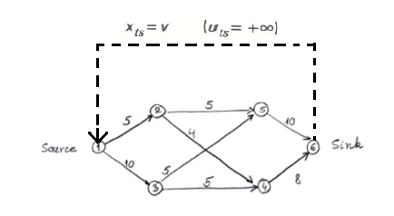

The virtual arc has been shown with bold dotted lines.

**Solution 2:**

1. The 1200 mcf gas, Maximum usage and Tariff are used to calculate the Minimum Total cost of transportation, which is our decision variable.

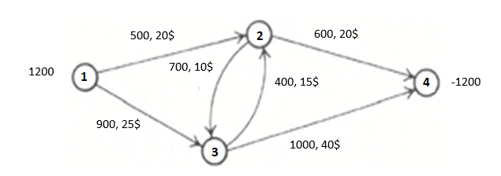

**Solution 3)** **Branch and Bound**

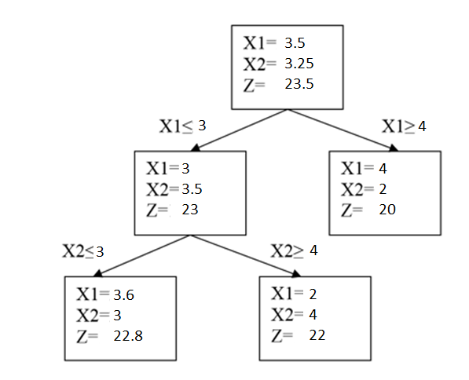

3

4