**NATIONAL ARCHIVES AND RECORDS ADMINISTRATION**



Configuration Management

Polytron Version Control System (PVCS) Version Manager (VM) Web Module User Guide

Version 1.2

Status Final

**Date 01/06/19**

REVISION HISTORY

|  |  |  |  |  |
| --- | --- | --- | --- | --- |
| **Date** | **Version** | **Author** | **Status** | **Revision Description** |
| 07/08/16 | 1.0 | CM Team | Final | PVCS WEB Module Users guide |
| 01/02/19 | 1.1 | CM Team | Final | PVCS Web Module Users Guide |
| 01/03/19 | 1.1a | CM Team | Draft | Incorporating updates for upgrade to version 8.6.2 |

Contents

[1 Introduction 4](#_Toc29189654)

[1.1 Purpose 4](#_Toc29189655)

[1.2 Applicability Statement 4](#_Toc29189656)

[1.3 Getting Help 4](#_Toc29189657)

[2 Getting Started 4](#_Toc29189658)

[2.1 Introducing Version Manager 4](#_Toc29189659)

[2.1.1 What is Configuration Management? 4](#_Toc29189660)

[2.1.2 What is Version Control? 4](#_Toc29189661)

[2.1.3 Why use Version Manager? 4](#_Toc29189662)

[2.2 Version Manager Web Client Features 5](#_Toc29189663)

[2.3 Connecting to the Version Manager Web Client 5](#_Toc29189664)

[2.4 Logging In to a Project Database 5](#_Toc29189665)

[2.5 Changing Your Password 6](#_Toc29189666)

[2.6 Switching Users 7](#_Toc29189667)

[2.7 Logging Out of a Project Database 7](#_Toc29189668)

[3 Navigating the interface 8](#_Toc29189669)

[3.1 Version Manager Web Client Panes 8](#_Toc29189670)

[3.2 Working in the Project Pane 9](#_Toc29189671)

[3.3 Working in the Content Pane 9](#_Toc29189672)

[3.4 Working in the Revision Pane 10](#_Toc29189673)

[3.5 Working in the Menu Pane 11](#_Toc29189674)

[3.6 Working in the Status Pane 12](#_Toc29189675)

[4 Performing Basic Tasks 13](#_Toc29189676)

[4.1 Selecting Items 13](#_Toc29189677)

[4.2 File Tab 13](#_Toc29189678)

[4.2.1 Creating a Project 13](#_Toc29189679)

[4.2.2 Setting a Workfile Location 15](#_Toc29189680)

[4.2.3 Renaming, Deleting and Setting a Workspace 15](#_Toc29189681)

[4.3 Edit Tab 15](#_Toc29189682)

[4.4 Actions Tab 15](#_Toc29189683)

[4.4.1 Add Workfile 15](#_Toc29189684)

[4.4.2 Get 16](#_Toc29189685)

[4.4.3 Check Out a Workfile 17](#_Toc29189686)

[4.4.4 Check In a Workfile 18](#_Toc29189687)

[4.4.5 Lock a File 18](#_Toc29189688)

[4.4.6 Unlock a File 19](#_Toc29189689)

[4.4.7 Label 20](#_Toc29189690)

[4.4.8 History Report 21](#_Toc29189691)

[4.5 Installation of web client version 8.6 23](#_Toc29189692)

[*Figure 1-Project DB* 6](#_Toc29189838)

[*Figure 2- Change Password* 6](#_Toc29189839)

[*Figure 3-Switch User* 7](#_Toc29189840)

[*Figure 4-Project DB logout screen* 7](#_Toc29189841)

[*Figure 5- Project DB with different Panes* 8](#_Toc29189842)

[*Figure 6-Revision Pane* 8](#_Toc29189843)

[*Figure 7-Icon Description* 9](#_Toc29189844)

[*Figure 8-Revision Pane* 10](#_Toc29189845)

[*Figure 9-Revision Pane* 11](#_Toc29189846)

[*Figure 10-File Menu Buttons Description* 11](#_Toc29189847)

[*Figure 11-Edit Menu Buttons Description* 12](#_Toc29189848)

[*Figure 12-Actions Menu Button Description* 12](#_Toc29189849)

[*Figure 13-Help Menu Button Description* 12](#_Toc29189850)

[*Figure 14- Status Icon Description* 13](#_Toc29189851)

[*Figure 15-Select Items* 13](#_Toc29189852)

[*Figure 16-Creating a Project* 14](#_Toc29189853)

[*Figure 17- Creating a Project within Project* 14](#_Toc29189854)

[*Figure 18-Workfile Location* 15](#_Toc29189855)

[*Figure 19-Select a Project* 16](#_Toc29189856)

[*Figure 20-Add Workfiles* 16](#_Toc29189857)

[*Figure 21-Get* 17](#_Toc29189858)

[*Figure 22-Check Out* 17](#_Toc29189859)

[*Figure 23-Check in* 18](#_Toc29189860)

[*Figure 24-Lock File Dialog Box* 18](#_Toc29189861)

[*Figure 25-Results of Lock File Action* 19](#_Toc29189862)

[*Figure 26-Unlock File* 19](#_Toc29189863)

[*Figure 27-Unlock file screen* 20](#_Toc29189864)

[*Figure 28-Version Label* 20](#_Toc29189865)

[*Figure 29-Report Types* 21](#_Toc29189866)

[*Figure 30-Report types* 22](#_Toc29189867)

[*Figure 31-Report containing latest revisions of all files under Deliverables folder* 22](#_Toc29189868)

[Figure 32- Windows installer 23](#_Toc29189869)

[Figure 33- Agent Connection 24](#_Toc29189870)

[Figure 34- Agent Connection being installed 24](#_Toc29189871)

[Figure 35- Install Wizard 25](#_Toc29189872)

[Figure 36- Agent connection 25](#_Toc29189873)

[Figure 37-Agent Connected 26](#_Toc29189874)

[Figure 38- Agent Configure 27](#_Toc29189875)

[Figure 39 Access to files by accepting the risk 28](#_Toc29189876)

# **Introduction**

## Purpose

PVCS Version Manager web client is the web-based client component of PVCS Version Manager that allows you to access Version Manager Projects via the Internet or intranet.

This document provides an overview of PVCS Version Manager web client and describes basic functions of the tool.

The purpose of this User Guide is to assist NARA Users in understanding of the basic functionality of the Version Manager Web client interface.

## Applicability Statement

This User Guide should be used as a reference for performing operations with PVCS Version Manager web interface.

## Getting Help

Version Manager provides extensive online help.

|  |  |
| --- | --- |
| **To view** | **Do this** |
| Help Contents | Click on the Help tab and then Help Menu button  bar, which will launch the Version Manager web client help system. |

# **Getting Started**

## Introducing Version Manager

### What is Configuration Management?

Configuration Management (CM) is the process of organizing and managing changes to the components development efforts, such as source code, build scripts, configuration files, documentation etc. Effective CM helps members of a development team retrieve and build any version of an application or documentation in a consistent and repeatable manner.

### What is Version Control?

Version Control is the process of managing and maintaining multiple revisions of the same file in an archive. An archive contains information about each revision of the stored files, allowing members of the team to retrieve modify and return any file revision in a safe, organized and consistent manner.

### Why use Version Manager?

With version control, you minimize the risk of overwriting changes made by another team member. Version Manager User does not need to worry about losing data, because all changes and information are archived and easily accessible. For all files stored in Version Manager, a user can retrieve any revision of that file and get specific information about each change that was made.

## Version Manager Web Client Features

Version Manager Web client provides the essential end-user version control features of Version Manager. It is designed for users who do not need access to administrative features.

PVCS Version Manager web client online help provides detailed procedures for using these features.

Version Manager Web client provides the following features:

* **Add Workfiles**. Add one or more workfiles to a project database or project. You can also add an entire directory with subdirectories, which becomes a project with subprojects in the project database.
* **Create sub-folders**. Manually create sub-folders within a project.
* **Check in** and **Check out**. Check files in to and out of archives.
* **Get.** Get copies of revisions without checking them out.
* **Lock** and **Unlock**. Lock and unlock revisions of files.
* **Version Labels**. Assign, change, and delete version labels.
* **Promotion Groups**. Promote revisions, and to assign, change, and remove promotion groups.
* **History Reports**. Run reports that show detailed information on archives.
* **Difference Reports**. Compare two revisions or two workfiles, or compare a workfile and a revision.
* **Merge Files.** Merge two revisions or two workfiles, or a workfile and a revision.
* **Options**. Set default dialog box and display options.
* **Copy** and **Move**. Copy or move versioned files between projects in a project database.
* **Workspaces**. Set, create, rename, and delete public or private workspaces.
* **Rename**. Change the names of projects in the interface (PVCS Administrator only).
* **Delete**. Remove projects and versioned files from the interface (PVCS Administrator only).
* **Change Password**. Change the password you use to log in to a project database. This also changes your password in Version Manager for that project.

## Connecting to the Version Manager Web Client

You connect to Version Manager Web client to establish a link between your web browser and Version Manager Project databases or roots. You must connect to the Version Manager Web client before you can log into a project.

**To connect to the web client:**

1. Start your web browser. It is recommended to use “Internet Explorer”.
2. Open the URL of the Version Manager Web client Project Databases page. The URL of this page is:

http://na2-pvcs-01.win.nara.gov:8080/vminet.html

The Project Databases page appears.

1. Click the name of the project database to which you want to connect in the **Link** list.

After you have connected to the Version Manager Server, the Login page appears.

## Logging In to a Project Database

Log in to a project database when you want to access Version Manager Projects and versioned files. To log in to a project database, you must have a valid user ID and password. PVCS VM administrator assigns user IDs and passwords.

**To log in to a project database:**

1. Open the Login page by connecting to Version Manager Web client as described in the section above.

The Login page appears.

1. Enter your user ID in the **User ID** field.

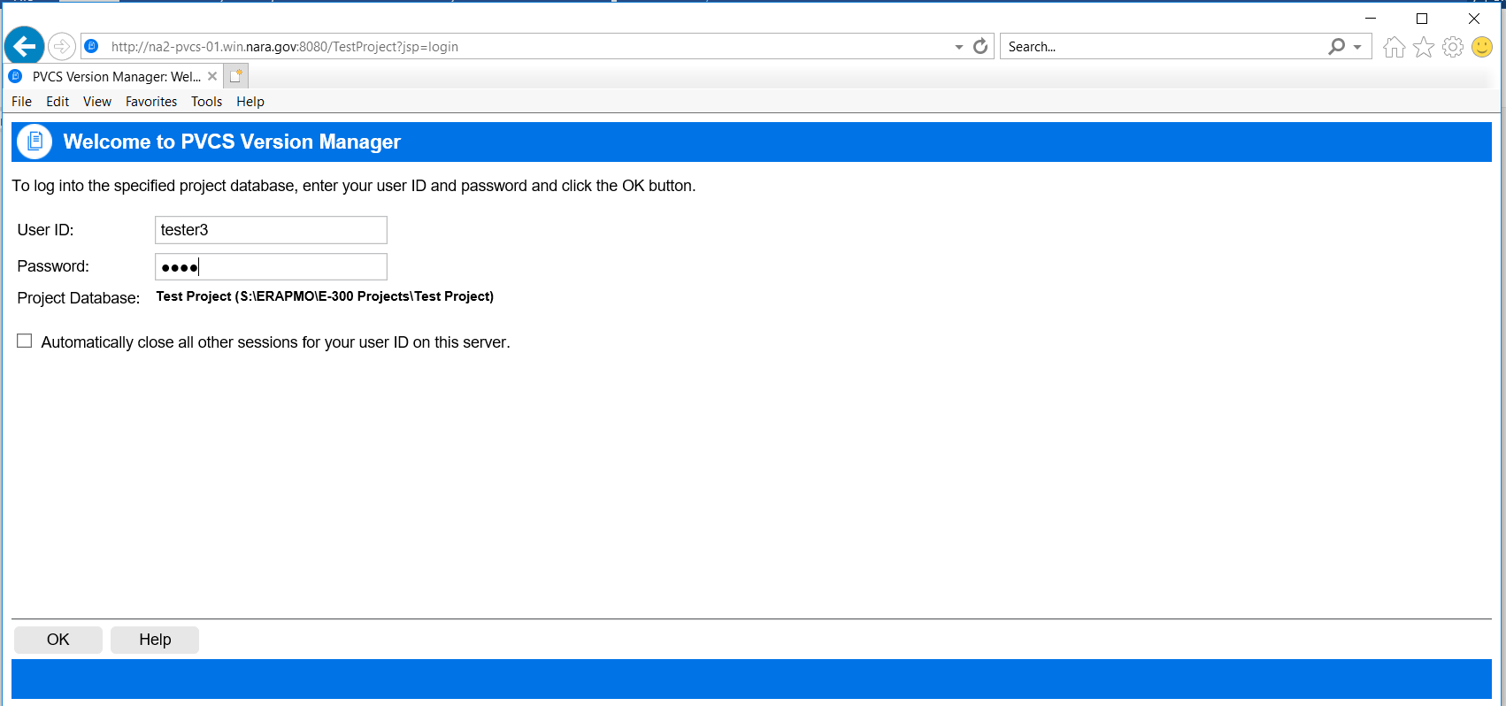

*Figure 1-Project DB*

1. Enter your password in the **Password** field.
2. Click **OK**.
3. Log into a project you have access to and the Login page appears when you select that project.

**To log into a project:**

1. Enter youruser ID in the **User ID** field.
2. Enter your password in the **Password** field.
3. Select the **Remember this user name/password** option to store this information so that you do not have to log in to the project for future Version Manager Web client sessions.
4. Click **OK**.

## Changing Your Password

You can change the password assigned to you by your administrator at any time. The password you change is the one that you entered in the Login page. Once you have changed your password, the new password takes effect the next time you log into the Version Manager Web client.

**NOTE** Changing your password in the Version Manager Web client changes it in the desktop client as well (and vice-versa).

**To change your password:**

1. On the File menu tab, click the **Change Password** button. The Change Password dialog box appears.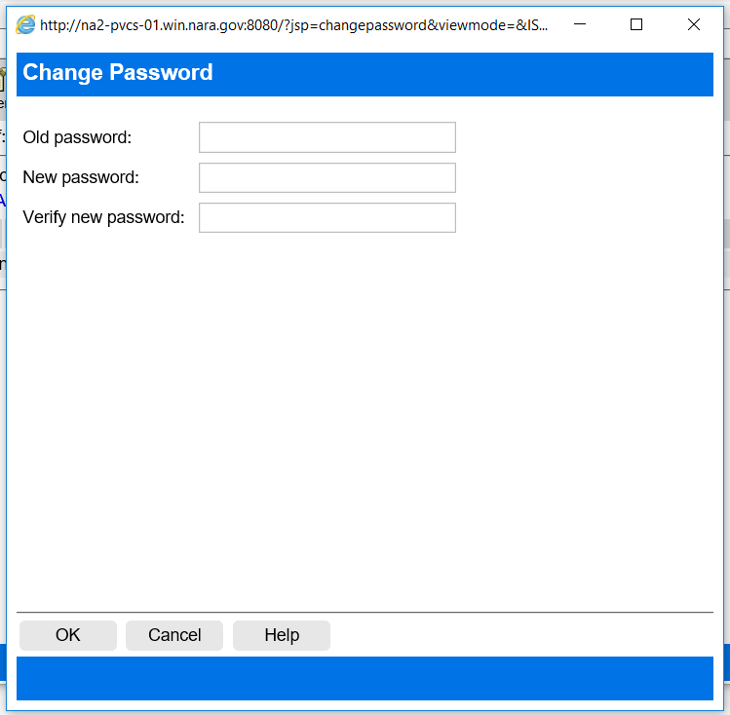

*Figure 2- Change Password*

1. Enter your current password in the **Old password** field.
2. Enter your new password in the **New Password** field, up to 29 characters.
3. Re-enter the new password in the **Verify new password** field.
4. Click OK.

## Switching Users

You can continue to work with an open project database or project using a different user name and password. The Switch User option provides a quick way to switch to a user ID with different privileges without having to close and reopen the project database.

**To switch users for a project database or project:**

1. On the **File** menu tab, click the **Switch User** button.

The Switch User dialog box appears.

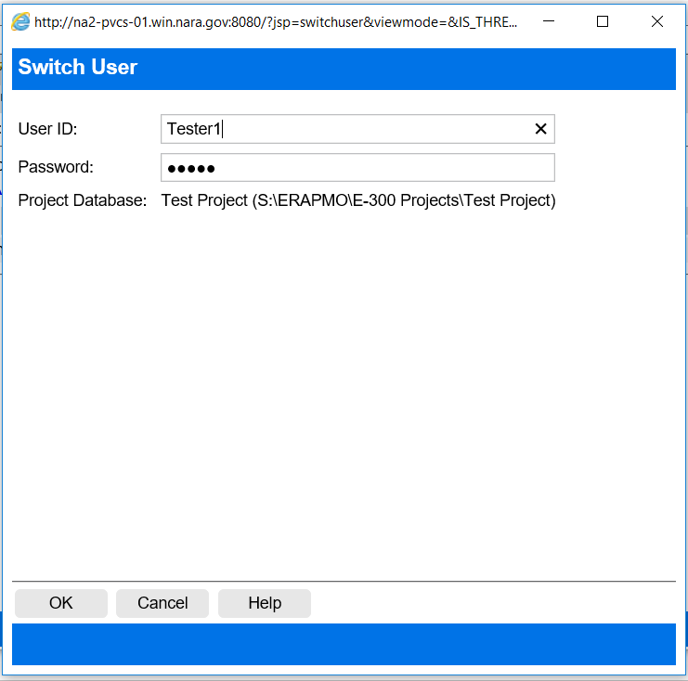

*Figure 3-Switch User*

1. Enter the new user ID in the **User ID** field.
2. Enter the password in the **Password** field.
3. Click OK.

## Logging Out of a Project Database

Log out of a project database when you are finished with your source control tasks or when you want to log in to a different project database. When you log out of a project database, your Version Manager Web client session is immediately terminated, requiring you to re-enter your user ID and password the next time you want to access a Version Manager Project database.

**To log out of a project database:**

Click the Logout button, located on the right side of the tabbed menus. The Logout page appears as shown below:

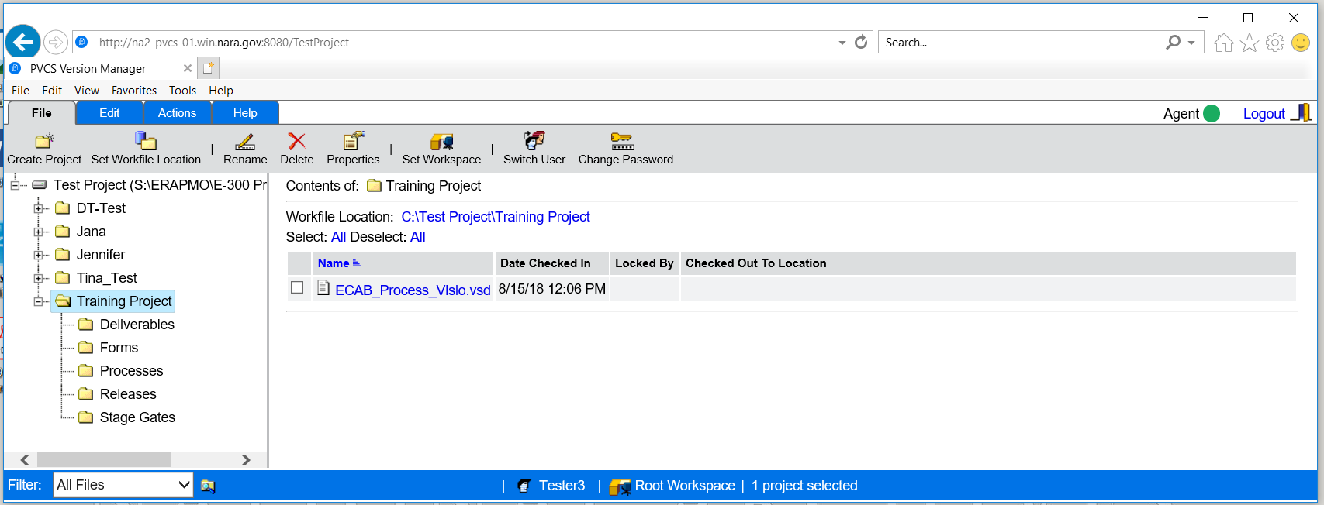

*Figure 4-Project DB logout screen*

* To log into a different project database, click the vminet.html link to view a list of project databases.

# **Navigating the interface**

## Version Manager Web Client Panes

Once you have logged in to a project database, navigate the Serena PVCS Version Manager web client interface to view the projects, subprojects, versioned files and revisions contained in the project database.

Five panes comprise the Version Manager Web client interface: the **Project pane**, **Content pane**, **Revision pane** (not shown below), **Menu pane**, and **Status pane**:

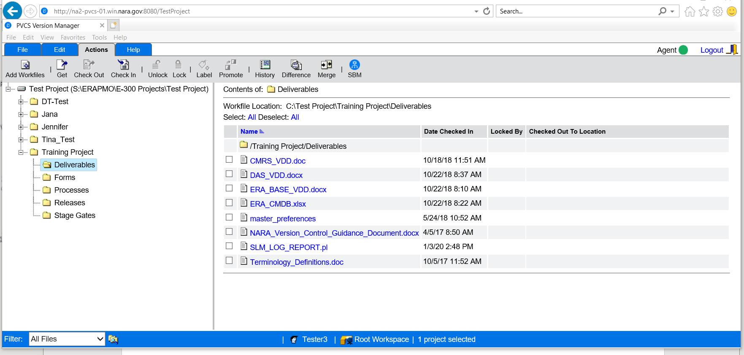

Status pane

Menu pane

Project pane

Content pane

*Figure 5- Project DB with different Panes*

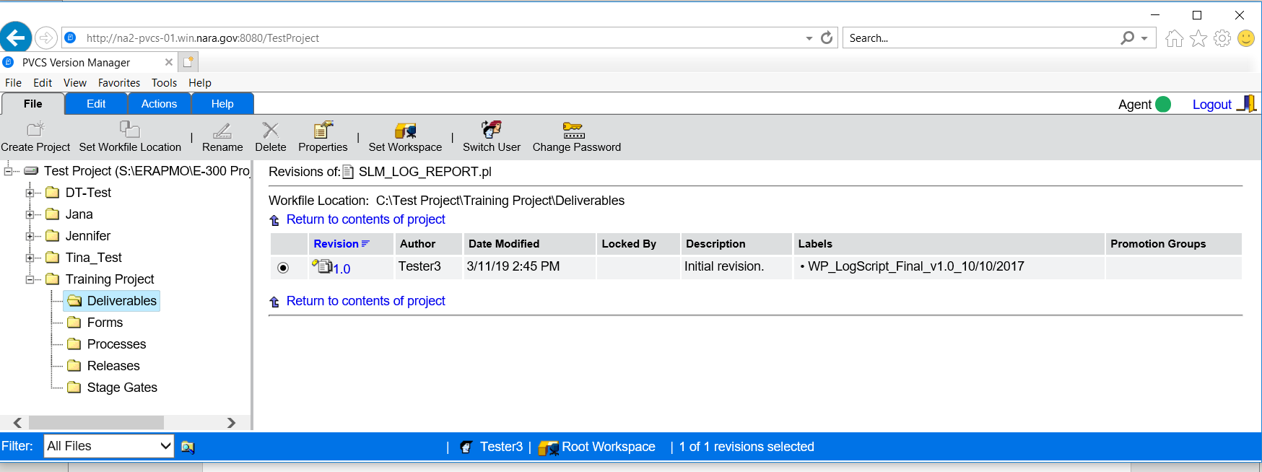

Revision Pane

*Figure 6-Revision Pane*

Revision pane

Revision pane

Revision pane

## Working in the Project Pane

The Project pane displays the open project database, its projects and subprojects in a hierarchical tree. Click +/- to expand or collapse the tree. When you select a project or subproject, its versioned files appear in the Content pane to the right.

The following icons can appear in the Project pane:

|  |  |
| --- | --- |
| **Icon** | **Description** |
|  | The open project database displayed by its name and its location in parenthesis. |
|  | A project, subproject, or folder. |
|  | A project with a configuration file attached to it. These configuration settings override the project database settings. |
|  | A project that you cannot open because you do not have access to it. |

*Figure 7-Icon Description*

## Working in the Content Pane

The Content pane displays the versioned files contained in the project database or project that you selected in the Project pane. To:

* Select versioned files for action, click the check boxes next them.
* Edit or view a versioned file in the default editor or browser, click the file icon.
* Open the Revision pane and view details on all of the revisions in a versioned file, click the file name.
* Sort the versioned files; click the heading of the column you wish to sort by. To inverse the sort order, click the column heading again.

The Content pane contains the following fields and icons:

|  |  |
| --- | --- |
| **Field or Icon** | **Description** |
| Contents of | Displays the name of the project database or project in which the versioned files reside. |
| Workfile Location | Displays the project's workfile location |
| Page | Only displays when more items exist than can be contained on the page. Click Previous, Next, or [number] to go to the previous, next, or specific page. Click Index to go to the Page Index on the bottom, which lists the first and last files on each page. This field is duplicated at the bottom of the page, except the Index link is replaced by Top, which takes you to the top of the page. |
| Select/Deselect | Options to select and clear all items. If more items exist than can be contained on the page, you can choose to select all items on the current page. |
| Name | The name of the versioned file. Click to open the Revision pane. |
| Date Checked In | The date and time the versioned file was last checked in. |
| Locked By | The user ID that currently holds a lock on the item. |
| Checked Out To  Location | If versioned file is checked out, it displays the path the file is checked out to. |
|  | A versioned file that does not contain any locked revisions. View or edit the file in the default editor. |
|  | A versioned file that contains a locked revision. |
|  | A versioned file that references an archive that cannot be found. |
| Page Index | Only displays when more items exist than can be contained on the page. It displays the page number and first and last files on each page. |

## Working in the Revision Pane

Once you click a versioned file link, the Revision pane appears. The Revision pane displays details on all revisions of the versioned file.

To:

* Select a revision for action, click the check box next it.
* Edit or view a revision in the default editor or browser, click the revision number.
* Sort the revisions; click the heading of the column you wish to sort by. To inverse the sort order, click the column heading again.

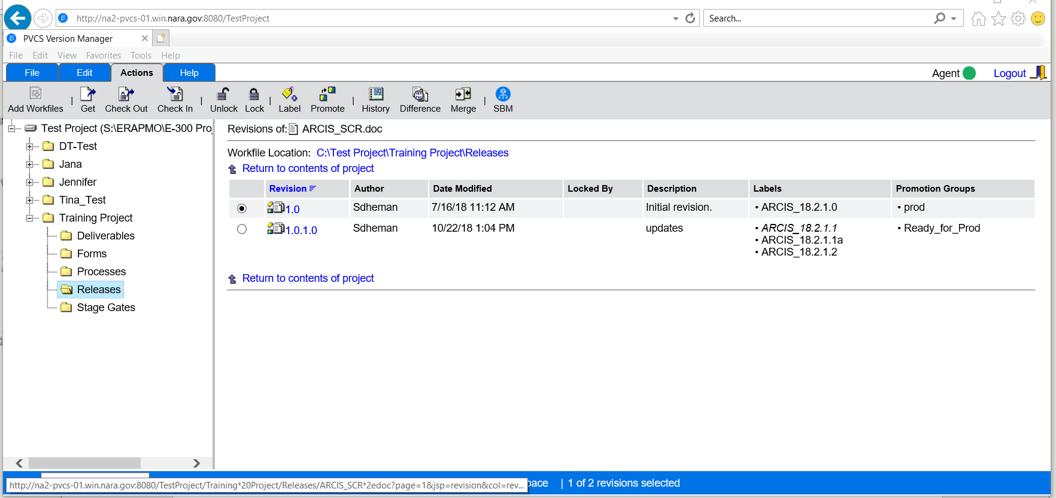

*Figure 8-Revision Pane*

The Revision pane contains the following fields and icons:

|  |  |
| --- | --- |
| **Field or Icon** | **Description** |
| Revisions of | Displays the name of the versioned file containing the revisions. |
| Workfile Location | Displays the workfile location of the versioned file. Click the workfile location link to bring up the Set Workfile Location dialog box. |
| Page | Only displays when more items exist than can be contained on the page. Click Previous, Next, or [number] to go to the previous, next, or specific page. |
| Return to the contents of the project | Brings you back to the Content pane. |
| Revision | The number of the revision. The default revision is selected. Click to edit or view the revision in the default editor. |
| Author | The original author of the revision. |
| Date Modified | The timestamp on the file when it was last checked in. |
| Locked By | The user ID who currently holds a lock on the revision. |
| Description | The description added to the revision when it was checked in. |
| Labels | If a label is assigned to the revision, the label name displays. |
| Promotion Groups | If a promotion group is assigned to the revision, the promotion group displays. |
|  | A revision. |
|  | A locked revision. |
|  | A revision assigned a promotion group. |
|  | A locked revision assigned a promotion group. |
|  | A revision assigned a version label. |
|  | A locked revision assigned a version label. |
|  | A revision assigned a promotion group and version label. |
|  | A locked revision assigned a promotion group and version label. |

*Figure 9-Revision Pane*

## Working in the Menu Pane

The Menu pane provides buttons to execute Version Manager Web client commands. Click a tab to access the commands on the File, Edit, Actions, or Help menu. Click a button on the menu to execute a command.

The following menu buttons are available:

|  |  |
| --- | --- |
| **File menu button** | **Description** |
|  | Creates a new project |
|  | Sets or changes a workfile location for the selected project database, project, or versioned file. |
|  | Renames an existing project |
|  | Deletes an existing project or versioned file. |
|  | Displays the properties of a project database, project or versioned file. |
|  | Sets, creates, renames, or deletes workspaces. |
|  | Switches to a different user ID for the selected project database or project. |
|  | Changes your password for logging into the selected project database or project. |

*Figure 10-File Menu Buttons Description*

|  |  |
| --- | --- |
| **Edit menu button** | **Description** |
|  | Copies one or more versioned files to another project. |
|  | Moves one or more versioned files to another project |
|  | Sets options for the Version Manager web client display and operations. |

*Figure 11-Edit Menu Buttons Description*

|  |  |
| --- | --- |
| **Actions menu button** | **Description** |
|  | Adds workfiles to a project database or a project. |
|  | Gets a revision and makes a copy in the workfile location. |
|  | Checks out an editable revision to the workfile location. |
|  | Checks in a modified workfile to the archive. |
|  | Unlocks a revision without performing a check in. |
|  | Locks a revision without performing a check out. |
|  | Assigns, renames, or deletes a version label from a revision. |
|  | Assigns, promotes, changes, or removes a promotion group from a revision. |
|  | Creates a history report on a project database, project or versioned file. |
|  | Launches the Merge Tool to compare (difference) revisions or workfiles. |
|  | Launches the Merge Tool to merge revisions or workfiles. |

*Figure 12-Actions Menu Button Description*

|  |  |
| --- | --- |
| **Help menu button** | **Description** |
|  | Launches the Version Manager web client help system. |
|  | Launches the What's New page in the help system. The “What's New” page communicates to you what features are new in this version of Version Manager. |
|  | Displays the status of the PVCS Client agent. Green is full rights. Red is Partial access to client. |
|  | Displays an About box with Version Manager web client copyright and version information. |
|  | Logs you out of the project database. |

*Figure 13-Help Menu Button Description*

## Working in the Status Pane

The Status pane lets you view and modify your current filter, user ID, and workspace. It also displays the number of items that are currently selected. To:

* Change the display of versioned files in the Content pane, click the Filter list.
* Switch users, click the user ID.
* Set a different workspace, click the Workspace name.

The Status pane consists of the following fields and icons:

|  |  |
| --- | --- |
| **Icon** | **Description** |
| Filter | View all files or filter your view by filename wildcards, locker, version labels, or promotion groups. Retains the last four filters used. |
|  | Toggle between recursive and non-recursive filter modes:  **Recursive:** The Content pane displays all projects, subprojects, and versioned files contained within the item selected in the Project pane.  **Non-recursive:** The Content pane displays only the versioned files contained at the root of the item selected in the Project pane. |
|  | The current user ID displays here. Click the name to switch to another user ID for this project database. |
| Public  Private | The current workspace displays here. Click the workspace name to set a different workspace for this project database.  The workspace icon indicates if the workspace is public or private. |
| [#] of  [total]  [items]  selected | Displays the number of currently selected projects, folders, versioned files, or revisions. For versioned files and revisions, it also displays the total number of versioned files in the project and the number of revisions of a versioned file (for example, 4 of 50 files selected). |

*Figure 14- Status Icon Description*

# **Performing Basic Tasks**

## Selecting Items

Select items in the Version Manager Web client to view information on them, or to perform actions such as check in, get, check out, lock, unlock, or assign a version label. After you have selected the items; click a menu button to perform an action.

|  |  |
| --- | --- |
| **To select...** | **Do this...** |
| The project database | Click the project database in the Project pane. |
| A project or folder | Click the project or folder in the Project pane. |
| Multiple projects | Press and hold the SHIFT or CTRL key while clicking the projects in the Project pane. You can only select multiple projects if they belong to the same parent project. |
| One or more versioned files | Click the check boxes next to the versioned files in the Content pane. To select all of the versioned files in a project, click the **Select: All** link. When versioned files exist on multiple pages, you can click **Select: All on this page** to select the versioned files on the current page only. If you navigate to another page after clicking **Select: All**, the selection is canceled. |
| A revision | Click the radio button next to the revision in the Revision pane. |

*Figure 15-Select Items*

## File Tab

### Creating a Project

Under File “Create Project” as shown below:

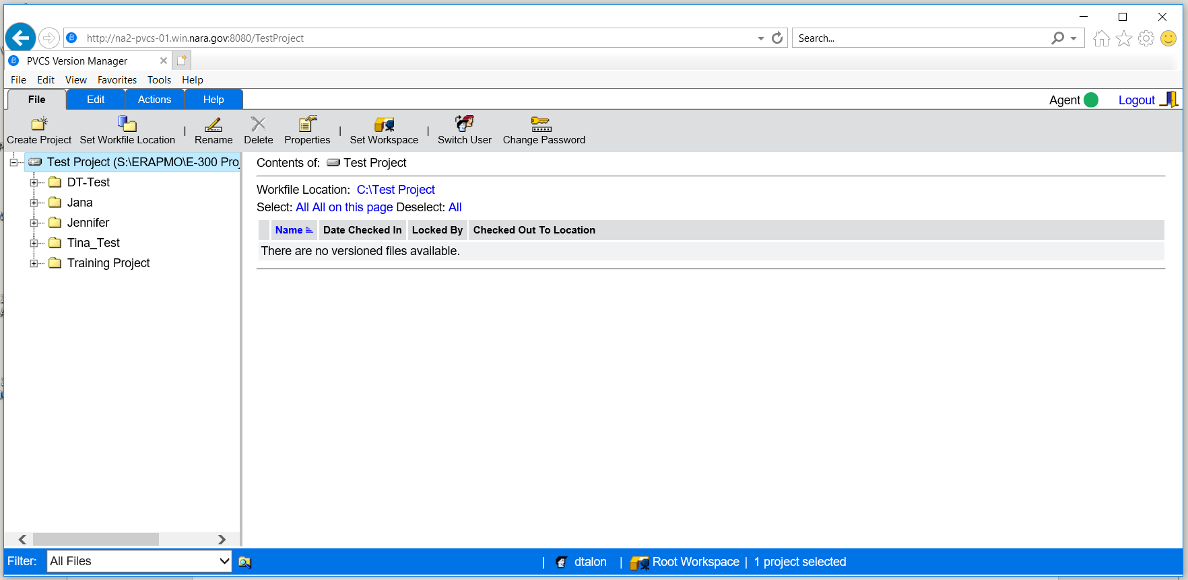

*Figure 16-Creating a Project*

The following screen appears and write the name of the project under the “Name” field as shown below:

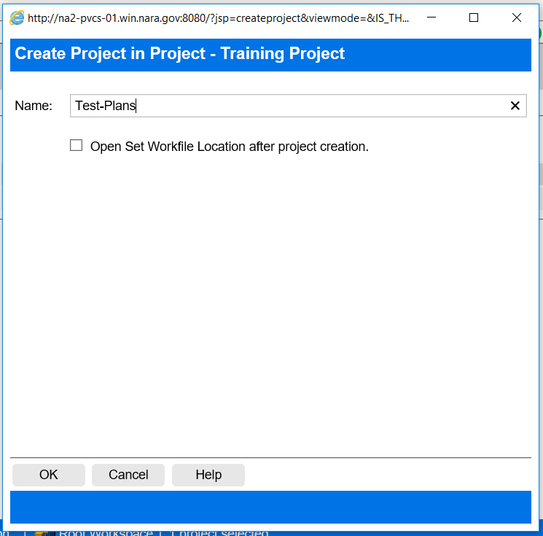

*Figure 17- Creating a Project within Project*

Click Ok and project will be created.

### Setting a Workfile Location

PVCS Administrator creates the workfile location automatically while creating the project. If for any reason a user wants to change that setting then this tab will help in changing the workfile location.

* Click on “Set Workfile Location” location and the following screen appears.
* Browse to the location of the workfile.
* Click Ok to save it.

After the workfile location is changed then it becomes the default workfile location for that project.

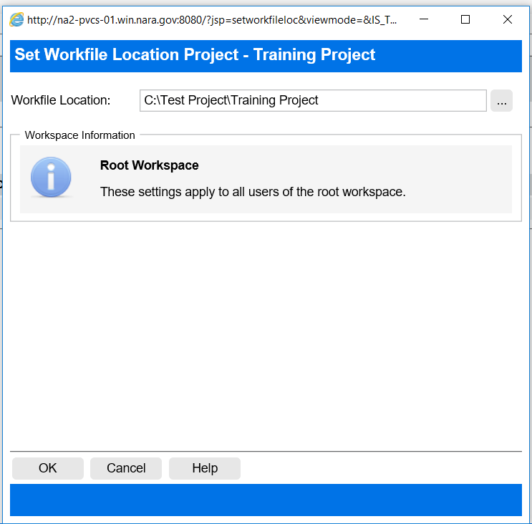

*Figure 18-Workfile Location*

**Note:** It is recommended not to change the workfile location and leave it to PVCS Administrator.

### Renaming, Deleting and Setting a Workspace

PVCS Administrator performs these functions.

## Edit Tab

Under the Edit Tab Copy and Move Functions are performed by CM Team. It is recommended to leave the “Options” on default settings.

## Actions Tab

### Add Workfile

When a user checks in a file for the first time “Add Workfile” function is used

* Highlight a folder.
* Select Actions tab.
* Click on Add Workfile icon.

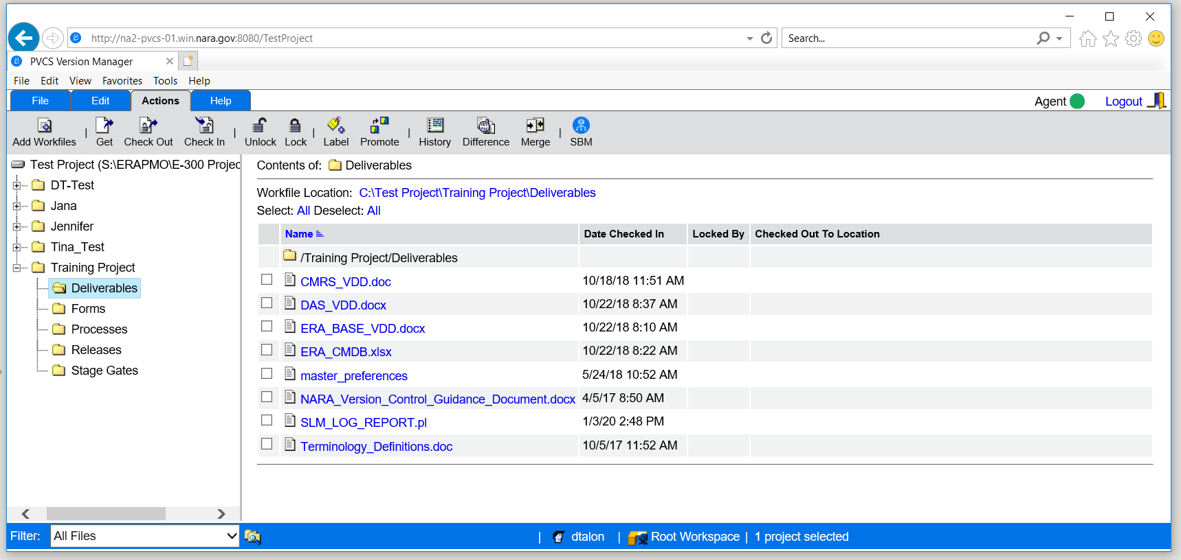

*Figure 19-Select a Project*

The following screen appears:

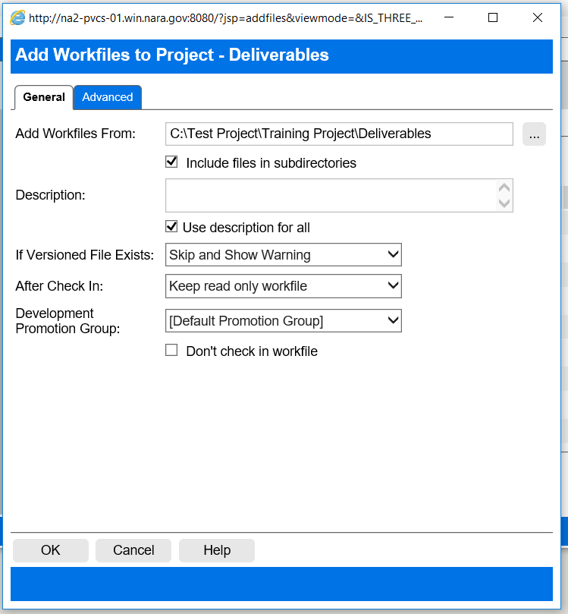

*Figure 20-Add Workfiles*

* Fill in the Description field. This step is required (fill in the details of who sent the file or copy and paste the email).
* Click Ok.

The file will be checked into CM repository.

### Get

The “Get” function is used when a user needs read-only version of a file.

* Highlight a folder.
* Select Actions tab.
* Click on Get [Get a specific revision without checking out a project or file.](javascript:window.parent.CONTENT99.document.master_form.viewmode.value='';clickGet()) icon.

The Get dialog box appears as shown below:

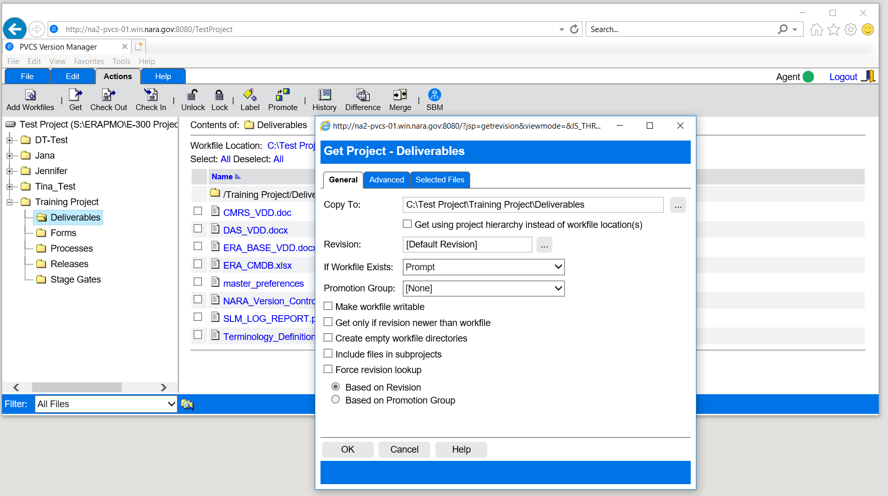

*Figure 21-Get*

Click Ok.

The file will be checked out on the C drive and mirror the project structure in PVCS VM.

### Check Out a Workfile

Select Actions | Check OutC:\Program Files\Serena\vm\gui_help\shared\graphics\tool_checkout.gif. The Check Out dialog box appears as shown below:

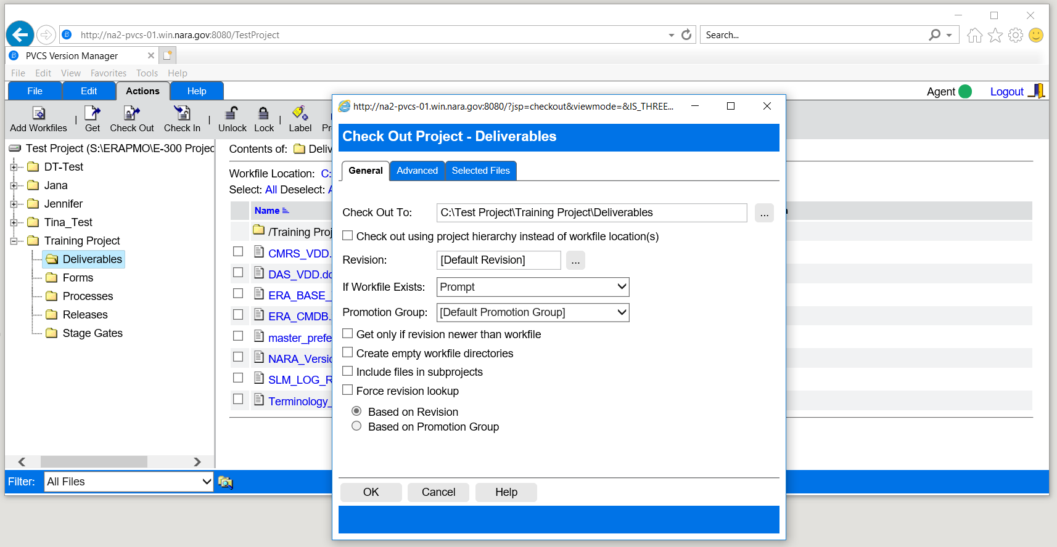

*Figure 22-Check Out*

Click Ok. The file will be checked out to the C drive and mirror the project structure in PVCS VM.

### Check In a Workfile

Select Actions | Check Inhttp://10.102.251.131:8080/vminet_images/inet_help/shared/graphics/tool_checkin.gif. The Check In dialog box appears as shown below:

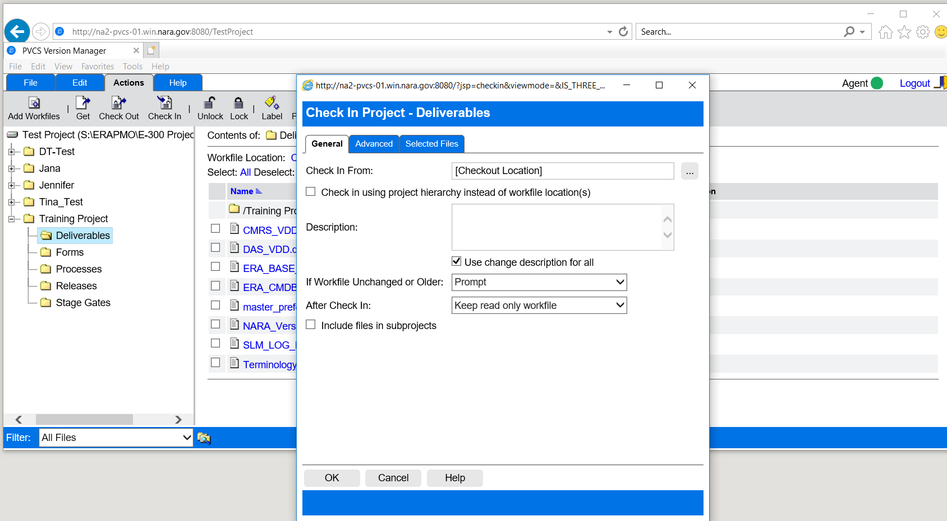

*Figure 23-Check in*

Click on browse 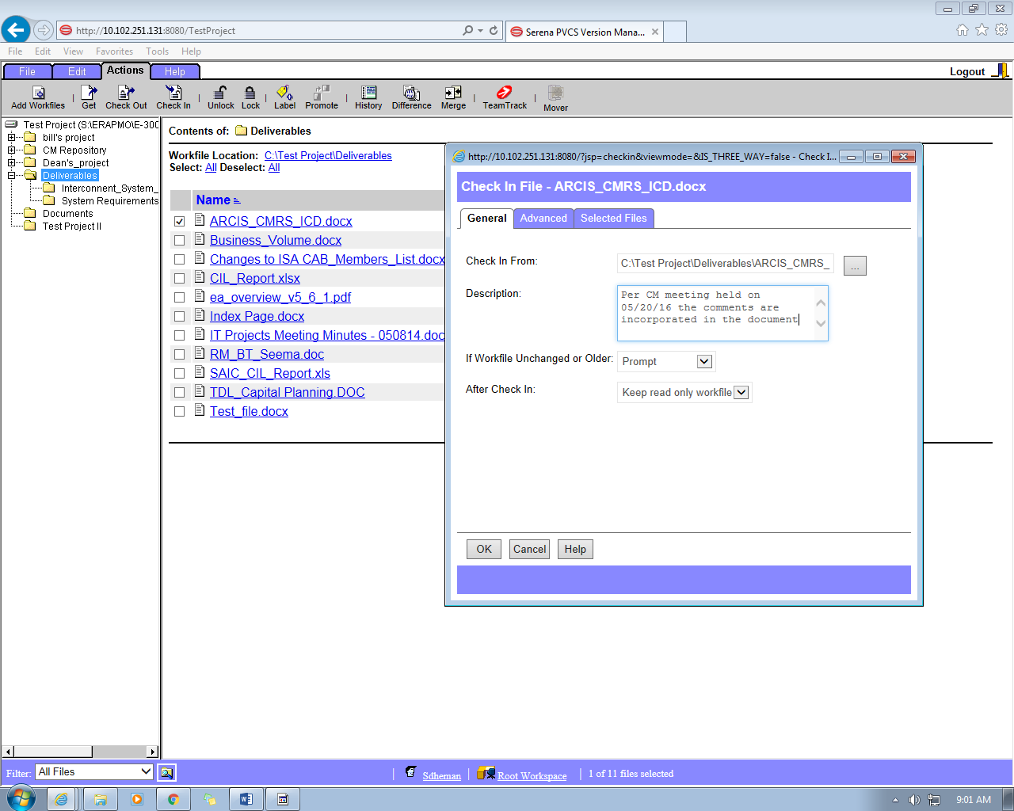 button and enter the location from which the workfile will be checked in. Enter a description of the changes made to the workfile. Version Manager uses this text for the revision description. Version Manager disables the **OK** button until you enter a change description.

**Note: The file must be locked before a new version is checked in.**

### Lock a File

Select the revision that you want to lock (you can also select one or more versioned files, projects, folders, or an entire project database).

Select Actions | Lockhttp://10.102.251.131:8080/vminet_images/inet_help/shared/graphics/tool_lock.gif.

The “Lock File” dialog box appears as shown below:

*Figure 24-Lock File Dialog Box*

Enter a revision number or a version label that you would like to lock or click browse  button to select it (default revision is the latest revision of a versioned file).

Click Ok.

The file will be locked for updates as shown below:

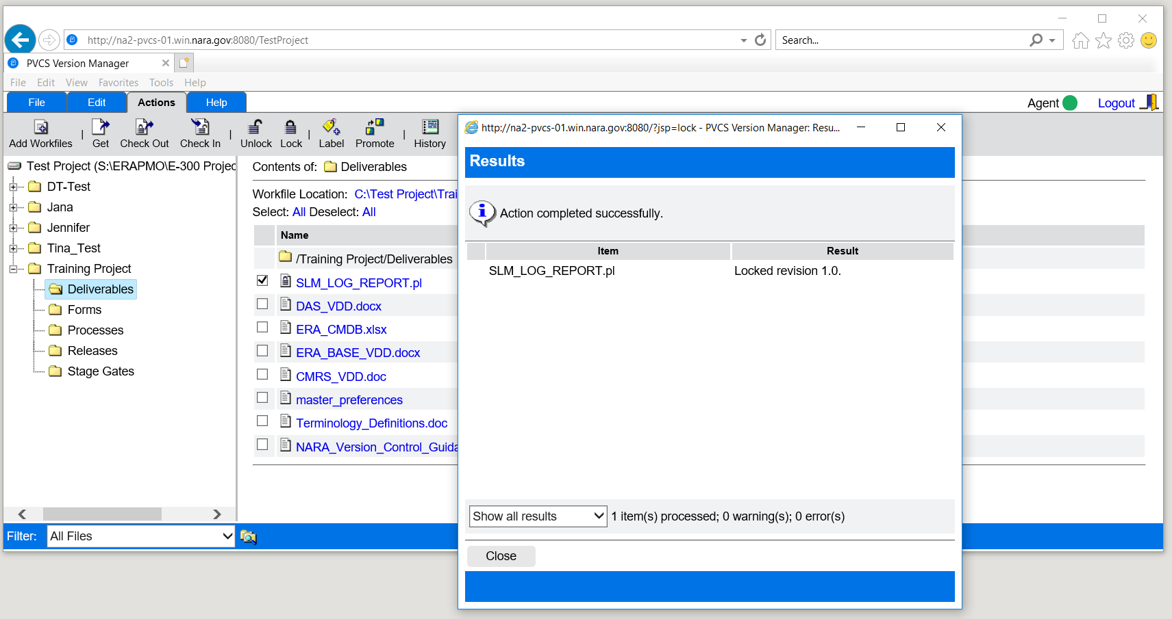

*Figure 25-Results of Lock File Action*

Results screen reflects the file name and version of the file that is locked for updates.

In PVCS VM the lock http://10.102.251.131:8080/vminet_images/inet_help/shared/graphics/tool_lock.gifappears next to the file name and name of the user who has locked the file.

### Unlock a File

Select a versioned file, project, or a project database, which contains the file revisions you would like to unlock.

Select Actions / Unlockhttp://10.102.251.131:8080/vminet_images/inet_help/shared/graphics/tool_unlock.gif.

The Unlock dialog box appears as shown below:

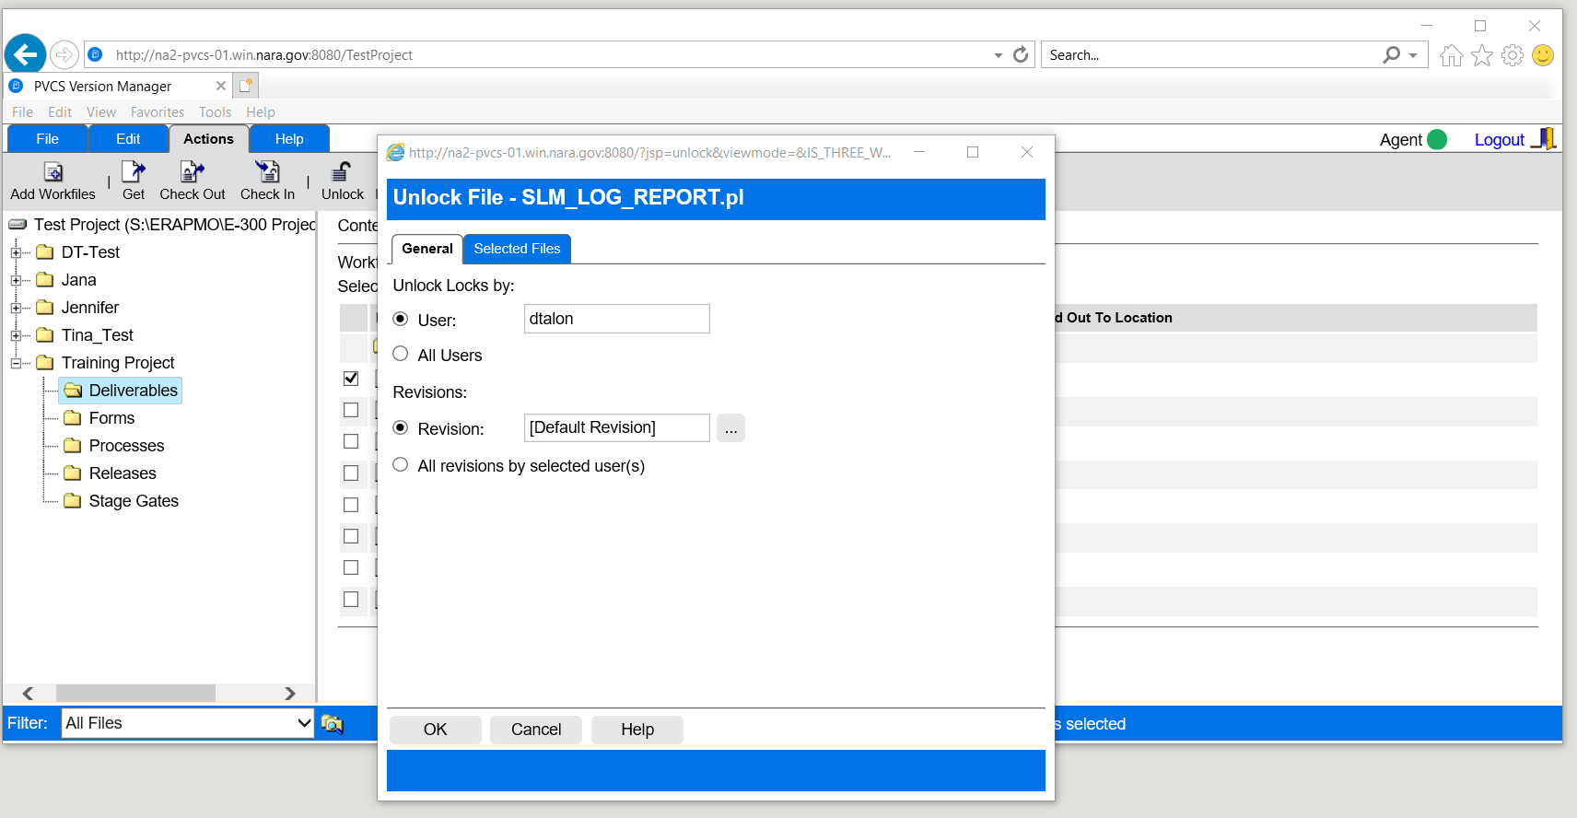

*Figure 26-Unlock File*

Under “Unlock Locks By” select your username and click Ok. PVCS Administrator can only select “All Users” function.

The following box will be displayed:

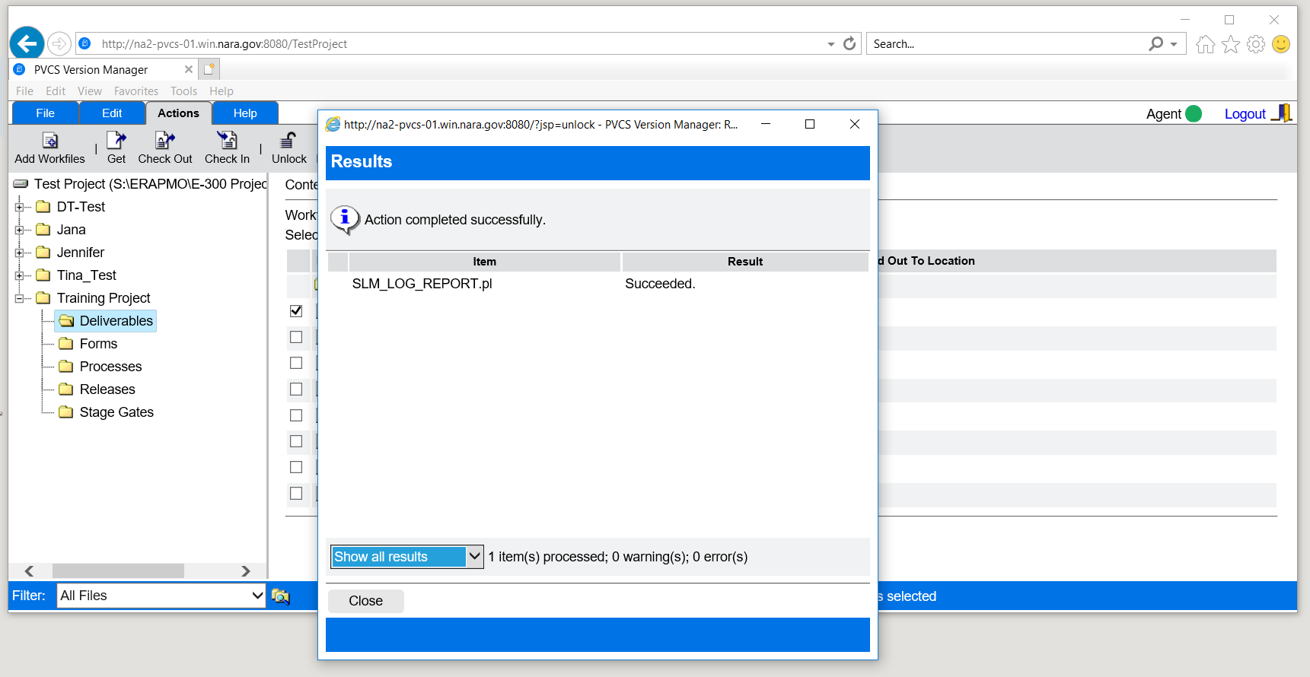

*Figure 27-Unlock file screen*

The file will be unlocked and ready for the check out by other users.

### Label

Version labels are tags used to identify a particular revision. Multiple version labels can be assigned to a revision; however, version labels must be unique within each versioned file. Version labels are case-sensitive. When working with version labels, make sure to specify the exact case of the version label.

To apply a version label:

* Select the file that you want to apply the label to.
* Select Actions/ **Label** ( http://10.102.251.131:8080/vminet_images/inet_help/i_net/graphics/tool_label.gif) icon.

The following screen will appear:

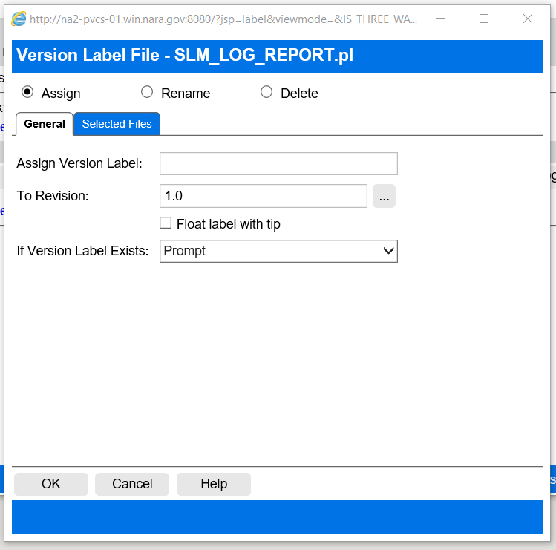

*Figure 28-Version Label*

Please follow “QA Naming and Labeling Guide” for PVCS VM.



***Note: if an error is made in the label, the “Rename” option can be used to overwrite the incorrect label with the corrected one.***

### History Report

A history report summarizes information about archives and/or revisions. A user can select the following types of reports as shown in the figure below and definitions are listed afterwards.

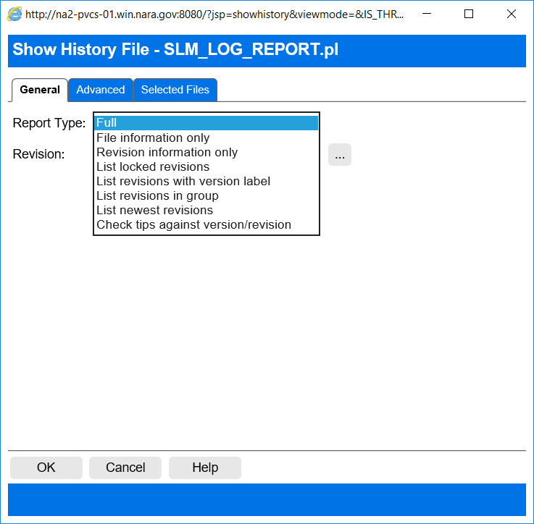

*Figure 29-Report Types*

* **Full:** provides comprehensive information about when and by whom the archive was created, when and by whom each revision was added, what attributes are set on the archive, and general information about the file's change descriptions, version labels, promotion group assignments, and locks.
* **File information only:** provides general information about the file, itself, including the location of its archive, the name of its workfile, how many revisions it has, what attributes have been set on its archive, who created the archive, what locks are placed on it, what version labels have been assigned to it, and what change descriptions have been added to it.
* **Revision information only:** identifies the name and location of its archive and when and who added the revision to the archives.
* **List locked revisions:** lists the revisions within a file that are locked.
* **List revisions with version label:** lists the revisions assigned version labels and the assigned version labels.
* **List revisions in-group:** lists the revisions assigned to a specific promotion group.
* **List newest revisions:** if multiple versioned files are selected, lists the revisions most recently checked in to Version Manager.
* **Check tips against version/revision:** provides information about archives whose tip revisions are different the specified revision or version.

To generate a history report:

* Select Actions tab.
* Select **History**  icon.

The “Show History” dialog box appears as shown below:

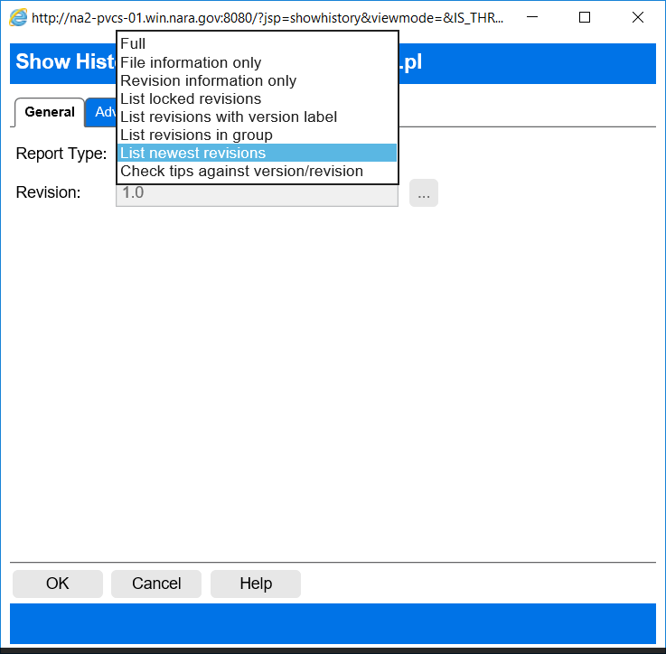

*Figure 30-Report types*

* Select the Report Type (in this example a user selected “List Newest Revisions” report for all files under the Deliverables folder).
* Click Ok.

The following screen appears reflecting the report:

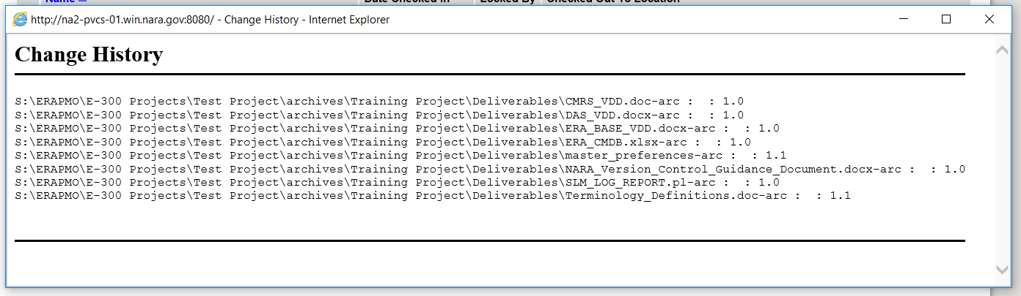

*Figure 31-Report containing latest revisions of all files under Deliverables folder*

## Installation of web client version 8.6

Insert the Web URL using Internet explorer (preferred browser)

<http://na2-pvcs-01.win.nara.gov:8080/vminet.html>

The following screen will display:

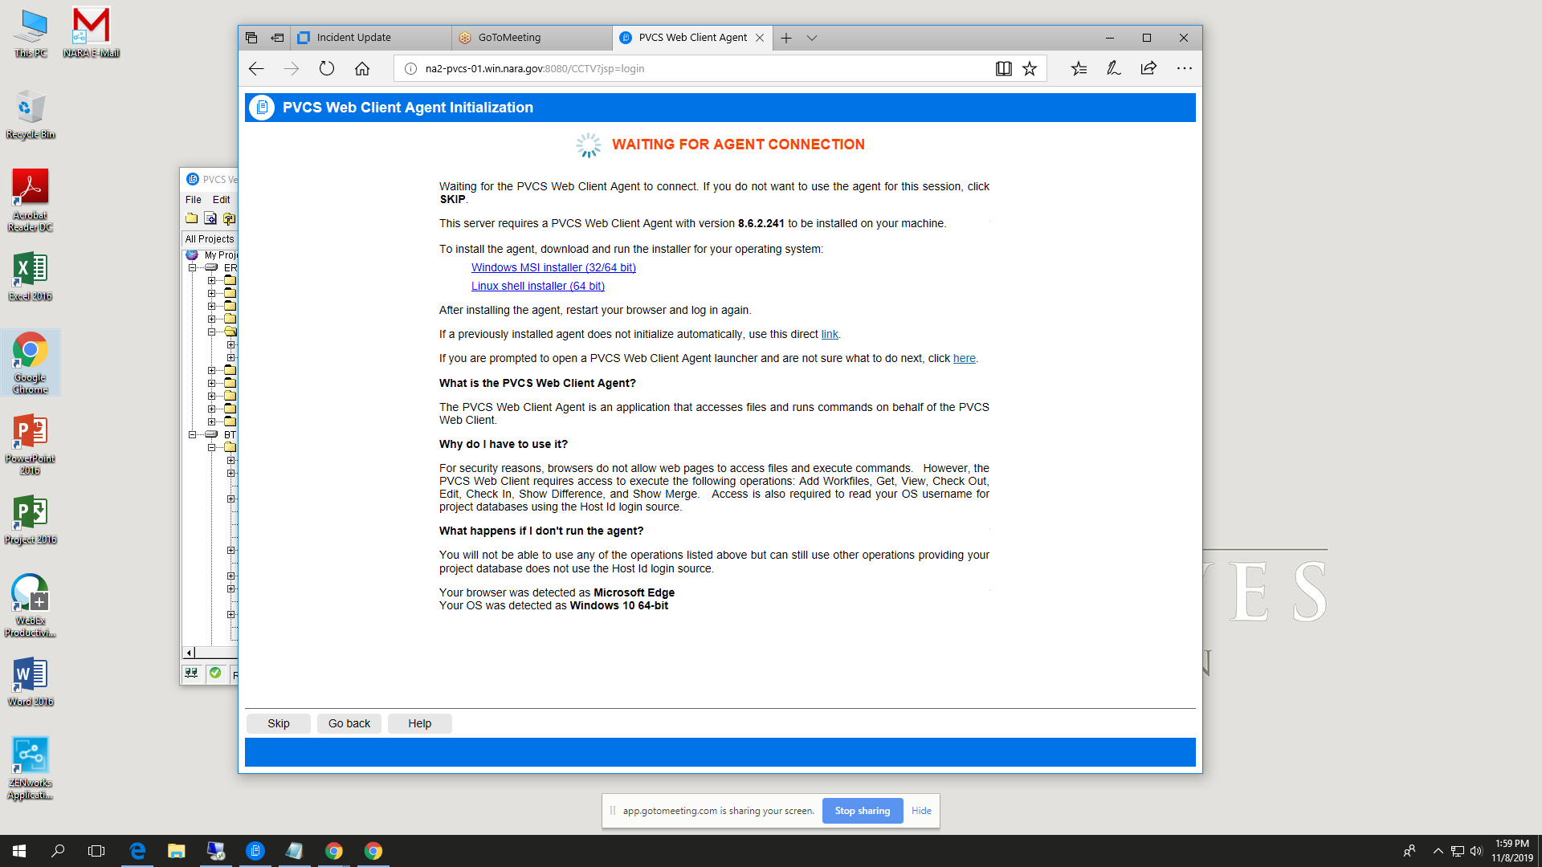

Figure 32- Windows installer

Click on Windows MSI Installer. This agent requires no special rights to install on the PC. The following screen displays:

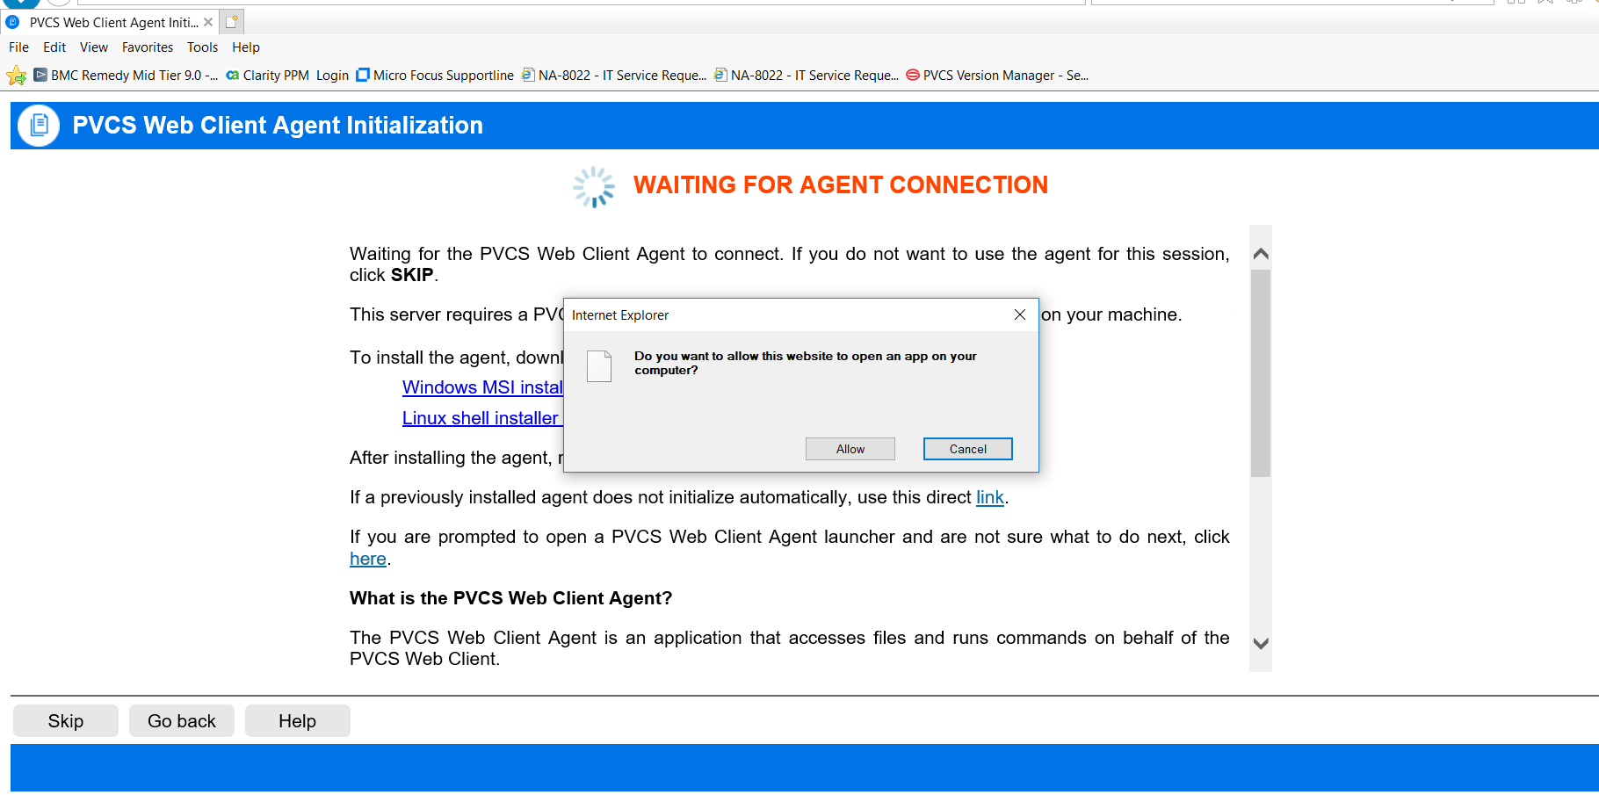

Figure 33- Agent Connection

Click Allow

The following screen displays:

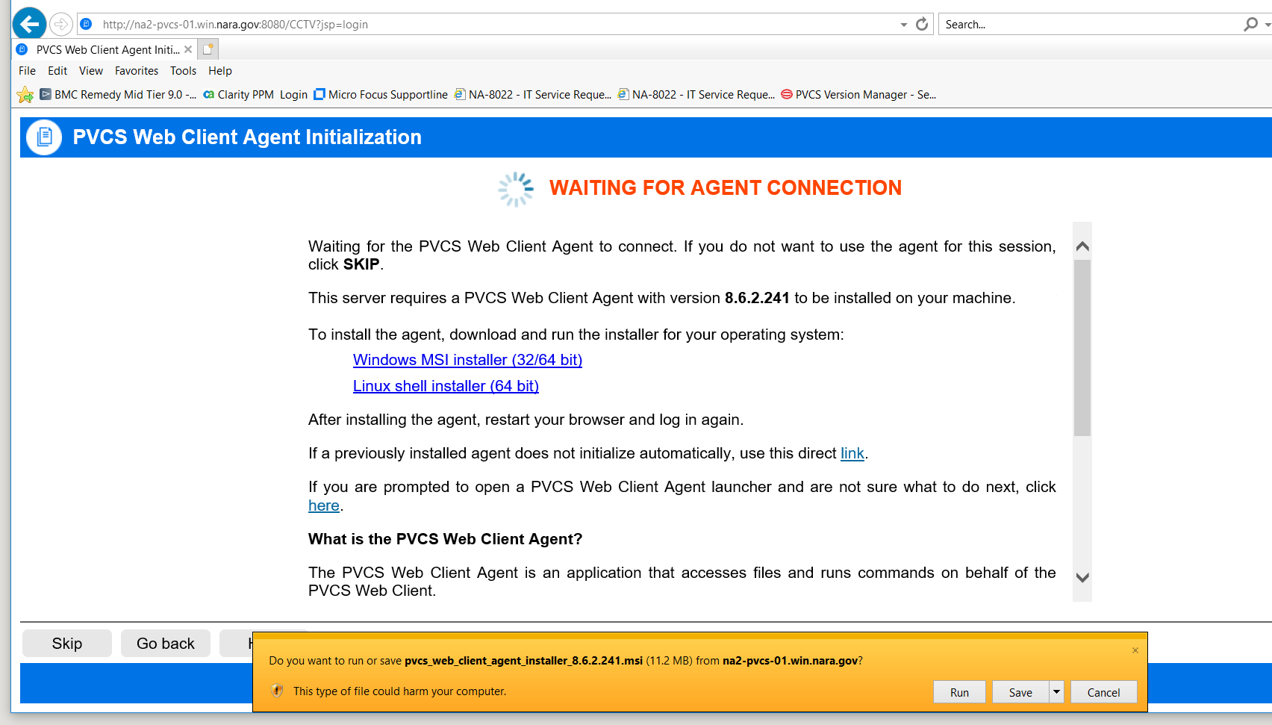

Figure 34- Agent Connection being installed

Click Run. The following screen displays:

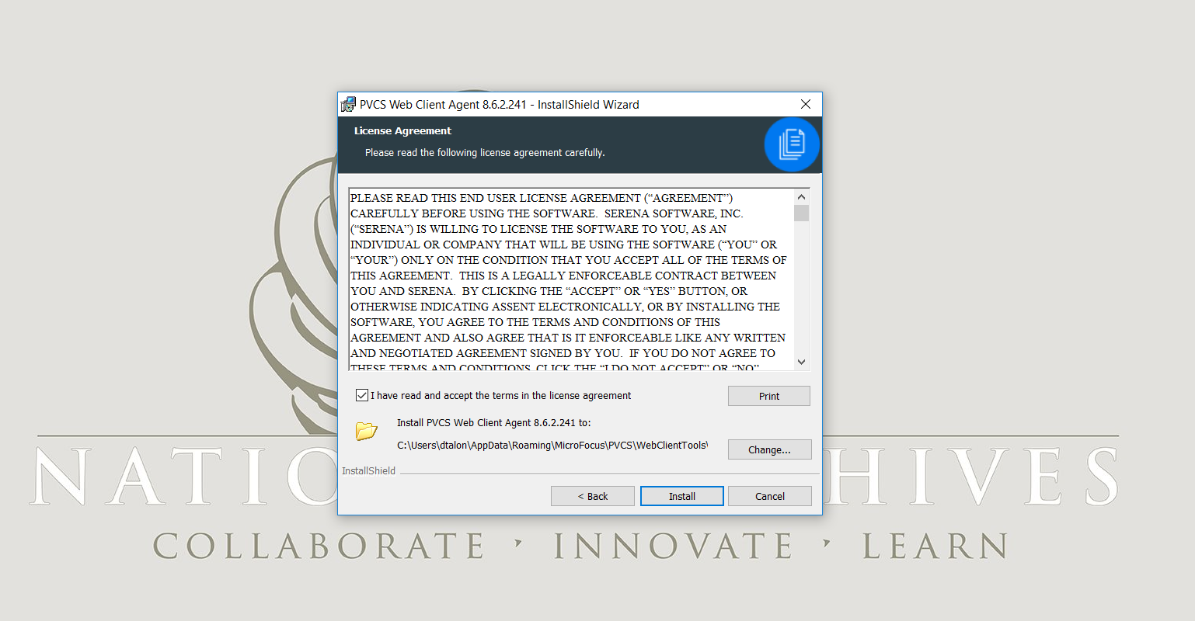

Figure 35- Install Wizard

New window will open in the same or new browser. Click check mark on “I have read and accept the terms in the license agreement”. Click Install. Sometimes it displays the message “Waiting for Agent to connect” and the following screen displays:

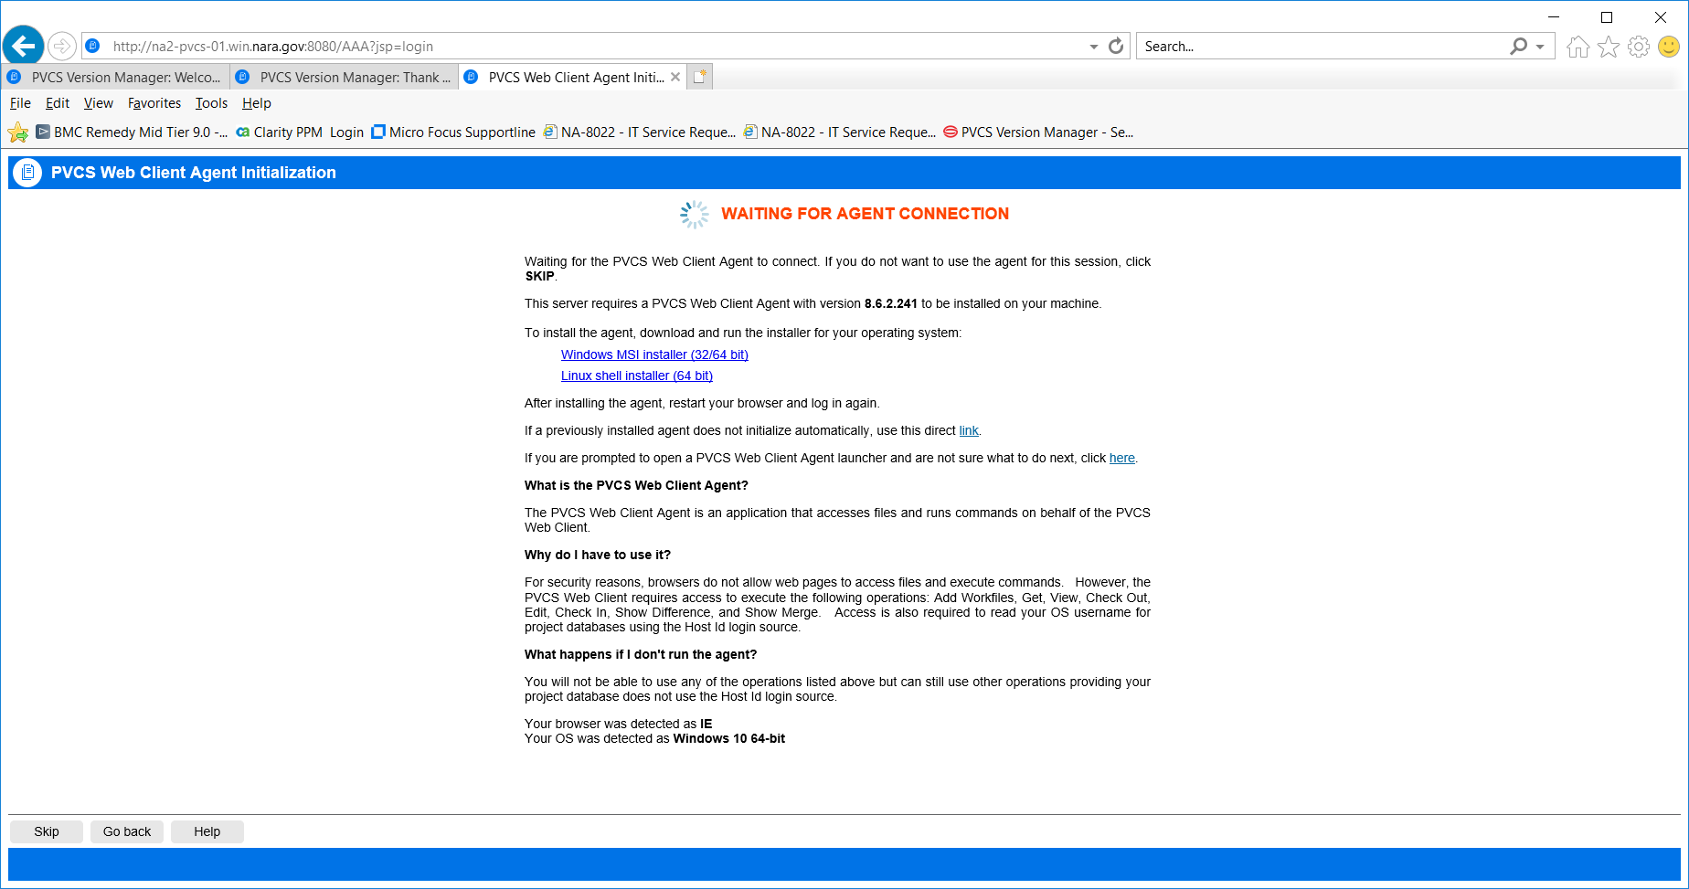

Figure 36- Agent connection

**Exit out altogether and log in again using the Web Address:**

The following screen displays

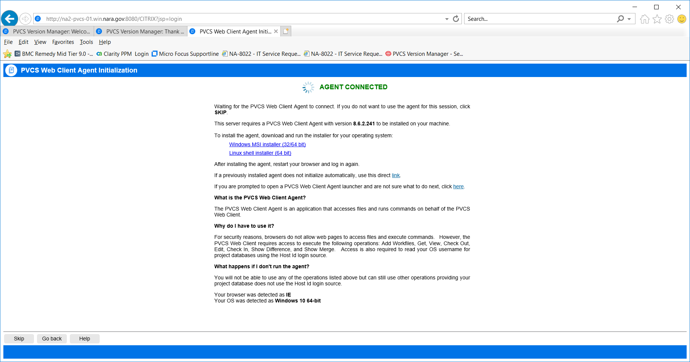

Figure 37-Agent Connected

Click on the project and enter user Id and PW. The following screen displays for the test Project

Choose any file to open. For the first time the following error will be displayed

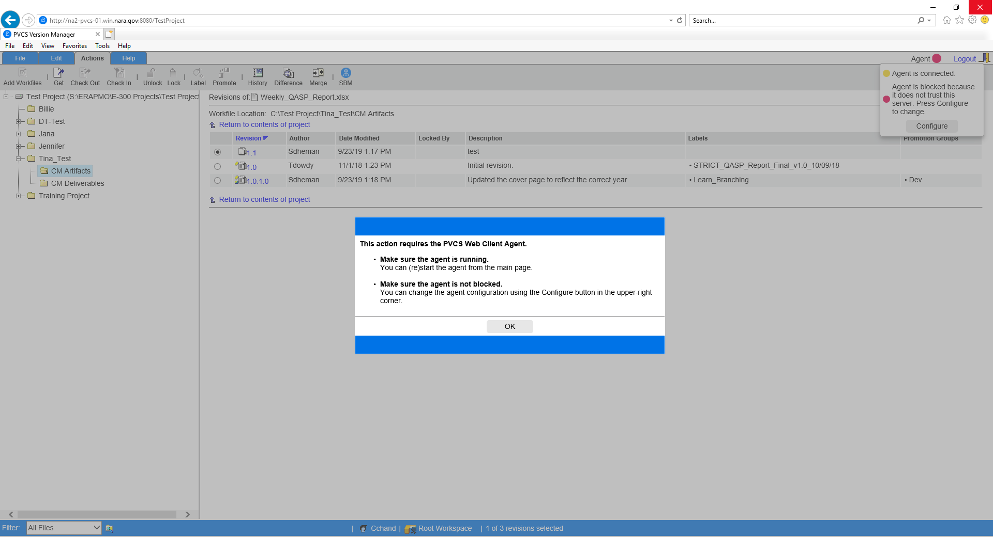

Figure 38- Agent Configure

Click Ok and select Configure. The following screen is displayed.

Click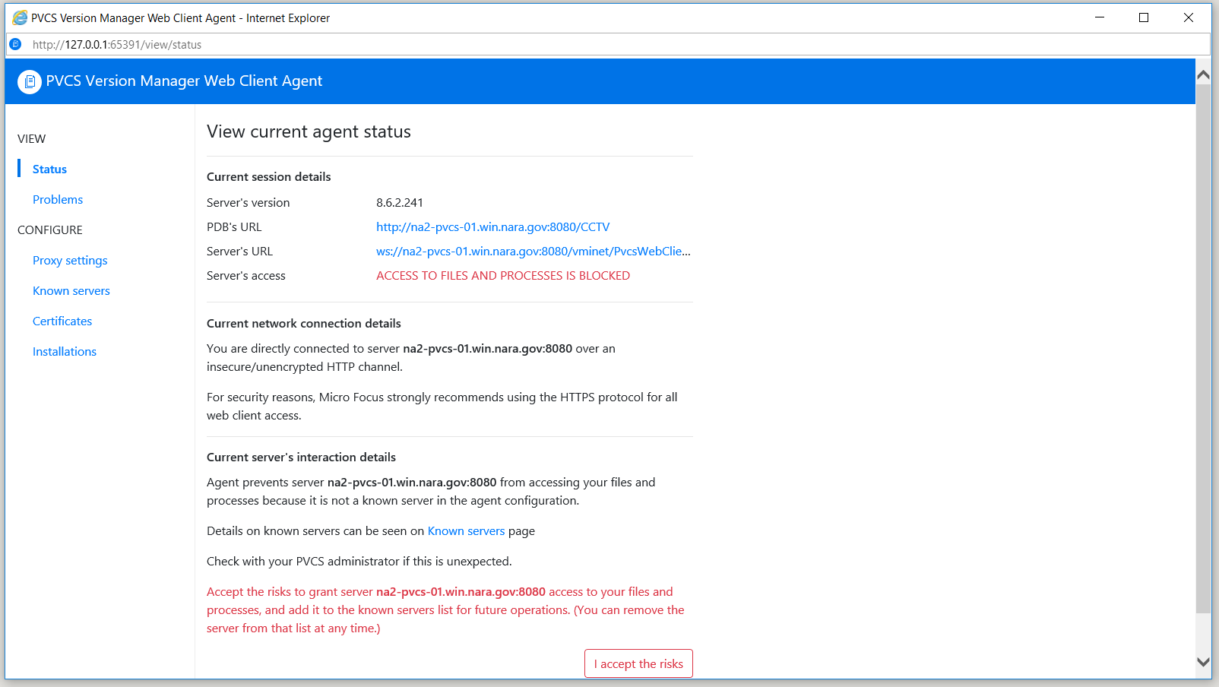

Figure 39 Access to files by accepting the risk

Click on I accept the risks and exit out of the screen.

This will show the that Agent it going through the connection Phase

The following screen displays showing agent is connected

After this, you will be able to log into the projects.