**PROJECT-NAME:PRIME VIDEO**

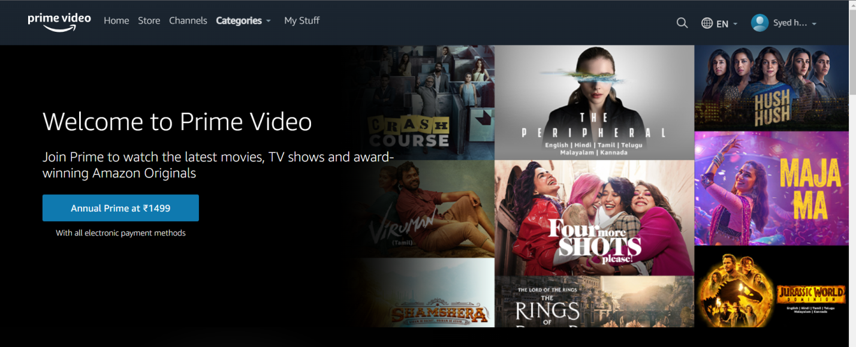

**\*OVERVIEW:** It’s a website where anyone can watch from latest to oldest movies Which are available with best quality.

1. **HOME PAGE:**

# LOGO

# SEARCH BAR

# SHOWING THE PLANS FROM MONTH TO ANNUAL

# DEALS - (MOVIE IMAGES)

# HEAD BAR – (HOME, STORE, CATEGORIES, MYSTUFF)

# SIGN UP, LOGIN, LANGUAGE CHANGING OPTION

# FOOTER – ( CONTACT US , HELPLINES , BRIEF DESCRIPTION

ABOUT THE COMPANY , SOCIAL-MEDIA HANDLE

ICONS , LINK TO MOBILE APP ).

1. **REGISTRATION FORM:**

# NAME

# EMAIL ID

# PASSWORD

# CONFIRMATION PASSWORD

**3. CATEGORIES:**

# TV SHOWS – (LATEST, POPULAR, TOP 10, I’LL PUT WISHLIST OPTION TO ALL OF THOSE MOVIES)

# MOVIES – (LATEST, POPULAR, TOP 10, I’LL PUT WISHLIST OPTION TO ALL OF THOSE MOVIES)

# KIDS – (LATEST, POPULAR, TOP 10, I’LL PUT WISHLIST OPTION TO ALL OF THOSE MOVIES)

# AMAZON ORIGINALS – (LATEST, POPULAR, TOP 10, I’LL PUT WISHLIST OPTION TO ALL OF THOSE MOVIES)

# ANIME – (LATEST, POPULAR, TOP 10, I’LL PUT WISHLIST OPTION TO ALL OF THOSE MOVIES)

**4. STORE:**

# HERE YOU CAN SEE A LOT OF MOVIES WHICH ARE AVAILABLE TO BUY OR RENT.

# PAYMENT PAGE – (ADDRESS , PAYMENT METHOD & PROCEED TO PAY).

**\*\***On each and every movie img i’ll apply :hover{transfermation} to make it beatiful. And i’ll apply carousel on each and every category and make it move manually with arraows and i’ll use some more bootstrap to design it in the proper way**