Load the libraries

# Load the libraries  
library(arules)

## Loading required package: Matrix

##   
## Attaching package: 'arules'

## The following objects are masked from 'package:base':  
##   
## abbreviate, write

library(arulesViz)

Load the data

Groceries <- read.transactions("Market_Basket_Optimisation.csv")

## Warning in asMethod(object): removing duplicated items in transactions

Create a frequency plot with 10 items

itemFrequencyPlot(Groceries,topN=20,type="absolute")

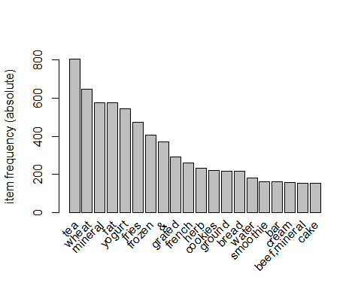

Now we get the rules

here we set support to .001

and confidence to .8

rules <- apriori(Groceries, parameter = list(supp = 0.001, conf = 0.8))

## Apriori  
##   
## Parameter specification:  
## confidence minval smax arem aval originalSupport maxtime support minlen  
## 0.8 0.1 1 none FALSE TRUE 5 0.001 1  
## maxlen target ext  
## 10 rules TRUE  
##   
## Algorithmic control:  
## filter tree heap memopt load sort verbose  
## 0.1 TRUE TRUE FALSE TRUE 2 TRUE  
##   
## Absolute minimum support count: 7   
##   
## set item appearances ...[0 item(s)] done [0.00s].  
## set transactions ...[5729 item(s), 7501 transaction(s)] done [0.01s].  
## sorting and recoding items ... [354 item(s)] done [0.00s].  
## creating transaction tree ... done [0.00s].  
## checking subsets of size 1 2 3 4 done [0.00s].  
## writing ... [271 rule(s)] done [0.00s].  
## creating S4 object ... done [0.00s].

Here we see the etop 5 rules

options(digits=2)  
inspect(rules[1:5])

## lhs rhs support confidence coverage  
## [1] {cookies,low} => {yogurt} 0.0011 1 0.0011   
## [2] {cookies,low} => {fat} 0.0011 1 0.0011   
## [3] {extra} => {dark} 0.0011 1 0.0011   
## [4] {burgers,whole} => {wheat} 0.0012 1 0.0012   
## [5] {fries,escalope,pasta,mushroom} => {cream} 0.0011 1 0.0011   
## lift count  
## [1] 14 8   
## [2] 13 8   
## [3] 83 8   
## [4] 12 9   
## [5] 48 8

Sorting the rules by confidence

rules<-sort(rules, by="confidence", decreasing=TRUE)

Now we see the rules in a graph

library(arulesViz)  
plot(rules,method="graph",interactive=TRUE,shading=NA)

## Warning in plot.rules(rules, method = "graph", interactive = TRUE, shading =  
## NA): The parameter interactive is deprecated. Use engine='interactive' instead.

## Warning: plot: Too many rules supplied. Only plotting the best 100 rules using  
## 'support' (change control parameter max if needed)