**Research Topic: Deskera’s Faculty Management software**

Deskera’s Faculty Management software allows you to maintain comprehensive faculty management information, including qualifications and skill sets, contract documents, define triggers to remind faculty and administrators of contract expiry dates and more, in the Faculty Management system. Capturing faculty data in multiple ways results in data inconsistencies and raises questions about how best to enhance data quality, accuracy, security, ease and timeliness of reporting while increasing cost effectiveness.

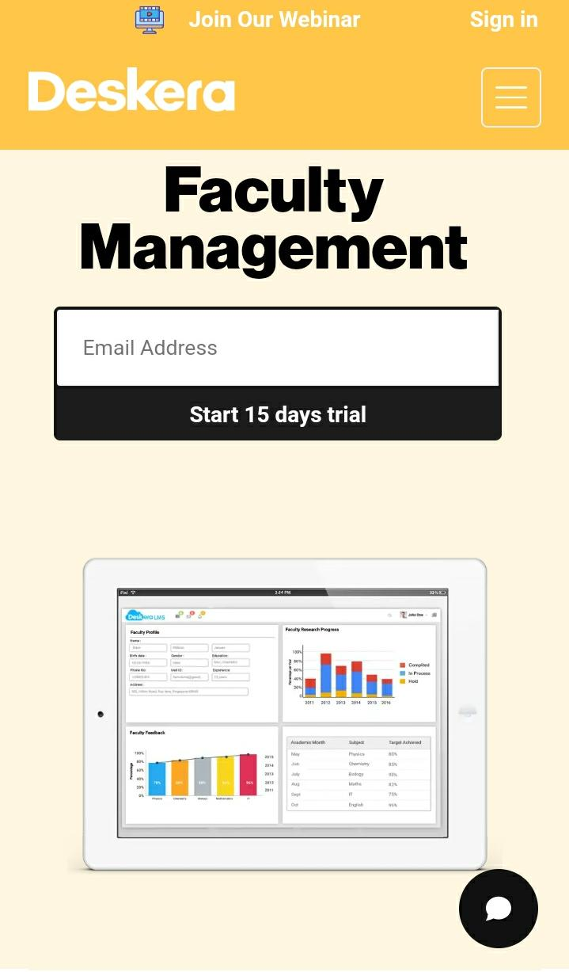

**Features:**

▪ Faculty Profiling

▪ Career Portal

▪ Faculty Scheduling

▪ Feedback Management

▪ Research Information System

**Here is a list of technologies that power the core of Deskera:**

Backend: Java, Javascript, PHP, Go

Frontend: Node Js

**Disadvantages of Deskere:**

### **1. Faculty attendence traking:**

### **Deskera is unable to track the details about on which date the faculty was absent and how many leaves he had taken in a month or year.**

### **2. Difficult terminology:**

### **The terminology/prompts on many screens are somewhat difficult to decipher, even for someone with accounting software experience.**