Research Topic: MasterSoft

MasterSoft is a highly trusted ERP solution provider company with over 800 software implementations across the globe. They offer all aspects of educational solutions such as a learning management system, faculty management system, accreditation management software, and others. The faculty management system is technologically advanced and highly secure software for managing faculty’s data, attendance, payroll, and hiring processes. The software is equipped with features and stores large amounts of data.

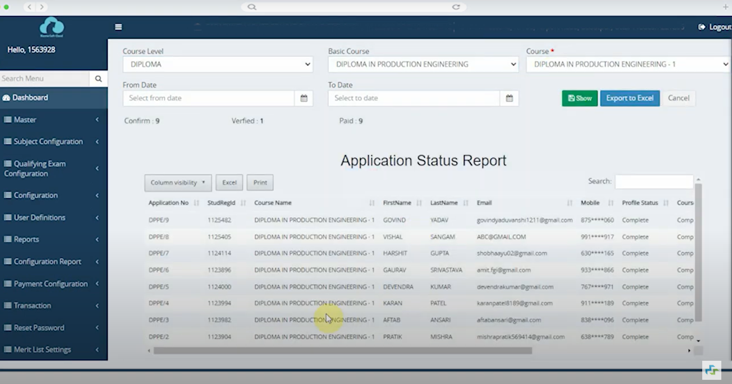

**Features:**

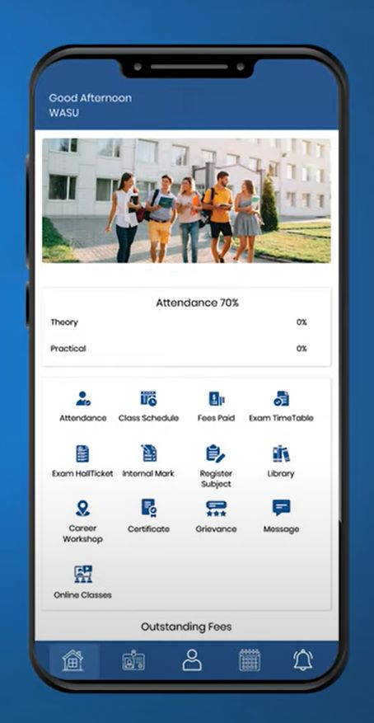

* AI-Powered Analytics Dashboard
* Analytics-enabled Dashboard
* Multi-campus Structure
* Accreditation Related Reports in a Click
* Auto-generated Daily Reports such as DCR
* Free Upgrades & Instant CCMS Software Implementation
* ERP Software with Role-based Access
* 24*7 Access to Student Data from Anywhere
* Integration with Advanced Mobile Apps, SMS & Emails
* Complete Control, Visibility & Transparency
* Modular ERP Software- Implement in Phases

**Here is a list of technologies that power the core of Mastesoft:**

**Framework:** .Net Framework: provides a comprehensive and consistent programming model for building Windows-based applications, web applications, and services.

**Programming language:** PHP

**Frontend**: CSS & HTML

**App:** Android & iOS,MasterSoft App

**Browser Support:**  Chrome, Mozilla Firefox, Internet Explorer, and others.

**Database**: Microsoft SQL Server

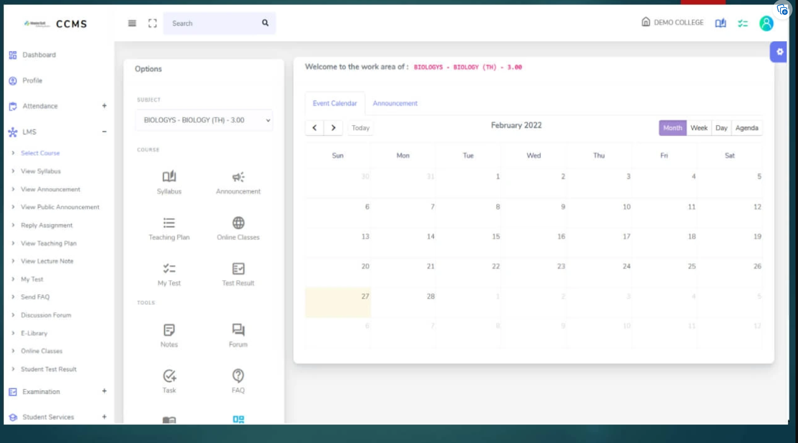

**Disadvantages of Mastersoft’s ERP:**

**1.speed:**

Slow processing speed sometimes

### **1. Cost:**

MasterSoft’s ERP software price is very high, which is costly as compared to other ERP systems out there, including initial setup costs, licensing fees, customization expenses, and ongoing maintenance fees. This can be a significant financial burden for smaller colleges or universities with limited budgets.