CHAPTER 1: INTRODUCTION

**Chapter 1. Introduction**

Enterprise resource planning (ERP) is a system of integrated software applications that manage day-to-day business processes and operations across finance, human resources, procurement, distribution, supply chain, and other functions.

**Introduction to concept/idea:**

ERP systems are the kind of software tools that are used to manage the data of an enterprise. ERP system helps different organizations deal with different departments of an enterprise. For instance, a College ERP System will manage the data related to their students, which include the management of Employees, Students, Books and Library Records, Parents’ details, Assignments, Admission Process, Results and Reports, Exams, Events, Attendance, Timetable, Fees and Other. Reports. It provides one-point access to manage this wide range of activities both effectively and efficiently. Before an ERP system, there are different databases of different departments which they managed on their own. The student of one department does not know anything about another department.

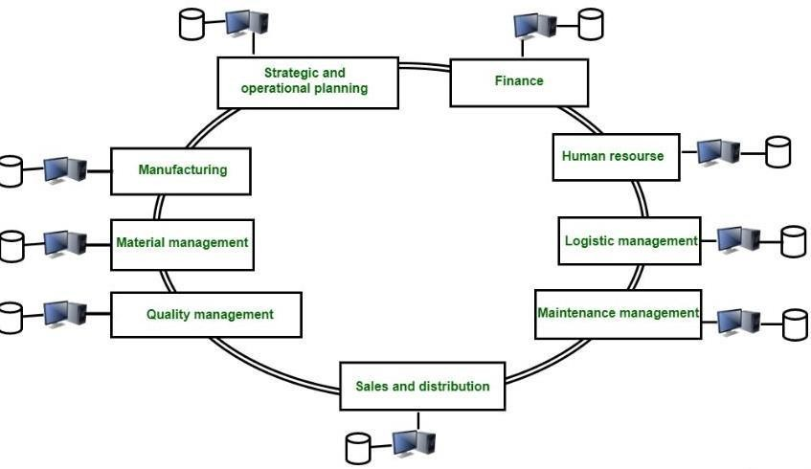

**Fig 1.1.[1] ERP system**

After the ERP system, databases of different departments are managed by one system called the ERP system. It keeps track of all databases within the system. In this scenario, an employee of one department has information regarding the other departments.

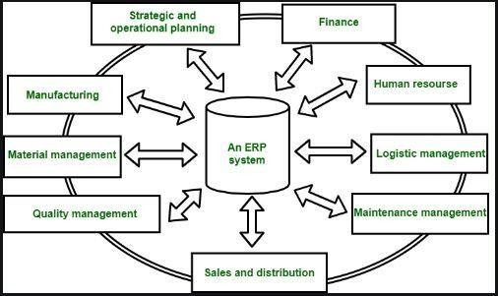

## Fig 1.1.2[2] ERP System

**Modules of College Management System**

Some of the modules are as follows:

1. Student Record Management
2. Admission Management
3. Attendance Management
4. Fees Management
5. Assessment/Exam Management
6. Library Management
7. **Student Record Management:**

**Easy Record Maintenance:**

With advanced reporting and unified data core features, you can manage large amounts of student data within a few clicks.

### Online Fee Management:

Effectively manage student's fee payment and discounts. With a single login, students can get information about program fee, financial aid, scholarships, debt management, etc.

### Conduct Different types of assessments

Enable effective planning, designing, creating, and executing various types of assessments, which includes, unit tests, quizzes, MCQ tests, descriptive exams, etc.

### Admission Management

The organization can handle all complicated process of admission with ease. This includes prospectus sale, student registration, verification etc.

### Attendance Management

This module provides a convenient platform for taking student's attendance online via smart phone. Parents will receive SMS about their ward's presence in the campus.

### Fees Management:

The administrator needs to keep a tab on daily fee-related transactions in educational institutions. Payment reconciliation, which incorporates cross-check methodology is the best way to track everyday transactions.

### Assessment/Exam Management:

Using this module, schools can define class-wise examination schemes, subject-offered grades, and passing criteria. Any type grace and exam rules can be defined by users.

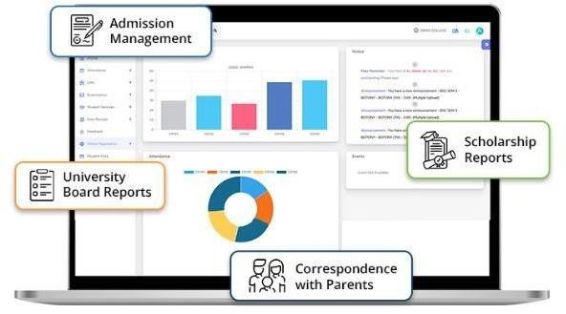

## Fig.1.1.3[3] Modules of ERP System

CHAPTER 2: REVERSE ENGINEERING

**Chapter 2 Phase 1: Reverse Engineering**

**2.1 Introduction and Study of Components/Artifact/Products for Reverse Engineering:**

Reverse engineering is the process of analyzing a system to understand its design and implementation. Reverse engineering can be used to learn how a system works, to identify security vulnerabilities, or to create a new system that is compatible with the existing system.

Now, we have to research and work on the reverse engineering topic on An ERP system for the Institute Management system.

In this topic, we have included a student management system which contains the study material option, attendance management, grade management, the syllabus options of the students.

This concept is similar to our topic for design engineering. And we would use some functionality of the idea as a student can see progress using the ERP system.

We learned about some additional features like application security options, student grade tracker, faculty can share the results of each student account, etc.

These characteristics may benefit us in the development of an effective application.

# Observation Record Sheet (AEIOU Framework)

## Activity Framework

These are goal-directed sets of actions- a path toward things people want to be done.

**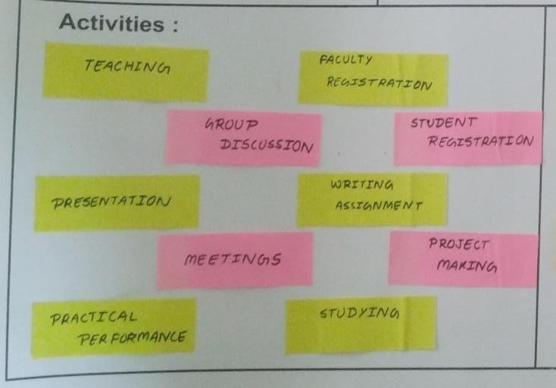****General impressions / Observations :**

**Fig: 2.2.1 Activity Framework**

#### The above Activity canvas includes:

* Group Discussion
* Faculty Registration
* Student Registration
* Writing Assignment
* Presentation
* Studying

## Environment:

- It includes the atmosphere where all the activities take place.

**General impressions / Observations :**

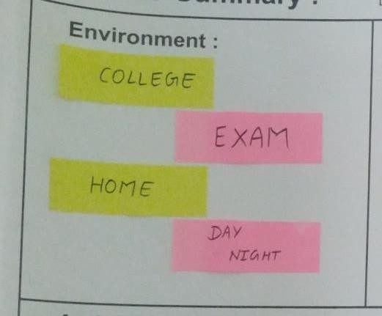

## Fig: 2.2.2 Environment Framework

**The above Environment canvas includes:**

* College
* Exam
* Home
* Day
* Night

## Interactions:

It includes all the interaction which we did during the activities

**General impressions/Observations: -**

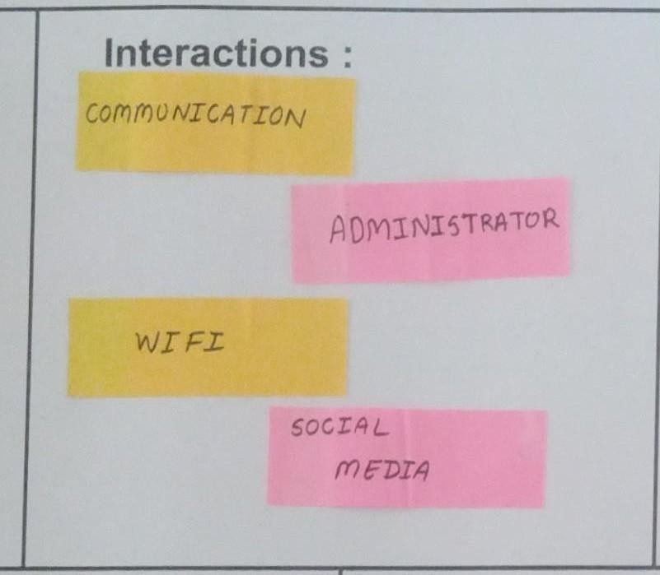

## Fig: 2.2.3 Interactions Framework

#### The above Interaction canvas includes:

* + - * Communication
      * Administrator
      * Wifi
      * Social Media

## Objects:

Objects are used in the performance of the activity.

**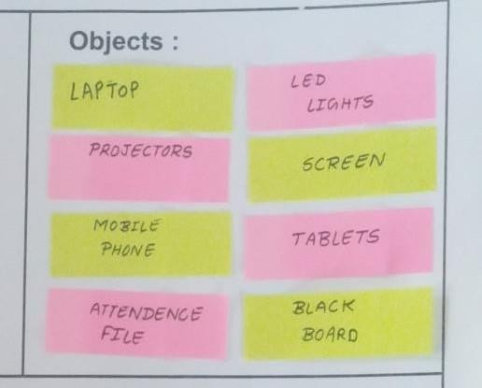****General impressions / Observations**:-

## Fig: 2.2.4 Object Framework

The above Object canvas includes:

* Laptop
* LED light: lighting
* Projector
* Screen
* Tablet
* Black Board
* Mobile phone
* Attendance file

## User:

It includes the people who take part in all the things being done around the environment.

**General impressions / Observations: -**

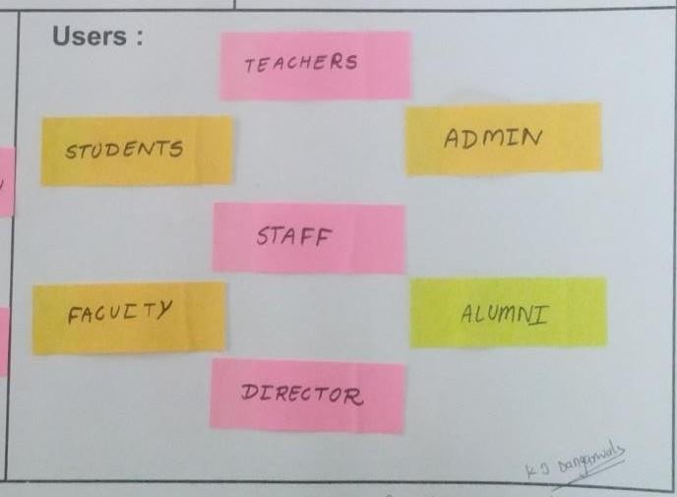

## Fig: 2.2.5 User framework

The above Environment canvas includes:

* Students
* Faculty
* Admin
* Staff
* Director
* Alumni
  + 1. **Empathy Mapping / Framework: -**

Empathy maps are being used to give the researcher/observer/Developer a stimulating experience ofthe applicant (User), so they can understand, build, improve or update their application.

This canvas has 4 aspects for resolution.

### User:

* + - * Staff
      * Students
      * Teachers
      * Faculty
      * Administration
      * Alumni

### Stakeholders:

* + - * Parents
      * Librarian
      * Technician

### Activities:

* + Teaching
  + Group Discussion
  + Faculty Registration
  + Student Registration
  + Writing Assignment
  + Presentation

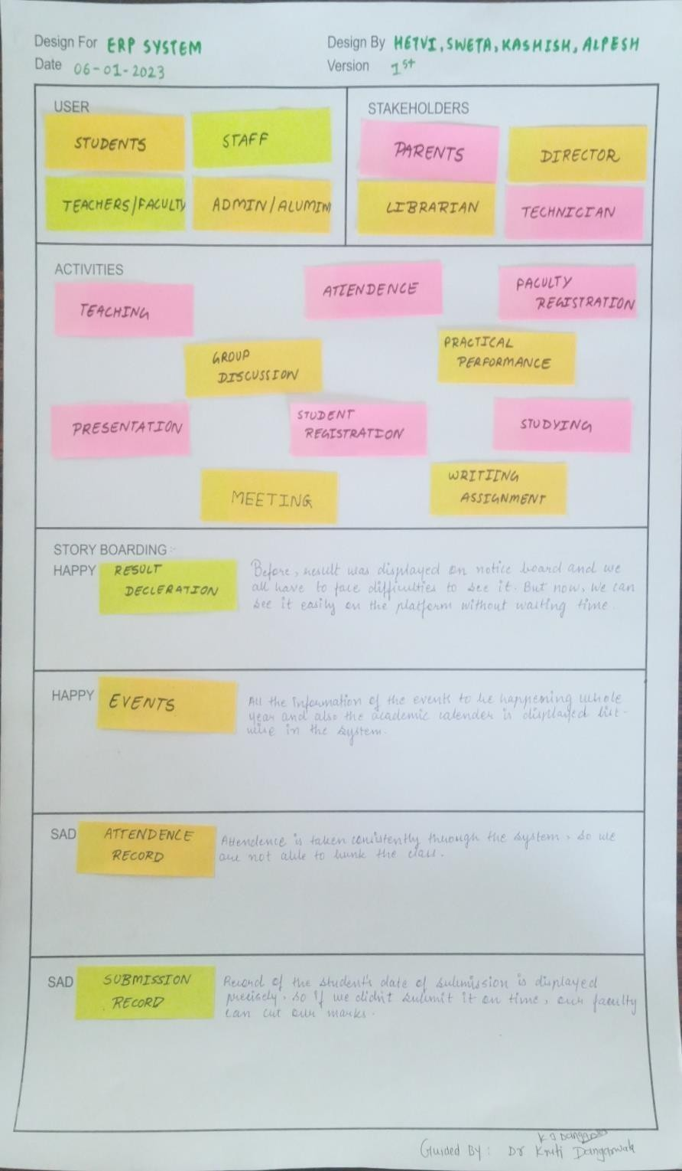

## Fig: 2.2.6 Empathy Mapping / Framework

* + 1. **Mind Mapping/Framework:**

Mind mapping is more accurate way of deciding, implementing, upgrading, structuring. It takes out most of your brain in order to Connect one entity with another with some particular relations. By one’s aspects of reasoning, a logical and creative way of thinking this methodology gives a better view of Ideas; in other words, it means mapping the ideas to terminate problems and define proper relations between different entities, by giving them identifying keywords.

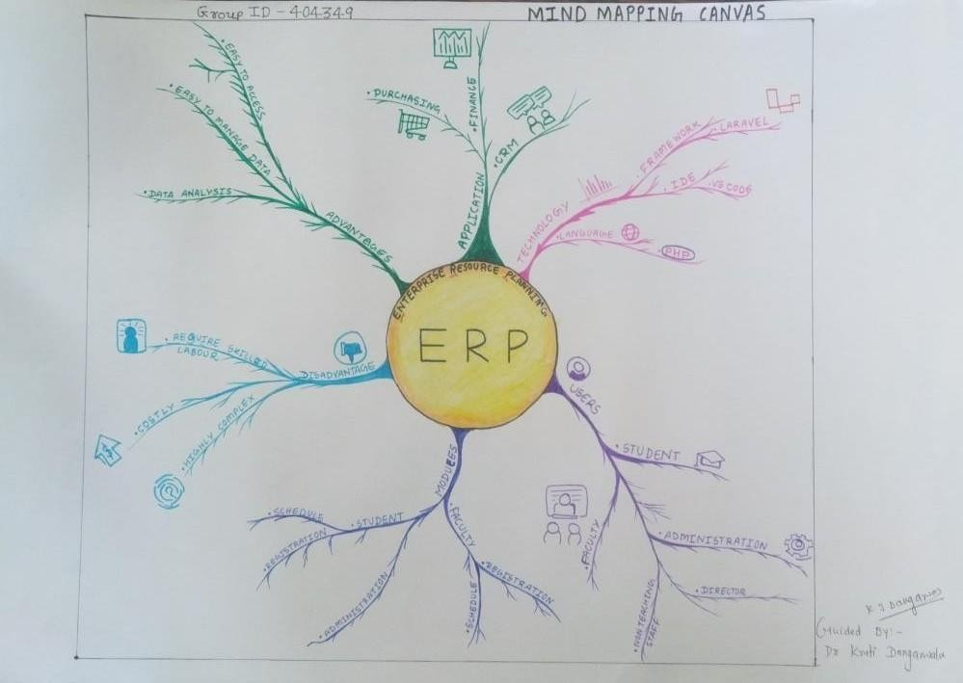

## Fig 2.2.7 Mind Mapping / Framework

* + 1. **Ideation Canvas / Framework**

Ideation canvas is needed when we’ve reached the point where we got an eye on the issue/problem/difficulty in performing tasks by our subject (say, user). This canvas performs as the front implement our idea in everyday real life.

For that, we need to consider.

### People:

* + - * Students
      * Teachers/Faculty
      * Staff
      * Administration
      * Director

### Activities:

* + - * Teaching
      * Group Discussion
      * Faculty Registration
      * Student Registration
      * Writing Assignment
      * Presentation

### Situation/context/location:

* + - * Laboratory
      * Library
      * Administration office
      * Admission process
      * Exam Form
      * Book Borrow

### Props/Tools/Objects/Equipment:

* + - * Laptop
      * Wifi
      * Laravel
      * Visual Studio

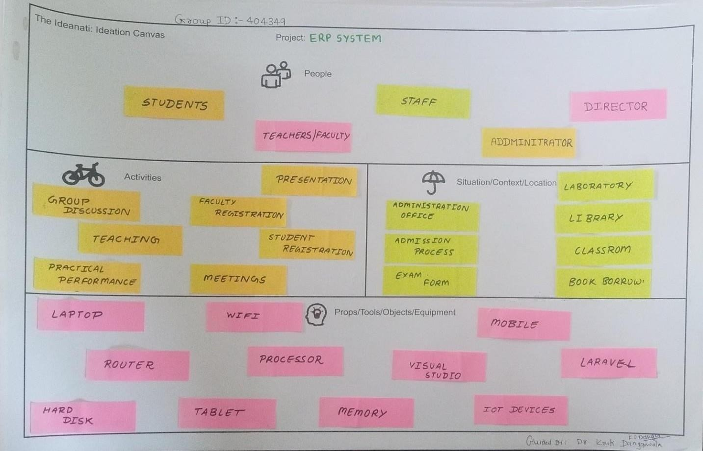

## Fig: 2.2.8 Ideation Canvas / Framework

1. **2.9 Product Development Canvas / Framework:**

It’s the closer to phase two, where our objectives are clear and ready to approach. What solution as over product should give, what features we need, how to function them properly in order to fulfill the requirements, surveying on our domain of buyers to reject/redesign/retain components of our product.

The canvas includes the following parts:

* + Purpose
  + People
  + Components
  + Product Experience
  + Product Functions
  + Product Features
  + Customer Revalidation
  + Reject, Redesign, Retain

### Purpose:

* Attendance
* Time Table
* Finance management
* Feedback

### People:

* + Students
  + Teachers/Faculty
  + Staff
  + Administration
  + Director

### Components:

* + Laptop
  + WIFI
  + Mobile Phone
  + Hard Disk
  + Tablets
  + Memory

### Product Experience:

* Easy to manage
* Excellent Analysis

### Product Functions:

* Department
* Fees
* Attendance
* Time Table
* Student Information

### Product Features:

* Branches
* Tutor, Student Attendance
* Easy to Access
* Data Analysis
* Reporting

### Customer Revalidation:

* Easy Access
* User Authentication
* Satisfied
* Language unavailability

### Reject, Redesign, Retain:

* Connectivity
* Cost
* Highly complex
* Requires Training

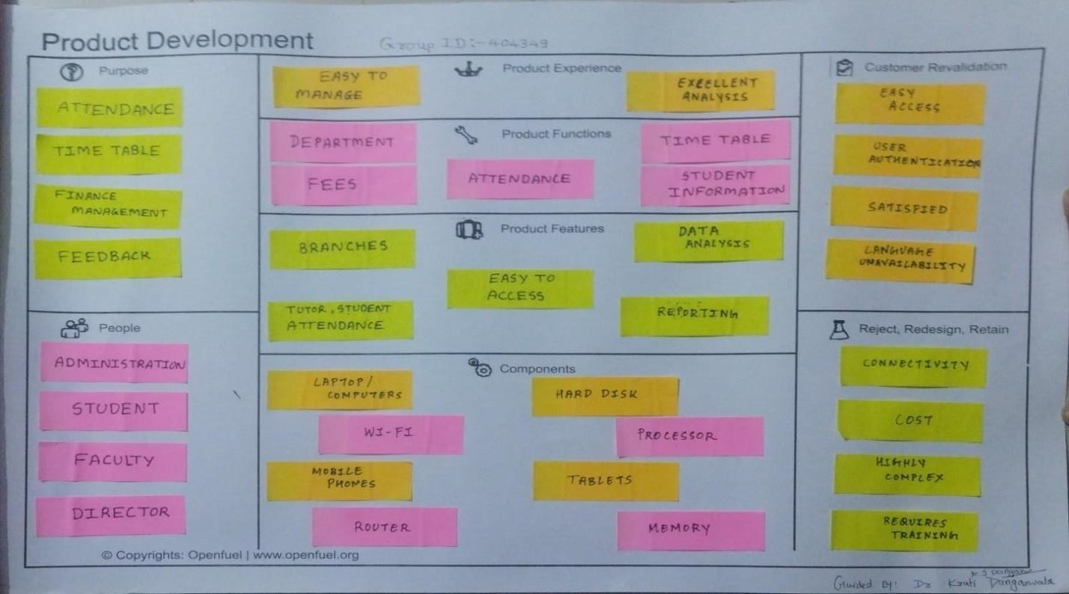

## Fig:2.2.9 Product Development Canvas / Framework

**2.2.10 Learnings Need Matrix Canvas:**

## Methods:

* + Probability & Statical data
  + Learning PHP 7.8
  + Web data Programming
  + Android Programming

## Simulation/Skill:

* + Java script
  + PHP
  + Graphical User Interface

## Components Morerials Strenght Criteria

* + Laptop
  + Mobile
  + User Interface

## Applicable Standaeds and Design Specification Principles and Experiments

* Institution Head Permission
* Faculty Permission

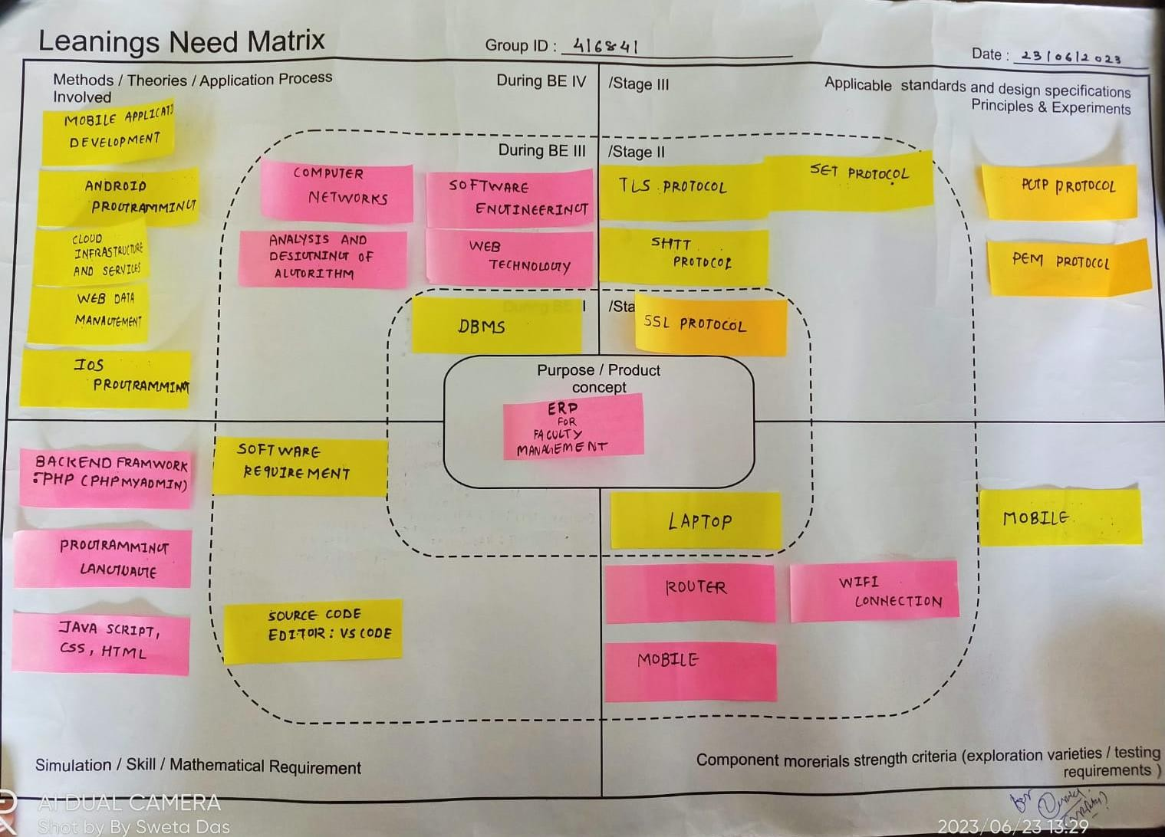

## Fig:2.2.10 Learning Need Matrix Canvas

* 1. **Literature Review / Prior Art Search:**

## Example of ERP Model:

* + 1. **SVMIT’s ERP-**

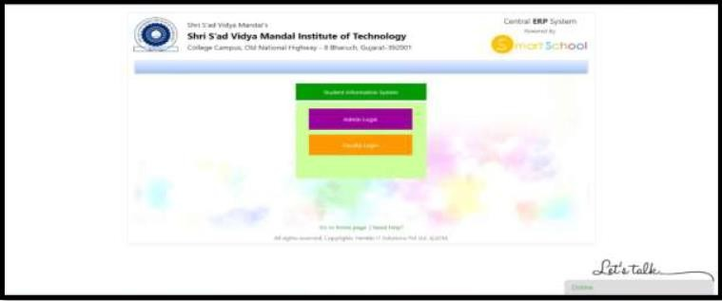

## Fig:2.3.1 Dashboard

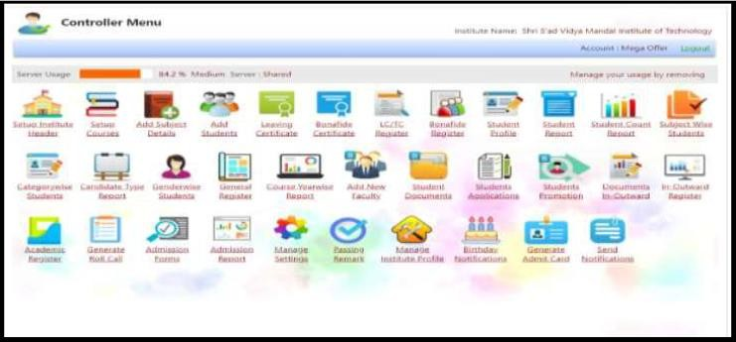

**Fig:2.3.2 Controller Menu**

At SVMIT’s SIM ERP, Smart School Management Information System is a Collective and competent

solution for information management in an educa tional Organization. A versatile MIS, designed by

putting together the best of cloud technologies, it provides efficiency and effectiveness in strategic

decision making concerning any educational Organization.

* + 1. **MasterSoft**

MasterSoft is a highly trusted ERP solution provider company with over 800 software implementations across the globe. They offer all aspects of educational solutions such as a learning management system, faculty management system, accreditation management software, and others. The faculty management system is technologically advanced and highly secure software for managing faculty’s data, attendance, payroll, and hiring processes. The software is equipped with features and stores large amounts of data.

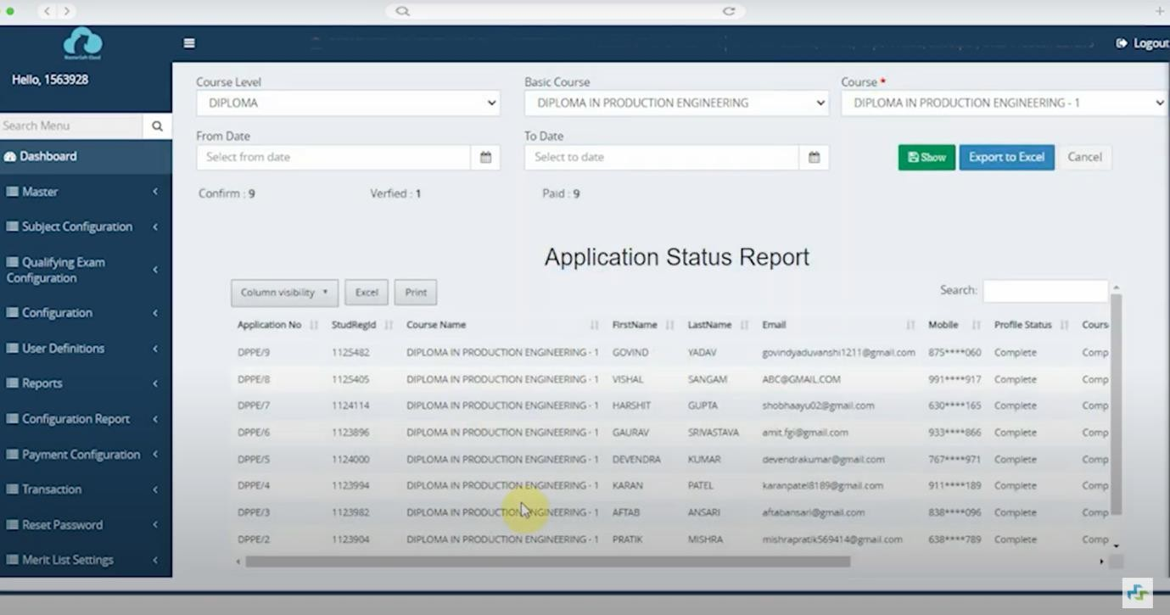

## Fig:2.3.3 Mastersoft ERP System

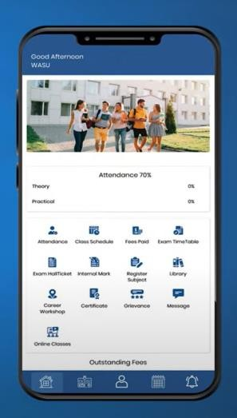

### Features:

* + AI-Powered Analytics Dashboard
  + Analytics-enabled Dashboard
  + Multi-campus Structure
  + Accreditation Related Reports in a Click
  + Auto-generated Daily Reports such as DCR
  + Free Upgrades & Instant CCMS Software Implementation
  + ERP Software with Role-based Access

**Fig 2.3.4 Features**

* + 24*7 Access to Student Data from Anywhere
  + Integration with Advanced Mobile Apps, SMS & Emails
  + Complete Control, Visibility & Transparency
  + Modular ERP Software- Implement in Phases

**Here is a list of technologies that power the core of Mastesoft:**

* **Framework:** .Net Framework: provides a comprehensive and consistent programming model for building Windows-based applications, web applications, and services.
* **Programming language:** PHP
* **Frontend**: CSS & HTML
* **App:** Android & iOS,MasterSoft App
* **Browser Support:** Chrome, Mozilla Firefox, Internet Explorer, and others.
* **Database**: Microsoft SQL Server

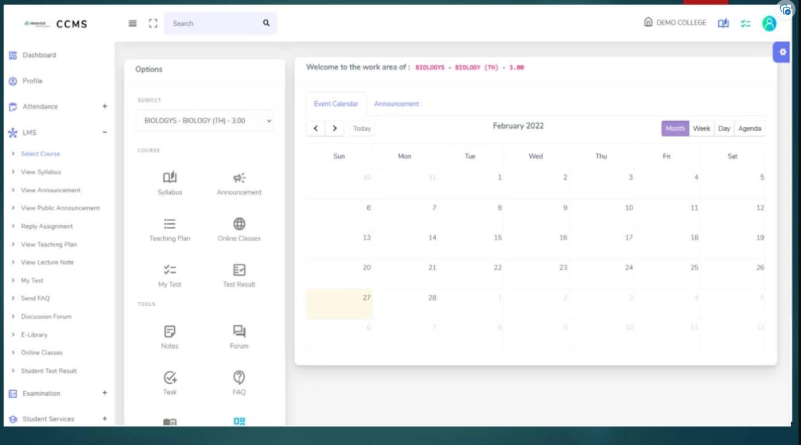

## Fig:2.3.5 Framework

### Disadvantages of Mastersoft’s ERP:

* + - 1. **Speed:**

Slow processing speed sometimes

### Cost:

Master Soft’s ERP software price is very high, which is costly as compared to other ERP systems out there, including initial setup costs, licensing fees, customization expenses, and ongoing maintenance fees. This can be a significant financial burden for smaller colleges or universities with limited budge

## Deskera’s Faculty Management software

Deskera’s Faculty Management software allows you to maintain comprehensive faculty management information, including qualifications and skill sets, contract documents, define triggers to remind faculty and administrators of contract expiry dates and more, in the Faculty Management system. Capturing faculty data in multiple ways results in data inconsistencies and raises questions about how best to enhance data quality, accuracy, security, ease and timeliness of reporting while increasing cost effectiveness.

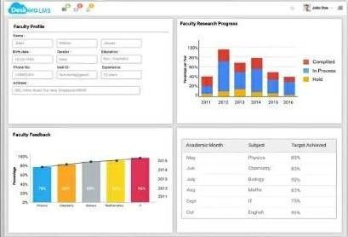

## Fig:2.3.6 Deskera’s Faculty Management software

### Features:

* Faculty Profiling
* Career Portal
* Faculty Scheduling
* Feedback Management
* Research Information System

### Here is a list of technologies that power the core of Deskera:

Backend: Java, Javascript, PHP, Go Frontend: Node Js

### Disadvantages of Deskere:

1. **Faculty attendence traking:**

Deskera is unable to track the details about on which date the faculty was absent and how many leaves he had taken in a month or year.

### Difficult terminology:

The terminology/prompts on many screens are somewhat difficult to decipher, even for someone with accounting software experience.

## Skolaro

Skolaro is a cloud-based ERP system designed specifically for K-12 schools. It provides a suite of

modules that help schools manage their academic and administrative operations efficiently. Some of

the key features of Skolaro include admissions management, student information management, fee

management, attendance management, timetable management, and examination management.

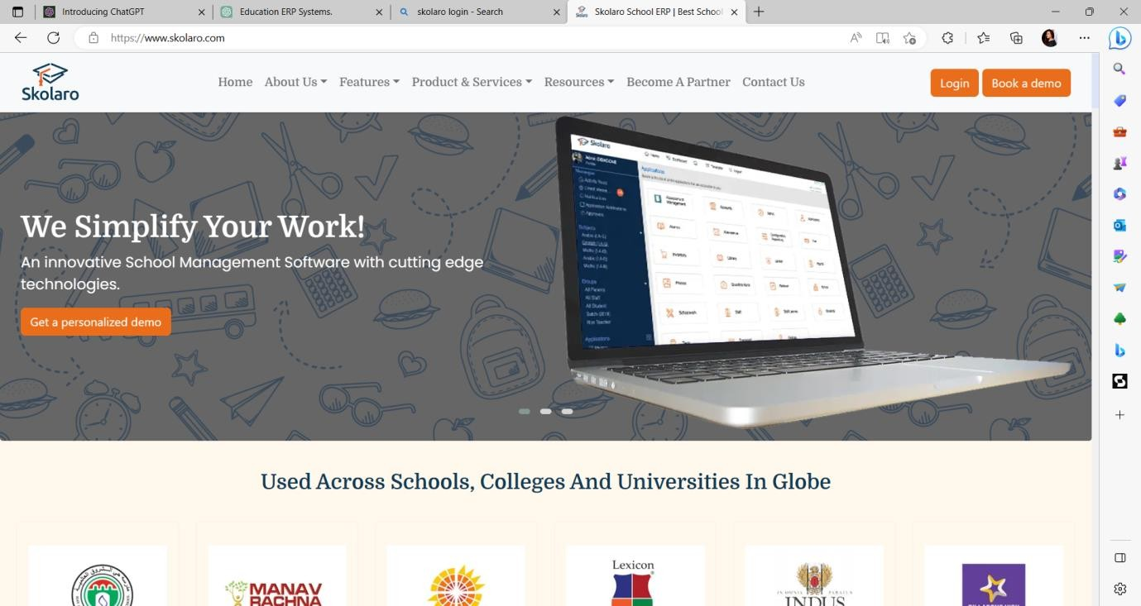

## Fig 2.3.7: Skolaro ERP System Dashboard

### Fetures:

1. Student management:
2. Fee management:
3. Library management
4. Payroll management
5. Examination management

6.Inventory management:

### Here is a list of technologies that power the core of Skolaro:

1. **Framework**:Laravel Framework: Skolaro is built using the Laravel framework, which is a PHP-based web application framework.
2. **Frontend**: Vue.js
3. **App**: Android, iOS
4. **Browser Support**: Internet Exlorer, Crome And other
5. **Database**: Skolaro uses the MySQL database management system to store and manage all the data

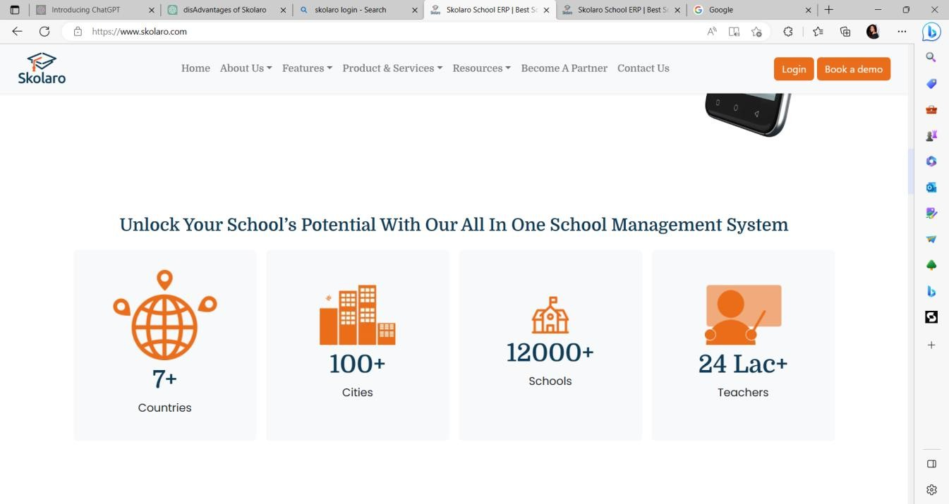

## Fig 2.3.8: Features

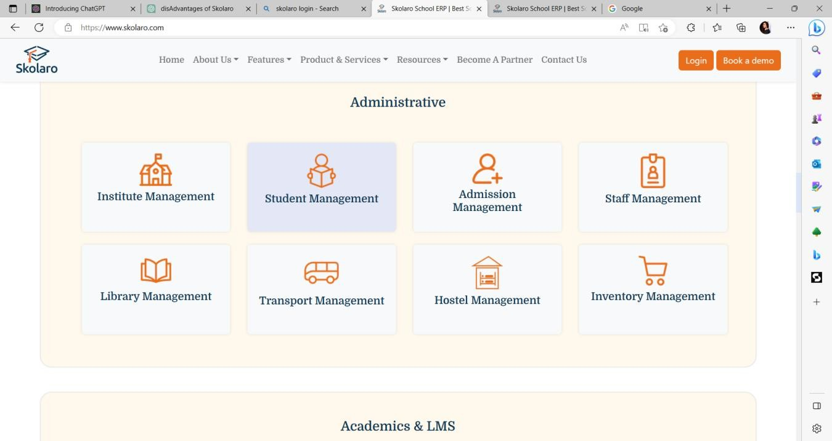

**Fig 2.3.9: Administrative**

### Disadvantage of Skolaro:

#### Cost:

Implementing and maintaining a college ERP system can be expensive, including initial setup costs,

licensing fees, customization expenses, and ongoing maintenance fees. This can be a significant

financial. burden for smaller colleges or universities with limited budgets

#### Complexity:

ERP systems are complex and require thorough planning, implementation, and training. They can be

challenging to set up and configure correctly, and may require significant technical expertise and

resources to manage effectively. This complexity can result in a steep learning curve for college staff,

which may lead to resistance and difficulties in adoption.

## EDUSYS

The EduSys College ERP is the cloud-based college management software system that automates the

entire campus operations, reduce operating cost and engage or save more time by bringing management,

professor, staff, parent, and students under one roof.

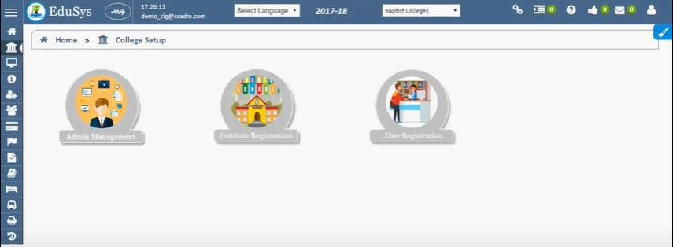

## Fig 2.3.10: Dashboard

### Features:

* + Staff Management System
  + Branch Management
  + Student Management
  + Human Resource Management
  + Visitor Management
  + Document Management
  + Fee Management
  + Placement Management
  + Report Management
  + Exam Management
  + Admission Management
  + Hostel Management
  + Library Management
  + Attendance Management

**Here is a list of technologies that power the core of EDUSYS:**

**Framework:** .Net Framework: provides a comprehensive and consistent programming model for building Windows-based applications, web applications, and services.

**Programming language:** C#, Visual Basic, and F#

**Frontend**: Blazor

**App:** Android & iOS

**Browser Support:** Chrome, Mozilla Firefox, Internet Explorer, and others.

**Database**: Microsoft SQL Server

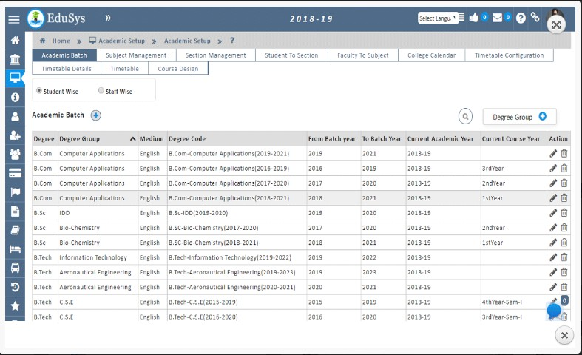

## Fig 2.3.11: Academic Setup

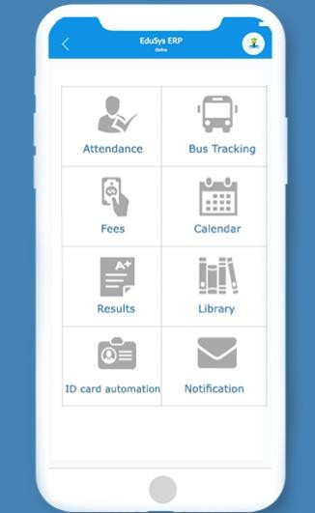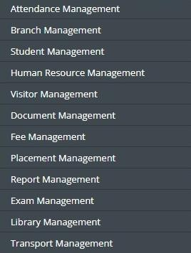

**Fig 2.3.12: College Management App And Modules**

### Disadvantages of EDSYS

1. **Cost:**

Starting price of the Edusys system is 4,999/-, which is costly as compared to other ERP systems out there, including initial setup costs, licensing fees, customization expenses, and ongoing maintenance fees. This can be a significant financial burden for smaller colleges or universities with limited budgets.

### Dynamic Features

There are no setup profile attribute features available in the system thereby making it static and complex software and less flexible as compared to other ERP systems.

## Research Paper Analysis:

### Case Study – False Bay College, Muizenberg, South Africa

Educational institutions are facing very different challenges than they did ten years ago. With the continuous improvement in technology, institutions need to be agile to keep up with the ever - changing demands and needs of the education sector. A modern, fit-for-purpose Student Information System/Service (SIS) should not only support the attainment of the College's strategic goals but also be flexible (configurable) enough to accommodate changing business models and support new or changing strategic objectives/direction.

2021 saw False Bay Technical and Vocational Education and Training (TVET) College break new ground. We were the first TVET College in South Africa to implement Academia Student Information System (SIS) and go live for applications and registrations. It is an amazing accomplishment as all project meetings, workshops, and training were delivered remotely due to the outbreak of Covid-19. While this was no easy feat, it illustrates the pioneering journey that False Bay TVET College undertook to adopt a robust SIS and replace its existing systems.

“We wanted a customizable solution as per the needs of our vocational & occupational programmes. Academia ERP was the system of choice as it provided us with rich functionalities and customization as per the College SIS requirements. We are very satisfied with the implementation and post-implementation services provided by Academia that helped us achieve automation and digital transformation”.

### Feedback/Summary of the Learning from Reverse Engineering Activity:

Reverse engineering is the process of taking something apart and putting it back together again, opening in new window in order to see how it works. It's not a technique specific to computer science; instead, it can be used any time someone wants to understand a process or project. Using Reverse Engineering, we examined so many applications which are already existing and also observed some features which can be helpful to the users of the application.

We learned some additional features like security options of the application, grade tracking record, Students management, attendance management, etc. These features can be advantageous to us in developing an efficient application.

CHAPTER 3 PREDESIGN

## Pre-design Calculation:

**Chapter 3 Phase 2 Predesign**

### Hardware Requirements:

To accomplish our project on a ERP for Institute Management System, we need hardware components such as,

* + - * Mobile phone
      * Laptop / PC

### Software Requirements:

The basic requirement of software for developing this application is,

* + - * Laravel Framework
      * XAMPP
      * Visual Studio

## Learning Need Matrix:

### Purpose/Product Concept:

* + - * Helping students, educators, libraries, etc.

### Tools/Methods/Theories/Application Process Involved

* + - * Learning PHP 7.8
      * Database Concept
      * WEB Technology
      * OOP Concepts
      * Advance WEB Technology
      * Data Integration

### Applicable Standards and Design Specification/Principles & Experiments

* Institute head permission

### Component Material Strength Criteria

* LAPTOP
* PC
* Android Smartphones
* Bootstrap, XAMPP, PHP 7.4
* Laravel Framework
* MySQL

### Software/Simulation/Skills/Mathematical Requirement

* Visual studio
* XAMPP

CHAPTER 4 PROTOTYPE MODEL

## Chapter-4 PROTOTYPE MODEL

### Features/Functions of proposed system

A **prototype** is basically an early access design just made for testing, and evaluation to improvise later on, before releasing the official product in the market. It is initially used by system analysts or applicants (users). We as engineers intend to minimize the differences that arise between the prototype and the ideal model of how the prototype should perform. *I.e*. if a virtual prototype isn't approachable due to components are not available for that, Developer has to find an appropriate substitute component that can give similar outputs

.

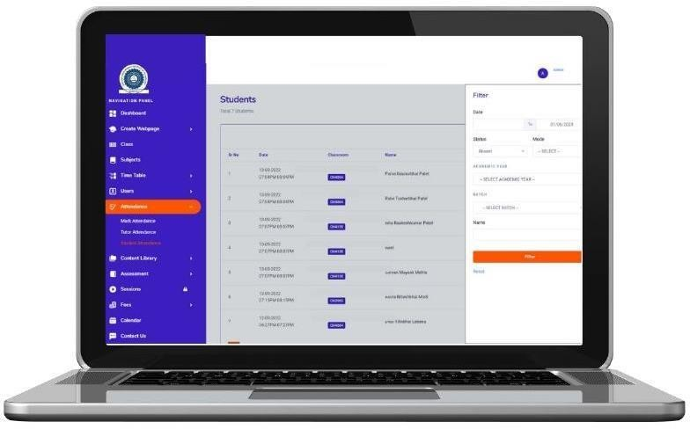**4.2 Fast Prototype Model/Conceptual Plan Layout**

## Fig 4.2.1: Registration dashboard of the student

## 

**Fig 4.2.2: Sign-in page**

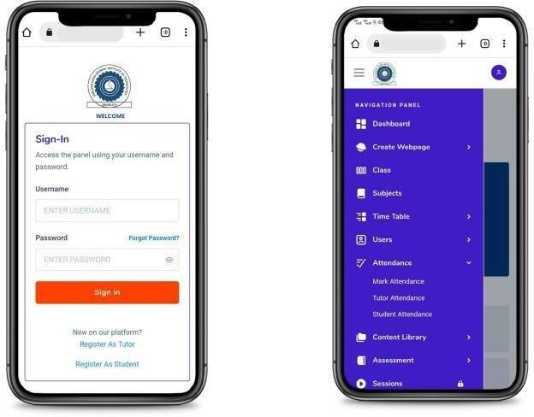

## Fig 4.2.3: Layout of the main system along with sign-in process in mobile

## configuration

**Future Scopes:**

### For the upcoming semesters, these are the flowing goals that we are going to follow:

* + 1. Designing a blueprint of the ERP system and designing a user-friendly UI and UX using software like bootstrap, angular, etc.
    2. Using a third-party integration for better understanding and display of the data in the ERP system.
    3. Integrate various modules of the ERP system at the college level like student management system, fee management and student registration system.
    4. Using Laravel as our base framework to work with the backend and front of the system along with Visual Studio code as our IDE.

## Conclusion

This report was made to introduce the reader to the problem, idea, concept, and solution in the form of a virtual prototype of database management in college permeases. This is WEB based virtual interface representing a prototype model of our ERP (Enterprise Resource Planning software). The aim was to demonstrate how the actual model will look alike after implementing all necessary components. Furthermore, the rest of the canvases illustrate how the idea was generated, its cause, effect, and design implications. Over all the empathy and ideation process and need for administration took us to take up this project, which we think/hope would be extremely applicable in the large area of the education system and individuals.

## References:

1. http[s://www.g](http://www.geeksforgeeks.org/introduction-to-erp/)eeks[forgeeks.org/introduction-to-erp/](http://www.geeksforgeeks.org/introduction-to-erp/) access on 11 Jan 2022,14:25
2. http[s://www.cio](http://www.cio.com/article/272362/what-is-erp-key-features-of-top-).com[/article/272362/what-is-erp-key-features-of-top-](http://www.cio.com/article/272362/what-is-erp-key-features-of-top-) enterprise-resource-planning-systems.html access on 11 Jan,15:35
3. https://ieeexplore.ieee.org/document/6516344 access on 12 Jan,13:45
4. https://www.tandfonline.com/doi/abs/10.1057/s41303-017-0060-3

access on 12 Jan,16:22

1. http[s://www.iit](http://www.iitms.co.in/college-erp/student-administration-)ms.[co.in/colleg](http://www.iitms.co.in/college-erp/student-administration-)e[-erp/student-administration-](http://www.iitms.co.in/college-erp/student-administration-) management/ access on 12 Jan,15:33
2. https://www.edusys.co/en-in/college-management-software.html on 3 Jun,15:09
3. https://www.iitms.co.in/blog/faculty-management-system-software-becoming-a-necessity.html on 3 Jun,15:30
4. https://www.skolaro.com/college-erp on 3 Jun,15:42
5. https://www.deskera.com/lms/faculty-management on 3 Jun,16:08

## 