**Research topic: Skolaro**

Skolaro is a cloud-based ERP system designed specifically for K-12 schools. It provides a suite of modules that help schools manage their academic and administrative operations efficiently. Some of the key features of Skolaro include admissions management, student information management, fee management, attendance management, timetable management, and examination management.

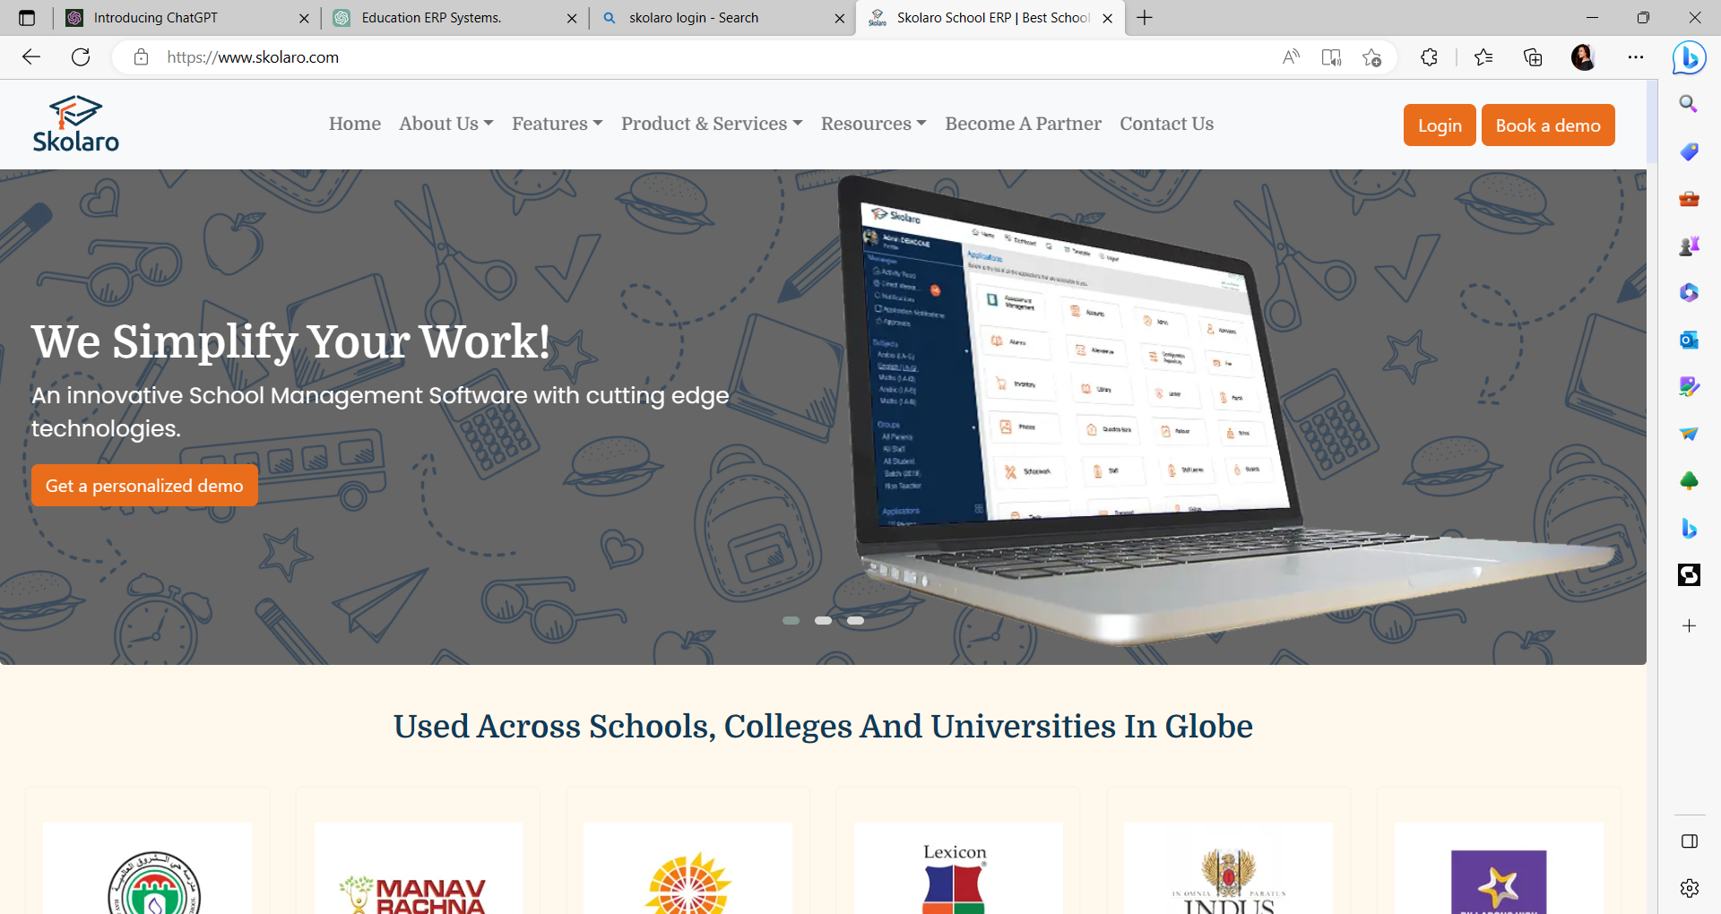

DASHBOARD

**Fetures:**

1.Student management:

2.Fee management:

3.Library managementPayroll management

4.Examination management

5.Inventory management:

**Here islist of technologies that power the core of Skolaro:**

**Framework:** Laravel Framework: Skolaro is built using the Laravel framework, which is a PHP-based web application framework.

**Frontend:**Vue.js

**App:**Android,iOS

**Browser Support:** Internet Exlorer,Crome,And other

**Database:** MySQL: Skolaro uses the MySQL database management system to store and manage all the data

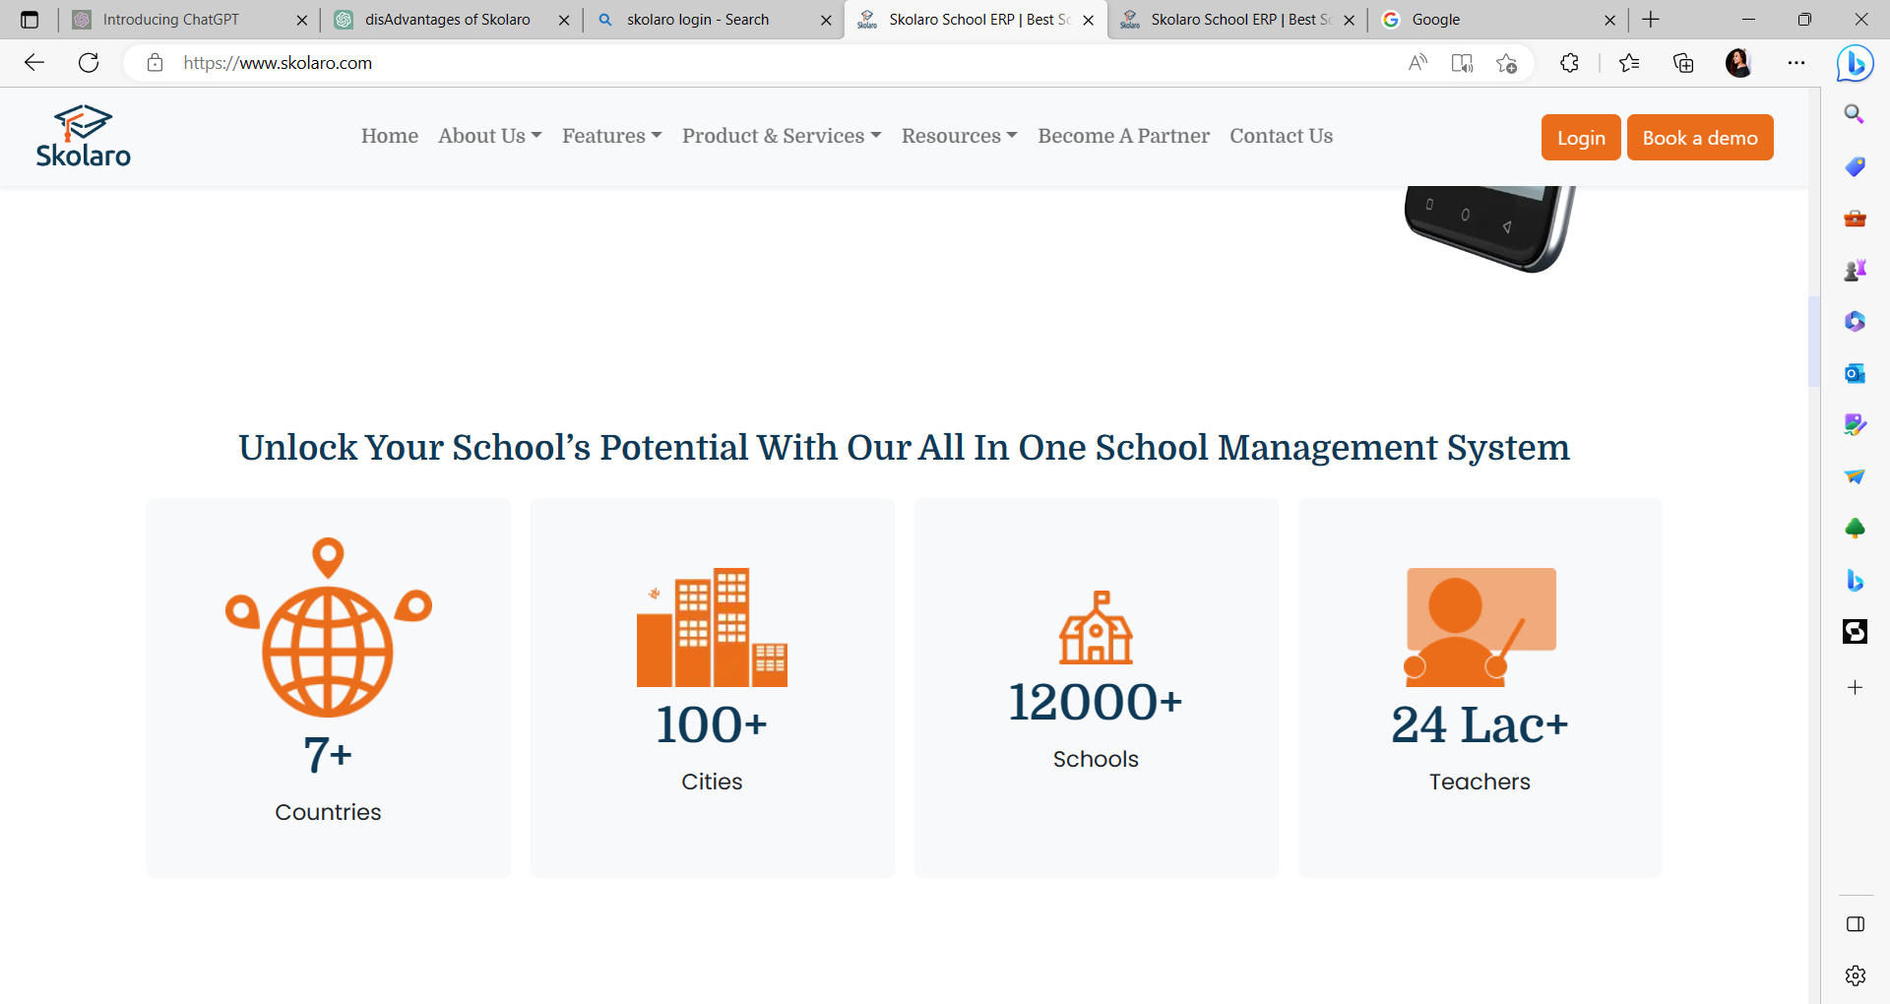

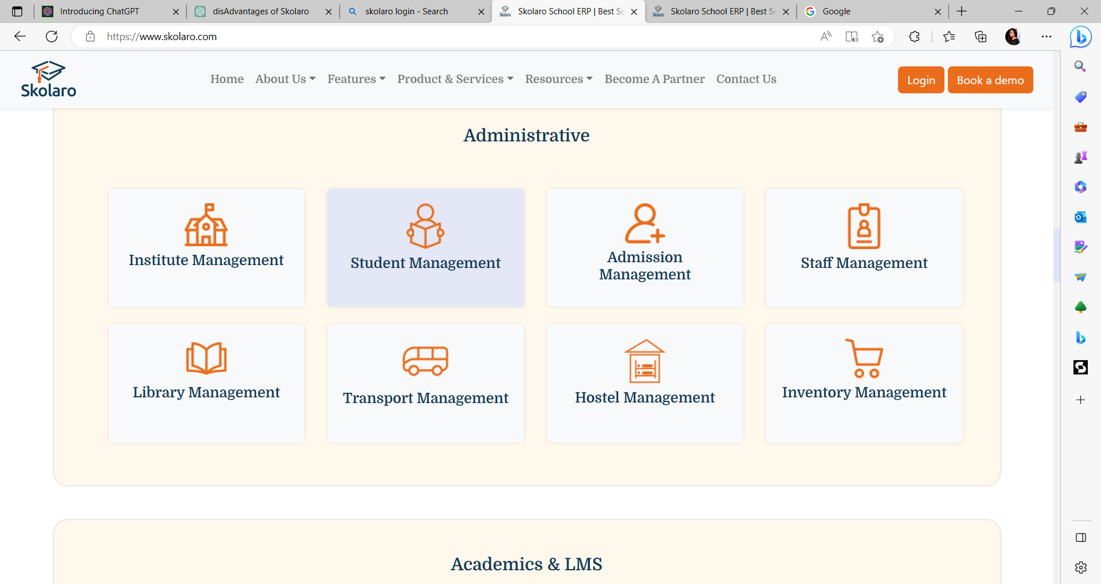

**Disadvantage of Skolaro:**

**1.Cost:**

Implementing and maintaining a college ERP system can be expensive, including initial setup costs, licensing fees, customization expenses, and ongoing maintenance fees. This can be a significant financial burden for smaller colleges or universities with limited budgets.

**2.Complexity**:

ERP systems are complex and require thorough planning, implementation, and training. They can be challenging to set up and configure correctly, and may require significant technical expertise and resources to manage effectively. This complexity can result in a steep learning curve for college staff, which may lead to resistance and difficulties in adoption.