Lucent Forge
World + Genesis Bible Expansion
Repository-integrated handoff for Claude
Prepared by Caelum for Shawn Dunn — August 2, 2026

Purpose
This package expands the existing Lucent Forge Bible rather than creating a parallel world bible. It separates canonical home-world requirements from Genesis technical architecture and preserves the existing Rooms & Panels doctrine.
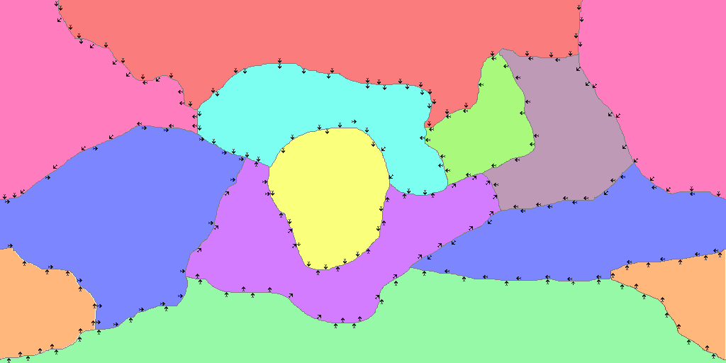
Current supplied plate layers composited for review.

Authority Model
Subject | Authority
Canonical home world | LucentForge/docs/bible
Panel and WorldPos model | Existing Rooms & Panels Addendum
Generator architecture | LucentForge/docs/genesis
Source maps and layers | LucentForge/assets/maps/world_map
Experimental algorithms | Genesis research/prototypes

Key Reconciliation
The planetary map is an authoring, indexing, and sparse-simulation layer. It does not create a Final Fantasy-style world-map body or replace the fixed 18x18 Panel. Players and NPCs continue to inhabit the existing one-scale panel world.

Proposed Bible Additions
- Lucent Forge World Foundation v1
- Planetary Tectonics Addendum v1
- World Map & Scale Addendum v1
- Climate, Hydrology & Biome Addendum v1

Genesis Technical Documents
- Genesis Architecture
- Generation Pipeline
- Data Contracts
- Validation Strategy
- Canonical Home-World Adapter

Current Plate Intent
The home world is approaching a supercontinent state. The Central Plate is the convergence focus; the Deep Ocean Plate is a closing ocean basin under pressure from Greaterlands and Lessorland; and the northern and southern archipelago systems are major island-producing tectonic regions.

Immediate Next Workshop
Number every visible boundary segment and classify it individually as convergent, divergent, transform, diffuse/complex, or uncertain. Do not assign one boundary type to an entire plate edge.

Package Contents
- 00_START_HERE.md
- 01_REPOSITORY_AUTHORITY_AUDIT.md
- 02_PROPOSED_FILE_PLAN.md
- 03_BIBLE_WORLD_FOUNDATION_DRAFT.md
- 04_BIBLE_TECTONICS_DRAFT.md
- 05_BIBLE_MAP_SCALE_DRAFT.md
- 06_BIBLE_CLIMATE_HYDROLOGY_DRAFT.md
- 07_MAP_ASSET_STANDARD.md
- 08_PLATE_REGISTRY_AND_REVIEW.md
- 09_GENESIS_ARCHITECTURE.md
- 10_GENESIS_PIPELINE.md
- 11_GENESIS_DATA_CONTRACTS.md
- 12_GENESIS_VALIDATION.md
- 13_CLAUDE_EXECUTION_PROMPT.md
- 14_COMPLETION_REPORT.md
- 15_DECISION_REGISTER.md

