Symplectic Euler Algorithm:

The use of the symplectic

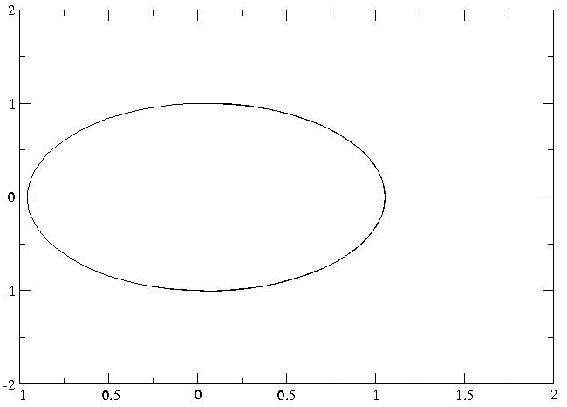

y
x

