OPENAI SHOWCASE SUBMISSION DOSSIER
Synthia
Living Taxonomy for Scientific Memory
Prepared by Jean-Sebastien Beaulieu | SecuredMe | 14 July 2026
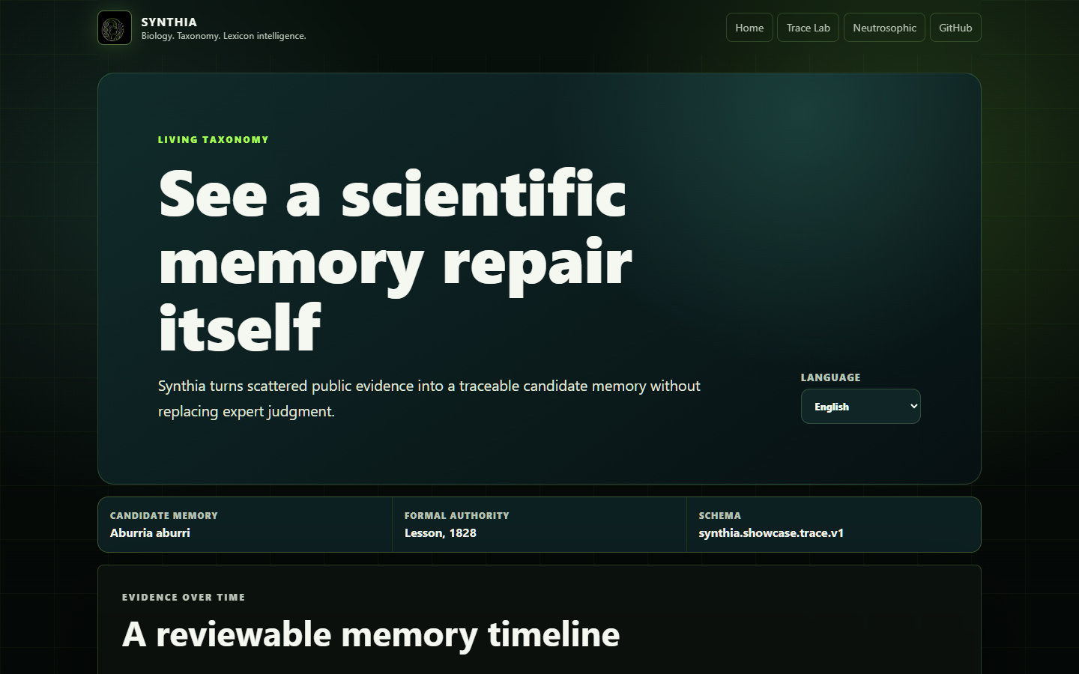
Traceable evidence. Explicit uncertainty. Human authority.

Prepared 2026-07-14 for the current OpenAI Showcase Gallery submission form (https://openai.com/form/showcase-submission/).

Submission decision
Synthia should be presented as a free, source-available educational research demo built with Codex, not as an OpenAI-powered production service. Its differentiator is the living taxonomy trace: public evidence is transformed into a versioned, reviewable candidate memory while sources, uncertainty, and human scientific authority stay visible.
The hosted Trace Lab makes that proposition understandable in under a minute. The Python CLI proves that the public JSON is generated by the repository rather than hand-authored for the website.

Copy-ready form answers

About you
- First name: Jean-Sebastien
- Last name: Beaulieu
- Email: Use the submitter's preferred public or account email.
- Website: https://securedme.ca/

About the project
What type of project are you submitting?
Free, source-available educational research demo and developer tool
Did you use Codex to build this?
Yes
Did you use another coding agent to build this?
No
Use “No” for this specific Showcase build unless another agent materially contributed to the submitted Trace Lab implementation and can be documented.
What is the tech stack used in the project?
Python 3.10+, argparse CLI, versioned JSON, static HTML/CSS/JavaScript, pytest, GitHub Actions, and cPanel static hosting.
List use cases showcased in your project — 159/255 characters
Education; biological taxonomy; scientific knowledge management; source traceability; uncertainty-aware classification; and human review of candidate memories.
Which capability are you showcasing? — 360/1000 characters
Codex-assisted source-available development and structured, traceable outputs. Codex helped inspect the existing system, preserve its scientific boundaries, implement a deterministic JSON export, add tests and CI, and build a multilingual Trace Lab. The result demonstrates how a coding agent can turn a research architecture into a reproducible community artifact.
Which OpenAI models and APIs are you using? — 222/500 characters
No OpenAI API is called at runtime. Codex, used through the authenticated OpenAI coding-agent workflow, helped build, test, review, and document the repository. The public demo is static, keyless, and reproducible locally.
Are you using other models or APIs? — 161/255 characters
No runtime AI model or external application API is used by the submitted Trace Lab. It reads a versioned JSON artifact generated locally by Synthia's Python CLI.
Describe the building process and coding-agent use — 475/500 characters
I began with a personal research codebase for context-preserving lexicon intelligence and taxonomy memory. With Codex, I audited the repository, formalized one public-safe Aburria case as a stable JSON contract, added privacy and authority guardrails, wrote tests and CI, and built a four-language static Trace Lab. Codex exercised the CLI, ran the full test suite, checked desktop and mobile layouts, and prepared this dossier while preserving Synthia's internal governance.

Project details
Public GitHub repository
https://github.com/SeCuReDmE-main-dev/Synthia
Hosted URL
https://synthia.securedme.ca/trace-lab.html
Setup steps — 401/500 characters
Clone the repository, create a Python 3.10+ virtual environment, and run python -m pip install -e . pytest. Generate the public case with python -m synthia_core.cli showcase export --case aburria --output trace.json --pretty. Run python -m pytest -q for validation. To view the Trace Lab locally, serve web/landing with any static HTTP server and open trace-lab.html. No API key is required.
Project title — 31/255 characters
Synthia: Living Taxonomy Memory
Project tagline — 183/255 characters
Turn scattered scientific evidence into a traceable candidate memory. Synthia keeps sources, uncertainty, and human authority visible from the first record to the final review packet.
Project description — 968/1000 characters
Scientific knowledge rarely arrives as one clean record. A name can gain morphology, ecology, and new interpretation across centuries. Synthia treats that history as a living, inspectable memory rather than flattening it into one answer.
The Aburria Trace Lab follows Aburria aburri from Lesson's 1828 authority through a critical 2012 redescription and a 2026 peer-reviewed taxonomy context. A deterministic Python command exports the same versioned JSON rendered by the English, French, Spanish, and Italian interface. Each trace identifies restored layers, unresolved questions, and public sources.
Codex helped turn the research architecture into this tested community artifact. Synthia does not claim nomenclatural authority or call an AI API at runtime: AI supports traceability, while qualified humans retain scientific judgment. Taxonomy direction credits Prof. Hector Fernando Aguilar; Jean-Sebastien Beaulieu leads software architecture and implementation.
Displayed author name — 35/500 characters
Jean-Sebastien Beaulieu (SecuredMe)
Public cover image
https://synthia.securedme.ca/assets/showcase-cover.png
The cover is a screenshot of the submitted Trace Lab. Verify that the URL returns HTTP 200 after deployment before submitting the form.

Demonstration script
- Open the hosted Trace Lab and identify the schema synthia.showcase.trace.v1.
- Follow the 1828 → 2012 → 2026 evidence timeline.
- Contrast the restored memory layers with the explicitly unresolved layers.
- Open a public source from the registry.
- Switch from English to French, Spanish, or Italian.
- Show the authority boundary and the invariant I -> I_system^S -> H_lex -> G_lex -> I_lexicon.
- Copy the local CLI command and regenerate the same JSON from the repository.

Claims and evidence
Claim | Repository evidence | Public proof
The trace is generated, not hand-written | synthia_core/showcase.py; synthia showcase export | Generated JSON displayed by Trace Lab
The output is stable | Deterministic JSON serialization and schema version | synthia.showcase.trace.v1 shown in the UI
Private evidence is excluded | Fail-closed marker scan and tests | Public registry contains only public citations/URLs
Human authority is preserved | human_review_required: true; ai_role: traceability_support_only | Boundary panel in the UI
The demo is multilingual | Locale contract and browser selector | English, French, Spanish, Italian
The demo is keyless | Static same-origin JSON fetch only | Browser network contains no AI/API request
The repository is testable | pytest suite and Python 3.10/3.12 CI | Public GitHub Actions after merge

Architecture
public sources
|
v
curated showcase builder -- fail-closed privacy/authority checks
|
v
synthia.showcase.trace.v1 JSON
| \
v v
Python CLI proof static Trace Lab
|
v
four languages + human review
The showcase package is deliberately separated from Synthia's private evidence ledger. It cannot read private Drive or correspondence identifiers. It also does not introduce the separate fractal hierarchy into the public I_lexicon chain.

Scientific source boundary
- Formal authority displayed by the case: Lesson, 1828.
- Critical redescription metadata: Aguilar, H. F. & Aguilar H., R. F. (2012), Revista de Ecología Latinoamericana 17(3):53-61.
- Current peer-reviewed context: Taxonomy of Aburria Reichenbach, 1853 (Aves, Galliformes, Cracidae) based on morphological characters (https://doi.org/10.11606/1807-0205/2026.66.014), 2026.
- Current registry context: NCBI Taxonomy Browser, Taxonomy ID 125058 (https://www.ncbi.nlm.nih.gov/Taxonomy/Browser/wwwtax.cgi?id=125058&mode=info).
These sources support a review trace. They do not turn Synthia into a formal nomenclatural authority.

Safety, privacy, and governance
- No raw API key, provider token, private correspondence, or private evidence ID is embedded in the trace or website.
- No AI model is invoked by a public visitor.
- Scientific conclusions remain review candidates.
- The SEL-2.0 license and SecuredMe school-tool governance remain unchanged.
- During pre-alpha, public feedback is issue-based and external pull-request evaluation remains paused.
- The OpenAI name must not be used to imply sponsorship, certification, endorsement, partnership, or joint product status.

Final submission gate
- [ ] The implementation is merged into main.
- [ ] GitHub Actions is green on Python 3.10 and 3.12.
- [ ] Issues are enabled; repository description and homepage are set.
- [ ] The hosted Trace Lab, JSON, JavaScript, CSS, and cover image return 200.
- [ ] The public cover URL renders without authentication.
- [ ] The repository contains no secret or private-evidence marker.
- [ ] The final displayed author and email are approved by Jean-Sebastien.
- [ ] Jean-Sebastien personally reviews and accepts the Showcase Program Agreement. Codex must not check the attestation box or submit the legal form.

Why this can stand out
Many AI demos optimize for a fluent final answer. Synthia makes the memory construction visible: what was restored, what remains unresolved, which source supports each step, which lexicon governs the classification, and where the AI must stop. That combination of scientific humility, deterministic developer tooling, multilingual explanation, and a no-key public demo gives the project a clear identity without overstating its maturity.

