SECUREDME EDUCATION / PUBLIC PRE-ALPHA
Scholarium Teach - Student Guide
STUDENT GUIDE
Edition: Public pre-alpha 2026.07
Data boundary: Synthetic education data only until the EFVP and pilot authorization are complete.

What Teach Is
Scholarium Teach helps you practice, preserve evidence of progress, connect schoolwork with projects and strengths, and decide what you want to share. A grade is one signal. It is never treated as a complete description of you.
Teach can structure and explain. It cannot diagnose you, certify a talent, make an official school decision, or replace a teacher, guardian, accessibility professional, or other qualified person.

Start A Session
- Open Teach from the Scholarium navigation.
- Choose Cours and select the lesson or review checkpoint.
- Confirm the learning goal shown for the session.
- Select an accessibility mode or keep your saved preferences.
- Answer in the mode that works for you: text, keyboard navigation, supported visual choices, or another available accessible path.
- End or pause when needed. Teach saves the exact checkpoint for the next session.

How Mastery Works
Teach records the learning process, not only the final response. A concept can move through six states: nouvelle, guidee, rappelee, contextualisee, maitrisee, and a revoir.
A correct answer counts as stronger evidence when you can recall it after a delay and use it in the right context. Reading a model, repeating a sentence, or selecting OK does not count as mastery by itself.
The help scale is visible and gradual: wait time, a hint, the first segment, segmentation, then a complete model. Using help is evidence about the next useful teaching step, not a penalty.

Accessibility Controls
Teach is designed so essential learning paths do not require voice, a mouse, or animation. Available preferences include:
- deaf or signed-language support with text-first presentation and signed content when available;
- non-verbal communication with text, choices, pictograms, and assisted communication paths;
- Autism Calm with predictable sequences and reduced surprise;
- Tourette Safe with no penalty for delay, movement, tic, or vocalization;
- ADHD Sprint with a short objective and a visible next action;
- Dyslexia Reading with adjustable typography, width, spacing, and audio support;
- Dyspraxia Motor with larger targets and no precision-only interaction;
- motion, contrast, saturation, density, sound, and speed controls.
Preferences support access. They are not diagnoses and are not shown as fixed labels about you.

Your Strength Mirror
Teach can store three kinds of strength observations: one you declare, one supported by an activity, or one proposed as a possible learning bridge. Every proposed observation keeps its evidence, contradiction, confidence, source, date, and expiry.
You can accept, reformulate, contest, expire, or delete an interpretation. A soccer success may suggest testing a spatial strategy for geometry, but it never proves mathematics mastery. The bridge is a hypothesis you control and test.

Portfolio And Growth Stories
A growth story can connect a result, the evidence behind it, the context, and your reflection. It may describe academic, athletic, musical, artistic, social, or project progress.
You can keep the original expression of a difficult moment and optionally prepare a second, shareable formulation. Teach does not force positivity and does not erase frustration. Sharing remains a separate choice.
Project threads preserve milestones, versions, files, sources, and contributions. Recognitions can describe perseverance, creativity, leadership, mutual aid, clarity, or progress without turning them into a single popularity score.

Sources And AI
Sources in Teach carry provenance: author or institution, URL, date, rights, and classification state. Synthia helps classify records. MemoryLake indexes trace records. HippoRAG retrieves approved passages only. Codex or Gemini prepares the user-facing explanation.
AI does not become a teacher, scientific authority, taxonomic authority, clinician, disciplinarian, or judge. Check the source trail and ask a human when a decision matters.

Video And Podcast Requests
Media generation is always started by you. The initial product quota is three videos of up to five minutes and five podcasts of up to thirty minutes per day, further limited by the actual free capacity of the media engine.
A media request uses selected sources and evidence. Generation does not publish anything. External publication requires a separate confirmation.

Your Data Controls
Teach separates consent for learning, personalization, profiling, sharing, and media. You can review or withdraw each purpose separately. Account tools support access, correction, export, consent withdrawal, and Teach-domain deletion.
If a proposed interpretation is wrong, correct it at the source. If a sharing choice no longer fits, revoke it. If you are under the applicable consent age, the guardian workflow also applies.

Quick Check Before Sharing
- Is the statement honest about both difficulty and progress?
- Is attached evidence yours to share?
- Are the people named allowed to appear?
- Does the source trail remain attached?
- Are you choosing to share, rather than being pressured?
- Would you still be comfortable if the intended circle saw it tomorrow?

Current Boundary
Scholarium Teach is in public pre-alpha. Use synthetic or approved demonstration data only. Do not enter medical records, identity documents, passwords, private provider tokens, disciplinary records, or other sensitive data into a demonstration account.

System Map
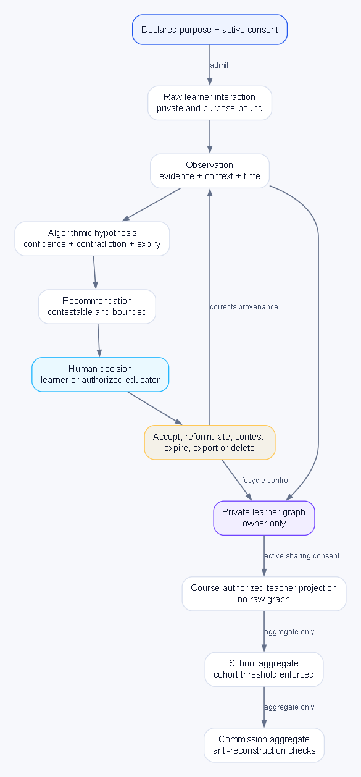
System map: learner control remains present from observation through correction, sharing, and deletion.

