SECUREDME EDUCATION / PUBLIC PRE-ALPHA
Scholarium Teach - Teacher Guide
TEACHER GUIDE
Edition: Public pre-alpha 2026.07
Operational boundary: Synthetic education data only until the EFVP and pilot authorization are complete.

Teaching Purpose
Teach organizes objectives, attempts, help levels, delayed recall, contextual transfer, accessible participation, projects, and learner-controlled strength observations. It supports instructional judgment; it does not automate grades, diagnoses, discipline, placement, or other consequential decisions.

Prepare A Course
- Confirm the school, course, class, and enrollment dates.
- Define the learning objective and the evidence needed to support mastery.
- Choose the available accessibility paths before assigning the activity.
- Set the reminder schedule and contextual-transfer checkpoint.
- Identify which records are required for teaching and which optional purposes need separate consent.
- Test the learner path without voice, mouse, or animation.

Read A Learning Summary
Teacher views expose course-authorized summaries, not the learner's private assistant graph or raw private notes. A useful summary distinguishes:
- the learning objective;
- the question and response context;
- the level of help required;
- recurring confusion or error pattern;
- immediate and delayed recall evidence;
- transfer to a new context;
- accessibility preferences relevant to delivery;
- a suggested next instructional action.
An answer seen once is not automatically mastery. A complete model supplied by the system is not learner evidence. Delayed recall and contextual use provide stronger evidence.

Plan An Intervention
Use the smallest intervention that can reveal the next learning step. Respect the learner's frequency, context, quiet mode, and quiet-until preferences. An off preference means zero automated interventions.
Tourette Safe never penalizes tic, delay, movement, or vocalization. Non-verbal and deaf/signed paths must preserve the same educational objective. Autism Calm favors predictability. ADHD Sprint narrows the immediate objective. Dyslexia and dyspraxia modes change presentation and interaction demands, not the standard of respect.

Work With Strength Observations
Declared strengths can be active immediately. Observed or proposed interpretations stay pending learner review and normally expire after 90 days. Evidence, contradictions, confidence, age, and learner correction remain visible.
Use a strength bridge as a testable instructional strategy. For example, documented spatial timing in soccer may justify trying angles, trajectories, or spatial representation in mathematics. It does not prove mathematics mastery and must not become a fixed intelligence label.

Assistant Cooperation
The teacher assistant can receive a bounded projection only when the learner is actively enrolled and has active sharing consent. scholarium.assistant-exchange.v1 requires a declared purpose, expiry within seven days, idempotency, and a read receipt.
Allowed purposes are progress review, intervention planning, and weekly alignment. The projection excludes raw answers, the private learner graph, private notes, and diagnostic labels. Recommendations are short, contestable, and subject to human review.

Portfolio, Projects And Recognition
Growth stories preserve evidence, context, and reflection. Project threads preserve milestones, versions, files, sources, and contributions. Recognitions describe a specific behavior or contribution such as perseverance, creativity, leadership, mutual aid, clarity, or progress.
Do not convert recognition into a composite learner-value score. Do not use reach or popularity as authority. An honest difficulty can remain visible; reformulation is optional and must not erase the learner's voice.

Teacher Analytics
Use the teacher dashboard to compare objectives, confusion patterns, help levels, recall timing, transfer evidence, accessibility delivery, and intervention outcomes. Analytics guide inquiry; they do not establish cause by themselves.
Avoid comparisons that reduce a person to a grade or popularity measure. Verify unusual patterns against course context and learner input before acting.

Sources, Research And Media
Production retrieval reads only the approved source graph. Preparation and quarantine remain isolated. HippoRAG is retrieval-only; Codex or Gemini generates the explanation from returned passages. Source provenance must remain attached.
Learners explicitly trigger each video or podcast request. Initial quotas are three five-minute videos and five thirty-minute podcasts per day, bounded further by the media engine. Generation and external publication are separate actions.

Privacy And Consent Checklist
- Use the minimum data needed for the declared educational purpose.
- Verify learning, personalization, profiling, sharing, and media consents separately.
- Apply the guardian workflow when required.
- Keep raw learner records out of email, plugins, proofs, media receipts, and observability logs.
- Use access, correction, export, withdrawal, and deletion workflows instead of ad hoc copies.
- Escalate consequential decisions to authorized humans.
- Use no real student data before EFVP approval and pilot authorization.

Incident Response
Stop the affected workflow, preserve technical evidence without learner content, notify the designated privacy or security lead, and follow the approved incident procedure. Do not use an assistant to make the final legal, disciplinary, clinical, or safety decision.

System Map
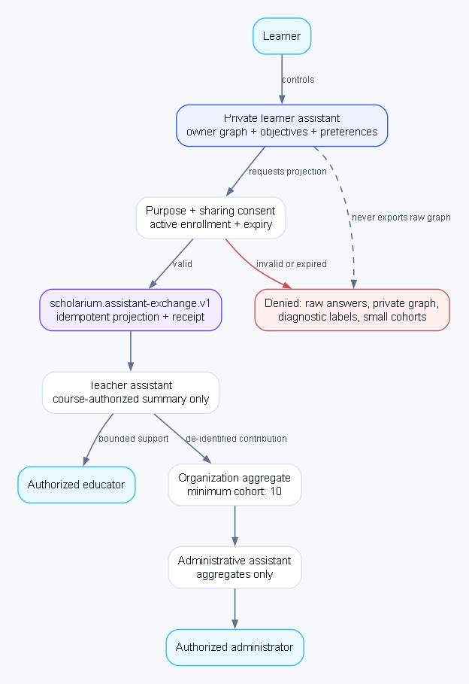
System map: assistants cooperate through bounded projections; the private learner graph is never exported.

