Table S2. All models tested for parameter-identity relationships

 | Fit Type: | Equation:
Single identity parameter | Linear | 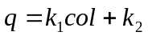
Single identity parameter | Quadratic | 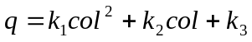
Single identity parameter | Cubic | 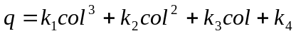
Single identity parameter | Rational (A) | 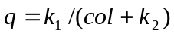
Single identity parameter | Rational (B) | 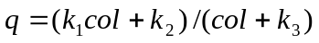
Single identity parameter | Power Law (A) | 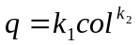
Single identity parameter | Power Law (B) | 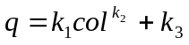
Single identity parameter | Exponential (A) | 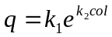
Single identity parameter | Exponential (B) | 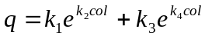
Single identity parameter | Exponential (C) | 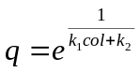
Two identity parameters | 2D Linear | 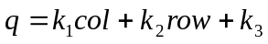
Two identity parameters | 2D Quadratic (A) | 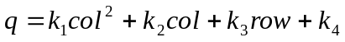
Two identity parameters | 2D Quadratic (B) | 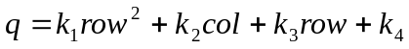
Two identity parameters | 2D Quadratic (C)

Note that in each equation for a single identity parameter, col could be replaced with row. col: column.

