МІНІСТЕРСТВО ОСВІТИ І НАУКИ УКРАЇНИ НАЦІОНАЛЬНИЙ УНІВЕРСИТЕТ «ЛЬВІВСЬКА ПОЛІТЕХНІКА»
Інститут прикладної математики і фундаментальних наук Кафедра прикладної математики



Лабораторна робота №5
з курсу “Програмування настільних застосунків”
Тема: “Наслідування. Створення та використання ієрархії класів”

Виконав студент групи ПМ-33 Венгринюк Олег
Прийняла Терендій О. В.
Завдання для лабораторної роботи:

- Розробити ієoрархію класів відповідно до варіанту.
- Створити базовий, похідні класи.
- Використати public, protected наслідування.
- Виконати перевантаження функцій в базовому класі, перевизначити їх в
похідних.
- Включити в звіт Uml-діаграму розробленої ієрархії класів.
- Продемонструвати можливості класів.

Класи, що потрібно реалізувати:
- Базовий кредит
- Кредит, при якому сума ділиться рівними платежами;
- Кредит, при якому нараховується відсоток від суми залишку;
- Пільговий кредит, при якому держава компенсовує частину відсотків по кредиту.
Класи повинні мати повний набір методів для роботи з ними. Кожен клас
обов’язково повинен вміти обчислити суму платежу в заданий місяць, суму виплачену
до заданого місяця, суму, яка буде виплачена за весь період.

Програмний код:
Main.java
import Credit.Credit;
import Credit.CreditPercentage;
import Credit.CreditSpecial;
import Credit.CreditUniform;

import java.util.Calendar;
import java.util.Date;

public class Main {
public static void main(String [] args){
testCredit(10000, "11-2019" , "10-2020");
testCreditPercentage(10000, "12-2019" , "12-2020");
testCreditUniform(10000, "11-2019" , "11-2020");
testCreditSpecial(10000, "11-2019" , "11-2020");
}

static private void testCredit(int sum, String dateTake, String dateGive){

Credit credit = new Credit(sum, dateTake, dateGive);

int paymentMonth = 6;
int totalPaymentMonth = 8;
int numberPayMonth = 12;

System.out.print("Sum: ");
System.out.println(sum);

System.out.print("Interest rate: ");
System.out.println(credit.getInterestRate());

System.out.print("Total sum with interest rate: ");
System.out.println(credit.getTotal());

System.out.print("Date when credit taken: ");
System.out.println(dateTake);
System.out.print("Date when credit given: ");
System.out.println(dateGive);

System.out.print("Payment history: ");
System.out.println(credit.getPaymentHistory());
System.out.print("Payment Schedule: ");
System.out.println(credit.getPaymentSchedule());

double moneyToPay = credit.getPaymentSchedule(dateTake);
System.out.println(String.format("You should pay %f money in %d month: ",moneyToPay, paymentMonth));

credit.pay(dateTake);

System.out.print(String.format("Total paid unit %d month: ", totalPaymentMonth));
System.out.println(credit.getTotalPaid(dateGive));
System.out.print("Total sum with interest rate: ");
System.out.println(credit.getTotal());
System.out.print("Ovepay: ");
System.out.println(credit.getOverpay());
}

static private void testCreditUniform(int sum, String dateTake, String dateGive){

CreditUniform credit = new CreditUniform(sum, dateTake, dateGive);

int paymentMonth = 6;
int totalPaymentMonth = 8;
int numberPayMonth = 12;

System.out.print("Sum: ");
System.out.println(sum);

System.out.print("Interest rate: ");
System.out.println(credit.getInterestRate());

System.out.print("Total sum with interest rate: ");
System.out.println(credit.getTotal());

System.out.print("Date when credit taken: ");
System.out.println(dateTake);
System.out.print("Date when credit given: ");
System.out.println(dateGive);

credit.pay("10-2019");
credit.pay("11-2019");
credit.pay("12-2019");

System.out.print("Payment history: ");
System.out.println(credit.getPaymentHistory());
System.out.print("Payment Schedule: ");
System.out.println(credit.getPaymentSchedule());

double moneyToPay = credit.getPaymentSchedule(dateTake);
System.out.println(String.format("You should pay %f money in %d month: ",moneyToPay, paymentMonth));

credit.pay(dateTake);

System.out.print(String.format("Total paid unit %d month: ", totalPaymentMonth));
System.out.println(credit.getTotalPaid(dateGive));
}

static private void testCreditPercentage(int sum, String dateTake, String dateGive){

CreditPercentage credit = new CreditPercentage(sum, dateTake, dateGive);

int paymentMonth = 6;
int totalPaymentMonth = 8;
int numberPayMonth = 12;

System.out.print("Sum: ");
System.out.println(sum);

System.out.print("Interest rate: ");
System.out.println(credit.getInterestRate());

System.out.print("Total sum with interest rate: ");
System.out.println(credit.getTotal());

System.out.print("Date when credit taken: ");
System.out.println(dateTake);
System.out.print("Date when credit given: ");
System.out.println(dateGive);

double payPart = 1000;

credit.pay("10-2019", payPart);
credit.pay("11-2019", payPart);
credit.pay("12-2019", payPart);
credit.pay("01-2020", payPart);
credit.pay("02-2020", payPart);
credit.pay("03-2020", payPart);
credit.pay("04-2020", payPart);
credit.pay("05-2020", payPart);
credit.pay("06-2020", payPart);
credit.pay("07-2020", payPart);
credit.pay("08-2020", payPart);
credit.pay("09-2020", payPart);
credit.pay("10-2020", payPart);

System.out.print("Payment history: ");
System.out.println(credit.getPaymentHistory());
System.out.print("Payment Schedule: ");
System.out.println(credit.getPaymentSchedule());

double moneyToPay = credit.getPaymentSchedule(dateTake);
System.out.println(String.format("You should pay %f money in %d month: ",moneyToPay, paymentMonth));

credit.pay(dateTake);

System.out.print(String.format("Total paid unit %d month: ", totalPaymentMonth));
System.out.println(credit.getTotalPaid(dateGive));
System.out.print("Total sum with interest rate: ");
System.out.println(credit.getTotal());
System.out.print("Overpay: ");
System.out.println(credit.getOverpay());
}

static private void testCreditSpecial(int sum, String dateTake, String dateGive){

CreditSpecial credit = new CreditSpecial(sum, dateTake, dateGive);

int paymentMonth = 6;
int totalPaymentMonth = 8;
int numberPayMonth = 12;

System.out.print("Sum: ");
System.out.println(sum);

System.out.print("Interest rate: ");
System.out.println(credit.getInterestRate());

System.out.print("Interest goverment dotation rate: ");
System.out.println(credit.getGovermentDotationRate());

System.out.print("Total sum with interest rate: ");
System.out.println(credit.getTotal());

System.out.print("Date when credit taken: ");
System.out.println(dateTake);
System.out.print("Date when credit given: ");
System.out.println(dateGive);

credit.pay("10-2019");

System.out.print("Payment history: ");
System.out.println(credit.getPaymentHistory());
System.out.print("Payment Schedule: ");
System.out.println(credit.getPaymentSchedule());

double moneyToPay = credit.getPaymentSchedule(dateTake);

System.out.println(String.format("You should pay %f money in %d month: ",moneyToPay, paymentMonth));

credit.pay(dateTake);

System.out.print(String.format("Total paid unit %d month: ", totalPaymentMonth));
System.out.println(credit.getTotalPaid(dateGive));
System.out.print("Total sum with interest rate: ");
System.out.println(credit.getTotal());
}

}
Credit.java
package Credit;

import java.util.HashMap;
import java.util.Calendar;
import java.text.SimpleDateFormat;
import java.util.Date;
import java.text.ParseException;

public class Credit {

protected static int minSum = 10000;
protected static int minDurationMonth = 6;
protected static double interestRate = 0.2;
protected static double interestRateMonth = interestRate/12;
static double firstPaymentPart = 0.3;

double body, total;
int durationMonth;
Date dateTake, dateGive;
HashMap <String, Double> paymentHistory, paymentSchedule;

Calendar c = Calendar.getInstance();
String dateFormat = "MM-yyyy";
SimpleDateFormat sdf = new SimpleDateFormat(dateFormat);

public Credit(double sum){
checkSum(sum);
Date dateTake = new Date();
Date dateGive = addDate(dateTake, minDurationMonth);

setBody(sum);
setDurationMonth(minDurationMonth);
initTotal();

setDateTake(dateTake);
setDateGive(dateGive);
initPaymentSchedule(dateTake, this.durationMonth);
initPaymentHistory();
}

public Credit(double sum, int duration){
checkSum(sum);
checkDuration(duration);

Date dateTake = new Date();
Date dateGive = addDate(dateTake, duration);

setBody(sum);
setDurationMonth(durationMonth);
initTotal();

setDateTake(dateTake);
setDateGive(dateGive);
initPaymentSchedule(dateTake, this.durationMonth);
initPaymentHistory();
}

public Credit(double sum, String dateTakeS, String dateGiveS){
checkSum(sum);
checkDateS(dateTakeS);
checkDateS(dateGiveS);

dateTake = keyToDate(dateTakeS);
dateGive = keyToDate(dateGiveS);
durationMonth = getDurationMonth(dateTake, dateGive);

setBody(sum);
setDurationMonth(durationMonth);
initTotal();

setDateTake(dateTake);
setDateGive(dateGive);
initPaymentSchedule(dateTake, durationMonth);
initPaymentHistory();
}

public Credit(Credit anotherCredit){

this.body = anotherCredit.getBody();
this.total = anotherCredit.getTotal();
this.dateTake = keyToDate(anotherCredit.getDateTake());
this.dateGive = keyToDate(anotherCredit.getDateGive());
this.durationMonth = anotherCredit.getDuration();
this.paymentSchedule = new HashMap<String, Double> (anotherCredit.getPaymentSchedule());
this.paymentHistory = new HashMap<String, Double> (anotherCredit.getPaymentHistory());
}

// --------------- Interface

public double getBody(){
return body;
}

public double getTotal(){
return total;
}

public int getDuration() {
return durationMonth;
}

public String getDateTake() {
return dateToKey(dateTake);
}

public String getDateGive(){
return dateToKey(dateGive);
}

public HashMap getPaymentHistory() {
return paymentHistory;
}

public HashMap getPaymentSchedule(){
return paymentSchedule;
}

public double getPaymentSchedule(String dateS){
checkDateS(dateS);

return paymentSchedule.get(dateS);
}

public double getTotalPaid(String dateS){
checkDateS(dateS);

Date startDate = dateTake;
Date endDate = keyToDate(dateS);
c.setTime(startDate);
double totalSum = 0;

while(getDurationMonth(c.getTime(), endDate) != 0){
totalSum += getPaymentHistory(dateToKey(c.getTime()));
}

return totalSum;
}

public double getOverpay(){
return total - body;
}

public double getPaymentHistory(String dateS){
checkDateS(dateS);
double record = paymentHistory.containsKey(dateS)? paymentHistory.get(dateS): 0;
return record;
}

public void pay(String dateS){
checkDateS(dateS);

paymentHistory.put(dateS, paymentSchedule.get(dateS));
paymentSchedule.put(dateS, 0.);
body -= paymentSchedule.get(dateS);
}

public double getInterestRate() { return interestRate; }

public double getInterestRateMonth() { return interestRateMonth; }

// --------------- Setters

void setBody(double sum){ body = sum; }

void initTotal(){
total = (1+interestRate/12*durationMonth)*body;
}

void setDurationMonth(int durationMonth) { this.durationMonth = durationMonth;}

void setDateTake(Date d){ dateTake = d; }

void setDateGive(Date d){ dateGive = d; }

void initPaymentSchedule(Date dateTake, int duration){
paymentSchedule = new HashMap();

double firstPayment = total*firstPaymentPart;
double otherPayment = total*(1-firstPaymentPart)/durationMonth;
c.setTime(dateTake);
paymentSchedule.put(dateToKey(c.getTime()), firstPayment);
for(int i=1; i<durationMonth; ++i){
c.setTime(dateTake);
c.add(Calendar.MONTH, i);
paymentSchedule.put(dateToKey(c.getTime()), otherPayment);
}
}

void initPaymentHistory(){
paymentHistory = new HashMap();
}

// --------------- Helpers

void checkSum(double sum){

}

void checkDateS(String dateS){

}

void checkDuration(int duration){

}

String dateToKey(Date d){
String key = sdf.format(d);
return key;
}

Date keyToDate(String key){
try {
return sdf.parse(key);
} catch (java.text.ParseException pe) {
throw new IllegalArgumentException(String.format("Incorrect date format, expect %s", dateFormat));
}
}

int getDurationMonth(Date a, Date b){
c.setTime(a);
int y1 = c.get(Calendar.YEAR), m1 = c.get(Calendar.MONTH);
c.setTime(b);
int y2 = c.get(Calendar.YEAR), m2 = c.get(Calendar.MONTH);
int duration = (y2 - y1)*12 + m2 - m1;

return duration;
}

Date addDate(Date d, int months){
c.setTime(d);
c.add(Calendar.MONTH, months);

return new Date();
}

Date addDate(Date d1, Date d2){

return new Date();
}
}
CreditPercentage.java
package Credit;

import java.util.Calendar;
import java.util.Date;
import java.util.HashMap;

import Credit.Credit;

public class CreditPercentage extends Credit {
private double startBody;

public CreditPercentage(double sum, String dateTakeS, String dateGiveS) {
super(sum, dateTakeS, dateGiveS);
setStartBody(sum);
initPaymentSchedule(keyToDate(getDateTake()), getDuration());
}

void initPaymentSchedule(Date dateTake, int duration) {
paymentSchedule = new HashMap<String, Double>();

for (int i = 0; i < durationMonth; ++i) {
c.setTime(dateTake);
c.add(Calendar.MONTH, i);
paymentSchedule.put(dateToKey(c.getTime()), 0.);
}

paymentSchedule.put("percents", 0.);
}

public void pay(String dateS, double sum){
checkDateS(dateS);
checkSum(sum);

String dateGiveS = dateToKey(dateGive);

paymentHistory.put(dateS, sum);
body -= sum;

double percents = paymentSchedule.get("percents");
percents += body*interestRateMonth;
paymentSchedule.put("percents", percents);

if (dateGiveS.equals(dateS)){
System.out.print("Overpay: ");
System.out.println(paymentSchedule.get("percentage"));
}

}

public double getTotal(){
return getPaymentSchedule("percents") + startBody;
}

private void setStartBody(double sum){ startBody = sum; }

public double getPaymentSchedule(String dateS){
checkDateS(dateS);

System.out.print(" ");

return paymentSchedule.get(dateS);
}

public double getOverpay(){
return paymentSchedule.get("percents");
}

}
CreditSpecial.java

package Credit;

import Credit.Credit;

public class CreditSpecial extends Credit{
private static double govermentDotationRate = 0.1;

public CreditSpecial(double sum, String dateTake, String dateGive){
super(sum, dateTake, dateGive);

this.total = sum*(1 + Credit.interestRate - govermentDotationRate);
super.initPaymentSchedule(keyToDate(dateTake), durationMonth);
}

public static double getGovermentDotationRate() {
return govermentDotationRate;
}
}
CreditUniform.java
package Credit;

import java.util.HashMap;
import java.util.Calendar;
import java.text.ParseException;

public class CreditUniform extends Credit{

public CreditUniform(double sum, String dateTakeS, String dateGiveS){
super(sum, dateTakeS, dateGiveS);
initPaymentSchedule();
}

void initPaymentSchedule(){
paymentSchedule = new HashMap<String, Double>();

double payment = total/durationMonth;
for(int i=0; i<durationMonth; ++i){
c.setTime(dateTake);
c.add(Calendar.MONTH, i);
paymentSchedule.put(dateToKey(c.getTime()), payment);
}
}

}

UML діаграм:

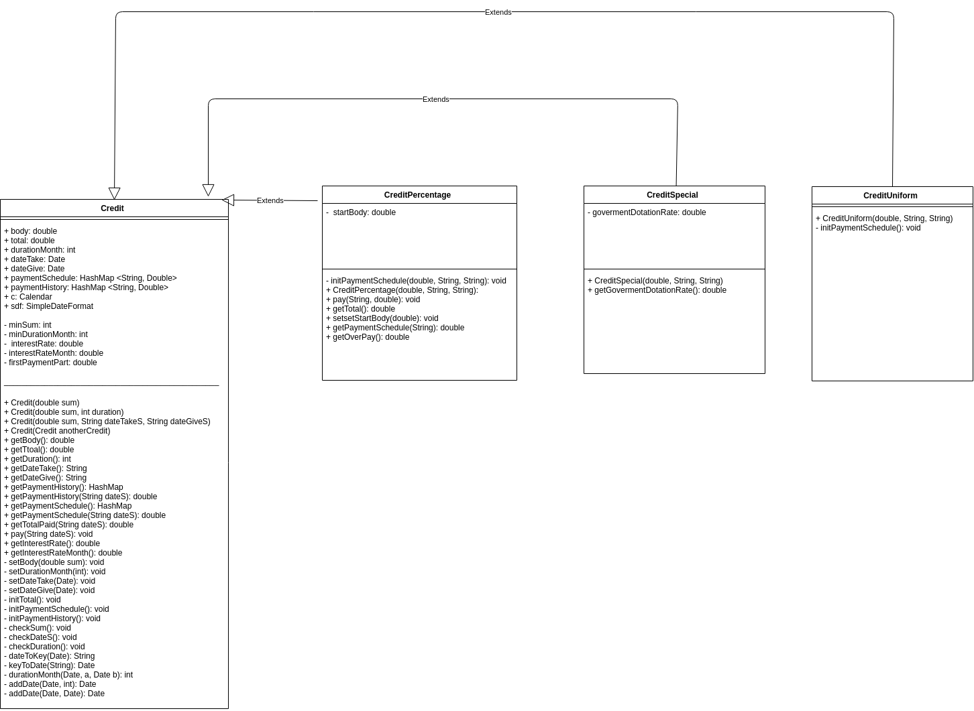

Результат виконання роботи:

Test Credit
Sum: 10000
Interest rate: 0.2
Total sum: 11833.33

Date when credit was taken: 11-2019
Date when credit was given: 10-2020

Pay 3550.00 on 11-2019
Pay 753.03 on 12-2019
Pay 753.03 on 01-2020

Payment Schedule
09-2020: 753.03
06-2020: 753.03
01-2020: 0.00
11-2019: 0.00
03-2020: 753.03
07-2020: 753.03
12-2019: 0.00
02-2020: 753.03
05-2020: 753.03
04-2020: 753.03
08-2020: 753.03

Payment history
01-2020: 753.03
11-2019: 3550.00
12-2019: 753.03

Total paid is 0.00 until 06-2020
Overpay: 1833.33

Test CreditPercentage
Sum: 10000
Interest rate:0.2
Total sum with interest rate: 10000.0
Date when credit taken: 12-2019
Date when credit given: 12-2020
Sum: 10000
Interest rate: 0.2
Total sum: 10000.00

Date when credit was taken: 12-2019
Date when credit was given: 12-2020

Payment Schedule
09-2020: 0.00
06-2020: 0.00
10-2020: 0.00
03-2020: 0.00
12-2019: 0.00
02-2020: 0.00
05-2020: 0.00
11-2020: 0.00
percents: 650.00
08-2020: 0.00
01-2020: 0.00
07-2020: 0.00
04-2020: 0.00

Payment history
09-2020: 1000.00
06-2020: 1000.00
10-2020: 1000.00
03-2020: 1000.00
12-2019: 1000.00
02-2020: 1000.00
05-2020: 1000.00
08-2020: 1000.00
01-2020: 1000.00
11-2019: 1000.00
07-2020: 1000.00
04-2020: 1000.00
10-2019: 1000.00

Total paid is 1000.00 until 06-2020
Overpay: 650.00

Test CreditUniform
Sum: 10000
Interest rate: 0.2
Total sum: 12000.00

Date when credit was taken: 11-2019
Date when credit was given: 11-2020

Pay 1000.00 on 11-2019
Pay 1000.00 on 12-2019
Pay 1000.00 on 01-2020

Payment Schedule
09-2020: 1000.00
06-2020: 1000.00
10-2020: 1000.00
01-2020: 0.00
11-2019: 0.00
03-2020: 1000.00
07-2020: 1000.00
12-2019: 0.00
02-2020: 1000.00
05-2020: 1000.00
04-2020: 1000.00
08-2020: 1000.00

Payment history
01-2020: 1000.00
11-2019: 1000.00
12-2019: 1000.00

Total paid is 0.00 until 06-2020
Overpay: 2000.00

Test CreditSpecial
Sum: 10000
Interest rate: 0.2
Interest goverment dotation rate: 0.1
Total sum: 11000.00

Date when credit was taken: 11-2019
Date when credit was given: 11-2020

Pay 3300.00 on 11-2019
Pay 641.67 on 12-2019
Pay 641.67 on 01-2020

Payment Schedule
09-2020: 641.67
06-2020: 641.67
10-2020: 641.67
01-2020: 0.00
11-2019: 0.00
03-2020: 641.67
07-2020: 641.67
12-2019: 0.00
02-2020: 641.67
05-2020: 641.67
04-2020: 641.67
08-2020: 641.67

Payment history
01-2020: 641.67
11-2019: 3300.00
12-2019: 641.67

Total paid is 0.00 until 06-2020
Overpay: 1000.00

Висновок: в ході виконання роботи було освоєно не тільки механізм наслідування в мові програмування JAVA, а також типи данних: HashMap, Date, Calendar. Також було освоєно правильний підхід до побудови архітектури класів. Зроблено UML-діаграму.

