A very strong El Niño is developing in the tropical Pacific and is forecast to peak this winter. Off Monterey Bay, Scripps underwater gliders on Line 66.7, analyzed at UCSC Ocean Sciences, show the ocean is already about 1.3 °C (2.4 °F) warmer than normal in the top 100 m, after a year-long marine heatwave, and warmer than at the same stage of any past El Niño in the 20-year glider record.
- The ocean is already warm, and warm to depth. The warm layer peaked in April 2026 at 1.9 °C (3.4 °F) above normal, higher than the peak of the 2015–16 El Niño (1.8 °C), and unlike the 2014–15 "Blob" it reaches deep: about 1.0 °C above normal at 100 m depth. Summer upwelling has cooled the surface a little, but the heat below remains.
- El Niño is forecast to be one of the strongest on record. NOAA's El Niño index stands at +1.4 °C (May–July 2026); NOAA gives a greater than 90 % chance of a "very strong" event this winter and a 69 % chance that it exceeds every event since 1950, peaking in December–January and lasting into spring 2027.
- The El Niño signal itself has not yet arrived at the coast, but is due in October. A pulse of high sea level (a coastal Kelvin wave) that raised sea level 9–14 inches in Central America in late August is expected at San Francisco in early-to-mid October; coastal sea level at Monterey is so far 6 cm above normal. Its arrival should deepen the warm layer and raise sea level further through the winter.
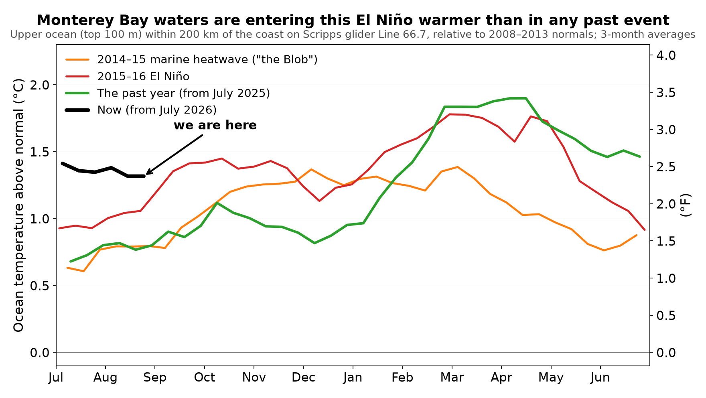
Figure 1. Upper-ocean temperature off Monterey Bay through four warm events, aligned by calendar month from July of the onset year. The current year (black) starts higher than the 2015–16 El Niño did, and the past year (green) exceeded that event's peak. Source: California Underwater Glider Network (Scripps), analyzed at UCSC.
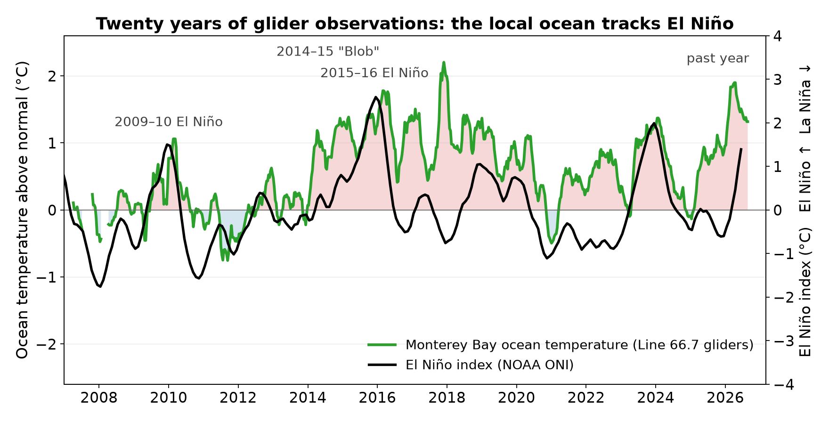
Figure 2. Twenty years of glider observations on Line 66.7 (green, left axis; red/blue shading = warmer/cooler than normal) with NOAA's El Niño index (black, right axis). Local ocean temperature follows El Niño, with two large departures: the 2014–15 heatwave and the past year.

What this means for the Monterey Bay region
- Coastal flooding and erosion. Strong El Niños raise California sea level by up to about a foot for months; with the winter storm season on top, Scripps researchers expect the highest coastal sea levels ever recorded in California this winter.1
- Marine life. The past year's heatwave has already brought seabird die-offs, warm-water species and renewed stress on kelp forests in and around Monterey Bay; a strong El Niño prolongs those conditions.2
- Fisheries and productivity. El Niño weakens the wind-driven upwelling that feeds the coastal food web; NOAA's ecosystem assessments flag reduced productivity as the main ecological risk for 2026–27.3
- Oxygen. The gliders also measure dissolved oxygen. The water now arriving along the coast at a given density carries roughly 30 µmol/kg (14 %) less oxygen than normal, a sign that warm, low-oxygen water from the south is being carried northward along the coast, an early hallmark of El Niño conditions that matters for fish and invertebrates living near the seafloor.

What we propose
UCSC Ocean Sciences has built the pipeline that turns the Scripps glider data into these monthly assessments within days of the gliders reporting. We propose to (1) continue the monthly analysis of Line 66.7 through the development, peak and decay of the event into 2027, (2) support a graduate student or postdoctoral researcher to carry the work, extend it to the other glider lines along the California coast and to the biological signals (oxygen, chlorophyll), and (3) explore targeted additional data collection in Monterey Bay during the winter peak.

What to watch next month
Arrival of the sea-level pulse at the coast in October; a renewed rise in ocean temperature against the seasonal trend; deepening of the warm layer below 100 m; and NOAA's September–October El Niño updates, which will show whether the index has crossed the "strong" (+1.5 °C) threshold.
Data: California Underwater Glider Network (D. Rudnick, Scripps Institution of Oceanography, Instrument Development Group), via SprayData and the IOOS Glider Data Assembly Center; NOAA Climate Prediction Center (El Niño index and forecasts); NOAA CO-OPS (sea level); NOAA OISST (satellite sea-surface temperature). Analysis: UCSC Ocean Sciences. Preliminary results, September 2026; full report on request; updated monthly.
1 San Francisco Chronicle, 2 Sep 2026; Gizmodo, 7 Aug 2026 (M. Merrifield, Scripps); Times of San Diego, 25 Aug 2026 (A. Young, Scripps). 2 KQED, 26 May 2026 (Monterey Bay Aquarium, International Bird Rescue); CBS Bay Area, 30 Aug 2026. 3 NOAA California Current IEA, Marine Heatwave Tracker (19 Aug 2026) and 2025–26 Ecosystem Status Report.

