Manual Magnaprobe RTK expansions

By: Achille Capelli and Anika Pinzer, 2024

# Table of Contents

Table of Contents 1

Download files from Magnaprobe 1

PPK of septentrio files 2

PPK of RINEX files 3

Merge files 3

# Download files from Magnaprobe

Use cable and DevConf from Campbell or USB dongle

## DevConfig

* Connect with RS232-USB adapter
* Open DevConfig
* Select COM port and logger CR800 series 🡪 Connect
* Download data in Data collection Tab, Choose folder, select OperatorView, Start

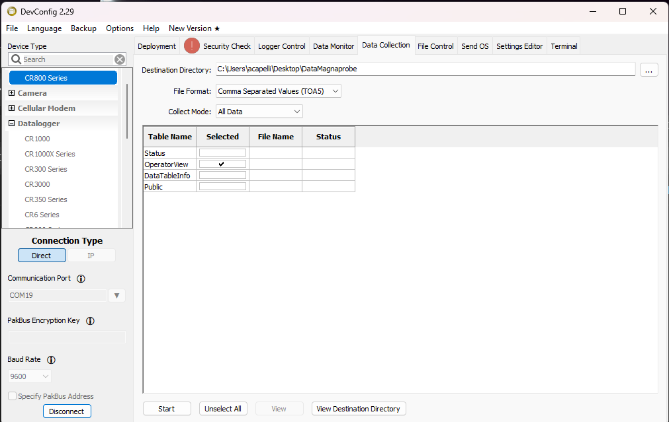

# Septentrio files

## Download Files (.sbf)

* Download .sbf file over USB and 192.168.3.1 in browser
* Alternative take out SD card and read
* Naming convention: **Folder**: *YYddd* (eg. 24336), **filename:** *STAT_ddd0.24_* (eg. Mg1_3360.24_)

## Extract RINEX files

* Use **RxTools:SBF Converter** to extract RINEX and ASCII .txt files

Opening the .sbf files

* open SBF converter app (in RX Toolbox)
* use: RINEX, the events (klicks) are saved int he ASCII format
* klick YES on window that opens
* creates a .txt file and an P and an O file
* Event A = Magnaprobe button
* Event B = Red button

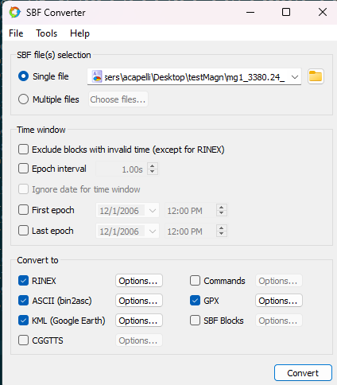

## PPK of RINEX files

* With Emlid Studio postprocess (PPK) data using Reach base station data and the exported RINEX data
* RTKLIB can be used as an alternative (less user friendly)

Emlid Processing

* OPUS correct base station files (see below on how to do it)
* open Emlid Studio
* Rover/ Base: O file
* Navigation file: P
* Antenna height of sea ice rod: 211.6cm (measured from the bottom of the rod to the bottom of the GNSS antenna –
* The SeptentrioX5 were set up with the antenna information of the TOP106 antenna (white geodetic) so the position is the ARP (antenna reference point) of the antenna. A close-up of a label

  Description automatically generatedA close up of a label

  Description automatically generated

# OPUS correcting the base file

* go to: <https://www.ngs.noaa.gov/OPUS/>
* upload the base station .O file
* if file is too large, open Emlid Studio software using ‘Convert to RINEX’
  + open settings
  + set ‘Interval’ to 30s instead of 1s
  + convert file and use that instead for opus correction

As alternative download CORS data and use static data processing in EMLID float.

# Merge files

### Python script in Spyder

* Spyder: open manuscripts
* Run magnamerge file first then the merge file

### Command line

* Use python script mergeMagna.py
* Open command line (Anaconda PowerShell)
* Navigate to root directory (cd d:)
* Example command:

**python .\scripts\mergeMagna.py magna009.sbf_SBF_ExtEvent1.txt SEPT2910.pos MagnaProbeRTK_2024-10-17.dat path=.\data\241017_TestRaptor\Magnaprobe**

Syntax:***mergeMagna.py file_events file_cont file_Magna plot=True, dt_min=0.1, dt_mean=0.5, tolerance=0.5, DeltaH=8, DeltaS=17***

*Parameters*

*----------*

*filename_events : TYPE*

*Event data GNSS. .txt from RXTools or .pos form Emlid studio*

*filename_cont : TYPE*

*Continus data GNSS. .pos form Emlid studio*

*file_magna : TYPE*

*File data magnaprobe.*

*file_save : TYPE, optional*

*Filename for saving data. The default is 'PPK_Magna.csv'.*

*file_saveB : TYPE, optional*

*Filename for saving events from button B. The default is 'PPK_Magna_B.csv'.*

*path: string, optional*

*path of files. The default is '\\'.*

*plot : float, optional*

*Produce plot to check sync. The default is True.*

*dt_min : float, optional*

*filter events nearer then dt_min. The default is 0.1.*

*window : float, optional*

*Window size for averaging continuous data around events in 's'. The default is 1.*

*tolerance : float, optional*

*tolerance in 's'for syncing Magnaprobe and GNSS. The default is 1.*

*DeltaH : float, optional*

*Time shift Magnaprobe in hours. GPS time to local time. The default is 8.*

*DeltaS : float, optional*

*Time shift Magnaprobe in seconds (leap seconds+ error). The default is 16.62*