Options Flow Tracker
Changze Li, Lizhou Wang, Jiawei Qin, Shijun Zhao
changzeli@vt.edu
jiaweiq@vt.com
lizhouw@vt.edu
shijunzhao@vt.edu
CS 4604, Dr. Nizamani
Spring 2026

Contents
1. Last Submitted ER diagram 3
2. Updated ER Diagram 4
2.1. ER diagram of logical database design 4
2.2. Details of the alterations 4
3. Relational Schema Diagram 5
4. Roles of Project Members 6

Last Submitted ER diagram

[Instruction]

Include the corrected conceptual ER diagram from the previous phase. This diagram serves as the starting point for logical database design. Correction and enhancement of the conceptual ER diagram after rectifying any identified errors

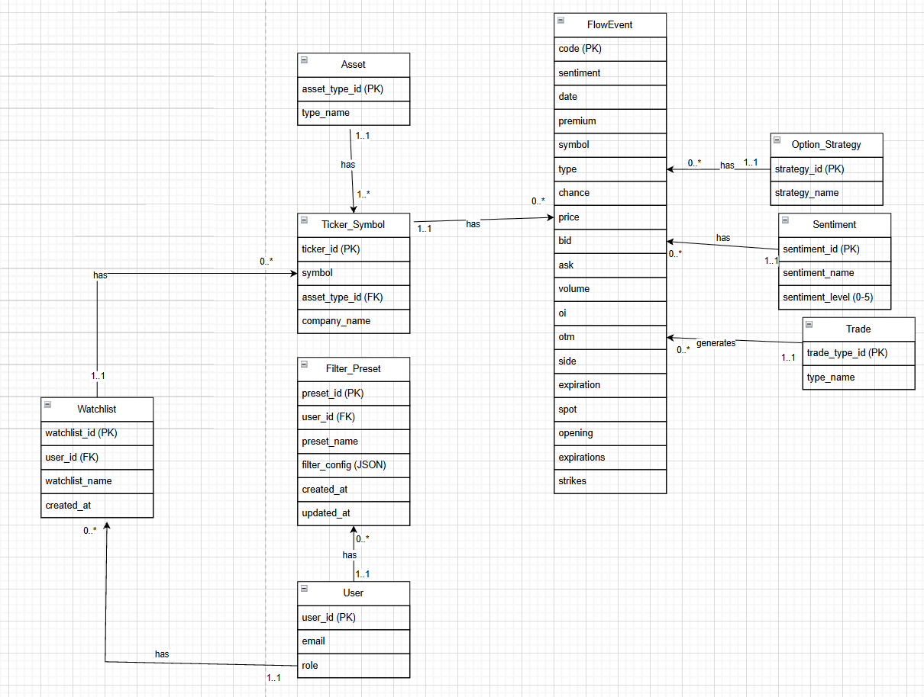

Updated ER Diagram
Conversion of conceptual ER diagram into logical ER diagram

ER diagram of logical database design
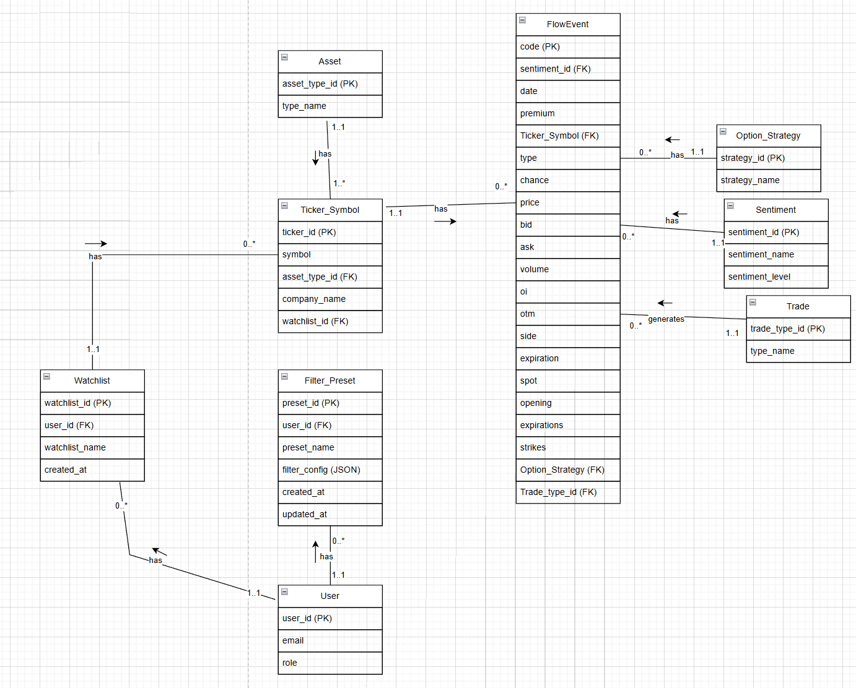

Details of the alterations
[instruction]
Please provide precise details of the alterations made to the design. Clearly explain what was changed or refined (e.g., relationship cardinalities, weak entities, multivalued attributes, associative entities). Justify these changes based on the database design rules discussed in Week 5.

First, we moved the arrows to the sides of the connecting lines, following the common convention of ER diagrams.

Second, we removed “(0–5)” from the name of the sentiment_level attribute in Sentiment, because this represents a constraint on the value rather than actual semantics, and therefore should not be placed in the attribute name.

Then, following the rules from conceptual to logical diagrams, and based on the one-to-many rule, we moved the primary key of the parent entity into the child entity as a foreign key. Specifically, we explicitly annotated the corresponding foreign keys that were originally implicit. In addition, we added Option_Strategy as the option_strategy foreign key in FlowEvent, and trade_type_id as the foreign key for Trade. Finally, we added watchlist_id as a foreign key in Ticker_Symbol.

Relational Schema Diagram
[instruction]
Display all database relations, emphasizing primary keys within each relation. Explicitly illustrate foreign keys, emphasizing the connections to referenced relations through directional arrows. Incorporate any relevant database constraints within the schema.

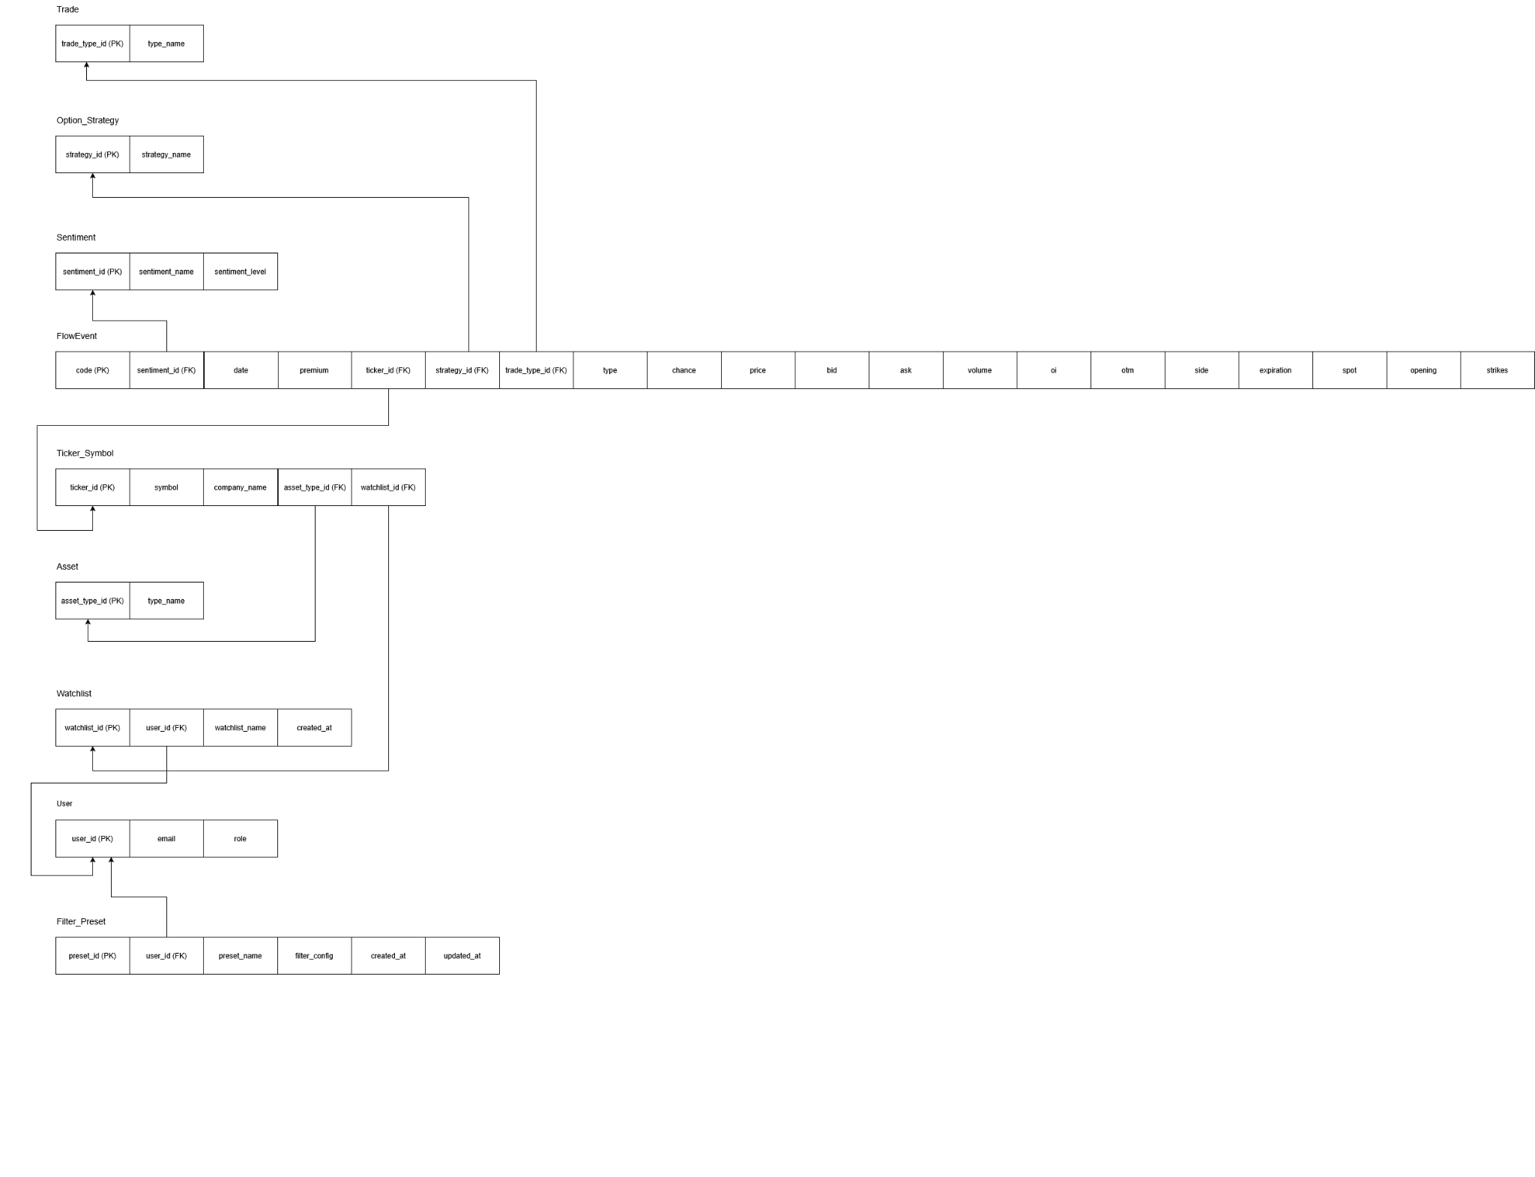
If this picture is not clear, we provided an individual file for this diagram.

Roles of Project Members
Describe the role and contribution of each team member, including Generative AI.
Team Member 1: Changze Li
Role: Write the Details of the alterations. Check the Relational Schema Diagram.

Team Member 2: Jiawei Qin
Role: Draw ER diagram and schema diagram

Team Member 3: Lizhou Wang
Role: Reviewed and verified the conversion from conceptual ER diagram to logical ER diagram. Assisted in writing the Relational Schema section and cross-checked foreign key references across all relations.

Team Member 4:
Role:Assisted in refining the logical ER diagram and validating primary/foreign key mappings to ensure consistency with relational design rules.

Generative AI:
Role: Use to check the requirement of the project and check the Relational Schema Diagram.

