AD&D Character Generation and General Notes

Creating The Player Character
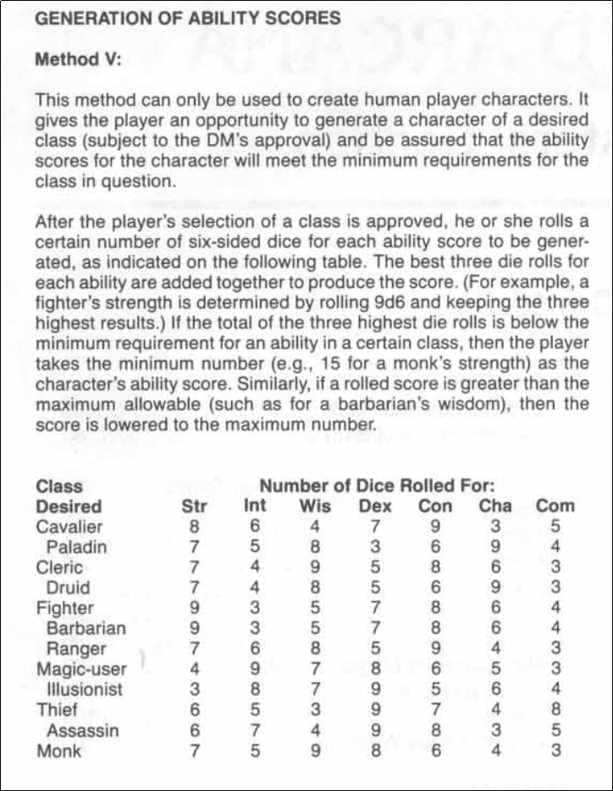

Note: READ your Racial And Class Adjustments BEFORE Continuing !!!
You Can Use The Tables Below To Adjust Your Score’s Affects.
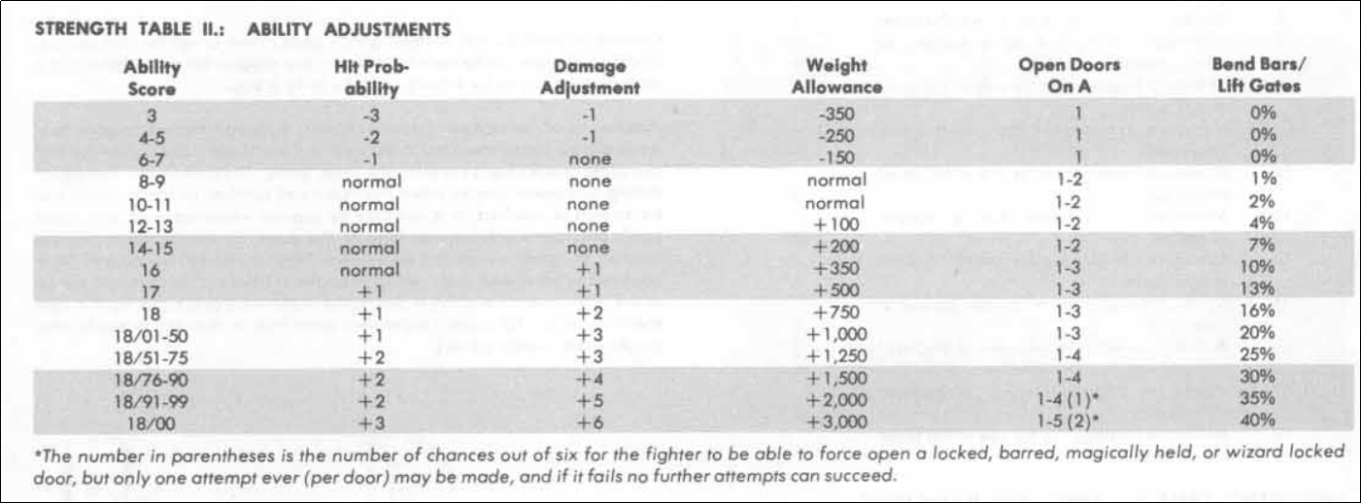
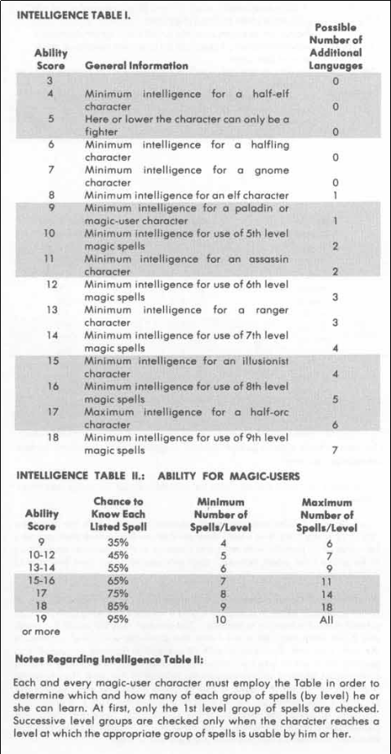
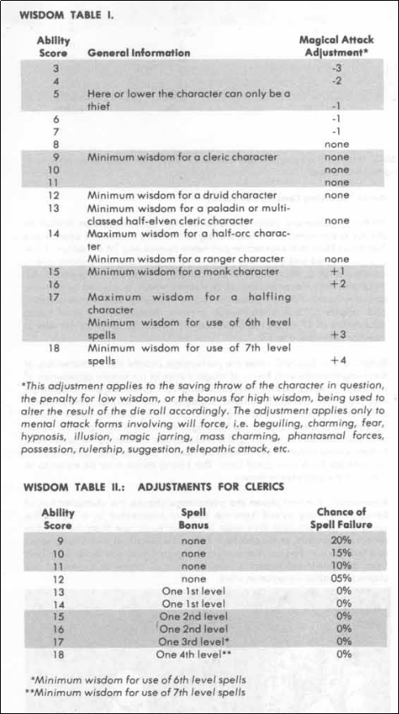

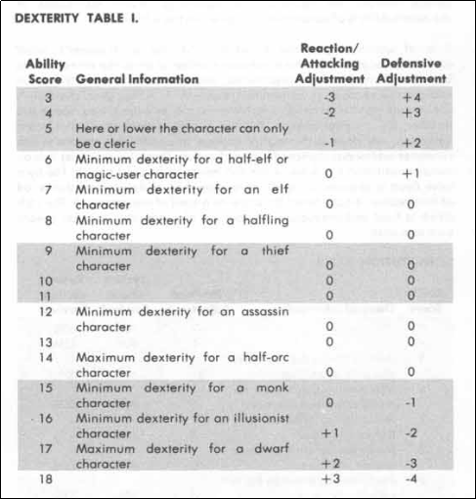
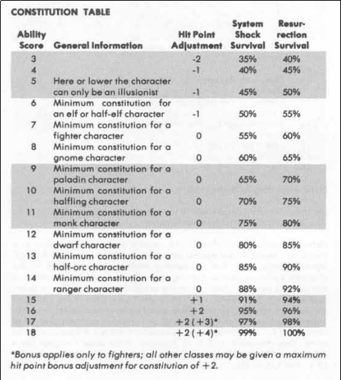

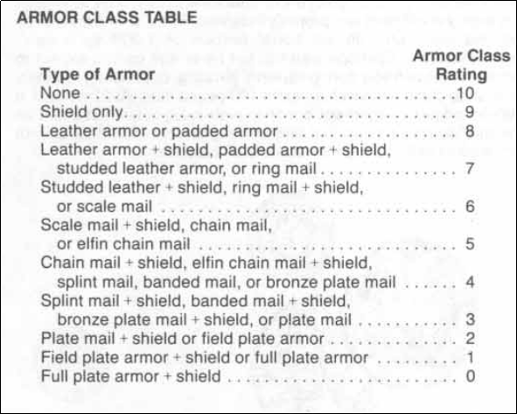

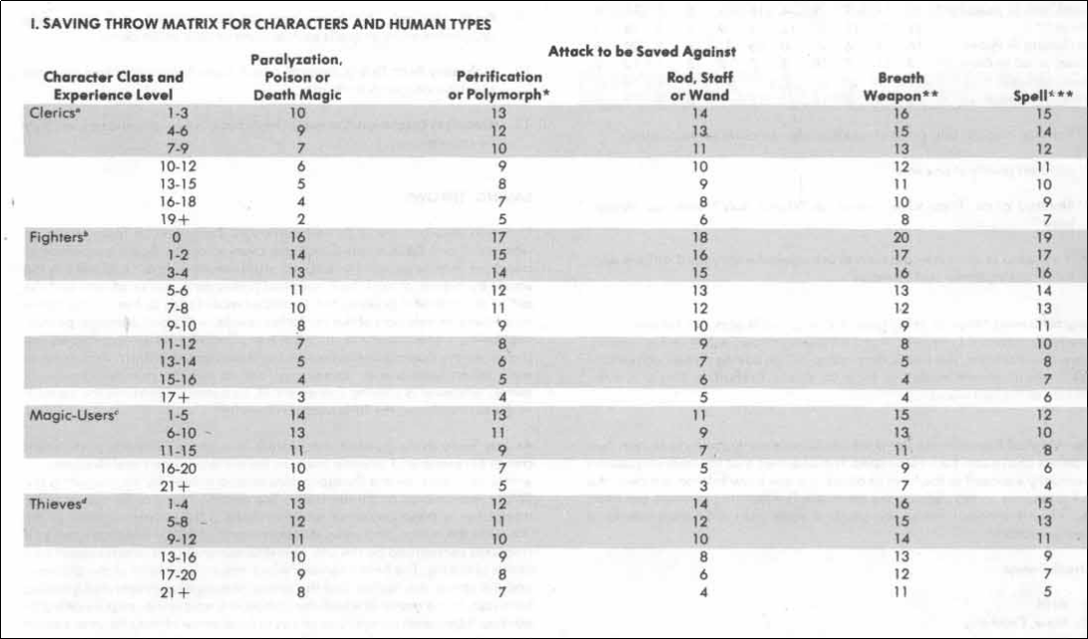
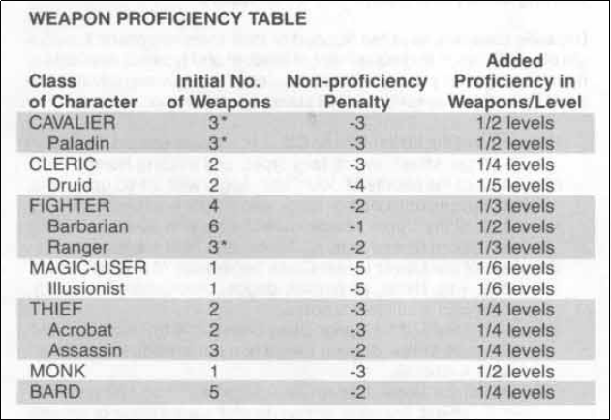
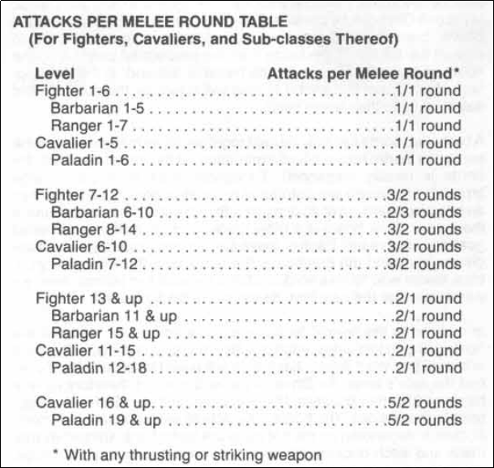

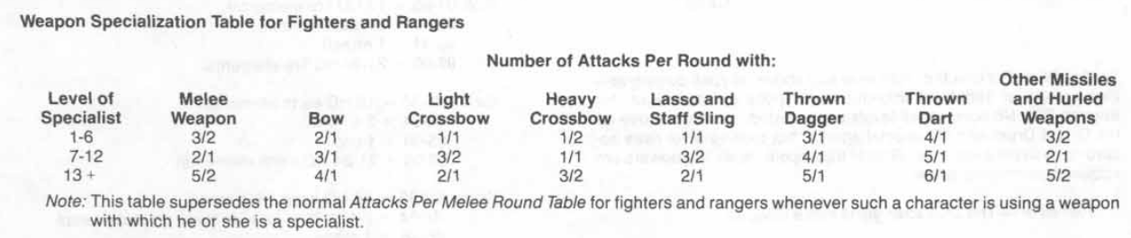
monetary System
The basic unit of exchange is the gold piece (g.p. hereafter). There are
coins of lesser and greater value, and these are shown on the table below.
It is also common to use gems of various sorts and values as coin.
10 copper pieces (c.P.) = 1 silver piece
20 silver pieces (s.P.) = 1 g.p.
2 electrum pieces (e.p.) = 1 g.p.
1 platinum piece (p.p.) = 5 g.p.
Thus:
200c.p. = 20s.p. = 2e.p. = 1 g.p. = 1/5p.p.

Calculated THAC0 Charts

ATTACK MATRIX FOR FIGHTERS, PALADINS, RANGERS, BARDS, AND 0 LEVEL HALFLINGS AND HUMANS*
Level | 0 | 1-2 | 3-4 | 5-6 | 7-8 | 9-10 | 11-2 | 13-14 | 15-16 | 17+
0 | 20 | 20 | 18 | 16 | 14 | 12 | 10 | 8 | 6 | 4
Note: After level 17 the to-hit decreases by 1 instead of 2

ATTACK MATRIX FOR THIEVES AND ASSASSINS
Level | 1-4 | 5-8 | 9-12 | 13-16 | 17-20 | 21+
0 | 20 | 19 | 16 | 14 | 12 | 10

ATTACK MATRIX FOR CLERICS, DRUIDS AND MONKS
Level | 1-3 | 4-6 | 7-9 | 10-12 | 13-15 | 16-18 | 19+
0 | 20 | 18 | 16 | 14 | 12 | 10 | 9

ATTACK MATRIX FOR MAGIC-USERS AND ILLUSIONISTS
Level | 1-5 | 6-10 | 11-15 | 16-20 | 21+
0 | 20 | 19 | 16 | 13 | 11

Notes to Players:
- Create a “Backstory”, ensure it has the following if you want the DM to attempt to work with it:
  - How your PC (Player Character) became an adventurer from a average person
  - Where your PC is from, why they left, etc.
  - Any goals, dreams, ambitions, etc.
  - Successes and failures, passions and fears, etc.
- Keep in mind the three types of backstories:
  - Public – Anyone can discover
  - Semi-Private – Takes work or your acknowledgment to discover
  - Private – Only the DM and your PC know, and sometimes not even your PC or you

Magic Item & Artifact Soul Binding
Base :
Wisdom Score + Wisdom Bonus + Constitution Score + Constitution Bonus
Factors :
Alignment-
+50 Exact Match
+35 Law, Chaos, True Match
-10 Law vs Chaos
-5 Law vs True
-5 Chaos vs True
+15 Good, Evil, Neutral Match
-10 Good vs Evil
-5 Good vs Neutral
-5 Evil vs Neutral
Score Total %
Effect:
Less Than OR Equal Score
Full Bond
Greater than Score but Less Than 25Points
Base Function, No Extra, Special, etc.
Greater than Score +25-35 Points
One Time Use, Then Inert
Greater than Score +36-50 Points
No Functionality
Greater than Score +51 Points Or Roll Of 98-100
Will Do All Things “FOR A PRICE” (DM Option)

Notes For Various Other Guidelines
- Advantage/Disadvantage:
Advantage is when the circumstances are such the PC would be in a position that would make it easier to perform a function or task, and likewise Disadvantage works the same in reverse.
Advantage on To-Hit Rolls – Roll 2 dice, pick the one you want, OR, Roll dice and add a d4 (Depending on DM knowledge of the circumstances).
Disadvantage – Same as Advantage in reverse
Note: The Decision of Which Method Used Must Be Stated Prior To Rolling
- PC Death:
When a PC’s Hit Points drop below zero they go unconscious and unless bleeding out will recover (1-3 HP) on their own in 6-8 hours.
If continuing to lose HP beyond zero or are below zero-constitution score they require immediate healing within 10-30 rounds unless what hit them says otherwise. Also once below zero-constitution they will need to make a Death Save (d20 score LESS THAN Constitution) once every round until either healed or 3 Failed attempts at which point they are Dead, next character please.
- Perception & Insight Checks:
Perception Check Is Used When The PC Wants To See If They Can Use Their Skills To See More Detail Than What The DM Has Presented.
Insight Check Is When The PC Wants To See If They Can Use Their Skills To Detect If Someone Is Lying Or Deceiving Them.
Perception (d20+Intelligence Bonus)
0-12 Only What Is Obvious
13-17 Slightly Finer Details, More Tunneled Concentration
18-19 Greater Detail, More Broad And Calculating
20+ Like A Detailed Picture You Can Hold In your Hand And Study Every Detail, And Tuned Into That Inner Sense Of Intuition And Awareness.
Insight Check (d20+Wisdom Bonus)
0-14 Not A Clue
15-18 Something Doesn’t Seem Right But Can’t Be Sure
19-20+ Damn Them!
- Initiative:
Standard Initiative OR Base30
Standard Is At The Beginning Of Every Round A d10 Is Rolled, Lowest Goes First, Starts At Zero. Spell Casters Announce That They Are Casting and Their Spell Goes Off On That Casting Time Segment (Casting Time 3 Segments Goes Off On Initiative 3)
Base30 Is At The Beginning Of Combat Roll A d20 And A d10 Are Rolled And Added Giving A 2-30 + The PC’s Main Attribute Bonus i.e. Fighter = Strength, Mage = Intelligence, Thief = Dexterity… However- Cavaliers, Paladins, Barbarians, And Multi-Class PCs Can Choose Which Main Attribute They Use. This Will Be The PCs Initiative For The Duration Of Combat. The Order Is Highest To Lowest. Spell Casters Announce They Are Casting And What Initiative It Will Go Off, This Is Calculated By The PC And Is Casting Time x 3 – 30 i.e. If Casting Time Is 3 Segments Then It Is 3x3=9 30-9=21 Spell Will Go Off And The Spell Caster’s Initiative Is 21 When Not Casting.
Spell Caster’s NOTE: DM May Allow “Spell Stacking” Which Is Casting Multiple Spells In A Single Round With 2 Segments Between, As Long As There Are Enough Segments And The Caster’s Ability Score Is 16 Higher (Mage=Intelligence Cleric=Wisdom) i.e. The Mage Wants to Cast Continual Light (2 Seg- 6 Init) Magic Missle (1 Seg- 3 Init) and Lightning Bolt (3 Seg- 9 Init) So Initiative As Follows- 2x3=6 30-6=24 Continual Light Goes Off At Initiative 24, -6 InitDelay = Initiative 18, Magic Missile = 18-3=15 Goes Off On Initiative 15, -6 InitDelay = Initiative 9, Lightning Bolt (3 Seg) = 3x3=9 Init 9 – 9 = 0 Lightning Bolt Goes Off At First In the Next Round And The Mage Can Not Begin To Cast Until InitDelay + New Spell Cast Time- 29-6=23 << Begin Casting.

Help The DM Help You
Create a Page with the following layout and details and provide it to the DM, I purposely made this the Last page in this doc so it can be filled out and cut off, or copied and printed.

Name:
Race:
Alignment:
Clases/s | Level/s:
AC:
HP:
BackStory:

Magic Items, Treasure, & Gold
Initial Gold/Money:
Magic Items:

Other Treasure and Objects of interest

