class04.r

script

2022-10-06

#This is a comment  
  
x <- 1:50  
plot(x, sin(x))

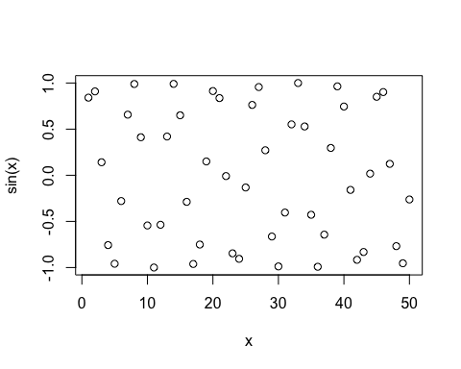

#Add more input arguments to get this how we want tt  
plot(x, sin(x), typ = "l", col = "red", lwd = 3)

