# 

# **CONESTOGA VIDEO GAME STORE**

# 

# **SITE ADMINISTRATION MANUAL**

# Introduction

This document is intended to guide administrators of the Conestoga Video Game Store in all steps of administration of the store.

Introduction

Store Administration

Employee Login

Game Management

Adding a Game

Updating a game

Event Management

Adding an Event

Editing and deleting events

Processing orders

Moderating reviews

Viewing/Printing Reports

Other

Lockouts and disabling accounts for employees

# Store Administration

## **Employee Login**

An employee account will be created and managed for you by your site admin. To login to this account direct your browser to [www.CVGS.com](http://www.cvgs.com) and click the “Login” tab at the top right corner of the page.



After clicking the login window will appear.

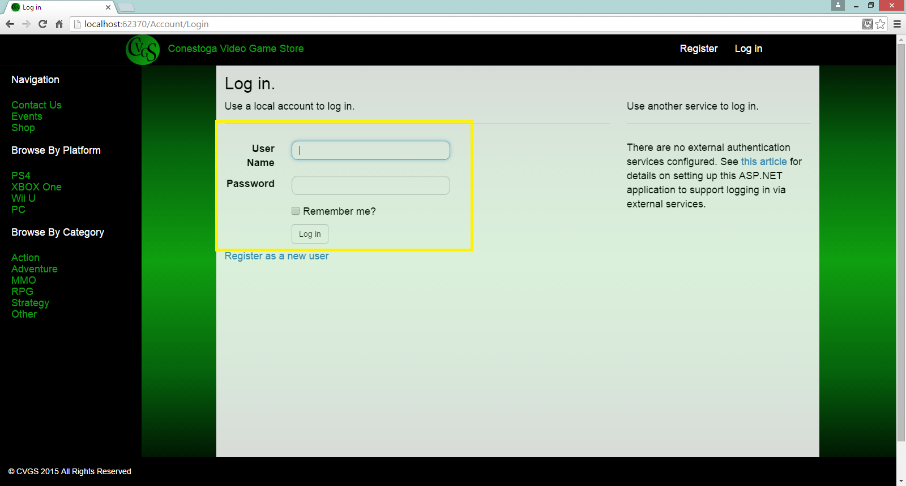

Enter the supplied username and password and click login.

Once logged in you will have additional top menu options.

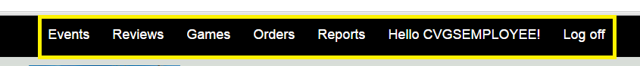

# Game Management

## **Adding a Game**

To add a game click the “Games” tab in the top bar (See: Employee Login), you will then be presented with the “Game Management” page. Here you will have the options to add games, update games, or delete games.

To add a game click the “Add New Game” button in the top left of the game management page.

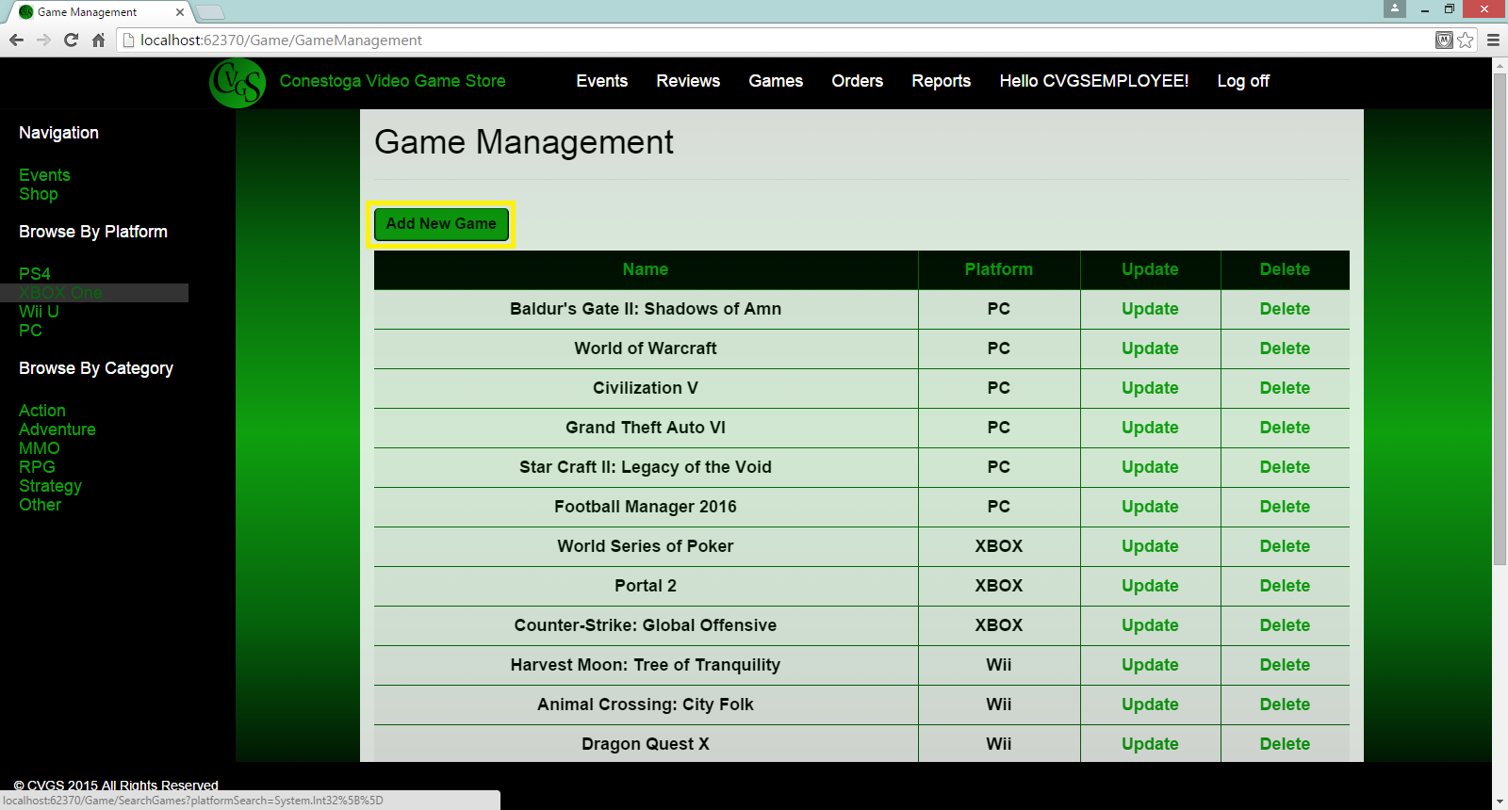

You will then be taken to a form to enter in the game details including, name, categories, platform, price, release date, publisher, rating, and a path to any game art. Click “Create” and the game will then be added to the stores database and be available for customer purchase.

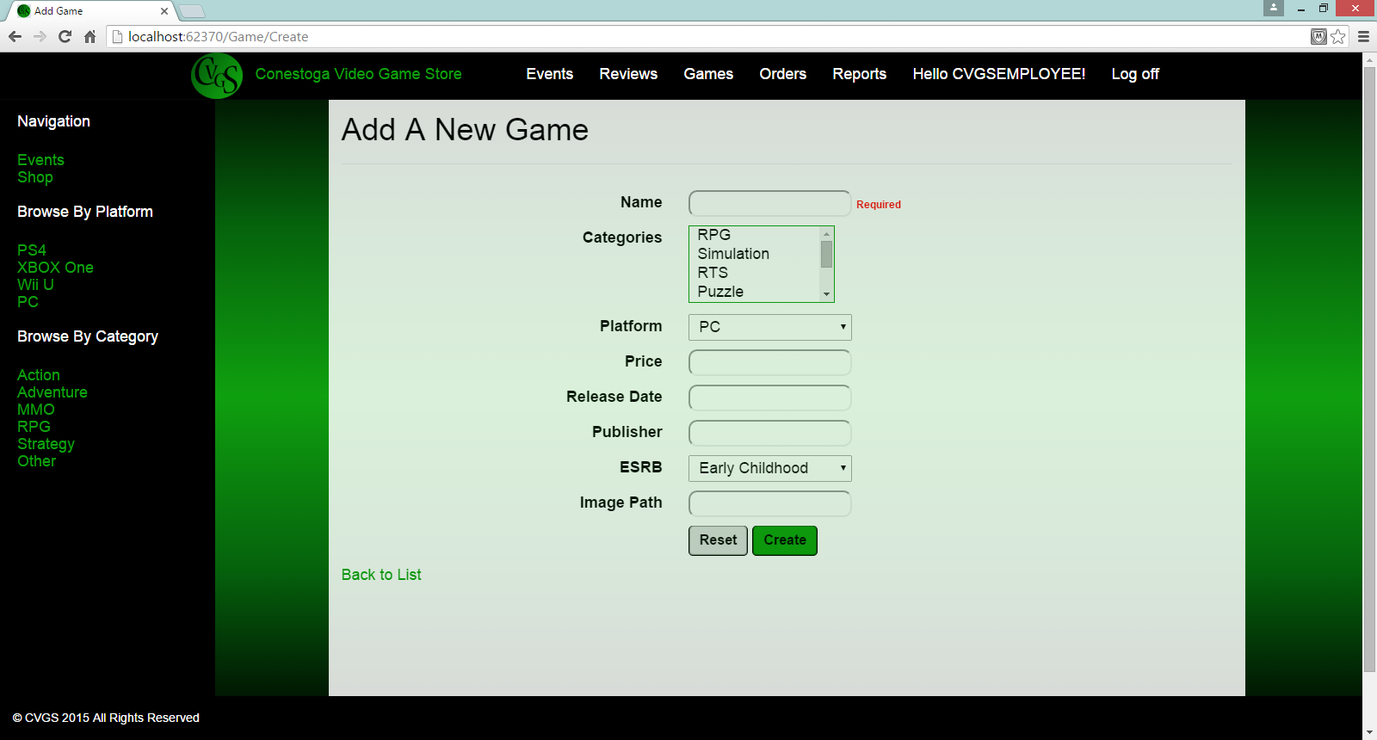

## **Updating a game**

To Update a game, after logging in, click the the “Games” in the top bar menu. Scroll through the list of the store’s games, on finding the game needing updated click the “Update” tab associated to that game.



You will be taken to a details page where you can update the game details as required.

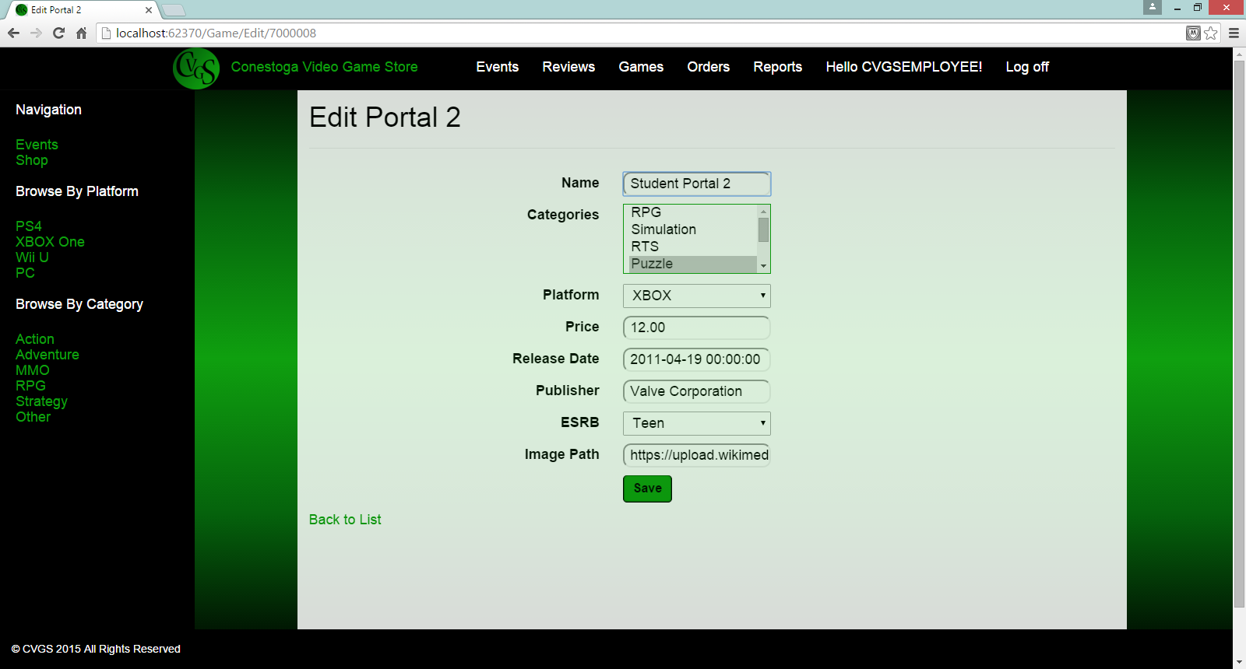

Clicking “Save” will update the database.

## Deleting a game

To delete a game click the “Delete” link in the Game Management section that aligns with the game you wish to delete.



On clicking, you will receive a message that the game has been deleted.

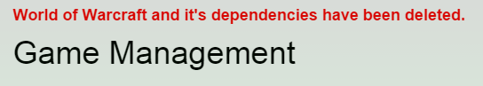

# Event Management

Click the “Events” tab in the top bar. You will be taken to the “Event Management” page. Here there will be an index of event to which may add, update, and delete.

## **Adding an Event**

Once on the “Event Management” page you will have the option to add an event.

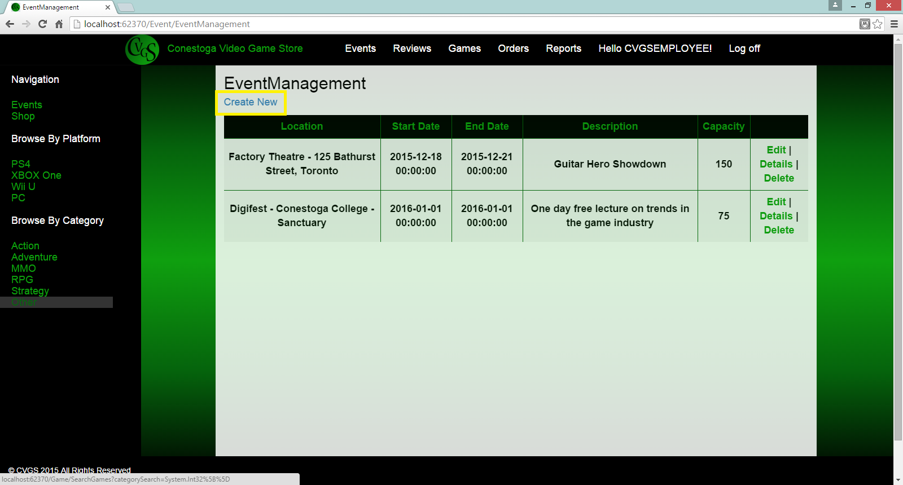

Click the “Create New” which will return the event form where you can add your event detail

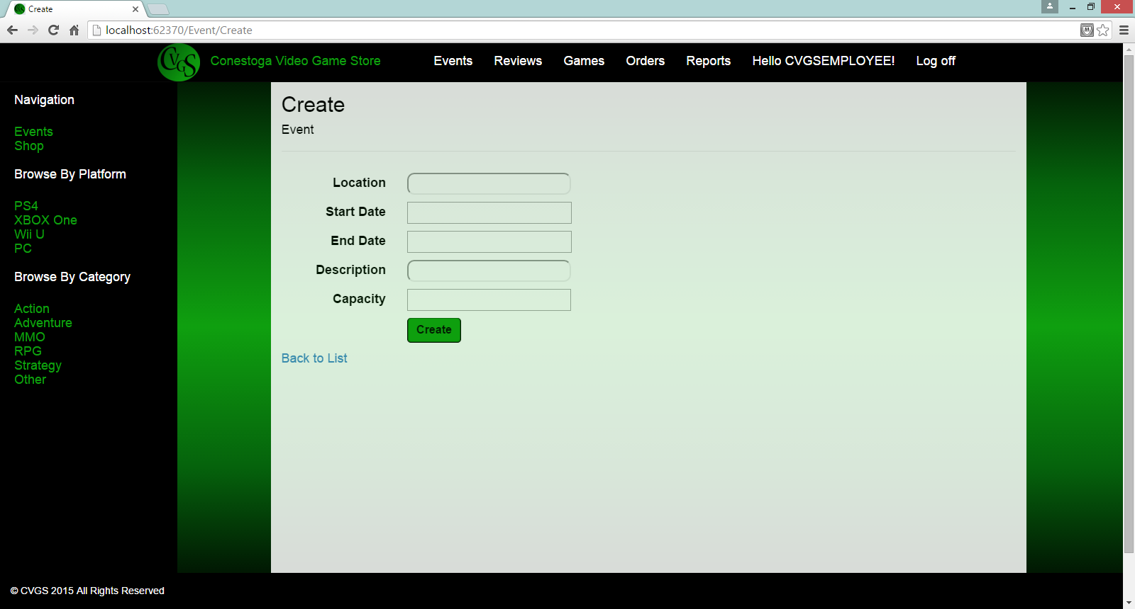

Clicking the “Create” button will add the event to the database.

## **Editing and deleting events**

As with adding a game, you can edit and delete events on the events page by clicking the appropriate link corresponding to the event.

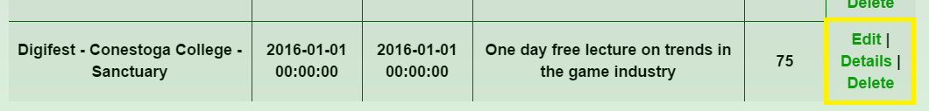

Clicking edit will return a details form allowing you to edit the particulars of the event.

On clicking delete you will receive a red bolded message accross the top of the page confirming the delete and the event will be removed from the database.

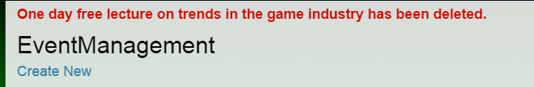

# 

# Moderating reviews

On clicking “Reviews” in the top bar you will be taken to a list of reviews that are pending moderation.

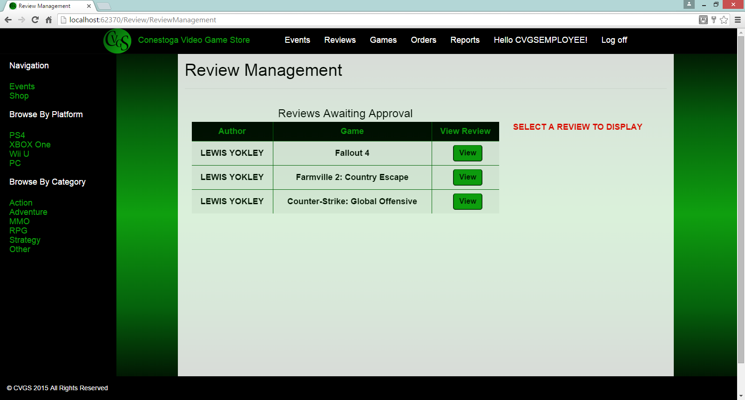

On clicking “View” the review will be displayed

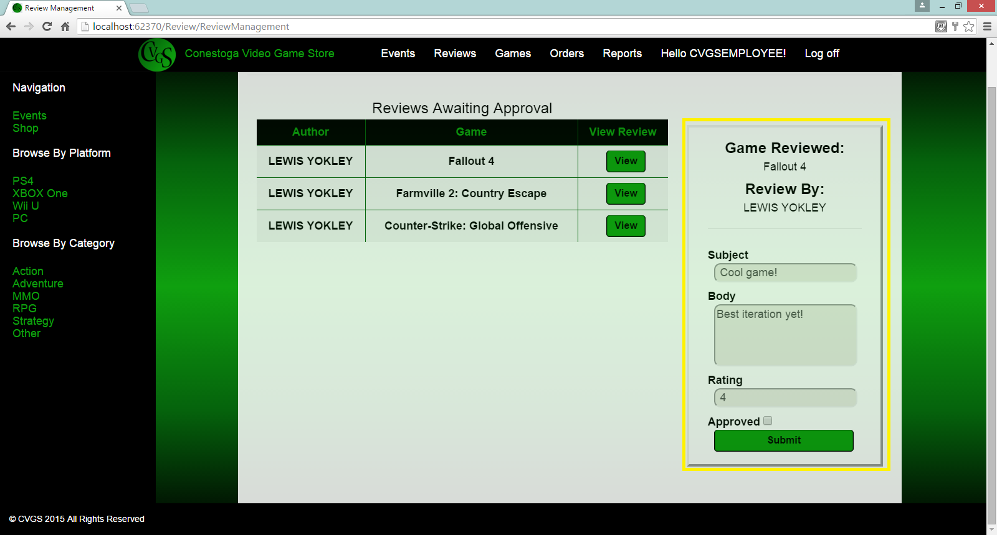

## **Approving a review**

To approve a review click the Approved checkbox above the “Submit” button and then click “Submit”.

## **Rejecting a review**

To reject a review simply click “Submit” without checking approved.

# Viewing/Printing Reports

The “Reports” tab of the top bar will allow you to view various reports on the state of the Conestoga Video Game Store.

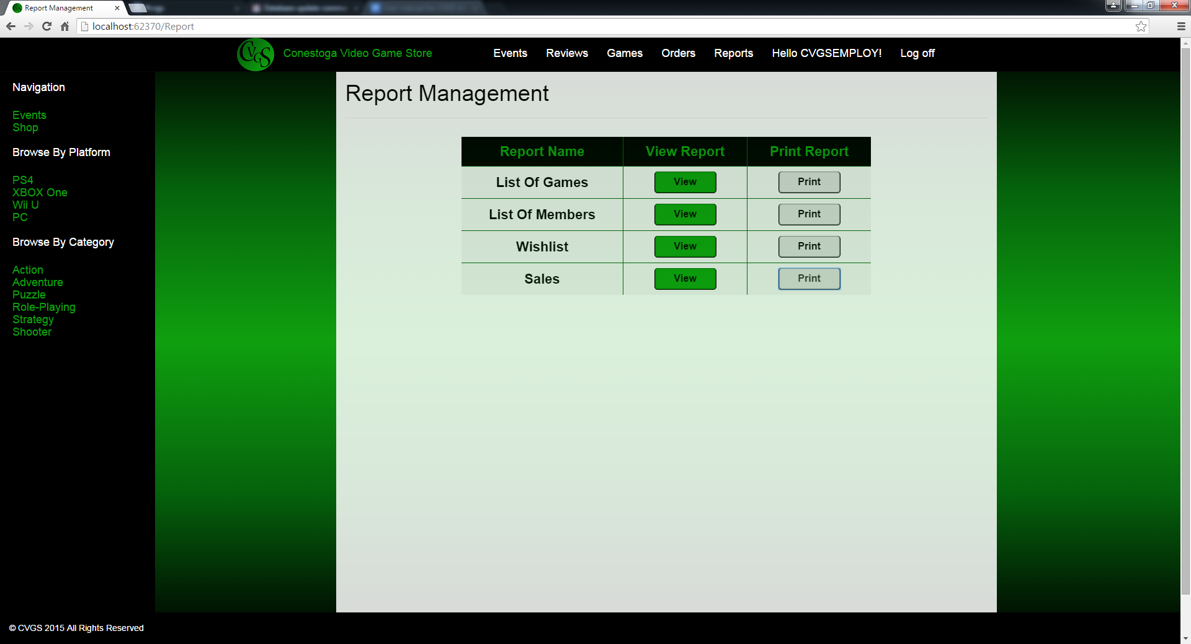

Clicking “View” will generate the corresponding report such as List of Games and List of Members.

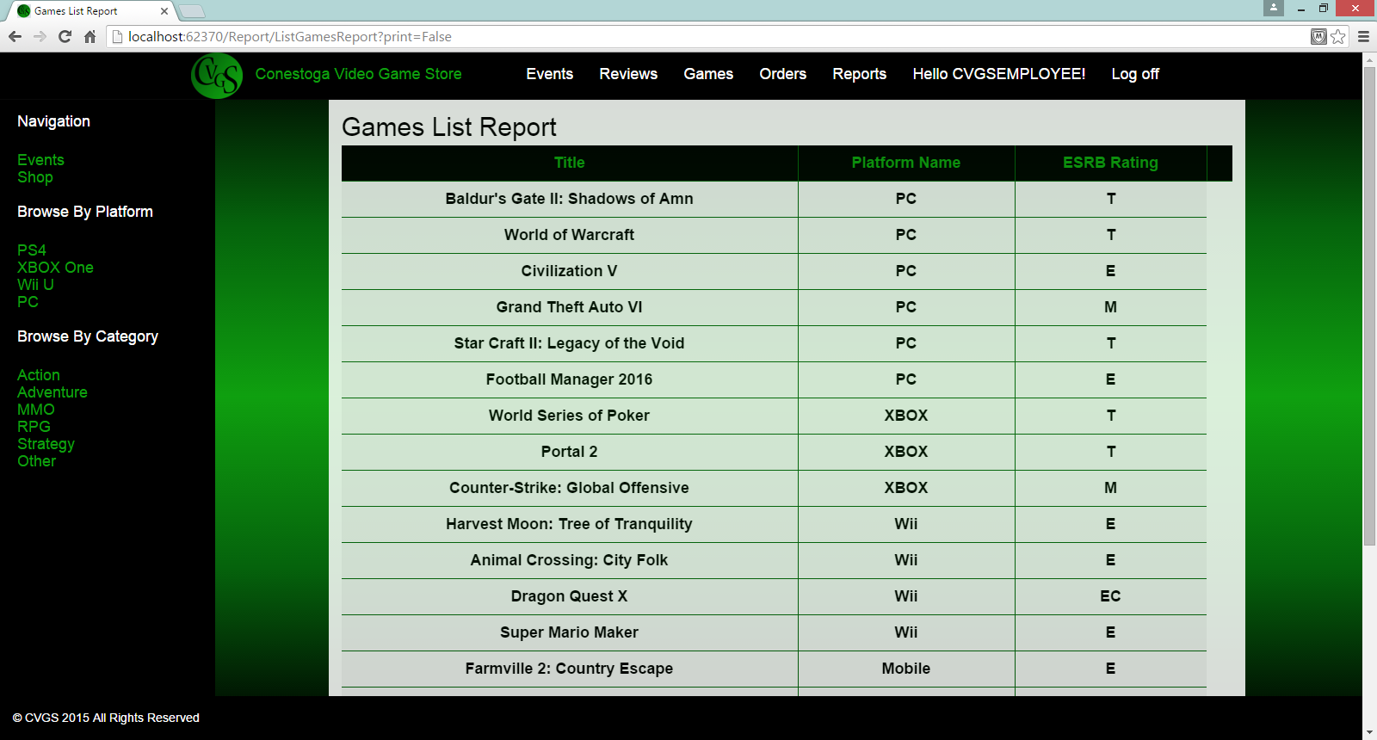

# Other

## **Lockouts and disabling accounts for employees**

In the event of a forgotten password or an employee account needing to be disabled please contact a site administrator.