Report by: Seadimo Bugqwangu
Damn vulnerable web application (dvwa)
Web application vulnerability assessment report

Table of Contents
Introduction
Scope of testing

Introduction
Web applications play a critical role in modern digital infrastructure, enabling businesses and individuals to deliver services, manage data, and interact with users over the internet. However, the increasing reliance on web-based systems has also made them a primary target for cyberattacks. Vulnerabilities within web applications can expose sensitive information, compromise user privacy, and allow unauthorized access to systems. As a result, identifying and mitigating these vulnerabilities is a fundamental aspect of cybersecurity.
This report presents the findings of a vulnerability assessment conducted on the DVWA, a deliberately insecure web application designed for educational and training purposes. DVWA provides a controlled environment in which common web application vulnerabilities can be safely identified, tested, and analysed without impacting real-world systems. The purpose of using DVWA in this assessment is to simulate realistic security weaknesses and demonstrate how such issues can be discovered and exploited by attackers.
The primary objective of this assessment was to identify common web application vulnerabilities, evaluate their potential impact, and provide appropriate remediation recommendations. The testing focused on key areas such as input validation, session management, and server-side processing. Specific vulnerabilities explored during this assessment include SQL Injection, Cross-Site Scripting(XSS), Command Injection, and security misconfigurations related to communication protocols and cookie handling.
This assessment was conducted within a controlled local environment using XAMPP as the hosting platform. The testing was performed using a combination of manual techniques and browser-based developer tools to observe application behaviour, manipulate inputs, analyze responses. All testing activities were limited to proof-of-concept demonstrations and did not involve any destructive or unauthorized actions.
By identifying these vulnerabilities and understanding their implications, this report aims to highlight the importance of secure coding practices, proper input validation, and robust configuration management. The findings and recommendations provided in this report are intended to support the development of more secure web applications and to reintroduce fundamental cybersecurity principles.

Scope of assessment
The scope of this assessment was limited to the DVWA application hosted locally using XAMPP. Testing focused on identifying vulnerabilities within the applications input handling, session management, and server-side execution mechanisms.
No attempts were made to perform destructive actions or exploit vulnerabilities beyond proof-of-concept demonstrations. All testing was conducted ethically within a controlled environment.

Tools and Environment
I made use of the following tools and technologies during this assessment:
- DVWA (Damn Vulnerable Web Application)
- XAMPP (Apache Web Server and MySQL Database)
- Google Chrome Browser
- Chrome Developer Tools ( for inspecting network activity and cookies)

Methodology
The following structured approach was followed in this assessment:
- Environment Setup and Configuration
- Baseline Security Assessment
- Vulnerability Identification
- Exploitation(proof-of-Concept)
- Documentation of Findings and Recommendations
Each vulnerability was tested in a controlled manner in order to demonstrate its existence and potential impact.

Vulnerability Findings
1. Insecure Communication (HTTP)
Description:
The application operates over HTTP rather than HTTPS, meaning that all data transmitted between the client and serve is unencrypted.
Risk Level: Medium
Impact:
An attacker on the same network can intercept sensitive data such as session cookies, login credentials, and transmitted information through man-in-the-middle attacks.
Recommendation:
Implement HTTPS using SSL?TLS encryption to ensure all communication is securely encrypted.
Evidence:
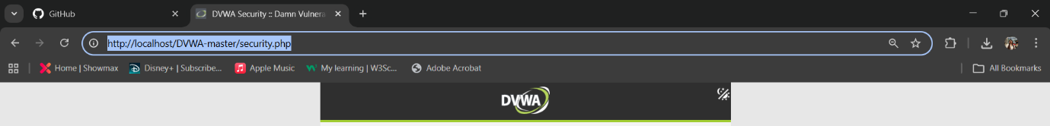

2. Insecure Session Cookies
Description:
Session cookies are not configured with Secure or HttpOnly attributes.
Risk Level: Medium
Impact:
- Cookies can be transmitted over unencrypted connections.
- JavaScript can access cookies, increasing exposure to XSS-based attacks
- This increases the risk of session hijacking
Recommendation:
- Enable Secure to ensure cookies are only transmitted over HTTPS
- Enable HttpOnly to prevent JavaScript access

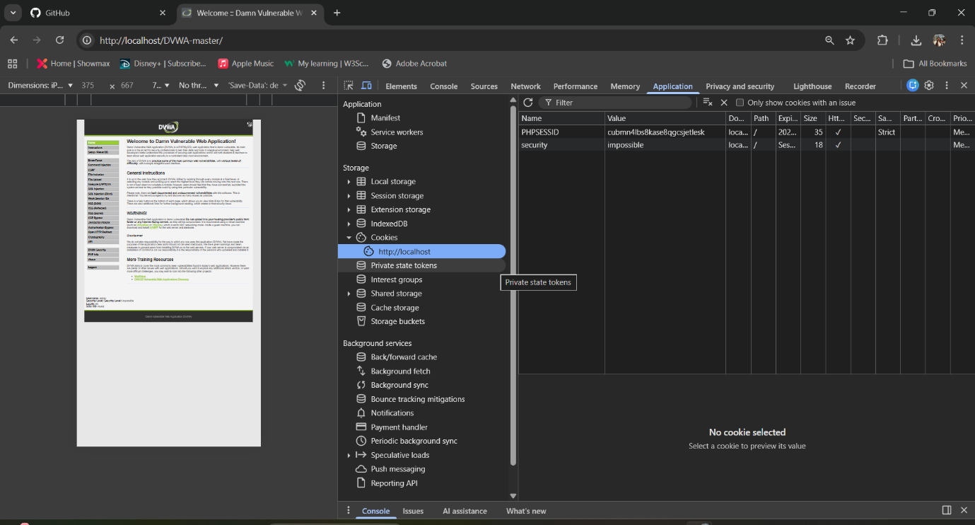

3. SQL Injection
Description:
The application is vulnerable to SQL Injection due to improper input validation. User input is directly incorporated into SQL queries without sanitization.
Risk Level: High
Impact:
Attackers can manipulate database queries to:
- Retrieve sensitive data
- Bypass authentication
- Modify or delete data
Proof of Concept:
Input used: 1’ OR ‘1’=’1
This input caused the application to return multiple user records, demonstrating that the query logic was altered.
Recommendation:
- Use parameterized queries(prepare statements)
- Implement input validation and sanitization

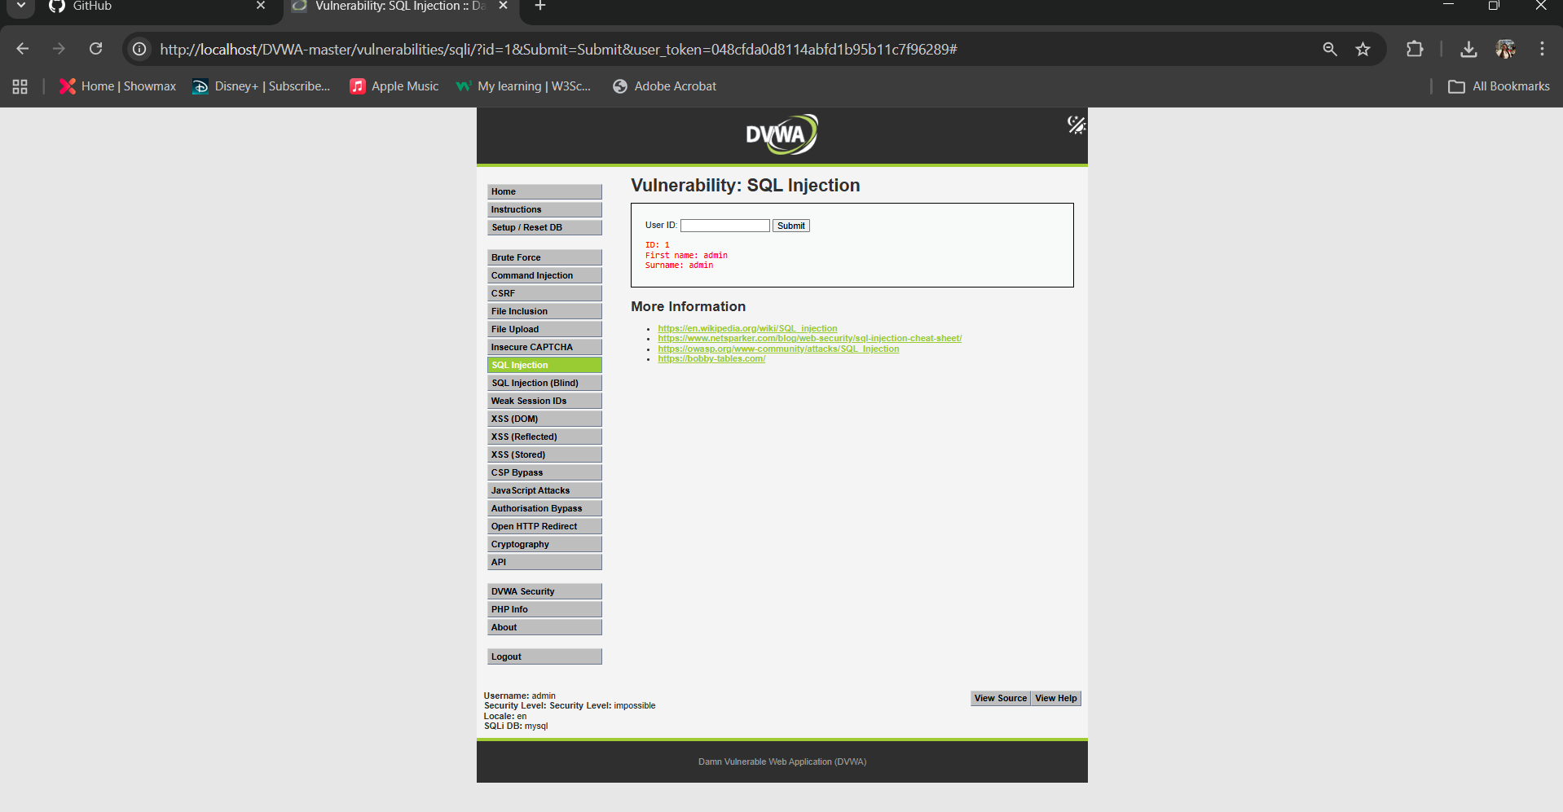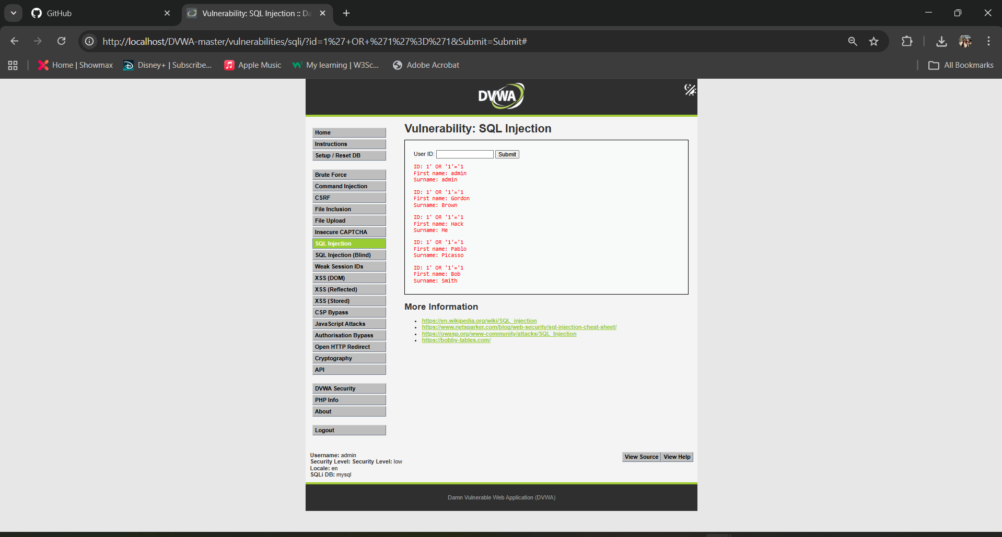

4. Cross-Site Scripting (XSS)
Description:
The application does not properly sanitize user input, allowing execution of malicious JavaScript in the browser.
Risk Level: High
Impact: Attackers can:
- Steal session cookies
- Redirect users to malicious websites
- Perform actions on behalf of users
Proof of Concept:
Input used: <script>alert('XSS')</script>
This resulted in a JavaScript alert being executed in the browser.
Recommendation:
- Sanitize and encode all user inputs
- Implement output encoding
- Use Content Security Policy(CSP)
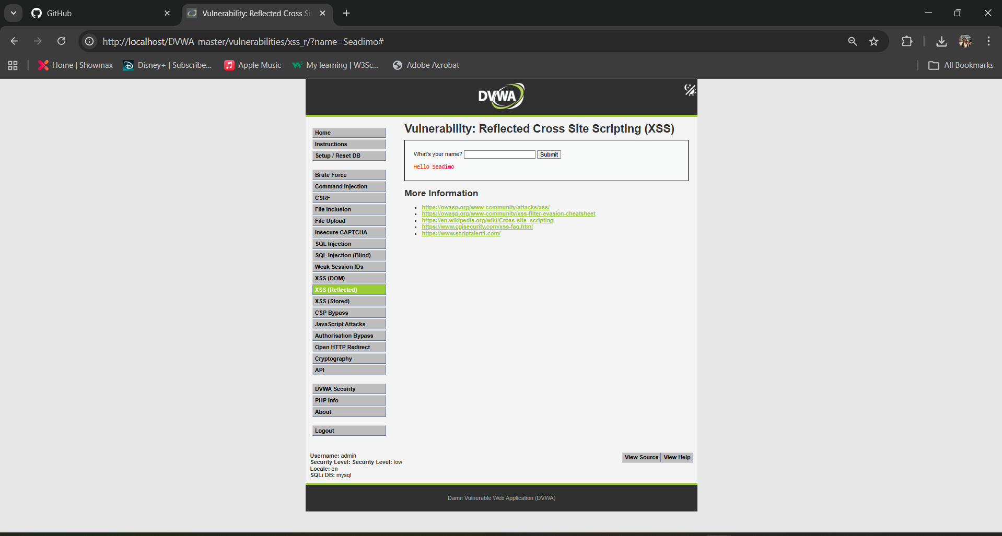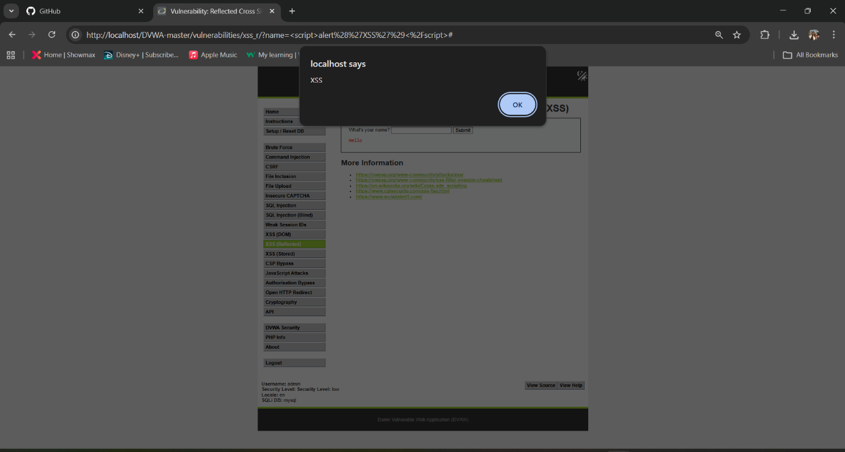

5. Command Injection
Description:
The application allows execution of system-level commands via user input without validation.
Risk Level: High
Impact: Attackers can:
- Execute arbitrary system commands
- Access sensitive files
- Potentially gain full control of the server
Proof of Concept:
Input used: 127.0.0.1 && dir
This resulted in both ping output and a directory listing, confirming command execution.
Recommendation:
- Validate and sanitize all inputs
- Avoid direct system command execution
- Use safe APIs where possible
Evidence:
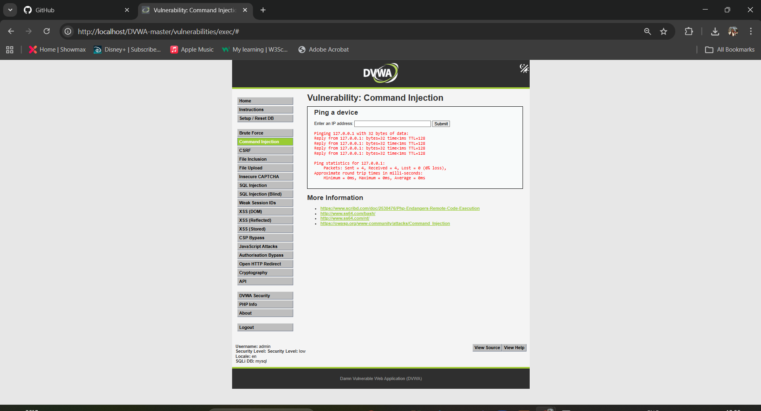

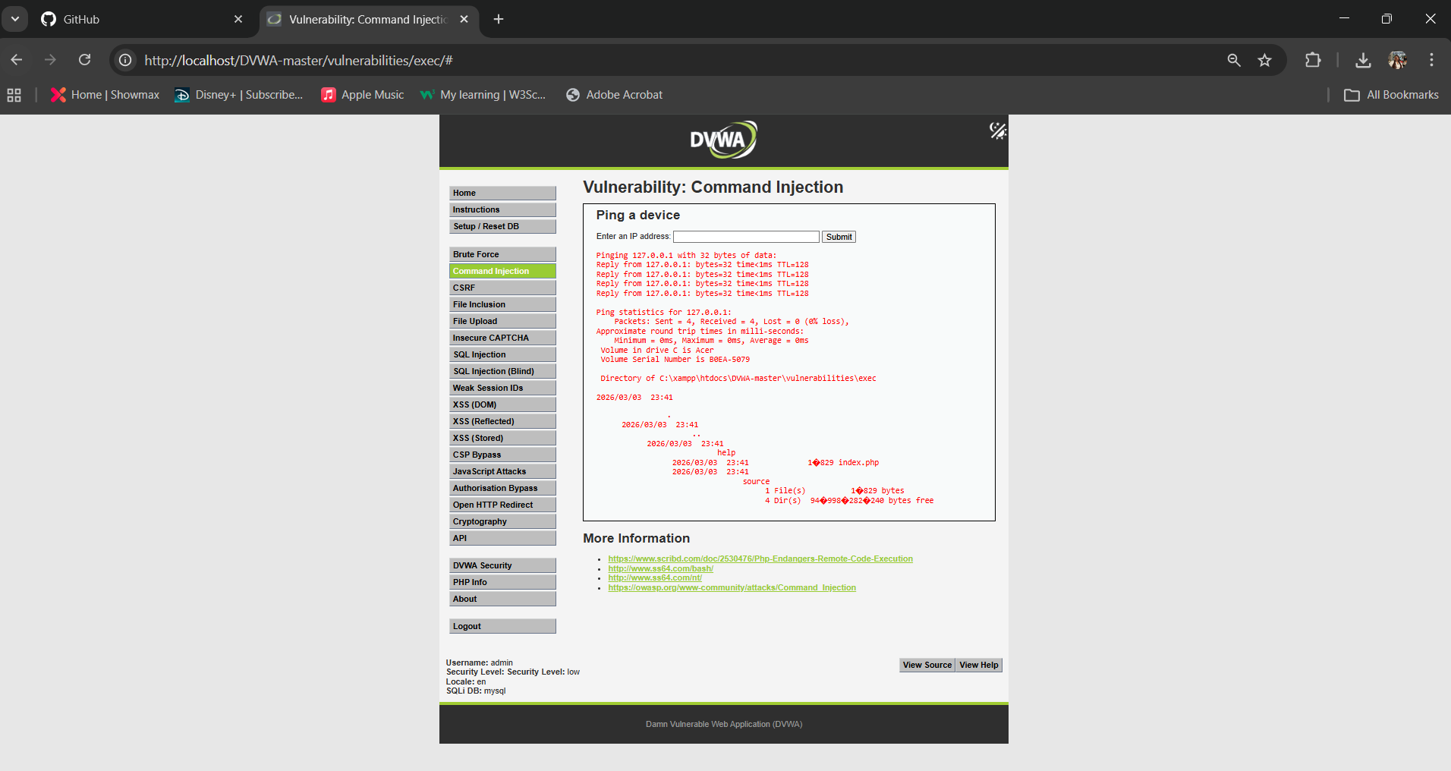

OWASP Top 10 Mapping
The identified vulnerabilities correspond to the following OWASP Top 10 categories:
- Injection (SQL Injection, Command Injection)
- Cross-Site Scripting (XSS)
- Security Misconfiguration (HTTP usage, insecure cookies)

Conclusion
The vulnerability assessment conducted on the Damn Vulnerable Web Application (DVWA) revealed multiple critical security weaknesses that are commonly observed in real-world web applications. The identified vulnerabilities—including SQL Injection, Cross-Site Scripting (XSS), Command Injection, and security misconfigurations—demonstrate how insufficient input validation, improper session handling, and insecure system configurations can significantly compromise the integrity, confidentiality, and availability of an application.
These findings emphasize the potential impact that even basic vulnerabilities can have if left unaddressed. Exploitation of such weaknesses could allow attackers to gain unauthorized access to sensitive data, execute malicious scripts in user browsers, or perform system-level commands on the hosting server. In a production environment, the consequences of these vulnerabilities could include data breaches, service disruption, reputational damage, and financial loss.
The assessment also highlights the importance of adopting a security-first approach throughout the software development lifecycle. Implementing secure coding practices, enforcing strict input validation, utilizing parameterized queries, and configuring secure communication protocols are essential measures in mitigating these risks. Additionally, proper session management and the use of security controls such as HttpOnly and Secure cookie attributes play a critical role in protecting user sessions from interception and misuse.
Furthermore, this exercise demonstrates the value of regular security testing and vulnerability assessments in identifying and addressing weaknesses before they can be exploited. Organizations should incorporate both automated and manual testing techniques as part of their ongoing security strategy to ensure continuous protection against evolving threats.
In conclusion, the vulnerabilities identified in this assessment serve as practical examples of the risks associated with insecure web application design and implementation. By addressing these issues and applying the recommended remediation strategies, organizations can significantly enhance their security posture and reduce their exposure to cyber threats.

References
OWASP Foundation. (2021). OWASP Top 10: The Ten Most Critical Web Application Security Risks. Available at: https://owasp.org/www-project-top-ten/
OWASP Foundation. SQL Injection. Available at: https://owasp.org/www-community/attacks/SQL_Injection
OWASP Foundation. Cross-Site Scripting (XSS). Available at: https://owasp.org/www-community/attacks/xss/
OWASP Foundation. Command Injection. Available at: https://owasp.org/www-community/attacks/Command_Injection
Digininja. Damn Vulnerable Web Application (DVWA). Available at: https://github.com/digininja/DVWA
Apache Friends. XAMPP. Available at: https://www.apachefriends.org/
Mozilla Developer Network (MDN). HTTP Cookies. Available at: https://developer.mozilla.org/en-US/docs/Web/HTTP/Cookies
Mozilla Developer Network (MDN). HTTP vs HTTPS. Available at: https://developer.mozilla.org/en-US/docs/Web/Security/Transport_Layer_Security
Future Interns. Cyber Security Task 1 (2026). Available at: https://futureinterns.com/cyber-security-task-1-2026/

