**LONGEVITY EXPERIMENT**

**Aim:** To fill in the Cluster and observe Throughput variations.

**Benchmark:** S3bench by [Seagate](https://github.com/Seagate/s3bench)

**Workload:** Write only, Skip clean up and Skip Read for 128 clients total

Clients Object Size Objects Buckets Total Type

[ 13 128Mb 4900 100 63TB WriteOnly ] x 8

[ 12 128Mb 4900 100 63TB WriteOnly ] x 2

**Hardware:**

* Primary: iu10-r22-pun.seagate.com
* Secondary: iu12-r22-pun.seagate.com
* Client: iu29-r22.pun.seagate.com

**Build:** [515](http://cortx-storage.colo.seagate.com/releases/cortx_builds/centos-7.8.2003/515/)

**Duration:** 27 November 2020 to 10 December 2020

**Description:**

The uniform workload is applied after the fresh deployment of #515. Observed decline in throughput from 2.4GBps at 0%, 1.8GBps at 70% full moving till 1.72GBps at 90%. The cluster is gracefully restarted at 67% space utilization. PerfPro benchmark tests ran at 70%, 80%, 90% and 99%.

**Findings:**

1. From the beginning write throughput has decreased steadily from 2.4GBps till 1.72GBps at 99% during the run.
2. For s3bench benchmark runs
   1. Overall Throughput increased after 70%; sustained same till 90% but dropped at 99% for large objects greater than 36MB.
   2. Overall latency increased till 80%; but dropped at 99% for large objects > 36MB.
   3. For small objects, major change is not observed.
3. For HSbench and COSbench benchmark runs
   1. Overall throughput seems readily decreasing till 99% for large objects.
   2. Overall latency also decreased till 99% for large objects.
   3. Almost remained constant for small objects.
4. Similar trends are observed for TTFB and IOPS.

For more details, please head over to <http://cftic2.pun.seagate.com:5002/> and choose '515', '515-70%-PC5'.. '515-99%-PC5' from Cortx-1.0 branch. You can find graphs on Performance tab whereas statistics at the bottom of Engineer's reports tab.

**Issues Identified and Reported:**

1. [EOS-15496](https://jts.seagate.com/browse/EOS-15496) : Observed decline in the throughput during Longevity test
2. [EOS-15519](https://jts.seagate.com/browse/EOS-15519) : Alert for 70% is shown though space utilized crossed 90%

|  |  |
| --- | --- |
| **Performance Report** | |
| **Product** | **LYVE DRIVE Rack R1.0** |
| **Space Utilization** | **0%** |
| **Date** | **27/11/2020** |
| **System** | **iu10/12-r22-pun.seagate.com** |

|  |  |  |  |  |  |  |  |  |  |
| --- | --- | --- | --- | --- | --- | --- | --- | --- | --- |
| **Single Bucket Performance Statistics (Average) using S3Bench** | | | | | | | | | |
| **Statistics** | **4 KB** | **100 KB** | **1 MB** | **5 MB** | | **36 MB** | **64 MB** | **128 MB** | **256 MB** |
| **Write Throughput (MBps)** | 0 | 6 | 59 | 515 | | 1627 | 1781 | 2096 | 2463 |
| **Read Throughput (MBps)** | 2 | 46 | 582 | 1857 | | 4009 | 4067 | 3994 | 3790 |
| **Write Latency (ms)** | 1066 | 1493 | 1693 | 953 | | 2151 | 3539 | 5995 | 10121 |
| **Read Latency (ms)** | 165 | 211 | 170 | 267 | | 882 | 1558 | 3172 | 6678 |
| **Write IOPS** | 90 | 66 | 59 | 103 | | 45 | 28 | 16 | 9 |
| **Read IOPS** | 587 | 469 | 582 | 371 | | 111 | 64 | 31 | 14 |
| **Write TTFB (ms)** | 1066 | 1493 | 1693 | 953 | | 2151 | 3539 | 5995 | 10121 |
| **Read TTFB (ms)** | 165 | 176 | 162 | 246 | | 628 | 787 | 838 | 913 |
| **Metadata Latencies (captured with 1KB object)** | | | | | | | | | |
| **Operation Latency (ms)** | | | | | **Response Time** | | | | |
| **Add / Edit Object Tags** | | | | | 338.0 | | | | |
| **Read Object Tags** | | | | | 73.0 | | | | |
| **Read Object Metadata** | | | | | 73.0 | | | | |

|  |  |  |  |  |  |  |  |  |  |
| --- | --- | --- | --- | --- | --- | --- | --- | --- | --- |
| **Multiple Buckets Performance Statistics (Average) using HSBench and COSBench** (Throughput inMBps and Latency in ms) | | | | | | | | | |
| **Bench** | **Statistics** | **4 KB** | **100 KB** | **1 MB** | **5 MB** | **36 MB** | **64 MB** | **128 MB** | **256 MB** |
| **HSbench**  **1 Bucket**  **1000 Objects**  **100 Sessions** | **Write Throughput** | 0 | 6 | 61 | 478 | 1622 | 2111 | 2234 | 2374 |
| **Read Throughput** | 2 | 45 | 545 | 1623 | 4216 | 4226 | 4014 | 4475 |
| **write Latency** | 1012 | 1536 | 1608 | 934 | 2113 | 2875 | 5420 | 10385 |
| **Read Latency** | 172 | 211 | 177 | 299 | 831 | 1428 | 2897 | 3660 |
| **Write IOPS** | 91 | 63 | 61 | 96 | 45 | 33 | 17 | 9 |
| **Read IOPS** | 559 | 457 | 545 | 325 | 117 | 66 | 31 | 17 |
| **HSbench**  **10 Buckets**  **100 Objects**  **100 Sessions** | **Write Throughput** | 0 | 5 | 60 | 465 | 1692 | 2107 | 2453 | 2447 |
| **Read Throughput** | 2 | 47 | 603 | 1740 | 4093 | 4099 | 4154 | 4057 |
| **Read Latency** | 1072 | 1628 | 1632 | 987 | 1991 | 2875 | 5013 | 10014 |
| **write Latency** | 179 | 201 | 158 | 279 | 841 | 1484 | 2855 | 3815 |
| **Write IOPS** | 87 | 59 | 60 | 93 | 47 | 33 | 19 | 9 |
| **Read IOPS** | 534 | 483 | 603 | 348 | 114 | 64 | 32 | 15 |
| **HSbench**  **50 Buckets**  **100 Objects**  **100 Sessions** | **Write Throughput** | 0 | 6 | 61 | 526 | 1761 | 2161 | 2382 | 2413 |
| **Read Throughput** | 2 | 41 | 506 | 1472 | 4198 | 4139 | 3840 | 3659 |
| **Read Latency** | 1009 | 1490 | 1632 | 926 | 2016 | 2930 | 5322 | 10524 |
| **write Latency** | 165 | 236 | 196 | 338 | 853 | 1530 | 3278 | 3748 |
| **Write IOPS** | 97 | 67 | 61 | 105 | 49 | 34 | 18 | 9 |
| **Read IOPS** | 601 | 420 | 506 | 294 | 117 | 65 | 30 | 14 |
| **COSbench**  **1 Bucket**  **1000 Objects**  **100 Sessions** | **Write Throughput** | 0 | 8 | 82 | 352 | 491 | 531 | 607 | 735 |
| **Read Throughput** | 0 | 8 | 84 | 353 | 487 | 530 | 628 | 735 |
| **Read Latency** | 1012 | 953 | 958 | 1076 | 5916 | 9674 | 16471 | 27179 |
| **Write Latency** | 248 | 259 | 250 | 342 | 1421 | 2393 | 4463 | 7649 |
| **Write IOPS** | 79 | 82 | 82 | 70 | 13 | 8 | 4 | 2 |
| **Read IOPS** | 80 | 83 | 84 | 71 | 13 | 8 | 4 | 2 |
| **COSbench**  **10 Buckets**  **100 Objects**  **100 Sessions** | **Write Throughput** | 0 | 8 | 80 | 348 | 485 | 527 | 599 | 735 |
| **Read Throughput** | 0 | 8 | 80 | 345 | 480 | 546 | 604 | 760 |
| **Read Latency** | 1010 | 938 | 987 | 1095 | 6124 | 9911 | 17618 | 27617 |
| **Write Latency** | 248 | 260 | 261 | 347 | 1316 | 2145 | 3729 | 6984 |
| **Write IOPS** | 79 | 83 | 80 | 70 | 13 | 8 | 4 | 2 |
| **Read IOPS** | 80 | 84 | 80 | 69 | 13 | 8 | 4 | 2 |
| **COSbench**  **50 Buckets**  **100 Objects**  **100 Sessions** | **Write Throughput** | 0 | 8 | 81 | 333 | 577 | 668 | 833 | 1034 |
| **Read Throughput** | 0 | 8 | 81 | 330 | 574 | 662 | 849 | 1101 |
| **Read Latency** | 1019 | 956 | 993 | 1146 | 5020 | 7670 | 11633 | 17668 |
| **Write Latency** | 236 | 247 | 241 | 358 | 1222 | 1938 | 3669 | 6677 |
| **Write IOPS** | 80 | 83 | 81 | 67 | 16 | 10 | 6 | 4 |
| **Read IOPS** | 80 | 83 | 81 | 66 | 15 | 10 | 6 | 4 |

**Trends of S3 Benchmark:**

*Fig 1. S3 benchmark trends at 0% space utilization*

**Trends during Put Object:**

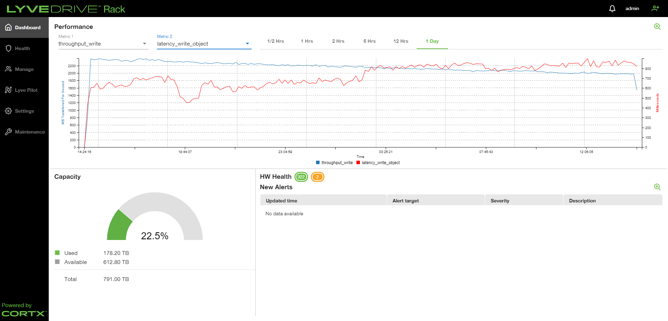

*Fig 2. Performance graph at 22.5% space utilization*

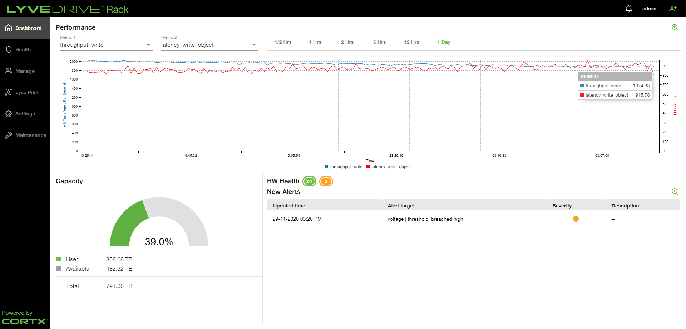

*Fig 3. Performance graph at 39% space utilization*

*Fig 4. Performance graph at 43% space utilization*

*Fig 5. Performance graph at 58.6% space utilization*

*Fig 6. Performance graph at 67% space utilization*

*Failover – failback is done at 67% space utilization.*

*Fig 7. Performance graph at 70% space utilization*

|  |  |
| --- | --- |
| **Performance Report** | |
| **Product** | **LYVE DRIVE Rack R1.0** |
| **Space Utilization** | **70%** |
| **Date** | **2/12/2020** |
| **System** | **iu10/12-r22-pun.seagate.com** |

|  |  |  |  |  |  |  |  |  |  |  |
| --- | --- | --- | --- | --- | --- | --- | --- | --- | --- | --- |
| **Single Bucket Performance Statistics (Average) using S3Bench** | | | | | | | | | | |
| **Statistics** | **4 KB** | **100 KB** | **1 MB** | **5 MB** | | **36 MB** | **64 MB** | **128 MB** | **256 MB** | |
| **Write Throughput (MBps)** | 0 | 6 | 60 | 490 | | 1382 | 1623 | 1546 | 1687 | |
| **Read Throughput (MBps)** | 2 | 44 | 554 | 1788 | | 4148 | 4429 | 4266 | 4117 | |
| **Write Latency (ms)** | 1821 | 1605 | 1639 | 1006 | | 2529 | 3877 | 8097 | 14930 | |
| **Read Latency (ms)** | 167 | 219 | 179 | 278 | | 848 | 1419 | 2969 | 6114 | |
| **Write IOPS** | 53 | 62 | 60 | 98 | | 38 | 25 | 12 | 6 | |
| **Read IOPS** | 581 | 452 | 554 | 358 | | 115 | 69 | 33 | 16 | |
| **Write TTFB (ms)** | 1821 | 1605 | 1639 | 1006 | | 2529 | 3877 | 8097 | 14930 | |
| **Read TTFB (ms)** | 167 | 186 | 171 | 257 | | 598 | 728 | 809 | 853 | |
| **Metadata Latencies (captured with 1KB object)** | | | | | | | | | |
| **Operation Latency** | | | | | **Response Time(ms)** | | | | |
| **Add / Edit Object Tags** | | | | | 501.0 | | | | |
| **Read Object Tags** | | | | | 161.0 | | | | |
| **Read Object Metadata** | | | | | 175.0 | | | | |

|  |  |  |  |  |  |  |  |  |  |
| --- | --- | --- | --- | --- | --- | --- | --- | --- | --- |
| **Multiple Buckets Performance Statistics (Average) using HSBench and COSBench** (Throughput inMBps and Latency in ms) | | | | | | | | | |
| **Bench** | **Statistics** | **4 KB** | **100 KB** | **1 MB** | **5 MB** | **36 MB** | **64 MB** | **128 MB** | **256 MB** |
| **HSbench**  **1 Bucket**  **1000 Objects**  **100 Sessions** | **Write Throughput** | 0 | 5 | 60 | 434 | 1281 | 1549 | 1627 | 1573 |
| **Read Throughput** | 2 | 44 | 565 | 1619 | 4279 | 4293 | 4443 | 4635 |
| **write Latency** | 1778 | 1536 | 1621 | 1056 | 2675 | 3982 | 7519 | 15766 |
| **Read Latency** | 171 | 210 | 170 | 297 | 810 | 1423 | 2646 | 3717 |
| **Write IOPS** | 53 | 61 | 60 | 87 | 36 | 24 | 12 | 6 |
| **Read IOPS** | 563 | 455 | 565 | 324 | 119 | 67 | 35 | 18 |
| **HSbench**  **10 Buckets**  **100 Objects**  **100 Sessions** | **Write Throughput** | 0 | 5 | 60 | 463 | 1316 | 1597 | 1609 | 1598 |
| **Read Throughput** | 2 | 43 | 555 | 1638 | 4372 | 4504 | 4292 | 4451 |
| **Read Latency** | 1738 | 1593 | 1633 | 993 | 2560 | 3840 | 7669 | 15490 |
| **write Latency** | 173 | 221 | 173 | 292 | 798 | 1376 | 2717 | 3635 |
| **Write IOPS** | 55 | 60 | 60 | 93 | 37 | 24 | 12 | 6 |
| **Read IOPS** | 560 | 440 | 555 | 328 | 121 | 70 | 34 | 17 |
| **HSbench**  **50 Buckets**  **100 Objects**  **100 Sessions** | **Write Throughput** | 0 | 6 | 60 | 532 | 1431 | 1669 | 1676 | 1634 |
| **Read Throughput** | 2 | 41 | 504 | 1406 | 4595 | 4371 | 3920 | 3961 |
| **Read Latency** | 1731 | 1554 | 1647 | 923 | 2490 | 3799 | 7567 | 15521 |
| **write Latency** | 170 | 233 | 196 | 353 | 775 | 1449 | 3205 | 3014 |
| **Write IOPS** | 57 | 64 | 60 | 106 | 40 | 26 | 13 | 6 |
| **Read IOPS** | 584 | 425 | 504 | 281 | 128 | 68 | 31 | 15 |
| **COSbench**  **1 Bucket**  **1000 Objects**  **100 Sessions** | **Write Throughput** | 0 | 8 | 81 | 346 | 506 | 517 | 604 | 714 |
| **Read Throughput** | 0 | 8 | 80 | 344 | 504 | 514 | 599 | 735 |
| **Read Latency** | 1771 | 946 | 990 | 1103 | 5756 | 10109 | 16929 | 27876 |
| **Write Latency** | 187 | 245 | 252 | 343 | 1359 | 2282 | 4291 | 7705 |
| **Write IOPS** | 51 | 84 | 81 | 69 | 14 | 8 | 4 | 2 |
| **Read IOPS** | 51 | 84 | 80 | 69 | 14 | 8 | 4 | 2 |
| **COSbench**  **10 Buckets**  **100 Objects**  **100 Sessions** | **Write Throughput** | 0 | 8 | 80 | 343 | 478 | 502 | 609 | 709 |
| **Read Throughput** | 0 | 8 | 79 | 345 | 481 | 515 | 622 | 765 |
| **Read Latency** | 1810 | 955 | 997 | 1114 | 6265 | 10559 | 17290 | 28200 |
| **Write Latency** | 118 | 252 | 260 | 343 | 1256 | 2129 | 3642 | 7283 |
| **Write IOPS** | 52 | 83 | 80 | 69 | 13 | 7 | 4 | 2 |
| **Read IOPS** | 52 | 83 | 79 | 69 | 13 | 8 | 4 | 2 |
| **COSbench**  **50 Buckets**  **100 Objects**  **100 Sessions** | **Write Throughput** | 0 | 8 | 81 | 335 | 564 | 673 | 841 | 978 |
| **Read Throughput** | 0 | 8 | 81 | 337 | 563 | 677 | 870 | 1032 |
| **Read Latency** | 1853 | 949 | 985 | 1130 | 5160 | 7511 | 11490 | 18869 |
| **Write Latency** | 98 | 235 | 245 | 360 | 1221 | 1984 | 3600 | 6904 |
| **Write IOPS** | 51 | 85 | 81 | 67 | 15 | 10 | 6 | 3 |
| **Read IOPS** | 51 | 84 | 81 | 67 | 15 | 10 | 6 | 4 |

**S3 Benchmark:**

*Fig 8. S3 benchmark trends at 70% space utilization*

*Fig 9. Performance graph at 77.8% space utilization*

*Fig 10. Performance graph at 79.7% space utilization*

|  |  |
| --- | --- |
| **Performance Report** | |
| **Product** | **LYVE DRIVE Rack R1.0** |
| **Space Utilization** | **80%** |
| **Date** | **5/12/2020** |
| **System** | **iu10/12-r22-pun.seagate.com** |

|  |  |  |  |  |  |  |  |  |  |
| --- | --- | --- | --- | --- | --- | --- | --- | --- | --- |
| **Single Bucket Performance Statistics (Average) using S3Bench** | | | | | | | | | |
| **Statistics** | **4 KB** | **100 KB** | **1 MB** | | **5 MB** | **36 MB** | **64 MB** | **128 MB** | **256 MB** |
| **Write Throughput (MBps)** | 0 | 6 | 59 | | 521 | 1368 | 1404 | 1634 | 1676 |
| **Read Throughput (MBps)** | 1 | 46 | 562 | | 1631 | 4197 | 4386 | 4224 | 4080 |
| **Write Latency (ms)** | 2015 | 1547 | 1680 | | 942 | 2556 | 4447 | 7655 | 14984 |
| **Read Latency (ms)** | 197 | 210 | 176 | | 304 | 836 | 1438 | 2958 | 6210 |
| **Write IOPS** | 48 | 64 | 59 | | 104 | 38 | 21 | 12 | 6 |
| **Read IOPS** | 493 | 471 | 562 | | 326 | 117 | 69 | 33 | 15 |
| **Write TTFB (ms)** | 2015 | 1547 | 1680 | | 942 | 2556 | 4447 | 7655 | 14984 |
| **Read TTFB (ms)** | 197 | 178 | 168 | | 284 | 591 | 746 | 831 | 880 |
| **Metadata Latencies (captured with 1KB object)** | | | | | | | | | |
| **Operation Latency** | | | | **Response Time(ms)** | | | | | |
| **Add / Edit Object Tags** | | | | 338.0 | | | | | |
| **Read Object Tags** | | | | 80.0 | | | | | |
| **Read Object Metadata** | | | | 81.0 | | | | | |

|  |  |  |  |  |  |  |  |  |  |
| --- | --- | --- | --- | --- | --- | --- | --- | --- | --- |
| **Multiple Buckets Performance Statistics (Average) using HSBench and COSBench** (Throughput inMBps and Latency in ms) | | | | | | | | | |
| **Bench** | **Statistics** | **4 KB** | **100 KB** | **1 MB** | **5 MB** | **36 MB** | **64 MB** | **128 MB** | **256 MB** |
| **HSbench**  **1 Bucket**  **1000 Objects**  **100 Sessions** | **Write Throughput** | 0 | 6 | 62 | 427 | 1334 | 1540 | 1573 | 1639 |
| **Read Throughput** | 2 | 47 | 561 | 1625 | 4289 | 4302 | 4050 | 4479 |
| **write Latency** | 1831 | 1515 | 1537 | 1076 | 2608 | 3959 | 7859 | 14977 |
| **Read Latency** | 176 | 202 | 171 | 296 | 805 | 1419 | 2867 | 3698 |
| **Write IOPS** | 52 | 63 | 62 | 85 | 37 | 24 | 12 | 6 |
| **Read IOPS** | 540 | 478 | 561 | 325 | 119 | 67 | 32 | 17 |
| **HSbench**  **10 Buckets**  **100 Objects**  **100 Sessions** | **Write Throughput** | 0 | 6 | 58 | 439 | 1317 | 1638 | 1644 | 1629 |
| **Read Throughput** | 1 | 42 | 561 | 1497 | 4528 | 4301 | 4169 | 4565 |
| **Read Latency** | 1900 | 1521 | 1652 | 1065 | 2570 | 3748 | 7506 | 15188 |
| **write Latency** | 192 | 222 | 172 | 324 | 765 | 1404 | 2823 | 3682 |
| **Write IOPS** | 50 | 62 | 58 | 88 | 37 | 25 | 12 | 6 |
| **Read IOPS** | 493 | 434 | 561 | 299 | 126 | 67 | 33 | 17 |
| **HSbench**  **50 Buckets**  **100 Objects**  **100 Sessions** | **Write Throughput** | 0 | 6 | 61 | 530 | 1424 | 1653 | 1667 | 1642 |
| **Read Throughput** | 2 | 41 | 504 | 1422 | 4686 | 4375 | 4025 | 3983 |
| **Read Latency** | 1836 | 1548 | 1620 | 926 | 2497 | 3834 | 7617 | 15428 |
| **write Latency** | 168 | 238 | 197 | 349 | 762 | 1447 | 3135 | 3121 |
| **Write IOPS** | 54 | 64 | 61 | 106 | 40 | 25 | 13 | 6 |
| **Read IOPS** | 589 | 418 | 504 | 284 | 130 | 68 | 31 | 15 |
| **COSbench**  **1 Bucket**  **1000 Objects**  **100 Sessions** | **Write Throughput** | 0 | 8 | 82 | 342 | 485 | 501 | 579 | 717 |
| **Read Throughput** | 0 | 8 | 82 | 341 | 482 | 532 | 623 | 745 |
| **Read Latency** | 1903 | 948 | 972 | 1121 | 6085 | 10295 | 17772 | 27979 |
| **Write Latency** | 207 | 248 | 252 | 341 | 1352 | 2334 | 4034 | 7468 |
| **Write IOPS** | 47 | 83 | 82 | 68 | 13 | 7 | 4 | 2 |
| **Read IOPS** | 47 | 84 | 82 | 68 | 13 | 8 | 4 | 2 |
| **COSbench**  **10 Buckets**  **100 Objects**  **100 Sessions** | **Write Throughput** | 0 | 8 | 80 | 342 | 482 | 507 | 602 | 722 |
| **Read Throughput** | 0 | 8 | 80 | 343 | 477 | 518 | 635 | 791 |
| **Read Latency** | 1960 | 947 | 989 | 1117 | 6279 | 10515 | 17494 | 27730 |
| **Write Latency** | 118 | 249 | 258 | 343 | 1207 | 2064 | 3571 | 7037 |
| **Write IOPS** | 48 | 84 | 80 | 68 | 13 | 7 | 4 | 2 |
| **Read IOPS** | 48 | 84 | 80 | 69 | 13 | 8 | 4 | 3 |
| **COSbench**  **50 Buckets**  **100 Objects**  **100 Sessions** | **Write Throughput** | 0 | 8 | 81 | 339 | 579 | 692 | 846 | 996 |
| **Read Throughput** | 0 | 8 | 81 | 341 | 586 | 703 | 844 | 1024 |
| **Read Latency** | 1994 | 948 | 990 | 1109 | 5029 | 7264 | 11550 | 18698 |
| **Write Latency** | 101 | 233 | 246 | 363 | 1179 | 1952 | 3582 | 6828 |
| **Write IOPS** | 48 | 85 | 81 | 68 | 16 | 10 | 6 | 3 |
| **Read IOPS** | 47 | 85 | 81 | 68 | 16 | 10 | 6 | 4 |

**S3 Benchmark:**

*Fig 11. S3 Benchmark graph at 80% space utilization*

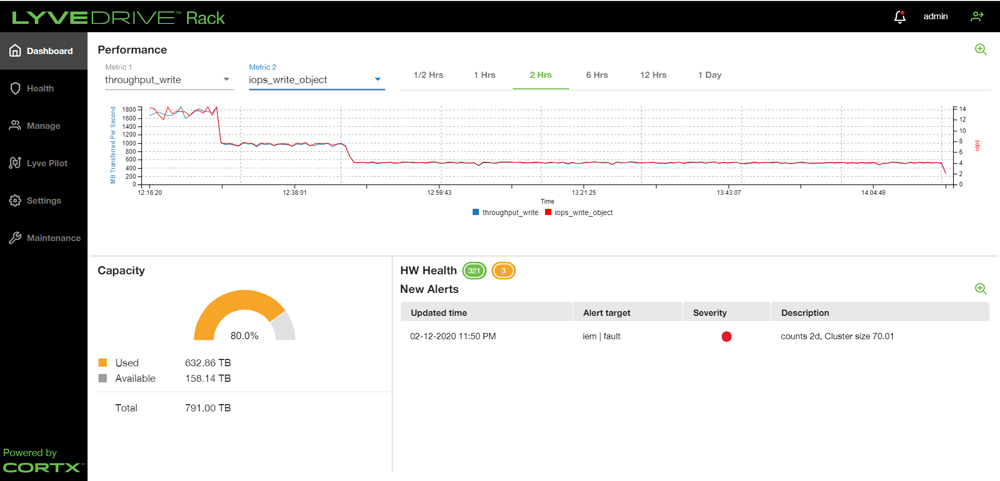

*Fig 12. Performance graph at 80% space utilization*

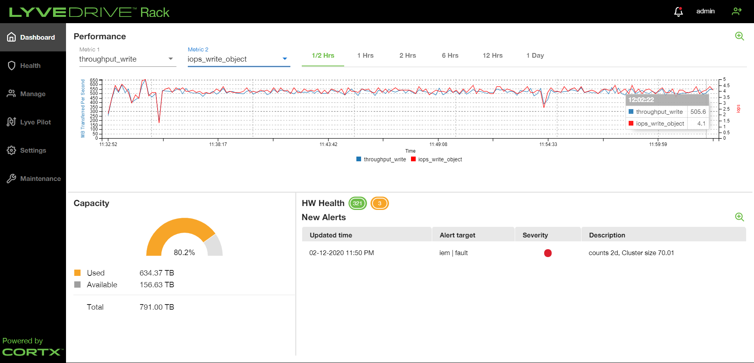

*Fig 13. Performance graph at 80.2% space utilization*

|  |  |
| --- | --- |
| **Performance Report** | |
| **Product** | **LYVE DRIVE Rack R1.0** |
| **Space Utilization** | **90%** |
| **Date** | **8/12/2020** |
| **System** | **iu10/12-r22-pun.seagate.com** |

|  |  |  |  |  |  |  |  |  |  |
| --- | --- | --- | --- | --- | --- | --- | --- | --- | --- |
| **Single Bucket Performance Statistics (Average) using S3Bench** | | | | | | | | | |
| **Statistics** | **4 KB** | **100 KB** | **1 MB** | | **5 MB** | **36 MB** | **64 MB** | **128 MB** | **256 MB** |
| **Write Throughput (MBps)** | 0 | 6 | 60 | | 479 | 1322 | 1363 | 1455 | 1660 |
| **Read Throughput (MBps)** | 2 | 46 | 509 | | 1592 | 4175 | 4286 | 4271 | 3843 |
| **Write Latency (ms)** | 2126 | 1571 | 1647 | | 1023 | 2646 | 4589 | 8589 | 15151 |
| **Read Latency (ms)** | 175 | 212 | 195 | | 312 | 841 | 1465 | 2956 | 6565 |
| **Write IOPS** | 46 | 63 | 60 | | 96 | 37 | 21 | 11 | 6 |
| **Read IOPS** | 555 | 467 | 509 | | 318 | 116 | 67 | 33 | 15 |
| **Write TTFB (ms)** | 2126 | 1571 | 1647 | | 1023 | 2646 | 4589 | 8589 | 15151 |
| **Read TTFB (ms)** | 175 | 179 | 187 | | 293 | 588 | 754 | 834 | 945 |
| **Metadata Latencies (captured with 1KB object)** | | | | | | | | | |
| **Operation Latency (ms)** | | | | **Response Time** | | | | | |
| **Add / Edit Object Tags** | | | | 338.0 | | | | | |
| **Read Object Tags** | | | | 81.0 | | | | | |
| **Read Object Metadata** | | | | 79.0 | | | | | |

|  |  |  |  |  |  |  |  |  |  |
| --- | --- | --- | --- | --- | --- | --- | --- | --- | --- |
| **Multiple Buckets Performance Statistics (Average) using HSBench and COSBench** (Throughput inMBps and Latency in ms) | | | | | | | | | |
| **Bench** | **Statistics** | **4 KB** | **100 KB** | **1 MB** | **5 MB** | **36 MB** | **64 MB** | **128 MB** | **256 MB** |
| **HSbench**  **1 Bucket**  **1000 Objects**  **100 Sessions** | **Write Throughput** | 0 | 5 | 59 | 441 | 1201 | 1479 | 1540 | 1554 |
| **Read Throughput** | 2 | 44 | 541 | 1647 | 4318 | 4419 | 4370 | 4773 |
| **write Latency** | 1968 | 1620 | 1601 | 1048 | 2846 | 4171 | 8077 | 15984 |
| **Read Latency** | 172 | 216 | 178 | 295 | 814 | 1388 | 2719 | 3684 |
| **Write IOPS** | 48 | 59 | 59 | 88 | 33 | 23 | 12 | 6 |
| **Read IOPS** | 556 | 448 | 541 | 329 | 120 | 69 | 34 | 18 |
| **HSbench**  **10 Buckets**  **100 Objects**  **100 Sessions** | **Write Throughput** | 0 | 6 | 58 | 432 | 1256 | 1523 | 1629 | 1565 |
| **Read Throughput** | 2 | 46 | 573 | 1654 | 4235 | 4274 | 4245 | 4607 |
| **Read Latency** | 2066 | 1535 | 1634 | 1071 | 2707 | 4018 | 7544 | 15881 |
| **write Latency** | 173 | 203 | 168 | 287 | 820 | 1426 | 2745 | 3584 |
| **Write IOPS** | 46 | 62 | 58 | 86 | 35 | 23 | 12 | 6 |
| **Read IOPS** | 554 | 470 | 573 | 331 | 118 | 67 | 33 | 17 |
| **HSbench**  **50 Buckets**  **100 Objects**  **100 Sessions** | **Write Throughput** | 0 | 6 | 60 | 536 | 1355 | 1634 | 1639 | 1602 |
| **Read Throughput** | 2 | 41 | 511 | 1472 | 4610 | 4347 | 4009 | 4002 |
| **Read Latency** | 2014 | 1508 | 1645 | 913 | 2633 | 3885 | 7730 | 15824 |
| **write Latency** | 171 | 237 | 195 | 338 | 775 | 1458 | 3131 | 3163 |
| **Write IOPS** | 49 | 66 | 60 | 107 | 38 | 25 | 12 | 6 |
| **Read IOPS** | 581 | 420 | 511 | 294 | 128 | 68 | 31 | 15 |
| **COSbench**  **1 Bucket**  **1000 Objects**  **100 Sessions** | **Write Throughput** | 0 | 8 | 81 | 343 | 500 | 518 | 602 | 724 |
| **Read Throughput** | 0 | 8 | 81 | 347 | 499 | 508 | 594 | 773 |
| **Read Latency** | 2097 | 949 | 975 | 1105 | 5821 | 10010 | 17130 | 27185 |
| **Write Latency** | 206 | 247 | 254 | 348 | 1386 | 2396 | 4192 | 7655 |
| **Write IOPS** | 43 | 84 | 81 | 69 | 13 | 8 | 4 | 2 |
| **Read IOPS** | 43 | 84 | 81 | 69 | 13 | 7 | 4 | 3 |
| **COSbench**  **10 Buckets**  **100 Objects**  **100 Sessions** | **Write Throughput** | 0 | 8 | 80 | 346 | 486 | 505 | 604 | 730 |
| **Read Throughput** | 0 | 8 | 80 | 346 | 501 | 502 | 627 | 724 |
| **Read Latency** | 2173 | 948 | 988 | 1100 | 6160 | 10542 | 17337 | 27978 |
| **Write Latency** | 121 | 248 | 260 | 346 | 1206 | 2148 | 3712 | 7199 |
| **Write IOPS** | 44 | 84 | 80 | 69 | 13 | 7 | 4 | 2 |
| **Read IOPS** | 44 | 83 | 80 | 69 | 13 | 7 | 4 | 2 |
| **COSbench**  **50 Buckets**  **100 Objects**  **100 Sessions** | **Write Throughput** | 0 | 8 | 81 | 340 | 569 | 668 | 748 | 827 |
| **Read Throughput** | 0 | 8 | 81 | 338 | 563 | 667 | 754 | 845 |
| **Read Latency** | 2192 | 945 | 994 | 1107 | 5169 | 7709 | 14034 | 25815 |
| **Write Latency** | 101 | 231 | 245 | 366 | 1172 | 1871 | 3072 | 4998 |
| **Write IOPS** | 44 | 85 | 81 | 68 | 15 | 10 | 5 | 3 |
| **Read IOPS** | 44 | 84 | 81 | 68 | 15 | 10 | 5 | 3 |

**S3 benchmark:**

*Fig 14. S3 Benchmark graph at 90% space utilization*

*Fig 15. Performance graph at 96.5% space utilization*

*Fig 16. Performance graph at 99.7% space utilization*

|  |  |
| --- | --- |
| **Performance Report** | |
| **Product** | **LYVE DRIVE Rack R1.0** |
| **Space Utilization** | **99%** |
| **Date** | **10/12/2020** |
| **System** | **iu10/12-r22-pun.seagate.com** |

|  |  |  |  |  |  |  |  |  |  |
| --- | --- | --- | --- | --- | --- | --- | --- | --- | --- |
| **Single Bucket Performance Statistics (Average) using S3Bench** | | | | | | | | | |
| **Statistics** | **4 KB** | **100 KB** | **1 MB** | **5 MB** | | **36 MB** | **64 MB** | **128 MB** | **256 MB** |
| **Write Throughput (MBps)** | 0 | 6 | 59 | 489 | | 1309 | 1310 | 1411 | 1446 |
| **Read Throughput (MBps)** | 2 | 44 | 587 | 1872 | | 4183 | 4393 | 3993 | 3523 |
| **Write Latency (ms)** | 2272 | 1597 | 1680 | 1006 | | 2683 | 4760 | 8910 | 17445 |
| **Read Latency (ms)** | 153 | 218 | 169 | 265 | | 845 | 1431 | 3162 | 7188 |
| **Write IOPS** | 43 | 62 | 59 | 98 | | 36 | 20 | 11 | 5 |
| **Read IOPS** | 635 | 454 | 587 | 374 | | 116 | 69 | 31 | 13 |
| **Write TTFB (ms)** | 2272 | 1597 | 1680 | 1006 | | 2683 | 4760 | 8910 | 17445 |
| **Read TTFB (ms)** | 153 | 185 | 161 | 245 | | 591 | 734 | 853 | 988 |
| **Metadata Latencies (captured with 1KB object)** | | | | | | | | | |
| **Operation Latency** | | | | | **Response Time (ms)** | | | | |
| **Add / Edit Object Tags** | | | | | 338.0 | | | | |
| **Read Object Tags** | | | | | 79.0 | | | | |
| **Read Object Metadata** | | | | | 80.0 | | | | |

|  |  |  |  |  |  |  |  |  |  |
| --- | --- | --- | --- | --- | --- | --- | --- | --- | --- |
| **Multiple Buckets Performance Statistics (Average) using HSBench and COSBench** (Throughput inMBps and Latency in ms) | | | | | | | | | |
| **Bench** | **Statistics** | **4 KB** | **100 KB** | **1 MB** | **5 MB** | **36 MB** | **64 MB** | **128 MB** | **256 MB** |
| **HSbench**  **1 Bucket**  **1000 Objects**  **100 Sessions** | **Write Throughput** | 0 | 6 | 64 | 469 | 1241 | 1571 | 1539 | 1519 |
| **Read Throughput** | 2 | 46 | 530 | 1657 | 4368 | 4255 | 4240 | 4605 |
| **write Latency** | 2049 | 1452 | 1490 | 975 | 2739 | 3944 | 7997 | 16114 |
| **Read Latency** | 166 | 205 | 177 | 293 | 798 | 1434 | 2747 | 4002 |
| **Write IOPS** | 47 | 65 | 64 | 94 | 34 | 24 | 12 | 5 |
| **Read IOPS** | 579 | 470 | 530 | 331 | 121 | 66 | 33 | 17 |
| **HSbench**  **10 Buckets**  **100 Objects**  **100 Sessions** | **Write Throughput** | 0 | 6 | 62 | 467 | 1296 | 1590 | 1577 | 1575 |
| **Read Throughput** | 2 | 45 | 618 | 1713 | 4497 | 4190 | 4378 | 4645 |
| **Read Latency** | 2093 | 1502 | 1557 | 983 | 2644 | 3884 | 7767 | 15755 |
| **write Latency** | 173 | 208 | 154 | 283 | 773 | 1434 | 2750 | 3585 |
| **Write IOPS** | 46 | 64 | 62 | 93 | 36 | 24 | 12 | 6 |
| **Read IOPS** | 556 | 465 | 618 | 343 | 125 | 65 | 34 | 18 |
| **HSbench**  **50 Buckets**  **100 Objects**  **100 Sessions** | **Write Throughput** | 0 | 5 | 61 | 546 | 1376 | 1594 | 1599 | 1580 |
| **Read Throughput** | 2 | 42 | 520 | 1474 | 4616 | 4189 | 3787 | 3898 |
| **Read Latency** | 2094 | 1631 | 1622 | 899 | 2583 | 3962 | 7939 | 16056 |
| **write Latency** | 161 | 230 | 191 | 337 | 774 | 1507 | 3329 | 3517 |
| **Write IOPS** | 47 | 61 | 61 | 109 | 38 | 24 | 12 | 6 |
| **Read IOPS** | 616 | 432 | 520 | 295 | 128 | 65 | 30 | 15 |
| **COSbench**  **1 Bucket**  **1000 Objects**  **100 Sessions** | **Write Throughput** | 0 | 8 | 81 | 345 | 489 | 548 | 603 | 699 |
| **Read Throughput** | 0 | 8 | 82 | 340 | 485 | 571 | 588 | 745 |
| **Read Latency** | 2179 | 963 | 974 | 1107 | 5992 | 9304 | 17263 | 28252 |
| **Write Latency** | 219 | 248 | 254 | 346 | 1380 | 2273 | 4088 | 7901 |
| **Write IOPS** | 42 | 83 | 81 | 69 | 13 | 8 | 4 | 2 |
| **Read IOPS** | 42 | 83 | 82 | 68 | 13 | 8 | 4 | 2 |
| **COSbench**  **10 Buckets**  **100 Objects**  **100 Sessions** | **Write Throughput** | 0 | 8 | 82 | 349 | 460 | 524 | 591 | 714 |
| **Read Throughput** | 0 | 8 | 82 | 345 | 468 | 525 | 622 | 748 |
| **Read Latency** | 2348 | 923 | 977 | 1100 | 6584 | 10133 | 17779 | 28536 |
| **Write Latency** | 112 | 234 | 247 | 337 | 1215 | 2082 | 3669 | 7058 |
| **Write IOPS** | 41 | 86 | 82 | 70 | 12 | 8 | 4 | 2 |
| **Read IOPS** | 41 | 87 | 82 | 69 | 13 | 8 | 4 | 2 |
| **COSbench**  **50 Buckets**  **100 Objects**  **100 Sessions** | **Write Throughput** | 0 | 8 | 82 | 341 | 578 | 666 | 759 | 817 |
| **Read Throughput** | 0 | 8 | 83 | 338 | 586 | 684 | 760 | 896 |
| **Read Latency** | 2288 | 927 | 979 | 1116 | 5062 | 7681 | 13803 | 25728 |
| **Write Latency** | 100 | 223 | 235 | 354 | 1152 | 1879 | 3063 | 5127 |
| **Write IOPS** | 42 | 87 | 82 | 68 | 16 | 10 | 5 | 3 |
| **Read IOPS** | 42 | 87 | 83 | 68 | 16 | 10 | 5 | 3 |

**

*Fig 17. S3 Benchmark graph at 99% space utilization*

**Guided by:** Rajesh Deshmukh

**Experiment by:** Sampada Petkar

@Seagate, Pune, 2020