Please Please Please OBJECT!

to this proposed development of our green space on Reeves Close
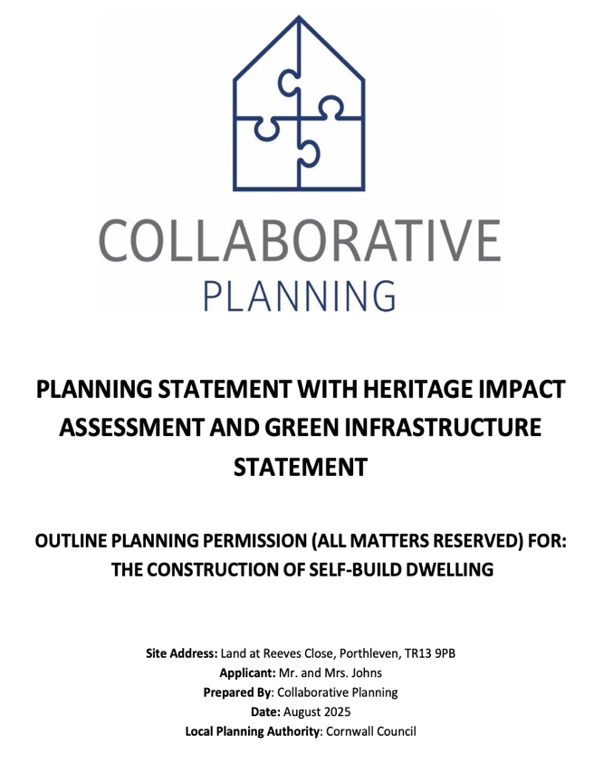
The strength of feeling in the community against this application is high. I urge the planning department to listen to local voices and to refuse this application, as it has rightly done before.

This Document
about the planning
has false information

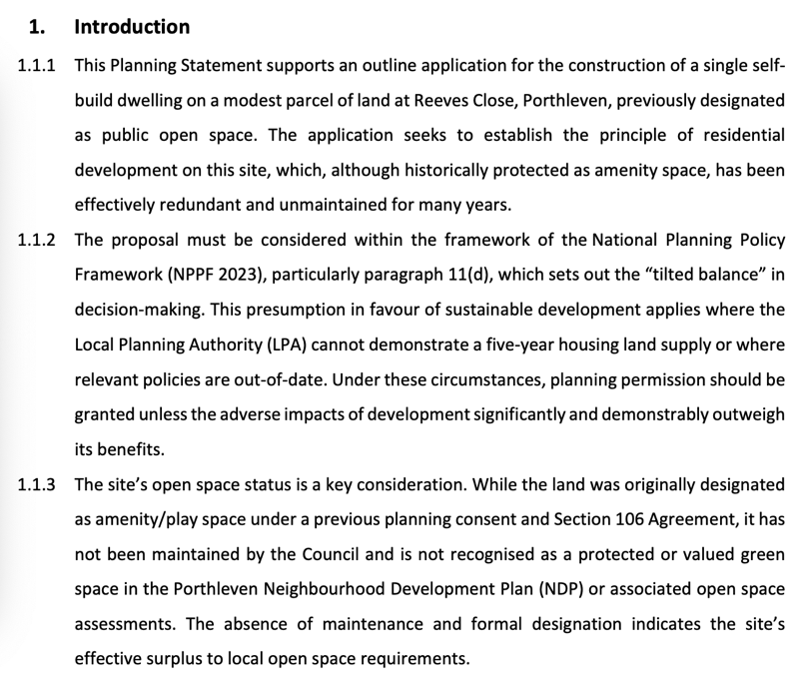
NOT TRUE - Local residents actively use and care for the land. A path is mown regularly by the neighbours to ensure it remains accessible for walking and general use.


NOT TRUE - the council mow, strim and prune the trees on the land throughout the year

Previously this proposal was rejected on the following grounds – Nothing has changed it should be rejected again
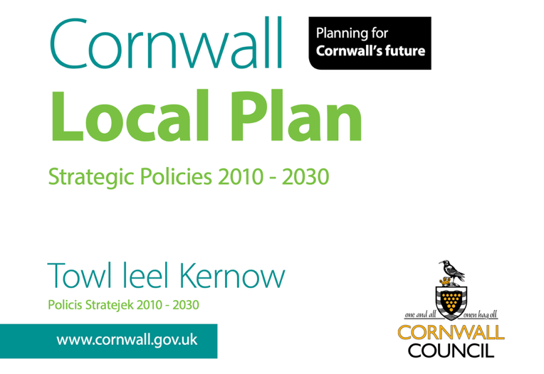

The proposal conflicts with policies 13, 16 and 25 of the cornwall local plan strategic policies 2010 – 2030.
https://www.cornwall.gov.uk/media/ozhj5k0z/adopted-local-plan-strategic-policies-2016.pdf
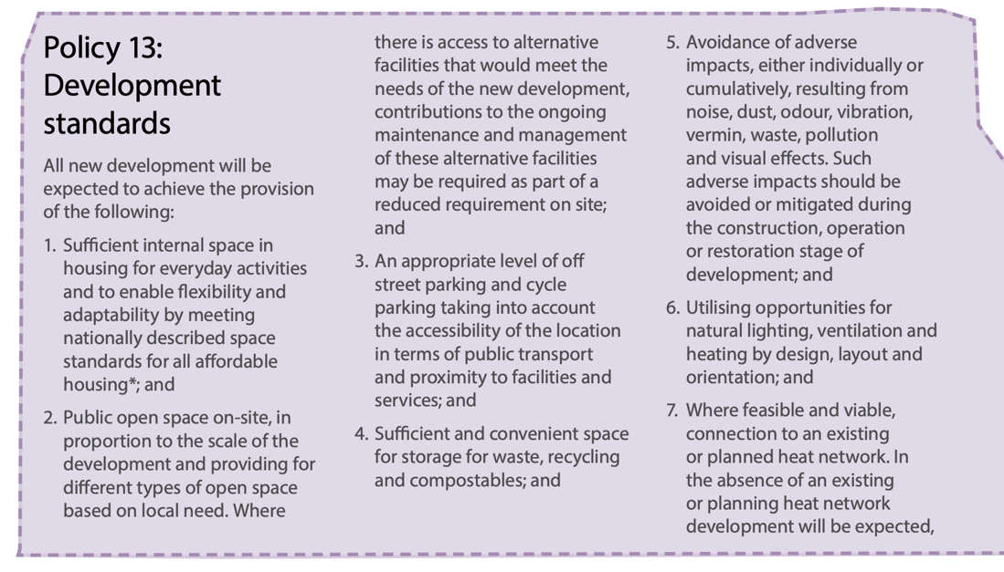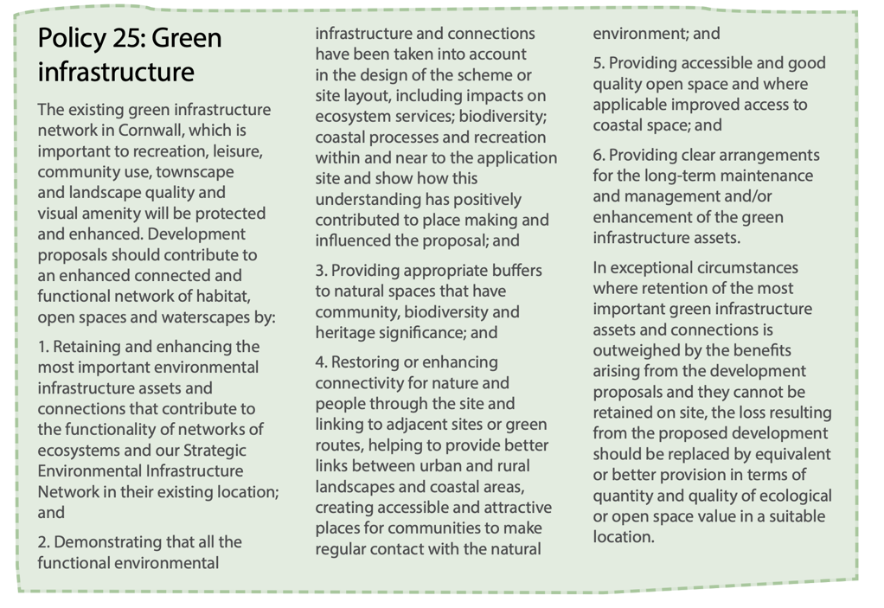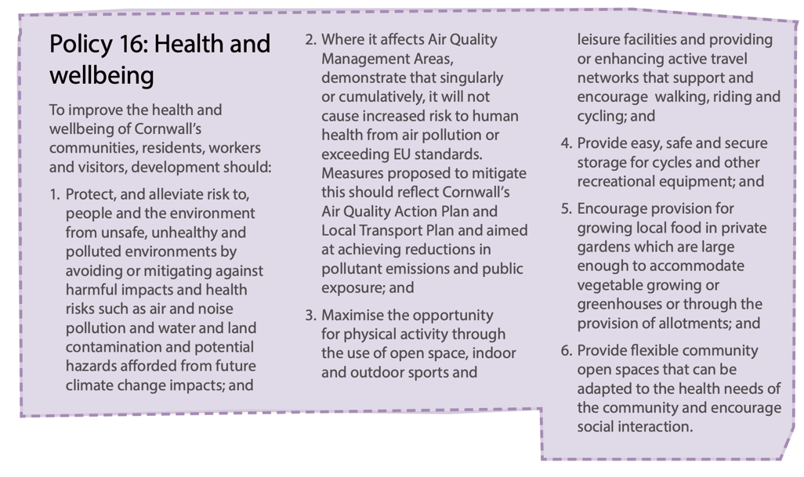


It also conflicts with policies C1 and G1 of the climate emergency development plan document.
https://www.cornwall.gov.uk/media/uxgjk4jn/climate-emergency-dpd.pdf

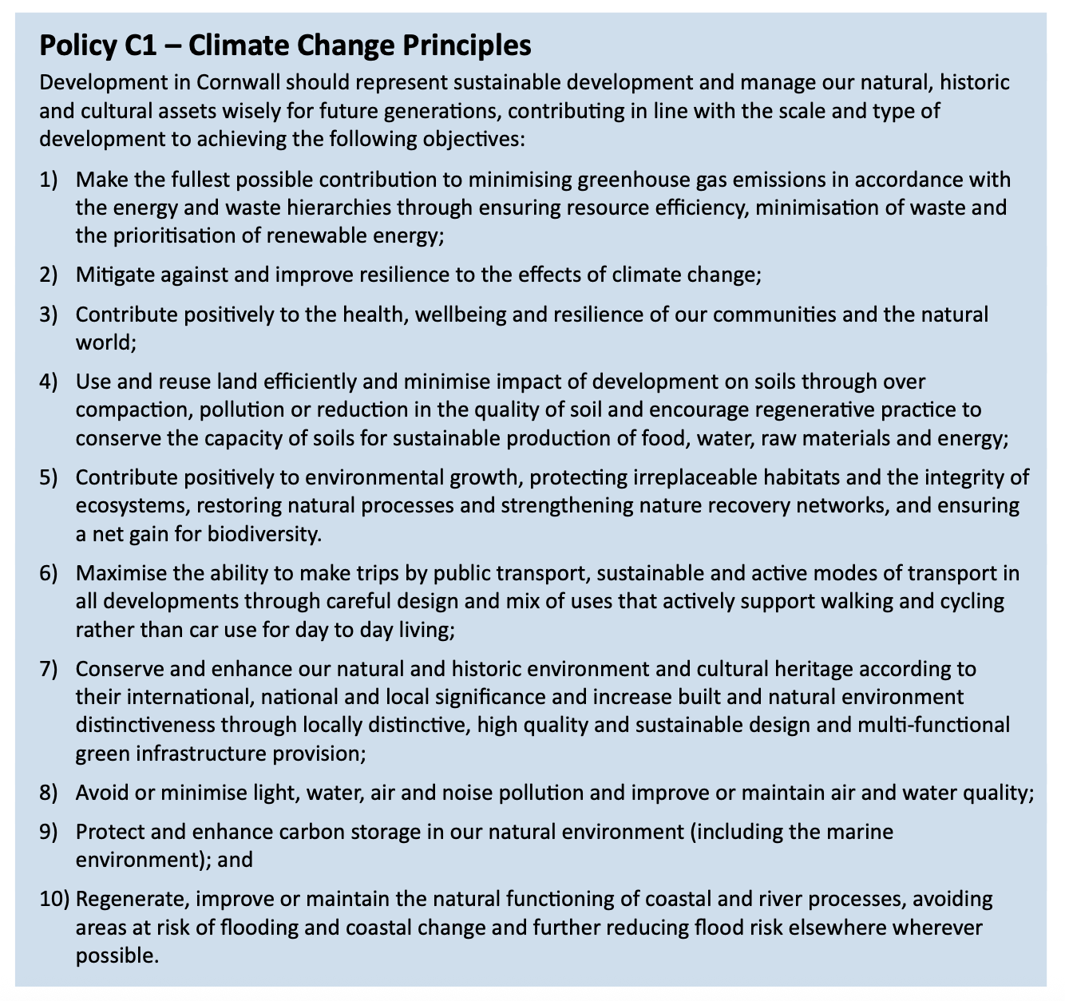
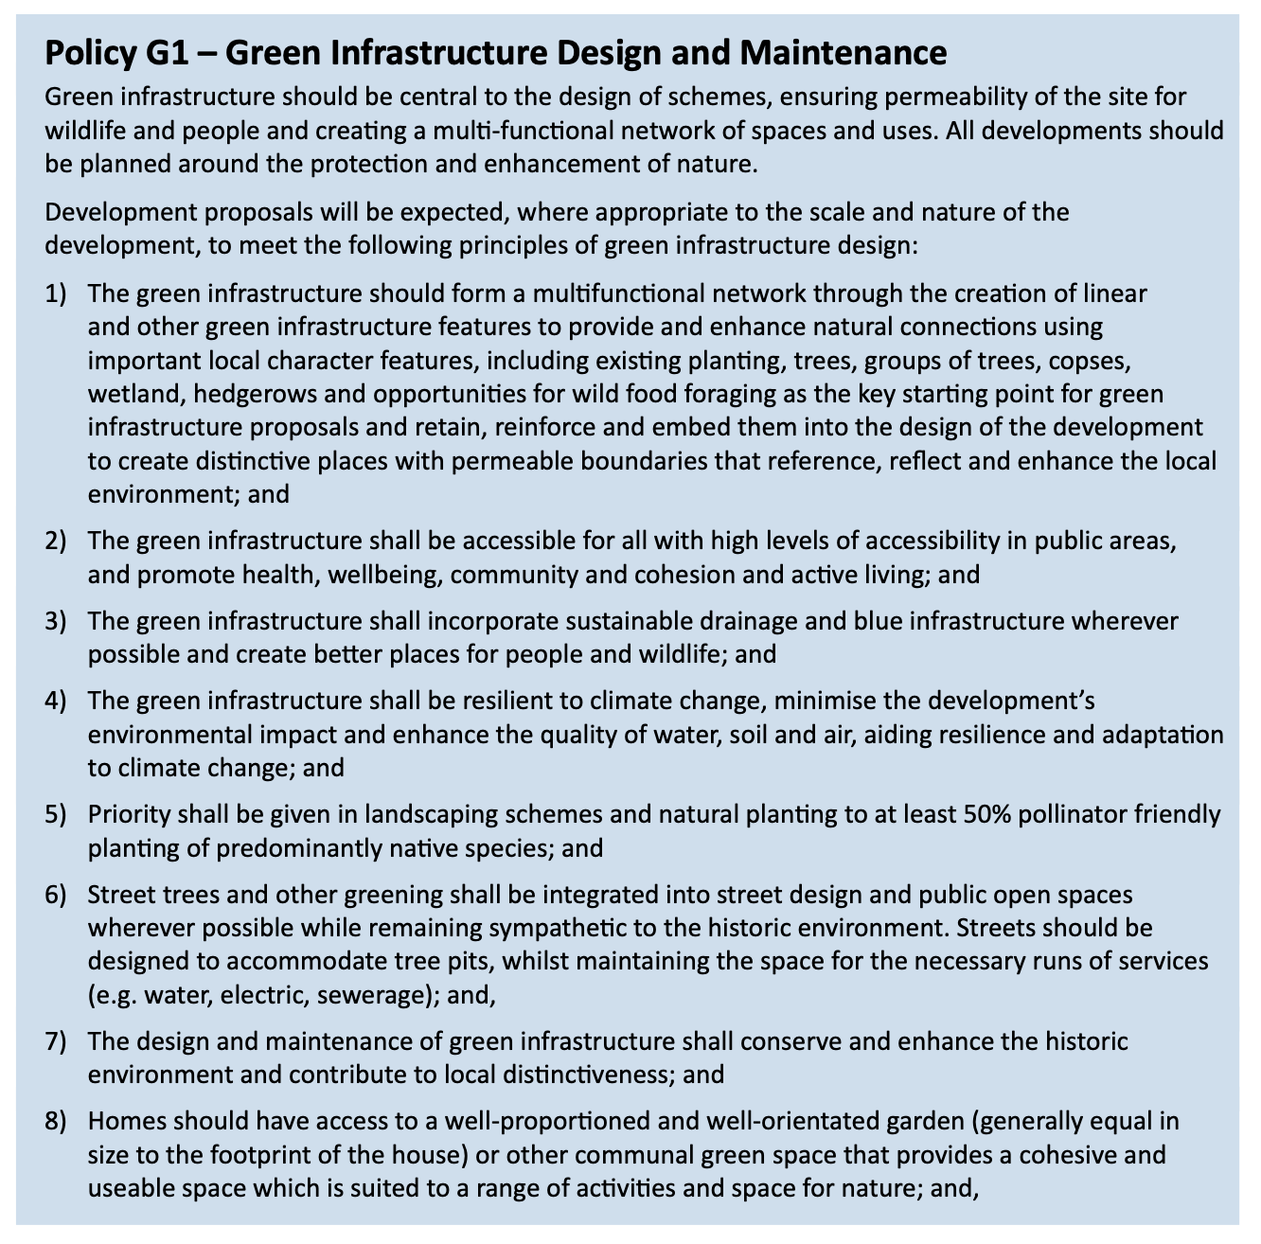

It also conflicts with paragraph 99 of the National planning policy framework (2021)

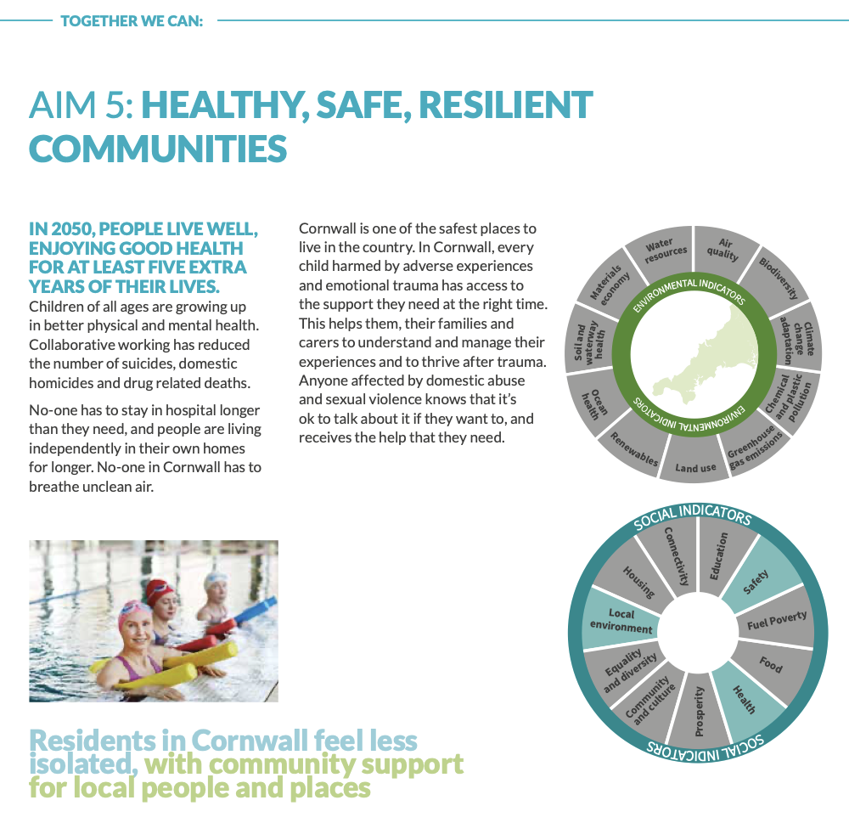It is also worth noting that in the Cornwall plan it emphasises the importance of mental health for wellbeing and health of communities.

Loss of this green space would certainly negatively impact the health and wellbeing of the residents and local community.

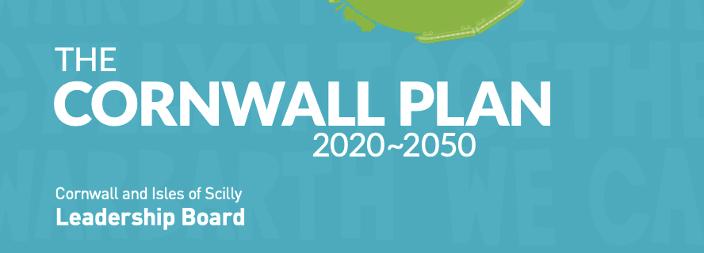

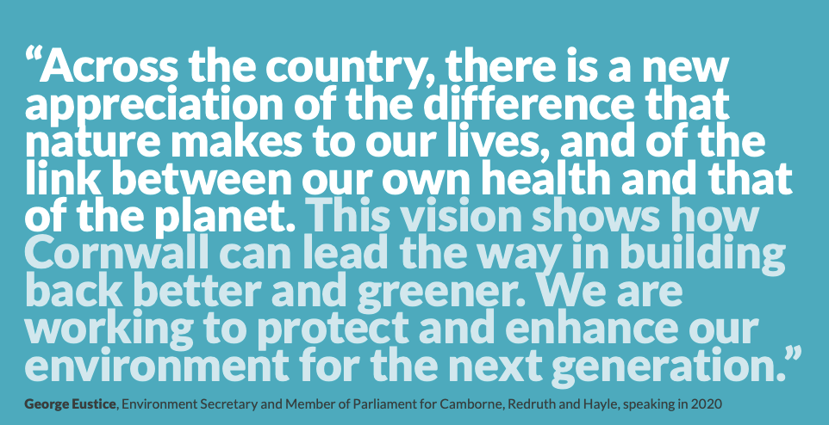

Once this land is built on, the change is irreversible. We must not lose this small but vital green space.

