Materials List
The Barn Brickfields
Purbeck white stone (3494)
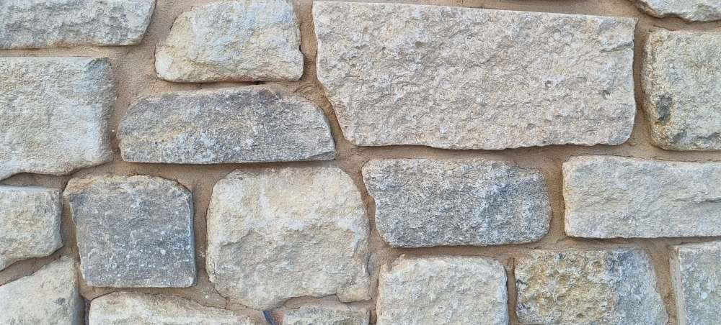

Cedar or larch featheredged black painted wooden cladding
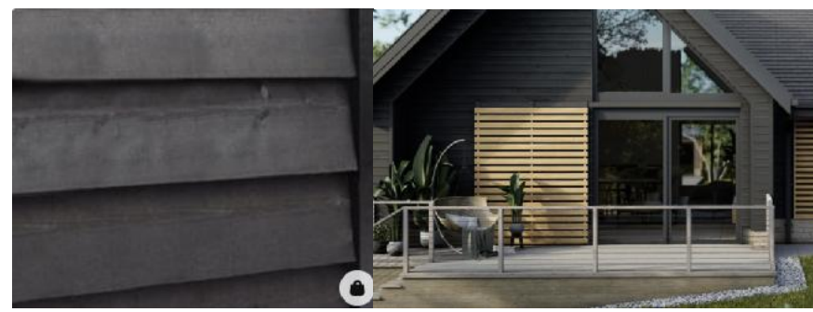
Natural slate roof
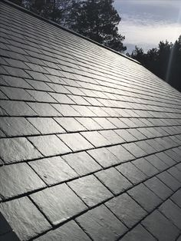

Galvanized steel guttering
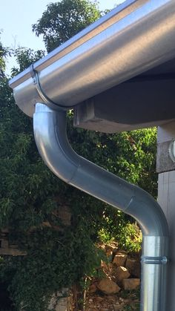

Grey aluminimum widow frames
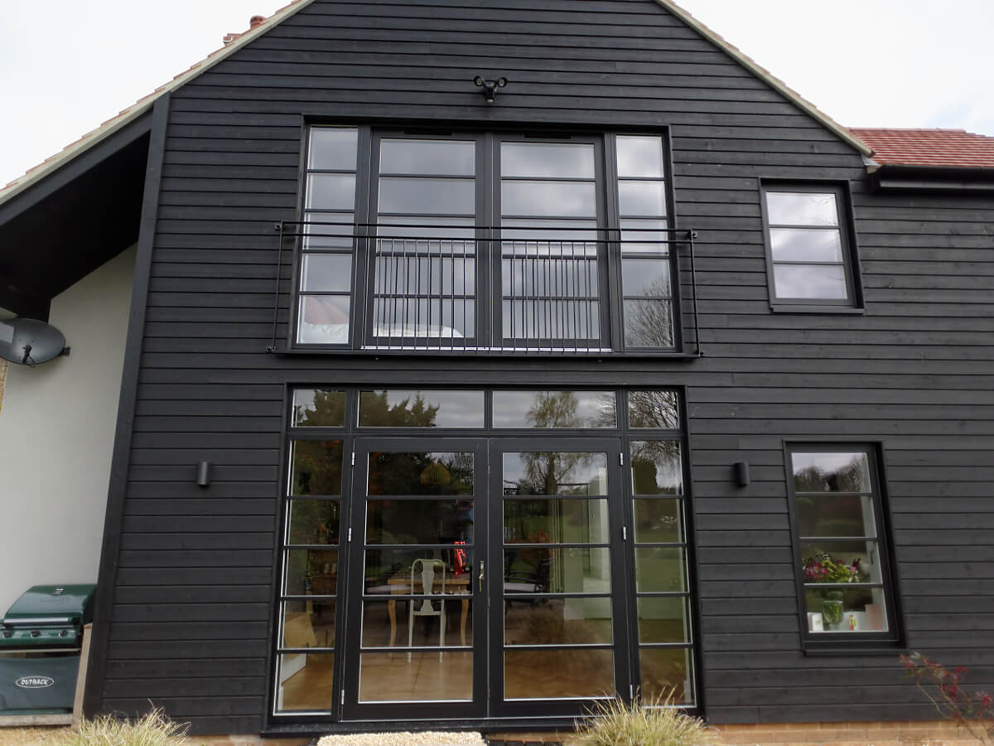

Low light LED up and down outside lights
