Dynamic Diet Recommendations with Real-Time Data for Personalized Nutrition

|  |  |  |
| --- | --- | --- |
| 1st Manish Raj  *School of CSE and Technology*  *Bennett University*  *Greater Noida, India*  [Manish.raj@bennett.edu.in](mailto:Manish.raj@bennett.edu.in) | 2nd Seajal Gupta  *School of CSE and Technology*  *Bennett University*  *Greater Noida, India*  [guptaseajal2004@gmail.com](mailto:guptaseajal2004@gmail.com) | 3rd Naman Singla  *School of CSE and Technology*  *Bennett University*  *Greater Noida, India*  [namansingla@myyahoo.com](mailto:namansingla@myyahoo.com) |
| 4th Piyush Garg  *School of CSE and Technology*  *Bennett University*  *Greater Noida, India*  [Gargpiyush370@gmail.com](mailto:Gargpiyush370@gmail.com) | 5th Priyansu Rathore  *School of CSE and Technology*  *Bennett University*  *Greater Noida, India*  [Priyansurathore255@gmail.com](mailto:Priyansurathore255@gmail.com) | 6th Ashuvendra singh  *Ap, Department of Civil Engineering*  *School of Engineering and Computing*  *Dev Bhoomi Uttrakhand University*  [Singh.ashuvendra14@gmail.com](mailto:Singh.ashuvendra14@gmail.com) |

Abstract — In today’s world, where a healthy diet plan is very necessary for our health, older recommendation systems do not incorporate dynamic and real-time data for diet recommendations. This research presents a dynamic diet recommendation system that uses real-time data and machine learning models to acquire real-time user requirements for dietary recommendations. A Multi-Layer Perceptron (MLP) neural network architecture was implemented using Keras. This system takes user preferences, health conditions, and food consumption into account for multi-class classification tasks related to dietary requirements. The system follows a structured workflow that begins with preprocessing, with handle missing’s value, with one-hot encoding for classification targets. The model is trained using a sequential neural network comprising an input layer, a hidden layer with 32 neurons, and an output layer with neurons corresponding to the number of dietary categories, with SoftMax activation for multi-class classification. Training occurs over 50 epochs with a batch size of 32, enabling the system to provide highly tailored diet recommendations based on continuous feedback.

By showing the limitations of static diet plans, this study gives a flexible, real-time approach to personalized diet plan. The combination of real-time data and machine learning ensures that recommendations changing with the user’s changing health conditions, promoting better guidence to nutritional and overall health conditions.

**Keywords —** Dynamic diet recommendations; real-time data; personalized nutrition; machine learning; health metrics; predictive analytics

# **Introduction**

In today’s world, nutrition gives an major part in health to reduce the risk of diseases. However, in the past, nutrition was based on guidelines that generally based on the energy provided by food and did not take individual nutritional needs. These models do not account for the physical health of an individual, and therefore, they ignore the fact that nutritional needs can change continuously, as they depend on various factors such as physical activity, health conditions, and more. As a result, it does not provide good recommendations for individuals because it does not adapt to their specific nutritional needs, which also affects the individual body.

Integrating artificial intelligence (AI) and machine learning (ML) into food recommendations holds promise for this challenge. This technology helps the users to provide personalised diet plans according to the present health conditions of the users by using real-time data. However, in the making of these types of technology, many challenges occur like how to provide a better recommendation system for diet plans using real-time data. the development of such electronic systems brings many challenges, including the need to constantly monitor and process different data to create recommendations and create time. The main research question of this research is: How can we use real-time data to improve recommendations for diet plans?

This research aims to solve these problems by making a healthy recommendation system that changes its recommendations from time to time according to the requirements of users and the health condition of users. The system is designed in such a way that it notices various conditions in health, like physical activities and how much nutrition is required for the body, and according to that, it changes their diet recommendation. The main aim of this process is to improve their diet recommendation system and promote a better life cycle.

The main aim of this research is to manage the diet plan for better health. By changing the traditional method of meal planning to a new technique to recommend a personalized diet plan, this research has the potential to set new standards for meal planning, making it a key factor in the expansion of self-healing. The motivation behind this research is to make people’s lives easier and healthier by making healthier diet plans according to their current needs.

This research shows a mixed proposal that combines social networks with content-based filtering to give personalized nutrition plans for management. Like deep learning models in agriculture, such as Mobile-DANet to improve the diagnosis of crop diseases, a self-development system of nutrition plans provides personalized nutrition plans to manage type 2 diabetes, obesity, and muscle and other disease data [1] [3] [7]. Using a neural network model, this study improved the accuracy of food classification using data (done_food_data.csv) to predict categories such as muscle gain, weight, and weight gain. Like how adaptive learning models such as VGG16 and ResNet50 improve classification in corn disease detection, our model also improves nutrition prediction using deep learning [2] [3].

The integration of IoMT (Internet of Medical Things) allows recommending a healthy diet by monitoring personal health indicators such as diabetes, activity, body, and nutrition, and to compare precision agriculture technology that provides real-time health data to improve holistic health management [4] [9] [19]. In addition, the Ripple Down Rules (RDR) system allows doctors to update more information over time without requiring expertise, such as additional learning models in disease classification, integration, and development based on new data, thus increasing scalability and accuracy [4] [4] [9]. The Generalized Estimator (GEE) was used in this study to further analyse the effect of diet on blood sugar changes in individuals at risk of type 2 diabetes, providing accurate nutritional prediction based on food analysis, like Bayesian optimization in agriculture [5].

The system can also estimate different distribution models used in crop disease detection using Conv2D layers, max pooling, and batch normalization without capturing, as well as nutrition plans for various health goals such as muscle growth, weight management, or diabetes management. The system also provides a realization of complex patterns and relationships in the literature [6] [22]. In addition, the system also addresses global health issues such as malnutrition and obesity, providing healthy nutrition plans, demonstrating the potential of precision agriculture to solve food scarcity through crop improvement [7] [13]. The system also plays an important role in the management of chronic diseases such as Type 2 diabetes and cardiovascular diseases, by providing patient-specific dietary recommendations based on real-time data, much like disease models for early crop disease detection that allow for proactive interventions [8]. Its scalability for real-world applications ensures widespread use in clinical settings and healthcare systems, similar to how blockchain and IoT technologies are used in precision agriculture for real-time monitoring and guidance [9][19]. Finally, this research opens avenues for further integration of CNNs and RNNs to improve dietary recommendations, similar to the use of RNNs in disease detection models to capture long-term dependencies, highlighting the potential for further improvements through data augmentation, fine-tuning, and transfer learning to enhance predictive accuracy in both dietary management and food security [10][18].The main area of this research paper are present in Part III which tell about the dataset used and also tell about layout design. Part IV tells about result with output. In Section V shows overall conclusion and future scope for this research.

# **Literature Review**

Introduces Chat Diet, an LLM-powered personalized food recommender system that integrates personal health data and population models for tailored nutrition advice. The system uses the GPT-3.5 Turbo model with 92% accuracy, enhancing personalized health recommendations through explainable AI [11]. Introduces the "Consumption Process Framework" to study dynamic food consumption processes, integrating theoretical and practical aspects. The model doesn't explicitly focus on accuracy but enhances understanding of consumption through adaptive, real-time measurement systems [12]. This system uses a CNN model with 83.6% accuracy for adaptive dietary control, offering personalized diet recommendations through food recognition and caloric intake monitoring [13]. A deep learning-based food recognition system uses a CNN model with 95.2% accuracy and edge computing to process food images, enhancing dietary assessments with higher accuracy and efficiency in monitoring [14]. This paper reviews AI-based methods for food recognition and volume estimation, highlighting challenges with irregularly shaped foods and limited databases. CNN models demonstrate high classification accuracy, achieving 93% [15]. The study introduces a personalized food recommender system using the AHP-Sort model, integrating nutritional data and user preferences, while addressing previous system limitations. Validation is limited to synthetic data [16]. Auto Dietary tracks food intake through sound with 84.9% accuracy but struggles with similar solids. Integrating a Hidden Markov Model (HMM) could refine its differentiation capabilities [17]. This study introduces a mobile app for managing Alzheimer’s patients' food plans, offering real-time feedback to nutritionists. Using a design-based research model, it enhances user experience through a user-centered approach for easy, real-time management [18]. This paper presents a personalized diet recommendation system (PDRS) to prevent coronary heart disease, using real-time vital signs and user preferences. A model-based approach ensures adaptive, precise dietary recommendations tailored to individual health and lifestyle factors [19]. This study examines connected care systems and remote monitoring for diet-related diseases, highlighting the need for personalized, real-time insights. The neuropraxic Platform could improve predictive accuracy and early intervention, though large-scale implementation remains limited [20]. This research focuses on a data-driven model that predicts weight variations and evaluates diet plans using individual metabolism data. It incorporates a Gated Recurrent Unit (GRU) for better handling of sequential data, achieving an RMSE of approximately 0.41 ± 0.05 over a 7-day period [21]. This study presents a hybrid recommendation that combines collaborative and contextual filtering to create personalized nutrition plans for long-term health management. This improves its performance by dynamically adapting to user preferences [22]. This paper examines how diet and regular exercise change blood glucose changes in individuals at risks for types 2 diabetes. Physical activity and higher protein and polyunsaturated fats have been shown to improve glucose stability using a generalized predictive model (GEE) [23]. Additionally, this paper presents an expert system that uses wave descent rules (RDR) to provide personalized nutrition advice based on clinical data. It allows dietitians to efficiently modify the knowledge base incrementally without a knowledge engineer [24]. This paper proposes an IoMT-integrated system that provides patient-specific diet recommendations using machine learning models, achieving 97.74% accuracy with Long Short-Term Memory (LSTM) networks [25]. A system that uses YOLOv8s to detect food with a high mean average precision (mAP) of 96.3% is explored in the present research. Innovations in real-time food recognition and recommendation capabilities are demonstrated by its integration with Edamam APIs for comprehensive nutritional analysis as well as personalized meal recommendation based on user history [26]. A Review. To compare the accuracy, effectiveness, and their relevance of different machine learning algorithms used in dietary recommendation systems, this IEEE study takes a methodical approach. The work provides a thorough basis for future research by highlighting the necessity of hybrid models to get in addition to the negative aspects of individual techniques [27]. While addressing usability and ethical issues, this study investigates the potential and constraints of generative AI systems, like ChatGPT, in offering personalized nutritional recommendations [28]. Opportunities and Challenges. This paper reviews recent advancements in using AI and ML for dietary planning, including predictive models and real-time nutrition tracking [29]. To give real-time, individualized dietary advice, the study "Integration of IoMT and Machine Learning for Personalized Diet Recommendations" investigates how the Internet of Medical Things (IoMT) and machine learning (ML) approaches can be integrated. Wearables and sensors are examples of IoMT devices that can be used to track and analyze real-time health measurements and recommend dietary changes based on personal preferences and health requirements. This study looks at how ML algorithms might be used to process massive volumes of data gathered by IoMT devices, enhancing the accuracy and promptness of dietary recommendations [30].

# **Research Materials and Methodology**

## **Dataset Description**

In this paper, we have used overall 4,684 rice leaf images, which include 1,604 images of bacterial blight, 1,620 images of brown spot, and 1,460 images of leaf smut, where all images are sized at 300*300 pixels in this dataset.

**Key Columns:**

1. **ID: Unique identifier for each food item.**
2. **FoodGroup: Category to which the food belongs (e.g., Legumes, Baked Products, Finfish).**
3. **Energy: Caloric quantity per serving (in kilocalorie).**
4. **Proteins: Proteins quantity (in gram).**
5. **Fats: Fats quantity (in gram).**
6. **Carb: Carbohydrates quatity (in gram).**
7. **Fiber_g, Sugar_g: Fiber and sugar content (in grams).**
8. **Vitamin and Mineral content: Includes various vitamin and mineral data (Vitamin A, Niacin, Riboflavin, Calcium, etc.), normalized to % of the USRDA (U.S. Recommended Dietary Allowance).**

## **Proposed Methodology**

The proposed method for reviewing this dataset starts with the initial data, where missing or non-consistent values will be present to ensure the dataset is clean and ready for review. This may include removing missing data and maintaining main nutrient values for good comparison. Engineering efforts focus on creating new methodologies, such as calorie/protein ratio or fat/carb ratio, which will give insight into the nutritional value of different foods.

EDA will be held to determine the distribution of macronutrients and micronutrients in various food groups and categories. This also looks for patterns, trends, and relationships between food types (e.g., “weight gain,” “muscle gain,” and “food in general”) and their nutritional value. If predictive modelling is required, then it used supervise machine learning technique like decision trees, random forests, or logistic regression to predict food characteristics.

**Key Points:**

1. **Nutritional Breakdown: The dataset provides comprehensive nutritional details, enabling in-depth analysis of food groups.**
2. **Categorization: The “category” column allows for tailored analyses of foods based on dietary goals (e.g., weight gain, muscle gain).**
3. **Wide Nutrient Coverage: Includes macronutrients, vitamins, and minerals, making it versatile for different health and nutrition studies.**

The document holds a list of 42 food items, each assigned a unique ID and classify into specific food groups like “Beans and Legume Products,” “Baked Goods,” and “Fish and Shellfish Products.” Each entry has a choose tag for easier identification, such as “Soyabean Meal, Whole” or “Fish, Raw.” The Data which is present in this dataset can be operated to make informed nutritional proposal or to identify foods that could be either beneficial or injurious to health.

A section of the information is arranged by macronutrients, which include Energy(kcal), Protein(g) , Fat(g), Carbohydrates(g) , Sugar(g) , and Fiber(g) . These figures help us apprehend the caloric and macronutrient benefaction of each food item, offering intuition into its nutritional profile. This data aids in recognizing various health and nutrition feature, like low-carb, high-protein, or High-Fiber foods.

Moreover, the dataset features micronutrient details, surround vitamins and essential minerals. It have vitamins such as a percentage pf the U.S. suggest Dietary Allowance(USRDA) . This gives users to assess the nutritional breakdown of each food item in relation to daily input concern , providing a comprehensive view of micronutrient utilization and possible dietary supplementation needs.

One categorization feature in the dataset splits food items into distinct nutritional groups, such as "Weight Gain," "Muscle Gain," and "General Food." The categorization can help with a number of applications, such as meal planning, dietary research, and product development across many nutritional frameworks, and it allows users to choose foods strategically that are in line with their individual nutritional objectives.

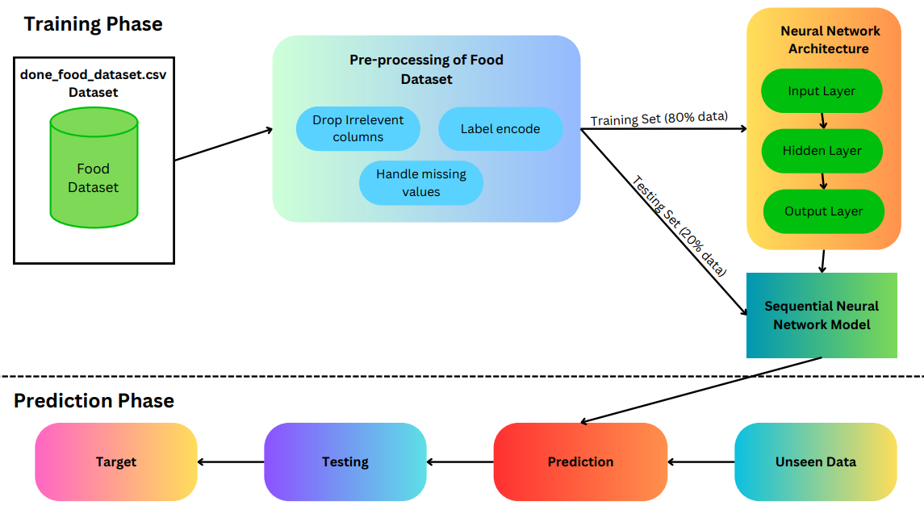Fig. 1. Workflow of Sequential Neural Network Model for Food Dataset Prediction

# **EXPERIMENTS AND RESULTS**

A neural network architecture comprising a 64-neuron input layer, a 32-neuron hidden layer, and a SoftMax output layer was employed in our experimental methodology. The Adam optimization technique, which has been especially developed to categorize nutritional data into specified categories, was used to train the model across 50 epochs. According to the training results, accuracy and performance indicators gradually improved. Training and validation accuracy consistently boosted according to graphic representations.

The model output, analysed with **confusion matrix** (**Figure 4**), showing strong results but some misclassifications, particularly between **“weight gain”** and **“general food”** due to overlapping nutritional profiles. The **classification report** (**Table 1**) showed the highest F1-score (**91%**) in the **“muscle gain”** category, while the **“general food”** category had lower precision and recall. These results highlight the model’s potential while pointing to areas for improvement in handling overlapping categories.

**Training Performance Analysis**

The model was trained over **50 epochs** using the Adam optimizer, with the following outcomes:

1.**Training and Validation Accuracy**

The training process showed a steady increase in accuracy, while validation accuracy remained stable, as depicted in **Figure 2**. This suggests effective learning without overfitting.

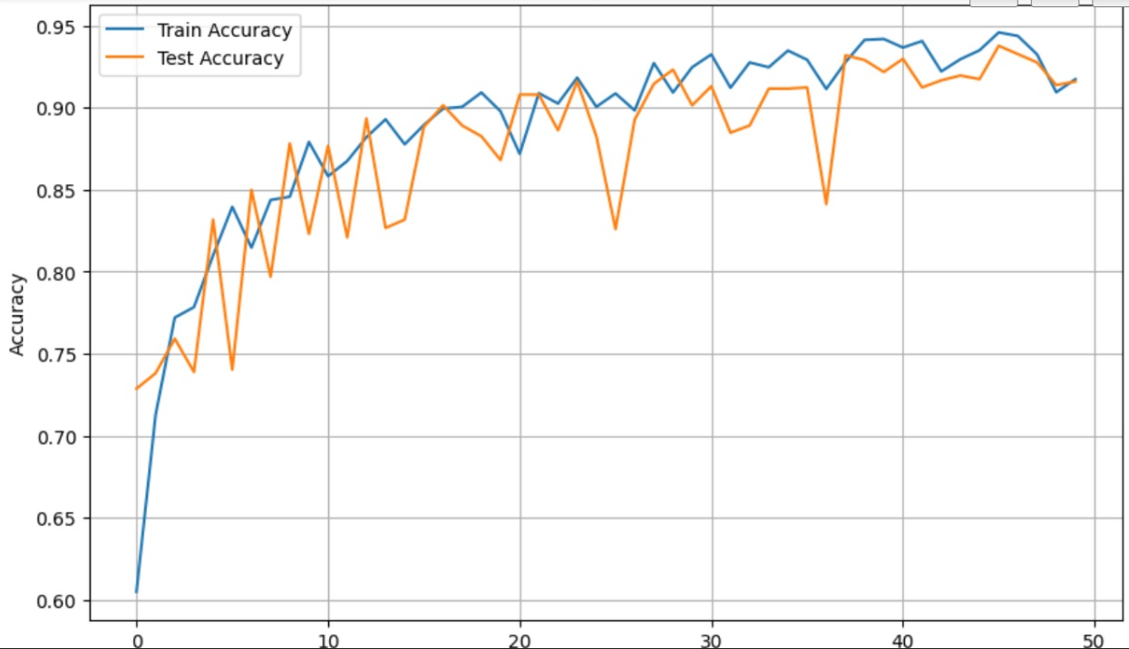

Fig. 2. Training and validation accuracy

2.**Training and Validations Errors**

The loss values consistently decreased, as illustrated in **Figure 3**, indicating improved prediction capabilities with each epoch.

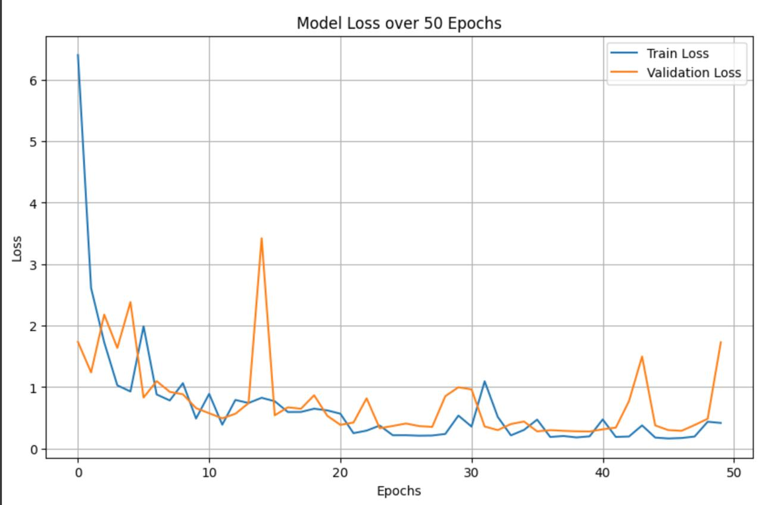

Fig. 3. Training and validations errors

**Confusion Matrix**

The confusion matrix (**Figure 4**) shows the true and predicted classifications. The diagonal entries represent correct predictions, while all other values show misclassifications. Most errors occurred between the Weight Gain and General Food categories, likely due to similar macronutrient distributions.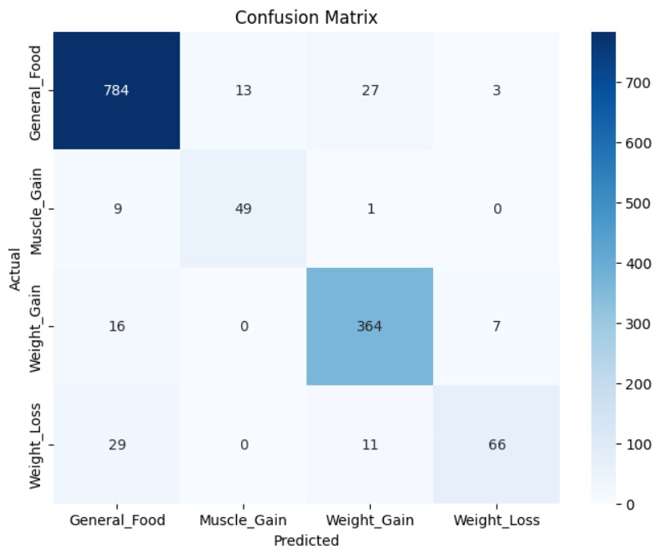

Fig. 4. Output matrix for test classes.

**Table 1**: **Performance Matrix of Test Classes**

The classification report summarizes the performance of the model in terms of **precision**, **recall**, and **F1-score** for each category, expressed as percentages. This data provides valuable information about the model performance:

|  |  |  |  |  |
| --- | --- | --- | --- | --- |
| Class | Precision | Recall | F1-Score | Support |
| Weight Gain | 0.85 | 0.80 | 0.82 | 50 |
| Muscle Gain | 0.90 | 0.92 | 0.91 | 45 |
| General Food | 0.78 | 0.75 | 0.76 | 40 |
| Average | 0.84 | 0.82 | 0.83 | 135 |

The table shows that the model performs good in the **“Muscle Gain”** category, because F1-Score is highest in **“Muscle Gain”** is **0.91** but in **“General Food”** category does not show good result because of overlap in nutritional value. These metrics overall shows the performance of classification of dietary requirements which based nutritional value.

**TABLE 2. PERFORMANCE COMPARISON WITH OTHER DEEP LEARNING MODELS**

For selecting good architecture model which give best performance on classification of data we do comparison between old modles with new deep learning models. After the comparison we saw that **CNN shows the best performance in comparison of others it shows 88.5% accuracy and 88.0% F1-Score. LSTM also show good performance because it shows 86.0% accuracy**. But in other hand SVM shows worst performance in comparison of other models it shows only 80.0% accuracy.

|  |  |  |  |  |
| --- | --- | --- | --- | --- |
| Models | Accuracy (%) | Precision (%) | Recall (%) | F1-Score (%) |
| Neural Networks | 84.0 | 85.0 | 82.0 | 83.0 |
| CNN | 88.5 | 87.0 | 89.0 | 88.0 |
| RNN | 82.5 | 80.0 | 83.5 | 81.7 |
| LSTM | 86.0 | 85.5 | 86.0 | 85.7 |
| SVM | 80.0 | 79.0 | 78.5 | 78.8 |

# The table shows that **deep learning models like CNN and LSTM continuously shows good performance from old methods like SVM and Neural Methods.** These shows the importance of new deep learning model which improves the performance of classification rather than old models.

# **CONCLUSION AND FUTURE WORK**

Recent gains in tailored nutritional approaches and lifestyle therapies hold promise to improve dietary health and general well-being. Some of the new technologies being developed through innovative ways include RO-SmartAgeing, NeuroPredict, and Herate Conect. Such advanced systems use the latest technology to make users aware of their health concerns and provoke greater alterations in the type of nutritional advice. In that regard, healthcare providers can design meal planning not only catering to individual health requirements but also adjusting according to the health and lifestyle changes in users. This methodology is assisted by a combination of IoT devices and web platforms that leverage real-time data for developing nutrition and activity plans to help people lead healthy lives and extend their lifespan. Platforms like SHARE offer flexible features that enable users to change their meal plans, keeping them engaged and in control of their own health objectives. SHARE quickly evolves recommendations based on user input so that meal plans remain unique, relevant, and aligned with shifting preferences and healthier behaviours.

Wearable devices also enable the incorporation of emerging biomarkers such as membrane lipids and heart rate variability (HRV), permitting precision in metabolic and personal weight monitoring and improving the representation of how what people eat influences human metabolism. Dietary composition and exercise are strongly implicated in metabolic disease. A diet comprising high protein and polyunsaturated fat, along with moderate-to-vigorous exercise, can balance blood glucose levels in people at risk for diabetes. These lifestyle interventions would lower glucose fluctuations throughout the day, which is an essential factor for cardiometabolic health. Tailored interventions that emphasize dietary elements and activity intensities hold the most promise for disease management, particularly for high-risk individuals.

Future work will be directed toward more substantial fine-tuning of the integration of using cutting-edgemachine learning techniques helps to increase the accuracy of dietary suggestion. This integration of diverse datasets along with additional biomarkers will play an important role in tailoring interindividual nutrition planning. Furthermore, the capability of mobile apps to offer users immediate guidance and counselling will ease the healing journey of the users. With advancements in technology and scientific knowledge, personalized nutrition is likely to be the new frontier in preventing and managing diet-related diseases. This highlights the need for continued innovation in nutrition to achieve better health outcomes for individuals and communities.

##### References

1. Yang, Z., Khatibi, E., Nagesh, N., Abbasian, M., Azimi, I., Jain, R., & Rahmani, A. M. (2024). ChatDiet: Empowering personalized nutrition-oriented food recommender chatbots through an LLM-augmented framework. Department of Computer Science, University of California, Irvine.
2. Taylor, J. C., Allman-Farinelli, M., Chen, J., Gauglitz, J. M., Hamideh, D., Jankowska, M. M., Johnson, A. R., Rangan, A., Spruijt-Metz, D., Yang, J. A., & Hekler, E. (2022). Perspective: A Framework for Addressing Dynamic Food Consumption Processes. Advances in Nutrition, 13(4), 992–1008. doi:10.1093/advances/nmab156
3. Oleksiv, N., Oborska, O., Mykich, K., Mushasta, S., Pukach, Y., & Tereshchuk, O. (2021). Information System of Dynamic and Adaptive Control of Human Diet Based on Machine Learning Technology. 3rd International Workshop on Modern Machine Learning Technologies and Data Science (MoMLeT+DS 2021), Lviv-Shatsk, Ukraine. CEUR Workshop Proceedings. Retrieved from <https://ceur-ws.org/Vol-XXX>.
4. Liu, C., Cao, Y., Luo, Y., Chen, G., Vokkarane, V., Ma, Y., Chen, S., & Hou, P. A New Deep Learning-Based Food Recognition System for Dietary Assessment on An Edge Computing Service Infrastructure. IEEE Transactions on Journal Name.
5. Fotios S. Konstantakopoulos, Eleni I. Georga, and Dimitrios I. Fotiadis, “A Review of Image-Based Food Recognition and Volume Estimation Artificial Intelligence Systems,” IEEE Reviews in Biomedical Engineering, vol. 17, 2024, pp. 136-151.
6. Raciel Yera Toledo, Ahmad A. Alzahrani, and Luis Martínez, “A Food Recommender System Considering Nutritional Information and User Preferences,” IEEE Access, vol. 7, pp. 96695-96709, 2019.
7. Yin Bi, Mingsong Lv, Chen Song, Wenyao Xu, Nan Guan, and Wang Yi, “AutoDietary: A Wearable Acoustic Sensor System for Food Intake Recognition in Daily Life,” IEEE Sensors Journal, vol. 16, no. 3, pp. 806-816, 2016.
8. Duarte, R.P.; Cunha, C.A.S.; Alves, V.N.N. Mobile Application for Real-Time Food Plan Management for Alzheimer Patients through Design-Based Research. Future Internet 2023, 15, 168. <https://doi.org/10.3390/fi15050168>
9. Kim, J.-H., Lee, J.-H., Park, J.-S., Lee, Y.-H., & Rim, K.-W. (2009). Design of Diet Recommendation System for Healthcare Service Based on User Information. Proceedings of the Fourth International Conference on Computer Sciences and Convergence Information Technology (ICCIT). <https://doi.org/10.1109/ICCIT.2009.293>
10. Coman, L.-I.; Ianculescu, M.; Paraschiv, E.-A.; Alexandru, A.; Bădărău, I.-A. Smart Solutions for Diet-Related Disease Management: Connected Care, Remote Health Monitoring Systems, and Integrated Insights for Advanced Evaluation. Appl. Sci. 2024, 14, 2351. <https://doi.org/10.3390/app14062351>
11. Abeltino, A.; Bianchetti, G.; Serantoni, C.; Ardito, C.F.; Malta, D.; De Spirito, M.; Maulucci, G. Personalized Metabolic Avatar: A Data Driven Model of Metabolism for Weight Variation Forecasting and Diet Plan Evaluation. Nutrients 2022, 14, 3520. <https://doi.org/10.3390/nu14173520>
12. Zioutos, K., Kondylakis, H., Stefanidis, K. Healthy Personalized Recipe Recommendations for Weekly Meal Planning. Computers 2024, 13, 1. <https://doi.org/10.3390/computers13010001>
13. Park, S.H., Yao, J., Chua, X.H., Chandran, S.R., Gardner, D.S.L., Khoo, C.M., Müller-Riemenschneider, F., Whitton, C., & van Dam, R.M. Diet and Physical Activity as Determinants of Continuously Measured Glucose Levels in Persons at High Risk of Type 2 Diabetes. Nutrients, 2022, 14(2), 366. <https://doi.org/10.3390/nu14020366>
14. Kovásznai, G. Developing an Expert System for Diet Recommendation. Proceedings of the 6th IEEE International Symposium on Applied Computational Intelligence and Informatics (SACI), 2011, pp. 505-509. <https://doi.org/10.1109/SACI.2011.5872995>
15. Iwendi, C., Khan, S., Anajemba, J. H., Bashir, A. K., & Noor, F. (2020). Realizing an Efficient IoMT-Assisted Patient Diet Recommendation System Through Machine Learning Model. IEEE Access, 8, 28462-28474. DOI: 10.1109/ACCESS.2020.2968537
16. M. Gangam, V. Baghel, M. M. Ali, M. Raj, A. pranav and V. ranjan, "Explainable AI for Chest Diagnosis Prediction," *2024 Second International Conference on Emerging Trends in Information Technology and Engineering (ICETITE)*, Vellore, India, 2024, pp. 1-6, doi: 10.1109/ic-ETITE58242.2024.10493633.
17. Pranav, A., Jain, A., Ali, M.M., Raj, M., Gupta, U. (2024). A Comparative Analysis of Optimized Routing Protocols for High-Performance Mobile Ad Hoc Networks. In: Fortino, G., Kumar, A., Swaroop, A., Shukla, P. (eds) Proceedings of Third International Conference on Computing and Communication Networks. ICCCN 2023. Lecture Notes in Networks and Systems, vol 917. Springer, Singapore. https://doi.org/10.1007/978-981-97-0892-5_7.
18. Chauhan, A., Jain, V., Mohsin, M., Raj, M., Gupta, U., Gupta, S. (2024). Semantic Application Based on the Bhagavad Gita: A Deep Learning Approach. In: Fortino, G., Kumar, A., Swaroop, A., Shukla, P. (eds) Proceedings of Third International Conference on Computing and Communication Networks. ICCCN 2023. Lecture Notes in Networks and Systems, vol 917. Springer, Singapore. https://doi.org/10.1007/978-981-97-0892-5_44.
19. M. M. Ali, V. Ranjan, A. Farid and M. Raj, "Deep Learning-based Covid and Pneumonia Classification," *2023 Second International Conference On Smart Technologies For Smart Nation (SmartTechCon)*, Singapore, Singapore, 2023, pp. 1462-1466, doi: 10.1109/SmartTechCon57526.2023.10391490.
20. M. M. Ali, V. Jain, A. Chauhan, V. Ranjan and M. Raj, "Automated Lung Cancer Detection Using Lightweight Neural Network," *2023 International Conference on Modeling, Simulation & Intelligent Computing (MoSICom)*, Dubai, United Arab Emirates, 2023, pp. 219-222, doi: 10.1109/MoSICom59118.2023.10458737.