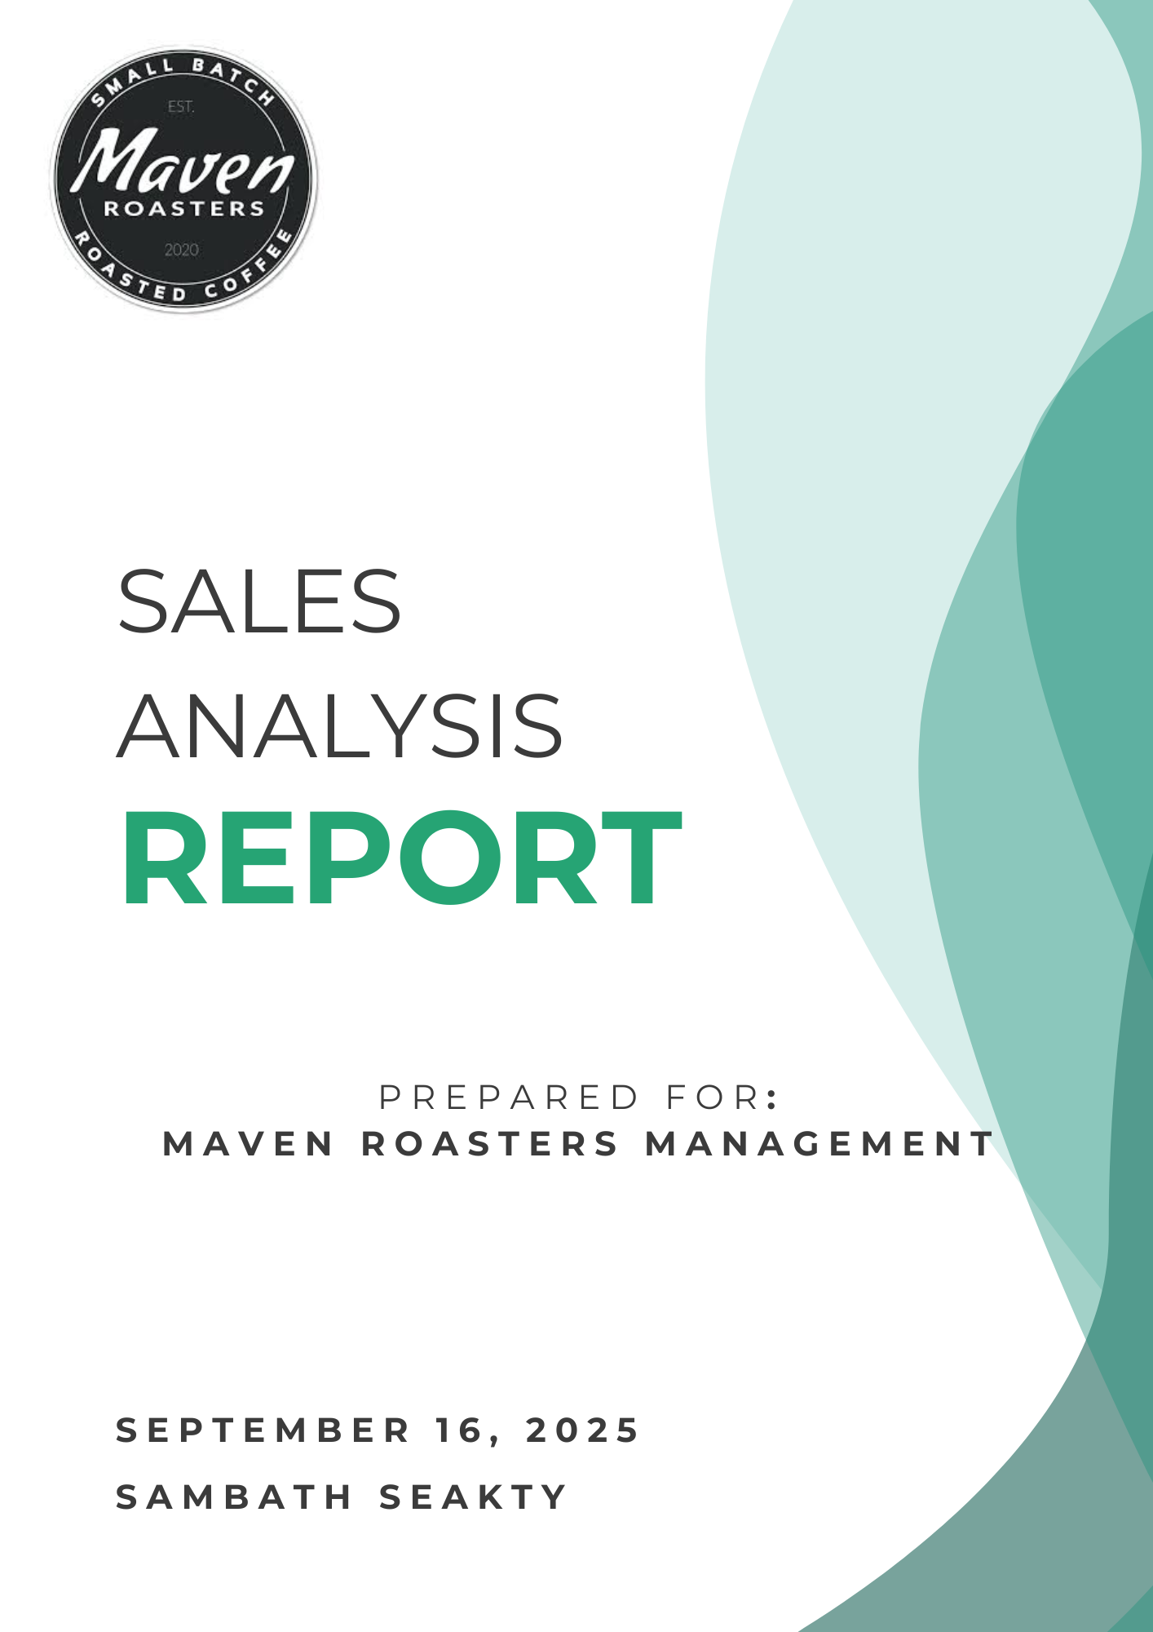

* **Executive Summary**

This report provides a comprehensive analysis of sales data for Maven Roasters for the first half of the year, identifying key performance trends and strategic opportunities for growth. The data clearly indicates that the business is healthy and expanding rapidly, with specific, actionable paths to increase revenue further.

**Key Findings**

* **Strong Overall Growth:** The business is on a remarkable growth trajectory, with daily revenue **more than doubling** over the six-month period analyzed.
* **Weekday-Centric Model:** Sales are primarily driven by a loyal weekday customer base, with significant revenue peaks during the **morning rush hours (8-11 AM)**.
* **Significant Weekend Opportunity:** A major performance gap exists on weekends, with Saturday sales dropping by **over 30%** compared to the weekday average. This represents a significant untapped market.
* **Core Product Strength:** A small selection of core products, led by **Barista Espresso and Brewed Chai Tea**, generate the majority of total revenue.

**Top Recommendations**

* **Capture the Weekend Market:** Launch a targeted marketing and promotional campaign specifically for weekends to attract a new customer segment (e.g., local residents and families).
* **Optimize Peak Hour Operations:** Reinforce staffing and streamline service during the critical 8-11 AM morning rush to maximize sales volume and efficiency.
* **Refine the Menu Offering:** Leverage data to prominently feature high-revenue products and re-evaluate the underperforming items to simplify operations and focus on profitability.
* **Analysis & Findings**

**Sales Trends Over Time**

To understand the overall business performance, we first analyzed sales trends across different time frames. The data shows a consistent and positive growth story.

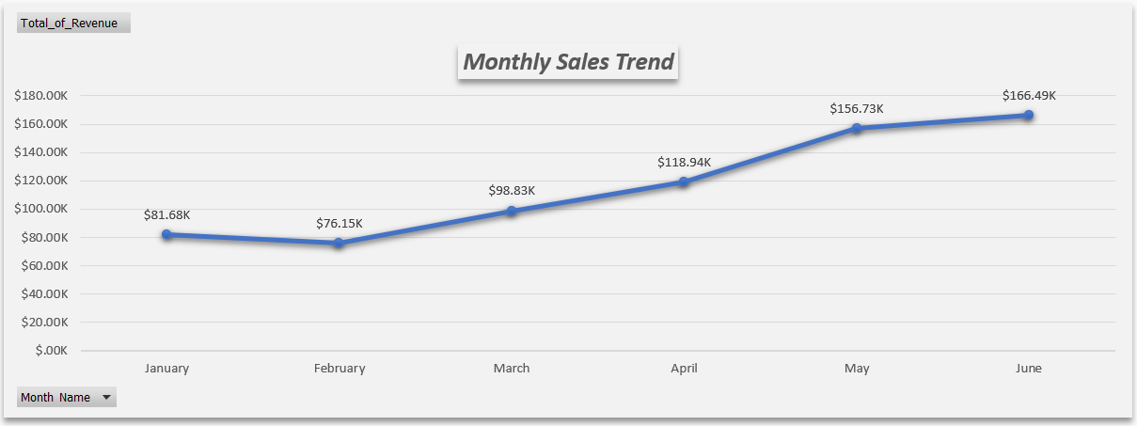

* 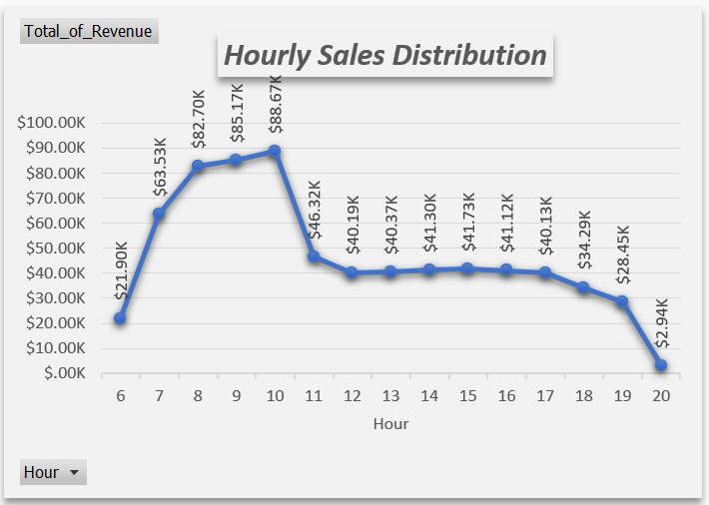**Analysis:** The chart above illustrates a powerful and accelerating growth trend in total monthly revenue since a slight dip in February. This strong upward trajectory indicates that the business is very healthy and rapidly gaining momentum. Strategies implemented in the early part of the year are proving effective and are successfully driving increased sales.
* **Analysis:** The hourly trend reveals a massive revenue peak between 8 AM and 10 AM. This pattern clearly defines the daily customer behavior, with the vast majority of business coming from the morning coffee rush. This period is the most critical for daily revenue generation and requires operational focus to maximize throughput.

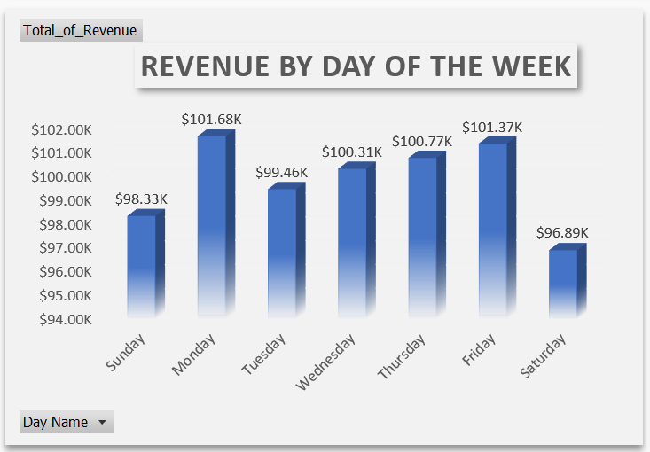**Weekly Customer Patterns**

* **Analysis:** The analysis of sales by day of the week shows that revenue peaks on Monday, with a secondary peak on Friday. Conversely, there is a dramatic drop in sales on Saturday, making it the lowest-performing day. This trend strongly suggests the primary customer base consists of weekday commuters and professionals. The business model is not currently capturing the weekend crowd, which represents a significant opportunity for growth.

**Product Performance Analysis**

* **Analysis:** The chart above displays the top revenue-generating products, with **Barista Espresso** and **Brewed Chai Tea** as the clear leaders. A key insight is that **Barista Espresso** is the #1 product for **Total Revenue** despite being lower in total quantity sold than other drinks. This identifies it as a high-value item with a strong price point that significantly boosts profitability and should be a focus for marketing efforts.
* **Conclusion & Detailed Recommendations**

**Conclusion**

The analysis of Maven Roasters' sales data paints a clear picture of a healthy, growing business with a strong, predictable customer base. The remarkable growth in revenue during the first half of the year is a testament to the store's quality and appeal. The data reveals specific, actionable opportunities to build on these strengths, optimize operations, and address key growth areas to ensure this positive trajectory continues.

**1. Target the Weekend Customer to Boost Sales**

* **The Insight:** The data clearly shows that sales drop dramatically on Saturdays, which is the lowest-performing day of the week. This suggests that the primary customer base is tied to the standard work week (commuters, local office workers) and that the business is currently missing out on the weekend crowd.
* **The Recommendation:** Launch a targeted marketing and promotional campaign specifically for weekends to attract a new customer segment (e.g., local residents, families, and shoppers).
* **Action Steps:**
  + **Introduce a "Saturday Special":** Create a compelling combo deal, like a coffee and pastry pairing, that is only available on Saturdays.
  + **Create a "Family Pastry Box":** Offer a shareable box of assorted pastries at a value price point to appeal to families.
  + **Use Social Media:** Promote these weekend-specific offers on social media platforms, targeting the local residential community.

**2. Optimize the Morning Rush to Maximize Revenue**

* **The Insight:** The hourly sales data reveals a massive revenue peak between 8 AM and 11 AM. This period is the most critical for daily revenue, and any friction in the customer experience can lead to lost sales.
* **The Recommendation:** Focus on increasing the speed and efficiency of the morning service to maximize customer throughput.
* **Action Steps:**
  + **Ensure Maximum Staff Coverage:** Schedule additional staff for the 8-11 AM window to reduce wait times for ordering and preparation.
  + **Implement a Mobile Order Express Lane:** Create a dedicated pickup area for customers who order ahead via an app or website, allowing them to bypass the main queue.

**3. Refine the Menu Based on Performance**

* **The Insight:** The analysis shows that a few "superstar" products, like **Barista Espresso** and **Brewed Chai Tea**, drive the majority of sales. It also identified a "long tail" of items that contribute very little to revenue.
* **The Recommendation:** Make data-driven decisions to simplify and enhance the menu, focusing on profitability.
* **Action Steps:**
  + **Promote High-Value Products:** Feature the high-revenue **Barista Espresso** in promotional materials and consider offering it in up-sell combos.
  + **Re-evaluate Underperforming Items:** Review the bottom 5-10 products on the sales list. Consider removing them from the menu to reduce waste, simplify inventory, and speed up kitchen operations.

**4. Understand and Sustain Growth**

* **The Insight:** The business experienced fantastic and accelerating growth starting in March.
* **The Recommendation:** Investigate the reasons behind this recent success to ensure that the positive drivers can be understood and replicated.
* **Action Steps:**
  + **Analyze Business Changes:** Review any marketing campaigns, new product launches, or operational changes that were implemented around February/March.
  + **Survey Regular Customers:** Engage with loyal customers to understand what they value most and what has recently enhanced their experience.