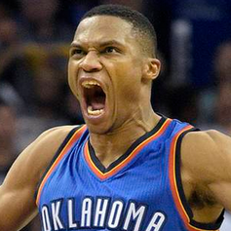

**Russell Westbrook #0**

|  |  |  |  |  |
| --- | --- | --- | --- | --- |
| **身高m** | **体重kg** | **能力值** | **位置** | **薪金** |
| **1.91** | **91** | **94** | **PG** | **12,000** |

|  |  |  |  |  |  |  |  |  |
| --- | --- | --- | --- | --- | --- | --- | --- | --- |
| **Player** | **MP** | **PTS** | **ORB** | **DRB** | **TRB** | **ATS** | **STL** | **BLK** |
| **Rajon Rondo** | **35.2** | **11.9** | **1.1** | **5.0** | **6.0** | **11.7** | **2.0** | **0.1** |
| **Russell Westbrook** | **34.4** | **23.5** | **1.8** | **6.0** | **7.8** | **10.4** | **2.0** | **0.3** |
| **John Wall** | **36.2** | **19.9** | **0.5** | **4.4** | **4.9** | **10.2** | **1.9** | **0.8** |
| **Chris Paul** | **32.7** | **19.5** | **0.5** | **3.7** | **4.2** | **10.0** | **2.1** | **0.2** |
| **Ricky Rubio** | **30.6** | **10.1** | **0.5** | **3.8** | **4.3** | **8.7** | **2.1** | **0.1** |
| **James Harden** | **38.1** | **29.0** | **0.8** | **5.3** | **6.1** | **7.5** | **1.7** | **0.6** |
| **Draymond Green** | **34.7** | **14.0** | **1.7** | **7.8** | **9.5** | **7.4** | **1.5** | **1.4** |
| **Damian Lillard** | **35.7** | **25.1** | **0.6** | **3.4** | **4.0** | **6.8** | **0.9** | **0.4** |

**进阶数据**

**每百回合**

**每36分钟**

**场均数据**

**返回**

**所有位置**