好友 消息

**Russell Westbrook #0**

|  |  |  |  |  |
| --- | --- | --- | --- | --- |
| **身高m** | **体重kg** | **能力值** | **位置** | **薪金** |
| **1.91** | **91** | **94** | **PG** | **12,000** |

**返回hui**

**Oklahoma City Thunder**

**Russell**

**Westbrook**



**PG**



**Steven**

**Adams**

**C**



**Serge**

**Ibaka**

**PF**



**James**

**Harden**

**SG**

**Kevin**

**Durant**

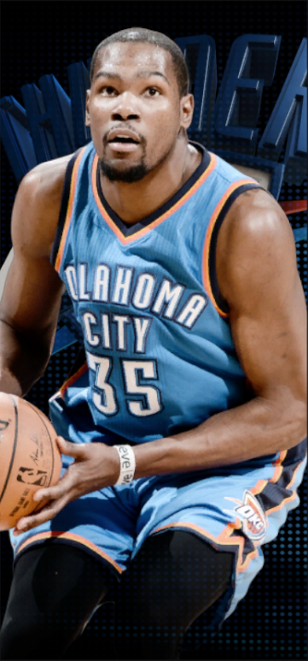

**SF**

**Kevin Durant #35**

|  |  |  |  |  |
| --- | --- | --- | --- | --- |
| **Height** | **Weight** | **Power** | **Position** | **Salary** |
| **2.11m** | **109kg** | **96** | **SF/PF** | **1,4000** |

**Kevin**

**Durant**



**小前锋/**

**大前锋**

**Kevin**

**Durant**



**SF/PF**