My game shares some similarities with hearthstone.

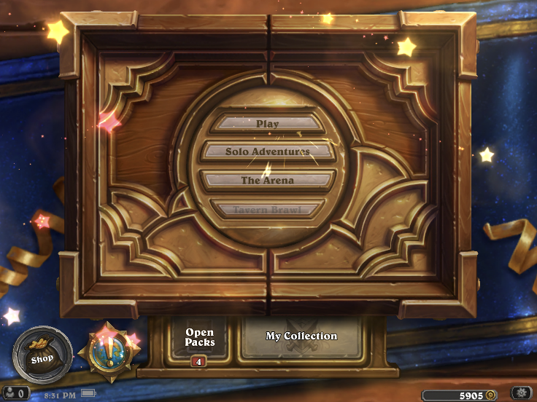

There are five major things for this game. I have almost finished one of it, the collection part, but I still have some bugs to fix. The other four things are Main scene, Play mode, Open Packs & Shop and Player-matching.

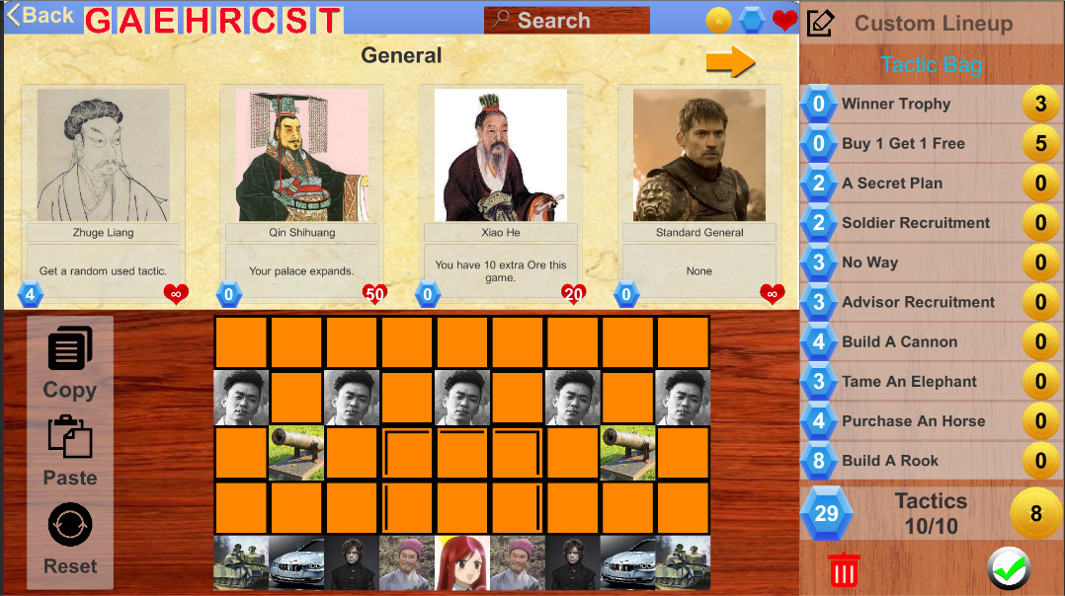

This is a lineup builder inside the collection view. Basically you will need to put your cards into those slots of a board (there will be different boards but let’s just focus on the standard board) and there will also be some default cards taking up those slots. And you will also need tactics. You can only have 10 tactics and most tactics cost Ores, like the mana in the hearthstone. By the way, you can only have 30 ores in a game. (But you can increase it through other ways). Some cards have powers and they only Cost ores. And some tactic cost coins/gold (name not decided yet). You can use coins to purchase card packs and obtains them from daily quests. (just like hearthstone). There is no limit for the gold cost in a game, or say the gold limit depends on how many coins you have. It is also noticeable that the ally cards have health, which means if you have one card destroyed in the game, the card will lose health by 1. You won’t keep a card forever unless they are standard cards (they have no card power and player will have infinite amount of them). I don’t have the plan to allow user to create or disenchant these cards yet.

The main scene will be simple and it should provide access to all other things. I hope the scene will be a scene in a tent with soldiers, generals and advisors around, but that is the easiest UI part so we don’t need to care about it too much.

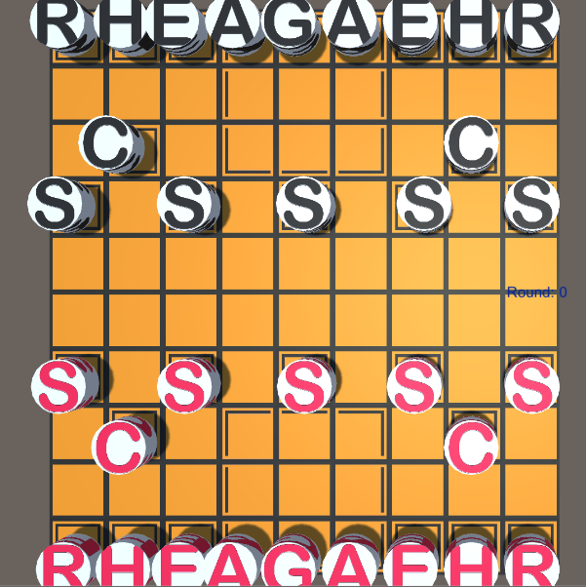

This is a temporary play mode. The play mode will be hardest part as I have no idea how to implement card powers for now. There will also be a round counter, some player info and a tactic bag on the right of the board. I made it into 3D at the very beginning but probably we should make it 2D. Most pieces will follow their rules of moving. The exceptions will occur as a result of tactics or card powers. One important rule is that you can only move one piece, use one tactic and use the power of one piece in your turn. And there will also be a time limit for each turn, which is 2 minutes. Another important definition is that A Round always starts with your turn and ends with your opponent’s turn. This means your round is not the same as your opponent’s. Additionally, it will be a draw if you exceed the round limit. I am considering the limit to be 150 rounds.

Open Packs & Shop will be easy. Since our game is called War Song, it’s actually not open packs. It’s like blowing a horn, sing a war song and recruit your allies. This is a button for the horn. I know I am a terrible UI designer:) And we don’t have things like rarity, so the Recruit can be totally random but there may be a necessity to adjust the rate and possibly we can also recruit allies according to their type. But they are not that important. One thing need to notice is that it is the server that decides what cards player will open in a pack.

Since we are not going to write an AI for it (Because I have no idea how to write it), we need to match players with other players. So it requires some network modules and we also need the network to save players’ data and the data produced during the game. And a rank mode and a casual mode is required. Note that we will have different board so we have to match according to the boards first.

I also have some other ambitions for this game but for this quarter what I have stated above should be enough. We don’t need to focus too much about the animation and sound effect, the UI part.

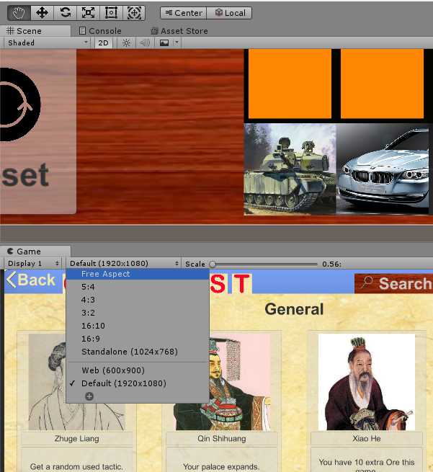

When I open the game on Mac, the resolution is not 1920×1080. You can change it here.