

American International University- Bangladesh

CSC 3215: Web Technologies

CO1.1 and CO2.1 Evaluation

Project Report

Fall 2021-22

Project Title: News Portal Management System

Section: F

|  |  |
| --- | --- |
| Student Name | Student Id |
| Seam, Md. Amir Hamja Pathan | 18-37083-1 |
| Rashedul Hasan Onim | 18-36318-1 |
| Sanjida Afroz Shimu | 18-37081-1 |
| Hasebul Hasan Shihab | 18-37031-1 |

Introduction:

*Newspaper is an important part of our regular life. There are two types of newspaper available - printed and digital (e-paper). E-paper has become increasingly crucial in this age of information and technology for gathering daily news. International newspapers are easily accessible via online paper or e-paper. The objective of this project is developing an online news portal.*

Background Study

*Almost all of the Bangladeshi newspapers have an online version. We took 5 e-paper as our reference. They are the Prothom Alo, the Daily Star, the kaler Kontho, the Jugantor and the Financial Express. In Prothom Alo, there is a log in option (Renew button) for the users. User can create account and read news without any problem. After creating account user will be able to see his/her account by clicking “My Account” option. Creating account is mandatory for reading news in the Prothom Alo where user can directly access the news in the Daily Star, the Kaler Kontho, the Financial Express and the Jugantor. There is a menu bar for the Daily Star and the Financial Express.*

Requirement Analysis:

1. User Category:

There are 4-types of Users here. They are:

* Admin
* Editor
* Reporter
* User

1. Feature List:

In this project the “Admin” has the following features:

* Registration
* Login
* Profile (update-view)
* Change Password
* Forget Password
* Approve user
* Reject approval of user
* Delete account
* View news
* Delete news

In this project the “Editor” has the following features:

* Registration
* Login
* Profile (update-view)
* Change Password
* Forget Password
* Approve news
* Reject news
* Show pending news
* Modify news
* View news

In this project the “Reporter” has the following features:

* Registration
* Login
* Profile (update-view)
* Change Password
* Forget Password
* Write news
* Post news for approval
* Show sends news for approval
* View news
* Modify rejected news

In this project the “User” has the following features:

* Registration
* Login
* Profile (update-view)
* Change Password
* Forget Password
* Read news
* Comments
* Report
* Like
* Add to Favorite

Design:

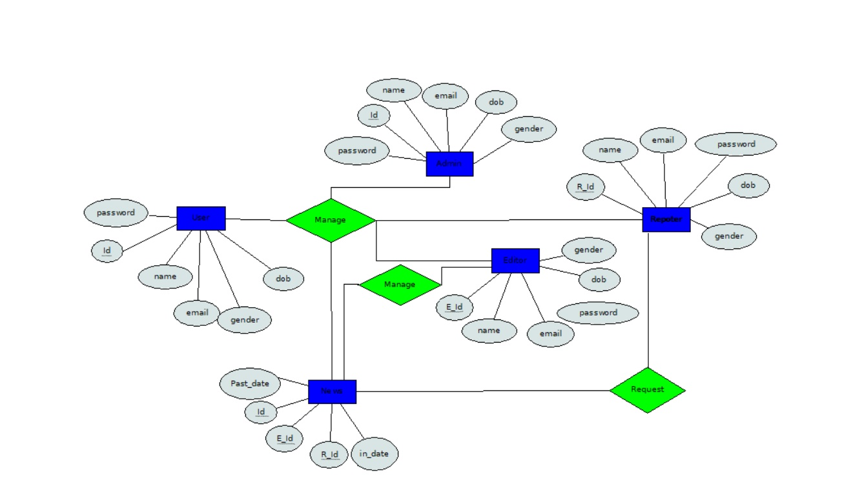

Tools Used:

To develop this project, we have used the following:

• Visual studio code

• XAMPP

• Web Browser

• GitHub

System Images against the Specification:

**For Admin:**

Welcome page:

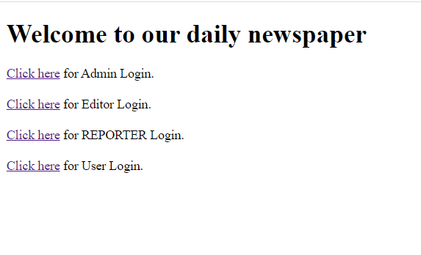

This page merges the whole project. If I click on admin login it will take me into admin login interface. Like this I can go any user type.

Registration page:

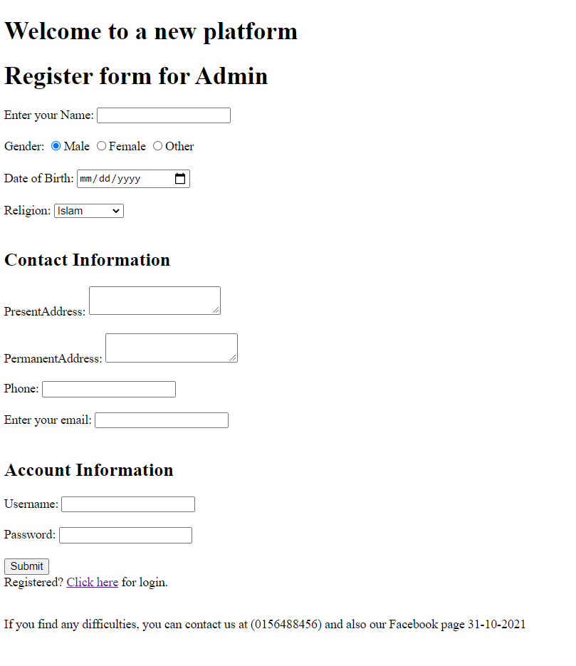

Admin can do registration. This registration page is completed by section, cookie, include, validation. The input is taken in a validated json file.

Admin Login:

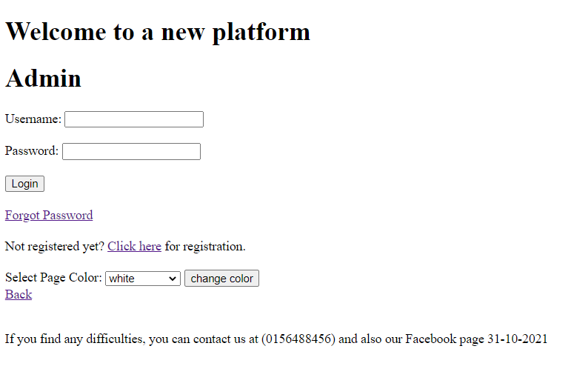

This is a admin login in interface. From This page I can go into registration page, I can change the color of this page and if I forgot my password, I can change it.

Forgot Password:

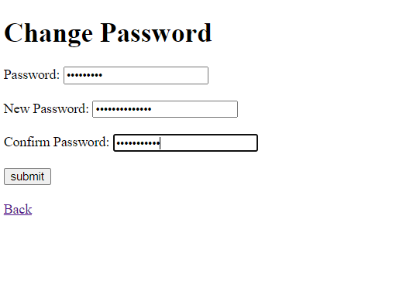

I can change my password if I forget my password.

Home Page:

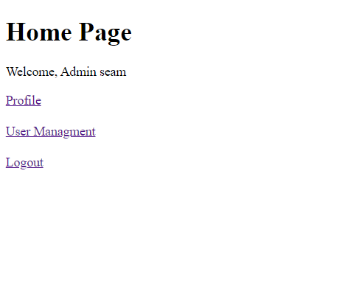

This admin home page. From here I can view and edit my profile and also control the user management.

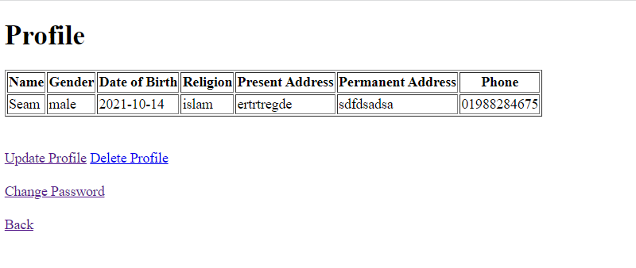

This interface shows the information of a login admin.

Change Password:

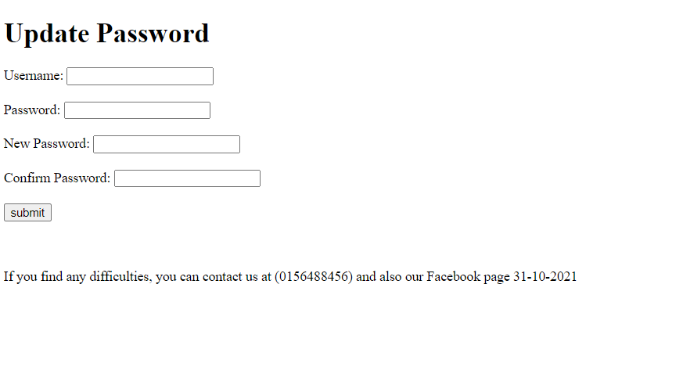

Here we can change update our password.

Update Profile:

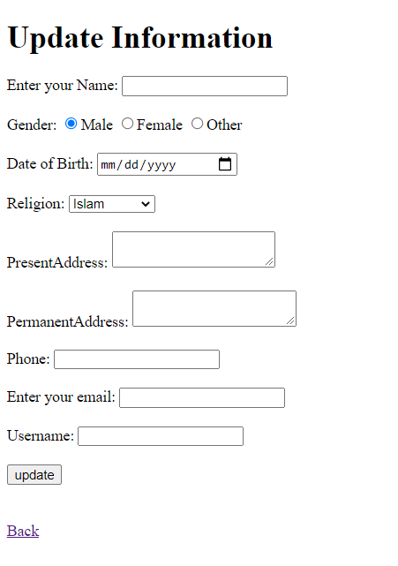

Here we can update the login in profile.

**Editor:**

Registration page:

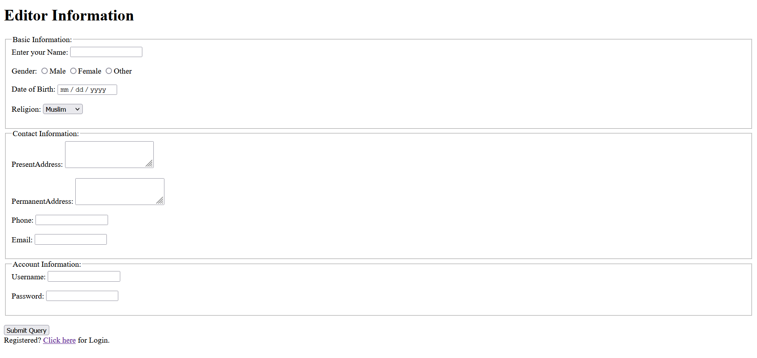

An editor must first create an account. He will do so by creating an account with all of his details, including his name. He will then be given a user name and password.

Login page:

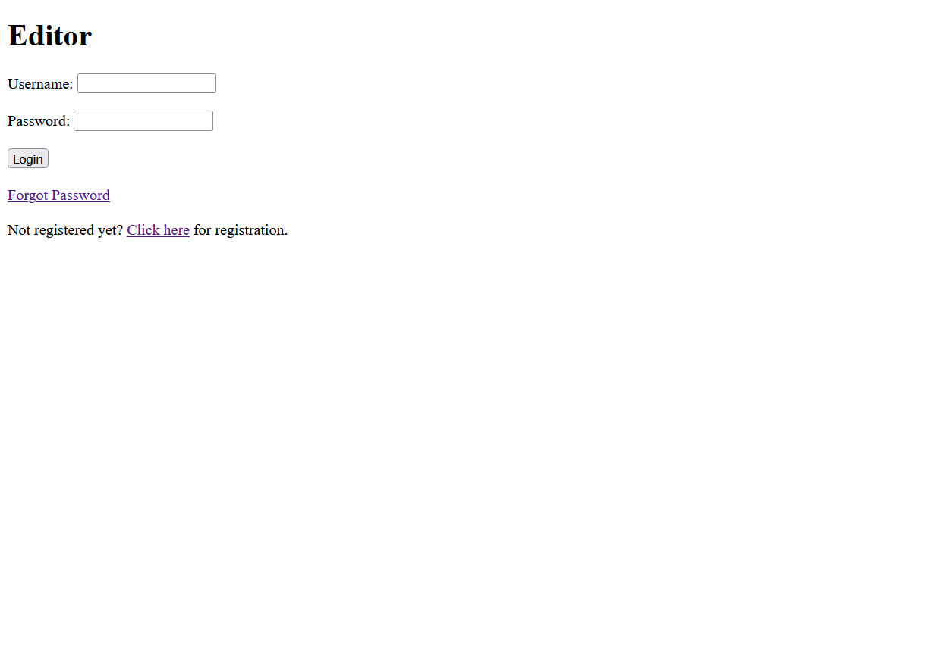

The editor will be given a username and password when he creates an account. With this username and password, the reporter will be able to access his account.

Update password:

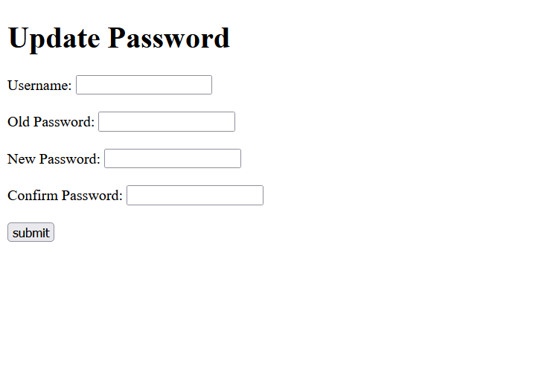

If the editor wishes, he can change his password. He must do so by selecting the Forgot Password option. Then he must submit the form using the new password.

Home page for Editor:

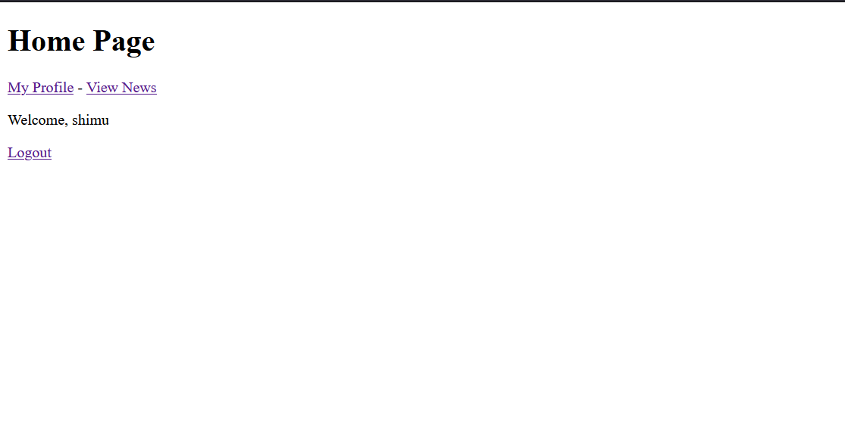

From here we can go to view news and can edit editor’s profile.

Profile:

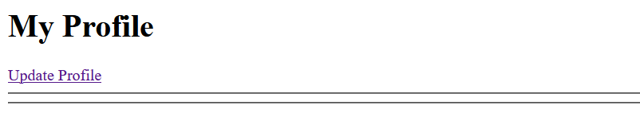

If the reporter so desires, he can make changes to his profile, such as his photo.

News List:

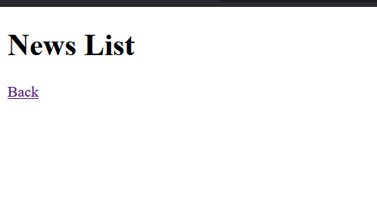

**Reporter:**

Register Form:

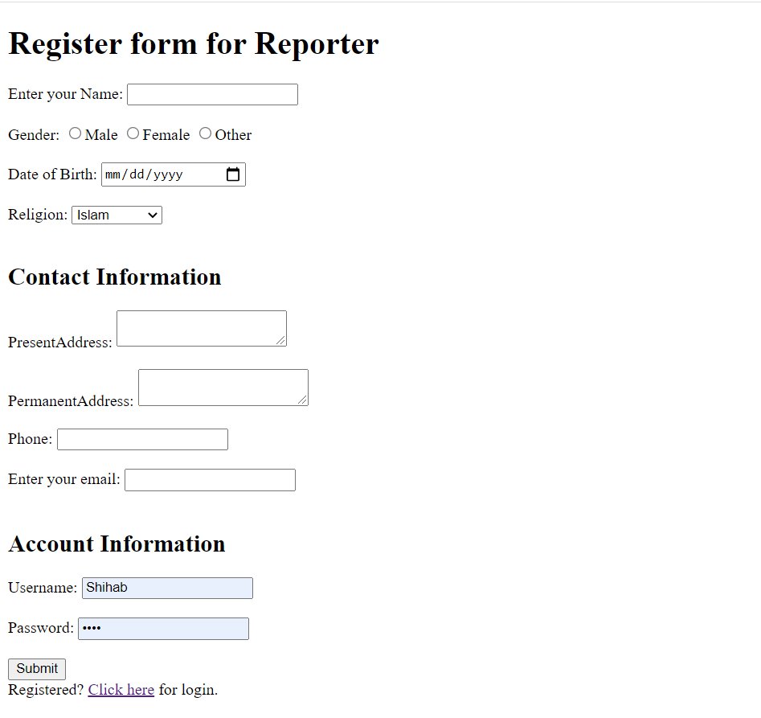

A reporter must first create an account. He will do so by creating an account with all of his details, including his name. He will then be given a user name and password.

Login:

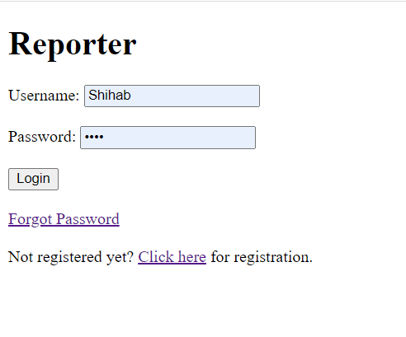

The reporter will be given a username and password when he creates an account. With this username and password, the reporter will be able to access his account.

Update Password:

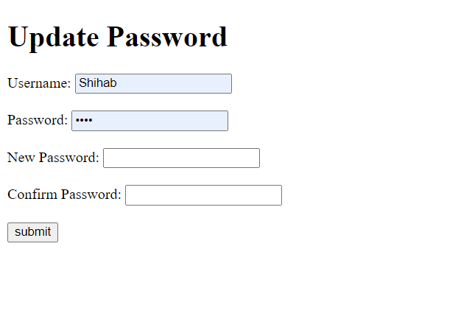

If the reporter wishes, he can change his password. He must do so by selecting the Forgot Password option. Then he must submit the form using the new password.

Home Page:

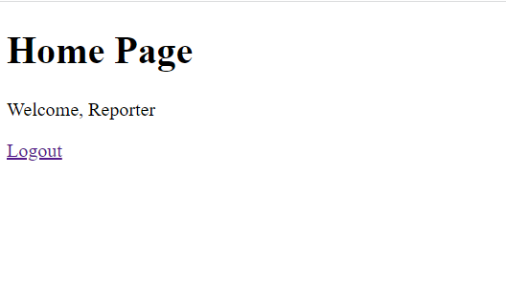

By logging into his account, the reporter will be able to access his home page and, if wanted, log out.

Profile:



If the reporter so desires, he can make changes to his profile, such as his photo.

**User:**

Login:

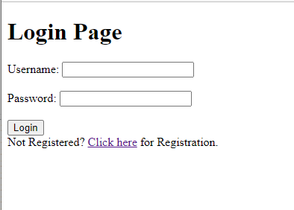

User can login if he/she is registered. If not registered, he/she can Register by clicking “Click here”.

Registration:

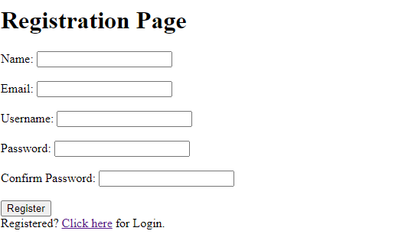

A user can Register through this page.

Edit Profile:

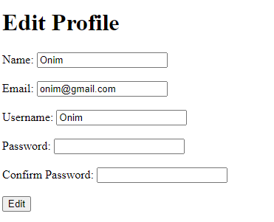

A user can edit his/her profile from here.

Profile:

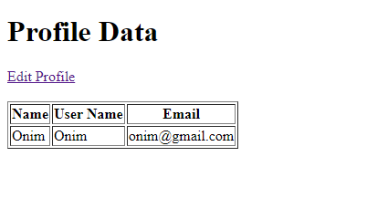

Here, User’s data are saved.

Home:

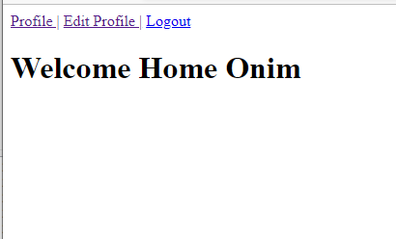

The Homepage of a user.

Impact of this Project:

Describe the increasing importance of your project on modern society and environment.

How will people be benefitted from your project?

An online newspaper is cutting their own specialty, particularly among the news freak. The youth consider the internet to be a suitable model for collecting data and news. In this present time, the field of competition has become wider as a result people have to update them self-regular and quick. Our newspaper helps to update them more quickly. People can read the news anywhere and any place. To move forward our newspaper is very important for modern society and environment.

Limitations and Possible Future Improvements:

Several future improvements can be done in this project. As this is a news portal, in the future we can develop some exciting features that make the news look more attractive. we have used four types of users in our project. We can develop some more features in those user sections also. In the news interface, we can add more sections like we can see different news in the different interfaces.

*[Note: Make sure that your report is maximum 10 pages (including cover page). Print (Colored) the report and submit it with spiral bind.]*

|  |  |  |  |  |  |
| --- | --- | --- | --- | --- | --- |
| CO1.1 and CO2.1 Evaluation: Project Report Evaluation | | | | | |
| Project Proposal  (5) | Background  Study  (5) | Requirement Analysis  (5) | Entity  Diagram  (5) | System Images  against the  Specification (5) | Total (25) |
|  |  |  |  |  |  |
|  | | | | | |