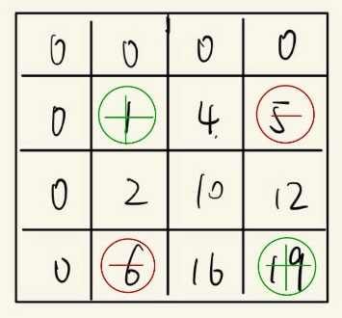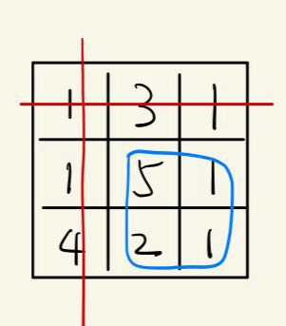 Matrix prefixSum

Calc the **sum** of (1, 1) & (2, 2) square.  
sum=prefixSum[3][3]-prefixSum[3][1]-prefixSum[1][3]+prefixSum[1][1] = 9

Note that (0, 0) is subtracted twice, so need to plus when calc the sum

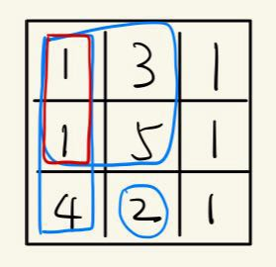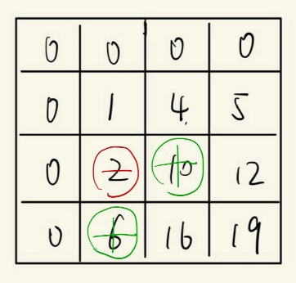 Matrix prefixSum

Calc the **prefixSum** of (3, 2) { (2, 1) in the matrix }

prefixSum[i][j] = grid[i-1][j-1] + prefixSum[i-1][j] + prefixSum[i][j-1] - prefixSum[i-1][j-1] = 16