Honey Filtration Animated Asset & Flutter Animation
Prompting Reference for ChatGPT/Codex Asset Generation and Claude Code Flutter Implementation

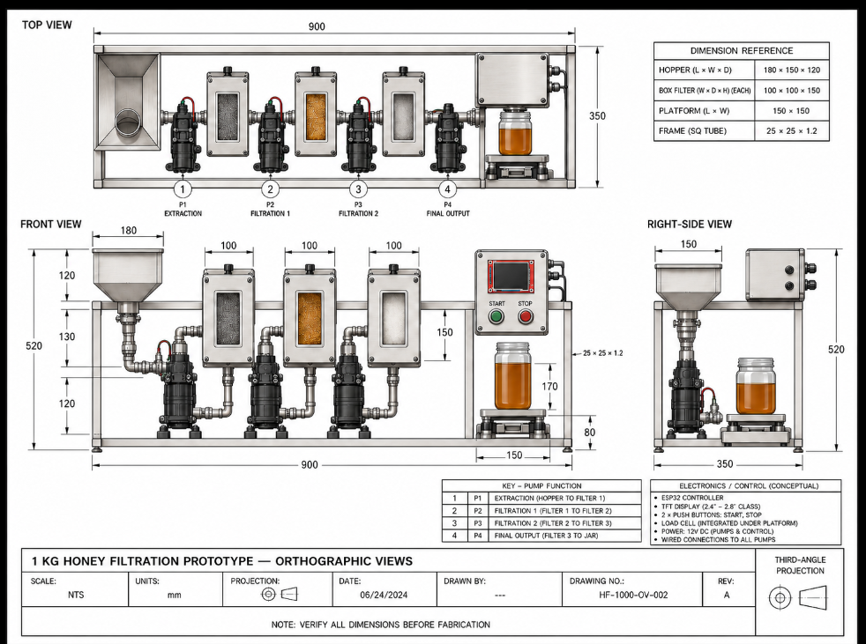
Engineering reference: 1 kg honey filtration prototype with four pumps, three filtration stages, output jar/load-cell platform, and ESP32-based control.
Purpose of this document
Use this as the master reference when prompting AI tools. Codex/ChatGPT should create clean, reusable 2D vector assets. Claude Code should assemble those assets in Flutter, animate them from machine state, and later connect them to real ESP32/sensor telemetry.

1. Project Objective
Create a simplified 2D digital twin of the honey filtration machine for a Flutter monitoring application. The visualization must show the machine's current operating stage, active pumps, honey flow, fill levels, sensor status, connectivity, and warnings without copying the orthographic drawing as a single static image.

2. Core Design Principle
- Do not animate the complete engineering drawing as one raster image.
- Keep the physical machine body mostly static and animate only meaningful states.
- Every object that must rotate, fill, blink, glow, move, pulse, change opacity, or change color must be a separate visual layer.
- Prefer SVG for machine components and icons because it scales cleanly on phones, tablets, and desktop displays.
- Use PNG/WebP only for optional textures such as realistic honey or metal surfaces.
- The animation must be state-driven: real device data decides which visual effects are active.

3. Recommended Visual Architecture
Four-layer approach
Layer 1: static machine base. Layer 2: animated mechanical indicators. Layer 3: animated honey-flow paths. Layer 4: dynamic fill masks and live UI/status overlays.

Layer 1 - Static Machine Base
- Primary file: machine_base.svg
- Contains frame, hopper shell, filter housings, pump housings, pipe outlines, controller enclosure, load-cell platform, jar outline, brackets, and other non-moving geometry.
- This layer should preserve the recognizable layout of the real machine but use a cleaner app-friendly illustration style.

Layer 2 - Animated Mechanical Components
- Reusable pump rotor or impeller indicator.
- Pump-active glow or status ring.
- Start/stop button pressed state.
- Online/offline indicator.
- Warning/error icon.
- Optional subtle filter-processing pulse.

Layer 3 - Honey Flow
- Pipe geometry stays in machine_base.svg.
- Create separate flow-path definitions or path metadata for each segment.
- Flutter should animate amber particles, dashes, or a moving fill along the paths using CustomPainter/PathMetric.
- The flow must stop immediately when the corresponding pump/stage becomes inactive.

Layer 4 - Dynamic Fill Levels
- Separate honey layer/mask for hopper, each filter chamber if needed, and the output jar.
- Use clipping or a vertical fill percentage instead of pre-rendered animation frames.
- Jar fill should ideally be tied to measured output weight or a calculated percentage.
- Sensor-value transitions should be smoothed visually, but the displayed numeric values must remain accurate.

4. Required Asset Set
Asset / Group | Recommended Format | Reuse | Animation Purpose
machine_base | SVG | 1 | Static base
pump_body | SVG | Reuse x4 | Static pump housing if not in base
pump_rotor | SVG | Reuse x4 | Rotation when P1-P4 are active
pump_glow | SVG | Reuse x4 | Active-state pulse/glow
filter_body | SVG | Reuse/variants | Static filter housing
filter_media_stage1 | SVG | 1 | Stage-specific visual
filter_media_stage2 | SVG | 1 | Stage-specific visual
filter_media_stage3 | SVG | 1 | Stage-specific visual
hopper_honey | SVG or clipped texture | 1 | Hopper fill level
filter_honey | SVG or clipped texture | x3 | Optional filter fill/processing
jar_body | SVG | 1 | Static output container
jar_honey | SVG or clipped texture | 1 | Output fill based on weight
flow path segments | SVG path / Dart path data | 8 segments | Moving honey flow
start_button / stop_button | SVG | 1 each | Pressed, glow, enabled state
online / offline / warning | SVG | 1 each | Status feedback
honey_texture | WebP/PNG optional | 1 | Visual texture only

5. Machine Flow Segments to Animate
- Hopper → P1 extraction
- P1 → Filter 1
- Filter 1 → P2
- P2 → Filter 2
- Filter 2 → P3
- P3 → Filter 3
- Filter 3 → P4
- P4 → Output jar
Important
Do not require eight separate rendered pipe images if the pipe network already exists in machine_base.svg. What is needed is eight independently controllable flow regions/paths so Flutter can activate each segment based on the process stage.

6. Non-Negotiable Asset Generation Rules
- All related overlay assets must use the exact same coordinate system, canvas size, SVG viewBox, origin, scale, and alignment.
- Assets intended to be stacked must perfectly overlap when placed at the same Flutter position.
- Use transparent backgrounds.
- Do not include text labels inside reusable component assets unless the label is permanently part of the physical machine.
- Avoid baked-in shadows that make overlapping layers misalign; use subtle, consistent shadows only where necessary.
- Keep SVG paths reasonably simple to avoid unnecessary Flutter rendering cost.
- Use semantic, stable filenames. Do not generate names such as image_1.svg or asset_final2.svg.
- Keep reusable components neutral; let Flutter control active/inactive colors where possible.
- Do not create GIFs or video loops for pump or honey animation. Flutter must control the animation state.
- The machine should look clean and technical, not photorealistic. It should remain recognizable as the actual prototype.

7. Recommended Folder Structure
assets/
└── honey_machine/
├── machine/
│ ├── machine_base.svg
│ ├── frame.svg
│ ├── hopper.svg
│ ├── control_box.svg
│ └── platform.svg
├── pumps/
│ ├── pump_body.svg
│ ├── pump_rotor.svg
│ └── pump_glow.svg
├── filters/
│ ├── filter_body.svg
│ ├── filter_media_stage1.svg
│ ├── filter_media_stage2.svg
│ └── filter_media_stage3.svg
├── liquid/
│ ├── honey_texture.webp
│ ├── honey_fill.svg
│ └── bubble.svg
├── paths/
│ └── flow_paths.svg
└── ui/
├── start_button.svg
├── stop_button.svg
├── online.svg
├── offline.svg
└── warning.svg

8. Flutter State Model
class HoneyMachineState {
final bool connected;
final bool running;
final bool pump1;
final bool pump2;
final bool pump3;
final bool pump4;
final double temperature;
final double ph;
final double turbidity;
final double conductivity;
final double weight;
final double hopperLevel;
final double filter1Level;
final double filter2Level;
final double filter3Level;
final double jarLevel;
final MachineStage stage;
final String? error;
}

9. State-to-Animation Mapping
Machine State / Data | Visual Response | Notes
connected = false | Offline indicator + disable live flow | Keep last values or show stale status
pump1 = true | Rotate P1 + animate hopper/P1/Filter 1 flow | Extraction stage
pump2 = true | Rotate P2 + animate Filter 1 → Filter 2 | Filtration stage 1
pump3 = true | Rotate P3 + animate Filter 2 → Filter 3 | Filtration stage 2
pump4 = true | Rotate P4 + animate Filter 3 → jar | Final output
weight changes | Smooth jar fill transition | Map measured weight to container capacity
warning/error | Pulse warning icon and affected component | Avoid excessive flashing
running = false | Stop rotors and flow particles | Static machine remains visible

10. Recommended Flutter Tools
Library / Feature | Purpose
flutter_svg | Render SVG machine assets.
AnimationController | Pump rotation, pulses, fades, and repeating motion.
CustomPainter + PathMetric | Animate honey particles or flow along pipe paths.
TweenAnimationBuilder | Smooth transitions for live sensor values and fill percentages.
AnimatedContainer / AnimatedOpacity | Status transitions and warnings.
Riverpod or Provider | Central machine-state management.
fl_chart | Historical sensor and batch analytics.

11. UI Scope Recommendation
- Machine View: animated digital twin, active stage, pump states, honey flow, output level, live status.
- Analytics View: temperature, pH, turbidity, color, conductivity, weight, processing time, batch ID, and historical charts.
- Avoid putting every sensor value directly on top of the machine illustration. Keep the visualization readable.

12. Prompt Template - Codex / ChatGPT Asset Generation
Using the attached orthographic drawing only as an engineering reference, create a clean 2D app-friendly digital twin asset set for a honey filtration prototype.
The physical layout is:
Hopper → P1 → Filter 1 → P2 → Filter 2 → P3 → Filter 3 → P4 → output jar on load-cell platform.
Generate SVG assets suitable for Flutter. Do not generate one flattened image and do not create GIF/video animations.
Required rules:
1. Use transparent backgrounds.
2. Use a consistent technical illustration style.
3. All overlay assets must share the exact same canvas dimensions, SVG viewBox, origin, scale, and alignment.
4. Reusable pump components should be generated once and reused four times.
5. Separate anything that must rotate, glow, fill, blink, change color, or be independently controlled.
6. Keep static machine geometry in machine_base.svg where practical.
7. Provide independent flow paths for each process segment.
8. Create fill overlays/masks for the hopper and output jar, plus filters if needed.
9. Use semantic filenames.
10. Avoid baked-in animation; Flutter will control all motion.
Deliver:
- machine_base.svg
- pump_rotor.svg
- pump_glow.svg
- filter stage visuals
- hopper/jar honey fill overlays
- eight controllable flow-path definitions
- start/stop/status/warning icons
- a manifest listing every asset, its purpose, canvas/viewBox, and intended Flutter animation.

13. Prompt Template - Claude Code Flutter Implementation
Build a reusable Flutter animated digital-twin widget for the honey filtration machine using the supplied SVG asset set.
Requirements:
1. Use a single central HoneyMachineState model.
2. Assemble the machine with Stack/Positioned or an equivalent responsive coordinate system.
3. Keep static geometry separate from animated overlays.
4. Rotate only the rotor of an active pump.
5. Animate honey flow using CustomPainter/PathMetric or an equally controllable path-based solution.
6. Independently control these flow regions:
Hopper→P1, P1→Filter1, Filter1→P2, P2→Filter2,
Filter2→P3, P3→Filter3, Filter3→P4, P4→Jar.
7. Stop flow and pump animations when their state becomes inactive.
8. Animate jar/hopper fill from 0.0–1.0 values using clipping.
9. Smooth visual transitions but never alter the actual sensor numbers.
10. Expose the widget so I can later feed state from Wi-Fi/Bluetooth/API telemetry.
11. Make the layout responsive for phone, tablet, and desktop.
12. Keep animation controllers properly disposed and avoid unnecessary rebuilds.
13. Use flutter_svg. Use Riverpod/Provider only if it improves separation of concerns.
14. Do not hard-wire API or Bluetooth code into the visual widget.
Also create:
- HoneyMachineState
- MachineStage enum
- a mock-data/demo mode
- state-to-animation mapping
- clean asset constants
- comments explaining where live ESP32 data will later be connected.

14. Completion Checklist
☐ Machine remains recognizable compared with the engineering reference.
☐ All required animated elements are separate and controllable.
☐ Overlay SVGs align perfectly without per-asset positional hacks.
☐ Pump rotor can start/stop independently for P1-P4.
☐ Eight process flow segments can be enabled independently.
☐ Jar fill can be driven from output weight or percentage.
☐ App has explicit online/offline and error states.
☐ Sensor values are visually smooth but numerically accurate.
☐ Animation widget is decoupled from networking/telemetry code.
☐ Assets and Flutter code are reusable across phone, tablet, and desktop.
Recommended implementation order
1) Finalize the simplified machine illustration and asset alignment. 2) Build mock-state animations in Flutter. 3) Validate every machine state manually. 4) Only then connect ESP32 telemetry. This prevents networking bugs from being confused with animation/layout bugs.

