
弦动光年：创造你独一无二的机器人伙伴
我们的愿景：让每个人都拥有自己独一无二的机器人。
弦动光年（Stringlight）成立于2025年6月，是一家专注于人形机器人多场景应用技术研发的创新企业。核心团队源自清华大学，在模块化本体设计、动态平衡算法、机器人交互设计及大语言模型融合等关键领域，拥有全栈自研能力。
我们相信，科技的灵魂在于赋予每个生命独特的陪伴与成长。因此，我们致力于为孩子、青年与老人这三个构筑我们社会的核心群体，量身定制属于他们自己的机器人伙伴，让科技温暖地融入生活的每一段旅程。

对于孩子：从创造到知心，陪伴成长的每一步
我们为孩子开启的，是一段从“消费者”到“创造者”的奇妙旅程。
创造的启蒙：我们为中小学至大学提供全链条机器人课程。孩子们将通过3D打印设计、机械电路装配、图形化编程乃至LLM大语言模型接入，亲手将一个想法变为一个能动作、会对话的机器人伙伴。这不仅是STEAM（科学、技术、工程、艺术、数学）教育，更是想象力、动手能力与解决问题能力的全面锻炼。
知心的伙伴：诞生于自己手中的小机器人，更是孩子专属的成长知己。它能陪孩子复习功课、讲述睡前故事、进行启发式的对话。更重要的是，它能成为情绪的树洞，通过积极的互动与心理疏导算法，守护孩子的心灵健康，让他们在科技的热爱中，自然地从冰冷屏幕回归到有温度的实体互动。

产品图1：模块化教育陪伴机器人TOTO

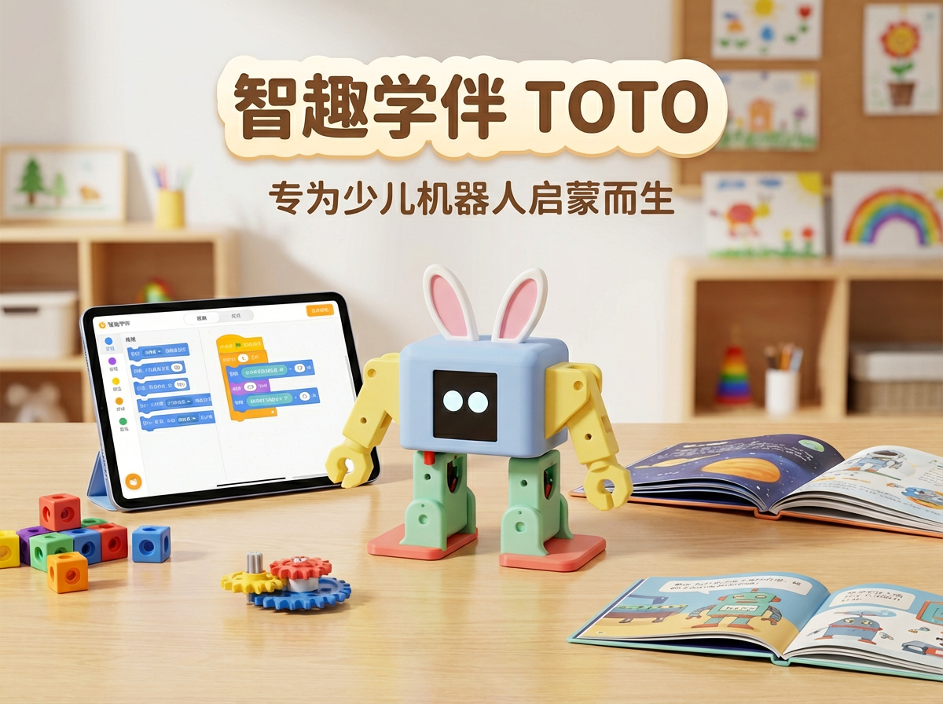

对于青年：一个懂你的情绪港湾与生活伴侣

步入社会的青年，面对快节奏的生活与无形的压力，更需要一个忠实的倾听者与得力助手。
情绪的慰藉：我们的机器人是24小时在线的贴心好友。它善于倾听工作烦恼、生活琐事，能进行有深度的交流，提供正向的情感支持，成为独处时的心灵慰藉，缓解孤独与焦虑。
高效的伴侣：它更是聪明的个人助理，能帮助管理日程、设定提醒、快速查询信息、控制智能家居，在追求效率的时代，为青年群体节省宝贵精力，提升生活品质。

产品图2：模块化智能陪伴机器人BOBO

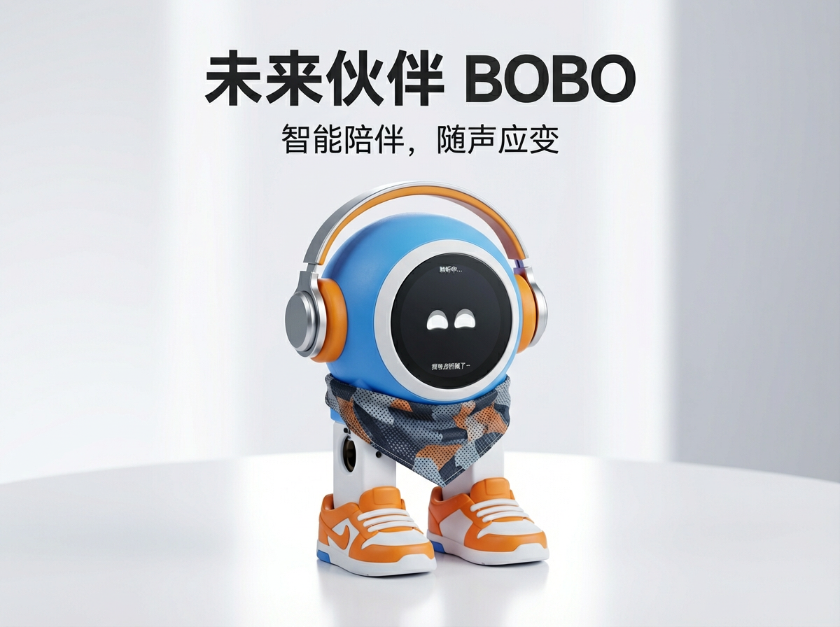

对于长者：贴心可靠的健康助理与生活伴侣

我们致力于让科技温柔地守护“银发一族”，让他们在数字时代生活得更从容、更精彩。
健康的守护：机器人化身贴心的健康助理，能轻松完成医院挂号、推荐医生科室、规划就诊路线，并能“一键”快速查找附近的急救中心位置，为健康争取宝贵时间。
生活的色彩：它还能为长者的退休生活增添乐趣，提供新闻播报、戏曲欣赏、记忆相册功能，并能规划适合的旅游线路、推荐社区活动，帮助他们与社会保持连接，拥抱安心的数字化晚年。

我们的产品与未来

目前，我们的小蓝、小紫和小白机器人家族，已在这三大场景中展现出独特的价值。未来，弦动光年将继续深耕，让人工智能与机器人技术更深入地理解每一个“人”的需求，让独一无二的机器人伙伴，成为每个家庭中不可或缺的温暖成员。

携手弦动光年，共同开启一个属于每个人、有温情、有陪伴的机器人时代。

欢迎随时联系我们：cannan09@gmail.com
微信：


-----------------------------------------------------------------------------------------------------

Stringlight: Your Unique Robotic Companion

Our Vision: A unique robot for every individual.
At Stringlight, we believe technology's true purpose is to provide unique companionship and growth for every life. We are dedicated to creating personalized robotic companions for the three core groups of our society: children, youth, and the elderly, seamlessly weaving technology into every stage of life.
For Children: From Creation to Confidant
We guide children on a transformative journey from being digital "consumers" to becoming real-world "creators."
Hands-On Creation:We provide comprehensive robotics courses for K-12 to university students. Through 3D printing, mechanical assembly, circuit design, graphical programming, and LLM integration, students **bring their ideas to life, building a tangible, moving, talking robotic companion from the ground up.** This is more than STEAM; it's a foundation for imagination, critical thinking, and problem-solving.
A Trusted Partner:The robot becomes a child's personal confidant. It assists with learning, tells stories, and engages in meaningful dialogue. More importantly, it serves as an emotional outlet, using positive interaction to safeguard mental well-being and naturally encourage engagement with the real world beyond the screen.

For Youth: Your Daily Support System
For young adults navigating a fast-paced world, we offer a reliable source of support and efficiency.
Emotional Resonance: Our robot is a 24/7 companion, ready to listen, converse, and offer positive emotional support, helping to alleviate the stresses and isolation of modern life.
Life Streamlined:It acts as an intelligent personal assistant, managing schedules, providing reminders, retrieving information, and controlling smart home devices, freeing up mental space and enhancing daily productivity.

For the Elderly: Dignity and Connection
We empower seniors to live independently and vibrantly in the digital age.
Health at Hand:The robot serves as a dedicated health aide, assisting with booking medical appointments, providing doctor recommendations, and instantly locating the nearest emergency services, offering peace of mind for them and their families.
Life Enriched:It helps cultivate a joyful lifestyle by sharing news, playing music, curating memory albums, and suggesting travel ideas and local activities, fostering social connection and mental engagement.

Our Products & The Path Forward
Our current family of robots—Xiao Lan, Xiao Zi, and Xiao Bai—are already delivering value across these areas. Looking ahead, Stringlight will continue to innovate, making the unique robotic companion an indispensable and joyful part of every household.

Join us at Stringlight. Let's build a future where everyone has a companion that understands, assists, and grows with them.

