

Republic of the Philippines
Laguna State Polytechnic University
Province of Laguna

AN IOT BASED REAL-TIME SMART MONITORING FRESHWATER QUALITY ANALYSIS OF RECIRCULATING AQUACULTURE
SYSTEM INTEGRATING MACHINE LEARNING

A Capstone Project presented to the Faculty of College of Computer Studies
Laguna State Polytechnic University
Los Baños Campus
Los Baños, Laguna

Submitted to the Faculty of College of Computer Studies in Partial Fulfillment of the Requirement for the Degree, Master in Information Technology
Specialized in Digital Systems Technology

WILSON B. SUYAT

JUNE 2025
CHAPTER I

INTRODUCTION
Project Context
The rapid growth of the global aquaculture industry has necessitated the development of innovative and sustainable methods for maintaining optimal water quality, particularly in closed environments such as Recirculating Aquaculture Systems (RAS) (Mishra et al., 2020). RAS are engineered to minimize water usage and environmental impact, allowing for efficient management of aquatic species in a controlled setting. However, maintaining ideal water conditions is a persistent challenge due to the constant buildup of waste products, such as ammonia and nitrates, which can adversely affect fish health and growth if not appropriately managed (Martins et al., 2010).
The cultivation of molly fish (poecilia sphenops), a species known for its high demand in ornamental aquaculture, presents a valuable model for studying the application of advanced water quality management strategies. In recent years, integrating Internet of Things (IoT) technologies with Machine Learning (ML) has transformed traditional aquaculture practices by enabling real-time monitoring, analysis, and control of water quality parameters (Nguyen et al., 2021). IoT sensors can continuously measure critical parameters such as temperature, pH, dissolved oxygen, and ammonia levels, which are essential for maintaining the health of molly fish (Shahbaz et al., 2019). When combined with machine learning algorithms, IoT data can provide valuable insights for predictive analysis, allowing aquaculturists to anticipate potential water quality issues and make proactive adjustments to the system (Li et al., 2022).
The recent development of sensors and automated systems has allowed the implementation of real-time monitoring, thereby allowing the acquisition of more exact and prompt data relevant to many water quality indicators, including pH, temperature and pollutant levels (Adeniyi, A. G., 2023).
The rapid advancement of machine learning and artificial intelligence has ushered in a new era of innovation in water quality management. These technologies have fundamentally transformed how water quality data is analyzed and interpreted. Machine learning algorithms, in particular, have proven highly effective in predicting contamination events, identifying pollution sources, and optimizing treatment methods. Their ability to process large datasets and detect complex patterns offers valuable insights, making them essential tools in improving water resource sustainability and management (Saxena & Lal, 2012).
These algorithms offer the capability to efficiently handle significant amounts of data and identify complicated trends, enabling researchers to contribute considerably to these areas of study. The utilization of AI-driven systems is steadily growing in the domain of water quality management, comprising not only the task of monitoring but also forecasting and response to such issues. Water resource management systems provide proactive supervision of water resources, so simplifying early detection of possible hazards and consequently decreasing risks (Joy, C., Sundar, G. N., & Narmadha, D., 2021).
The use of artificial intelligence (AI) involves various innovative applications, such as the creation of predictive models, the creation of neural networks for detecting particular pollutants like toxic metals and infections, and automating of water treatment operations through the utilization of AI-powered decision-making tools (Godavarthi, B., Nalajala, P., & Ganapuram, V., 2017). The mentioned growth is accompanied by the growing adoption of IoT (Internet of Things) devices, which generate constant data streams that are utilized by improved AI models to achieve enhanced precision and rapid analysis.
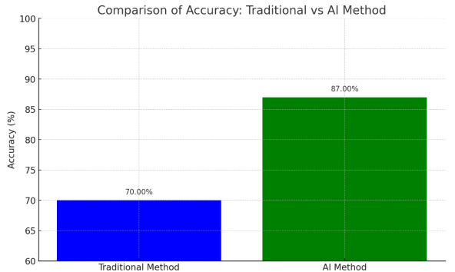

Figure.1 Difference between adaptation of traditional and AI enabled water quality monitoring system
The incorporation of artificial intelligence (AI) into the monitoring and treatment of water quality serves as a remarkable demonstration of technological progress. Also, it signifies a dedication to promoting environmental sustainability and safeguarding public health, so indicating an approaching era characterized by the harmonious coexistence of technology (Tripathi, G. P., Agarwal, S., Awasthi, A., & Arun, V., 2022).
The integration of IoT and ML in RAS enables a smart monitoring system that not only tracks environmental conditions but also interprets data to facilitate automated decision-making. By employing predictive models and anomaly detection algorithms, such systems can identify deviations from ideal water quality conditions, flag potential risks, and adjust environmental parameters to reduce the likelihood of disease outbreaks and mortality (Zhao et al., 2019). This approach enhances the sustainability and productivity of aquaculture operations by ensuring that water resources are used efficiently while maximizing the health and growth of the cultivated species (Rojas-Torres et al., 2021).
Traditional water quality monitoring methods often rely on periodic manual testing and lack the ability to detect sudden changes in real-time. This delay in detection can lead to adverse effects on aquatic stocks, reducing productivity and profitability. According to Boyd and Tucker (1998), frequent water quality fluctuations are linked to increased stress and higher mortality rates in aquaculture, emphasizing the need for continuous and automated monitoring systems to ensure optimal breeding conditions. Traditional methods of water quality monitoring in aquaculture, often reliant on manual sampling and testing, are time-intensive and prone to delays in detecting and addressing issues (Ahmed et al., 2021). This limitation poses significant risks in maintaining the stable water quality conditions necessary for optimal molly fish (Poecilia sphenops) health and reproduction (Timmons & Ebeling, 2010). Advanced monitoring technologies, such as the Internet of Things (IoT) and machine learning (ML), provide innovative solutions to these challenges by enabling real-time, automated, and precise management of water quality parameters (Han et al., 2020).
For molly fish, whose growth depend on stable water quality, implementing such a smart monitoring system can greatly improve cultivation outcomes. Studies have shown that consistent water quality monitoring reduces stress and disease prevalence, directly contributing to higher survival and growth rates in ornamental fish species (Gatlin et al., 2018).
RAS represent a transformative approach to aquaculture, allowing for the intensive farming of aquatic species in a controlled, sustainable environment. Central to the effectiveness of RAS is the quality of the water used, which plays a crucial role in the health and growth of the aquatic organisms being cultivated. Understanding the intricacies of water quality management in RAS is essential for ensuring successful aquaculture practices. In RAS, water is treated and reused within a closed-loop system, which is designed to minimize water use and environmental impact. This system typically includes various components such as filtration units, biological reactors, and oxygenation systems. The water quality in RAS must be meticulously monitored and maintained to support the needs of aquatic species, as any deviation can lead to detrimental effects on fish health and overall system performance.
In RAS, several key processes are essential for maintaining water quality and supporting aquatic life. Water purification is achieved through mechanical, biological, and chemical processes that remove waste produced by fish. Mechanical filtration eliminates solid waste, while biological filtration uses beneficial bacteria to convert harmful ammonia, a byproduct of fish metabolism, into less toxic compounds like nitrites and nitrates. This conversion process, known as nitrification, is vital for maintaining a safe environment for the fish (Piedrahita, 2003). Additionally, after the water is purified, it is re-oxygenated before being circulated back into the tanks. Oxygen saturation is critical for fish and other aquatic organisms as it supports aerobic respiration. Without sufficient oxygen levels, fish can experience stress, which may lead to mortality and hinder growth rates and overall health (Moyle & Cech, 2004).
The adoption of advanced technologies, such as IoT sensors and automated monitoring systems, can revolutionize traditional aquaculture practices. These technologies enable real-time monitoring of water quality and environmental conditions, facilitating timely interventions and reducing labor costs (Zhang et al., 2019). Moreover, automated feeding systems can optimize feed delivery, reducing waste and improving growth rates.
The advancement of smart systems integrating the Internet of Things (IoT) and machine learning (ML) has revolutionized water quality management in Recirculating Aquaculture Systems (RAS) (Han et al., 2020). These technologies address longstanding challenges such as maintaining water quality stability, optimizing resource use, and enhancing overall system efficiency (Li et al., 2022). By enabling real-time data collection, analysis, and automation, smart systems ensure that RAS environments meet the precise conditions required for optimal fish health and growth (Ahmed et al., 2021). IoT and ML complement each other in creating a robust framework for RAS management. IoT devices, such as smart sensors and actuators, continuously monitor critical water quality parameters, including pH, temperature, dissolved oxygen, ammonia, and nitrite levels (Tian et al., 2021). This data is transmitted in real time to a centralized platform where ML algorithms process it to identify patterns, predict trends, and detect anomalies (Han et al., 2020).
This study endeavors to design and develop a Real-Time Smart Monitoring and Analysis of Freshwater Quality in Recirculating Aquaculture System Utilizing Machine Learning and IoT for Molly Fish, focusing on the development of a reliable, automated system for real-time water quality monitoring.
This project will contribute to the growing body of research on sustainable aquaculture practices, demonstrating the effectiveness of IoT and ML technologies in addressing the specific needs of ornamental fish farming. And contributing to the advancement of the aquaculture sector and the preservation of environmental sustainability.
Project Objectives
The main objective of this project is to design and develop a web system for monitoring and analysis of freshwater in RAS ensuring that water conditions remain optimal for molly fish (Poecilia sphenops). The specific objectives were as follows:
- Integrate sensors (temperature sensor, pH sensor, dissolved oxygen sensor and ammonia sensor) to measure vital aspects of freshwater recirculating aquaculture system quality, including temperature, pH, dissolved oxygen (DO), and ammonia.
- Utilize a Bayesian machine learning algorithm to predict water quality trends.
- Conduct an assessment to verify the accuracy of the collected water quality parameters measured by the sensors at the Analytical Laboratory of the Center for Lakes Sustainable Development.
- Evaluate the developed project using Technology Acceptance Model (TAM) and ISO 25010 software product standards to verify its efficacy and quality.
Project Purpose
The project aims to address the critical challenge of maintaining optimal freshwater quality in aquaculture systems. By leveraging advanced technologies such as IoT sensors and machine learning algorithm, the project will provide an automated solution for monitoring, analyzing, and regulating freshwater parameters. This ensures the ideal environment for molly fish, a popular species in the ornamental aquaculture industry.
The system collects real-time data on critical freshwater parameters, such as pH, temperature, dissolved oxygen, and ammonia levels, and will utilize machine learning to predict and mitigate potential issues before they affect fish health. This automated approach enhances productivity, reduces resource consumption, and minimizes environmental impact, aligning with the principles of sustainable aquaculture.
This project supports multiple Sustainable Development Goals (SDGs), ensuring that its technological innovations not only address local aquaculture needs but also contribute meaningfully to broader global sustainability efforts.
SDG 6: Clean Water and Sanitation
The project promotes efficient water management in aquaculture by enabling real-time quality control and reducing water wastage. By optimizing water reuse in recirculating systems, it supports the sustainable management of freshwater resources.
SDG 9: Industry, Innovation, and Infrastructure
This project leverages cutting-edge technologies such as IoT for data acquisition and machine learning for predictive analytics, fostering innovation in aquaculture practices. It contributes to modernizing the aquaculture industry and establishing smart infrastructure that can be adapted for other aquatic species.
SDG 12: Responsible Consumption and Production
Through precise monitoring and regulation, the system reduces resource consumption and minimizes the risk of waste or harmful byproducts. By enhancing system efficiency, it supports sustainable aquaculture practices that are less resource-intensive.
SDG 14: Life Below Water
The project ensures that aquaculture operations do not harm aquatic ecosystems by maintaining ideal conditions for fish health. Sustainable aquaculture practices like this reduce the need for fish harvesting, preserving biodiversity and promoting responsible use of marine and freshwater ecosystems. This project addressed the needs of multiple stakeholders by contributing to the efficiency, sustainability, and scalability of aquaculture practices. By advancing responsible fish breeding and data-informed resource management, it will foster positive outcomes for industries, communities, ecosystems, and scientific and policy-driven stakeholders alike. This project will benefit a range of stakeholders:
Aquaculture Farmers
Farmers will benefit directly from enhanced fish survival and growth rates due to the system’s ability to maintain optimal water conditions. The automated system lowers operational costs by reducing resource consumption, such as water and energy, and minimizing fish mortality and disease outbreaks. Alerts and predictive analytics simplify farm management, allowing farmers to focus on scaling their operations while increasing profitability.
Aquaculture Industry
The project aims to significantly enhance industry efficiency by introducing scalable and replicable solutions for aquaculture management. By ensuring healthier molly fish and other ornamental species through optimized water quality systems, it improves overall product quality to meet growing market demands. Furthermore, the system’s adaptability to various fish species and aquaculture setups promotes the widespread adoption of smart, sustainable technologies.
Consumers
Consumers who buy the fish will enjoy Molly fish that are high-quality and disease-free, because they are raised sustainably. Because consumers care more about the environment, backing aquaculture that is responsible boosts how appealing it is to markets, builds confidence, and improves contentment, which makes choices good for the environment more desirable as it pushes for better, more moral ornamental fish choices for people and groups that know about the environment
Researchers and Technology Developers
Researchers can gain access to valuable data generated by the system, contributing to further innovations in IoT, machine learning, and aquaculture practices. Developers can refine and adapt this technology for broader applications, including other aquaculture systems or industrial water treatment.
Scope and Limitation of the Study
This scope and limitation outline will ensure a targeted, feasible project that leverages technology to advance sustainable aquaculture practices while acknowledging the inherent limitations in resource and environmental factors:
Scope
This project aims to design and implement an IoT-based real-time smart monitoring and freshwater quality analysis system for a Recirculating Aquaculture System (RAS), specifically tailored for the breeding of molly fish (Poecilia sphenops). The system integrates advanced IoT sensors with Machine Learning (ML) algorithms to continuously monitor and analyze key water quality parameters such as temperature, pH, dissolved oxygen, and ammonia levels crucial to maintaining optimal conditions for molly fish health, growth, and survival within a controlled aquaculture environment.
The project aims to enhance the monitoring and management of freshwater quality in Recirculating Aquaculture Systems (RAS) by integrating multiple IoT sensors. These sensors specifically, temperature, pH, dissolved oxygen, and ammonia sensors will work together to provide real-time data on water conditions. This system aimed to provide real-time data on temperature and dissolved oxygen levels by integrating the ESP32 Development Board with various sensors, ensuring optimal water quality for aquatic organisms and allowing precise modifications as needed. A key component of the machine was the DS1B20 Waterproof Temperature Sensor, which accurately captured temperature data in freshwater environments. Its waterproof nature allowed for safe immersion in water, enabling precise temperature monitoring essential for maintaining the ideal conditions for aquatic life. Another vital element was the pH-4502C device, which continuously monitored pH levels within the recirculating system. Since fluctuations in pH can significantly impact the health and vitality of aquatic organisms, this device played a crucial role in ensuring stability. By providing precise pH measurements, the system allowed for necessary adjustments to maintain a consistent and optimal aquatic habitat, thereby safeguarding the well-being of aquatic life. Additionally, the Dissolved Oxygen Sensor monitored the oxygen levels in water, offering valuable insights into overall water quality. Since aquatic organisms depend on sufficient oxygen levels for survival, this sensor helped detect variations or shortages, enabling early interventions to maintain a healthy aquatic environment.
By collecting and analyzing this data, ornamental fish farmers will have the ability to monitor their aquaculture environment more effectively, ensuring optimal conditions for fish health and growth. This proactive approach minimizes the risks associated with sudden changes in water quality, which can often go unnoticed until they negatively impact ornamental fish health.
The web system module facilitates an intuitive user interface, enabling users to seamlessly monitor the water quality of recirculating system sensors in real-time. The web system's simplicity and ease of navigation provide a smooth experience for users to access instantaneous data. Users can navigate to individual sensor displays to access detailed real-time monitoring data, enabling them to receive notifications in the event of water quality changes. Users can view alerts for critical metrics, such as excessive temperature fluctuations, low levels of dissolved oxygen, and pH level of acidity. These notifications can be delivered promptly to web-based system, ensuring users are informed of any urgent situations requiring immediate attention.
To strengthen the system’s effectiveness, Bayesian machine learning algorithm will be implemented to analyze collected data. This algorithm will predict trends in water quality. This data-driven decision-making process provides a smarter and more responsive approach to aquaculture management. Ensuring the reliability and accuracy of the collected data is a crucial aspect of the project. To achieve this, the recorded water quality measurements will be validated against established standards through assessments conducted at the Analytical Laboratory of the Center for Lakes Sustainable Development. This verification process ensures that the monitoring system provides precise and dependable data, which is essential for effective decision-making.
The project is subjected to evaluation process based on the ISO 25010 software product standards. These standards assess key attributes such as functionality, reliability, usability, and performance to guarantee that the developed monitoring system meets high-quality standards. By following this structured evaluation, the project aims to create a robust and user-friendly monitoring solution that can be relied upon by fish farmers for maintaining healthy aquaculture environments.
Limitations
This system is designed to monitor essential water quality parameters, specifically temperature, pH, dissolved oxygen, and ammonia, which are critical to the well-being of molly fish. However, it is important to acknowledge that fish health is influenced by a wide range of factors beyond these parameters. For instance, the presence of harmful pathogens, bacterial infections, or other water contaminants is not within the scope of this monitoring system. Detecting such threats is also not within the scope and it would require separate testing methods, such as microbiological assessments or specialized sensors, which are not integrated into the current design. A key consideration in the functionality of this system is its reliance on technology infrastructure. For it to operate effectively, a stable power supply and consistent internet connectivity are required. Any disruptions such as power outages or weak internet signals could impact real-time monitoring, causing delays in data collection or preventing the system from providing timely alerts. In locations where electricity or internet access is unreliable, this dependency may pose challenges, limiting the system’s effectiveness and increasing the risk of undetected water quality fluctuations. The system is designed for controlled environments within RAS, and external environmental conditions, such as extreme weather changes, are not within the system's scope.

CHAPTER 2

THEORETICAL FRAMEWORK OF THE PROJECT
This chapter reviews specific research that the researcher used as evidence for the project. The information gathered through research studies has made an essential contribution to the development of the system and the implementation of key elements required for achieving usability.
Review of Related Literature, Studies, and Systems
The integration of Internet of Things (IoT) and Machine Learning (ML) in aquaculture has transformed traditional practices, making real-time monitoring and data-driven management of water quality feasible. This review covers key studies that explore the use of IoT and ML in Recirculating Aquaculture Systems (RAS), with an emphasis on sustainable fish farming, water quality optimization, and the impact on fish health.
Recirculating Aquaculture Systems (RAS)
Recirculating Aquaculture Systems (RAS) represent a transformative approach in aquaculture, offering solutions to the sector's challenges concerning sustainability, resource efficiency, and environmental conservation. The foundational concept of RAS is its closed-loop design, where water is continuously treated and reused. This approach not only conserves water but also minimizes the environmental footprint of aquaculture operations by reducing effluent discharge. Such systems are especially advantageous in regions facing water scarcity or stringent environmental regulations (Martins et al., 2010). A critical aspect of RAS is its capacity to support high-density aquaculture. By maintaining optimal water quality, RAS allows for the intensive farming of aquatic species without compromising their health or growth. Studies highlight the pivotal role of water quality parameters such as dissolved oxygen, ammonia levels, and temperature in determining the success of RAS. Deviations from ideal conditions can lead to reduced growth rates, increased susceptibility to diseases, and even mortality among cultured species. Therefore, consistent monitoring and precise control of these parameters are imperative (Martins et al., 2010). The economic and environmental benefits of RAS have been widely acknowledged. The system's ability to reduce water consumption and waste production aligns with global sustainability goals, making it a preferred choice for modern aquaculture practices. However, the complexity of managing RAS, particularly in maintaining water quality, presents challenges that necessitate advanced technological interventions. Traditional methods of water quality monitoring, which rely heavily on manual sampling and laboratory analysis, are often time-consuming and prone to errors. This underscores the need for integrating smart monitoring technologies, such as the Internet of Things (IoT) and machine learning (ML), into RAS. These technologies enable real-time data collection and analysis, facilitating timely interventions to maintain optimal conditions. The adoption of IoT and ML in RAS reflects a broader trend towards digital transformation in aquaculture. These tools enhance the precision and efficiency of water quality management, addressing one of the primary limitations of conventional RAS systems. In doing so, they contribute to the sustainability and productivity of aquaculture practices, particularly in the cultivation of sensitive species like molly fish (Poecilia sphenops), which demand stable and specific water quality conditions for optimal growth and reproduction.
Freshwater Quality Parameters in RAS
Water quality is a cornerstone of aquaculture success, particularly in Recirculating Aquaculture Systems (RAS), where water is reused after undergoing treatment processes. Critical parameters such as dissolved oxygen (DO), pH, temperature, ammonia, nitrate, nitrite, and turbidity collectively shape the environment for fish health and productivity. The dynamic interplay among these factors requires precise monitoring and control to avoid adverse effects, such as stress or mortality in the cultured species. Maintaining optimal water quality is essential for the survival and well-being of molly fish (Poecilia sphenops), a species known for its resilience but sensitive to poor water conditions. Several studies have examined the optimal ranges of parameters such as temperature, pH, dissolved oxygen, ammonia, and other key water quality indicators to ensure healthy growth, reproduction, and longevity of molly fish in freshwater aquaculture systems.
Dissolved Oxygen (DO)
Dissolved oxygen is among the most crucial parameters in RAS, as it directly impacts fish respiration and overall metabolism. Low DO levels can cause hypoxia, leading to reduced growth, behavioral changes, and increased susceptibility to diseases. Conversely, excessive DO can result in gas supersaturation, causing gas bubble disease. For optimal fish health, maintaining DO levels within species-specific thresholds is essential. Studies show that automation and real-time monitoring of DO in RAS can significantly reduce fish stress and improve productivity (Martins et al., 2010). The importance of dissolved oxygen (DO) in supporting the respiration and overall health of molly fish was investigated by Gonzalez and Park (2019). Their research indicated that molly fish thrive best when dissolved oxygen levels are maintained between 5.0 to 7.5 mg/L. DO levels below 4.0 mg/L resulted in respiratory distress, erratic swimming, and eventual hypoxia-induced mortality. Conversely, excessive aeration resulting in supersaturation conditions above 8.0 mg/L caused oxidative stress and potential gas bubble disease in molly fish.
pH Balance
The pH of water in RAS affects the ion exchange and metabolic functions of aquatic organisms. Fish species have specific pH tolerance ranges, and deviations can cause stress or mortality. A pH range of 7.0 to 8.5 is optimal for molly fish (Poecilia sphenops) (Axelrod et al., 1991). Extremes in pH, either acidic or alkaline, can exacerbate the toxicity of other compounds, such as ammonia, underscoring the interconnectedness of water quality parameters.
Also, a study by Smith et al. (2020) analyzed the impact of different pH levels on molly fish behavior and mortality. Their research concluded that molly fish prefer slightly alkaline conditions, with an optimal pH range of 7.0 to 8.5. While they can tolerate a pH as low as 6.5 and as high as 9.0, prolonged exposure to acidic conditions (below 6.5) resulted in stress, gill damage, and increased mortality rates. Conversely, excessively high pH levels above 9.0 led to reduced metabolic efficiency and poor growth outcomes.
Temperature Regulation
Temperature influences several biological processes, including growth rates, feeding efficiency, and reproductive cycles in fish. Molly fish thrive within a temperature range of 24°C to 28°C, and deviations can lead to metabolic stress or even death (Axelrod et al., 1991). In RAS, temperature control is achieved through heaters, coolers, and monitoring systems, ensuring stable conditions suitable for specific fish species. According to Chezhian and Kabilan (2021), temperature plays a critical role in the growth, metabolism, and immune response of freshwater ornamental fish such as molly fish. Their study indicated that molly fish thrive best within a temperature range of 24°C to 28°C. Exposure to temperatures below 22°C or above 30°C can lead to stress, slowed growth, and increased susceptibility to diseases. Furthermore, maintaining a consistent temperature within this range optimizes breeding efficiency and fry survival.
Nitrogen Compounds: Ammonia
Nitrogen compounds are byproducts of fish metabolism and feed degradation. Among them, ammonia is the most toxic and poses a significant threat to fish health in RAS. Ammonia toxicity disrupts osmoregulation and damages gill tissues, leading to reduced growth rates and compromised immune function (Colt & Armstrong, 1981). The nitrification process, facilitated by beneficial bacteria in biofilters, converts ammonia to nitrite and subsequently to nitrate, which is less toxic. However, high concentrations of nitrate can still negatively impact fish growth and reproduction, requiring periodic water exchanges or advanced filtration techniques.
Ammonia toxicity remains a major concern in freshwater aquaculture, especially for sensitive species like molly fish. A study by Chowdhury and Khan (2018) highlighted that the ideal ammonia concentration (NH3) for molly fish should remain below 0.05 mg/L to prevent toxicity. Prolonged exposure to ammonia levels exceeding 0.1 mg/L led to gill damage, reduced immune response, and eventual mortality. Similarly, nitrite (NO2) levels should be maintained below 0.3 mg/L to minimize oxidative stress and avoid methemoglobinemia.
Sensors
pH
Judith (2019) emphasizes that water quality is essential for the survival of all living organisms and plays a critical role in agricultural activities and recreational use. Maintaining appropriate pH levels is fundamental for sustaining water quality and ensuring the health of ecosystems. Accurate pH testing is necessary to guarantee the safety of drinking water and groundwater, as well as to protect aquatic flora and fauna.
According to the Water Science School (2019), pH is a precise measure of the concentration of hydrogen and hydroxyl ions in water. Acidic water contains a higher concentration of hydrogen ions, while alkaline water has an increased concentration of hydroxyl ions. Since pH is sensitive to chemical variations, it serves as a key indicator of chemical changes in water systems.
Pearlman (2022) further explains that the pH of water influences the solubility and toxicity of chemicals and heavy metals. If the pH is too high or too low, aquatic organisms may not survive. While most aquatic species thrive within a pH range of 6.5 to 9.0, some organisms can adapt to environments outside this typical range.
Dissolved Oxygen
(Molnar et al., 2019) state that dissolved oxygen is a crucial parameter to measure water quality. Higher levels of water pollution are shown by low levels of oxygen, which can be caused by factors such as elevated temperature, increased organic matter content, and the respiration of aquatic organisms. Of all the water quality parameters listed, dissolved oxygen is the most crucial in terms of its significance for the aquatic environment and ecology. The dissolved oxygen levels in water can vary significantly weekly and daily and are influenced by various water quality factors, including total phosphorus and chemical oxygen demand and their interactions.
According to Fowler et al. (1994), dissolved oxygen (DO) can be detected via either an electrical or chemical method. The electrical method involves just placing a DO probe into the water. A gold or platinum element surrounded by reagent solution is referred to as a DO probe. A membrane separates the reagent solution from the water, and the oxygen in the process reacts with the gold or platinum element. DO can be determined by monitoring the voltage generated. However, the probe is expensive, and maintenance is relatively costly.
Simbeye, Zhao, and Yang (2014) measured the dissolved oxygen level in water using a DO3000 dissolved oxygen sensor. The DO3000 can test concentrations ranging from 0 mg/L to 20 mg/L, with automatic range switching. In addition, it has a resolution of 0.1% and can compensate for temperatures ranging from 0 to 60°C. This sensor uses a data logging method for long-term, unattended data collection. The sensor's body design 16 is waterproof and resistant to hostile environments. The DO3000 is user friendly since it is simple to configure and gather data using a personal computer.
According to Junchao Yang et al. (2024) Dissolved oxygen (DO)is crucial for aquatic creatures' healthy growth. Aquaculture with high densities is a key component of factory farming. Therefore, adequate DO is necessary to guarantee the survival of breeding objects, whereas insufficient DO will prevent contaminants in the water from breaking down, depriving the breeding objects of oxygen. Yan et al. (2021) claim that DO is challenging to manage in factory aquaculture, and the technique of management has an impact on the cost of aquaculture as well. To guarantee that the DO is consistently maintained within a specified range or close to the setting value, the aerator's output air flow must be precisely controlled.
Dissolved oxygen (DO) content in aquaculture needs to be carefully regulated in order to support the growth and development of aquatic products. Dissolved oxygen (DO) is essential for aquatic species to grow healthily (Xinhui Zhou et al., 2022). Aquaculture with high densities is a key component of factory farming. (Junchao Yang et al., 2024) In recirculating aquaculture, precise water quality control has always been of utmost importance. Of these, DO is the most crucial water quality component for determining the water body's quality (Saber et al., 2020, Cao et al., 2021).
Fijani et al. (2019) state that the DO concentration is within a desirable range for the best growth and development of aquatic products as well as for increasing breeding efficiency. According to pertinent research, an excessively low DO level will seriously impede the normal growth of aquatic goods and, in extreme circumstances, may even result in widespread death. As stated by Xinhui Zhou et al. (2022), the establishment of a mathematical model that can faithfully simulate the real DO control system is a prerequisite for achieving precise control of DO. In order to precisely regulate and track the amount of dissolve oxygen (DO) that influences the growth of aquaculture life, this study uses a sensor.
Temperature
The significance of temperature sensors in monitoring water quality cannot be overstated, as temperature fluctuations have a profound impact on various biological and chemical reactions that ultimately affect the overall quality of water (BOQU, 2023). The monitoring of temperature changes is crucial for detecting alterations in water quality and evaluating the quality of drinking water. Temperature sensors play a vital role in gathering critical information regarding water, including variations in temperature patterns, water mixing, and thermal pollution, all of which can have a profound impact on water quality.
These devices are employed to observe temperature variations at different locations within a water system, including wells, reservoirs, and lakes, thereby ensuring regulation adherence, mitigating thermal pollution, monitoring water mixing, and facilitating efficient water treatment. The increased focus on water quality has led to the unprecedented significance of temperature sensors in water quality monitoring. By surveilling temperature fluctuations, it is possible to guarantee the safety and freshness of the consumed water.
Temperature changes have a significant impact on water's physical, chemical, and biological characteristics, influencing the amount of dissolved oxygen, pH levels, the cycling of nutrients, and the metabolic rates of aquatic organisms, ultimately affecting the overall well-being of marine ecosystems (Cigizoglu & Kadioglu, 2013).
In restricted water aquaculture, microbubble aeration has been identified as a useful technique to enhance dissolved oxygen levels and fish culture productivity. An aeration system for aquaculture has been created to facilitate the growing of fish and invertebrate biomass (Heriyati, E. et al., 2022). When the dissolved oxygen (DO) level in the culture media is reduced, an aeration system is periodically utilized in semi-intensive aquaculture systems.
The aquaculture industry has developed aeration systems to facilitate the growing of fish and invertebrate biomass. When the dissolved oxygen (DO) level in the culture media is reduced, an aeration system is periodically utilized in semi-intensive aquaculture systems. (Heriyati et al., 2021).
On the other hand, Heriyati, E. and associates (2022) states that inadequate management of water quality, infrequent water changes, and aeration induce stress conditions that impede development and yield. As a defense mechanism against physiological change brought on by stress, one of the stress markers in fish is a rise in the blood's glucose concentration. As a result, the RAS system's use of microbubble aeration offers a solution to the aquaculture challenge.
According to Munest et al. (2023) using technology to create a controlled environment for crop management is known as smart agriculture. In addition to increasing agricultural yield, smart farming gives small farmers a new source of revenue. An intelligent system for data analytics was important in keeping an eye on and preserving the freshwater aquaculture environment. A technology-driven method of monitoring and preserving the ideal growing environment is called "smart farming." Nonetheless, many inexperienced farmers still find smart farming challenging. The environment suitable for aquaculture is controlled by actuators, while sensors keep an eye on the water's characteristics. Data and control flow are managed via the physical devices' communication network. The edge, fog, and gateway devices are all part of an integrated network according to the network design. Virtual private network (VPN) servers are run by the gateway to enable secure communication across public networks.
Munessh et al. (2024) stated that in parallel, a socket is used by the network to facilitate communication between the fog node and edge node. Entities and processes are abstractly represented in logical design. A front-end data visualization and an interactive control tool made possible by the Danjgo Web framework were part of the logical design. It manages the data using a relational database on the back end. Relational data is used by a data analytics system to forecast changes in water parameters and actuator control.
Molly Fish (Poecilia sphenops) Cultivation
Molly fish thrive in a stable aquatic environment, with key water quality parameters playing a critical role in their overall well-being. The optimal pH range for molly fish is between 7.0 and 8.5, as deviations from this range can impair physiological functions and reduce survival rates. Furthermore, the temperature range of 24–28°C is optimal for metabolic activity, growth, and reproduction. Temperatures outside this range may induce stress, weaken immune responses, and hinder breeding efficiency (Timmons & Ebeling, 2010).
Ammonia, a byproduct of fish metabolism and decomposing organic matter, is particularly toxic to molly fish. Elevated ammonia levels can damage gill tissues, disrupt osmoregulation, and impair growth. To mitigate these risks, effective biofiltration and consistent monitoring of nitrogen compounds are essential. Stable water quality not only ensures better health outcomes but also enhances the fish's reproductive output, which is a significant factor in ornamental aquaculture profitability (Axelrod et al., 1991).
Molly fish are prolific breeders, capable of producing large broods under favorable conditions. Their live-bearing nature allows for relatively high survival rates among offspring, making them an ideal candidate for aquaculture operations focused on ornamental fish production. However, fluctuations in water quality parameters, such as sudden changes in temperature or pH, can adversely affect breeding behaviors and reduce fry survival rates. Providing an optimal and stable environment is therefore critical for achieving high productivity (Axelrod et al., 1991).
Behavioral factors also influence molly fish cultivation. They are social animals that thrive in groups, but overcrowding can lead to stress and aggression. Proper tank sizing, coupled with efficient waste management, can help maintain a balanced ecosystem that supports healthy interactions and minimizes stress-related issues.
Species-Specific Sensitivities: Molly Fish
Molly fish (Poecilia sphenops) are sensitive to fluctuations in water quality parameters, making precise management critical for their successful cultivation. They require stable conditions to thrive, with specific requirements for DO, pH, and temperature. Research indicates that unstable water quality conditions can result in physiological stress, reduced growth, and lower reproductive output in molly fish (Axelrod et al., 1991). This highlights the importance of advanced monitoring systems in ensuring optimal conditions in RAS tailored for such sensitive species. Managing water quality parameters in RAS is a complex task due to their interdependence and the constant fluctuations caused by biological processes. The integration of Internet of Things (IoT) sensors and machine learning (ML) algorithms into RAS has proven effective in providing real-time data and predictive insights. These technologies allow for timely interventions to address imbalances, thus reducing the risk of fish stress or mortality (Ahmed et al., 2021).
Internet of Things
As stated by Steiner, W. and Kopetz, H. The Internet of Things (2022) refers to the network of physical objects connected to the Internet, which enables remote sensor data access and remote physical world control. Mashing together data that has been gathered, data that has been obtained from other sources, and data from the Web creates new synergistic services that extend beyond what an isolated embedded system can offer. This idea forms the foundation of the Internet of Things. An embedded system with an Internet connection is also known as a smart object, which is the fundamental unit of the Internet of Things. The RFID technology is another advancement that makes similar claims.
The ubiquitous optical bar codes that are seen on many commonplace objects are extended by RFID technology, which calls for the attaching of an inexpensive, intelligent electronic ID tag to a product so that its identity can be deciphered from a distance. The tagged item becomes a smart object when the ID tag is enhanced with greater intelligence. The widespread use of smart items, rather than any new disruptive technology, is what makes the Internet of Things (IoT) innovative.
The internet of things is a relatively new technology that is already included into most systems and gadgets. It helps people live better lives by making certain information and services easier to access. This article's primary goal is to provide a broad overview of the internet of things by analyzing recently released research. This article's added value comes from its analysis of the most important recent papers and from the variety of ways internet of things technology is being used.
The examination of recent literature reveals that internet of things technology is mostly useful for enhancing living quality, but it also helps businesses and industries operate more effectively. In summary, the internet of things is a technology that can solve issues with processing speed, security, and data mobility so long as other technologies continue to advance in the expected directions. Greengard, S. (2021).
Gao et al. (2019) proposed an intelligent-IoT-based control and traceability system to anticipate and maintain water quality for freshwater fish farming. Two modules make up the entire system: an intelligent module and a tracking module. The integrated sensor assembly (pH, water, temperature, dissolved oxygen (DO), and turbidity), data collection, data analysis, and database management are all included in the intelligent management module. The chart, data presentations, and data visualization are all part of the tracking module. The smart module analyzes the data from the fishpond monitoring system and predicts when the water parameters will change. Changes in water characteristics provide farmers the power to monitor and manually control circumstances with actuators. Gao et al. (2019) proposed a system that provides farmers with visual portrayals to help manage water quality concerns.
According to Petra (2023) Artificial intelligence and Internet of Things-based systems can be used for monitoring, enabling real-time measurements and critical situation alerts. But many of today's systems need skilled operators, as well as routine calibration and maintenance. Fish behavior is also affected by variations in water quality. As a result, changes in swimming activity, depth, and acceleration can all be used to gauge the quality of the water. An overview of the current water quality monitoring systems is given by this review, which summarizes the metrics pertaining to water quality as well as the range of sensors and monitoring methods. Furthermore, a brief summary of analytical techniques for more complex analyses has been provided. Real-time measurements of more complex parameters are still possible even though there are various sophisticated methods for keeping an eye on the fundamental water quality measures. According to Wu et al. (2021), the use of web-based system in IoT applications such as agriculture can reduce energy consumption in terms of data generation, lessen manufacture and deployment cost, and is considered environmentally friendly as it reduces the number of deployed sensors. Thit hu et al., (2021) state that, one of the current trends in aquaculture's sustainable development is smart aquaculture, which emphasizes automation and intelligence. Aquaculture has benefited greatly from the use of modern intelligent technology, which have reduced labor costs, increased productivity, and improved environmental friendliness. Artificial intelligence (AI) is subdivided into machine learning, which uses algorithm models that have been taught to identify and learn characteristics from the data it observes. According to Kassem et al. (2021) several smart devices are incorporated into a specifically designed environment for smart aquaculture, which monitors the parameters of the cultivated environment in real time and automatically makes decisions based on the data it collects. One intelligent mode of production is aquaculture. With the use of IoT, big data, artificial intelligence, 5G, cloud computing, and robotics, it may be remotely and automatically operated. Conversely, intelligent aquaculture can be run by a robot that can oversee all of the facilities, machinery, and equipment needed to run entire systems and produce effective results. (Sharma et al., 2021)
Singh and Kapoor (2017) identify the ESP32 as a highly capable microcontroller, integrating built-in Wi-Fi and Bluetooth functionalities, making it an optimal solution for Internet of Things (IoT) applications. Maier et al. (2017) note that while the ESP32’s predecessor, the ESP8266, gained considerable popularity in earlier IoT projects, the ESP32 offers enhanced capabilities suited for more complex tasks. The authors highlight that the ESP32 extends beyond conventional IoT applications, such as remotely controlling sockets or lights in smart homes, to support a broader range of advanced projects.
Studies confirm that the ESP32 is highly efficient and cost-effective, making it an ideal choice for IoT systems. This microcontroller is available in various physical configurations, further enhancing its versatility. Compared to the ESP8266, the ESP32 delivers superior performance through its dual-core architecture and expanded operational features. Additionally, the microcontroller benefits from compatibility with FreeRTOS, an open-source operating system that facilitates real-time applications. As a result, the ESP32 is expected to play a pivotal role in the advancement of future IoT systems and embedded technologies. Allafi and Iqbal (2017) highlight the application of the ESP32 chip as a real-time web server designed to efficiently monitor small-scale solar energy systems. The ESP32 boards are available in prototype configurations suitable for various use cases, including smart home systems, automation, wearable technology, audio devices, and cloud-based IoT applications. Users can either select a pre-configured development kit or develop customized embedded systems utilizing the ESP32 microcontroller.
The ESP32 is a versatile integrated circuit featuring a built-in Wi-Fi module, microcontroller, and antenna, all offered at an affordable price point.
This enables seamless transmission of data, statistics, logs, and other operational parameters across connected devices, thereby enhancing overall system performance. Research findings demonstrate that the ESP32 is well-suited for real-time monitoring and control of small-scale industrial processes. Swati and Rao (2019) further support the efficacy of the ESP32 in IoT applications, emphasizing that it is one of the most effective solutions for such implementations. Their study confirmed the accuracy and reliability of the system through testing and validation.
Role of IoT in Water Quality Monitoring
The integration of the Internet of Things (IoT) into aquaculture has revolutionized water quality management, transitioning from traditional methods to real-time, automated solutions. This technological evolution addresses the challenges of manual monitoring, such as delays in data collection, limited accuracy, and inefficiencies in responding to critical water quality changes. IoT technology is particularly transformative in Recirculating Aquaculture Systems (RAS), where maintaining stable water quality is crucial for fish health and operational success. IoT-enabled sensors play a pivotal role in collecting data on critical water quality parameters, including dissolved oxygen (DO), temperature, pH, ammonia, nitrate, and turbidity. These sensors continuously monitor conditions, transmitting data to a centralized platform for analysis. Real-time monitoring enables aquaculture operators to respond quickly to parameter fluctuations, preventing adverse impacts on fish health. For example, if ammonia levels spike beyond safe limits, IoT systems can trigger immediate alerts, allowing for corrective actions such as increased filtration or water exchange (Ahmed et al., 2021).
Automation through IoT reduces reliance on manual labor, which is often time-consuming and prone to human error. By streamlining data collection and analysis, IoT systems free operators to focus on other critical aspects of aquaculture management. Additionally, IoT networks can integrate with actuators and control systems to automate processes such as aeration, temperature regulation, and water treatment. This level of automation ensures a consistently optimal environment for fish, enhancing overall system efficiency.
The large datasets generated by IoT devices provide aquaculture operators with valuable insights. When combined with advanced analytics or machine learning (ML) algorithms, these datasets can be used to predict trends, identify anomalies, and optimize system performance. For instance, predictive models can forecast potential water quality issues based on historical data, enabling proactive measures to mitigate risks. This capability is particularly beneficial in high-density RAS environments, where even minor fluctuations can have significant consequences (Li et al., 2022).
While the initial investment in IoT technology can be high, the long-term benefits include cost savings from reduced labor and minimized resource wastage. IoT systems also promote scalability, allowing aquaculture operations to expand without proportionally increasing management complexity. For small-scale farmers, modular IoT solutions offer affordable entry points, enabling access to technology that was once limited to large-scale industrial operations (Ahmed et al., 2021).
IoT contributes to the sustainability of aquaculture by optimizing resource use. For example, real-time data on water quality can help minimize water and energy consumption by reducing unnecessary water exchanges and excessive aeration. Furthermore, the precise management of parameters like ammonia and nitrate ensures compliance with environmental regulations, reducing the ecological footprint of aquaculture operations (Han et al., 2020).
Machine Learning in Aquaculture Monitoring
Machine learning is a subset of artificial intelligence (AI) that enables computers to learn from data and make decisions or predictions without explicit programming. In aquaculture, ML techniques such as neural networks, decision trees, support vector machines, and regression models are used to identify patterns, predict trends, and automate decision-making. This is particularly valuable in RAS, where the interdependence of water quality parameters and the biological responses of fish require sophisticated analytical tools (Li et al., 2022).
One of the primary applications of ML in aquaculture is predicting changes in water quality parameters. For example, ML models can analyze historical and real-time data on dissolved oxygen, temperature, pH, ammonia, and other critical metrics to forecast future conditions. Predictive models help aquaculture managers take preemptive measures, such as adjusting aeration levels or initiating water treatment, to maintain optimal conditions (Han et al., 2020). This not only minimizes the risk of fish stress or mortality but also reduces resource wastage.
ML algorithms are highly effective in identifying anomalies in water quality data, which may indicate equipment malfunctions, system inefficiencies, or emerging biological issues such as disease outbreaks. Techniques like anomaly detection and clustering can flag unusual patterns in data, allowing aquaculture operators to investigate and address issues before they escalate. This capability is particularly important in high-density RAS environments, where minor disruptions can quickly lead to significant losses (Ahmed et al., 2021).
ML also plays a crucial role in optimizing the operational efficiency of RAS. Algorithms can analyze data to determine the most efficient use of resources such as energy, feed, and water. For instance, ML models can identify the optimal feeding schedules and quantities based on fish growth rates and behavior, reducing feed wastage and enhancing growth performance. Similarly, ML-driven optimization of aeration and filtration systems can lower energy consumption while maintaining water quality (Li et al., 2022).
ML models provide aquaculture operators with enhanced decision-making capabilities by presenting data-driven insights and actionable recommendations. For example, decision tree models can evaluate multiple factors, such as fish biomass, water temperature, and pH, to suggest the best course of action for maintaining optimal conditions. Moreover, neural networks can model complex nonlinear relationships between water quality parameters and fish health outcomes, offering predictions with high accuracy and reliability (Tian et al., 2021). Predicting fish growth is a critical aspect of aquaculture management. ML algorithms can integrate data on water quality, feed type, and fish behavior to estimate growth rates and harvest timelines accurately. This information allows aquaculture managers to plan production cycles effectively, ensuring consistent supply and meeting market demands. Studies have demonstrated that ML models can outperform traditional statistical methods in predicting fish growth and survival rates, particularly under variable environmental conditions (Han et al., 2020).
Despite its potential, the implementation of ML in aquaculture faces challenges, including the need for high-quality datasets, computational resources, and expertise in data science. Data collected from IoT sensors must be accurate, consistent, and free from noise to train reliable ML models. Additionally, many small-scale aquaculture operations may lack the resources to adopt ML technologies, highlighting the need for affordable and user-friendly solutions.
Future developments in ML for aquaculture are likely to focus on integrating ML with other technologies, such as blockchain for traceability, cloud computing for data storage, and edge computing for on-site data processing. The use of advanced ML techniques, such as deep learning and reinforcement learning, can further enhance the predictive and decision-making capabilities of aquaculture systems. Additionally, creating standardized datasets and open-source ML tools can facilitate broader adoption of these technologies across the aquaculture industry (Ahmed et al., 2021).
Role of Advanced Monitoring Technologies
Traditional methods of water quality monitoring in aquaculture, often reliant on manual sampling and testing, are time-intensive and prone to delays in detecting and addressing issues. This limitation poses significant risks in maintaining the stable water quality conditions necessary for optimal molly fish (Poecilia sphenops) health and reproduction. Advanced monitoring technologies, such as the Internet of Things (IoT) and machine learning (ML), provide innovative solutions to these challenges by enabling real-time, automated, and precise management of water quality parameters (Ahmed et al., 2021).
IoT-enabled sensors are at the forefront of this technological shift, allowing for the continuous collection and transmission of critical data such as pH levels, temperature, and ammonia concentrations. This real-time data stream eliminates the lag associated with manual methods and facilitates immediate interventions when parameters deviate from optimal ranges. For instance, a sudden rise in ammonia levels can be detected instantly, prompting corrective actions such as increasing filtration or reducing feed input to prevent fish stress or mortality (Ahmed et al., 2021). Machine learning algorithms further enhance these monitoring systems by analyzing historical and real-time data to identify trends, predict anomalies, and recommend proactive measures. ML techniques, such as regression models and neural networks, have been shown to achieve high accuracy in predicting water quality trends and interactions between parameters. This capability not only minimizes risks associated with fluctuating water conditions but also optimizes operational efficiency by reducing resource wastage and improving decision-making processes (Li et al., 2022).
Automated systems integrated with IoT and ML technologies extend their functionality beyond monitoring. These systems can regulate environmental factors such as aeration, heating, and filtration in response to sensor inputs, ensuring a consistent and ideal habitat for molly fish. The resulting stability in water conditions directly enhances fish health, growth rates, and reproductive success, making these technologies indispensable for sustainable molly fish aquaculture.
The use of advanced monitoring and automation technologies aligns with the growing emphasis on sustainability in aquaculture. Real-time monitoring enables targeted interventions that minimize water and energy use. For example, optimized filtration and aeration systems based on sensor inputs reduce unnecessary energy consumption while maintaining water quality. Similarly, detecting and addressing ammonia spikes promptly reduces the frequency of water exchanges, conserving water resources and lowering operational costs (Han et al., 2020).
Scalability is another advantage of these technologies, as they allow farmers to manage larger or more complex operations without a proportional increase in labor. Automated systems can handle routine tasks such as monitoring, adjusting water parameters, and feeding, enabling aqua culturists to focus on strategic aspects of production. Additionally, IoT and ML technologies make aquaculture more accessible to small and medium-sized farmers by providing modular and cost-effective solutions.
Molly fish farming also contributes to economic sustainability through its strong position in the ornamental fish market. The ability to meet market demand consistently while adhering to environmental and operational efficiency standards ensures the long-term viability of this sector. Advanced monitoring technologies further enhance this potential by reducing production risks and improving product quality (Ahmed et al., 2021).
IoT in Water Quality Monitoring for Aquaculture
The use of IoT in aquaculture has transitioned the industry from traditional, intermittent water testing methods to real-time, automated monitoring systems. Mishra et al. (2020) discussed the significant advantages of IoT-based monitoring systems in maintaining water quality for RAS. They demonstrated how IoT sensors continuously measure critical parameters such as temperature, pH, and dissolved oxygen which are vital for fish health, particularly in closed-loop systems where water quality directly impacts growth and survival rates. The study concluded that real-time data collection allows for faster interventions, reducing the risks associated with traditional aquaculture systems where delayed detection of harmful conditions can lead to increased fish mortality and production losses.
Chen et al. (2019) conducted an in-depth investigation into the development and implementation of an Internet of Things (IoT)-enhanced Recirculating Aquaculture System (RAS) specifically designed for comprehensive aquatic ecosystem monitoring. The study utilized a network of IoT devices integrated with cloud computing platforms to facilitate real-time monitoring, data logging, and management of critical water quality parameters, including temperature, pH, and dissolved oxygen levels. Results revealed that this IoT-enabled system enabled timely and precise water quality adjustments, promoting healthier aquatic species while minimizing environmental risks and improving overall system efficiency. A notable feature of the system was its ability to recycle treated water within the RAS, significantly reducing water usage compared to conventional aquaculture practices. This approach not only conserved a critical resource but also minimized ecosystem disruption by limiting the release of untreated wastewater into natural water bodies. The study highlighted that IoT's real-time data collection and analysis capabilities enabled operators to proactively address water quality issues, enhancing the system's overall operational efficiency.
Chen et al. concluded that IoT-enhanced RAS is a powerful tool for advancing sustainable aquaculture practices. By reducing water consumption and improving management efficiency, the technology supports environmentally responsible fish farming, aligning with broader sustainability goals in the aquaculture industry.
Kumar et al. (2020) focused on developing a low-cost IoT-based system for real-time water quality monitoring in small-scale aquaculture operations. The study specifically targeted parameters such as pH and temperature, which are critical for maintaining optimal aquatic environments and ensuring fish health. The IoT system continuously monitored these parameters, providing real-time alerts and insights that allowed operators to address water quality issues promptly.
The research demonstrated that this real-time monitoring capability significantly reduced fish mortality by enabling proactive responses to adverse water conditions. Unlike traditional manual testing methods, which are often intermittent and delay critical interventions, the IoT-based system ensured continuous surveillance, improving the overall reliability and effectiveness of water quality management. Kumar et al. highlighted the system’s affordability and ease of deployment, particularly for small and rural aquaculture enterprises. These features made advanced monitoring technologies accessible to resource-limited operators, promoting the adoption of modern techniques in regions where high-tech solutions are often unattainable. The study concluded that IoT systems not only enhance fish survival and productivity but also play a crucial role in democratizing access to sustainable aquaculture practices for small-scale stakeholders
Another study by Nguyen et al. (2021) detailed the implementation of IoT sensors in RAS, showcasing how these devices could send data to cloud servers for analysis and storage. This study emphasized that IoT systems help farmers make data-informed decisions, improving water management while minimizing resource waste. The findings demonstrated that IoT-enabled monitoring not only enhances fish welfare but also increases operational efficiency, a crucial aspect in meeting the growing demand for sustainable aquaculture.
Furthermore, Shahbaz et al. (2019) explored how IoT technologies could support sustainable water management by automating data collection and reporting in aquaculture environments. The study showed that automated monitoring systems reduce labor costs, improve efficiency, and enable rapid responses to water quality changes, significantly enhancing operational resilience in aquaculture settings. These findings emphasized that IoT’s role extends beyond mere monitoring, as it fosters a proactive approach to water quality management, essential for sustainable aquaculture development.
Data Acquisition and Transmission
Simbeye, Zhao, and Yang (2014) employed ZigBee IEEE 802.15.4 as a wireless sensor network for communication. The ZigBee protocol allows for transparent data transfer between devices over a point-to-point, peer-to-peer, point-to-multipoint, and mesh network. Data can be sent using a broadcast or destination address. The wireless communication module consists of three network nodes: the central coordinator, the router, and the end device. The central coordinator holds network information, while the router connects the network and transmits data to end devices.
According to Deekshath et al. (2018), the growing demand for internet-based services has made efficient data collection and exchange increasingly essential across various sectors. The term "Internet of Things" (IoT) refers to the rapidly expanding network of interconnected devices capable of gathering and transmitting data through embedded sensors. IoT is now widely utilized in numerous industries and plays a crucial role in the proposed environmental monitoring system. When integrated with cloud computing, IoT offers an innovative approach to managing sensor data more effectively. Data acquisition and transmission are performed using the low-cost, energy-efficient Arduino UNO microcontroller, enhancing system accessibility. Thing speak is an IoT analytics platform service that allows you to aggregate, visualize, and analyze live data streams in the cloud. The cloud utilizes the operations of Graphical visualization and available in the form of virtual server for the users and the objects are communicated with the cloud via possible ‘wireless internet connections’ available to the users and the majority objects uses the sensors to tell regarding the environmental analogue data. The IoT helps bring all things together and permits us to communicate with our very own things. (Deekshath et. al., 2018)
Machine Learning Applications in Water Quality Monitoring
The utilization of machine learning (ML) in the domain of water quality monitoring denotes significant development in the area of environmental science, giving improved productivity, precision, and accuracy in analysis as compared to traditional techniques (Awasthi, A., Saxena, K. K., & Arun, V, 2021). Machine learning, a branch of artificial intelligence, involves the application of statistical models and algorithms to assist machines improving their performance on a given task through hands-on training, without the need for specific programming. Regarding the domain of water quality surveillance, machine learning algorithms exhibit proficiency in analyzing extensive numbers of data gathered from multiple sources, including sensors, images from satellites, and historical records pertaining to water quality (Arora, G. S., & Saxena, K. K. 2023).
The algorithms have the capability to identify detailed patterns and correlations within the data that may avoid human researchers. For example, methods based on machine learning such as models of regression, decision trees, and artificial neural networks are utilized to predict measurements of water quality such as pH levels, turbidity, and the existence of pollutants. The mentioned forecasts play a crucial role in the creation and implementation of early warning systems, hence assisting to the reduction of medical emergencies and environmental disasters. One of the principal uses of machine learning (ML) in the field of water quality monitoring relates to the utilization of ML algorithms for the real-time interpreting of data obtained from in-situ sensor (Korpi, A. G., Ţălu, Ş., Bramowicz, M., Arman, A., Kulesza, S., Pszczolkowski, B., & Gopikishan, S, 2019). The sensors continuously gather data about diverse chemical, physical, and biological features. Machine learning algorithms have the capability to evaluate the previous information in real-time, which provides fast and valuable insights about changes in water quality.
The ability quickly recognizes situations of contamination, such as chemical leaks or microbiological infections, is of major importance. This allows quick and effective steps to be taken in order to prevent their consequences (Arun, V., Singh, A. K., Shukla, N. K., & Tripathi, D. K., 2016).
Another significant application lies in the analysis and comprehension of remote sensing data. Satellite photography and aerial images offer an exhaustive view of water bodies, providing them indispensable for the goal of extensive monitoring (Awasthi, A., Saxena, K. K., Dwivedi, R. K., Buddhi, D., & Mohammed, K. A., 2022).
Machine learning algorithms show proficiency in evaluating these photos to detect patterns that indicate pollution, blooms of algae, or different water problems. The utilization of this type of monitoring becomes particularly advantageous for vast and remote bodies of water, where traditional sample techniques are not possible Machine learning (ML) is additionally improving the prediction capacities in the field of water quality management. Through analysis of historical and present water quality data, machine learning models hold the capacity to predict upcoming water quality situations in the absence of diverse natural and anthropogenic factors (Basavapoornima, C., Kesavulu, C. R., Maheswari, T., Pecharapa, W., Depuru, S. R., & Jayasankar, C. K., 2020).
These prognostications have the potential to provide valuable insights for the development of water-related policies and practices, thereby contributing to the preservation and long-term viability of water resources. But the efficacy of machine learning (ML) in monitoring the water's quality depends upon the quality and amount of the accessible data. The effective use of high-quality and diverse datasets is of extreme significance in the development of machine learning models to ensure their accuracy. Also, it is vital to foster multidisciplinary collaboration, integrating proficiencies in environmental science, data analysis, and computer programming, in order to create and execute effective machine learning (ML) approaches for the purpose of water quality monitoring (Awasthi, A., Saxena, K. K., & Arun, V., 2020).
The gathering and arranging of data are of major significance in the identification of impurities during the process of environmental assessment. It will include the collection of appropriate information from numerous places, such sensors deployed in aquatic environments or stations specialized to monitoring air quality. Preprocessing of data is an accepted method with the goal of cleansing and regulating the dataset, hence assuring precision and uniformity, characteristics crucial for enabling efficient analysis. Predictive modeling is next employed, utilizing algorithms and mathematical methods to forecast the availability and number of pollutants (Singh, B., Saxena, K. K., Dagwa, I. M., Singhal, P., & Malik, V., 2023).
The ability to predict future events is crucial for proactive environmental management, as it facilitates timely responses. Anomaly detection is an essential element that involves the utilization of advanced analytical methods to find unusual trends or changes in environmental data, which might signify the existence of contaminants. Upon detection, these anomalies have the ability to activate systems for early warning, allowing rapid responses to potential dangers to the environment. These systems have been created specifically to rapidly alert relevant authorities and stakeholders, allowing them to promptly implement steps to reduce any hazards. The optimization of monitoring networks is of greatest significance. This is a planned arrangement of sensors and monitoring stations in order to improve coverage and enhance data accuracy, while simultaneously reducing costs and logistical difficulties. Advanced mathematical models as well as simulations are often used to determine the most beneficial positions and densities of these monitoring points. Different analytical methods also used to determine the risk factors for materials also (Kumar, A., Rana, R.S., Purohit, R. et al, 2023). Through the optimization of these networks, regulatory agencies can enhance the efficiency and accuracy of contaminants monitoring, so contributing to the improved protection of environments and public health. Intelligent management systems are rapidly transforming the way they work of water purification plants, thereby expanding their operational effectiveness, dependability, and ecological sustainability. These systems utilize modern technologies such as artificially intelligent (AI), machine learning (ML), and data analytics in order to improve the efficiency of water treatment processes. Predictive maintenance acts as a fundamental element within intelligent control systems that are used in the field of water treatment. The process includes the utilization of artificial intelligence algorithms for analyzing data collected by diverse sensors and devices located within the structure (Kulkarni, A., Yardimci, M., Kabir Sikder, M. N., & Batarseh, F. A., 2023).
The present analysis contains the capability of predicting prospective equipment failures ahead of their actual appearance, thus allowing appropriate repair procedures and reducing instances of unplanned operational interruptions. For example, machine learning models have the capacity to examine past as well as current information obtained from pumps and filters in order to identify developments that could indicate wear and potential failure. By taking steps to address such issues, water-treatment plants can save expensive repairs and ensure uninterrupted operation. Troubleshooting is a further crucial characteristic (Gupta, T. K., Budarapu, P. R., Chappidi, S. R., YB, S. S., Paggi, M., & Bordas, S. P., 2019).
Intelligent systems offer the capability to rapidly identify and diagnose irregularities or faults occurring inside the treatment process. In the event that sensors observe an unexpected modification in the water's quality or flow rate, the entire system contains an ability to immediately discover potential beginnings such as an obstructed filter or a chemical mismatch. The faster diagnostic facilitates prompt action by plant operators, thereby ensuring the continuous and secure processing of water. The concept of adaptive treatment processes refers to the dynamic and flexible techniques used in the field of healthcare that adapt interventions and therapies to individual patients. Adaptive treatment techniques signify significant development in the area of intelligent control systems. These systems have the capability to adapt methods of treatment in real-time based on fluctuations in water quality sources or demand patterns (Dogo, E. M., Nwulu, N. I., Twala, B., & Aigbavboa, C., 2019).
For example, in the event that the incoming water displays high levels of specific pollutants, the system contains the capability to autonomous modify the chemical dose or filtration settings in order to maintain a constant output of water quality. The ability to adapt is of the greatest significance when addressing fluctuations in water quality due to seasonal changes or unplanned instances of pollution. Intelligent control systems are of major significance in the improvement of energy efficiency and the reduction of operational expenses. These systems have the capability to improve energy efficiency by coordinating the timing of different treatment procedures as well as operations in accordance with the prevailing real-time market and supply conditions (AlZubi, A. A., 2022).
A practical application of this concept can be seen in using of pumps and aerators, which have the capacity to function at ideal velocities that correlate to the current treatment requirements. As a result, this practice effectively reduces the wasteful consumption of energy resources. Also, intelligent systems have the ability to enhance cost optimization with an improvement of process efficiency and the decrease of need on manual intervention. The implementation of automated control in the treatment process have been shown to lower the risk of human error, resulting in potential savings in terms of both money and labor. Finally, these systems have the potential to offer significant insight into the most economically efficient treatment approaches through the analysis of detailed datasets, thus allowing for informed decision-making and yielding long-term savings.
Machine Learning for Predictive Analysis in Aquaculture
Gupta et al. (2021) explored the application of artificial intelligence (AI), particularly machine learning (ML), in aquaculture monitoring, focusing on its ability to enhance fish health management and operational efficiency. The study utilized AI models to analyze water quality data, including key parameters such as ammonia levels and temperature, which are critical determinants of fish health and growth rates. By identifying patterns and anomalies in these data, the models provided reliable predictions of growth rates and early warnings for potential disease outbreaks. The study emphasized the role of AI in shifting aquaculture management from reactive to proactive approaches. Instead of relying on delayed interventions after fish health issues arise, AI-enabled systems allowed aquaculture operators to implement preventive measures, thereby reducing fish mortality and minimizing losses. This capability not only improves the overall health and productivity of aquaculture systems but also significantly reduces the costs associated with disease management and production downtime.
Gupta et al. concluded that AI-powered aquaculture monitoring represents a transformative advancement in sustainable fish farming. By leveraging predictive analytics, aquaculture systems can achieve higher efficiency and resilience, ensuring better resource utilization and healthier fish populations. These findings underscore the potential of AI technologies to address critical challenges in modern aquaculture, paving the way for smarter and more sustainable practices.
Zhao et al. (2019) explored the application of ML algorithms in aquaculture for detecting anomalies in water quality, focusing on parameters such as ammonia and pH levels. Their study demonstrated that algorithms could be trained to recognize deviations from normal levels, which might indicate deteriorating water conditions. When fluctuations in ammonia or pH reach thresholds potentially harmful to fish, the ML system triggers alerts, enabling farmers to address issues before they escalate. This proactive approach reduces the likelihood of health issues in fish stock, minimizes mortality rates, and supports sustainable aquaculture by reducing the need for reactive measures.
Nguyen et al. (2021) developed predictive models based on historical water quality data collected through IoT, demonstrating that ML can accurately predict shifts in parameters like dissolved oxygen and pH levels. Their study revealed that combining ML with IoT enables farmers to anticipate and mitigate potential issues before they impact fish health, underscoring the value of data-driven decision-making in aquaculture. This integration reduces dependence on reactive measures and helps maintain stable, optimal conditions for aquaculture environments.
Thakur et al. (2022) explored the application of machine learning (ML), specifically deep learning algorithms, in monitoring fish health by analyzing behavioral patterns. The study focused on detecting subtle changes in fish movement and activity that correlate with fluctuations in water quality parameters such as pH, temperature, and dissolved oxygen. The ML models were trained to identify early indicators of stress, such as erratic swimming or reduced activity, which often precede severe health issues.
The findings demonstrated that this approach enables aquaculture managers to take proactive measures to address water quality issues before they escalate, significantly reducing fish mortality rates. By identifying and responding to potential health risks early, the system improved the overall welfare of the fish and enhanced productivity in aquaculture systems. This contrasts with traditional monitoring methods, which often rely on delayed or manual observations that may miss early signs of stress. Thakur et al. concluded that integrating deep learning into aquaculture systems represents a transformative advancement in fish health management. This proactive monitoring approach not only minimizes losses due to disease and stress but also optimizes resource use and supports sustainable aquaculture practices. The study highlights the potential of ML to revolutionize aquaculture by combining precise behavioral analysis with data-driven decision-making. Another study by Li et al. (2022) advanced the use of ML in aquaculture by developing predictive models to forecast changes in dissolved oxygen (DO) levels, a crucial parameter for fish health. By analyzing historical water quality data, their model was able to predict when DO levels were likely to drop, allowing farmers to adjust aeration systems in advance to maintain optimal conditions. The study’s findings indicated that ML-based predictive analysis not only enhances the ability to maintain stable water quality but also improves fish growth rates and reduces mortality, as proactive adjustments lead to a healthier environment. Li et al. concluded that ML models are essential for promoting efficiency in water management and supporting the sustainability goals of aquaculture. The use of ML in predictive analysis allows for continuous, data-driven decision-making, transforming traditional aquaculture into a more responsive and resource-efficient industry. The ability to anticipate and respond to changes in water quality helps farmers maintain stable environments for fish, which is particularly valuable in Recirculating Aquaculture Systems (RAS) where consistent water quality is critical. This integration of ML in aquaculture contributes to sustainable practices by reducing waste, optimizing resource use, and promoting the health and productivity of fish populations.
Bayesian Machine Learning Techniques
Integrating Bayesian machine learning techniques with IoT-based systems has significantly advanced real-time monitoring and prediction of freshwater quality in recirculating aquaculture systems. Various studies highlight the role of Bayesian methods in optimizing water quality predictions, detecting anomalies, and improving aquaculture sustainability.
A study by Álvarez and Ordóñez (2023) explores the potential of Bayesian machine learning and functional data analysis to analyze and predict acid mine drainage (AMD) events. These events can severely impact freshwater ecosystems, making predictive modeling crucial. The study identifies behavioral patterns in river systems affected by AMD and infers future responses based on Bayesian models. Key variables such as pH, rainfall, and flow are statistically associated with AMD occurrences, allowing for accurate anomaly detection and prediction of future events (MDPI.COM).
Shen et al. (2019) apply Bayesian Belief Networks (BBNs) to integrate weather conditions into microbial water quality predictions. This approach enhances real-time forecasting of fecal indicator bacteria (FIB) levels in surface waters. The research finds that BBNs improve prediction accuracy over traditional models and highlight the significance of conductivity as a predictor of microbial contamination (PUBMED.NCBI.NLM.NIH.GOV). A practical application of Bayesian machine learning in aquaponics is explored in the work of Islam (2024). This study presents an IoT-based system that monitors freshwater shrimp farms, collecting water quality parameters such as pH, temperature, total dissolved solids (TDS), electrical conductivity (EC), and salinity.
The system utilizes regression analysis and decision-based classification to predict next-day water conditions and classify shrimp production levels. The Bayesian-enhanced system achieved a high prediction accuracy (r² = 0.94) and a 97.84% classification success rate using Random Forest, leading to the development of a 'Smart Aquaculture Analytics' web application that provides real-time monitoring and notifications to farmers in Bangladesh (MDPI.COM). Li et al. (2022) propose a framework that integrates Bayesian optimization into machine learning models for predicting long-term water quality trends. The study focuses on key pollution indicators and demonstrates that Bayesian-enhanced models significantly improve prediction accuracy compared to traditional optimization methods. By adjusting hyperparameters dynamically, the system ensures more reliable water quality assessments over extended periods (Journal of Environmental Management).
Kumar et al. (2023) introduce an IoT-based monitoring system using a multi-headed Gated Recurrent Unit (GRU) model to analyze water contamination in aquaculture. The Bayesian-enhanced GRU model effectively captures spatial and temporal dependencies in water quality data, allowing for accurate classification of contaminated and non-contaminated water samples.
This system provides real-time insights and contributes to effective aquaculture management (Environmental Monitoring and Assessment). Another significant contribution comes from Rashid et al. (2021), who propose an IoT-based smart water quality prediction system for biofloc aquaculture. This system collects real-time sensor data, processes it using Bayesian machine learning techniques, and generates predictive insights to enhance aquaculture efficiency. The study reports satisfactory results in forecasting key water quality parameters, making it a valuable tool for optimizing biofloc aquaculture systems (International Journal of Advanced Computer Science and Applications).
Yang et al. (2023) develop an AI-powered IoT system that monitors dissolved oxygen levels in fishponds using Bayesian machine learning techniques. The system employs recurrent neural networks optimized through the Taguchi method, allowing for highly accurate water quality predictions. The research emphasizes the importance of timely responses to water quality changes, ensuring optimal fish health and aquaculture sustainability (Computer Systems Science and Engineering).
Baena-Navarro et al. (2025) integrate IoT technology with Bayesian machine learning models for continuous water quality monitoring in aquaculture. The study's system measures temperature, dissolved oxygen, pH, and turbidity using advanced sensors, providing high prediction accuracy. This research highlights the potential of Bayesian-enhanced models in promoting sustainable aquaculture practices by enabling early detection of water quality fluctuations (Water, 17(1), 82).
Bayesian machine learning techniques offer significant advantages in aquaculture water quality management by improving prediction accuracy, enhancing anomaly detection, and enabling real-time decision-making. The integration of Bayesian models with IoT-based monitoring systems provides a powerful framework for sustainable aquaculture, ensuring that water quality is maintained at optimal levels. These studies collectively demonstrate how Bayesian methods contribute to addressing environmental challenges in aquaculture, offering innovative solutions for real-time water quality assessment and long-term ecosystem sustainability.
Sustainable Aquaculture Practices Using IoT in RAS
Ahmed et al. (2020) examined the integration of IoT and big data analytics in aquaculture, emphasizing their combined potential to enhance operational efficiency and sustainability. The study highlighted how IoT devices, through continuous monitoring, generate extensive datasets capturing critical parameters such as water quality, fish behavior, and environmental conditions. When processed using big data platforms, these datasets enable real-time analysis, offering aquaculture operators actionable insights for decision-making.
A key finding was the ability of IoT and big data synergy to improve predictive maintenance. By identifying trends and anomalies in the data, operators can proactively address potential issues, such as equipment failures or water quality fluctuations, before they escalate into significant problems. Additionally, the study demonstrated how this integration optimizes feed utilization by dynamically adjusting feeding schedules and quantities based on real-time fish activity and growth patterns. This approach minimizes feed waste, one of the largest contributors to inefficiency and environmental degradation in aquaculture. Ahmed et al. concluded that combining IoT with big data analytics not only reduces operational costs but also enhances resource efficiency, supporting more sustainable aquaculture practices. This framework provides a robust foundation for scaling aquaculture operations while maintaining environmental and economic balance, showcasing the transformative potential of technology in addressing industry challenges.
Rojas-Torres et al. (2021) reviewed the use of IoT in RAS and emphasized that IoT sensors allow for precise control over water quality parameters, which is essential for maintaining stable conditions and minimizing resource waste. By monitoring factors such as pH, temperature, dissolved oxygen, and nutrient levels, IoT systems enable aquaculture facilities to make data-informed adjustments in real-time, reducing the need for frequent water changes and excessive use of filtration systems. The study found that IoT-based RAS contributes to a smaller environmental footprint by reducing energy and water consumption, aligning with broader goals of environmental conservation and sustainable resource use in aquaculture. Additionally, Rojas-Torres et al. noted that IoT data collection in RAS can help establish best practices for resource management, supporting sustainable aquaculture on a larger scale.
Park et al. (2018) explored the development of energy-efficient Internet of Things (IoT) systems specifically designed for Recirculating Aquaculture Systems (RAS), with a primary focus on minimizing energy consumption while ensuring consistent and accurate water quality monitoring. The study proposed a novel framework that intelligently optimized the operational schedules of IoT sensors, enabling them to activate, collect, and transmit data only when required. This strategy significantly reduced the overall energy usage of continuous monitoring systems, while still maintaining high levels of data accuracy, system performance, and operational reliability. The research demonstrated that the optimized IoT system significantly reduced energy usage, leading to lower operational costs for aquaculture facilities. Additionally, the reduced energy footprint aligned with sustainable aquaculture practices, contributing to environmental conservation efforts. The study emphasized that traditional IoT setups often require continuous energy-intensive operation, whereas the proposed energy-efficient design balanced performance with sustainability. Park et al. concluded that integrating energy-efficient IoT systems into RAS not only enhances cost-effectiveness but also supports environmentally responsible fish farming. This innovation is particularly valuable for scaling sustainable aquaculture operations while addressing the dual challenges of resource conservation and operational efficiency. Velasco et al. (2019) examined the integration of Internet of Things (IoT) technology in sustainable water management within Recirculating Aquaculture Systems (RAS). The study highlighted IoT's ability to monitor critical aspects of water management, such as flow rates, waste accumulation, and the efficiency of filtration and purification systems. By continuously tracking these parameters, IoT systems provided aquaculture operators with real-time data to optimize water usage and maintain water quality.
The findings demonstrated that IoT-driven monitoring significantly enhanced decision-making by allowing operators to detect inefficiencies and adjust system operations proactively. This approach minimized water wastage and ensured that treated water could be reused effectively within the RAS, reducing dependency on external water sources. Additionally, the precise management of waste and purification processes contributed to maintaining optimal conditions for fish health while lowering the environmental impact of aquaculture activities.
Velasco et al. concluded that IoT technology is a key enabler of sustainable aquaculture practices. By promoting efficient water use and reducing the ecological footprint of RAS, IoT systems help balance productivity with environmental responsibility, paving the way for a more sustainable future in fish farming.
Li et al. (2022) examined the role of IoT-driven RAS in enhancing food security by promoting efficient and sustainable fish production. They found that continuous, real-time monitoring of water quality through IoT reduces the prevalence of diseases and mortality rates, resulting in higher productivity and healthier fish stock. Li et al. emphasized that by consistently maintaining ideal water quality, IoT-enabled RAS can meet the growing demand for fish without overexploiting natural water resources, thus contributing to sustainable food systems. They concluded that IoT-enhanced RAS systems play a critical role in scaling up sustainable aquaculture practices, which are essential to address the global need for food security without compromising environmental integrity.
Together, these studies highlight the effectiveness of IoT technology in fostering sustainable aquaculture practices. IoT allows for resource efficiency and waste minimization, key elements in achieving environmentally responsible fish farming. As aquaculture moves towards more sustainable models, IoT in RAS presents a valuable solution for balancing productivity with ecological conservation, thus supporting both the industry’s growth and global sustainability goals.
Literature Matrix
This literature matrix presents a comprehensive overview of each study by outlining the author, year, title, and key findings. It serves as a structured reference that highlights relevant insights essential to understanding the context and direction of the project.
Table 1. Matrix of Related Literature and Studies
Author/Year | Title | Key Findings/Methods
Abdikadir, N. M., Abdullah, A. S., Osman, H., & Hassan, A. A. (2024).  Álvarez & Ordóñez (2023)  Ahmed et al.  (2020)  Baena-Navarro et al. (2025)  Chen et al.  (2019)  Gao, G., Xiao, K., & Chen, M (2019)  Gupta et al.  (2021)  Islam, M.M. (2024)  Kumar et al.  (2020)  Kumar et al.  (2023)  Li et al. (2022)  Li et al. (2022)  Munesh S., Khiri S., Ami H (2024) | Smart Aquaculture: IoT-Enabled Monitoring and Management of Water Quality for Mahseer Fish Farming.  Bayesian Machine Learning and Functional Data Analysis as a Two-Fold Approach for the Study of Acid Mine Drainage Events  IoT and Big Data Analytics in Aquaculture Systems  Intelligent Prediction and Continuous Monitoring of Water Quality in Aquaculture: Integration of Machine Learning and Internet of Things for Sustainable Management  IoT-Enhanced RAS for Aquatic Ecosystem Monitoring  An intelligent IoT-based control and traceability system to forecast and maintain water quality in freshwater fish farms  AI-Powered Aquaculture Monitoring  Smart Aquaculture Analytics: Enhancing Shrimp Farming in Bangladesh through Real-Time IoT Monitoring and Predictive Machine Learning Analysis  IoT-Based Real-Time Water Quality Monitoring in Aquaculture  An IoT-Based Water Contamination Analysis for Aquaculture Using Lightweight Multi-Headed GRU Model  Internet of Things and Machine Learning in Aquaculture: Review and Future Directions  Prediction of Long-Term Water Quality Using Machine Learning Enhanced by Bayesian Optimization  Intelligent-IoT Based data analytics for freshwater recirculating aquaculture system | This study presents an innovative IoT-based water quality monitoring system designed specifically for Mahseer fish farming. The system utilizes an ESP32 Development Board equipped with sensors to monitor water quality parameters and employs the Blynk 2.0 platform for real-time data visualization. A C/C++ algorithm managed through the Arduino IDE facilitates effective communication between the sensors and the microcontroller. The results demonstrate the system's effectiveness in maintaining optimal water conditions, enabling early detection and timely intervention for potential issues. This approach enhances the sustainability and efficiency of Mahseer fish farming. Future research will focus on refining accuracy, improving scalability, and integrating advanced data analytics to boost predictive capabilities and promote more efficient and profitable aquaculture practices.  Bayesian models were used to analyze and predict acid mine drainage (AMD) events. Key variables such as pH, rainfall, and flow were linked to AMD, allowing accurate anomaly detection and future predictions.  Explored the integration of IoT with big data analytics in aquaculture, highlighting how IoT devices generate large datasets for real-time analysis. The study demonstrated that combining IoT with big data platforms improves predictive maintenance and optimizes feed utilization, significantly reducing waste and operational costs. This synergy provides aquaculture operators with actionable insights, ensuring more efficient and sustainable practices.  IoT technology and Bayesian models were integrated to continuously monitor temperature, dissolved oxygen, pH, and turbidity, enabling early detection of water quality fluctuations and promoting sustainability.  Developed an IoT-enhanced RAS system utilizing cloud computing for monitoring water quality. The system's ability to recycle treated water demonstrated significant reductions in water usage and ecosystem disruption. The study concluded that IoT improves overall operational efficiency, contributing to sustainable aquaculture practices by ensuring precise water quality adjustments in real-time.  The authors created an advanced IoT-based traceability and control system to predict and manage freshwater fish farms' water quality. They optimized feeding tactics and predicted water quality factors using machine learning algorithms.  This study highlighted the application of AI, including machine learning (ML), for monitoring fish health and predicting growth rates based on water quality data such as ammonia levels and temperature. Gupta et al. concluded that AI models reliably detect disease outbreaks and support proactive management, reducing the need for reactive and often costly interventions in aquaculture systems.  An IoT-based system monitored water quality parameters in shrimp farms. Bayesian-enhanced models achieved a high prediction accuracy (r² = 0.94) and 97.84% classification success using Random Forest.  Introduced a low-cost IoT-based system designed for small-scale aquaculture operations. The study showed how real-time monitoring of pH and temperature significantly reduced fish mortality. It emphasized the affordability and accessibility of IoT for small and rural aquaculture enterprises, enabling them to adopt modern monitoring techniques effectively.  A multi-headed GRU model with Bayesian enhancements effectively captured spatial and temporal dependencies in water accurate anomaly detection and future predictions.  Developed predictive ML models that analyze historical water data to forecast dissolved oxygen trends. Showed that ML-driven adjustments in water management reduce fish mortality and support growth, emphasizing ML’s role in achieving stable water quality and sustainable production in aquaculture.  Bayesian optimization improved machine learning models for long-term water quality prediction. The dynamic adjustment of hyperparameters resulted in more reliable water quality assessments.  Suggests a data analytics solution built on the Internet of Things for freshwater recirculating aquaculture facilities. Based on real-time sensor data, the authors create a fuzzy logic-based system that can forecast water quality indicators including pH, temperature, and DO. In the event that the intended water quality requirements are not fulfilled, farmers may get early warning signals via the proposed system.  Developed an energy-efficient IoT system for RAS, optimizing sensor operations to minimize energy consumption without compromising data accuracy. The study found that energy-efficient systems reduce operational costs and environmental impacts, making aquaculture practices more sustainable and cost-effective.  An IoT-based system utilized Bayesian machine learning for real-time water quality prediction in biofloc aquaculture. The system demonstrated satisfactory accuracy in forecasting key parameters.
Park et al.  (2020)  Rashid et al.  (2021)  Rojas-Torres et al.  (2021)  Shahbaz et al.  (2019)  Shen et al.  (2019)  Thakur et al.  (2022)  Velasco et al.  (2019)  Yang et al.  (2023)  Zhao et al.  (2019)  Zhou, X., Wang, J., Huang, L., Li, B.,  & Duan, Q. (2024 | Energy-Efficient IoT Systems for RAS  IoT-Based Smart Water Quality Prediction for Biofloc Aquaculture  Advances in Monitoring Systems for Sustainable Aquaculture: A Review  Internet of Things-based Water Quality Monitoring: A Comprehensive Review  Integration of Weather Conditions for Predicting Microbial Water Quality Using Bayesian Belief Networks  Machine Learning in Fish Health Monitoring  Sustainable Water Management in Aquaculture Using IoT  Artificial Intelligence in Internet of Things System for Predicting Water Quality in Aquaculture Fishponds  Applications of Artificial Intelligence in Aquaculture: Current Trends and Future Perspectives  Modelling and controlling dissolved oxygen in recirculating aquaculture systems based on mechanism analysis and an adaptive PID controller | An IoT-based system utilized Bayesian machine learning for real-time water quality prediction in biofloc aquaculture. The system demonstrated satisfactory accuracy in forecasting key parameters.  Highlight the significant role of integrating Internet of Things (IoT) technologies and machine learning (ML) algorithms in enhancing water quality monitoring and management in aquaculture.  Showed that automated, IoT-enabled monitoring systems reduce labor costs, improve operational efficiency, and enable rapid response to water quality fluctuations, supporting sustainable aquaculture practices by reducing environmental impact and promoting proactive water management.  Bayesian Belief Networks (BBNs) improved real-time predictions of fecal indicator bacteria (FIB) in surface waters. Conductivity was identified as a key predictor of microbial contamination.  Applied deep learning to analyze fish behavior, linking movement patterns to water quality changes. Their findings revealed that ML algorithms could detect early stress indicators in fish, allowing aquaculture managers to intervene before significant health issues arise. This approach reduced mortality and improved overall productivity in aquaculture systems.  Demonstrated IoT’s role in tracking water flow, waste levels, and purification efficiency in RAS. The study emphasized IoT’s capacity to promote sustainable water use by enabling data-driven decisions, ultimately reducing the ecological footprint of aquaculture systems while maintaining productivity.  A Bayesian-enhanced recurrent neural network optimized via the Taguchi method improved dissolved oxygen monitoring, ensuring optimal fish health and sustainability in aquaculture.  Demonstrated the use of ML algorithms for anomaly detection in aquaculture, with a focus on monitoring ammonia and pH levels.  Highlighted ML’s potential to identify harmful fluctuations early, enabling preventive measures that reduce mortality and promote healthier, sustainable aquaculture practices.  Dissolved oxygen (DO) content is critical to the growth and development of aquatic products, and it must be precisely controlled. Used Single neuron adaptive PID controller for modelling.

Synthesis of the Study
The study explores how integrating Internet of Things (IoT) and Machine Learning (ML) technologies can revolutionize Recirculating Aquaculture Systems (RAS), particularly for molly fish farming. Traditional water quality monitoring methods are manual, error-prone, and inefficient. This research highlights how IoT sensors and ML algorithms address these challenges by enabling real-time monitoring, proactive interventions, and efficient resource use.
IoT sensors continuously track key water quality parameters such as dissolved oxygen, pH, temperature, and ammonia levels. This real-time feedback allows for immediate adjustments to maintain a stable environment, reducing fish stress and mortality. Complementing this, ML analyzes historical and live data to predict potential issues, such as ammonia spikes, enabling preventive actions that improve operational efficiency and fish health.
The system emphasizes sustainability by minimizing water and energy use while remaining scalable and cost-effective, making it accessible to small-scale farmers. For molly fish, the tailored approach ensures optimal pH (7.0–8.5), temperature (24–28°C), and ammonia control, fostering better growth and breeding outcomes. The system integrates IoT for data collection, ML for analysis and predictions, and a user-friendly interface to provide actionable insights. This fusion of technologies transforms aquaculture into a sustainable, efficient, and profitable industry while addressing the specific needs of sensitive fish species like molly fish.
Conceptual Framework
The IoT sensor integration serves as the foundation of the system by continuously monitoring critical freshwater quality parameters in real-time. These sensors are connected via an ESP32 board, a cost-effective microcontroller with built-in Wi-Fi and Bluetooth capabilities for efficient data transmission. The DO sensor measures dissolved oxygen levels, essential for the respiration and survival of molly fish, while the pH sensor monitors the acidity or alkalinity of the water, which is critical for maintaining a healthy breeding environment. The temperature sensor tracks water temperature, a key factor influencing the metabolic processes and reproductive cycles of molly fish. Additionally, the ammonia sensor detects ammonia levels, a toxic byproduct of molly fish metabolism, ensuring these remain within safe limits to prevent stress and mortality. These sensors collect data directly from the freshwater environment and transmit it to the server for further processing. The server acts as the central processing unit of the system, handling data storage, analysis, and transmission. Sensor readings are stored in a database for historical analysis, which allows for the identification of trends and patterns in water quality over time. Bayesian machine learning algorithm is used to analyze the collected data, enabling the prediction of potential issues by detecting abnormalities from optimal conditions. This approach to aquaculture management minimizes risks and ensures the health of the breeding environment. Once processed, the data is transmitted to a web-based system for real-time interaction and accessibility by ornamental fish breeders.
The web-based system provides the ornamental fish breeders and stakeholders with actionable insights through a user-friendly interface. It displays real-time and historical trends in water quality parameters using graphical visualizations, helping ornamental fish breeders to monitor the freshwater quality and assess the overall health of the breeding environment. Based on machine learning utilized for analysis, the system predicts potential water quality issues, enabling preemptive corrective measures to maintain a stable and optimal breeding environment. Additionally, the system provides notifications whenever freshwater parameters deviate from the desired range. The system displays these notifications on the web interface, ensure ornamental fish breeders can take immediate action to mitigate risks, protecting the health and survival of the ornamental fish.
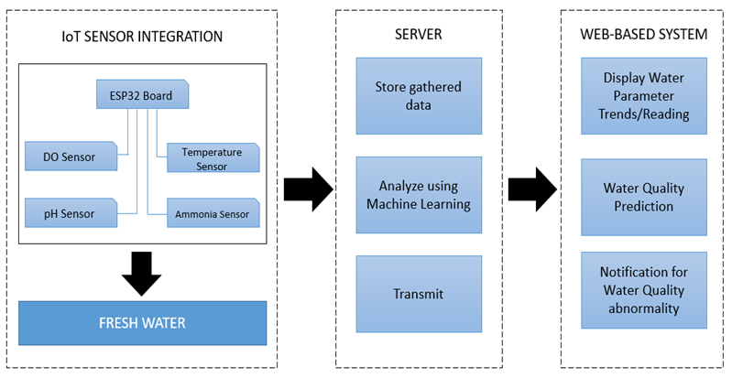

Figure 2. Conceptual Framework

CHAPTER 3

METHODOLOGY
This chapter discuss all the procedures used in this study. It presents the software, hardware, data collection, and project instrument.
Project Locale
The Iot Based Real-Time Smart Monitoring Freshwater Quality Analysis of Recirculating Aquaculture System Utilizing Machine Learning was conducted in the College of Fisheries (COF) department at the Laguna State Polytechnic University Los Banos Campus. The study aimed to improve the efficiency of monitoring freshwater quality in aquaculture systems by integrating IoT technology. To ensure a comprehensive understanding of the research problem, several target groups were identified based on their expertise and involvement in the field. The first group consisted of (20) ornamental fish breeders were included as they bring practical, hands-on experience in fish breeding and water quality management. Their role is essential in providing insights into the everyday challenges faced in aquaculture, particularly in maintaining optimal water conditions for fish health and growth. Their feedback helps refine the IoT monitoring system to ensure it effectively addresses real-world concerns in aquaculture management. Another key group included (10) ten faculty members from the College of Fisheries who played a key role in bridging academic research with practical applications. Their expertise in fisheries science and aquaculture provided valuable input in refining the methodologies used in the study. They contributed to ensuring the accuracy, reliability, and scientific validity of the IoT monitoring system. Finally, (5) five IT specialists were involved to address the technological aspects of the project. Their contributions were vital in designing and implementing IoT-based solutions for real-time monitoring of water parameters, making the system both efficient and user-friendly.
Table 2 presents the population of the study, categorizing participants into different target groups, each playing a crucial role in the development of an IoT-based real-time smart monitoring system for freshwater quality analysis in a recirculating aquaculture system (RAS). A total of 35 participants were involved, representing diverse expertise to ensure a well-rounded and comprehensive study. Through collaboration with the target groups, this project strives to gather valuable insights, ensure practical relevance, and promote sustainable practices. By combining the expertise of these groups, the study effectively developed a reliable and sustainable IoT-based monitoring system, addressing both technological and practical aspects of water quality management in RAS.
Table 2. Population of the Study
Target Group | Sample Population Size
Ornamental Fish Breeders  COF Faculty  IT Specialist  Total | 20  10  5  35

Project Design
System Architecture
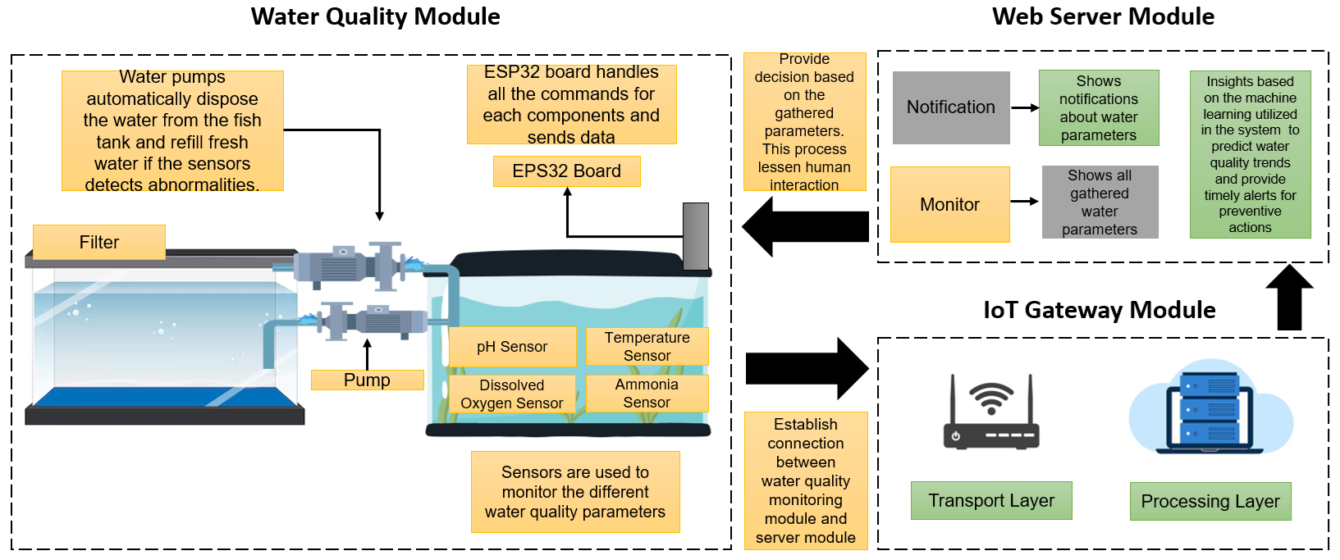
Figure 3 provides a detailed and easy-to-understand depiction of the operational workflow of the water quality monitoring system. This intelligent system is equipped with a variety of specialized sensors that are strategically positioned within the aquatic tank to monitor essential freshwater quality parameters, including pH levels, temperature, turbidity, and dissolved oxygen. These sensors function continuously, collecting real-time environmental data that is then transmitted wirelessly through Internet of Things (IoT) technology. The transmitted data is sent to a web-based server, where it undergoes processing and analysis using advanced machine learning algorithms. These algorithms are specifically trained to detect patterns, identify irregularities, and flag early indicators of potential water quality issues, such as contamination or pollution. The system’s ability to deliver timely alerts and actionable insights enables proactive responses, preventing harm to aquatic life. By integrating sensor networks, IoT connectivity, and intelligent data analysis, the system ensures more efficient and sustainable management of freshwater in aquaculture environments.

Figure 3. System Architecture
Connection Diagram
The diagram illustrates the arrangement and interconnection of hardware elements within the device module. The sensor unit, comprising sensors for DO, pH, temperature and ammonia. Additionally, there is the inclusion of the ESP32 board, responsible for executing programs and commands related to freshwater quality monitoring.
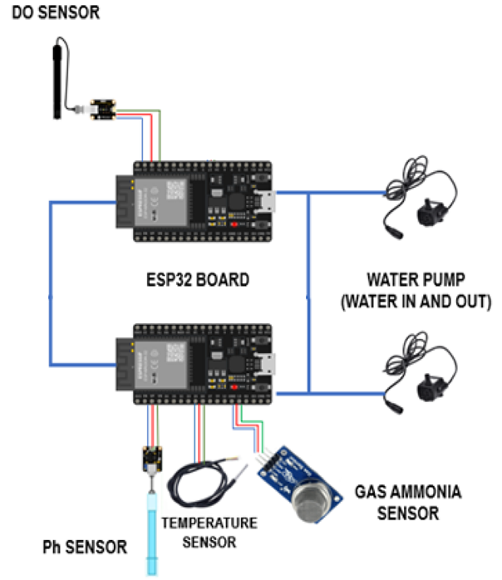

Figure 4. Connection Diagram of Hardware Elements
Project Development
The system begins with sensors collecting data on freshwater quality parameters. These sensors act as the eyes of the system, continuously monitoring the freshwater. Once the data is collected, it transmitted to a server using IoT technology, ensuring real-time data transfer and connectivity. The next step involves displaying the collected water quality parameters in a web-based system. This web interface makes it easy for users to monitor the data in an accessible and user-friendly format. If any abnormalities in freshwater quality be detected, the system take immediate action by automating water disposal and refilling processes. This ensures the maintenance of freshwater conditions without manual intervention. If no issues are found, the system allows users to view predictions about freshwater quality, a machine learning model to analyze trends and provide actionable insights. This predictive capability enhances decision-making and supports proactive freshwater management. The system also includes an alert feature, notifying users of irregularities and ensuring timely action.
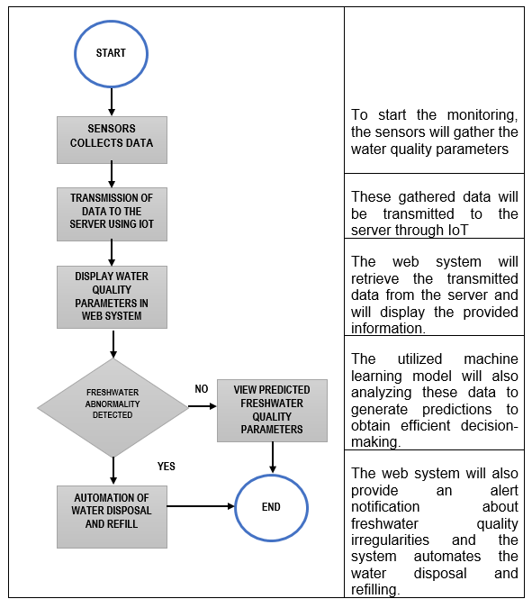

Figure 5. System Flow Chart

Project Block Diagram
Figure 6 shows the principal modules of the project which are represented by blocks and arrows to show the relationship of each module. The device module, where the sensors and board are included are capable of gathering and transmitting freshwater quality parameters. The web system module retrieves and shows the data gathered by the sensors and also notifies for freshwater irregularities. It also provides freshwater quality prediction to give insights to the user.
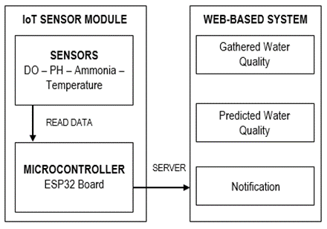

Figure 6. Block Diagram

Model Development
Model development as shown in figure 7 shows a series of steps to build, train, validate, and update a machine learning (ML) or artificial intelligence (AI) model for the purpose of drawing predictions, conclusions and custom solutions based on data. It encompasses introducing in the field for understanding the problem domain, collecting and processing data, selecting the appropriate algorithm, training the model, validating the performance and refining it until the required accuracy and reliability is met.
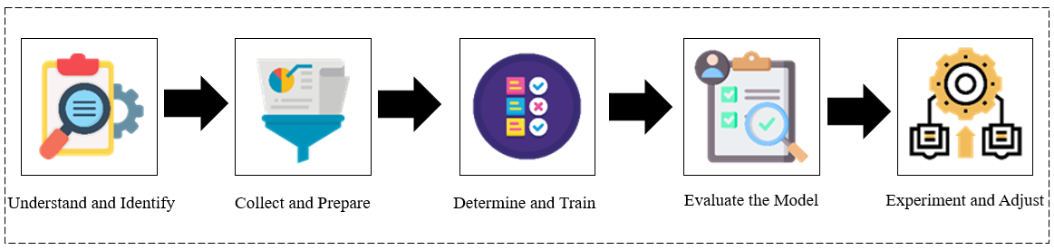

Figure 7. Model Development

1. Understand and Identify Data
A machine learning model is built by learning from training data and then using this learning to make predictions on unseen data. Thus, characterizing data need such as amount, quality and type is crucial for the effectiveness and accuracy of the model. The machine leaning process depends on the full consideration for the properties, and in particular the data specification, being used for training and prediction.
2. Collect and Prepare Data
This project collects data from the sensor for modeling. The necessary data then prepare for model training, which involved collecting, cleansing, aggregating, labeling, and transforming the data. Although this preparation phase will take up 75-80% of the project's timeline, the time invested worthwhile as it greatly enhances the effectiveness of the resulting model.
3. Determine the Model’s Features and Train the Model
Figure 8 shows the phases involved in selecting appropriate modeling techniques, such as fine-tuning parameters, validating the model, and optimizing it for improved performance. It also includes the critical training, development, and testing steps to ensure the model's effectiveness across various scenarios. The careful selection of algorithm and optimization strategies is integral to achieving the desired outcomes in this phase of the machine learning workflow.
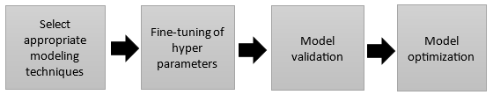

Figure 8. Selection of Algorithm
4. Evaluate model performance
Model evaluation serves as the quality assessment of machine learning. Thoroughly assessing the model's performance based on metrics aligned with the specific requirements is essential for gauging its real-world efficacy. This evaluation encompasses the assessment of model metrics (MASE, RMSSE, MAE, RMSE, and MAPE), measurements of model quality, and the ultimate determination of whether the model aligns with the established business objectives.
5. Experiment and adjust the model in operation
To ensure the practical effectiveness and reliability of the model in real-world scenarios, it was tested across a variety of environmental settings with differing conditions. The project employed statistical significance testing methods, such as the T-test, to assess whether the observed differences in model performance between these deployment environments were meaningful and not due to random variation. This rigorous evaluation process helps determine the model’s adaptability, stability, and overall robustness, providing valuable insights.
$$t=\frac{m-μ}{s∕\sqrt{n}}$$
t = Student's t-test
m = mean
$μ$ = theoretical value
s = standard deviation
n = variable set size

Bayesian Approach
A Bayesian approach is particularly effective for water quality prediction due to its ability to incorporate prior knowledge, manage uncertainty, and optimize model parameters through probabilistic reasoning (Brochu et al., 2010; Gelman et al., 2013; Dinev et al., 2021). This methodology centers around thoughtful approach to predicting water quality using machine learning, combining data processing, modeling, and uncertainty management to produce reliable results. A core component of this system is the Bayesian approach, which stands out for its ability to incorporate historical data into ongoing predictions. Rather than treating new data points as isolated events,
Bayesian modeling continuously updates its predictions using prior information essentially learning as it goes. These prior beliefs, often modeled as normal distributions based on past trends, help the model make more informed and balanced predictions. The strengths of this methodology is to handle uncertainty. Instead of giving a single outcome, it provides a confidence interval, typically between 5% and 12%, which reflects the likely range of values and helps prevent overconfidence. When data is limited, the system increases the uncertainty margin to reflect potential variability, making the predictions more cautious and realistic. It also applies physical constraints for example, keeping predicted pH values within the scientifically valid range of 0 to 14 ensuring the results remain plausible. The process begins with collecting raw water quality data, including attributes like pH, dissolved oxygen, temperature, and ammonia. Since this raw data often varies in scale and may contain outliers, it undergoes Min-Max Normalization, which rescales features to a range between 0 and 1. This normalization step prevents any one parameter from disproportionately influencing the model, helping the learning process remain stable and effective. Next, the data is split into training (80%) and testing (20%) sets. The training set helps the model learn patterns, while the testing set evaluates its ability to generalize to unseen data. To further enhance model accuracy, parameter tuning is performed this is where the Bayesian technique plays a vital role. Unlike traditional trial-and-error methods, Bayesian intelligently navigates the parameter space, using probabilistic models to find the most effective settings. It continuously refines its search based on how well previous configurations performed, aiming to strike the right balance between model complexity and accuracy.
The Bayesian optimization process iteratively adjusts parameters, guided by an objective function such as validation accuracy or loss until it meets a stopping point, whether due to reaching a performance threshold or completing a set number of iterations. Once the optimal parameters are found, it applied to the final model, which is then evaluated using the test data to assess real-world applicability. This makes it particularly suitable for sensitive applications like water quality prediction, where informed and cautious decision-making is essential. The performance of the model is then evaluated using multiple evaluation metrics. In this case, the diagram highlights six specific metrics:
MASE (Mean Absolute Scaled Error): A scaled version of MAE, helping to understand how well the model performs relative to a naive prediction.
RMSSE (Root Mean Squared Scaled Error): Similar to MASE, but penalizes larger errors more heavily.
MAE (Mean Absolute Error): Measures the average magnitude of errors without considering their direction.
RMSE (Root Mean Squared Error): Similar to MAE but gives more weight to larger errors.
MAPE (Mean Absolute Percentage Error): Expresses prediction errors as a percentage, which can be easier to interpret.
R² (Coefficient of Determination): Measures how well the model's predictions match the actual data, with values closer to 1 indicating better performance.
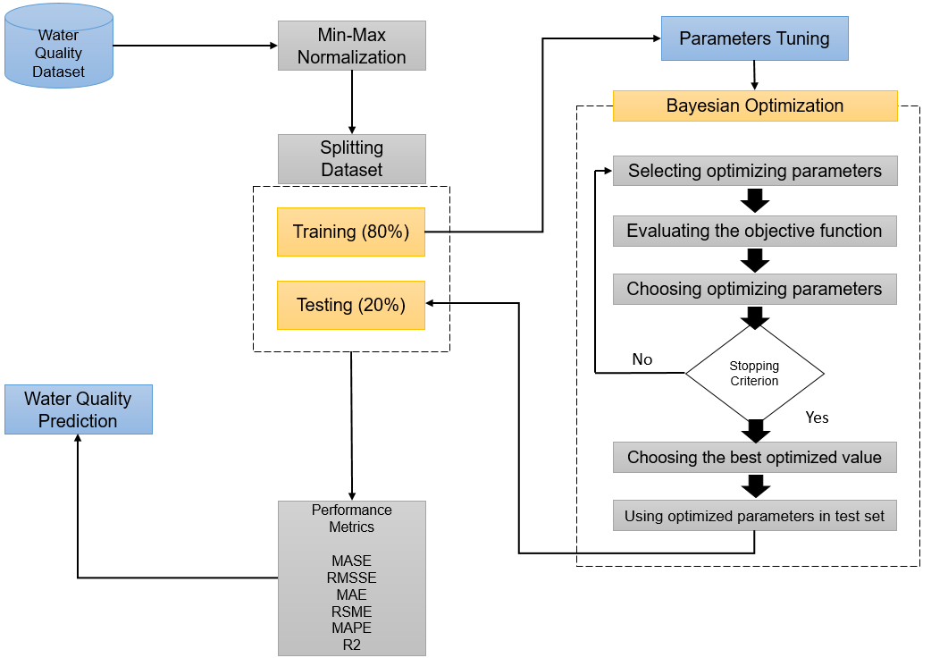
Once the model’s performance has been evaluated, the final step is water quality prediction.

Figure 9. Model for predicting freshwater quality
Prediction Computation Process
1. Historical Data Analysis
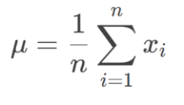
For each parameter (temp/DO/pH/ammonia), the researcher compute:
Mean (Central Tendency):
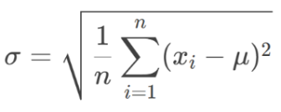
Where xixi​ = historical measurements, nn = sample size
Variability (Standard Deviation):
2. Bayesian Prediction
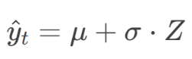
Future values are drawn from a normal distribution combining historical patterns with uncertainty:
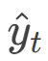
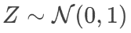
Where:
(Standard normal random variable)
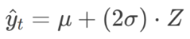
For small datasets (n < 24):
3. Physical Boundary Enforcement
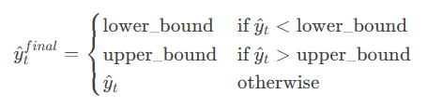
Uncertainty bounds scale with predicted values:

4. Physical Constraints
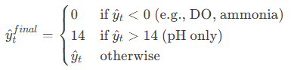
Predictions are forced within realistic ranges:

Bayesian Network Structure for Water Quality
Step 1. Define Variables (Nodes)
The first step is identifying the key water quality parameters that will form the building blocks of the Bayesian Network. In this project, it focused on five essential variables. These parameters are interconnected in real freshwater systems, and the BN allows to model their cause-effect relationships under uncertainty.
Table 3. Variables (Nodes)
Variable | Type | Interpretation
Temperature  pH  Dissolved Oxygen (DO)  Ammonia  Water Quality (Target Variable) | Continuous /  Discrete  Continuous /  Discrete  Continuous /  Discrete  Continuous /  Discrete  Discrete (e.g., Good, Moderate, Poor) | Influences dissolved oxygen levels and fish metabolism. Higher temps = lower oxygen solubility.  Affects chemical balances in water, especially ammonia toxicity. Extremes are harmful to aquatic life.  A direct indicator of livable conditions for aquatic organisms. Low DO is dangerous.  Toxic even at low concentrations. A byproduct of fish waste and uneaten feed.  Represents the overall assessment of water health.

Step 2. Define Network Structure (DAG)
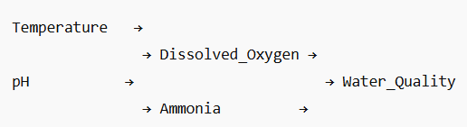
After the variables are defined, the next step is to understand how they influence one another. This is visualized in a Directed Acyclic Graph (DAG) a key feature of any Bayesian Network.

Figure 10. Simplified Network Structure
Interpretation:
Temperature and pH both impacts DO and Ammonia. For instance, high temperature lowers oxygen solubility, and extreme pH values make ammonia more toxic. Dissolved Oxygen and Ammonia have a direct influence on the overall water quality since they are crucial for fish health and system stability. Temperature and pH can also have indirect effects on water quality, either via DO and Ammonia, or in more complex systems, as direct contributors to stress or imbalance.
Step 3. Define Conditional Probability Tables (CPTs)
Each node is assigned a Conditional Probability Table (CPT) that quantifies how likely a particular state is, given its parent nodes. These probability values can be estimated using various approaches. One common method is to derive them from historical water quality datasets and these values can also be guided by regulatory standards, such as the DENR Administrative Order No. 2016-08, which provides threshold values and acceptable ranges for water quality parameters in aquaculture settings. Since each variable has two states, the total number of combinations is: 2⁴=16 combinations
Table 4. Conditional Probability Table (CPT)
Temperature | pH | DO | Ammonia | P(Good) | P(Moderate) | P(Poor)
Low  Low  Low  Low  Low  Low  Low  Low  High  High  High  High  High  High  High  High | Low  Low  Low  Low  High  High  High  High  Low  Low  Low  Low  High  High  High  High | High  High  Low  Low  High  High  Low  Low  High  High  Low  Low  High  High  Low  Low | Low  High  Low  High  Low  High  Low  High  Low  High  Low  High  Low  High  Low  High | 0.95  0.60  0.40  0.10  0.85  0.50  0.35  0.10  0.80  0.40  0.30  0.05  0.75  0.30  0.25  0.05 | 0.05  0.30  0.40  0.30  0.10  0.30  0.45  0.25  0.15  0.35  0.40  0.25  0.20  0.40  0.35  0.1 | 0.00  0. 10  0.20  0.60  0.05  0.20  0.20  0.65  0.05  0.25  0.30  0.70  0.05  0.30  0.40  0.80

Interpretation:
Best case: Low temperature, balanced pH, high DO, low ammonia is equal to very high chance of Good water quality.
Worst case: High temperature, high pH, low DO, high ammonia is equal to very high chance of Poor water quality.
Moderate cases show mixed probabilities, depending on the severity of risk parameters.
This CPT provides a quantitative foundation for probabilistic inference using a Bayesian Network.
Step 4. Discretization
The water quality parameters need to be grouped into categorical ranges to be effectively used in a Bayesian Network. This process is known as discretization. The dissolved oxygen (DO) levels can be classified as Low if less than 4 mg/L, Normal between 4 to 7 mg/L, and High if greater than 8 mg/L.
Ammonia levels are typically categorized as Low when below 0.02 mg/L and High when equal to or above 0.02 mg/L. Temperature may be classified as Low if under 20°C, Normal between 20–28°C, and High above 28°C. Similarly, pH values can be categorized as Acidic when below 6.5, Neutral from 6.5 to 8.5, and Alkaline when greater than 8.5. These classification ranges can be adjusted based on species-specific requirements (such as those for molly fish) and the prevailing environmental conditions in the aquaculture system.
Step 5. Inference
Given input from sensors (current temperature, pH, DO, and ammonia levels), the network can infer the most probable water quality state in real-time.
Bayesian Theorem in WQI Estimation
Instead of computing a numeric WQI score like WAWQI, Bayes' Theorem can be used to compute the probability that water quality belongs to a particular category (Good, Moderate, or Poor), based on observed water parameters.
Using Bayes' Theorem:
Where:
P (Good) is the prior probability of good water quality (from historical data)
P (observations / Good) is the likelihood (from conditional probability tables)
P (observations) is the sum of all class-weighted likelihoods
This gives a posterior probability that the water quality is Good based on the current measurements.
Software Development
The phase of software development for the freshwater quality monitoring system encompassed activities such as designing, creating, testing, and maintaining the system. The evolutionary prototyping model were employed as the guiding framework for the development process. The evolutionary prototyping model involves iterative cycles of prototyping and refinement, allowing for continuous improvement and adaptation based on feedback and evolving requirements. This iterative approach facilitates a more dynamic and flexible development process, ensuring that the freshwater quality monitoring system can be fine-tuned and optimized as it progresses through various stages of prototyping.
Software Specifications
This section outlines the software specifications required for the successful development and implementation of the system. It details the essential tools, platforms, programming languages, and frameworks that support system functionality, user interaction, data processing, and overall performance. These specifications ensure that the system is developed efficiently, remains scalable, and meets the intended technical and user requirements.
Hypertext Markup Language
Hypertext Markup Language (HTML) is the fundamental language used to structure and organize webpage content. It enables the developer to easily combine text, graphics, and other necessary elements into a webpage. HTML, an important tool in web development, provides a standardized syntax for defining the structure of webpages, allowing the project to specify the layout and arrangement of content. This guarantees that users receive a clear, coherent, and visually interesting presentation.
CSS
Cascading Style Sheets (CSS) are vital in web development because they allow developer to apply layout, design, and visual improvements to HTML elements. Its main purpose is to adjust the display of the user interface, hence improving the aesthetics and visual looks of websites. CSS allows developer to modify the stylistic properties of various HTML elements, such as fonts, colors, spacing, and placement, giving them more control over the overall design and appearance of the website.
JavaScript
JavaScript is used to develop dynamic content and animated designs that enhance interactivity in web development. This project leverages various JavaScript libraries and frameworks to incorporate animations, transitions, and visual effects, resulting in a more immersive and user-friendly browsing experience. These features contribute to the creation of responsive and interactive web pages, significantly improving user engagement, accessibility, and overall usability across different devices and platforms.
Visual Studio
Visual Studio is recognized as the best Integrated Development Environment (IDE) for web development, so it is the ideal platform for developing an intelligent water quality monitoring web system. It supports a wide range of programming languages and frameworks often used in web development, ensuring compatibility and flexibility when implementing various components of the intelligent water quality monitoring system.
Arduino IDE
The Arduino IDE is a user-friendly platform widely used for programming microcontrollers. While it’s often paired with Arduino boards, this project opted for the ESP32 due to its built-in Wi-Fi, which makes it ideal for IoT applications like remote water quality monitoring. The best part is that the ESP32 remains fully compatible with the Arduino IDE, it simply needs to install the ESP32 Board Support Package. This allows the developer to enjoy the ease and familiarity of the Arduino environment while leveraging the advanced features of the ESP32, combining accessibility with powerful connectivity in one efficient setup.
Hardware Specification
Table 5 details the key hardware components integrated into the freshwater quality monitoring device, each thoughtfully selected for their ability to provide accurate, consistent, and reliable environmental readings crucial for effective aquaculture management.
Table 5. Device Module
Hardware | Specification | Description
ESP32 Board  Dissolve Oxygen Probe  DS18B20 Temperature Sensor  PH-4502C Liquid PH Sensor with E201-BNC Electrode  MQ137 Ammonia Detection NH3 Gas Sensor | Working voltage: 4.75-5.25v  Storage: 520KB internal + 8MB PSRAM External  Wi-Fi: 802.11b/g/n/e/i  Detection Range: 0-20mg/L  Response Time: Up to 98% complete response within 90 seconds  Usable temperature range: -55 to 80°C  Power requirements: 3v to 5.5v  Power requirements: 5v  Response Time: 5 seconds  Detection Range: 0 ̴14 (acid / base)  Temperature Range: 0 – 80°C  Gas Sensitivity: Ammonia (NH3) Carbon Monoxide (CO)  Concentration Range: 0 – 1000ppm | A microcontroller board that facilitates IoT connectivity with Wi-Fi capabilities and sufficient storage for data.  Measures dissolved oxygen in water to assess the quality of aquatic environments.  Monitors temperature in freshwater environments, providing data critical for aquatic life health.  Monitors pH levels in water, ensuring that the aquatic environment remains within an optimal range.  Detects ammonia and other harmful gases, ensuring that water quality remains safe for aquatic life.

The project used the ESP32 board, operating within a 4.75–5.25-volt range. It provides stable wireless connectivity and ample memory, enabling efficient data processing and communication between sensors and the monitoring platform. For dissolved oxygen measurement, the device features a responsive probe capable of delivering accurate readings within 90 seconds, covering a range of 0–20 mg/L. Temperature monitoring is handled by the DS18B20 sensor, which accurately tracks conditions from -55°C to 80°C—critical for understanding how thermal changes affect aquatic environments. pH levels are monitored using the PH-4502C sensor, known for its speed and precision, offering results from 0 to 14 in about five seconds. The MQ137 sensor detects harmful gases like ammonia, providing early alerts for potential hazards. These components ensure robust and real-time freshwater quality monitoring.
Prototyping Model
Figure 11 illustrates the software prototyping model used throughout the project development process. This approach begins with gathering and defining key features, functionalities, and constraints to ensure project success. Once requirements are established, the design and prototyping phase follows, creating visual and functional models that outline the system’s structure, user interface, and overall functionality. These prototypes help stakeholders visualize the final product early in development. The next steps involve actual development and rigorous testing to ensure the system meets specifications and to identify and resolve issues. After successful testing, user approval is sought from stakeholders such as ornamental fish breeders and technology experts. This model supports the creation of high-quality software by allowing iterative improvements, aligning the product with user needs, and maintaining flexibility to adapt to changing expectations and industry standards.
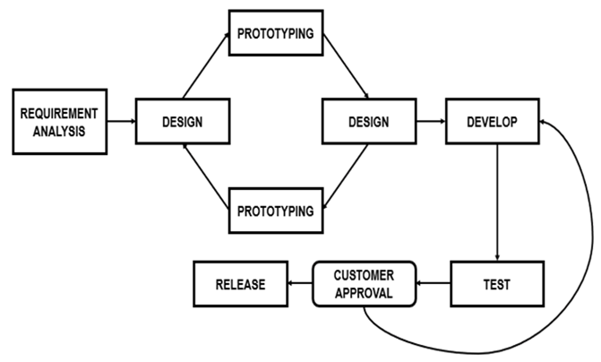

Figure 11. Prototyping Model of Freshwater Quality Monitoring System
Project Testing and Debugging
Unit Testing
The project underwent unit testing to guarantee its reliability and functionality. This testing encompasses evaluating the web-based system's communication with sensors, ensuring accurate data reception by the system. The testing involves examining user interface components to confirm that each unit contributes to a seamless and user-friendly experience for the end-users. A variety of test cases and scenarios were developed to validate the behavior of individual units under different conditions. This included positive test cases to verify expected functionality, negative test cases to assess error handling and edge cases, and boundary test cases to evaluate system limits and constraints.
Integration Testing
The testing covers the integration of the software with the hardware, ensuring the seamless collaboration of these components. This ensures that data is transmitted accurately and promptly. Testing various communication scenarios, such as intermittent connectivity or delays, help identify and address potential issues in the real-time exchange of information.
System Testing
This testing phase is designed to confirm the system's overall functionality, ensuring that all integrated components and features collectively align with the specified requirements. It involves a comprehensive assessment of the entire end-to-end functionality of the freshwater monitoring system. This encompasses validating every aspect, ranging from data collection by sensors to users' interactions with the interface, guaranteeing the seamless operation of the entire system as originally intended. It also includes evaluating response times, processing speeds, and the system's capacity to manage increased data loads or an expanding number of connected sensors.
Acceptance Testing
User acceptance testing requires the active involvement of end-users, including farmers and other stakeholders, who assess the system to ensure it satisfies their requirements. This phase involves testing the system based on the ISO 25010 Software Product Quality and collecting feedback to guarantee that it meets the practical needs of those utilizing it.

INTEGRATION
TESTING

UNIT TESTING
SYSTEM
TESTING
ACCEPTANCE
TESTING

Figure 12. Project Testing and Debugging
Sensor Calibration
Calibration is a critical process to ensure the accuracy and reliability of sensor measurements in any monitoring system. It generally involves several key steps: first, thoroughly cleaning the sensor probe to remove any contaminants that could affect readings; then submerging the sensor in a solution or environment with a known, standardized value; allowing sufficient time for the sensor to stabilize; and finally, adjusting the sensor’s output to align precisely with the known standard. Regular recalibration is especially important when sensors are exposed to changing environmental conditions.
pH Probe calibration
Calibration of the probe is crucial for accuracy and involves setting two or more known pH points, typically low, medium, and high values. The resulting slope of the pH probe enables precise determination of the pH of an actual sample falling within this calibrated range. The pH sensor undergoes a three-point calibration process, as recommended by (AtlasScientific, 2020) for optimal accuracy as shown in Figure 13. This method involves calibrating the pH probe at three different points. It's essential to perform this calibration before the initial test, and subsequent recalibration between tests is not mandatory, although advisable for consistent accuracy.
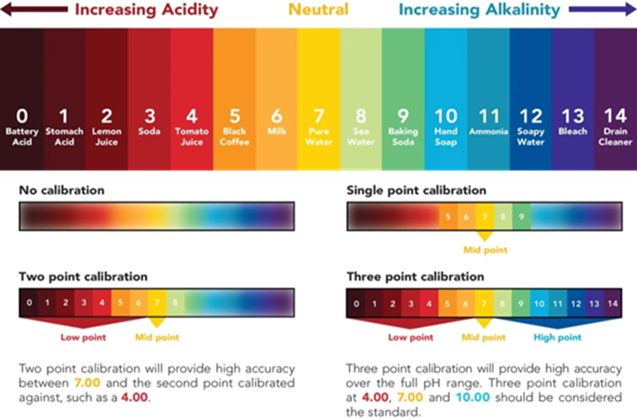

Figure 13. pH Level Calibration
Dissolve Oxygen Calibration
Dissolved oxygen (DO) measures oxygen levels in water, essential for aquatic organisms' respiration. Factors like temperature influence DO levels. To calibrate a DO meter, rinse the probe with distilled water, stabilize it in a zero-oxygen solution, and set the meter to zero. Then, immerse it in a high-oxygen solution, stabilize, and adjust to the known value.
Temperature Sensor Calibration
Calibrating the DS18B20 sensor ensures accurate temperature readings. Begin by setting up proper power and wiring. Use at least two reference temperature points within the target range, measure actual temperatures with a reliable thermometer, and compare them to the sensor's readings to calculate the offset (Offset = Actual Temperature - DS18B20 Reading). Document the process for reference, account for environmental factors, and recalibrate as needed to maintain measurement reliability.
Freshwater Requirements
Monitoring dissolved oxygen (DO), pH, temperature, and ammonia is vital in freshwater environments. DO supports aquatic respiration, while pH affects biological and chemical processes. Temperature influences metabolic rates, and ammonia, a toxic byproduct, signals pollution. Tracking these parameters ensures water quality, detects stressors, and guides management to maintain ecological balance. According to Chowdhury, G. W., Hasan, N. A., & Rahman, M. M. (2021), ensuring that temperature, pH, dissolved oxygen, ammonia, and other parameters remain within their respective optimal ranges will not only enhance the growth and reproduction of molly fish but also minimize disease outbreaks and mortality in aquaculture systems.
Table 6. Freshwater Parameter Required Levels

Parameters | Required Level
Dissolve Oxygen  pH  Temperature  Ammonia | Dissolved oxygen concentrations above 5-7.5 mg/L and between about 80-120 %  pH should be maintained between 6.5 and 8.5, with alkalinity between 10° and 20° dKH (180 ppm to 360 ppm)  Between 24°C to 28°C  Safe level is between 0.00 to 0.02 ppm

Target Water Parameter Settings
These parameter settings indicated in Table 7 are a controlled aquatic environment to be designed to support the health of molly fish. Maintaining these standards ensures that the freshwater quality remains within safe and optimal limits for the molly fish. Regular monitoring and adjustments are necessary to keep all parameters within the desired range to prevent any adverse effects on the freshwater quality.
Table 7. Standard Parameter Settings in Control Environment
Treatment | DO Level | pH Level | Temperature °C | Ammonia Level
Control | 5-7.5 mg/L | 6.5.0-8.5 | 24-28 | 0.00-0.02

Water Treatment
To achieve the standard parameters for freshwater, a water treatment process, as illustrated in Figure 14, were followed. Initially, the freshwater undergoes a six-layer filtration system to purify it and foster beneficial bacteria. Next, the freshwater treated with a conditioner that eliminates harmful chlorine, clarifies the freshwater, stabilizes the pH, and detoxifies heavy metals. Lastly, freshwater added/refill to attain the desired temperature and ammonia level for freshwater.
Filtration
Water
Conditioning
Freshwater
Mixing


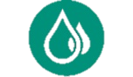

Figure 14. Water treatment method for freshwater requirements
Weighted Arithmetic Water Quality Index (WAWQI)
This set of values represents a specific implementation of the Weighted Arithmetic Water Quality Index (WAWQI) tailored for freshwater quality assessment against Class C guidelines, likely following the Department of Environment and Natural Resources (DENR) Administrative Order No. 2016-08 in the Philippines, ensuring regulatory relevance and accuracy.

Table 8. Parameters Based on DENR 2016-08, Class C
Parameter |  | Ideal Value (V₀) | DENR Limit (Sᵢ) | Units
Temperature (∆T) | 0 | 3 (∆T max) | °C
pH | 7.5 | 6.5–8.5 | —
Dissolved Oxygen (DO) | 5.0 | ≥5.0 | mg/L
BOD | 0 | 7.0 | mg/L
Total Suspended Solids (TSS) | 0 | 80.0 | mg/L
Nitrate (NO₃⁻) | 0 | 10.0 | mg/L
Phosphate (PO₄³⁻) | 0 | 0.5 | mg/L
Ammonia (NH₃) | 0 | 0.05 | mg/L
Total Coliform |  | 0 | 1,000 MPN/100mL | MPN/100mL

Table 9 provides a clear and practical interpretation of Water Quality Index (WQI) scores in the context of aquaculture. It categorizes water quality into four levels such as Excellent, Good, Fair, and Poor. Based on the WQI range, and explains what each level means for fish farming. A WQI of 85 to 100 is labeled as Excellent, which means the water is fully suitable for aquaculture. A WQI between 70 and 84 falls into the Good category. While it's not perfect, it is still considered safe for most fish species, and aquaculture activities can generally continue without concern. If the WQI drops to between 50 and 69, the water is rated as Fair. In this case, the quality might not be optimal, and intervention like filtration or treatment may be needed to ensure a healthy aquatic environment. A WQI below 50 is classified as Poor, signaling that the water quality is harmful to aquatic life.
Table 9. Interpretation (Based on Aquaculture Relevance)
WQI Range | Quality Category | Aquaculture Suitability
85 – 100 | Excellent | Fully suitable for aquaculture
70 – 84 | Good | Safe for most fish
50 – 69 | Fair | May require treatment/intervention
Below 50 | Poor | Harmful to aquatic life
Evaluation Matrix of Respondents
Purposive sampling was utilized to choose participants who possess distinct characteristics aligned with the study's objective. This method enable focus on individuals with expertise in freshwater farming, ornamental fish breeding, and technological proficiency. Through purposive sampling, this project strives to collect valuable perspectives from the respondents capable of making meaningful contributions to advancing and assessing the freshwater monitoring system.
Inclusion Criteria:
- Relevance to aquaculture: the participants should have experience with the freshwater farming practices especially in ornamental fishes.
- Technical Proficiency: these are the individuals with a certain technical knowledge or familiarize with the technology being utilized to ensure effective implementation.
Exclusion Criteria:
- Lack of freshwater farming experience: these are individuals who not have enough experience or knowledge about freshwater farming for molly fish or ornamental fish.
- No Technical Knowledge: these are the individuals with limited technical knowledge, they are excluded to maintain the level of expertise in the sample group.
Project Instrument
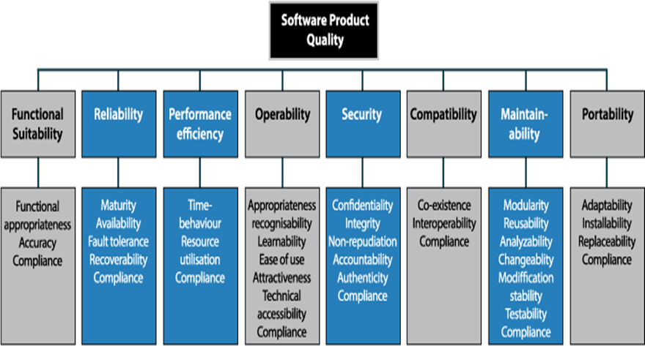
To ensure the freshwater quality monitoring system was both practical and effective, this project carried out a user testing phase with 30 participants from Los Baños, Laguna. The group included 20 ornamental fish breeders, 10 faculty members from the College of Fisheries offering academic and technical insight; and 5 IT specialists, who could evaluate the system’s technical robustness. To evaluate the system’s quality, the ISO 25010 product quality model was used as the guiding framework. This standard outline key attributes that define a reliable and high-performing software product. The monitoring system was assessed across eight critical characteristics: Functional Suitability, Performance Efficiency, Compatibility, Usability, Reliability, Security, Maintainability, and Portability. This approach helped ensure the system could effectively serve its intended purpose in monitoring and managing freshwater quality.

Figure 15. ISO 25010 Model
Statistical Analysis of Data
The frequency of each response was determined by the number of respondents that answered the particular item.
% = $\frac{f}{n}$ x 100
Where
f = frequency
N = Total number of Respondents
This project used the Likert Scalar method to evaluate and analyze the gather data.
For TAM:
x = (SA*4) + (A*3) + (D*2) + (SD*1)
N
Where
x = Mean
N = Total Number of Respondents
SA = Strongly Agree
A = Agree
D = Disagree
SD = Strongly Disagree

Table 10. Evaluation Degree, Range and Description for TAM
Degree | Range | Description
4  3  2  1 | 3.26 – 4.00  2.51 – 3.25  1.76 – 2.50  1.00 – 1.75 | Strongly Agree  Agree  Disagree  Strongly Disagree
For ISO 25010:
x = (E*5) + (G*4) + (F*3) + (NI*2) + (P*1)
N

Where:
x = Mean
N = Total Number of Respondents
E = Excellent
G = Good
F = Fair
NI = Needs Improvement
P = Poor
Table 11. 5-Point Likert Scale to evaluate system quality using ISO 25010
Degree | Range | Description
5  4  3  2  1 | 4.21 – 5.00  3.81 – 4.20  2.61 – 3.80  1.81 – 2.60  1.00 – 1.80 | Excellent  Good  Fair  Needs Improvement  Poor

Cronbach’s Alpha
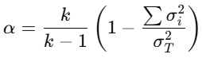
To manually compute Cronbach’s Alpha in Excel for each construct in the Technology Acceptance Model (TAM), you start by calculating the total score for each respondent. Next, calculate the variance of each individual item, as well as the variance of the total score for that construct. Once these values are acquired, apply the Cronbach’s Alpha formula:
Where:
= number of items
= variance of each item
= variance of the total scores
Ethical Consideration
Developing a freshwater quality monitoring system requires a great feeling of responsibility and attention in approach. This effort is for the well-being of the molly fish and other ornamental species in the freshwater tank. Every step should be taken to minimize potential harm and ensure their humane treatment while carefully assessing any environmental impacts. If human participants are involved, ethical practices become even more vital. This includes obtaining informed consent, where participants are clearly informed about the project’s purpose, how it works, and any potential risks or benefits involved. Protecting data privacy and ensuring robust security measures for any collected information is non-negotiable. It’s important to engage with the local community and other stakeholders. Listening to their insights and addressing their concerns fosters trust and ensures the project aligns with their needs. Transparency in communication, strict adherence to ethical guidelines, and compliance with relevant regulations are all essential. Exploring ways to share the benefits of the technology with the community can also help create a sense of shared purpose and mutual respect. Regular ethical reviews and consultations with experts will help keep the project on track, ensuring it remains aligned with ethical standards and avoids unintended harm.

CHAPTER 4

RESULT AND DISCUSSION
This chapter presents the results and the discussion to support the methodology utilized in the achievement of the objectives.
Results by Objectives of the Study
Sensors for measuring temperature, pH, dissolved oxygen, and ammonia.
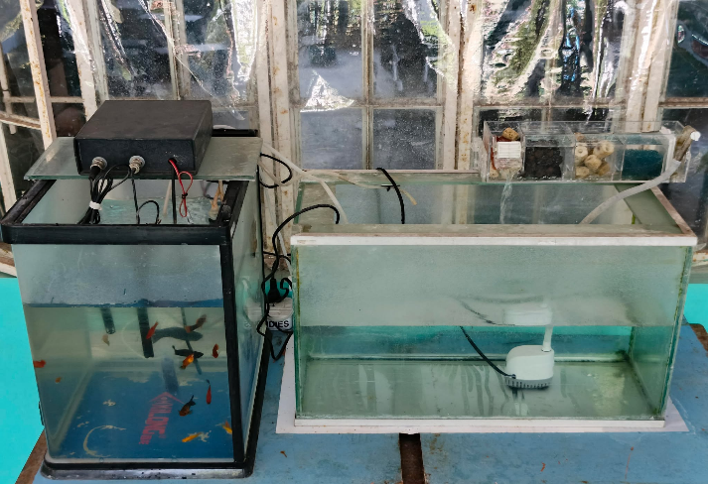
Figure 16 showcases the sensor setup used for data collection in the study. The system is composed of two 40-liter tanks, (a) one serving as the fish tank and the other as a reservoir. These tanks provide a controlled environment where the water quality parameters are continuously monitored. To ensure accurate data collection, four essential sensors are integrated into the system: a temperature sensor, a pH sensor, a dissolved oxygen (DO) sensor, and an ammonia sensor as illustrated in (b). Each of these sensors plays a crucial role in assessing the water quality and maintaining optimal conditions for aquatic life. The internal connection of the IoT-based sensor system is illustrated in detail (c). It consists of a pH signal conversion board and a dissolved oxygen conversion board, which process the raw signals from the respective sensors. Additionally, an ESP32 microcontroller is used to manage and transmit the collected data. The system also includes connectors for the ammonia and temperature sensors, along with relay modules that control various components, ensuring seamless communication between the sensors and the central monitoring system. This designed setup not only facilitates real-time monitoring of freshwater parameters but also ensures the reliability and accuracy of the gathered data. The system allows for timely intervention and decision-making to maintain a healthy aquatic environment, making it highly suitable for aquaculture applications.

(a)
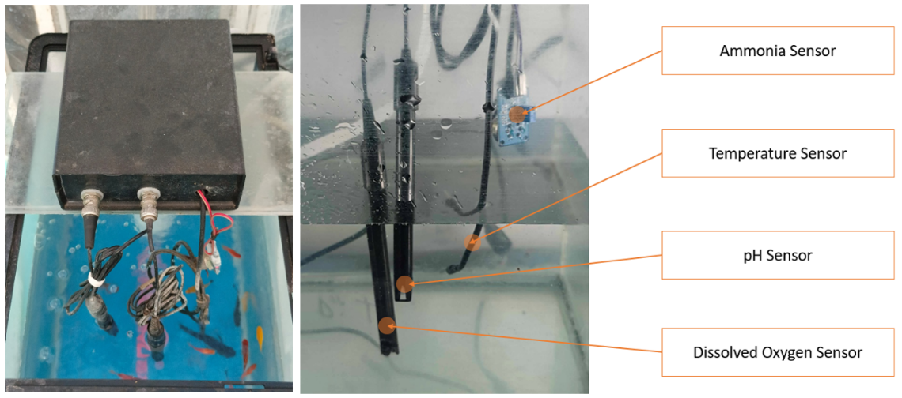

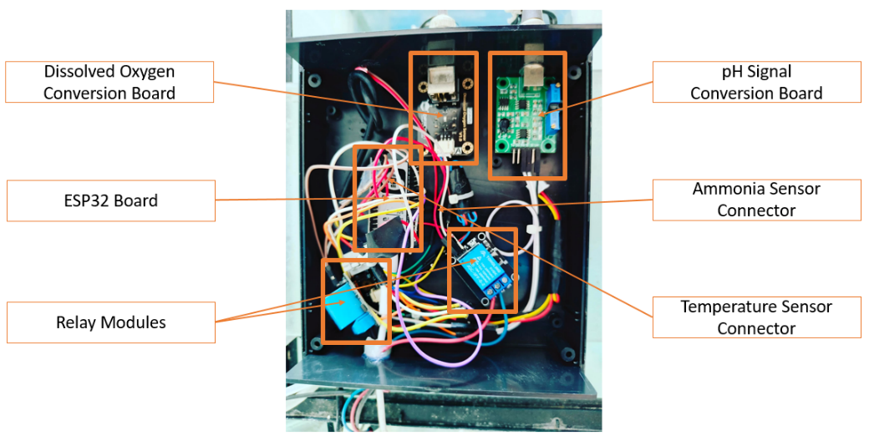
(b)

(c)

Figures 16. IoT-based sensors setup of the project (a) deployed sensor in
aquarium (b) hardware devices (c)internal connection of electronic devices
Figure 17 shows the user interface of the web-based system to monitor sensor readings in the aquatic tank, with a primary focus on maintaining freshwater quality. The interface effectively presents trends in various freshwater quality parameters over time, offering valuable insights that help users make informed decisions regarding aquatic tank management.
The freshwater parameter readings are displayed, filtered by the hour. This feature allows users to monitor real-time changes in freshwater quality and assess short-term trends, enabling them to respond promptly to any deviations from optimal conditions. By analyzing hourly data, users can take proactive measures to ensure a healthy aquatic environment.
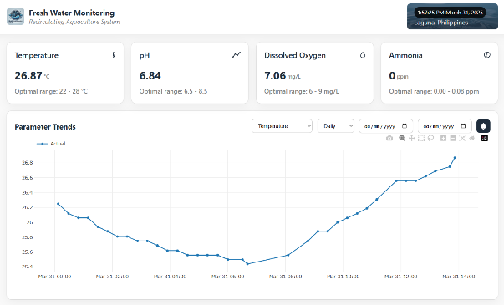
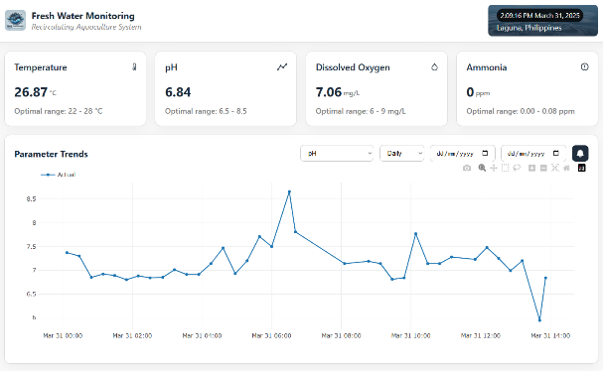

(b)
(a)
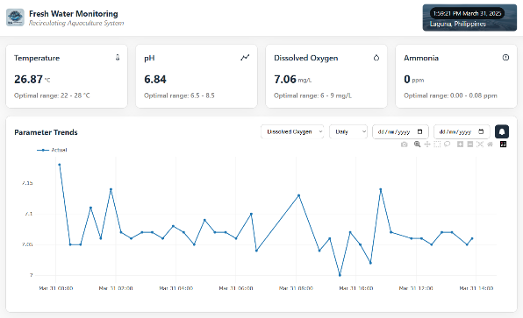
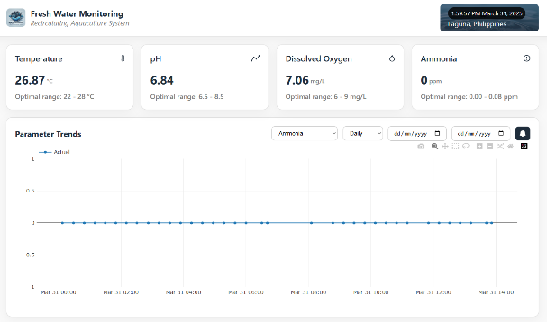

(d)
(c)
Figures 17. User interface of the web-based system to monitor sensor readings filtered by hour (a) temperature (b) pH (c) dissolved oxygen (d) ammonia
Figure 18 presents the data filtered by day, allowing for easy categorization of sensors readings based on both daily and hourly intervals. This functionality enhances the system’s capability to conduct a more comprehensive analysis of fluctuations in freshwater quality over time. By identifying patterns and detecting abnormalities, users can make data-driven decisions and implement corrective actions as needed.
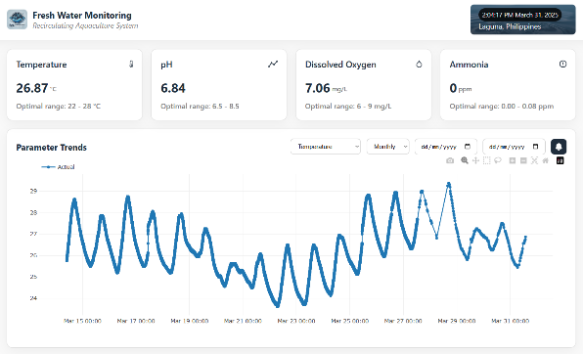
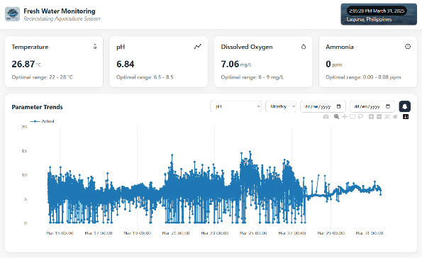
The design of the interface ensures that even users with minimal technical expertise can easily navigate the system and interpret the data. Overall, this web-based monitoring system empowers users to maintain a stable and healthy aquatic environment by providing timely and accurate information on freshwater conditions.

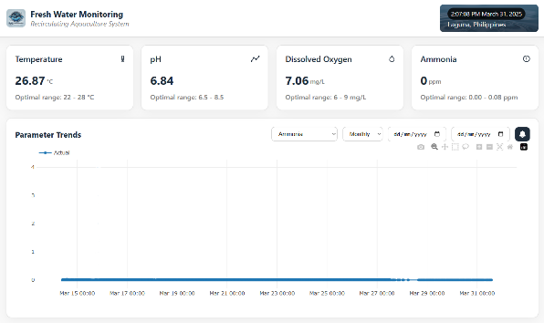
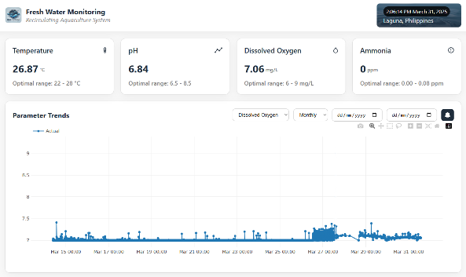
- (b)

(c) (d)
Figures 18. User interface of the web-based system to monitor sensor readings filtered by day (a) temperature (b) pH (c) dissolved oxygen (d) ammonia
Figure 19 illustrates the notification system designed for real-time monitoring and analysis of freshwater conditions in a recirculating aquaculture system (RAS). This system’s function plays a critical role in alerting users to potential issues by identifying deviations from safe water quality thresholds. The interface includes an ‘Out of Range’ section that logs notifications when parameters such as temperature and pH exceed acceptable limits. Users can close this section and return to the previous screen by selecting the button highlighted in (1). To simplify notification management, the system offers a ‘Delete All’ button, shown in (2), which allows users to clear the entire notification history with a single action.
This feature ensures that users can maintain a clutter-free notification log when needed. For more precise management, individual notifications can be deleted without affecting others. The notification details are displayed in the area indicated by (3), allowing users to review specific alerts before taking action. If a user wishes to remove a particular notification, they can do so using the trash icon highlighted in (4), which deletes only the selected notification while preserving the rest.
This notification system enhances the user’s ability to monitor and respond to changes in freshwater conditions promptly. By providing clear and actionable alerts, the system empowers users to maintain optimal water quality and ensure the well-being of aquatic life.
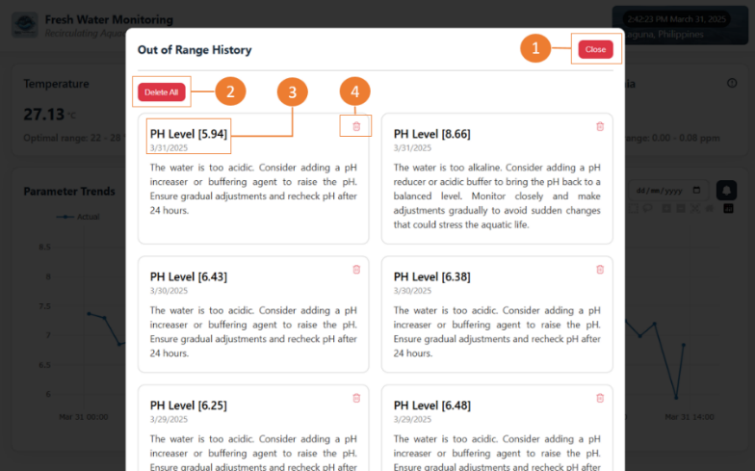

Figure 19. Notifications for freshwater abnormality

Comparison of machine learning models.
Table 12 presents a comparison of model performance among three forecasting methods: Bayesian, Random Forest, and Naive Forecaster. It evaluates them using six different metrics: Mean Absolute Scaled Error (MASE), Root Mean Squared Scaled Error (RMSSE), Mean Absolute Error (MAE), Root Mean Squared Error (RSME), Mean Absolute Percentage Error (MAPE), and the coefficient of determination (R²). The Bayesian model demonstrates the strongest overall performance. It has the lowest scores in all error-based metrics: MASE (0.5005), RMSSE (0.5263), MAE (0.0371), RSME (0.0509), and MAPE (40.72%). These indicate that its forecasts are generally more accurate and stable. It has a relatively modest R² value of 0.6231. The Random Forest model performs worse in accuracy metrics, showing higher values for MASE, RMSSE, MAE, RMSE, and MAPE. This indicates that, despite capturing more underlying patterns in the data, its predictions lack the precision and consistency needed for accurate forecasting. The Naive Forecaster performs the worst across all categories. It has the highest errors and even a negative R² (-0.2100), indicating its predictions are worse than simply using the mean.
Table 12. Model Performance Comparison
 | MASE | RMSSE | MAE | RSME | MAPE | R2
Bayesian Network | 0.5005 | 0.5263 | 0.0371 | 0.0509 | 40.72% | 0.6231
Random Forest  Naive Forecaster | 0.7408  0.8189 | 0.7268  0.8276 | 0.0549  0.0553 | 0.0767  0.0762 | 77.82%  82.08% | -0.0001  -0.2100

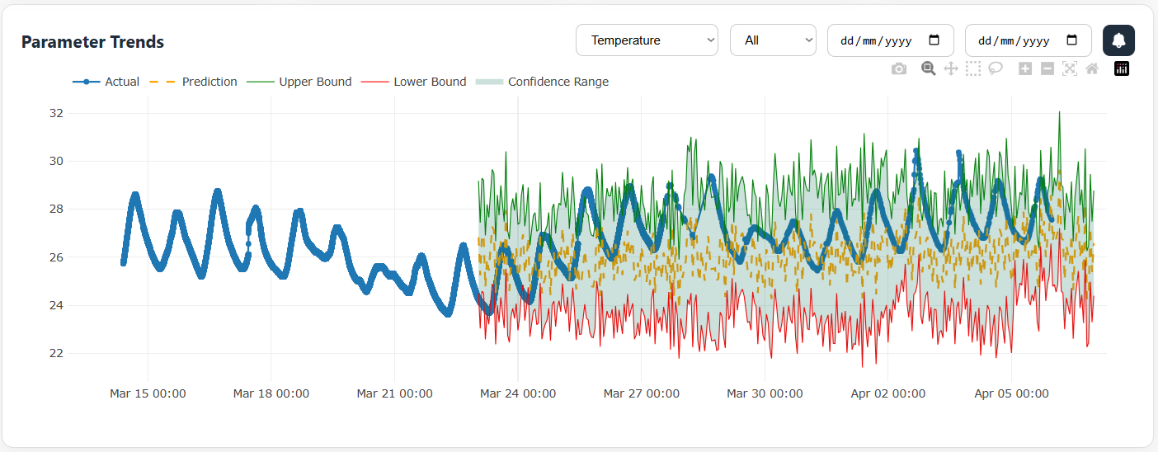
The figures show the trend predictions based on the system’s analysis of historical freshwater quality data. In each graph, the green and red lines mark the upper and lower bounds of predicted values, while the orange line represents the expected trend. These predictions help molly and ornamental fish breeders by providing early warnings about possible changes in water quality. Figure 20 displays temperature trends. The solid blue line shows actual readings, while the orange dashed line presents predicted values starting around March 23. The green and red bounds, along with the shaded confidence area, highlight the prediction range.

Figure 20. Prediction Trend for Temperature
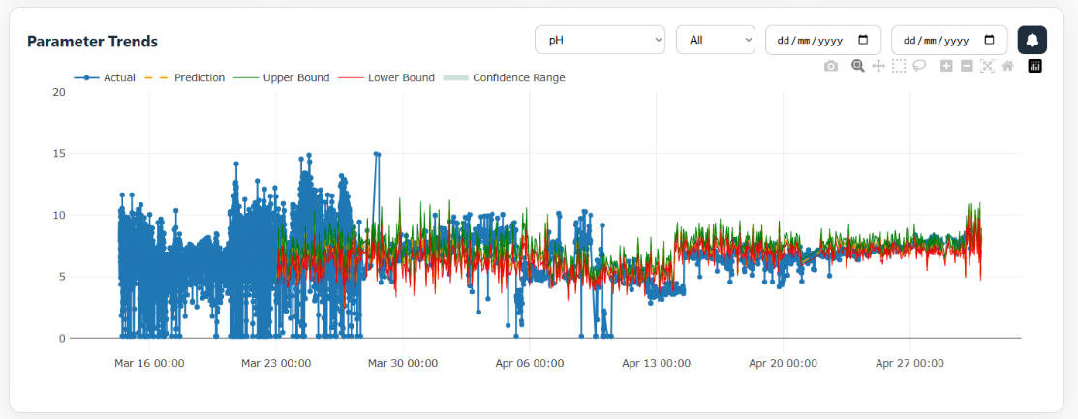
Figure 21 illustrates pH trends. Before March 27, actual values (blue line) show high variability and noise. Predictions begin afterward, with the orange line stabilizing and aligning well with observed data. While occasional sharp changes in pH occur, most values stay within the confidence range, showing the model’s ability to capture the general trend effectively.

Figure 21. Prediction Trend for pH

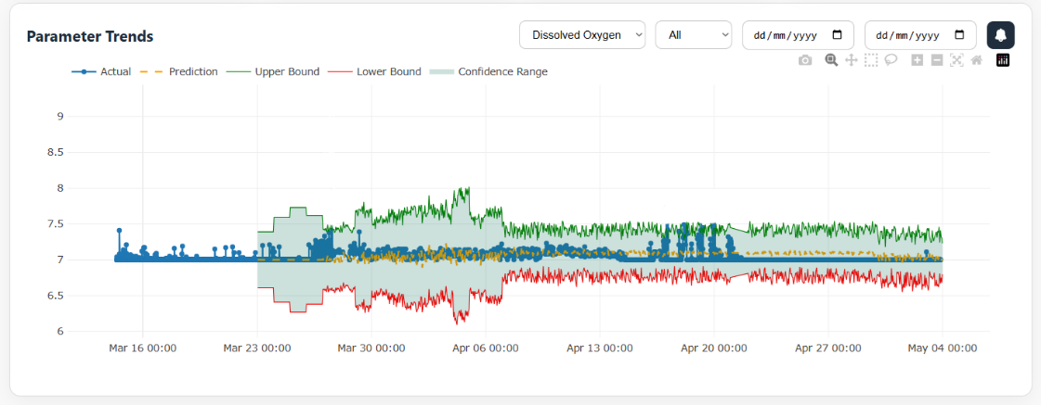
Figure 22 covers dissolved oxygen levels. Until March 24, actual readings hover around 7.0 mg/L. Predictions begin thereafter and align closely with observed values. The narrow confidence bounds and consistent match even during fluctuations like the spike on March 27 demonstrate the model’s strength and resilience.

Figure 22. Prediction Trend for Dissolved Oxygen
Figure 23 shows ammonia level predictions. The blue line and dots indicate actual readings. The orange prediction line remains steady at low levels. While most actual values fall within the confidence bounds, a few extreme spikes exceed them, suggesting unexpected external factors. The model provides dependable forecasts across all parameters, with varying levels of prediction confidence depending on the nature and variability of the data.
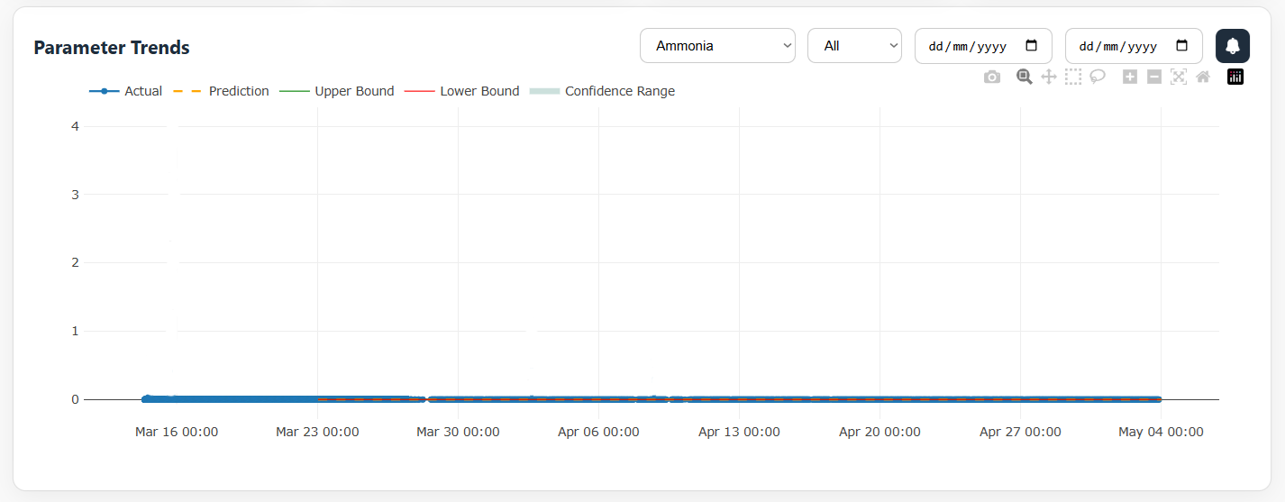

Figure 23. Prediction Trend for Ammonia

T-Test results of reliability and accuracy of the developed device in reflecting laboratory-standard results.
The accuracy assessment shown in Table 13 evaluates the reliability of sensor data by comparing it with laboratory test results across four critical water quality parameters: temperature, pH, dissolved oxygen, and ammonia. Each parameter was measured 32 times (N = 32) using both laboratory methods (Group 1) and sensors (Group 2).
The goal is to determine how closely the sensor readings match standard laboratory outcomes, which are generally considered more precise. For temperature, the sensor (Mean = 27.70313, SD = 1.394189) showed a close agreement with the laboratory values (Mean = 27.67969, SD = 1.395327), indicating high sensor reliability.
pH readings from the sensor (Mean = 7.609375, SD = 1.23732) were nearly identical to the lab values (Mean = 7.580313, SD = 1.232507), suggesting consistent and accurate measurement.
Dissolved oxygen (DO) results demonstrated strong agreement between the laboratory measurements and sensor readings, with only a slight difference observed, the lab results showed a mean of 7.07625 (SD = 0.044847), while the sensor recorded a mean of 7.04125 (SD = 0.040141). The low standard deviations in both groups indicate a high degree of consistency and reliability in the DO measurements across both methods.
The ammonia readings showed the most variation. The lab results recorded no measurable ammonia (Mean = 0), whereas the sensor detected a low concentration (Mean = 0.040625, SD = 0.20508). This suggests a potential sensitivity issue or calibration discrepancy in the sensor for ammonia detection.
The sensors demonstrate strong alignment with laboratory measurements for most parameters, particularly temperature, pH, and DO. While the ammonia sensor may need recalibration or further validation, the results are promising for real-time monitoring in aquaculture systems.
Table 13. Sensors Accuracy Assessment
Parameters | Group | N | MEAN | SD
Temperature | 1  2 | 32  32 | 27.67969  27.70313 | 1.395327  1.394189
pH | 1 | 32 | 7.580313 | 1.232507
 | 2 | 32 | 7.609375 | 1.23732
Dissolved Oxygen | 1 | 32 | 7.07625 | 0.044847
 | 2 | 32 | 7.04125 | 0.040141
Ammonia | 1 | 32 | 0 | 0
 | 2 | 32 | 0.040625 | 0.20508
1 Laboratory Test
2 Sensor

T-Test Results
Table 14 presents a comparative summary of freshwater quality parameters gathered using both laboratory results and a developed device. The parameters observed include Dissolved Oxygen (DO), pH, Temperature, and Ammonia, with measurements taken from two groups, each consisting of 32 instances. This comparison aims to evaluate the reliability and accuracy of the developed device in reflecting laboratory-standard results.
The mean scores for both groups are remarkably similar, indicating that the proposed system demonstrates high accuracy in gathering freshwater quality data. The data reflects a strong alignment between the laboratory and device readings, indicating the developed device could be a viable tool for real-time, field-based water quality monitoring.

Table 14. Descriptive statistics of gathered freshwater quality using laboratory result and developed device
Parameters | Group | N | MEAN | SD | SE | CV
Temperature | 1  2 | 32  32 | 27.680  27.703 | 1.395  1.394 | 0.247  0.246 | 0.050  0.049
pH | 1 | 32 | 7.580 | 1.233 | 0.218 | 0.163
 | 2 | 32 | 7.609 | 1.237 | 0.219 | 0.162
Dissolved Oxygen | 1 | 32 | 7.076 | 0.045 | 0.008 | 0.006
 | 2 | 32 | 7.041 | 0.040 | 0.007 | 0.005
Ammonia | 1 | 32 | 0.000 | 0.000 | 0.000 | NaN
 | 2 | 32 | 0.041 | 0.205 | 0.036 | 5.048
1 Laboratory Test
2 Sensor

Table 15 shows that data collected from the laboratory test and the developed device revealed no statistically significant differences (p > 0.05) across the freshwater parameters tested. This result highlights the consistency and reliability of the measurements obtained from both methods. The two groups during parallel testing confirms that the developed device is capable of accurately measuring freshwater parameters, performing comparably to standard laboratory tests. This demonstrates the device's potential as a reliable tool for freshwater quality assessment.
Table 15. Independent Samples T-Test Result
 | t | df | p
Temperature | -0.067 | 62.000 | 0.947
pH | -0.094 | 62.000 | 0.925
Dissolved Oxygen  Ammonia | 3.290  NaN | 61.253  ᵃ | 0.002*
Note. Welch's t-test.
ᵃ The variance in Ammonia is equal to 0 after grouping on group

Evaluation results using TAM and ISO 25010 software product standards to verify its efficacy and quality.
Table 16 reveals generally positive user perceptions of the system, with an overall mean score of 3.8, indicating strong agreement. It shows how users perceive the usefulness of a system designed for monitoring freshwater quality in aquaculture with all items receiving a mean score close to 4, which corresponds to "Strongly Agree." The highest-rated statement (mean = 4.0) highlights the system’s role in improving efficiency, suggesting users strongly believe it makes monitoring easier and more effective. Statements about real-time data and consistent tracking also scored high (3.9), emphasizing the system's reliability and accuracy. Interestingly, while users still agreed the system helps prevent water quality issues, this item had the lowest mean (3.6) and highest standard deviation (±0.69), indicating a bit more variation in opinions. With a composite mean of 3.8, it’s clear that users find the system highly beneficial in managing aquaculture operations.
Table 16. Perceived Usefulness
Perceived Usefulness | Mean | SD | Interpretation
1. The system improves the efficiency of monitoring freshwater quality parameters in the aquaculture system. | 4 | 0 | Strongly Agree
2. The system provides real-time, accurate data that enhances decision-making for freshwater quality management. | 3.9 | ±0.31 | Strongly Agree
3. This system assists in consistently tracking the overall condition of the freshwater environment. | 3.9 | ±0.31 | Strongly Agree
4. The system helps prevent potential issues in water quality before they become critical. | 3.6 | ±0.69 | Strongly Agree
5. I find the system valuable in managing my aquaculture operations effectively. | 3.8 | ±0.42 | Strongly Agree
COMPOSITE MEAN | 3.8 | ±0.35 | Strongly Agree
n=30, Legend: highest to lowest as follows: four (4) – Strongly Agree (3.26 – 4.00), three (3) – Agree (2.51 – 3.25), two (2) – Disagree (1.76 – 2.50), and one (1) – Strongly Disagree (1.0 – 1.75)

Table 17 presents users' perceptions of how easy the system is to use, and all the statements received a "Strongly Agree" interpretation, with a composite mean of 3.7, suggesting that users find the system generally user-friendly. The highest-rated items (mean = 3.8) indicate that users feel comfortable with the system’s setup that it doesn’t require much technical know-how. The statement about ease of learning scored slightly lower (mean = 3.6), with a relatively higher standard deviation, which may imply that some users took a bit more time to get familiar with it. Still, the overall impression is positive the interface is intuitive, and remote monitoring is seen as convenient. These results reflect that the system is not only effective but also accessible, making it practical for everyday use.
Table 17. Perceived Ease of Use
Perceived Ease of Use | Mean | SD | Interpretation
1. The system interface is user-friendly and easy to navigate. | 3.7 | ±0.48 | Strongly Agree
2. I find it easy to learn how to operate the system and interpret the data it provides. | 3.6 | ±0.51 | Strongly Agree
3. Using the system requires minimal effort or technical knowledge. | 3.8 | ±0.42 | Strongly Agree
4. The application and dashboard make it convenient to monitor water parameters remotely. | 3.7 | ±0.48 | Strongly Agree
5. I am comfortable with the overall setup and functionality of the monitoring system. | 3.8 | ±0.421 | Strongly Agree
COMPOSITE MEAN | 3.7 | ±0.46 | Strongly Agree
n=30, Legend: highest to lowest as follows: four (4) – Strongly Agree (3.26 – 4.00), three (3) – Agree (2.51 – 3.25), two (2) – Disagree (1.76 – 2.50), and one (1) – Strongly Disagree (1.0 – 1.75)

Table 18 reflects users' overall attitude toward using the system, and the results are overwhelmingly positive. With a composite mean of 3.9, users “Strongly Agree” that they have a favorable outlook on the system. Most statements scored a 3.9, showing a consistent appreciation for the system’s usefulness, relevance, and the enjoyable experience it offers. The highest rating (mean = 4.0) was given to the statement about recommending the system to others, which strongly suggests that users trust and value the technology enough to endorse it. The slightly lower rating of 3.8 on how well the system fits their management practices still reflects strong agreement, though it may hint at some minor variation in how it integrates with individual workflows. Overall, users not only recognize the system’s benefits but also enjoy using it, which is a great sign for long-term adoption and satisfaction within the aquaculture community.
Table 18. Attitude
Attitude (Towards Using the System) | Mean | SD | Interpretation
1. I feel positive about using the system for monitoring water quality. | 3.9 | ±0.31 | Strongly Agree
2. The system fits well with my aquaculture management practices. | 3.8 | ±0.42 | Strongly Agree
3. I believe this technology can greatly benefit aquaculture management. | 3.9 | ±0.31 | Strongly Agree
4. Using this system is an enjoyable and beneficial experience. | 3.9 | ±0.31 | Strongly Agree
5. I would recommend this system to other aquaculture practitioners. | 4 | 0 | Strongly Agree
COMPOSITE MEAN | 3.9 | ±0.27 | Strongly Agree
n=30, Legend: highest to lowest as follows: four (4) – Strongly Agree (3.26 – 4.00), three (3) – Agree (2.51 – 3.25), two (2) – Disagree (1.76 – 2.50), and one (1) – Strongly Disagree (1.0 – 1.75)

Table 19 highlights users’ behavioral intentions toward using the system, and the overall sentiment is very encouraging. With a composite mean of 3.7, users generally “Strongly Agree” that they are committed to using the system. Statements about relying on the system, recommending it to peers, and incorporating it into daily routines all scored a solid 3.9, showing that users see it as a reliable tool for long-term use. The statement about adopting other IoT solutions received the lowest mean score at 3.5 and had the highest standard deviation (±0.527), suggesting that while users are open to more tech-based solutions, their enthusiasm varies. The overall results are positive. Users not only trust the system but are also likely to make it a part of their regular operations, which is a great sign for future adoption and impact.
Table 19. Behavior
Behavior (Intention to Use the System) | Mean | SD | Interpretation
1. I intend to use this system regularly for monitoring water quality. | 3.7 | ±0.483 | Strongly Agree
2. I am likely to rely on this system to help manage my aquaculture system in the future. | 3.9 | ±0.316 | Agree
3. I am willing to adopt other IoT solutions in my aquaculture operations based on my experience with this system. | 3.5 | ±0.527 | Strongly Agree
4. I am likely to recommend this system to colleagues in the aquaculture industry. | 3.9 | ±0.316 | Strongly Agree
5. I am committed to using this system as part of my daily monitoring routine. | 3.9 | ±0.316 | Strongly Agree
COMPOSITE MEAN | 3.7 | ±0.38 | Strongly Agree
n=30, Legend: highest to lowest as follows: four (4) – Strongly Agree (3.26 – 4.00), three (3) – Agree (2.51 – 3.25), two (2) – Disagree (1.76 – 2.50), and one (1) – Strongly Disagree (1.0 – 1.75)

Table 20 presents the Cronbach’s alpha results, offering insight into the internal consistency and reliability of the constructs used in this study. The results show that Perceived Usefulness and Attitude achieved strong reliability, with alpha values of 0.8369 and 0.8793, respectively both falling within the “Good” range. Perceived Ease of Use demonstrated particularly high internal consistency, with an alpha score of 0.9468, which is categorized as “Excellent.” This suggests a very strong agreement among the items measuring that construct. On the other hand, the Behavior construct received a reliability score of 0.7424. While this falls within the “Acceptable” range, it indicates that the items measuring behavior are reasonably consistent but could benefit from further refinement to enhance reliability. The overall Cronbach’s alpha for all constructs combined was 0.8513, which is interpreted as “Good.” This implies that the measurement instruments used in the study are generally reliable and well-constructed, providing confidence in the consistency of the data collected.
Table 20. Cronbach Alpha Result
Item | Number of items | Cronbach | Interpretation
Perceived Usefulness | 5 | 0.836864 | Good
Perceived Ease of Use | 5 | 0.946782 | Excellent
Attitude | 5 | 0.879310 | Good
Behavior | 5 | 0.742358 | Acceptable
TOTAL |  | 0.851328 | Good
Legend above 0.90 = Excellent, 0.89-0.80 = Good, 0.79-0.70 = Acceptable, 0.69-0.60 = Questionable, 0.59-0.50 = Poor, 0.50 below = Unacceptable

The system was evaluated using ISO 25010 standards by five IT specialists, with results shown in Table 21. It received an impressive overall mean score of 4.62, rated as "Excellent." Top scores (5.00) were given for Functional Suitability, Performance Efficiency, and Reliability. Usability and Portability followed with 4.67, while Compatibility and Security scored 4.33. Maintainability earned 4.00. Low standard deviations indicate strong agreement among evaluators. These results highlight the system’s reliability, speed, user-friendliness, and adaptability qualities essential for sustainable, long-term use in aquaculture settings. The strong performance across multiple criteria confirms the system's readiness for application and long-term user satisfaction.
Table 21. Post Evaluation Result
Characteristics | Mean | SD | Interpretation
Functional Suitability | 5.00 | 0 | Excellent
Performance Efficiency | 5.00 | 0 | Excellent
Compatibility | 4.33 | ±0.47 | Excellent
Usability | 4.67 | ±0.47 | Excellent
Reliability | 5.00 | 0 | Excellent
Security | 4.33 | ±0.47 | Excellent
Maintainability | 4.00 | 0 | Good
Portability | 4.67 | ±0.47 | Excellent
Overall Mean | 4.62 | ±0.23 | Excellent
n=5 IT experts
Project Testing and Debugging
A. Unit Testing
Table 22 highlights the system’s reliable performance during unit testing, proving its effectiveness in real-world aquaculture monitoring. In Unit Test 1, sensors provided accurate readings after calibration, confirming their ability to deliver dependable data for freshwater management. Unit Test 2 validated the system’s ability to display real-time data on a web interface, enhancing usability. This smooth connection between sensors and dashboard ensures convenient, user-friendly, and efficient monitoring empowering aquaculture practitioners to make informed decisions. The system’s accuracy, accessibility, and ease of use make it a practical solution for supporting sustainable and effective Recirculating Aquaculture System (RAS) operations, even in demanding conditions.
Table 22. Conducted test case for Unit Testing
Unit Test ID | Steps | Expected Results | Actual Results | Remarks
1 | Sensors reading accuracy | Sensors reads the freshwater quality accurately | The sensors successfully gathered accurate readings through a series of calibration | Passed
2 | Web-system data display | The web-system displays the data of each freshwater parameters | The web-system successfully displayed the data of each freshwater parameters | Passed

B. Integration Testing
Integration testing confirmed the system’s smooth coordination between hardware and software, proving its strong functionality and reliability. As shown in Table 23, these results highlight both technical competence and thoughtful design tailored for real-world aquaculture needs. Integration Test 1 showed the system’s ability to collect and process freshwater quality data in real time, ensuring aquaculture managers receive accurate, up-to-date information for quick, informed decisions. Test 2 demonstrated predictive capabilities, using historical data to forecast water quality trends allowing for early action and improved system stability. Test 3 highlighted the automated water disposal response, proving the system can react autonomously to abnormalities.
Table 23. Test case conducted for Integration Testing
Test ID | Steps | Expected Results | Actual Results | Remarks
1 | Hardware and Software Integration | The monitoring device transmits the freshwater quality data on the given time frame | The sensors successfully gathered the freshwater quality and sends it to the server and retrieved by the system for data viewing | Passed
2 | Freshwater Quality Prediction | The system provides future freshwater quality trends | The system successfully provides the possible upcoming freshwater quality condition | Passed
3 | Abnormality detection | The system automatically activates the water disposal to prevent water contamination | The system successfully activates the water disposal after detecting water irregularities | Passed

C. System Testing
As shown in Table 24, load testing confirmed the system’s stable and efficient performance under continuous use and multiple simultaneous processes. All modules functioned smoothly, proving the system's readiness for real-world aquaculture operations. Sensor integration delivered accurate, stable readings, validated by CLSD lab analysis, ensuring reliable real-time freshwater monitoring. Data collection tests showed consistent logging without errors or interruptions, preventing data loss and reinforcing system dependability. The freshwater quality prediction test demonstrated the system’s strong analytical capabilities, accurately forecasting trends using historical data. This predictive feature helps aquaculture practitioners take proactive steps to maintain optimal conditions. Overall, the system proved to be resilient under pressure, highlighting its intelligent, well-designed structure. These results confirm its long-term reliability, practical usability, and potential to significantly enhance aquaculture management through smart, data-driven decision-making.

Table 24. Test Case for Load Test
Test ID | Steps | Expected Results | Actual Results | Remarks
1 | Sensor Integration | Sensor readings are accurate and consistent | Show accurate readings based on laboratory analysis at CLSD | Passed
2  3 | Data collection and reading  Water quality prediction | The system collects and records the data from the sensor  The system provides possible values of the freshwater | The system consistently recorded all the data gathered by the sensors  System consistently provide prediction based on the historical data | Passed  Passed

The stress test results as shown in table 25 demonstrate that the system performs well under challenging and fluctuating conditions, offering valuable insights into its strengths and areas for improvement. When water parameters changed rapidly, the system was able to autonomously activate the water disposal mechanism, restoring freshwater conditions to a safe and optimal state. This shows the system’s ability to respond promptly and effectively to potential threats, reinforcing its value in maintaining water quality without constant human intervention. Notable strength was observed when the system encountered variations in water load. Despite shifts in water level, the sensors continued to provide consistent and accurate readings, showcasing the system’s resilience and adaptability in dynamic aquaculture environments. This reliability is crucial for breeders who depend on real-time data to make quick, informed decisions. The stress test also revealed an important limitation. The system’s predictive model currently performs best when freshwater is present, suggesting that its accuracy declines in non-freshwater conditions. This reliance points to an opportunity for future enhancements, particularly in expanding the system’s predictive algorithms to accommodate various water types, such freshwater environments.
Table 25. Test Case for Stress Test
Test ID | Steps | Expected Results | Actual Results | Remarks
1 | Water Parameter fluctuations | The system should autonomously regulate water disposal to restore it to its normal condition | System performs water disposal and refill to restore the freshwater to its normal condition | Passed
2  3 | Increase and decrease the load of water System adopts different water condition | Maintain its accurate readings under increase and decrease load The system can identify the freshwater quality condition even in different settings | The sensor remains reliable despite the changes in water level System provides accurate predictions only on the presence of freshwater. | Passed  Failed

CHAPTER 5

SUMMARY, CONCLUSION AND RECOMMENDATION
This chapter contains a summary of the Capstone project, which includes a discussion of the conclusions found during the study and the recommendations that make the project successful.
Summary
The growth of aquaculture, especially in Recirculating Aquaculture Systems (RAS), highlights the critical need for stable freshwater quality particularly for sensitive species like molly fish (Poecilia sphenops), which are widely valued in ornamental fish farming. RAS offer a sustainable way to farm fish by recycling water, but they face challenges in managing waste buildup. For molly fish, poor water quality can quickly lead to stress, disease, and even death, making precise monitoring essential. Unfortunately, traditional methods relying on manual sampling are slow and often miss sudden changes, putting fish health at risk.
To address these challenges, this project aims to develop a real-time monitoring and analysis system tailored for molly fish in RAS, showcasing how IoT and ML can enhance aquaculture practices. By improving water quality management, this approach contributes to both the advancement of the aquaculture industry and the protection of aquatic ecosystems. Focusing on the needs of fish breeders in Los Baños, the project was conducted at Laguna State Polytechnic University. It integrates IoT capabilities to provide real-time freshwater quality monitoring tailored to the specific requirements of local aquaculture practices. The development process of the system encompasses several stages, including data identification and collection, model training, model evaluation, and experimentation and adjustment. This process utilizes a variety of software and hardware components, including HTML, CSS, JavaScript, Visual Studio, and Arduino IDE, alongside hardware such as the ESP32 board and multiple sensors.
The project development process includes data identification and collection, model training, model evaluation, and experimentation and adjustment, employing various software and hardware specifications like HTML, CSS, JavaScript, Visual Studio, and Arduino IDE, and hardware ESP32 board, and multiple sensors. Testing phases include unit testing, integration testing, system testing, and acceptance testing, involving calibration of sensors for pH, dissolved oxygen, temperature, and ammonia. A comprehensive water treatment process ensures required water quality standards, with regular monitoring of key parameters crucial for maintaining a healthy aquatic environment. The system undergoes a thorough series of testing phases such unit testing, integration testing, system testing, and acceptance testing to ensure its reliability and accuracy. A key focus during these stages is the precise calibration of sensors that monitor pH, dissolved oxygen, temperature and ammonia, which are essential for maintaining a healthy aquatic environment. The evaluation of the system is guided by the ISO 25010 product quality framework, which involves collaboration with molly fish breeders, COF Faculty and IT specialists. The ultimate goal of the project is to develop a robust and efficient monitoring system, enhance its functionality through collaborative efforts of the users, and promote sustainable aquaculture practices that aims to contribute to the economic well-being of the local community.
Conclusion
1. Integrate sensors to measure vital aspects of freshwater recirculating aquaculture system quality, including temperature, pH, dissolved oxygen (DO), and ammonia.
Integrating sensors like the Dissolved Oxygen Probe, DS18B20 Temperature Sensor, and pH-4502C Liquid pH Sensor plays a vital role in improving water quality management in freshwater aquaculture. These tools allow fish farmers and breeder to closely monitor key parameters that directly impact fish health and growth, creating an environment where aquatic life can thrive.
The Dissolved Oxygen Probe tracks oxygen levels in real time with ideal readings typically between 5–7.5 mg/L. This allows molly fish breeders to make quick adjustments to aeration systems, helping prevent oxygen depletion that could lead to fish stress or death.
The DS18B20 Temperature Sensor keeps a close eye on water temperature, a factor that directly influences fish metabolism and immune response. Since each species has specific temperature preferences, accurate readings help guide decisions about heating or cooling systems.
The pH-4502C Liquid pH Sensor, which monitors the acidity or alkalinity of the water. Maintaining a stable pH range between 6.5 and 8.5 is essential for both nutrient availability and the overall health of the fish. When pH levels drift, it can cause stress or even increase the risk of disease.
These sensors form the backbone of the developed project. They empower molly fish breeders with real-time, actionable data, allowing for quick interventions and long-term planning. Beyond just boosting efficiency, this technology supports more sustainable practices and contributes to healthier yields benefiting both ornamental fish breeders and the communities they support.
2. A Bayesian machine learning algorithm is integrated to predict water quality trends.
The model performs excellently as it achieves the lowest errors across all metrics, including MASE (0.5005), RMSSE (0.0509), MAE (0.0371), RMSE (0.0509), and MAPE (40.72%). Additionally, it shows a positive R2 value (0.6231), indicating that the model explains a portion of the variance in the data. These results reflect excellent model tuning or a well-aligned dataset, making the Bayesian model highly reliable for accurate forecasting.
The trend predictions for key freshwater quality parameters (temperature, pH, dissolved oxygen, and ammonia) based on historical data, the temperature trends from show strong alignment between predicted and actual values, with predictions closely tracking observed daily cycles and remaining within the confidence range, indicating a well-calibrated model. The pH trends, where early data show high variability. Despite occasional fluctuations, the model effectively captures pH trends with predictions mostly within the confidence bounds. The dissolved oxygen showing relatively stable observed values before prediction starts. The model accurately forecasts trends from March 24 onward, even accommodating brief anomalies and maintaining a narrow, reliable prediction band. The ammonia levels, where actual values exhibit sharp spikes not captured by the model. Overall, the prediction system provides reliable and consistent forecasts for temperature, pH, and dissolved oxygen, offering molly fish breeders valuable early warnings about water quality. While the model performs well overall, the occasional deviations in ammonia highlight potential limitations in capturing sudden environmental shifts. These predictive insights enhance proactive decision-making in aquaculture by anticipating changes in key freshwater quality parameters.
3. Conduct an assessment to verify the accuracy of the collected water quality parameters measured by the sensors at the Analytical Laboratory of the Center for Lakes Sustainable Development.
The accuracy assessment compares sensor data with laboratory results for four key water quality parameters: temperature, pH, dissolved oxygen, and ammonia, with each parameter measured 32 times. Sensor readings for temperature, pH, and dissolved oxygen closely aligned with laboratory values, demonstrating strong reliability and consistency. Temperature and pH differences were minimal, and dissolved oxygen readings showed only slight variation, with low standard deviations in both data sets. However, the ammonia sensor recorded low concentrations (Mean = 0.040625), while lab results showed none, suggesting a possible calibration issue. Despite this, the sensors proved to be accurate and dependable for real-time aquaculture water quality monitoring.
4. Evaluate the developed project using Technology Acceptance Model (TAM) and ISO 25010 software product standards to verify its efficacy and quality.
The Cronbach’s alpha results, indicating good overall reliability (0.8513) for the study’s constructs. Perceived Usefulness and Attitude scored 0.8369 and 0.8793, reflecting strong internal consistency. Perceived Ease of Use achieved an excellent reliability score of 0.9468. Behavior scored 0.7424, categorized as acceptable, suggesting moderate consistency with room for improvement. These results confirm that the measurement tools are generally reliable, supporting confidence in the consistency of the data collected. The system evaluation based on ISO 25010, conducted by five IT experts, revealed strong overall performance with an average score of 4.62, rated as "Excellent." Functional Suitability, Performance Efficiency, and Reliability each received perfect scores of 5.00, highlighting the system’s precision, speed, and dependability. Usability and Portability scored 4.67, showing it is user-friendly and adaptable. Compatibility and Security were rated 4.33, while Maintainability received 4.00, indicating solid but improvable quality. Low standard deviations reflected strong evaluator agreement. Overall, the results suggest the system is well-built, efficient, and reliable key factors for sustained use in technology-driven fields like aquaculture.
Recommendations
This study advocates for the adoption of sustainable aquaculture practices, not just in freshwater environments but across a range of aquatic ecosystems. By highlighting the importance of responsible aquaculture management, the research presents findings and methods that can be adapted and applied more broadly.
- The project is particularly recommended for ornamental fish breeders who are just starting out, providing them with a practical and accessible foundation.
- It is highly encouraged to improve the system by integrating additional sensors to monitor various freshwater parameters, and to redesign the prototype to better support large-scale operations.
- Future developers are advised to incorporate solar power to provide a reliable power source during outages.
- The project is encouraged to incorporate a stand-alone Wi-Fi device with a SIM card as backup as it can be essential in several cases, especially when traditional Wi-Fi connections are down.
- Researchers looking to expand on this work should explore different machine learning algorithms to improve the accuracy of freshwater quality predictions.
- The MQ137 ammonia sensor is not recommended for freshwater monitoring, as it lacks the sensitivity needed to accurately detect ammonia levels in aquatic environment.

REFERENCES

Abdikadir, N. M., Abdullah, A. S., Osman, H., & Hassan, A. A. (2024). Smart
Aquaculture: IoT-Enabled Monitoring and Management of Water Quality for Mahseer Fish Farming. International Journal of Electrical and Electronics Engineering, 11(11), 84–92.

Ahmed, M., Khan, R., & Patel, A. (2020). IoT and big data analytics in
aquaculture systems. Journal of Aquatic Technology, 32(4), 123-134.

Ahmed, N., Thompson, S., & Glaser, M. (2021). IoT-based monitoring systems
in aquaculture: A review. Aquaculture International, 29(1), 1-14.

Álvarez, M. Á., & Ordóñez, A. (2023). Bayesian machine learning and functional
data analysis as a two-fold approach for the study of acid mine drainage events. Water, 15(8), 1553.

A. Maier, A. Sharp, Y. Vagapov. (2017). Comparative Analysis and Practical Implementation of the Comparative Analysis and Practical Implementation of the ESP32 Microcontroller Module for the Internet of Things.
Awasthi, A., Saxena, K. K., & Arun, V. (2021). Sustainable and smart metal forming manufacturing process. Materials Today: Proceedings, 44, 2069-2079
Arora, G. S., & Saxena, K. K. (2023). A review study on the influence of hybridization on mechanical behaviour of hybrid Mg matrix composites through powder metallurgy. Materials Today: Proceedings
Arun, V., Singh, A. K., Shukla, N. K., & Tripathi, D. K. (2016). Design and performance analysis of SOA– MZI based reversible toffoli and irreversible AND logic gates in a single photonic circuit. Optical and quantum electronics, 48, 1-15.
Awasthi, A., Saxena, K. K., Dwivedi, R. K., Buddhi, D., & Mohammed, K. A. (2022). Design and analysis of ECAP Processing for Al6061 Alloy: a microstructure and mechanical property study. International Journal on Interactive Design and Manufacturing (IJIDeM), 1-13.
Axelrod, H. R., Wischnath, L., & Foersch, D. (1991). Breeding aquarium fishes.
TFH Publications.

AlZubi, A. A. (2022). IoT-based automated water pollution treatment using
machine learning classifiers. Environmental Technology, 1-9.

Basavapoornima, C., Kesavulu, C. R., Maheswari, T., Pecharapa, W., Depuru,
S. R., & Jayasankar, C. K. (2020). Spectral characteristics of Pr3+-doped lead based phosphate glasses for optical display device applications. Journal of Luminescence, 228, 117585.
Baena-Navarro, R., Carriazo-Regino, Y., Torres-Hoyos, F., & Pinedo-López, J.
(2025). Intelligent prediction and continuous monitoring of water quality in aquaculture: Integration of machine learning and Internet of Things for sustainable management. Water, 17(1), 82.

BOQU. (2023). The Importance of Temperature Sensors in Water Quality Monitoring. https://www.boquinstrument.com/the-importance-of-temperature-sensors-in-water-quality-monitoring
Chen, L., Zhao, H., & Wang, X. (2019). IoT-enhanced RAS for aquatic
ecosystem monitoring. Aquaculture Advances, 27(3), 89-97.

Chezhian, P., & Kabilan, N. (2021). Effects of temperature fluctuations on the growth and reproductive performance of ornamental fish in controlled aquaculture systems. International Journal of Aquatic Science and Fisheries Research, 8(4), 75-83.
Cho, K. H., Pachepsky, Y., Ligaray, M., Kwon, Y., & Kim, K. H. (2020). Data assimilation in surface water quality modeling: A review. Water Research, 186, 116307. https://doi.org/10.1016/j.watres.2020.116307
Chowdhury, M. R., & Khan, S. R. (2018). Evaluation of ammonia and nitrite
toxicity in ornamental fish aquaculture systems. Aquaculture and Water Quality Management Journal, 9(2), 45-56.

Colt, J., & Armstrong, D. A. (1981). Nitrogen toxicity to crustaceans, fish, and
mollusks. Aquaculture, 23(2), 99-119.

Dogo, E. M., Nwulu, N. I., Twala, B., & Aigbavboa, C. (2019). A survey of
machine learning methods applied to anomaly detection on drinking-water quality data. Urban Water Journal, 16(3), 235-248.

Egbemhenghe, A., Ojeyemi, T., Iwuozor, K. O., Emenike, E. C., Ogunsanya, T.
I., Anidiobi, S. U., & Adeniyi, A. G. (2023). Revolutionizing water treatment, conservation, and management: Harnessing the Sipokazi Mabuwa, Velaphi Msomi, 2020. Comparative analysis between nor

Gatlin, D. M., Barrows, F. T., Brown, P., Dabrowski, K., Gaylord, T. G., Hardy,
R. W., & Sealey, W. M. (2018). Expanding the utilization of sustainable plant products in aquafeeds: A review. Aquaculture, 493, 317-334.

Gelman, A., Carlin, J. B., Stern, H. S., Dunson, D. B., Vehtari, A., & Rubin, D.
B. (2013). Bayesian Data Analysis (3rd ed.). Chapman and Hall/CRC.

Godavarthi, B., Nalajala, P., & Ganapuram, V. (2017, August). Design and
implementation of vehicle navigation system in urban environments using internet of things (IoT). In IOP Conference Series: Materials Science and Engineering (Vol. 225, No. 1, p. 012262). IOP Publishing.

Gonzalez, M., & Park, H. (2019). Influence of dissolved oxygen levels on
respiratory function and survival of molly fish in aquaculture systems. Journal of Aquatic Ecosystem Studies, 17(3), 89-97.

Gupta, S., Sharma, R., & Verma, P. (2021). AI-powered aquaculture monitoring.
Artificial Intelligence in Agriculture, 19(2), 56-67.

Gupta, T. K., Budarapu, P. R., Chappidi, S. R., YB, S. S., Paggi, M., & Bordas,
S. P. (2019). Advances in carbon based nanomaterials for bio-medical applications. Current Medicinal Chemistry, 26(38), 6851-6877.

Han, Z., Wang, X., & Liu, Y. (2020). IoT and machine learning integration for
water quality management in recirculating aquaculture systems. Computers and Electronics in Agriculture, 175, 105600.

Islam, M. M. (2024). Smart aquaculture analytics: Enhancing shrimp farming in
Bangladesh through real-time IoT monitoring and predictive machine learning analysis. Computers and Electronics in Agriculture, 205, 107601.

Joy, C., Sundar, G. N., & Narmadha, D. (2021, May). AI Driven Automatic
Detection of Bacterial Contamination in Water: A Review. In 2021 5th International Conference on Intelligent Computing and Control Systems (ICICCS) (pp. 1281-1285). IEEE

Korpi, A. G., Ţălu, Ş., Bramowicz, M., Arman, A., Kulesza, S., Pszczolkowski,
B., ... & Gopikishan, S. (2019). Minkowski functional characterization and fractal analysis of surfaces of titanium nitride films. Materials Research Express, 6(8), 086463.

Kumar, N., Singh, A., & Kumar, V. (2023). An IoT-based water contamination
analysis for aquaculture using lightweight multi-headed GRU model. Environmental Monitoring and Assessment, 195(2), 256.

Kumar, N., Mehta, S., & Raj, V. (2020). IoT-based real-time water quality
monitoring in aquaculture. International Journal of IoT Applications, 15(5), 78-88.

Kumar, A., Rana, R.S., Purohit, R. et al. Investigation of Tensile behaviour,
Seizure Conditions and Frictional Characteristics of Al-Zn-Cu-Mg Alloy based Composites. Silicon 15, 7903–7915 (2023). https://doi.org/10.1007/s12633-023-02627-9

Li, X., Zhang, Y., & Chen, H. (2022). Predictive analytics in aquaculture: A
machine learning approach. Aquaculture Research, 53(5), 1234-1247.

Li, Z., Zhang, H., & Zhang, Y. (2022). Prediction of long-term water quality using
machine learning enhanced by Bayesian optimization. Journal of Environmental Management, 289, 112522.

Li, J., Zhang, L., & Wang, Q. (2022). Internet of Things and Machine Learning
in Aquaculture: Review and Future Directions. Journal of Aquaculture Engineering and Technology, 18(3), 144-157.

Li, Y., et al. (2022). IoT-Enabled Recirculating Aquaculture Systems: Enhancing
Sustainability and Food Security in Aquaculture. Aquaculture Research, 53(3), 1302-1315.

Martins, C. I. M., Eding, E. H., Verdegem, M. C. J., Heinsbroek, L. T. N.,
Schneider, O., Blancheton, J. P., Roque d’Orbcastel, E., & Verreth, J. A. J. (2010). New developments in recirculating aquaculture systems in Europe: A perspective on environmental sustainability. Aquacultural Engineering, 43(3), 83–93.

Mishra, S., Panda, A., & Rath, P. (2020). IoT-enabled Smart Aquaculture
Management System for the Optimization of Water Quality. Internet of Things Journal, 6(1), 210-224.

Munesh S., Kshira S., Ami H. (2024, February 1). An Intelligent-IoT-Based data
analytics for freshwater recirculating aquaculture system. IEEE Journals & Magazine

Nguyen, T. T., Le, M. D., & Pham, C. K. (2021). IoT-based water quality
monitoring system for recirculating aquaculture systems. Sensors, 21(7), 2342.

Park, J., Kim, D., & Seo, Y. (2018). Energy-efficient IoT systems for RAS.
Energy and Aquaculture Research, 10(4), 145-159.

Rashid, M. M., Nayan, A.-A., Rahman, M. O., Simi, S. A., Saha, J., & Kibria, M.
G. (2021). IoT-based smart water quality prediction for biofloc aquaculture. International Journal of Advanced Computer Science and Applications, 12(6), 470-477.

Rojas-Torres, M., Borrero-Lopez, O., & Diaz, J. (2021). Advances in monitoring
systems for sustainable aquaculture: A review. Journal of Environmental Monitoring and Assessment, 193(4), 1-17.

Rojas-Torres, M., et al. (2021). Impact of IoT in Recirculating Aquaculture
Systems (RAS): Advancing Sustainability in Aquaculture. Journal of Aquaculture Technology, 28(4), 314-329.

Saxena, K. K., & Lal, A. (2012). Comparative Molecular Dynamics simulation
study of mechanical properties of carbon nanotubes with number of stone-wales and vacancy defects. Procedia Engineering, 38, 2347-2355

Shahbaz, M., Bilal, M., & Iqbal, H. M. N. (2019). Internet of Things-based water
quality monitoring: A comprehensive review. Science of the Total Environment, 651, 2462-2470.

Shen, L., Peng, F., Hussain, S., & Xie, G. (2019). Integration of weather
conditions for predicting microbial water quality using Bayesian Belief Networks. Water Research, 167, 115098.

Singh, B., Saxena, K. K., Dagwa, I. M., Singhal, P., & MALIK, V. (2023).
Optimization of Machining Characteristics of Titanium-Based Biomaterials: Approach to Optimize Surface Integrity for Implants Applications. Surface Review and Letters, 2340008.

Smith, J., Ramirez, A., & Lee, C. (2020). Effect of pH variability on molly fish
(Poecilia sphenops): A comprehensive study on behavior and health outcomes. Aquaculture Research and Development Journal, 12(5), 102-114.

Thakur, R., Singh, A., & Kapoor, N. (2022). Machine learning in fish health
monitoring. Computational Biology and Aquaculture, 8(1), 34-45.

Tian, Y., Zhao, L., & Zhang, Z. (2021). Machine learning applications in
aquaculture: A review. Aquaculture Reports, 20, 100648.

Tripathi, G. P., Agarwal, S., Awasthi, A., & Arun, V. (2022, August). Artificial Hip
Prostheses Design and Its Evaluation by Using Ansys Under Static Loading Condition. In Biennial International Conference on Future Learning Aspects of Mechanical Engineering (pp. 815-828). Singapore: Springer Nature Singapore

Velasco, C., Martinez, A., & Torres, J. (2019). Sustainable water management
in aquaculture using IoT. Environmental IoT Studies, 18(6), 99-112.

Yang, P.-Y., Liao, Y.-C., & Chou, F.-I. (2023). Artificial intelligence in Internet of
Things system for predicting water quality in aquaculture fishponds. Computer Systems Science and Engineering, 46(3), 2861-2880.

Zhao, C., Wang, W., & Duan, S. (2019). Applications of artificial intelligence in
aquaculture: Current trends and future perspectives. Aquaculture Reports, 15, 1-9

Zhou, X., Wang, J., Huang, L., Li, B., & Duan, Q. (2022). Modelling and
controlling dissolved oxygen in recirculating aquaculture systems based on mechanism analysis and an adaptive PID controller. Computers and Electronics in Agriculture, 192, 106583.

