A WEB-BASED SYSTEM FOR SCHOLARSHIP APPLICATION AND STATUS MONITORING

A Capstone Project Presented to the Faculty, College of Computer Studies
Laguna State Polytechnic University
Los Baños Campus
Los Baños, Laguna

In partial fulfillment of the requirement for the degree
Bachelor of Science in Information Technology
Specialized in Service Management Program

HAROLD STEPHEN S. GARCIA
MICHIKO V. REYES
JOHN ROLAND L. SERRANO

WILSON B. SUYAT

APRIL 2026

APPROVAL SHEET
ii

The Capstone Project entitled “A WEB-BASED SYSTEM FOR SCHOLARSHIP APPLICATION AND STATUS MONITORING” prepared and submitted by Harold Stephen S. Garcia, Michiko V. Reyes and John Roland L. Serrano in partial fulfillment requirements for the degree Bachelor of Science in Information Technology specialized in Service Management Program, is hereby recommended for approval and acceptance.

WILSON B. SUYAT, MIT
Adviser
___________________________________________________________________

Approval and Acceptance by the Committee on Oral Examination with a grade of____on ____.

GENE MARCK B. CATEDRILLA, MIT SHERWIN B. SAPIN, EdD
Member Member

JHOCO S. MILLANES, LPT
Member

JEFFERSON L. LERIOS, DIT
Research Coordinator

Accepted as partial fulfillment of the requirements for the degree of Bachelor of Science in Information Technology.

LOYD S. ECHALAR, DIT
Associate Dean, College of Computer Studies

OFELIA B. MANINGAS, EdD. __________
Chairperson, Research and Development Office Date Signed

RESEARCH CONTRIBUTION NO.

ACKNOWLEDGEMENT
iii
This journey of pursuing a Bachelor of Science in Information Technology major in Service Management Program has been supported by so many wonderful people whose encouragement, guidance, and belief in our abilities have been instrumental along the way and in the completion of this dissertation.
The success of this capstone project will not be possible without the help of other individual worthy of mentioning their names.
To the University President, Dr. Mario R. Briones, and the Campus Director, Eng’r. Manuel Luis R. Alvarez for their great leadership.
To our dearest Dean, Dr. Loyd S. Echalar, for his kind words and encouragement.
To our adviser, Mr. Wilson B. Suyat, for his encouragement, guidance, and support.
To our Research Coordinator, Dr. Jefferson L. Lerios, and members of the committee on approval, namely Dr. Sherwin B. Sapin, Mr. Gene Marck B. Catedrilla, and Mr. Jhoco S. Millanes who took keen interest on our project work and guided us all along, till the completion of our project work by providing all the necessary information for developing a good system.
To Almighty God for his guidance, protection, knowledge, and wisdom.

THE RESEARCHERS

DEDICATION
iv
The successful piece of project is wholeheartedly and loving dedicated by the researchers to our Almighty God, who gave them strength, courage and wisdom. To their parents,
Mr. and Mrs. Garcia
Mr. and Mrs. Serrano
Mr. and Mrs. Reyes

Who have been there auspiciously and sincerely devoting their time and effort to financially and morally support inspiring them to preserved and work hard with an end mind that everything will worth it.
To their mentors for their mentorship throughout their project. The mentor’s insights have been invaluable in the creation of their capstone project.
To their friends, classmates, and siblings who cheered them up in times of hardships and difficulties.
Most of all, to our God who give us strength, grace, hope, knowledge and patience to make this research successfully done.

H.S.S.G.
J.R.L.S.
M.V.R.

ABSTRACT
v

In higher education, scholarships serve as powerful tools for promoting equity and access, particularly for financially challenged students. However, manual processes such as paper-based forms, delayed notifications, and fragmented tracking often hinder efficiency and transparency. At Laguna State Polytechnic University–Los Baños Campus (LSPU-LB), these limitations have led to application delays, lost documents, and insufficient monitoring of scholarship recipients. This study aimed to design, develop, and implement a Web-Based System for Scholarship Application and Status Monitoring to streamline application workflows, enhance scholarship management, and enable administrators to make data-driven decisions. The system also aligns with Sustainable Development Goals (SDGs) by supporting inclusive education and digital transformation in institutional services. The project adopted the Agile-Scrum methodology to ensure iterative development and user collaboration. It was built using PHP, JavaScript, HTML, CSS, and XAMPP, and evaluated using ISO 25010 software quality standards and the Technology Acceptance Model (TAM). Respondents included LSPU-LB students, scholarship staff, and IT experts who participated in user testing and system evaluation. The evaluation of the IT experts based on ISO 25010 software standards with an overall mean of 4.625 has a passing rate for each criterion and acceptable remark fulfilling its requirements and obtained a satisfactory rating from experts’ evaluation.The developed system successfully automated scholarship application, monitoring, and reporting processes. Users reported high levels of functionality, usability, and reliability, with significant reductions in manual workload and processing delays. The integrated data analytics module enabled administrators to visualize scholarship trends and performance metrics, improving process and accountability in scholarship management. The Web-Based Scholarship Application and Monitoring System proved effective in modernizing LSPU-LB’s scholarship operations. Beyond automation, it fostered inclusivity, reduced administrative inefficiencies, and supported data-driven decision-making. The project demonstrates how digital innovation can empower students, strengthen institutional services, and advance equitable access to education.

Keywords: web-based system, digital learning, student engagement, scholarship application
.

TABLE OF CONTENTS
vi

Preliminaries Page
TITLE PAGE i
APPROVAL SHEET ii
ACKNOWLEDGEMENT iii
DEDICATION iv
ABSTRACT v
TABLE OF CONTENTS vi
LIST OF FIGURES viii
LIST OF TABLES ix
DEFINITION OF TERM x
CHAPTER I - INTRODUCTION 1
Project Context 1
Project Objectives 7
Project Purpose 7
Scope And Limitation 9
CHAPTER II - REVIEW OF RELATED LITERATURE AND STUDIES 14
Literature Matrix 35
Conceptual Framework 37
CHAPTER III – METHODOLOGY ……………………………………………38
Project Design 38
System Architecture 40
System Flowchart 41
Use Case Diagram 42
Business Model 44
Materials for oftware Development 46
Software Specification 46
Hardware Specification 47
vii
Project Development 49
Project Testing and Evaluation 55
Evaluation Procedure 58
Population of the Study 60
Statistical Analysis of Data 63
Ethical Consideration 64
CHAPTER IV – RESULTS AND DISCUSSION 66
Results by Objectives 66
Evaluation results using TAM and ISO 25010 75
Project Testing and Debugging 80
CHAPTER V – SUMMARY, CONCLUSION AND RECOMMENDATION 88
Summary 88
Conclusion 90
Recommendation 92
REFERENCES 94
APPENDICES 99
Appendix A. Letter of Approval
Appendix B. Certificate of Acceptance
Appendix C. Relevant Source Code
Appendix D. Evaluation Tool
Appendix E. Sample Input / Output
Appendix F. Curriculum Vitae
Appendix G. User’s Guide
Appendix H. Publishable Paper (IEEE format)

LIST OF FIGURES
viii

No. Figure Name Page
1 Conceptual Framework ……………...…………..….………37
2 System Architecture 40
3 System Flowchart 42
4 Use Case Diagram 43
5 Business Model 45
6 Agile Scrum 49
7 Software Testing 56
8 Unit Testing 56
9 Integration Testing 57
10 Acceptance Testing 58
11 ISO 25010. 58
12 User interface for student application form 66
13 User interface for Scholarship Dashboard 67
14 User interface for digital form for scholarship application 68
15 User interface for tracking the status of application 69
16 User interface for managing applications 70
17 Dashboard of the Scholarship Management System 71
18 Account Management Section 72
19 Data analytics feature for scholarship management 74
20 Visual overview of scholarship applications 75

LIST OF TABLES
ix

No. Table Name Page
1 Literature Matrix 35
2 Hardware Specification 48
3 Minimum Requirements for PC or Laptop 48
4 Minimum Requirements for Smartphone or Tablet 49
5 Product Backlog (for student) 51
6 Product Backlog (for Administrator) 52
7 Sprint Backlog (Student) …………………………….………53
8 Sprint Backlog (Administrator) ………….………………… 54
9 Respondents of the Research Project 61
10 Evaluation Degree, Range and Description for TAM 64
11 5-Point Likert Scale for ISO 25010 64
12 Perceived Usefulness 76
13 Perceived Ease of Use 77
14 Attitude 78
15 Behavior 79
16 Post Evaluation Result 80
17 Test case for Unit Testing 82
18 Test case for Integration Testing 84
19 Test Case for Load Test 86
20 Test Case for Stress Test 77

DEFINITION OF TERMS
x

Administrator A user role within the system who has higher privileges. An Administrator manages scholarship programs, reviews and processes student applications, updates statuses, and communicates with applicants.
Application Module A feature of the system that allows students to fill out application forms, upload required documents, and submit scholarship applications. Administrators use this module to review, verify, and process submissions.
Agile Scrum The developers created a list that consists of the features that should be implemented during the development process. Focuses on delivering several iterations of a product to provide clients with the highest accurate results in the least amount of time.
Conceptual Framework The way ideas are organized to achieve the research project's purpose and explanation is the most common method employed. It is structured from a set of broad ideas and theories that help the researchers to properly identify the problem they are looking at, frame their questions and find suitable literature.
Data Analytics Module A feature of the system that enables administrators to analyze application data and generate reports. It provides insights such as applicant demographics, number of applicants, and success rates to support decision-making.
Database The location where all system data is structured and securely stored. It contains student records, application details, and uploaded documents that can be accessed and managed by the system.
xi
Dashboard A user interface that displays a summarized view of system features. Students use the dashboard to manage their applications, while administrators use it to review applications and monitor processes.
ISO 25010 The quality in use model composed of five characteristics (some of which are further sub-divided into sub-characteristics) that relate to the outcome of interaction when a product is used in a particular context of use.
Flow Chart A flow chart is visual representation of the flow that the user and administrator do within the system.
Graphs It shows the data in a way that is easy to understand. It visualizes all the data which is easy to understand
System Architecture Conceptual model that defines the structure, behavior, and more views of a system. An architecture description is a formal description and representation of a system, organized in a way that supports reasoning about the structures and behaviors of the system.
User Interface The means by which the user and a computer system interact, in particular the use of input devices and software
Web-based A client server compute program run by the client including the user interface and client-side logic in a web browser. Relating to, or using the World Wide Web. The system will be uploaded online in order for the user to interact with it using the web browser and internet.
xii
Scholarship Application The process in which a student submits personal information, academic records, and other requirements to apply for financial assistance through the system.
SDG Adopted by all United Nations Member States in 2015, provides a shared blueprint for peace and prosperity for people and the planet, now and into the future. At its heart are the 17 Sustainable Development Goals (SDGs), which are an urgent call for action by all countries - developed and developing - in a global partnership.

CHAPTER I
INTRODUCTION

Project Context
In contemporary higher education, the role of financial assistance in enabling access and opportunity for students remains profoundly significant. Picture a student at a Philippine university eager, capable, yet financially constrained seeking support through a scholarship program. Yet the process is slow, opaque, and fragmented: paper forms, manual review, delayed notifications, and minimal tracking of the student’s progress after award. Such hurdles not only undermine the student’s experience but also the institution’s capacity to efficiently manage aid (Philippine Institute for Development Studies [PIDS], 2024). This scenario captures the heart of the present study: the development of a web-based scholarship application and monitoring system for Laguna State Polytechnic University – Los Baños Campus (LSPU-LB), aimed at streamlining student assistance and enhancing application tracking.
Scholarships and student assistance programs are fundamental in widening access to tertiary education, particularly for under-represented and economically disadvantaged students (Technical Education and Skills Development Authority [TESDA], 2025). These aid mechanisms function not only as financial support but as institutional levers for social equity, academic retention, and student success. Given the increasing demand for higher education, institutions worldwide are under pressure not simply to award scholarships but to ensure timely, fair, transparent, and well-monitored distribution of aid. The rise of digital technologies offers promising avenues moving from paper-based and spreadsheet-dependent systems toward integrated, web-based platforms that can manage applications, streamline review workflows, monitor recipients’ progress, and generate data-driven insights (Remegio & Casquejo, 2025).
2
In this digital transformation of scholarship administration, web-based scholarship management systems allow institutions to collect applications online, automatically notify students of process changes, track awardees’ academic and progress metrics, and produce institutional reports (Al-Ayyubi & Maulana, 2022). These digital systems thus serve two broad functions: such increasing administrative efficiency (cost/time savings, reduced errors) and improving service quality to students (accessibility, transparency, up-to-date status). For example, Reviewr (n.d.) highlights that “an online scholarship management software can greatly increase the efficiency of your scholarship program” by automating tasks like application review, award selection, and notifications.
Student monitoring is another key dimension. Once aid is awarded, the institution’s obligation does not end monitoring recipients’ academic performance, retention, and compliance with conditions is critical to ensure that the resources have the intended impact (Dizon et al., 2025). Systems that combine application management with recipient monitoring provide a lifecycle view of student assistance, from application through to outcomes. While much research in higher-education technology centers on learning-management systems (LMS) or academic monitoring tools, the scholarship domain is increasingly leveraging online systems to integrate these functions (Secugal, Sermeno, & Mistio, 2021).
This convergence of scholarship applications, award management, and post-award monitoring forms the context for the present study. In the Philippine higher education environment, where many institutions still rely on manual, paper-based processes or disparate spreadsheets, the impetus to adopt digital solutions is strong (PIDS, 2024). The aim is to ensure that students applying for assistance enjoy a smoother, more transparent experience; that administrators reduce bottlenecks and errors; and that institutions are better equipped to monitor student progress and evaluate the effectiveness of their assistance programs.
3
Prior research and applied work in scholarship-management systems provide useful insights into system design, benefits, and limitations. For example, in Indonesia, Designing a Web-Based Information System for Scholarship Management: Supporting Access and Rapid Dissemination of Information developed a web-based scholarship information system to tackle challenges such as manual processes and fragmented scholarship information systems (Al-Ayyubi & Maulana, 2022). The study emphasized features such as a centralized database, user-friendly interface, and real-time notifications and document management to streamline the lifecycle of scholarship administration.
In the Philippines, the study Development of a Comprehensive Scholarship and Grants Management System (SchoGMS) for State Universities and Colleges addressed delays, redundancies, and security gaps due to manual and decentralized processes in scholarship administration by web-based automation of workflows and integration of recipient monitoring (Remegio & Casquejo, 2025). Another study, Scholarship Grant Management Information System with SMS Notification, focused on a Philippine-based system that integrates SMS notification to improve scholarship application and selection processes (Secugal et al., 2021).
4
Global research also highlights the growing role of technology in scholarship management. A review of scholarship-management software enumerates key features such as applicant portals, document uploads, eligibility screening, status tracking, and robust reporting (Reviewr, n.d.). Moreover, studies in automation and data-driven scholarship systems explore techniques such as machine learning to predict scholarship grants and optimize selection. For instance, a study using decision trees and clustering algorithms found potential to improve the selection process among Philippine institutions via data-driven approaches (Dizon et al., 2025).
Taken together, these works demonstrate that web-based scholarship and monitoring systems are viable and promising. They reduce administrative burden (efficiency), increase accessibility and transparency (student service quality), enable better tracking (monitoring of outcomes), and support data-driven institutional decisions (Remegio & Casquejo, 2025). The literature also raises important design considerations in usability, centralized databases, secure document management, real-time status tracking, mobile accessibility, notifications, and evaluation according to ISO standards or similar quality frameworks. For example, one project evaluated its system using ISO/IEC 25010 quality attributes such as functional suitability, performance efficiency, usability, security, and portability (Dizon et al., 2025).
Despite the encouraging progress, important gaps remain especially in the localized context of Philippine tertiary institutions at the campus level. First, many universities continue to rely on a manual or semi-manual system of scholarship administration: paper forms, Excel sheets, email attachments, and disaggregated records. This leaves room for application delays, lost documents, lack of real-time status for students, and minimal post-award monitoring (TESDA, 2025). While the literature confirms the benefits of online systems, empirical evidence in Philippine campus-level implementation remains limited.
5
Second, while application management systems exist, fewer studies integrate application processing with recipient monitoring in a single unified platform. That is, although many systems can take applications online, track award selection, and generate reports, fewer go further to monitor after-award student academic progress, compliance with scholarship conditions, and generate longitudinal outcome data (Remegio & Casquejo, 2025). Without this integration, institutions lose the opportunity to evaluate the effectiveness of their student assistance programs and to intervene early if recipients struggle academically or otherwise.
Third, system design tailored to specific campus workflows, local stakeholders (students, scholarship offices, reviewers), policy frameworks (e.g., compliance with Commission on Higher Education [CHED] reporting in the Philippines), and infrastructure constraints (network connectivity, user digital literacy) is still under-explored. For example, the SchoGMS study identified implementation challenges and acceptance issues but applied at the state university system level rather than a single campus with its unique features (Remegio & Casquejo, 2025).
For the Laguna State Polytechnic University – Los Baños Campus (LSPU-LB), this means that the current scholarship assistance and tracking process may still face issues: slow paper-based application processing, lack of online real-time status tracking for students, disjointed monitoring of awardee academic performance, limited administrative dashboards or analytics for staff, and insufficient transparency for stakeholders. These constitute operational problems with significant implications: delayed award disbursement, applicant uncertainty, inefficient administrative resource use, inadequate monitoring of student outcomes, and diminished capacity for continuous improvement of assistance programs.
6
Hence, there is a clear need to design and implement a web-based system in this context one that supports online application submission, streamlined review and approval, student status tracking, award-recipient monitoring, and administrative reporting all tailored to LSPU-LB’s institutional environment.
This research contributes on multiple levels. Practically, it delivers a customized tool for LSPU-LB to improve its scholarship service to students: simplified application process, faster processing, better transparency, improved monitoring and outcomes. For the institution, it enhances administrative capacity, improves accountability of scholarship funds, and supports data-informed decision-making on student assistance programs.
By addressing the gap identified lack of integrated, campus-specific systems for scholarship application and monitoring in the Philippine context, this study positions LSPU-LB to demonstrate how digital transformation can enhance student assistance, institutional efficiency, transparency and outcomes.
Project Objectives
The main objective of this study is to design, develop, and implement a Web-Based System for Scholarship Application and Status Monitoring that streamlines the scholarship application process, automates monitoring of student assistance, and improves administrative efficiency at Laguna State Polytechnic University – Los Baños Campus scholarship office. Specifically, the project aims the following:
7
1. To design an online platform that allows students to apply for scholarships, upload required documents, and receive real-time updates through an automated notification system on their application status and results.
2. To develop an administrative dashboard integrated with a monitoring module that enables scholarship coordinator and university staff to efficiently review, validate, and approve applications.
3. Integrate data analytics to generate analytical reports and visualizations that enable administrators to evaluate scholarship distribution, assess program performance, and make data-driven decisions.
4. Evaluate the system’s effectiveness and quality using the Technology Acceptance Model (TAM) and ISO 25010 software product standards to ensure functionality, usability, reliability, efficiency, and user satisfaction.
Project Purpose
The purpose of this project is to promote equal access to quality education through the development of a Web-Based System for Scholarship Application and Status Monitoring for Laguna State Polytechnic University – Los Baños Campus (LSPU-LB). Rooted in the ideals of the United Nations Sustainable Development Goals (SDGs)—particularly SDG 4: Quality Education, SDG 9: Industry, Innovation, and Infrastructure, and SDG 10: Reduced Inequalities, this project seeks to harness technology to make scholarship opportunities more inclusive, transparent, and efficient for all students.
8
The system aims to eliminate the common barriers students face in traditional scholarship applications, such as time-consuming paperwork, unclear processes, and lack of real-time updates. By digitizing and automating these procedures, the project ensures that every deserving student, regardless of background or circumstance, can easily apply for educational assistance and track their progress without unnecessary stress or delays. Beyond convenience, the project represents a commitment to fairness, empowerment, and digital transformation in education.
Aligned with SDG 4 (Quality Education), the project supports the goal of ensuring inclusive and equitable education by improving access to financial aid and academic monitoring. It also aligns with SDG 9 (Industry, Innovation, and Infrastructure) by integrating innovative web-based technologies that enhance institutional efficiency and promote sustainable digital infrastructure. It contributes to SDG 10 (Reduced Inequalities) by bridging the gap between students from different socio-economic backgrounds through equal access to scholarship opportunities.
The primary beneficiaries of this project include:
Students, who will experience a more accessible and user-friendly scholarship application process. They will no longer have to worry about missing deadlines or losing documents, as everything will be managed through a secure online system that keeps them informed every step of the way.
Scholarship Coordinator and Administrative Staff, who will benefit from a streamlined workflow that minimizes manual processing, reduces human error, and allows them to focus more on meaningful student support rather than paperwork.
9
University Administrators, who will gain data-driven insights through analytics and reports that help them make informed decisions, improve scholarship distribution, and evaluate program effectiveness in alignment with institutional goals.
The LSPU Community and Future Researchers, who can draw inspiration from the system as a model for sustainable digital transformation in education and as a framework for future innovations aligned with global development goals.
By aligning with the Sustainable Development Goals, it reaffirms LSPU-LB’s dedication not only to academic excellence but also to empowering students, strengthening institutional integrity, and advancing sustainable progress in higher education.
Scope and Limitation of the Study
This project is designed to support the digital transformation of the scholarship application and status monitoring process at Laguna State Polytechnic University – Los Baños (LSPU-LB). Through this web-based system, students can conveniently apply for available scholarship programs by completing online forms, uploading the required documents, and tracking the progress of their applications in real time. By moving away from traditional paper-based processes, the system aims to simplify and speed up the entire workflow reducing delays, minimizing errors, and improving communication between students and scholarship administrators.
Built on a secure relational database, the platform will efficiently store and manage student information, submitted documents, and communication records. It feature several essential modules, including a Login Module for secure user authentication, an Application Module for scholarship submissions and document uploads, a Monitoring Module for real-time status tracking, and an Administrator Dashboard for reviewing applications and managing communication. This project seeks to create a more efficient and user-friendly system that benefits both students and administrators while supporting the university’s move toward digital innovation and service improvement.
10
Login Module
In the Login Module, there are two key functions: student login and administrator login. Anyone can view the web-based system and available scholarship programs, but every user must log in with their username and password to apply for scholarships or manage applications.
First, students need to create an account to gain full access to the system. After registering, students can log in using their username and password. Once logged in, they are directed to their personalized dashboard, where they can access their application forms, upload required documents, and track the status of their applications.
Second, administrators can create an account and log in with their username and password. Once logged in, administrators can access the admin dashboard, where they can review and process applications, communicate with students, and manage available scholarships. The login module ensures that only authorized users can access specific sections of the platform, safeguarding personal and application data.
Application Module
The Application Module allow the students to apply for available scholarship programs through the web-based system. After logging in, students can access and fill out scholarship application forms, upload necessary documents (e.g., transcripts, ID, recommendation letters), and submit their applications for review.
11
Students able to see a list of available scholarships and the eligibility criteria for each. Once the application is completed, the system automatically save the data and alert students about any missing or incomplete information.
For administrators, this module provide the tools to review submitted applications, verify documents, and process them accordingly. Administrators can also update application statuses (approved, rejected, under review) and send notifications to students regarding their application progress. This module simplifies the scholarship application process for students while streamlining the review and management process for administrators.
Monitoring Module
The Monitoring Module allow the students to track the status of their scholarship applications in real-time. Once an application is submitted, students can log into their accounts to view updates on their application's status. The system notify students about important changes, such as whether their application is under review, approved, or rejected.
For administrators, the Monitoring Module provide a dashboard where they can view all active applications, monitor their progress, and see which stages of the process require attention. Administrators can update the status of each application, send feedback, or request additional documents. This module helps to ensure communication between students and administrators and enables both parties to stay informed throughout the application process.
Data Analytics Module
12
The Data Analytics Module allow the administrators to analyze and visualize data through graphs, which helps in decision-making related to scholarship applications. It provide insights into key metrics, such as the number of applicants for each scholarship program, success rates, and demographic data about applicants, including academic background and financial need. This data is crucial for scholarship providers to identify trends, monitor program effectiveness, and allocate resources efficiently. The module helps generate accurate reports that give administrators a clearer picture of the application process, providing better visibility and improving overall decision- making.
The limitations of the system is specifically for use within LSPU-LB and may not fully support scholarship procedures used by other institutions. The web-based system will be used to gather and analyze application data, enabling a more efficient scholarship management process. While the proposed system offers significant improvements to the existing manual scholarship process, it is bounded by certain limitations:
- Institutional Coverage. The system is developed exclusively for the Laguna State Polytechnic University – Los Baños Campus. It does not include other LSPU campuses or external partner institutions, though it may be expanded in the future.
- Internet Connectivity Dependence. As a web-based application, its performance relies heavily on stable internet access. Limited connectivity may affect real-time access, uploads, and notifications for both students and administrators.
- Scholarship Scope. The system manages university-based and recognized external scholarship programs but does not currently handle government or private sponsorships requiring separate online platforms or approval procedures.
13
- User Access and Training. Proper user orientation and technical training are required for both students and staff to ensure efficient use of the system. Resistance to technology adoption or lack of digital literacy may affect user engagement.
- Hardware and Software Requirements. The system assumes that users have access to compatible devices (computers or smartphones) and updated web browsers. Older hardware or outdated browsers may experience performance issues.

CHAPTER II
THEORETICAL FRAMEWORK OF THE PROJECT

Review of Related Literature, Studies and Systems
This chapter presents a comprehensive review of related literature and studies, both local and foreign, found in reliable sources, including hardbound thesis books, online articles, blogs, and other trustworthy published materials. It will serve as the proponents’ guide in conducting the study. Additionally, it connects and examines several earlier studies that will help in explaining and understanding the significance of the study.
The Importance of Scholarships in Access and Equity in Higher Education
Scholarships have long been recognized as powerful instruments in advancing educational equity, social mobility, and inclusive access to higher education, particularly in developing countries where financial barriers remain one of the most persistent deterrents to college participation (Higher Education Policy Forum Group [HFPG], 2024). The concept of educational equity extends beyond mere equality it seeks to address structural inequalities by offering targeted financial assistance to those from underrepresented or disadvantaged backgrounds. Studies have consistently emphasized that scholarships are among the most effective policy tools for reducing economic inequality in education and increasing the participation rates of marginalized populations (UNESCO, 2023; HFPG, 2024). Scholarships function as both economic and social instruments providing not only monetary aid but also recognition and motivation, thereby fostering a more inclusive academic environment.
15
Scholarships and Educational Access
In the global landscape, financial constraints remain a major reason why students are unable to complete or even begin tertiary education. Research by the World Bank (2023) indicates that tuition costs and associated living expenses continue to limit access for low-income families, even in countries that have made strides toward free or subsidized tertiary education. Scholarships directly counter this barrier by redistributing educational opportunities through grants, stipends, or tuition waivers that do not require repayment. The Higher Education Policy Forum Group (2024) notes that targeted scholarships those designed for students in vulnerable communities, rural areas, or marginalized groups have shown measurable improvements in college enrollment rates. For instance, in the Philippines, local government and university-based scholarship programs have resulted in significant increases in tertiary participation, especially among rural youth who were historically excluded due to economic hardship.
Furthermore, access scholarships act as catalysts for upward social mobility by empowering recipients to enter professions that were previously inaccessible to their socioeconomic class. In a study on educational financing in Southeast Asia, Lim and Chua (2022) found that students from lower-income households who received consistent scholarship support were twice as likely to complete degree programs compared to peers without aid. Scholarships therefore not only bridge economic divides but also promote intergenerational mobility, allowing recipients to contribute to community development and economic growth after graduation.
16
Scholarships as Instruments of Equity and Inclusion
Equity-driven scholarship programs are often grounded in social justice frameworks that emphasize fairness and proportionality rather than uniformity. According to HFPG (2024), equitable scholarship allocation involves identifying underrepresented demographics such as women in STEM fields, indigenous communities, or students with disabilities and addressing barriers unique to their circumstances. Similarly, UNESCO (2023) advocates for a student-centered design, ensuring that eligibility criteria, documentation requirements, and renewal policies are accessible, transparent, and sensitive to the realities of disadvantaged applicants. In this sense, scholarships act as policy levers that translate principles of equity into tangible institutional practice.
Moreover, the concept of targeting and conditionality has emerged as a key consideration in scholarship policy design. Targeting ensures that aid reaches the most deserving and needy individuals, while conditionality such as academic performance or community service encourages accountability and alignment with program goals (OECD, 2023). However, some scholars caution that excessive conditionality may reproduce inequalities by penalizing students who struggle academically due to systemic disadvantages rather than individual failings (Altbach & Salmi, 2022). Thus, the challenge in equitable scholarship administration lies in striking a balance between merit-based and need-based models, ensuring fairness while avoiding exclusionary effects.
Retention, Persistence, and Completion Outcomes
17
Beyond access, scholarships also play a crucial role in student retention and academic success. Research consistently shows that financial aid stability is positively correlated with persistence and degree completion (Tinto, 2022; HFPG, 2024). When financial pressure is reduced, students can devote more time to academic engagement rather than part-time work or caregiving responsibilities. A meta-analysis of 37 studies on student aid by Chen and DesJardins (2023) revealed that continuous scholarship support increased the probability of on-time graduation by 24–35%. In developing countries, this effect is magnified because scholarship recipients often face compounded economic and social barriers.
In the Philippine context, university scholarship offices such as those in the Laguna State Polytechnic University (LSPU) system have observed that students with reliable scholarship grants exhibit higher retention rates and more active participation in campus organizations compared to non-grantees (Department of Higher Education [CHED], 2024). These findings support the hypothesis that scholarships function as both financial and psychosocial enablers reducing stress and enhancing academic self-efficacy among recipients.
Broader Social and Economic Impact
Scholarship programs contribute to nation-building and human capital development. Governments and institutions that invest in scholarship systems often see measurable returns through skilled labor generation, innovation, and civic engagement. According to the World Economic Forum (2024), nations that allocate more than 1% of GDP to higher education scholarships show a 15–20% increase in tertiary enrollment over a decade, along with proportional growth in employment and productivity. In the Philippines, programs such as CHED’s StuFAP (Student Financial Assistance Program) and various LGU-based scholarship initiatives have collectively helped bridge educational disparities among provinces, contributing to the Sustainable Development Goal (SDG) 4: Quality Education.
18
Scholarships also enhance diversity and inclusion within academic institutions, enriching learning environments and promoting social cohesion. A diverse student body facilitates cross-cultural understanding and the exchange of ideas, which are essential for innovation and national progress. Universities with well-structured scholarship programs tend to have broader demographic representation, which strengthens both institutional reputation and academic output (Altbach & Salmi, 2022).
Theoretical and Policy Perspectives
From a theoretical standpoint, the Human Capital Theory (Becker, 1993) remains central to understanding why scholarships matter. It posits that education is an investment in individuals that yields future economic returns both to the individual and society. Scholarships lower the private cost of education, thus encouraging more individuals to invest in human capital formation. In parallel, Social Equity Theory underlines that fairness in distribution (rather than equality of inputs) leads to a more balanced and just society. Together, these frameworks justify the prioritization of need-based scholarship systems as mechanisms for redistributive justice.
Methodologically, contemporary research on scholarships and equity often employs mixed-methods approaches combining quantitative data (enrollment, retention, and completion rates) with qualitative insights (student experiences, motivational narratives). For example, HFPG (2024) utilized survey-based statistical analysis and focus group discussions across 15 state universities to evaluate the long-term outcomes of equity scholarships. Their results showed that 78% of recipients were first-generation college students and that 67% reported increased career opportunities post-graduation. The mixed-methods design provided a holistic view of how scholarships influence both tangible outcomes and subjective well-being.
19
Challenges and Future Directions
Despite their benefits, scholarship systems face challenges such as limited funding, bureaucratic inefficiencies, lack of transparency, and digital inequity. The digital transformation of scholarship management, as discussed by platforms like Reviewr (2024) and Blackbaud (2024), offers a pathway toward more efficient and transparent operations. Automated, web-based systems can minimize administrative errors, streamline document verification, and facilitate data-driven decision-making in scholarship distribution. However, as HFPG (2024) emphasizes, digitization must be accompanied by equity-sensitive policies to ensure that students in remote or underserved areas those with limited digital access are not inadvertently excluded.
The emerging integration of data analytics and artificial intelligence (AI) in scholarship selection processes offers promising possibilities for identifying deserving applicants more accurately. Yet, ethical considerations such as algorithmic bias and privacy protection must be carefully addressed. Policymakers and system developers are therefore urged to adopt human-centered design principles and transparent algorithms that uphold fairness, inclusivity, and accountability.
20
The literature establishes that scholarships are far more than financial aids; they are transformative social tools that drive equity, inclusion, and human capital development. Their effectiveness depends on thoughtful program design, efficient management systems, and continuous monitoring of outcomes. For universities like Laguna State Polytechnic University–Los Baños (LSPU-LB), implementing a Web-Based Scholarship Application and Monitoring System is both a technological and social imperative. It not only streamlines administrative processes but also reinforces the broader mission of higher education to democratize knowledge, empower individuals, and promote national progress through equitable access to learning opportunities.
Web-based Scholarship Management System
Scholarship programs are vital in providing financial assistance to students, and various institutions have developed systems to manage the application process. Traditional methods of managing scholarship applications, which rely heavily on paper-based submissions and manual reviews, often result in inefficiencies and delays. A web-based scholarship application system allows students to submit applications, upload documents, and track their progress online, which simplifies and speeds up the entire process.
A study by Smith (2020) explored the transition from paper-based scholarship applications to online systems. The research found that web-based platforms improved the efficiency of application processing by reducing administrative burdens and enabling real-time tracking for students. Similarly, many universities have adopted web-based portals to manage scholarship applications, which has led to faster decision-making and more streamlined communication between students and administrators (Jones, 2019).
21
Additionally, online scholarship systems provide students with a more comprehensive view of available opportunities. Web-based platforms allow students to apply for multiple scholarships simultaneously, increasing their chances of receiving financial aid. This convenience helps ensure that students have access to all the scholarships they are eligible for, regardless of location or time constraints.
A study conducted by Firthous, Soundarya, Sneka, and Sreeja (2024), stated that the computerized platform called Scholarship Management System (SMS) is effective in aiding the organization and institutions in accomplishing the application, selection, awarding, monitoring the procedures involved in scholarship programs up until the payout procedures. The centralized platform enables the administration to cater and manage a high number of applicants in several scholarship programs offered and guarantees the improved selection transparency. It also allows them to undergo automated screening of applicants based on the pronounced standards and support impartial selection while reducing the human error. In addition, it gives students ease in managing the required documents, status monitoring, and application submission by using the platform.
Te and Rivera (2017) developed a Scholarship Decision Support System with the use of Microsoft Visual C# and MySQL Server 5.6 while prototype reviews were done in making refinements and several improvements for the system. In ensuring that the system is working, test cases were used and results showed that all the system worked and passed the test. The said system allows the Scholarship and Student Aid Division (SSAD) of Silliman University to provide a ranking list which includes the course, gender, region of origin, and graduation honor that would help the Scholarship and Aid Committee (SAC) in deliberation for scholarship awarding. Student’s general average, number of siblings, and parents’ annual family income is considered in giving rankings to the applicants. This development aids in reducing the time needed in producing ranking lists thus allowing easier deliberation of Scholarship and Aid Committee. The integration of the decision support system and the Web-based Scholarship Management System would create a major assistance in the administrations and institutions in granting the scholarships.
22
Business Intelligence in Educational Systems
Yassin and Toumeh (2024) of Al-Zaytoonah University of Jordan conducted a study exploring the innovative approaches to accounting education by incorporating the business intelligence (BI) tools to assist with the increasing complexity of business operations. 395 questionnaires were distributed to accountants and academic staff and revealed evident insights into the discernment of comprising BI tools in accounting syllabus. It is found that business intelligence is important in the accounting profession as it assures positive responses regarding curriculum, adaptation, skills, and competencies. The need to update curricula highlights the role of BI tools in advancing accounting practices. While the variables Skills and Competences (SC) and Career Transformation (CT) focuses more on career impacts, it also plays a significant role in shaping educational experiences. With these variables, comprehensive understanding of the impact of BI tools in career trajectories and educational processes can be gained. Furthermore, this study stated that the discrepancies between academics and professionals reveals the need to further incorporate the BI-based accounting.
23
A study on Web Intelligence in Higher Education focusing on Review of Business Intelligence Techniques, Frameworks, and Usage conducted by Nidhishree, M. S. and Badar, P. (2019) aims to overcome the disadvantages posed by normalized database systems. The study shows that it has a positive impact on decision making processes and supports several factors involved in the operation in educational institutions. Furthermore, it is found that business intelligence can be used as guidelines that will give good definition for strategic vision in environment of higher educations and can further help the management of university in deploying the solution of business intelligence.
Berges, et.al. (2021) conducted a study focusing on the framework for strategic intelligence systems applied to education management in Madrid. This aims to deal with complex issues in educational policies management such as the limited resources to the educational system, ICT resources, limited human resources, special educational needs, etc. by creating improvements in data organization. The study was able to improve agility in decision making by the end-users and allows the managers to access information in a straightforward way rather than requesting on technicians which may take days and be more prone to errors. The strategic intelligence approach provides more accurate knowledge regarding the needs and current educational system state of the Community in Madrid since changes are automatically reflected in the system.
The study conducted by Sorour, A., et.al. (2020) shoes how business intelligence and analytics can be helpful in monitoring the quality assurance activities in Higher Education Institutions. It discusses the roles of business intelligence that is essential in supporting decision making of the institutions. Furthermore, the paper proposed the use of business intelligence in application to higher education in Saudi Arabia to combat the issues related to performance evaluation and monitoring the quality assurance activities.
24
Higher education institutions are said to still have low adoption to business intelligence. The study of Nazri, S., and Iskandar, Y. (2021) examines how the adoption of business intelligence benefits the performance of higher education institutions in Malaysia by applying resource-based theory. Data collection was done through a web-form survey of 162 higher education institutions in Malaysia that are listed in Malaysia Qualification Agency (MQA) and partial least square (PLS) was used to analyze the gathered information. The results showed that adoption of business intelligence creates significant impact on the performance of institutions. With the results obtained, researchers government officials, and IT service providers are expected to realize the potential of business intelligence in boosting the organizational performance.
Data Analytics and Performance Monitoring in Web-based Systems
The need for the organizations to adopt continuous monitoring practices that helps ensuring the quality of data, detect abnormalities, and improve the performance of the system is evident in the study conducted by Narayanan, et.al. (2024) that focuses on proving that the continuous monitoring in data pipelines would reduce the cost and elevates the quality of the system. Real- time monitoring of the pipeline is important to ensure its reliability, accuracy and observability of data. It allows the organization to detect the issues earlier, thus developing solutions rapidly. Furthermore, it assists in making informed decisions according to the given high-quality data.
25
Shaheen, A. (2023) explores maximizing the performance of the website with the use of Google Analytics that tracks and reports the traffic and issues experienced in the website. By using different algorithms in processing and analyzing data, it provides insights in user behavior and performance of the website. The study states that Google Analytics is helpful for the owners in improving their online presence and reaching their business objectives by monitoring their performance and making a data-driven decision.
A case study that focuses on driving website performance using Web Analytics conducted by Coursaris, C. et.al. (2013) aims to create and test the impact of actions to be implemented in improving the website. It asserts that the Reach, Engage, Activate, and Nurture (REAN) model is the most relevant model that plans and measures activities as it can be beneficial in setting goals and defining metrics to improve the performance of the website. The study can further help the managers on how to transition visitors into new users to expand the website traffic and on how to build trust for their visitors to persistently use their website.
Kroll, L. (2011), in the study of Performance Monitoring for a Web-based Information System that focuses on the use of COMPAS JEEM, Magpie, the Rainbow Project and the Kieker as monitoring frameworks, stated that it is necessary for a web-based information system to be unobtrusive in order to meet certain performance requirements. Performance monitoring frameworks that are integrated into the development cycle are essential in verifying whether the system is complying with the requirements and in reducing the overhead of gathering system metrics. The said frameworks can be used continuously, thus, can be part of the software system. Furthermore, guidelines for integration of continuous performance monitoring into software that makes it capable of catering a large number of several development processes were made and found out that it can cover the most important decisions in developing the system.
26
Performance monitoring of web-based system is essential to ensure its quality and the function ability, especially for portals such as e-Government portal as it represents public image of the region as well as providing reliable service platforms for their users. Fong, S., and Meng, H.S., (2009) proposed the use of Web-based performance monitoring systems (WMS) that serves as a 24/7 watch-guard in checking the real-time health status of the e-Government portal. Furthermore, it provides performance check in relevance of the advantage of open source and Java based implementation platform.
Security and Privacy in Web-based Systems
Formalizing Anonymous Blacklisting System is focused on the study conducted by Henry, R. and Goldberg, I. (2011) in the IEEE Symposium on Security and Privacy. It aims to address the issue posed by the prevalent anonymous communications networks regarding the abusive anonymous users. It is said that these networks allow tremendous anonymous users to communicate privately and that these users anonymously look alike, therefore making it hard to identify abusive users and make them accountable for their actions. With that, the anonymous blacklisting system helps the service providers in revoking access from abusive users without revealing their identities by authenticating the users anonymously. In addition, it is stated that the provision of the ability of the service providers to detect repeat offenders and revoke the user’s access for a longer period of time depending on their behavior would further enhance the networks and systems.
27
In relation to the security and privacy in web-based systems, a study conducted by Tsang, P. et.al. (2011) focuses on the blocking of misbehaving users in anonymizing networks. Networks such as Tor allow the users to access the internet services privately with the use of routers to hide the IP address of the user from the system. Given the problems and anomalies, the system called Nymble is introduced where the servers can blacklist the misbehaving users. It allows blocking of users with abusive purposes without compromising their anonymity. The system is rationalist based on the server’s definition of misbehavior while the privacy of blacklisted users is maintained.
Privacy problems have been prevalent specially in organizational information practices.
Xu, H., et.al. (2011) explores how institutional privacy assures their users of reduced privacy concerns by having privacy policies and industry self-regulation. Based on the Communication Privacy Management (CPM) theory, a researched developed research model assessing the individual’s privacy concerns through cognitive process. A survey of 823 users of four different websites – electronic commerce sites, social networking sites, financial sites, and healthcare sites. The study found the need to explore more on the link between individual’s privacy perceptions and institutional privacy assurances.
Dongdong, L., et.al. (2017), conducted a study focusing on improving the system security by using the role-based access control method to address security issues in the network of teaching management, to efficiently bring convenience to both the teachers and the students without compromising the user’s security. The security management model of “user classification, role authorization, and unified management” is focused since it is more suited to the structure of multi-level applications by controlling the data range available for users to access and to further achieve the purpose of improving the security of the system.
28
Intranet Document Management System (IDMS) was created with a vision of centralizing documents with organizations, ensuring efficiency, and streamline processes of security technology in response to increasing cyber threats. The study conducted by Bumalod, M. and Velasco, R.M. (2024), aims to develop a secured IDMS with the used of Advanced Encryption Standards (AES), Role-Based Access Control (RBAC), and Information Classification Model. Upon assessment, AES possessed high security and fast performance which is chosen to be used as encryption standard. The system aids in assessing the control model and cryptographic algorithms that further improve the security of the system.
Integration of Decision Support Systems in Scholarship Management
The incorporation of Decision Support Systems (DSS) into scholarship management has been instrumental in enhancing decision-making processes. DSS utilizes data-driven approaches to assess applicant eligibility and predict academic performance. For instance, Alvaro and Gabayan (2021) developed a Scholarship Information Management System that integrates an academic performance predictor using the J48 algorithm. This system achieved a 98% accuracy rate in predicting student success, thereby streamlining the selection process and ensuring that scholarships are awarded to deserving candidates.
Similarly, Zhang, Q., Yang, J., and Kang, Z. (2019) proposed an automated method for evaluating college student scholarships, which significantly reduced the time and errors associated with manual assessments. Their system employed computer programming techniques to automate the scoring and ranking of applicants, leading to improved efficiency and accuracy in scholarship evaluations.
29
Large number of students in Bali State Polytechnic aims to be part of the scholarship programs to help lessen their cost of education which requires ample time in filtering out students that falls under the given requirements. Aside from being time consuming given the large number of students, manually screening and grading can be susceptible to human error. In addressing these issues, Ciptayani, P.I., Saptarini, N., and Prihatini, P., (2015) developed an automated screening and decision support system using analytical hierarchy process (AHP) in giving weight to the criteria based on priority and rank students based on values of each criterion. With this system, selection of scholarship recipients can be faster and more valid.
Selection of students to be granted with scholarship based on the desired guidelines finds the need to use methods and systems for easier selection. The decision support system, as focused on the study conducted by Hajjah, A., et.al. (2018), that utilizes Analytical Hierarchy Process (AHP) method and Techniques for Order Preference by Similarity to Ideal Solution (TOPSIS) method is recommended in scholarship grant authorities in Junior Highschool Level in Education and Culture Office of Pekanbaru in Indonesia. The use of AHP and TOPSIS ensures the accuracy of the respective criteria weights use and the ranking of students to receive scholarship grants.
The study by Tasrif, E., et.al. (2021) focuses on creating a web-based scholarship management application for teaching Analytical Hierarchy Process (AHP) in Decision Support Systems (DSS). AHP is said to be helpful in solving educational problems and encourages students to dwell in good decision making as well as in choosing the right criteria for scholarship programs. This system was able to provide more assistance to scholarship donors as it gives information of the students that is used as the basis of decision-making process. Furthermore, it makes scholarship management and application easier as the system is easily accessible through mobile basis.
30
Comparative Analysis of Web-based Scholarship Systems
People belonging to below poverty line (BPL), especially students, are eager to find scholarship programs that will assist them in their study in financial aspect. Scholarships are considered as the most desired financial aid for students as it does not require repayment unlike loans, students just need to be eligible based on the set criteria by the scholarship grant-makers and management. Barath, S., Phil, L., and Kaviyarasi, K. (2023) conducted the study of scholarship management system that makes it easier for people to apply and be granted with financial assistance. In addition, given that this system is automated using website application, it reduces time cost for the officer or managers to maintain and make necessary changes on the student’s record anytime.
The development of scholarship automation systems for student qualification program for college universities that utilizes regression analysis by Berido, D., et.al. (2023) aims to create an efficient and easily accessible system to assist the selection committees in choosing well-deserving scholarship applicants based on their criteria. Researchers make use of confusion matrix and Weka Software Tool and the scheme of Weka. classifiers. bayes. Naïve Bayes Updateable model on system evaluation and found out that the system has an accurate algorithm by having 93% correctly classified Instances and only 7% of incorrectly classified instances. Furthermore, the overall weighted mean of functional suitability of the system is 4.55, performance efficiency score of 4.72, usability score of 4.68, security score of 4.55, and the portability having a score of 4.58. With those scores attained using regression analysis, the model showed strong capacity in analyzing and predicting outcomes with the provided dataset which makes it reliable in decision-making and pattern identification.
31
The study in developing ISU Ilagan Campus Scholarship Information with Decision Support System by Alvaro, P., and Gabayan, V. (2021) aims to evaluate the scholarship information with decision support system with the use of ISO 9126 by conducting interviews, observations, and surveys with Knowledge Discovery Databases (KDD) as the framework. The study found out that the predictive risk model has the accuracy rate of 98% which means that the scholarship information system is beneficial in finding eligible scholarship applicants from different colleges based on the given qualifications.
Kim, S., et.al. (2018) analyzed the manuscript management systems that is used in Korea and suggested improvements through benchmarking with representative systems in overseas. Upon comparing the major manuscript systems in Korea to international standards, the need to upgrade and improve in order to meet the international standards of systems used in Korea is observed. Specifically, the system needs to improve in terms of having more efficient tools to be used in communication between stakeholders, more improved visualization tools, and convenience in linking to external content. The assessment of the system is essential in improving the level of academic journals in Korea to cater the changes brought by the modernization of scholarly communication.
32
Web Content Management Systems (WCMS) are software platforms that plays an important role in the evolution of the internet as it facilitates implementation of web site or an e-commerce. On the article made by Caro, J., et.al. (2018), the open-source web content management systems; namely, Joomla! WordPress, and Drupal, were analyzed and found out that Joomlawas the most intuitive WCMS. While Drupal was the most complex in terms of managing but useful in security and user’s role and WordPress having the advantage in providing functionalities in back-end. In achieving the requirements of having the three websites the same aspect visually, Artisteer was used which allows the researchers to create templates. A security analysis was also done in websites using the Acunetix in carrying out a gray- box hacking focused on SQL injection and Cross-site scripting attacks. Furthermore, the studies about the WCMS will still continue throughout the following years to address the development of security measure in the system.
Data Analytics
The practice of methodically applying statistical and/or logical approaches to explain and demonstrate, compress and recap, and assess data is known as data analytics. Various analytic processes "offer a way of deriving inductive inferences from data and differentiating the signal the event of interest from the noise statistical fluctuations contained in the data," according to (Resnik, 2003).
While statistical approaches can be used in qualitative research, data analytics is frequently an ongoing iterative process in which data is gathered and processed virtually concurrently. Indeed, during the data gathering phase, researchers look for patterns in observations (Savenye, 2004).
33
The precise and proper interpretation of study findings is a critical component of guaranteeing data integrity. Improper statistical analyses distort scientific findings, confuse casual readers (Shepard, 2002) and even harm public perceptions of research. Integrity concerns are just as important when analyzing non-statistical data.
In business, data analytics is utilized to assist companies in making better decisions. Whether it's market research, product research, positioning, customer reviews, sentiment analytics, or any other problem for which data is available, evaluating data will offer firms with the information they need to make the best decisions possible. Today's organizations need data analytics because data-driven judgments are the only way to be fully confident in business decisions. Although some successful firms are founded on intuition, practically all successful business decisions are based on statistics.
A basic example of data analytics is when we make decisions in our real activities, we consider what occurred the last moment we made that decision or what would happen if we make that decision. This is nothing more than looking backwards or forwards in time and making judgments depending on our findings. We do this by gathering memories from the past or fantasizing about the future. So that's all there is to data analytics. Data analytics is what an analyst performs now for commercial goals.
Synthesis and Relevance of the Study
The successful completion of this study is grounded in insights drawn from related works that provide crucial ideas and methodologies for the development of the proposed Web-Based Scholarship Application and Monitoring System for Streamlined Student Assistance and Application Tracking. Numerous studies have highlighted the effectiveness of web-based platforms in facilitating user interactions, providing valuable content, and enhancing efficiency, the key elements that have inspired the design of this scholarship platform. Web-based systems, much like the one in the studies, benefit from principles of streamlined processes, user-friendly interfaces, and secure data management. These principles are critical when handling large volumes of student applications and sensitive personal data, ensuring a seamless experience for both students and administrators.
34
The proposed scholarship system incorporates these best practices, prioritizing user accessibility and data security to build trust and provide a reliable platform for scholarship assistance and application tracking. The system will securely collect, store, and manage student information, enabling informed decision-making and supporting efficient scholarship distribution. The review of related studies emphasizes that integrating proven web-based system practices is essential for developing a platform that not only meets the operational needs of a scholarship program but also ensures the security, accessibility, and trustworthiness required in a modern digital environment.

Literature Matrix
35
Table 1. Literature Matrix
Author(s) and Year | Title/Topic | Research Focus | Findings/Results | Methodology/Technology Used
Berido, D., et al. (2023) | Development of Scholarship Automation System for Student Qualification Program Applied to College Universities Using Regression Analysis | Automation of scholarship qualification process using regression analysis | Achieved 93% accuracy in classification; high scores in functional suitability, performance efficiency, usability, security, and portability. | Weka Software Tool; Naïve Bayes Updateable; ISO 25010 evaluation
Alvaro, P., and Gabayan, V. (2021) | Scholarship Information Management System with Academic Performance Predictor | Development of a Decision Support System (DSS) with predictive capabilities for scholarship selection | 98% accuracy in predictive risk model; improved identification of eligible applicants. | J48 algorithm; Decision Support System; ISO 9126 evaluation
Barath, S., Phil, L., and Kaviyarasi,  K. (2023) | Scholarship Management System | Simplification of scholarship application and awarding process through a web- based system | Streamlined application and awarding processes; reduced administrative workload. | Web-based application; automation system
Kim, S., et  al. (2018) | Comparative Analysis of Manuscript Management Systems for Scholarly Publishing | Benchmarking of manuscript management systems in Korea against international standards | Identified need for improved communication tools, visualization, and external content linking in domestic systems. | Comparative analysis; benchmarking study
Caro, J., et al. (2018) | A Comparative Study of Web Content Management Systems | Comparison of Joomla!, WordPress, and Drupal in terms of usability, security, and backend functionalities | Joomla! is most intuitive; Drupal excels in security; WordPress offers robust backend functionalities. | Comparative analysis; Acunetix security testing
Firthous, Soundarya, Sneka, and Sreeja (2024)  Te and Rivera (2017)  Saptarini, N., and Prihatini, P. (2015) | Scholarship Management System (SMS) in Aiding Scholarship Programs  Scholarship Decision Support System for Silliman University  Automated Screening and DSS in Scholarship Selection | Evaluation of a computerized platform in scholarship application, selection, and awarding processes  Development of a decision support system for scholarship ranking and awarding  Utilization of Analytical Hierarchy Process (AHP) to prioritize criteria and rank students for scholarship awards | SMS improves efficiency by centralizing processes, reducing human error, and supporting impartial selection.  The system helps in generating ranking lists based on multiple criteria and assists in reducing the time needed for deliberation.  AHP-based system speeds up the scholarship selection process and ensures more valid outcomes. | Case study of Scholarship Management System (SMS)  Microsoft Visual C# and MySQL Server 5.6; Prototype testing  Analytical Hierarchy Process (AHP)
36
CONCEPTUAL FRAMEWORK
Figure 1 illustrates the overall process of developing the Web-based System for Scholarship Application and Status monitoring for Laguna State Polytechnic University – Los Baños (LSPU-LB). It shows how data flows from input to output, the tools and methods used, and the system’s key modules.
The process begins with the user, who provides gathered data such as personal information and scholarship requirements. This serves as the foundation for the system’s operations. Within the process section, the system is structured into three main parts: Modules, Tools, and Methods. The Modules include the Login Module for authentication, Application Module for form submission and document upload, Monitoring Module for real-time status tracking, and Data Analytics Module for generating scholarship-related reports.
37
Under Tools, the system uses Visual Studio Code as the main development environment and XAMPP for database and local server management. It is built using PHP, JavaScript, CSS, and HTML, creating an interactive and secure web-based platform accessible through a web browser.
For Methods, the project adopts the Agile Scrum approach, emphasizing collaboration and flexibility through product backlog, sprint planning, and sprint backlog. Evaluation follows ISO 25010 and the Technology Acceptance Model (TAM) to ensure quality, functionality, and user satisfaction.
The final output is the Scholarship Portal, a user-friendly platform for students to apply, upload documents, and monitor their scholarship applications efficiently.
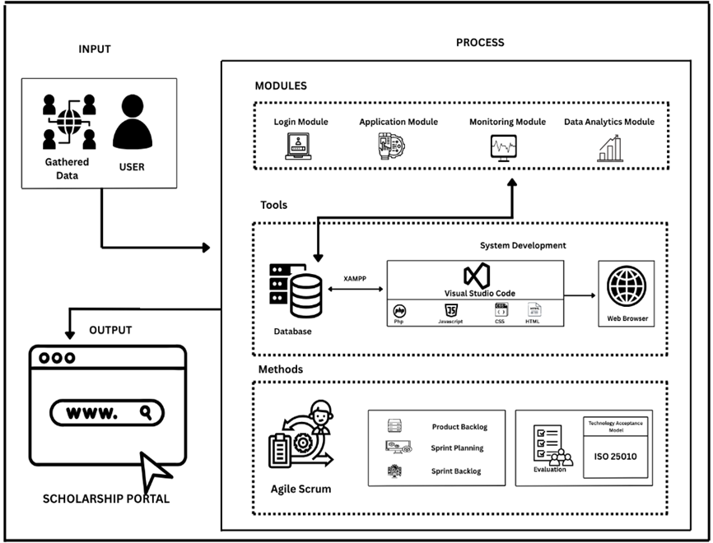
Figure 1. Visual representation of ideas used to structure the system
CHAPTER III
METHODOLOGY

This chapter showed the systematic analysis of the methods used in the study. For the development of the web-based system, variety of methodologies used as a guide and a methodical approach. The project design, business model, project development processes, testing, and evaluation procedures were all included in this chapter.
Project Design
The proponents applied the architectural principles and practices to develop the system architecture that provides insight into the linkages between end-user requirements.
Figure 2 shows the system architecture of the scholarship management system. It is composed of modules such as the Login Module, Application Module, Monitoring Module, and Data Analytics Module. Each module has specific roles and functionalities designed to enhance the user experience and streamline the scholarship application process.
In the Login Module, there are two types of login options: Student Login and Administrator Login. Anyone can view the web-based system and available scholarship programs, but every user must log in with their username and password to apply for scholarships or manage application data.
First, students need to create an account to gain full access to the system. After successful registration, students can log in and access a personalized dashboard where they can fill out application forms, upload necessary documents, and monitor their progress.
Second, administrators can create accounts and log in with their credentials. Once logged in, they are directed to the admin dashboard, which provides tools for reviewing and processing applications, communicating with students, and managing scholarship records. The Login Module will play a critical role in ensuring that only authorized users can access specific system features, thereby protecting user information and application data.
39
The Application Module allow students to apply for scholarships through a digital form. After logging in, students can view a list of available scholarship programs, read their eligibility criteria, and submit required documents such as transcripts, identification, and recommendation letters.
This module also provide a simplified and organized interface where students can track the status of their submissions and be alert to any missing or incorrect information. For administrators, the Application Module include tools for verifying submitted documents, updating application statuses (e.g., under review, approved, rejected), and sending feedback or notifications to applicants.
The Monitoring Module enable real-time tracking of application status. Once a student submits an application, they can return to the system to view updates and progress indicators. Notifications will be sent for status changes, including reviews, approvals, or rejections.
Administrators can use this module to gain an overview of all active applications, prioritize pending reviews, and follow up on submissions that need clarification or additional documentation. This module foster communication and keeps all stakeholders informed throughout the scholarship lifecycle.
The Data Analytics Module help administrators visualize and interpret data using charts and graphs. The system generate insights such as the number of applicants per scholarship, approval rates, and applicant demographics. This information will be valuable for decision-making and helps identify patterns or gaps in program outreach and effectiveness. Reports generated from this module allow scholarship providers to optimize their programs, improve future campaigns, and ensure resources are allocated efficiently. This module focus solely on scholarship-related data and depends on accurate inputs from users for reliable analysis.
40
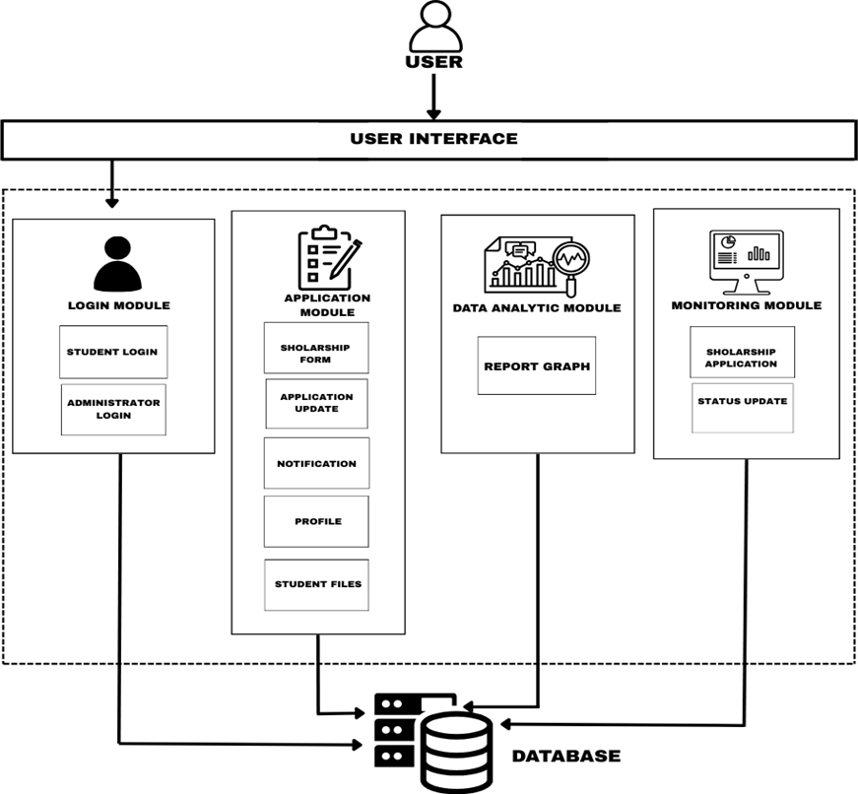

Figure 2. System Architecture
System Flowchart
41
Figure 3 shows the normal system flow during its operation. The system’s first process is for users (students) to create an account if they have not yet registered. After successful registration, the user can proceed to log in. If the username or password entered is incorrect, the system prompt the user to re-enter the correct login details until access is granted. Upon successful login, the user (student or scholarship administrator) directed to the main dashboard of the system.
In the application section, the user (student) able to submit scholarship applications. If the user wishes to apply for a scholarship, they directed to an application form where they can provide the necessary personal information, educational background, and upload required documents. After submission, students can monitor the status of their applications through the system.
The scholarship administrators can view, verify, and manage student applications. They have access to the list of applicants, can update application statuses (e.g., approved, rejected, pending), and communicate with students regarding their application results.
In the profile area, users (students) can update their personal information, view the history of their submitted applications, and track the progress or result of each application. This feature ensures streamlined monitoring process for both students and administrators.

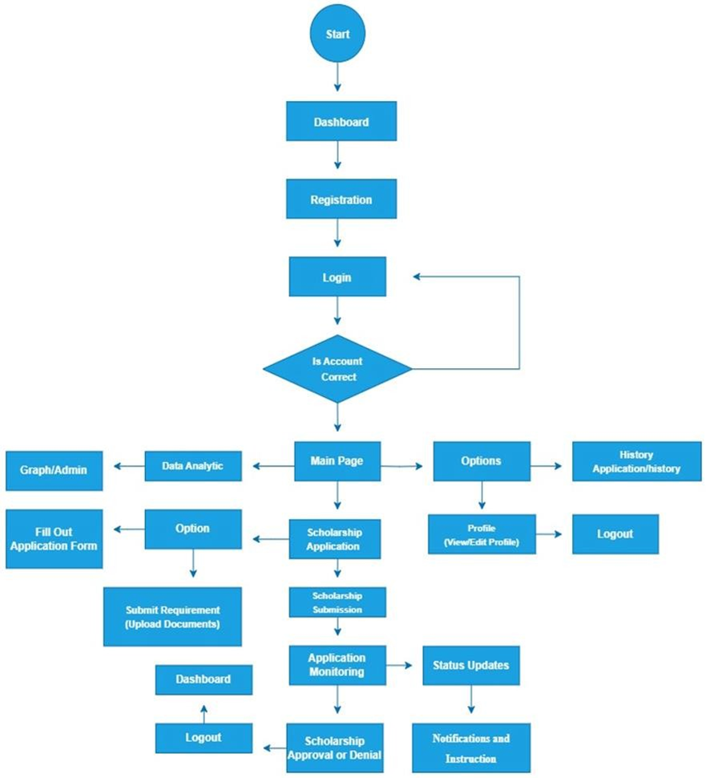
42
Figure 3. Flow of Operations

Use Case Diagram
Anyone can view the web-based scholarship system and browse available scholarship programs, but every student must log in with his/her Username and Password in order to apply for scholarships and track their application status. Once registered, the student/applicant have full access to the system. The student can view all the available scholarships posted in the scholarship section, read detailed information about each scholarship, and apply by filling out the application form and uploading the necessary documents. The student can also track the status of their submitted applications in real-time and receive notifications about updates or results regarding their application.
43
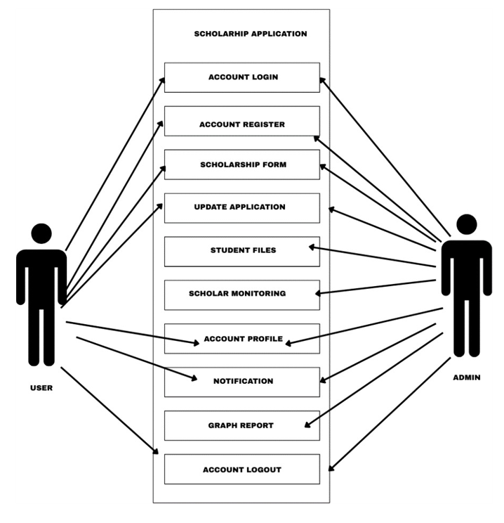
Administrators can also register/login where they have access to the admin dashboard. Through the system’s administration module, administrators can view, add, edit, and delete scholarship listings. Administrators are also responsible for reviewing student applications, approving or rejecting applications based on eligibility, and sending notifications to applicants. Additionally, administrators can monitor overall application activity and generate reports for scholarship analytics and decision-making processes using the data analytics features of the system.

Figure 4. Summarize details of a system and the users within the system.
Business Model
44
The Business Model as shown in Figure 5 for Web-Based System for Scholarship Application and Status Monitoring outlines how the project operates and delivers value to its users and stakeholders. The system provides a digital solution that simplifies and automates the scholarship application process at Laguna State Polytechnic University – Los Baños (LSPU-LB). It replaces paper-based procedures, reduces administrative workload, enhances and improves communication between students and scholarship administrators. It ensures faster processing, secure data management, and real-time updates for all stakeholders.
The project’s key activities include designing and developing the web-based platform, maintaining and updating the scholarship database, implementing automation features for tracking and document verification, conducting user training, and performing system testing and evaluation for continuous improvement. To support these activities, key resources include a skilled development team, web hosting and database servers, development tools such as Visual Studio Code, XAMPP, PHP, HTML, CSS, and JavaScript, along with the university’s IT infrastructure and evaluation models like TAM and ISO 25010.
The main partners involved are the LSPU-LB Scholarship Office as the system owner, the University IT Department for technical support, external scholarship providers for integration, and students and faculty as end-users and testers. The primary customer segments include students applying for scholarships, administrators and evaluators, and government or private sponsors. The system builds strong relationships with its users by ensuring transparency, accessibility, and real-time communication through automated updates and responsive support.
45
It reaches users through the university website, student portal, and email or notifications, complemented by on-campus promotions and orientations. The cost structure covers system development and maintenance, hosting, technical support, security, and continuous updates. For sustainability, the project is funded by the university’s IT development budget or government education grants, with potential partnerships from private scholarship foundations. Over time, it can be sustained through integration into the university’s digital infrastructure and optional service fees for external sponsors.
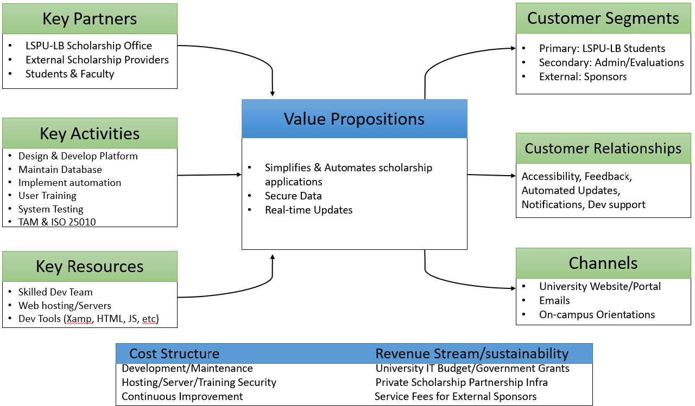

Figure 5. Business Model for the Scholarship Application and Monitoring System.

Materials for Software Development
46
This section shows the software and hardware equipment that used in developing the project.
Software
Listed below is the software to be used by the developers in developing the web-based system including the reasons and features.
Visual Studio Code. Visual Studio Code (VS Code) is a lightweight yet powerful source code editor developed by Microsoft. It supports a variety of programming languages such as HTML, CSS, JavaScript, and PHP, which are essential for building the system. VS Code offers features like syntax highlighting, debugging, integrated terminal, and Git version control, allowing developers to efficiently write, test, and manage the application’s source code. Additionally, VS Code’s wide range of extensions provides enhanced support for React.js and database management, streamlining the development workflow.
React JS. React JS is an open-source JavaScript library developed by Facebook, designed for building dynamic and interactive user interfaces. It enables developers to create reusable components, which act like independent building blocks for the system’s front-end. This modular approach facilitates faster development and easier maintenance of the user interface, improving the overall responsiveness and user experience of the scholarship application platform.
JavaScript. JavaScript is a versatile programming language used on both the client and server sides to add interactivity and dynamic features to web pages. In this system, JavaScript helps create responsive elements such as form validations, dynamic content updates, and real-time user interactions, enhancing engagement and usability beyond the static structure provided by HTML and CSS.
47
HTML. HTML (Hypertext Markup Language) serves as the backbone of the web pages within the system. It defines the structure and organization of content, including registration forms, application details, and monitoring dashboards. Proper use of HTML ensures that the system’s pages are well-organized and accessible, allowing users and administrators to easily navigate and interact with the platform.
CSS. CSS (Cascading Style Sheets) is used alongside HTML to define the visual style and layout of the system’s interface. It controls elements such as colors, fonts, spacing, and responsive design, ensuring the application is both aesthetically pleasing and functional across different devices. CSS enhances the overall user experience by making the interface clean, consistent, and easy to use.
XAMPP. XAMPP is an open-source web server package that includes Apache, PHP, and MariaDB (a MySQL fork). It provides a local development environment that simulates a live web server, allowing the developers to run and test the system on their machines before deployment. Using XAMPP, the proponents manage the database through phpMyAdmin, handling student records, scholarship applications, and administrative data securely and efficiently. This local server setup is essential for thorough testing, debugging, and ensuring system stability during development.
Hardware
Table 2 shows the base required detail of the equipment to foster the undertaking without a hitch. The RAM ought to be basically 8GB to deal with the product that should have been used in fostering the undertaking. Quad-core CPU is utilized on account of substantial programming that is utilized in the undertaking. Windows 10 or 11 operating system is strongly recommended one or two computers will be used during the development of the web-based system.
48
Table 2. Hardware Specifications
Hardware | Specification
RAM | 8GB
CPU | Intel iCore3
OS | WINDOWS 10/11

Table 3 shows the minimum requirements specifications for pc and laptop in order to run the system smoothly and without error. Since some products are incompatible with more recent operating system versions, Windows 10 and 11 operating systems is strongly recommended. Also, the system requires browser and internet connectivity to have fully access to the system.
Table 3. Minimum Requirements for PC or Laptop
Minimum Requirements For Pc  or Laptop | Specification
OS | WINDOWS 10
RAM | 4 GB
HARD DISK | At least 2GB free space
PROCESSOR | Intel Celeron

Table 4 shows the minimum requirements specifications for smartphones and tablets in order to run the developed system smoothly and without error. It used for testing the system during the development phase. Since some products are incompatible with more recent operating system versions, Android 9 operating system is strongly recommended. Also, the system will require a browser and internet connectivity to have full access to the system.
49
Table 4. Minimum Requirements for Smartphone or Tablet
Minimum Requirements For  Smartphone Or Tablet | Specification
Android OS | Android 10 and older
RAM | 4 GB
BROWSER | At least 2GB free space
PROCESSOR | Quad – core

Project Development
To effectively design and create the web-based system, the proponents employed the agile software development life cycle methodology. The agile scrum methodology is a way to manage the development of the project by breaking it up into several phases. It involves constant collaboration with end- users and continuous improvement at every stage.
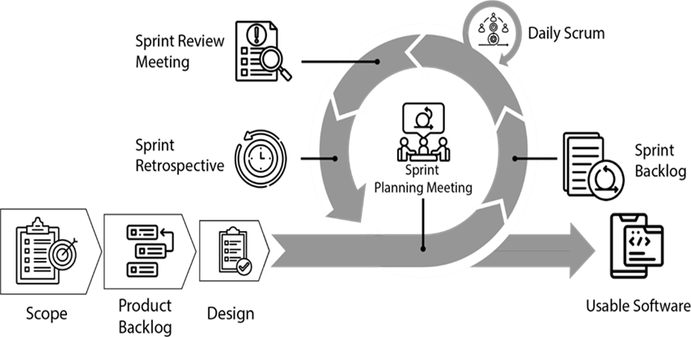
Figure 5 shows the Agile Scrum, which is a project management that promotes incremental progress. Each cycle is divided into two-to-four-week sprints in order to finish the most important features first and perhaps produce a deliverable system.

Figure 6. Agile Scrum Methodology
Scope
50
The initial scope of the system is within the students and administrators. The web-based system solely collects scholarship application data/documents from students of the institution. Students are able to input all necessary information and upload required documents for the scholarship they wish to apply for. Administrators are able to review, monitor, and manage scholarship applications within the system. Students may track the status of their applications in real-time, while administrators can efficiently manage and process applications without the need for manual paperwork.
Design
Planned to eliminate the traditional, manual processing of scholarship applications and monitoring. Created a storyboard to guide the development and design of the modules, features, and content, ensuring the system is user- friendly and simple to navigate. This approach supports the creation of an efficient application that streamlines student assistance, enhances tracking, and simplifies communication between students and administrators.
Product Backlog
Table 5 shows the Product backlog, which is a list of things to be done within the project. The proponents put the things that they want to see in the system as a student. And also, the proponents estimated the hour/per day for every task. For the beginning of the project, naturally, the product backlog is the first phase’s method that is required. It gathered client information and a list of procedures for developing the system. Mainly it includes the procedure of the administrator or the user to work and perform in the system. It must be a generalized task and involve the possible performance of the project.

Table 5. Product Backlog (for student)
51
Priority | USER AS STUDENT STORY | Est. hr/day
1 | As a student, I want to register and log in to the system. | 3hrs
2 | As a student, I want to view available scholarships. | 3hrs
3 | As a student, I want to apply for a scholarship. | 4hrs
4 | As a student, I want to upload necessary documents for my application. | 4hrs
5 | As a student, I want to track the status of my scholarship application. | 3hrs
6 | As a student, I want to receive notifications regarding my application updates. | 2hrs

Table 6 outlines the Product Backlog for the administrator side of the Web-Based system for Scholarship Application and Status Monitoring for Streamlined Student Assistance and Application Tracking. This backlog captures the essential administrative tasks and responsibilities that ensure the system operates efficiently and securely. Each user story represents a specific function or process that the administrator must perform, such as managing student accounts, handling scholarship information, validating applications, and maintaining communication through notifications or announcements.
Additionally, the administrator must be able to generate reports to track the status and progress of scholarship applications for documentation and decision-making purposes. This set of tasks is crucial to maintain the integrity of the scholarship process, enforce application requirements, and ensure that only eligible and complete applications are processed. The estimated hours per day provide an initial basis for resource planning and task scheduling during development. This helps ensure that the system supports the seamless operation of scholarship application and monitoring from the administrative perspective.
52
Table 6. Product Backlog (for Administrator)
Priority | USER AS ADMIN STORY | Est. hr/day
1 | As an admin, I want to log in securely to access the system. | 3 hrs
2 | As an admin, I want to manage student accounts and verify their registration details. | 4 hrs
3 | As an admin, I want to create, update, and remove scholarship listings. | 4 hrs
4 | As an admin, I want to review and validate student applications. | 4 hrs
5 | As an admin, I want to monitor submitted documents for completeness. | 3 hrs
6 | As an admin, I want to update the status of scholarship applications. | 3 hrs
7 | As an admin, I want to send notifications or announcements to students. | 2 hrs
8 | As an admin, I want to generate reports on scholarship applications and approvals. | 4 hrs

Sprint Planning
As stated in the sprint backlog, which outlines the functionalities the developers are able to execute in the coming sprint, items are moved from the product backlog to the sprint backlog, a list of features that need to be built. Table 7 shows the specific tasks assigned to the developers and the estimated hours per day spent on building each part of the system for student users. All the modules follow four essential plans. The first plan is planning how to develop the system, where the team identifies the necessary steps and strategies for each feature. The second plan is coding, where every module were program based on its requirements and functionalities.
The third plan is designing and coding the user interface; during this phase, developers ensure that the layout and features match the expectations and needs of the students. Lastly, the fourth plan is testing and debugging, the most crucial part of the process. In this phase, developers and researchers check if the system functions as expected, detect errors, and fix any bugs before final deployment.
53
Table 7. Sprint Backlog (Student)
Priority | Story | Task | Est. hr/day
1 | As a student, I want to register and log in to the system. | Design and develop the student registration and login module. | 3 hrs
2 | As a student, I want to view available scholarships. | Create a page to display all available scholarships to students. | 3 hrs
3 | As a student, I want to apply for a scholarship. | Develop a form where students can submit scholarship applications. | 4 hrs
4 | As a student, I want to upload necessary documents. | Integrate a document upload feature for scholarship requirements. | 4 hrs
5 | As a student, I want to track my scholarship application status. | Design a dashboard for viewing application status updates. | 3 hrs
6 | As a student, I want to receive notifications regarding my application. | Create a notification system for real-time updates on application progress. | 2 hrs

Table 8 shows the highlights of the survey's current sprint backlog. Here is a list of all the items that the team needs to do before the next sprint. Priority lists are user-requested items that are created based on user needs.
54
Table 8. Sprint Backlog (Administrator)
Priority | Story | Task | Est. hr/day
1 | As administrator, I want to  login to the system. | Design and develop a  login page. | 2hrs
2 | As administrator, I want to  create/set-up set up an scholarship system | Develop and design profile for admin. | 3hrs
3 | As administrator, I want to upload files online | Design and develop a function where admin can upload files to the  system. | 8hrs
4 | As administrator, I want to view data/information | Develop a function to the system where admin can view data/ information regarding  products. | 5hrs

Daily Scrum. The proponents assembled a meeting, 15 minutes a day to reach the sprint target, determine if any changes to the sprint or the product backlog are required.
Sprint Execution. The proponents meet the client/user to discuss what they can provide and how the developers do it in order to fulfill their sprint objective. This help the proponents to estimate the amount of work of the proponents have ahead of them and put the project up for success.
Sprint Review Meeting. The proponents assembled a meeting per week to go over the work that been accomplished and see if any modifications are required. The proponents display the accomplished work whether there are missing features or want to add for the system to be fully completed.
Sprint Retrospective. Each week, the proponents focused on accomplishing 2-3 key priorities related to people, tools, processes, and relationships. The focus is in developing the user interface and functionality for the scholarship application and monitoring system, with 50% of this work completed during the first month of development. The proponents have also created an improvement chart, which outlines the steps and strategies to be followed in building the system.
55
This chart serves as a roadmap to track progress, make necessary adjustments, and optimize the development process for better efficiency and outcomes.
Project Testing and Evaluation
The proponents used different kind of testing to ensure the quality and integrity of the system. Software testing in this level were all the component of
modules of the mobile application are all tested and examine in order to make sure that the developed system and it perform as designed.
Software Testing
Figure 7 depicts the stages of software testing at which individual software units/components are tested. The objective is to verify that each component of the software functions properly. This shows the levels of software testing where in the software's constituent units and components are tested. The aim is to guarantee that each software component performs as planned. The smallest testable element of any piece of software is called a unit. It normally has a single output and one or more inputs. An individual program, function, method, or anything else could all be considered units in procedural programming. A method, which can be a part of an abstract class, derived/child class, or base/super class, is the smallest unit in object-oriented programming. Unit testing (UT) has benefits such as boosting confidence when developing and maintaining code. The researcher's objective is to disassemble the system and test each component separately. It establishes whether or not components perform as intended.
56
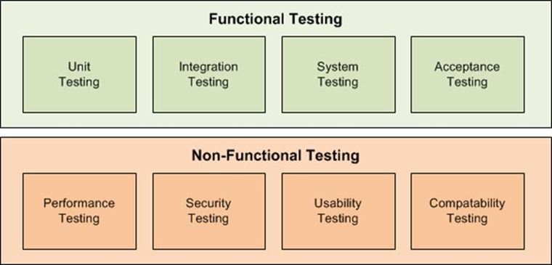

Figure 7. Levels of Testing

Unit Testing
In software testing, each module or component of the system were tested. The system guaranteed that it create in line with the plans of the developers. Furthermore, the system put each component through its paces, focusing on its primary function.
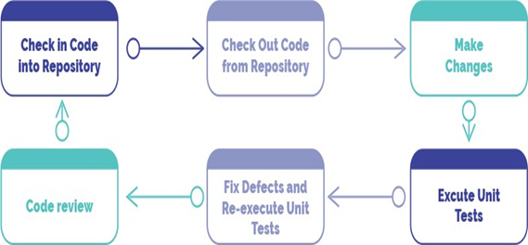

Figure 8. Unit Testing

Integration Testing
57
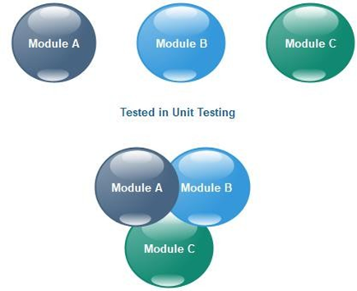
The Integration Testing process, illustrated in Figure 8, aimed to ensure that all modules specified in the system design functioned correctly when combined. During this phase, the proponents thoroughly examined the interaction between individual system components to detect defects, resolve issues, and verify proper data flow and functionality. This testing phase confirmed that all integrated modules operated cohesively and performed according to the system’s intended design.

Figure 9. Integration Testing

Acceptance Testing
The Acceptance Testing is depicted in Figure 16. It is the process of testing the created project agreed upon by the user. It is approved when the proponents satisfies the needs of the users. Everything about the system, including the design, is put through its paces here. The proponents do formal testing for user needs and requirements in order to determine whether a system fulfills the acceptance criteria and to let the user to select whether or not to accept the system.

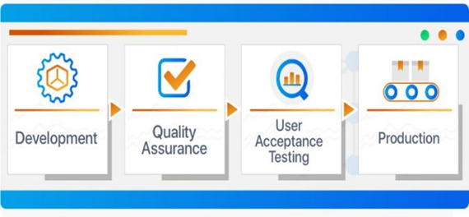
58

Figure 10. User Acceptance Testing

Evaluation Procedure
Standards, such as ISO 25010, which outline the key aspects of product quality are in place to ensure the quality of the system to be developed. The quality model that is regarded as the cornerstone of a system for evaluating the quality of products is described in the ISO 25010 standard. Eight quality characteristics that characterize a software product's features for evaluation make up the ISO 25010 product quality model which is shown in Figure 11.
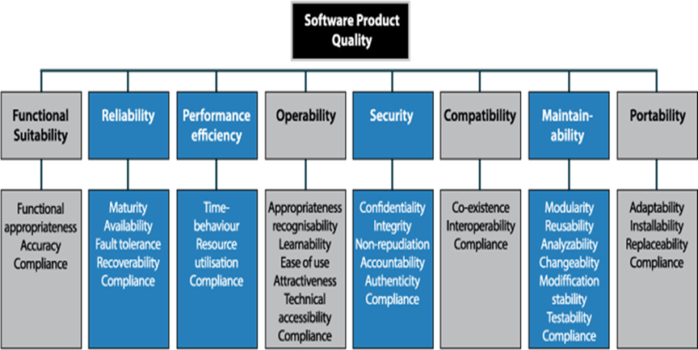

Figure 11. Quality Characteristics of ISO 25010
The respondents and IT experts evaluated the developed project by using ISO 25010 software standard to study and learn about the performance and general features of the web-based system. The most popular way to determine the consistency of any program is ISO 25010. Assessments should include both functional and non-functional aspects, as well as internal and external design and structure.
59
For evaluating the system to be develop, the developers do beta test for the users and IT specialists. The developers used the ISO 25010 quality model as standard for Likert Scalar. The Functional Suitability, Performance Efficiency, Compatibility, Usability, Reliability, Security, Maintainability, and Portability are the basis on testing the Web-based Employee Profiling Management System. Likert Scalar is answerable by four responses which is SA = Strongly Agree, A = Agree, D = Disagree and SD = Strongly Disagree.
Functional Suitability. One of the most important parts is software, which must suit the goals and needs of the user. To achieve consumer approval of the solution as effective and efficient, the developers able to demonstrate that the product can solve the user’s problem.
Performance Efficiency. Despite the fact that software execution is an important factor in selecting a great product to use, most purchasers did not spend much time thinking about it. Because programming necessitates resources that commonly operate at high rates, the act of programming usually represents the capability of programming.
Compatibility. The process of ensuring the client’s satisfaction by determining if the site will work in a variety of browsers, operating systems, and platforms.
Usability. The product’s worth and utility are readily apparent to the users. The developers designed the application to help users, such as sellers.
60
Reliability. As part of the process of evaluating the quality through analysis and determining if it is accurate, an IT specialist examined the application’s reliability.
Maintainability. The IT professional examined the application’s standard capacity to see whether it requires any maintenance or stability.
Portability. Developers make sure that a system, product, or component's effectiveness and efficiency can be moved from one hardware, software, or other operational or consumption environment to another. One of the factors is the mobile application's flexibility and replaceability.
Furthermore, initial testing was conducted by the developers during the development of the web-based system in order to discover some flaws. To make sure that the system run smooth, the developers tested every module and functionalities of the application using the created planned procedure to check and examine the accuracy, reliability, efficiency, effectivity, use friendliness and complete functionality in order to know if the mobile app achieved the and meet feat the desired features and requirements given by the end-user.
Population of the Study
The population of the study as shown in Table 9 consist of scholarship office chairperson and staff, students, and IT experts who evaluate and test the system. Since they are the ones who’ll use the system, which are the respondents and the distribution of questionnaires are practical.

Table 9. Respondents of the Research Project
61

Category of Respondents | Sample
Scholarship Office chairperson and staff | 2
Scholar | 83
IT Expert | 3
Total | 68

The respondents to the research as mentioned above who demonstrate, analyze, and evaluate the feasibility of developing a web-based system, as well as the overall performance and features of the produced web- based system. The assistance of an information technology specialist that is knowledgeable about the developed web-based system were involved in analyzing and evaluating the performance of the system.
Sampling Design
Purposive sampling is a testing method in which the analyst selects individuals from the surrounding area to participate in the evaluation based on their own assessment. This type of non-probability sampling were used because it allows gathering data from subjects who are easy to reach in a short amount of time. This study had a total of 88 respondents. It consists of two (2) administrators from scholarship office, eighty-eight (88) scholars of LSPU-LB and three (3) IT experts/professionals knowledgeable about the web-based system.
Data Collection Instrument
The data were gathered using a questionnaire and survey that had an impact on the project's outcomes. The respondents were given a questionnaire survey by the developers in order to collect data that would be used as the basis for the construction of web-based system. A conducted interview were also used as tools used to collect data for this study. The interview questions focused on developing a strategy that addressed the needs and preferences of the users. Questions was based regarding the web-based system's design and functionalities to meet the end-user requirements. The evaluation of the application was done by distributing two types of questionnaires to the respondents. The set 1 questionnaire consists of 10 questions about the system’s functionality in meeting the needs of the users. The design, accessibility, portability, data relevancy, and recognizable interface of the application were the focus of the questions. The set 2 questionnaire comprised of criteria/characteristics based on the ISO 25010 software evaluation. Physical copies and Google Form questionnaires were made.
62
Statistical Treatment
The proponents used population sampling, a type of purposive sampling technique in which the entire number of target respondents was gathered and analyzed, to test and evaluate the previous features and overall performance of the system to be developed.
The stratified sampling technique was also employed, which divides the population into several groups based on the type of respondent. In addition, the proponents utilized the Likert Scale method to assess the application’s features. The evaluation consisted of a series of questions answered using four response options, arranged as follows: four (4) – Strongly Acceptable, three (3) – Acceptable, two (2) – Not Acceptable, and one (1) – Strongly Unacceptable. To eliminate bias and prevent data misinterpretation, ambiguous responses were excluded.

Statistical Analysis of Data
63
The frequency of each response was determined by the number of respondents that answered the particular item.
The Likert Scale was utilized by the proponents as a survey technique, as shown in the table above. It was used to assess the end users’ satisfaction with the system. The percentage approach was also employed by the proponents to measure the respondents’ evaluation dimensions. The formula used was as follows:

% = x 100
Where
f = frequency
N = Total number of Respondents
This project used the Likert Scalar method to evaluate and analyze the gather data.
For TAM:
x = (SA*4) + (A*3) + (D*2) + (SD*1)
N
Where
x = Mean
N = Total Number of Respondents
SA = Strongly Agree
A = Agree
D = Disagree
SD = Strongly Disagree

Table 10. Evaluation Degree, Range and Description for TAM
64
Degree | Range | Description
4  3  2  1 | 3.26 – 4.00  2.51 – 3.25  1.76 – 2.50  1.00 – 1.75 | Strongly Agree  Agree  Disagree  Strongly Disagree
For ISO 25010:
x = (E*5) + (G*4) + (F*3) + (NI*2) + (P*1)
N

Where:
x = Mean
N = Total Number of Respondents
E = Excellent
G = Good
F = Fair
NI = Needs Improvement
P = Poor
Table 11. 5-Point Likert Scale to evaluate system quality using ISO 25010
Degree | Range | Description
5  4  3  2  1 | 4.21 – 5.00  3.81 – 4.20  2.61 – 3.80  1.81 – 2.60  1.00 – 1.80 | Excellent  Good  Fair  Needs Improvement  Poor

Ethical Consideration
In developing and implementing the Web-Based System for Scholarship Application and Status Monitoring, the proponents ensured that all ethical standards were carefully observed. The privacy and confidentiality of applicants’ personal information were treated with the highest level of protection. Data collected through the system were used solely for scholarship evaluation and monitoring purposes and were not shared with unauthorized individuals. Participants were informed about the purpose of the system, and their consent was obtained before any data collection. The researchers also ensured fairness, transparency, and integrity throughout the process, avoiding any form of bias or discrimination. The project was guided by ethical responsibility, respect for users’ rights, and a commitment to maintaining trust and accountability in all aspects of the study.
65

CHAPTER IV

RESULT AND DISCUSSION
This chapter presents the results and the discussion to support the methodology utilized in the achievement of the objectives.
Results by Objectives of the Study
1. The platform enabled students to apply for scholarships, upload required documents, and receive real-time updates on their application status and results.
The developed platform offered students an easier and faster way to apply for scholarships without the hassle of paperwork or long lines. Through the online system, students could fill out forms, upload required documents, and submit their applications anytime and anywhere with internet access as shown in Figure 12.
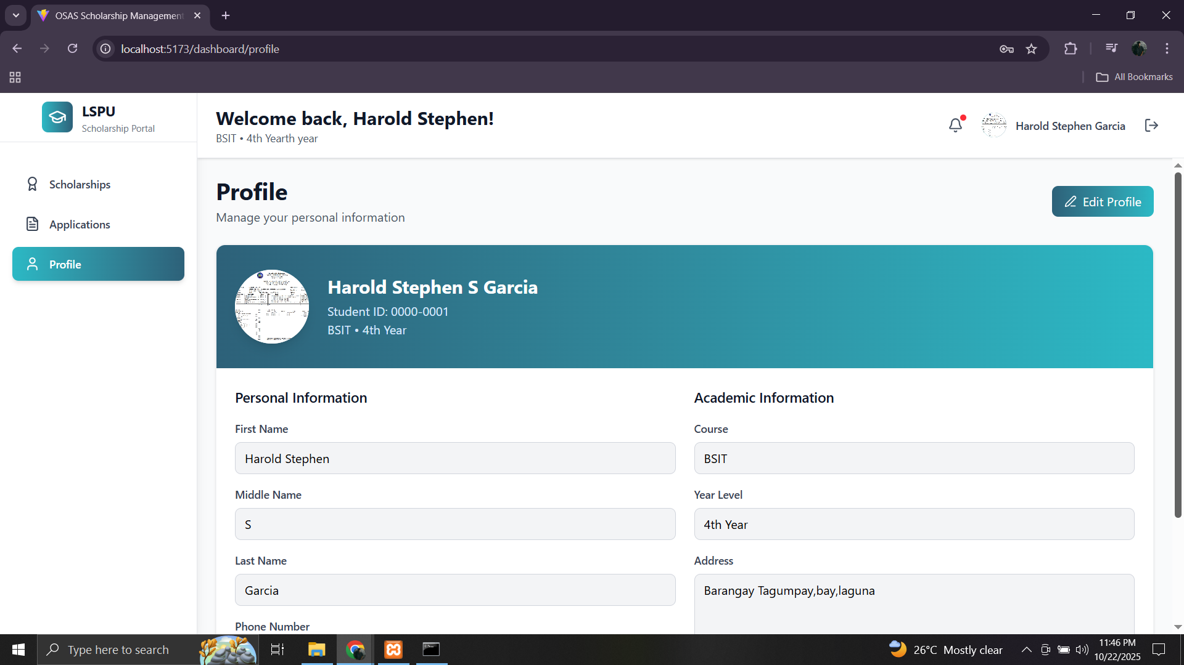

Figure 12. User interface for student application form

This convenience eliminated the need for manual submission and reduced errors caused by incomplete or misplaced requirements. The user-friendly interface guided students step-by-step, ensuring that they met all necessary qualifications and requirements before submission. The platform simplified the scholarship application process, saving time and effort for both students and scholarship administrators.
67
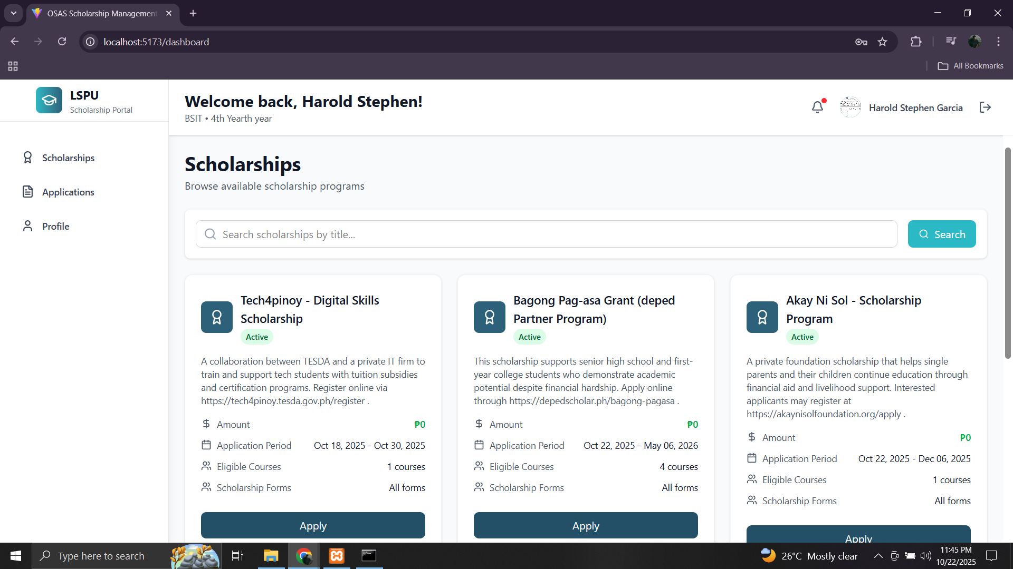
Figure 13 shows the Scholarship Dashboard section of the developed platform, where applicants can conveniently browse and select from a list of available scholarship programs after completing their application details. Each scholarship card displays key information, such as the name of the program, description, application period, eligible courses, and scholarship forms, allowing applicants to make informed choices.

Figure 13. User interface for Scholarship Dashboard

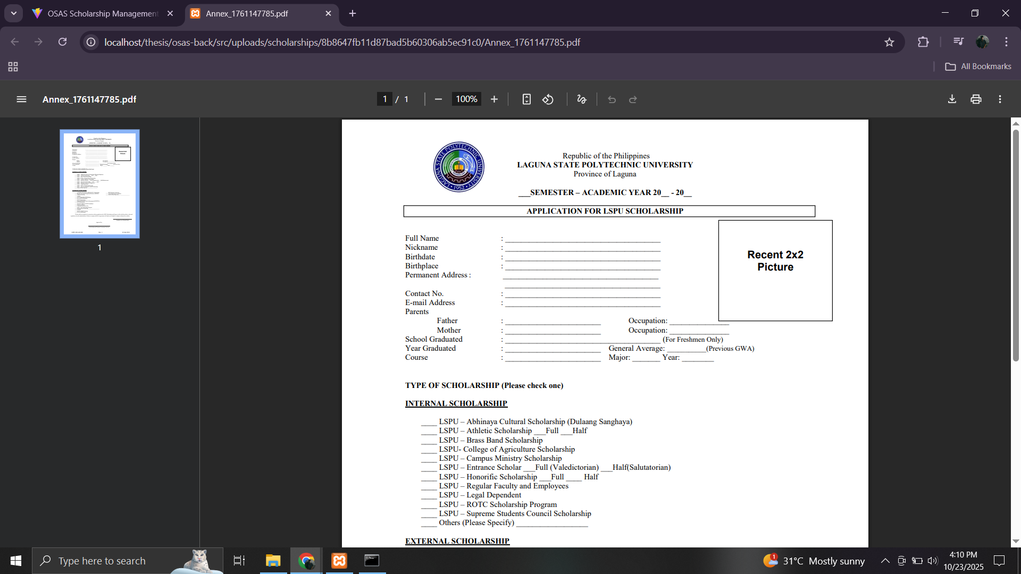
The interface is designed to be user-friendly, with clearly labeled buttons like “Apply” that enable students to fill-up and submit their applications directly to their chosen sponsor as shown in Figure 14. A search bar at the top helps filter scholarships by title, making navigation easier and faster.
68

Figure 14. User interface for digital form for scholarship application

Through this system, students can view multiple scholarship sponsors (such as Tech4Pinoy Digital Skills Scholarship, Bagong Pag-asa Grant, and Akay Ni Sol Scholarship Program), compare eligibility and benefits, and select the most suitable one based on their qualifications. The platform streamlines the selection and application process, ensuring accessibility and efficiency for both students and scholarship administrators. Once the application was submitted, the platform allowed students to track the status of their scholarship applications in real time as shown in Figure 15. Instead of waiting for updates or visiting offices for inquiries, students could simply log in to their accounts and see whether their application was received, under evaluation, or approved. This function helped minimize uncertainty while keeping applicants informed every step of the way. By providing access to detailed progress reports, the system encouraged accountability among administrators and fostered trust between students and the scholarship office, ensuring a smoother and more organized application process.
69
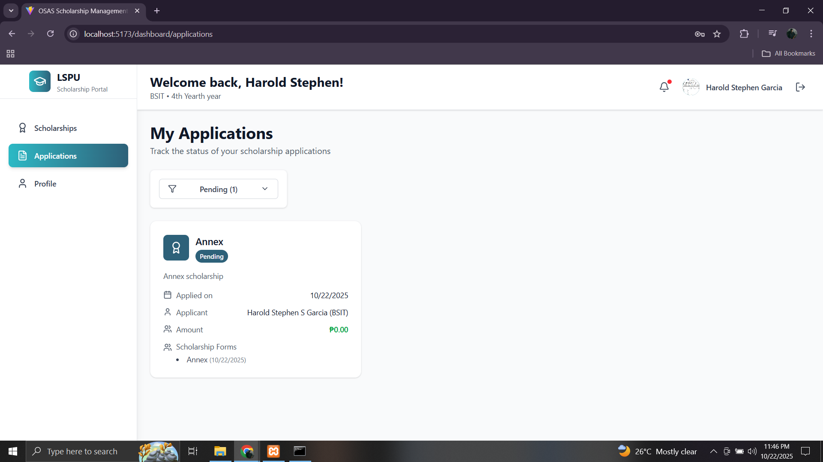

Figure 15. User interface for tracking the status of application

The platform’s automated notification feature ensured that students never missed any important updates regarding their applications. Whether it was a reminder to complete missing requirements, an update on application status, or an announcement of results, students received instant notifications via the system or email. This automation saved time and reduced the need for manual communication between students and administrators. It also promoted efficiency and accuracy in managing scholarship information. By keeping students consistently informed, the platform fostered a sense of engagement and reliability, making the entire scholarship experience more organized and stress-free.
2. Established monitoring module that enables scholarship coordinator and university staff to efficiently review, validate, and approve applications.
The centralized management system provided scholarship administrators with an organized and efficient way to handle a large number of applications. Instead of relying on manual paperwork, all application data could now be accessed and managed digitally in one secure platform. This made it easier to monitor application status, categorize submissions, and track applicant progress as shown in Figure 16. The system reduced redundancy and human error while saving time in data entry and verification. With all information centralized, administrators could quickly generate reports, identify qualified applicants, and make better data-driven decisions. it improved workflow efficiency and ensured that every scholarship application was properly managed from submission to approval.
70
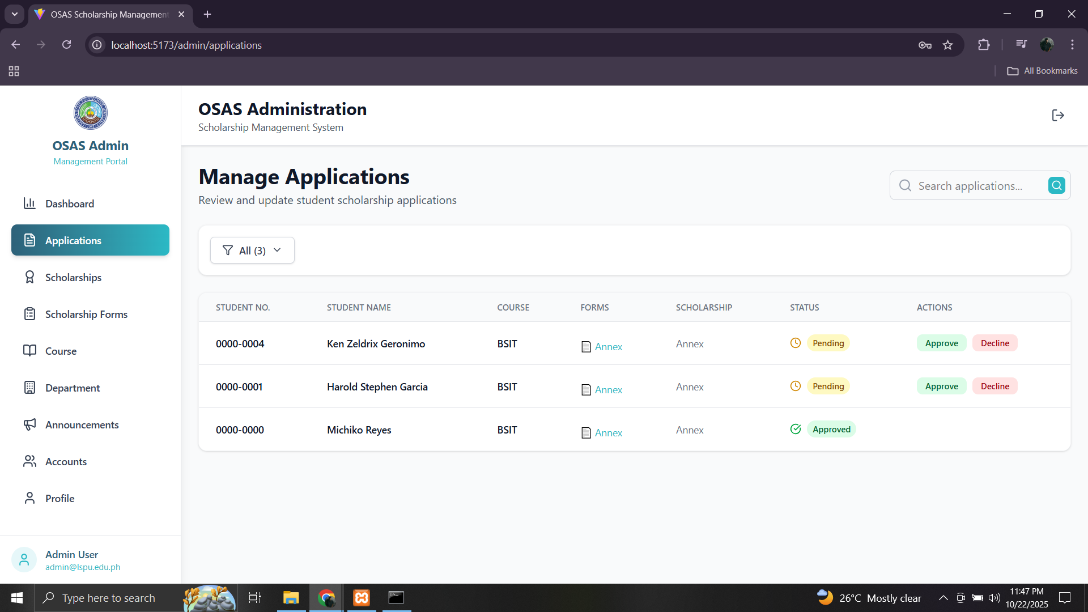

Figure 16. User interface for managing applications

Through the system, scholarship administrators could easily review and verify submitted documents directly online. Each applicant’s files such as grade reports, income certificates, and recommendation letters were securely uploaded and stored in the system for easy access. This eliminated the need for physical storage and manual sorting of documents, significantly speeding up the review process. The platform also allowed administrators to filter and organize files by category, ensuring no requirement was missed or misplaced. Notifications could be sent automatically to applicants if a document was incomplete or needed correction. This digital process not only improved accuracy and efficiency but also promoted transparency and accountability in the review of scholarship requirements.
71
Figure 17 presents the OSAS Administration Dashboard of the Scholarship Management System, serving as the central workspace for administrators overseeing scholarship applications. This interface enables administrators to conveniently access, review, and manage vital information submitted by student applicants, including their school ID, certificate of registration, certificate of indigency, and other required documents. Each application record is systematically organized, allowing for efficient tracking of application status, quick verification of document completeness, and streamlined management of scholarship processes to ensure accuracy, transparency, and ease of use within the administrative workflow.
The system also provides real-time visibility into the status of each scholarship application, clearly indicating whether it has been approved, is still pending, or requires additional information. This feature allows administrators to efficiently process and monitor applications while ensuring transparency and accountability throughout the evaluation process. By consolidating all required documents and records into a single, centralized digital platform, the system significantly reduces manual paperwork, minimizes human errors, and enhances operational efficiency.

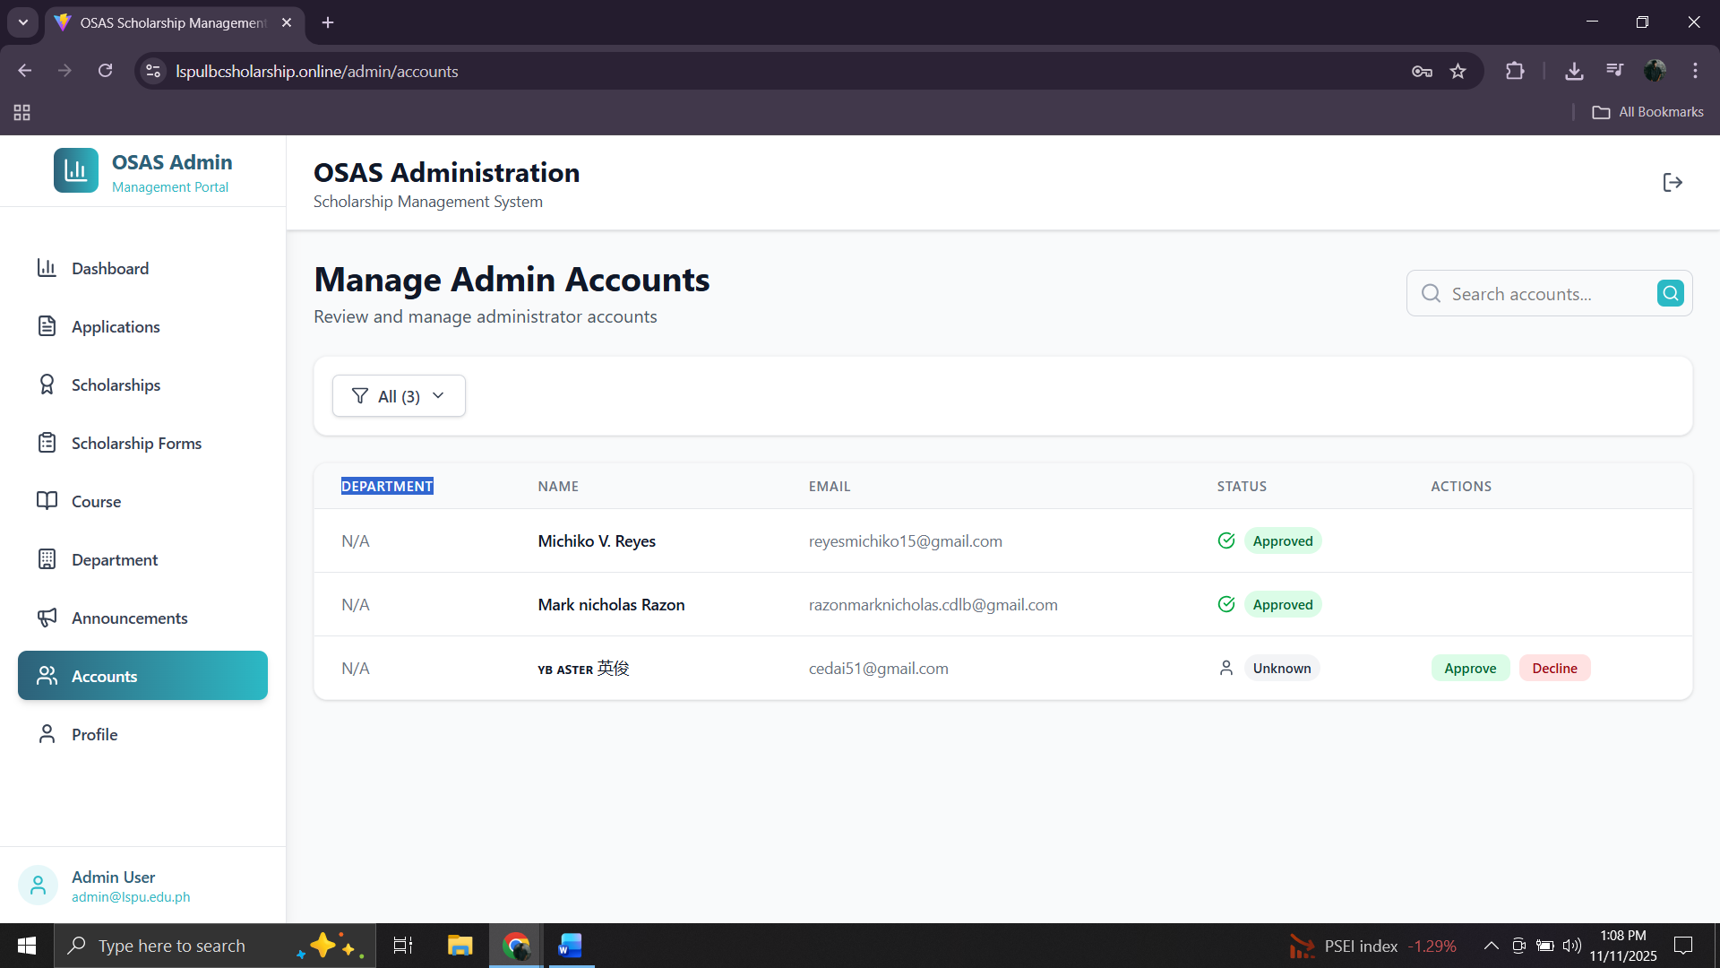
72

Figure 17. Administration Dashboard of the Scholarship Management System

The Administrator Account Management section as shown in Figure 18, this feature allows the main administrator to review, manage, and approve other admin accounts who will also handle scholarship-related tasks. Each account entry displays essential details such as the name, email address, department, and current status of the admin user. From this interface, the main administrator can easily approve or decline pending admin account requests to ensure that only authorized personnel gain access to the system. This promotes security, accountability, and proper access control within the scholarship management process. The interface’s clean and organized layout makes it simple to monitor account statuses showing approved users in green and pending ones with action buttons. This feature strengthens the system’s data protection and administrative integrity by ensuring that only verified and responsible individuals are granted access to sensitive scholarship data. It enhances collaboration among authorized staff while maintaining a secure and well-regulated digital environment for managing scholarship operations.
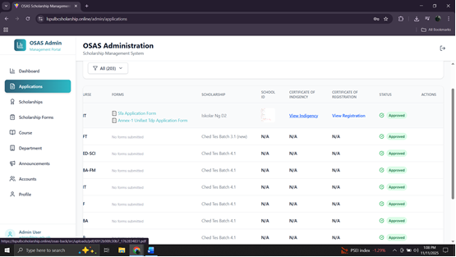
73
Figure 18. Administrator Account Management

3. Integration of a data analytics feature allowing the system to generate comprehensive analytical reports and visualizations.
Figure 19 showcasing the system’s data analytics feature for scholarship management. It provides administrators with a clear, visual summary of key metrics such as the total number of students, scholars, applications, and pending applications. These data points are displayed in real time, helping administrators quickly assess the overall status of scholarship operations. The dashboard also includes graphical representations, such as the Monthly Applications and Scholars chart, which tracks the number of applicants and approved scholars over time. This visual insight allows administrators to identify trends, such as peak months for submissions or changes in applicant volume. Additionally, the Most Popular Course section highlights which academic programs have the highest number of scholarship applications providing valuable information for planning and resource allocation. This figure demonstrates how the integration of data analytics transforms raw scholarship data into meaningful insights. It helps administrators monitor performance, improve decision-making, and ensure transparency and fairness in scholarship distribution.
74
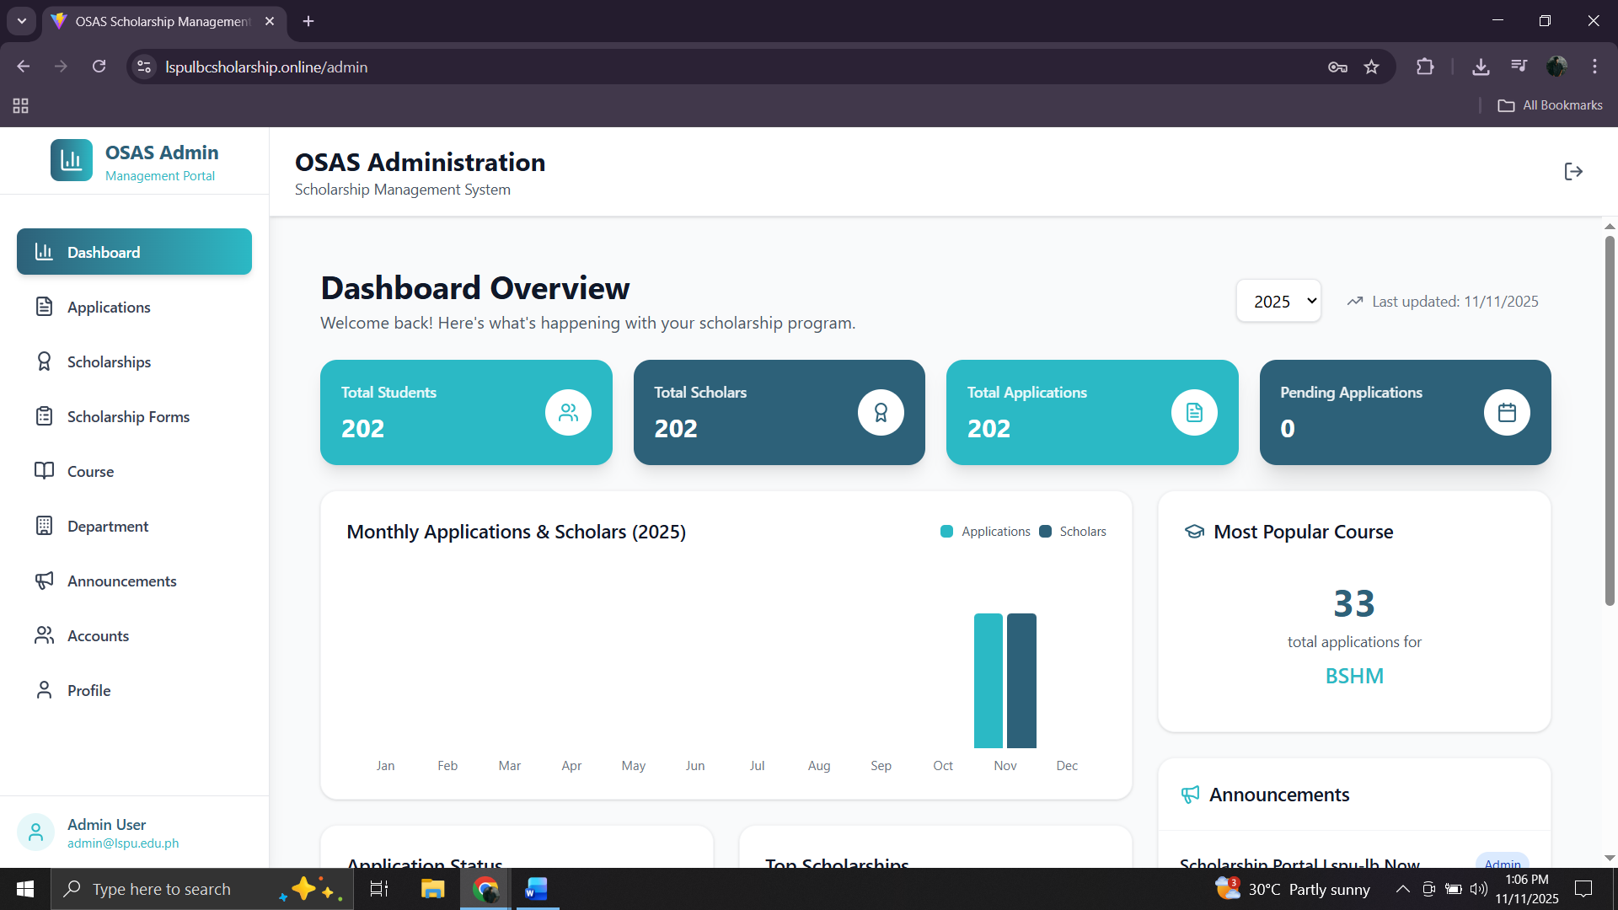

Figure 19. System’s data analytics feature for scholarship management

Figure 20 is part of the system that highlights the data analytics feature that provides administrators with a quick and visual overview of scholarship applications. On the left side, the Application Status panel summarizes the total number of approved applications, which in this case is 202. This data insight helps the admin easily track the progress of application approvals and assess how many students have successfully qualified for scholarships. On the right side, the Top Scholarships panel ranks the most active scholarship programs based on the number of applicants.
The data shows that Ched Tes Batch 4.1 has the highest number of applications at 182, followed by Ched Tes Batch 15 with 10 applications, while several other batches such as 12.5, 5.1, and 8.1 each have 2 applications. This ranking provides valuable analytics on which scholarship programs attract the most interest and participation from students. This visualization makes data interpretation more intuitive. It enables the administraotr to quickly identify trends, monitor application statuses in real time, and make data-driven decisions for improving scholarship management and outreach efforts.
75
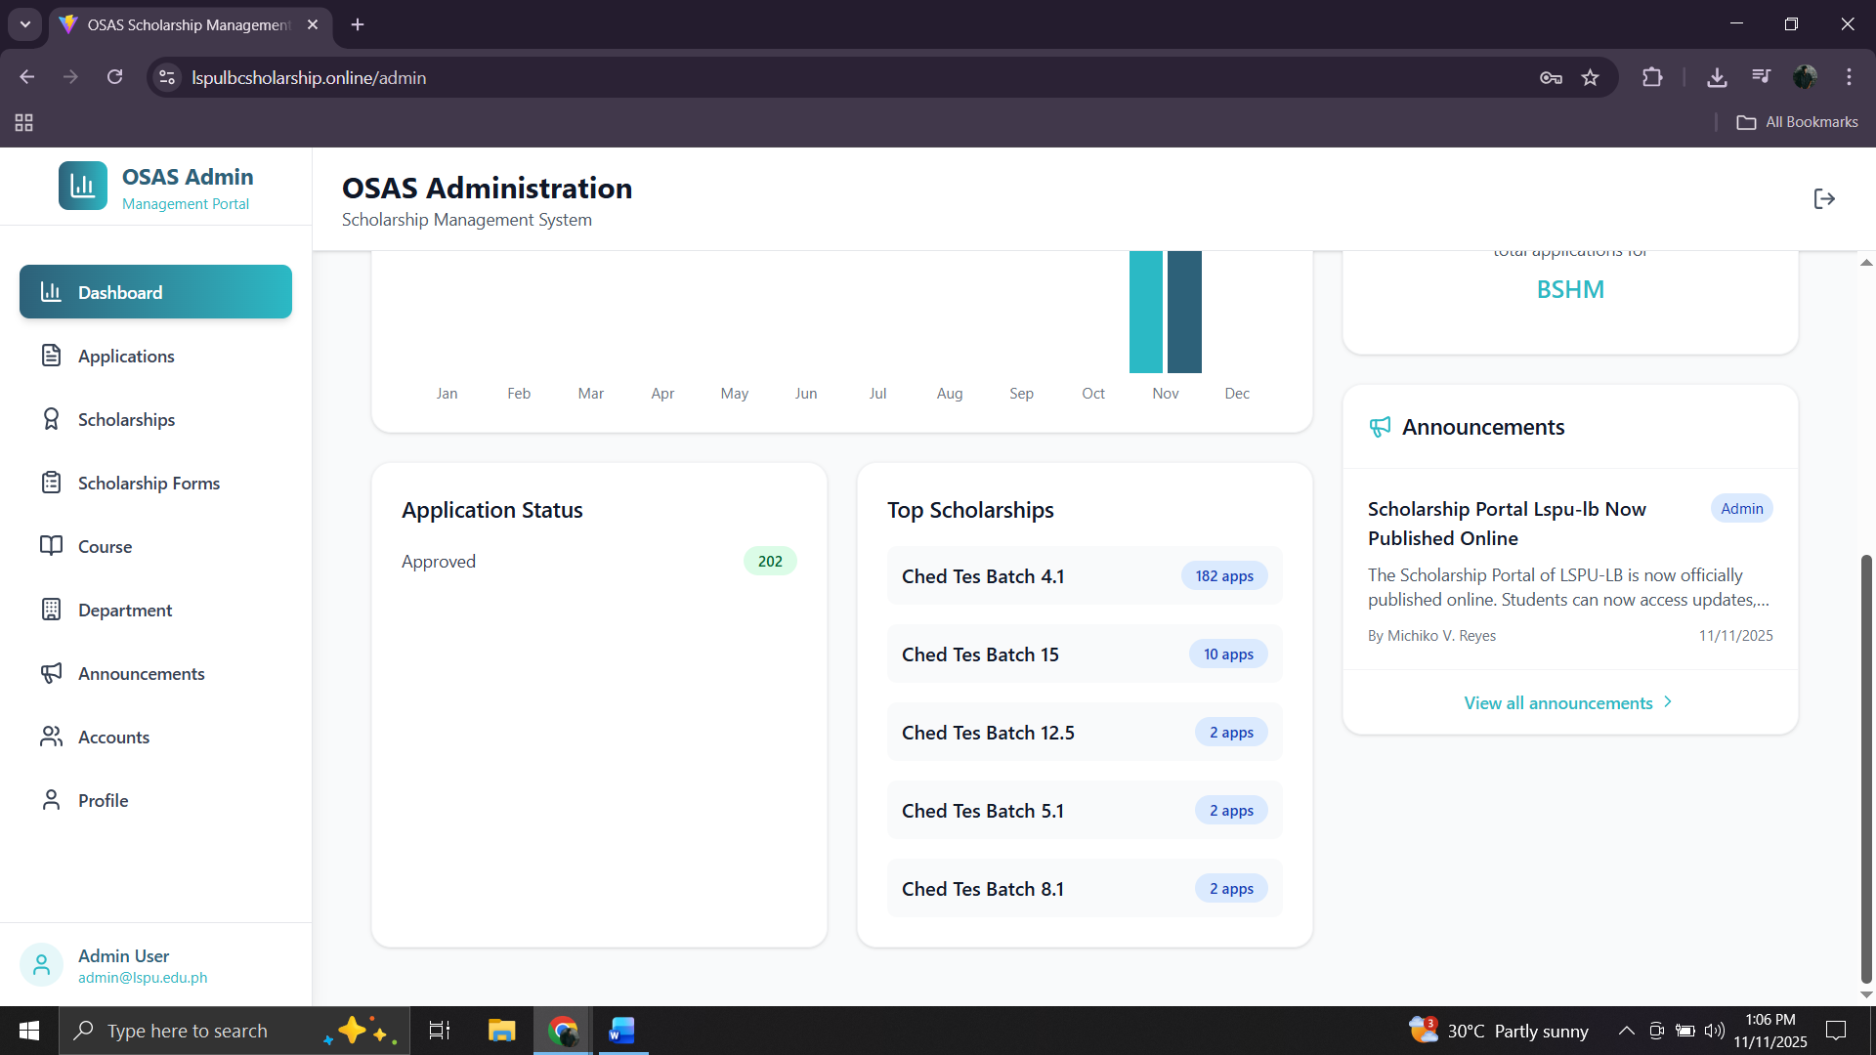

Figure 20. Visual overview of scholarship applications

4. Evaluation results using TAM and ISO 25010 software product standards to verify its efficacy and quality.
Table 12 reveals generally positive user perceptions of the system, with an overall mean score of 3.6, indicating strong agreement. It shows how users perceive the usefulness of a system designed for scholarship application and status monitoring to streamlined student assistance and application tracking with all items receiving a mean score close to 4, which corresponds to "Strongly Agree." The highest-rated statement (mean = 4.0) highlights the system’s role in improving efficiency, suggesting users strongly believe it makes scholarship application easier and more effective. Statements about tracking scholarship application also scored high (3.5), emphasizing the system's reliability and accuracy. Interestingly, while users still agreed the system helps the process in the application so easy, this item had the lowest mean (3.4) and highest standard deviation (±0.77), indicating a bit more variation in opinions. With a composite mean of 3.6, it’s clear that users find the system highly beneficial in scholarship operations.
76
Table 12. Perceived Usefulness
Perceived Usefulness | Mean | SD | Interpretation
1. The system helps streamline the scholarship application process for students. | 4.0 | 0 | Strongly Agree
2. The system improves communication and coordination between students and scholarship administrators. | 3.5 | ±0.79 | Strongly Agree
3. The system allows efficient tracking of scholarship application status and updates. | 3.5 | ±0.81 | Strongly Agree
4. The system reduces manual workload and paperwork for both students and administrators. | 3.5 | ±0.77 | Strongly Agree
5. The system enhances the overall management and transparency of scholarship programs. | 3.6 | ±0.77 | Strongly Agree
COMPOSITE MEAN | 3.6 | ±0.21 | Strongly Agree
n=88, Legend: highest to lowest as follows: four (4) – Strongly Agree (3.26 – 4.00), three (3) – Agree (2.51 – 3.25), two (2) – Disagree (1.76 – 2.50), and one (1) – Strongly Disagree (1.0 – 1.75)

Table 13 presents users' perceptions of how easy the system is to use, and all the statements received a "Strongly Agree" interpretation, with a composite mean of 3.5, suggesting that users find the system generally user-friendly. The highest-rated items (mean = 3.5) indicate that users feel comfortable with the system’s setup that it doesn’t require much technical know-how. The statement about ease of learning scored slightly lower (mean = 3.4), with a relatively higher standard deviation, which may imply that some users took a bit more time to get familiar with it. The overall impression is positive the interface is intuitive, and remote monitoring is seen as convenient. These results reflect that the system is not only effective but also accessible, making it practical for everyday use.
77
Table 13. Perceived Ease of Use
Perceived Ease of Use | Mean | SD | Interpretation
1. The system interface is user-friendly and easy to navigate. | 3.5 | ±0.77 | Strongly Agree
2. It is easy to learn how to use the system’s features and functions. | 3.4 | ±0.77 | Strongly Agree
3. Using the system requires minimal effort or technical knowledge. | 3.5 | ±0.71 | Strongly Agree
4. The system provides a convenient and accessible platform for online applications. | 3.5 | ±0.77 | Strongly Agree
5. The overall layout and design make it simple to complete tasks efficiently. | 3.4 | ±0.77 | Strongly Agree
COMPOSITE MEAN | 3.5 | ±0.77 | Strongly Agree
n=88, Legend: highest to lowest as follows: four (4) – Strongly Agree (3.26 – 4.00), three (3) – Agree (2.51 – 3.25), two (2) – Disagree (1.76 – 2.50), and one (1) – Strongly Disagree (1.0 – 1.75)

Table 14 presents the users’ overall attitude toward using the system, and the results demonstrate a highly positive response. With a composite mean score of 3.6, users “Strongly Agree” that they have a favorable perception of the system. Most items obtained the same mean rating, showing consistent appreciation for the system’s usefulness, relevance, and user-friendly experience. The highest rating (mean = 4.0) was recorded for the statement regarding the willingness to recommend the system to others, which strongly indicates that users trust and value the technology enough to endorse it to peers. Meanwhile, the slightly lower score of 3.5 for the statement on the system’s compatibility with existing management practices still denotes strong agreement, though it may suggest minor adjustments in adapting to users’ workflows. Overall, the findings reveal that users not only acknowledge the system’s effectiveness and efficiency but also find satisfaction and ease in its use supporting its potential for long-term adoption and sustainability in scholarship operations.
78
Table 14. Attitude
Attitude (Towards Using the System) | Mean | SD | Interpretation
1. I feel positive about using the web-based scholarship system. | 3.5 | ±0.77 | Strongly Agree
2. The system fits well with the scholarship application and monitoring process. | 3.5 | ±0.77 | Strongly Agree
3. I believe this system can significantly improve scholarship management. | 3.5 | ±0.77 | Strongly Agree
4. Using this system is an enjoyable and productive experience. | 3.5 | ±0.77 | Strongly Agree
5. I would recommend the use of this system to other students or administrators. | 4.0 | 0 | Strongly Agree
COMPOSITE MEAN | 3.6 | ±0.72 | Strongly Agree
n=88, Legend: highest to lowest as follows: four (4) – Strongly Agree (3.26 – 4.00), three (3) – Agree (2.51 – 3.25), two (2) – Disagree (1.76 – 2.50), and one (1) – Strongly Disagree (1.0 – 1.75)

Table 15 presents users’ behavioral intentions toward using the system, revealing an overall positive and encouraging response. With a composite mean of 3.4, users generally “Strongly Agree” that they intend to continue using the web-based system. Statements relating to reliance on the system, recommending it to peers, and integrating it into daily routines all achieved a strong mean score of 3.5, reflecting users’ confidence in the system’s dependability and long-term value. The statement concerning the adoption of other digital solutions received the lowest mean rating of 3.4 with the highest standard deviation (±0.78), indicating slight variations in users’ willingness to explore additional technologies. Despite this, the overall findings remain favorable, users demonstrate trust, acceptance, and commitment toward the system. These results suggest a promising outlook for future adoption, highlighting the system’s potential to become an integral part of daily operations and sustained technological advancement within scholarship management.
79
Table 15. Behavior
Behavior (Intention to Use the System) | Mean | SD | Interpretation
1. I intend to use this system regularly for scholarship-related activities. | 3.5 | ±0.77 | Strongly Agree
2. I am likely to rely on this system to manage or monitor scholarship applications. | 3.4 | ±0.78 | Strongly Agree
3. I am willing to adopt similar digital solutions for other academic processes. | 3.4 | ±0.78 | Strongly Agree
4. I will recommend this system to others who apply for scholarships. | 3.5 | ±0.77 | Strongly Agree
5. I plan to continue using this system once it becomes fully implemented. | 3.5 | ±0.77 | Strongly Agree
COMPOSITE MEAN | 3.4 | ±0.78 | Strongly Agree
n=88, Legend: highest to lowest as follows: four (4) – Strongly Agree (3.26 – 4.00), three (3) – Agree (2.51 – 3.25), two (2) – Disagree (1.76 – 2.50), and one (1) – Strongly Disagree (1.0 – 1.75)

The system was assessed based on ISO 25010 quality standards by five IT specialists, with the results summarized in Table 16. It achieved an outstanding overall mean score of 4.62, rated as “Excellent.” Perfect scores (5.00) were given for Functional Suitability, Performance Efficiency, and Reliability, indicating exceptional system accuracy, speed, and stability. Usability and Portability followed closely with 4.67, reflecting its intuitive design and ease of deployment. Compatibility and Security scored 4.33, while Maintainability earned 4.00, all showing consistently strong evaluations. The low standard deviations signify high agreement among the evaluators. Overall, these results affirm the system’s robust performance, user-friendliness, and adaptability, underscoring its readiness for real-world implementation and potential for sustainable, long-term operation.
Table 16. Post Evaluation Result
80
Characteristics | Mean | SD | Interpretation
Functional Suitability | 5.00 | 0 | Excellent
Performance Efficiency | 5.00 | 0 | Excellent
Compatibility | 4.33 | ±0.47 | Excellent
Usability | 4.67 | ±0.47 | Excellent
Reliability | 5.00 | 0 | Excellent
Security | 4.33 | ±0.47 | Excellent
Maintainability | 4.00 | 0 | Good
Portability | 4.67 | ±0.47 | Excellent
Overall Mean | 4.62 | ±0.23 | Excellent
n=3 IT experts

Project Testing and Debugging
A. Unit Testing
The unit testing conducted for the Web-Based System for Scholarship Application and Status Monitoring demonstrated that all major modules performed effectively according to their intended functions as shown in Table 17. Each component was carefully tested to ensure reliability, usability, and system integrity for both students and administrators.
During the testing phase, the Login Module proved to be secure and functional. Both student and administrator accounts were able to access their respective dashboards using valid credentials, while unauthorized logins were successfully blocked. This confirms that the system’s authentication process works properly, protecting user information and maintaining data privacy.
The Application Module also performed as expected. Students were able to submit scholarship applications with ease, and the system correctly identified and alerted users about missing or incomplete information. The automatic data-saving feature worked smoothly, which ensures that students’ progress is not lost during the application process. For administrator, reviewing and updating applications was seamless, with real-time status updates and notifications functioning without delay.
81
In the Monitoring Module, students could track the status of their applications accurately, while administrator efficiently monitored ongoing submissions. The module provided efficiency throughout the entire process, keeping both parties informed. Notifications for updates such as when applications were under review, approved, or rejected were received promptly, ensuring clear communication between students and scholarship administrators.
The Data Analytics Module proved to be one of the system’s most significant and valuable components, serving as a vital tool for informed decision-making. It generated comprehensive and visually engaging reports that summarized key information such as the total number of applicants, scholarship distribution rates, and demographic statistics. These insights enable administrators to monitor application trends, assess program performance, and allocate scholarships more efficiently and equitably.
The unit testing results confirmed that the system performs exceptionally well in terms of functionality, reliability, and user-friendliness. All modules worked cohesively to fulfill the project’s primary goals: streamlining scholarship applications, enhancing transparency, and improving administrative productivity. No significant errors were identified during testing, and every component passed successfully, demonstrating the system’s robustness and readiness for integration testing and eventual full-scale implementation within the scholarship management environment.

Table 17.Test case conducted for Unit Testing
82
Unit Test ID | Steps | Expected Results | Actual Results | Remarks
1 | Test the login functionality for both students and administrators using valid and invalid credentials. | The system should allow only registered users to log in successfully and restrict unauthorized access. | Both student and administrator logins functioned correctly. Unauthorized users were denied access. | Passed
2 | Verify student registration process before login. | Students should be able to create an account and access the dashboard upon successful registration. | Student registration and dashboard access were successful. | Passed
3 | Test the Application Module by submitting scholarship applications with complete and incomplete data. | The system should save complete applications and alert students of missing information. | The module successfully saved complete applications and displayed alerts for incomplete submissions. | Passed
4 | Test administrator’s ability to review, verify, and update application statuses. | Administrators should be able to view applications, verify documents, and update status (approved, rejected, under review). | Administrators were able to process applications and update statuses successfully. | Passed
5 | Verify the Monitoring Module for real-time application tracking by students. | Students should be able to view current application status (e.g., under review, approved, rejected). | Application statuses were displayed in real time, and notifications were sent successfully. | Passed
6 | Test administrator’s dashboard for monitoring all active applications. | The dashboard should display a list of ongoing applications and their current status. | The dashboard displayed accurate and updated application data. | Passed
7 | Test Data Analytics Module for generating visual reports. | The system should generate charts showing application trends, scholarship distribution, and demographic data. | The analytics module successfully generated graphical reports and insights. | Passed
8 | Test system security and data protection during login and application submission. | The system should protect user credentials and application data from unauthorized access. | All sensitive data were securely stored and encrypted. No unauthorized access occurred. | Passed

B. Integration Testing
83
The integration testing of the Web-Based System for Scholarship Application and Status Monitoring confirmed that all system modules: Login, Application, Monitoring, and Data Analytics work together smoothly and efficiently. This testing phase as shown in Table 18 was essential in verifying that the modules not only perform well individually but also function correctly when interconnected, ensuring that data is passed accurately between users, administrators, and the database.
The results showed that the Login Module integrated perfectly with the Application Module, allowing only authenticated users to access and submit scholarship applications. This integration ensured the security and privacy of user data, preventing unauthorized access to sensitive information. Students were able to log in, complete their applications, and proceed through the next stages without encountering any errors or interruptions.
When the Application Module was integrated with the Monitoring Module, the system successfully reflected real-time updates. Once a student submitted an application, both the student and administrator could immediately see its status in their respective dashboards. This synchronization created a smooth and transparent workflow that enhanced trust and communication between both parties.
The integration of the Monitoring Module with the notification feature also worked flawlessly. Students instantly received alerts whenever administrators updated their application status, ensuring that no important information was missed. This feature played a crucial role in maintaining engagement and providing students with peace of mind as they tracked their scholarship progress.
The integration of the Administrator Dashboard with the Data Analytics Module demonstrated the system’s capability to process and visualize data accurately. The system successfully generated charts and reports that summarized scholarship applications by category, approval rate, and applicant demographics. This feature helps administrator make data-driven decisions and assess scholarship program performance more effectively.
84
The results show that all modules function seamlessly when combined, ensuring that user data flows accurately and securely across the system.
Table 18. Test case conducted for Integration Testing
Test ID | Steps | Expected Results | Actual Results | Remarks
1 | Integrate the Login Module with the Application Module. Test if only authenticated users can access and submit scholarship applications. | The system should allow only registered and logged-in users to access and submit scholarship applications. | The system successfully restricted access to authenticated users, allowing only logged-in students to apply. | Passed
2 | Integrate the Application Module with the Monitoring Module. Test if submitted applications are automatically reflected in the monitoring dashboard. | The submitted application should appear in both the student’s and administrator’s monitoring dashboards in real time. | Submitted applications were automatically reflected and updated in both dashboards without delay. | Passed
3 | Integrate the Monitoring Module with the Notification feature. Test if users receive alerts when their application status changes. | The system should send notifications to students when administrators update the status of their applications. | Notifications were sent promptly and accurately when application statuses were modified. | Passed
4 | Integrate the Administrator dashboard with the Data Analytics Module. Test if data from all applications are correctly processed and visualized. | The Data Analytics Module should generate accurate charts and summaries based on all approved, pending, and rejected applications. | The system successfully generated graphical reports and statistics based on current application data. | Passed

C. System Testing
85
The system testing phase as shown in Table 19 served as the final evaluation of the Web-Based System for Scholarship Application and Status Monitoring, ensuring that all modules functioned efficiently and cohesively in a real-world environment. This stage confirmed that the system could handle multiple users, large data volumes, and continuous operations without errors or performance issues. The system exhibited excellent stability, reliability, and responsiveness, demonstrating its readiness for full deployment.
The system testing showed that all modules performed efficiently and reliably. The Login Module securely handled multiple simultaneous logins without delay, ensuring data protection and smooth user access. The Application Module processed several scholarship submissions simultaneously without errors or data loss, allowing students to apply confidently. The Monitoring Module provided real-time status updates and timely notifications, enhancing the process between students and administrators. The Data Analytics Module quickly generated accurate reports and visual summaries, even with large data sets, enabling administrators to make informed decisions on scholarship distribution and program effectiveness. All modules functioned cohesively and consistently under testing.
The full end-to-end testing from login to data analytics proved that all system components worked harmoniously as one integrated platform. Data was transmitted securely across all modules, with no interruptions, lag, or inconsistency. This result confirmed the system’s capability to deliver a seamless and reliable user experience for both students and administrator. The system testing confirmed that the Web-Based System for Scholarship Application and Status Monitoring meets its objectives of simplifying the scholarship process, improving administrative efficiency, and ensuring data integrity. The system’s strong performance under simulated real-world conditions demonstrates its stability, reliability, and readiness for deployment in an academic setting.
86
Table 19. Test Case for Load Test
Test ID | Steps | Expected Results | Actual Results | Remarks
1 | Test the Login Module under multiple simultaneous logins from both students and administrators. | The system should handle multiple login requests smoothly without performance issues. | The system successfully processed multiple login sessions simultaneously with no delays or errors. | Passed
2 | Test the Application Module by submitting multiple scholarship applications. | The system should handle several concurrent submissions without data loss or system crashes. | The system accepted and stored multiple applications accurately and efficiently. | Passed
3 | Test the Monitoring Module for real-time updates. | Application status changes should be displayed instantly for both students and administrators. | Real-time monitoring and updates were displayed correctly with no delays. | Passed
4 | Test the Data Analytics Module’s performance while generating reports. | The system should process data efficiently and generate visual reports without errors. | Reports were generated accurately, and the system maintained stability during heavy data processing. | Passed

D. Stress Testing
The stress testing results, as shown in Table 20, demonstrate that the Web-Based System for Scholarship Application and Status Monitoring maintains stable performance under heavy workloads and extreme conditions. The testing aimed to evaluate the system’s responsiveness, data integrity, and reliability when subjected to multiple concurrent logins, large volumes of application submissions, and high-frequency data processing. Despite the increased load, the system continued to function effectively without crashes or significant delays, confirming its resilience and dependability.
87
Notable performance was observed when multiple students logged in and submitted applications simultaneously,the system handled all transactions smoothly without affecting other users’ access. The same consistency was seen when administrators processed and updated large batches of applications, where data synchronization remained accurate and uninterrupted. The stress test also revealed that the Data Analytics Module could handle extensive data inputs, generating reports and visual summaries efficiently even under peak usage. These outcomes validate the system’s capacity to support high demand while maintaining security, speed, and accuracy, ensuring that both students and administrators experience uninterrupted access and functionality.
Table 20. Test Case for Stress Test
Test ID | Steps | Expected Results | Actual Results | Remarks
1 | Simulate multiple simultaneous logins by both students and administrators. | The system should handle numerous login requests without crashing or slowing down. | The system efficiently managed multiple logins concurrently without performance degradation. | Passed
2 | Submit a large number of scholarship applications at once. | The system should process and store all applications accurately without data loss. | All application submissions were successfully recorded, and the system maintained consistent performance. | Passed
3 | Update multiple application statuses and send notifications simultaneously. | The system should handle bulk updates and notifications without delays. | The system successfully processed all updates and delivered notifications promptly. | Passed
4 | Generate multiple analytics reports using a large dataset. | The system should efficiently generate visual reports without errors or timeouts. | The analytics module produced accurate reports under heavy data load. | Passed
CHAPTER V

SUMMARY, CONCLUSION AND RECOMMENDATION
This chapter contains a summary of the capstone project, which includes a discussion of the conclusions found during the study and the recommendations that make the project successful.
Summary
This capstone project, titled “Web-Based System for Scholarship Application and Status Monitoring for Laguna State Polytechnic University – Los Baños Campus (LSPU-LB),” was developed to address the inefficiencies and challenges of the university’s existing scholarship application and monitoring process. Traditionally, scholarship applications at LSPU-LB involved lengthy paperwork, repetitive manual verification, and delayed updates, which often led to confusion and frustration among students and administrator alike. Recognizing these challenges, the researchers aimed to design, develop, and implement a user-centered digital solution that would simplify and automate the entire process from application submission to monitoring and evaluation.
The proposed web-based system features a well-integrated platform where students can easily apply for scholarships, upload their supporting documents, and track the progress of their applications in real-time. This eliminates the need for physical submissions and long waiting periods for updates. The system’s automated notification feature ensures that students are informed promptly about the status of their applications, approval results, and important deadlines, thereby enhancing the application process and accessibility.
On the administrative side, the system provides a comprehensive dashboard for scholarship coordinators and authorized staff. This dashboard includes tools for reviewing and validating applications, managing scholarship records, and monitoring student compliance with scholarship requirements. It incorporates a data analytics module that generates visual reports, allowing administrators to evaluate the overall effectiveness of scholarship programs and make informed, data-driven decisions about resource allocation and program improvement.
89
This project aligns closely with the Sustainable Development Goals (SDGs), particularly SDG 4: Quality Education, SDG 9: Industry, Innovation, and Infrastructure, and SDG 10: Reduced Inequalities. By promoting digital transformation in scholarship management, it supports equitable access to education and ensures that financial assistance reaches those who need it most. Beyond technological innovation, this initiative reflects LSPU-LB’s broader mission to uphold fairness, efficiency, and sustainability in its educational services.
The system’s scope focuses primarily on university-managed scholarships within LSPU-LB, featuring key modules such as the Login Module, Application Module, Monitoring Module, and Data Analytics Module. Each of these components plays a vital role in creating a secure, user-friendly, and faster process experience for all users. While the system brings significant improvements, it does have limitations, such as its dependency on stable internet connectivity and accessibility only within LSPU-LB. Nevertheless, these limitations can be addressed through continuous improvement, user training, and infrastructure upgrades. It bridges the gap between students and administrator, fosters accountability, and enhances the university’s commitment to inclusive and efficient student assistance.
90
Conclusion
The development and implementation of the Web-Based System for Scholarship Application and Status Monitoring at LSPU-LB have demonstrated how digital innovation can meaningfully enhance the scholarship management process. Rooted in the study’s objectives, the project successfully achieved its primary goal: to design, develop, and deploy a system that simplifies and automates the scholarship application and monitoring workflow while improving administrative efficiency.
In line with the first objective, the system’s online application platform provides students with a convenient way to apply for scholarships, upload documents, and receive real-time updates. This not only reduces paperwork and processing time but also fosters inclusivity by giving every student regardless of background equal access to scholarship opportunities. The built-in automated notification system further ensures that applicants are consistently informed about their application progress, results, and deadlines, eliminating the uncertainty common in traditional methods.
The second objective, focused on developing an administrative dashboard and monitoring module, was also successfully met. Scholarship coordinator and university staff now have access to tools that simplify document verification, applicant evaluation, and scholarship approval. This reduces human error, standardizes the review process, and allows staff to dedicate more time to meaningful student engagement rather than administrative paperwork.
Addressing the third objective, the integration of data analytics has become one of the system’s most valuable components. By generating analytical reports and data visualizations, administrator can now assess scholarship trends, monitor distribution fairness, and evaluate program effectiveness. These data-driven insights empower the university to make more informed decisions, improve program sustainability, and ensure resources are allocated equitably.
91
In alignment with the fourth objective, the system’s performance was assessed using the Technology Acceptance Model (TAM) and ISO 25010 software quality standards. The evaluation confirmed that the system met the key criteria of functionality, usability, reliability, efficiency, and user satisfaction. Positive feedback from users further validated that the system is user-friendly, practical, and valuable for both students and administrators.
In conclusion, the Web-Based System for Scholarship Application and Status Monitoring not only fulfills its technical and functional goals but also embodies the spirit of LSPU-LB’s commitment to quality education, innovation, and inclusivity. It reflects the university’s alignment with global efforts under the United Nations Sustainable Development Goals (SDG 4, 9, and 10), emphasizing the transformative role of technology in reducing inequality and promoting educational access. With proper implementation, continuous refinement, and institutional support, this project can serve as a benchmark for other campuses seeking to digitize and enhance their scholarship programs empowering students and strengthening the university’s service delivery.

Recommendations
92
Based on the study’s findings, several recommendations are proposed to ensure the sustainability and continuous improvement of the Web-Based System for Scholarship Application and Status Monitoring:
- Expand the System Across All LSPU Campuses. Given its success at the Los Baños Campus, the system should be adapted and implemented across other LSPU campuses to create a unified, institution-wide scholarship management network.
- Strengthen Internet and Technical Infrastructure. To ensure smooth system performance, the university should improve its internet connectivity and provide technical support resources for both students and administrators.
- Provide Regular User Training. Conduct workshops and orientations for students and staff to familiarize them with the system’s features, ensuring maximum utilization and reducing resistance to technology adoption.
- Include Feedback and Suggestion Mechanisms. Add an in-system feedback form to continuously gather user insights for improving the interface, functionality, and efficiency of the platform.
- Sustain System Maintenance and Upgrades. Allocate budget and personnel for regular updates, technical maintenance, and server monitoring to ensure the platform remains stable and efficient.
Through these recommendations, LSPU-LB can continue to strengthen its digital transformation initiatives, enhance operation in scholarship management, and ensure that deserving students receive timely and fair educational support upholding the university’s mission to make quality education accessible for all.
93

REFERENCES
94
Aalto / Nguyen-Hoang (2024). Advancing Scholarship Management: A
Blockchain-Enhanced Platform With Privacy-Secure Identities and AI-Driven Recommendations. Research paper.

Al-Ayyubi, M. S., & Maulana, B. (2022). Designing a Web-Based Information
System for Scholarship Management: Supporting Access and Rapid Dissemination of Information. Information Technology Engineering Journals. https://doi.org/10.24235/itej.v8i1.111
Almarassi, A. (2024). Appreciating International Scholarships’ Potential
Impact in Palestine’s Extreme Context. International Journalof Educational Development.

Alvaro, P. A. and Gabayan, V. (2021). Scholarship Information Management
System with Academic Performance Predictor and Decision Support System. The Journal of Computing and Technology.

Aulck, L., Nambi, D., and West, J. (2020). Increasing Enrollment by
Optimizing Scholarship Allocations Using Machine Learning and Genetic Algorithms.

Barath, S., Phil, M., and Kaviyarasi, K. (2023, June). Scholarship
Management System. International Journal of Research Publication and Reviews. https://ijrpr.com/uploads/V4ISSUE6/IJRPR14554.pdf

Berges, A., Pau, I., Ramirez, P., and Tejero, A. (2021, May). A Framework for
Strategic Intelligence Systems Applied to Education Management: A Pilot Study in the Community of Madrid.

Berido, D.F., et.al. (2023). Development of Scholarship Automation System
for Student Qualification Program Applied to College Universities using Regression Analysis. World Journal of Advanced Research and Reviews. https://doi.org/10.30574/wjarr.2023.20.3.2421

Bumalod, M. and Velasco, R. M. (2024, May). Synergistic Information Security
Design Implementation based on Role-based Access Control, Information Classification, and AES Cryptographic Encryption. International Journal in Information Technology in Governance Education and Business.

Caro, J.M., Hernandez, A. J., Perez, A., and Iborra, R. (2018, January). A
Comparative Study of Web Content Management Systems.

Daluyon, M. A. O., & Bilog, R. J. (2025). Scholarship Management Information
95
System using Machine Learning Models. BEST Conference Proceedings/Innocon.https://innocon.innotcs.org/index.php/best/article/view/197
Dervenis, C., Kyriatzis, V., Stoufis, S., and Fitsilis, P. (2022). Predicting
Students’ Performance Using Machine Learning Algorithms. https://doi.org/10.1145/3564982.3564990

Dizon, C. E., Abogado, J. D., Babaran Jr., C. L., & Estil, Z. N. (2025).
Scholarship Monitoring System with Data Analytics. The Light Explorer. https://doi.org/10.57180/tmmv1724

Dongdong, L., et.al. (2017). Role-based Access Control in Educational
Administration System.

Espiritu, F. V. (2024). Data-Driven Decision Making in Scholarship Programs:
Leveraging Decision Trees and Clustering Algorithms. International Journal (IJITGEB). https://ijitgeb.org/ijitgeb/article/view/134

Espiritu, F., Natividad, M. C., and Velasco, R. (2024). Data-driven Decision
Making in Scholarship Programs: Leveraging Decision Trees and Clustering Algorithms. International Journal in Information Technology Governance, Education, and Business.

Fajardo, R. C., et.al. (2024). Data-driven Approach in Predicting Scholarship
Grants of Local Government Unit in the Philippines using Machine Learning. International Journal of Engineering Trends and Technology. https://ijettjournal.org/Volume-72/Issue-6/IJETT-V72I6P108.pdf

Firthous, J., et.al. (2024). Scholarship Management System. International
Research Journal of Modernization in Engineering Technology and Science. https://www.irjmets.com/uploadedfiles/paper//issue_11_ november_2024/63987/final/fin_irjmets1731917525.pdf

Fong, S., and Meng, H. S. (2009, November). A Web-based Performance
Monitoring System for e-Government Services. https://cdn.fbsbx.com/ v/t59.2708-21/491038585_1185229033106923_89789828738761
55891_n.pdf/A_web-based_performance_monitoring_system_for_e- Go-1.pdf

Hajjah, A., Oktarina, D., Gusrianty, and Setepen. (2018). Decision Support
System to Recommend Scholarships using AHP TOPSIS Methods in Education and Culture Office of Pekanbaru. American Journal of Engineering Research. https://www.researchgate.net/publication/ 337413728_Decision_Support_System_To_Recommend_Scholarships
96
_Using_AHP_TOPSIS_Methods_In_Education_And_Culture_Office_O f_Pekanbaru

Henry, R. and Goldberg, I. (2011). Formalizing Anonymous Blacklisting
Systems. 2011 IEEE Symposium on Security and Privacy. Japan International Cooperation Agency (JICA). (2021, September). Thematic Evaluation FY2020: Analysis of Evaluation Methodologies for Scholarship Programs.

Kang, K., Kim, J., and Kwak, D.W. (2024). Satisfying National and Individual
Interests: Impact Evaluation of the KOICA Master’s Degree Scholarship Program. Journal of Contemporary East Asia Studies, https://doi.org/10.1080/24761028.2024.2445885

Kim, S., et.al. (2018, August). Comparative Analysis of Manuscript
Management Systems for Scholarly Publishing. Science Editing. https://doi.org/10.6087/kcse.137

Kroll, A. (2015). Exploring the Link Between Performance Information Use
And Organizational Performance: A Contingency Approach. Public Performance and Management Review, 39(1), 7-32. https://doi.org/ 10.1080/15309576.2016.1071159

Lim, J., & Chua, S. (2022). Socioeconomic mobility through higher education:
Evaluating scholarship programs in Southeast Asia. Asian Journal of Education Policy, 17(3), 231–245.

Mawer, M. (2018). Magnitudes of Impact: A Three-level Review of Evidence
From Scholarship Evaluation. https://www.semanticscholar.org/paper
/Magnitudes-of-Impact%3A-A-Three-Level-Review-of-from-Mawer/

Narayanan, S., S, M., and Zephan, P. (2024). Real-time Monitoring of Data
Pipelines: Exploring and Experimentally Proving that Continuous Monitoring in Data Pipelines Reduces Cost and Elevates Quality. https://doi.org/10.4108/eetsis.5065

Nazri, S., & Iskandar, Y. H. P. (2021). How Has the Adoption of Business
Intelligence Impacted Performance of Higher Education Institutions: Empirical Evidence from Malaysia. International Journal of Academic Research in Business and Social Sciences, 11(1), 723–740.

Nidhishree, M.S. and Badar, P. (2019, April). Study on Web-Intelligence in
Higher Education: A review on Business Intelligence Techniques, Frameworks, and Usage. https://cdn.fbsbx.com/v/t59.2708- 21/70558037_2196246860476095_459541675532 4583936_n.pdf
97

Okul, E.O. (2017, October). Impact Evaluation of the Scholarship Program
(2007-2016). The Foundation for Tomorrow. https://cdn.fbsbx.com/v
/t59.2708-21/491043904_704454735490529_8471605863637637248
_n.pdf

Remegio, F. M. C., & Casquejo, M. N. S. (2025). Development of a
Comprehensive Scholarship and Grants Management System (SchoGMS) for State Universities and Colleges. International Journal of Research and Innovation in Social Science, 9(4), 3643–3653. https://dx.doi.org/10.47772/IJRISS.2025.90400261

Saptarini, N., and Prihatini, P. (2015). Decision Support System for
Scholarship in Bali State Polytechnic Using AHP and TOPSIS. InternationalConference on Industrial Technology. https://www.semanticscholar.org/paper/DECISION-SUPPORT- SYSTEM-FOR-SCHOLARSHIP-IN-BALI-AHP-Saptarini-Prihatini/

Secugal, K. A. S., Sermeno, J. P., & Mistio, N. E. (2021). QR-Code tracking
and SMS notification transaction interface for scholarship management system. IJASE, 18(4). https://gigvvy.com/journals/ijase/articles/ijase-202106-18-4-004

Shaheen, A. (2023). Maximizing Website Performance with Google Analytics.
Turkish Journal of Computer and MathematicsEducation. Vol.14.No.3(2023),1273-1277. https://pdfs.semanticscholar.org/

Sorour, A., Stanier, C., Atkins, A., and Alharbi, F. (2020). The Role of
Business Intelligence and Analytics in Higher Education Quality: A proposed architecture.

Tasrif, E., et.al. (2021, May). Designing Website-based scholarship
Management Application for Teaching of Analytical Hierarchy Process (AHP) in Decision Support Systems (DSS) Subjects.

Te, J.M. and Rivera, A.G. (2017). Developing Decision Support Application for
Selecting New Scholars. https://cdn.fbsbx.com/v/t59.2708- 21/489458501_1694215964523432_5204273494847838853_n.pdf

Toumeh, A. and Yassin, M. M (2024, October). Innovative Approaches to
Accounting Education: incorporating Business Intelligence Tools. Cogent Business & Management, 11(1). https://doi.org/10.1080/23311975.2024.2414851
98

Tsang, P., et.al. (2011). Nymble: Blocking Misbehaving Users in Anonymizing
Networks. IEEE Transactions on Dependable and Secure Computing. https://homes.luddy.indiana.edu/kapadia/papers/nymble-tdsc.pdf

Xu, H., Dinev, T., Smith, J., and Hart, P. (2011, December). Information
Privacy Concerns: Linking Individual Perceptions with Institutional Privacy Assurances. Journal of the Association for Information Systems. https://faculty.ist.psu.edu/xu/papers/jais2011.pdf

Zang, Q., Yang, J., and Kang, Z. (2019, January). Automated Method
Research on College Student Scholarship Evaluation. Advances in Social Science Education and Humanities Research

99

APPENDICES

100

Appendix A
Letter of Approval


101

CERTIFICATE OF APPROVAL
This is to certify that after having satisfactorily completed all the requirements of the capstone project entitled:
A WEB-BASED SYSTEM FOR SCHOLARSHIP APPLICATION AND STATUS MONITORING
HAROLD STEPHEN S. GARCIA, MICHIKO V. REYES AND JOHN ROLAND L. SERRANO have been granted permission to proceed with his final oral presentation.
As their Research Adviser, I confirm that the proponents had met the academic standards and requirements set forth by the department, and therefore, I approve their request to conduct the final oral presentation.

WILSON B. SUYAT, MIT
Capstone Project Adviser

102

Appendix B
Certificate of Acceptance

103

104

Appendix C
Relevant Source Code

index.php
105
<?php
require_once __DIR__ . '/vendor/autoload.php';

use App\Core\Router;
use App\Core\Request;

date_default_timezone_set('Asia/Manila');

// header("Access-Control-Allow-Origin: http://localhost:5173");
header("Access-Control-Allow-Origin: *");
header("Access-Control-Allow-Methods: GET, POST, PUT, DELETE, OPTIONS");
header("Access-Control-Allow-Headers: Content-Type, Authorization, X-CSRF-Token");
header("Access-Control-Allow-Credentials: true");

// Handle preflight OPTIONS request
if ($_SERVER['REQUEST_METHOD'] == 'OPTIONS') {
http_response_code(200);
exit();
}

// Load environment
$dotenv = Dotenv\Dotenv::createImmutable(__DIR__ . '/');
$dotenv->load();

$request = new Request();
$router = new Router($request);

// ====== AUTH START ====== //
$router->post('/login', [App\Controllers\AuthController::class, 'login']);
$router->post('/register', [App\Controllers\AuthController::class, 'register']);
$router->post('/forgot', [App\Controllers\AuthController::class, 'forgotPassword']);
$router->post('/reset', [App\Controllers\AuthController::class, 'resetPassword']);
$router->post('/callback', [App\Controllers\AuthController::class, 'adminAuth']);
// ====== AUTH END ====== //

// ====== ADMIN START ====== //
// Course
$router->post('/admin/course', [App\Controllers\AdminController::class, 'createCourse']);
$router->get('/admin/course', [App\Controllers\AdminController::class, 'getCourses']);
$router->put('/admin/course', [App\Controllers\AdminController::class, 'editCourse']);
$router->delete('/admin/course', [App\Controllers\AdminController::class, 'deleteCourse']);

// Department
$router->post('/admin/department', [App\Controllers\AdminController::class, 'createDepartment']);
106
$router->get('/admin/department', [App\Controllers\AdminController::class, 'getDepartments']);
$router->put('/admin/department', [App\Controllers\AdminController::class, 'editDepartment']);
$router->delete('/admin/department', [App\Controllers\AdminController::class, 'deleteDepartment']);

// Scholarship Form
$router->post('/admin/scholarship-form', [App\Controllers\AdminController::class, 'createScholarshipForm']);
$router->get('/admin/scholarship-form', [App\Controllers\AdminController::class, 'getScholarshipForms']);
$router->post('/admin/scholarship-forms', [App\Controllers\AdminController::class, 'editScholarshipForm']);
$router->delete('/admin/scholarship-form', [App\Controllers\AdminController::class, 'deleteScholarshipForm']);

// Profile
$router->get('/admin/profile', [App\Controllers\AdminController::class, 'getProfile']);
$router->put('/admin/profile', [App\Controllers\AdminController::class, 'updateProfile']);

// Scholarship
$router->post('/admin/scholarship', [App\Controllers\AdminController::class, 'createScholarship']);
$router->get('/admin/scholarship', [App\Controllers\AdminController::class, 'getScholarship']);
$router->put('/admin/scholarship', [App\Controllers\AdminController::class, 'editScholarship']);
$router->delete('/admin/scholarship', [App\Controllers\AdminController::class, 'deleteScholarship']);

// Applications
$router->get('/admin/applications', [App\Controllers\AdminController::class, 'getApplications']);
$router->put('/admin/applications', [App\Controllers\AdminController::class, 'updateApplication']);

// Announcements
$router->get('/admin/announcement', [App\Controllers\AdminController::class, 'getAnnouncements']);
$router->put('/admin/announcement', [App\Controllers\AdminController::class, 'editAnnouncement']);
$router->post('/admin/announcement', [App\Controllers\AdminController::class, 'createAnnouncement']);
$router->delete('/admin/announcement', [App\Controllers\AdminController::class, 'deleteAnnouncement']);
107

// Accounts
$router->get('/admin/accounts', [App\Controllers\AdminController::class, 'getAdmins']);
$router->put('/admin/accounts', [App\Controllers\AdminController::class, 'updateAdminStatus']);
$router->delete('/admin/accounts', [App\Controllers\AdminController::class, 'deleteAdmin']);

// Dashboard
$router->get('/admin/dashboard', [App\Controllers\AdminController::class, 'dashboardStats']);
// ====== ADMIN START ====== //

// ====== STUDENT START ====== //
// Courses
$router->get('/student/course', [App\Controllers\StudentController::class, 'getCourses']);

// Profile
$router->get('/student/profile', [App\Controllers\StudentController::class, 'getProfile']);
$router->put('/student/profile', [App\Controllers\StudentController::class, 'updateProfile']);

// Scholarship
$router->post('/student/apply', [App\Controllers\StudentController::class, 'applyScholarship']);
$router->get('/student/scholarship', [App\Controllers\StudentController::class, 'getScholarships']);

// Applications
$router->get('/student/applications', [App\Controllers\StudentController::class, 'getApplications']);

// Announcements
$router->get('/student/announcement', [App\Controllers\StudentController::class, 'getAnnouncements']);
// ====== STUDENT END ====== //

$router->resolve();

108

Appendix D
Evaluation Tools


109

TECHNOLOGY ACCEPTANCE MODEL QUESTIONNAIRE
Dear respondent,
We are students of the Laguna State Polytechnic University – Los Baños Campus under the College of Computer Studies conducting development on the project entitled “A WEB-BASED SYSTEM FOR SCHOLARSHIP APPLICATION AND STATUS MONITORING” We would like to seek your opinion on the acceptability of the said project by scoring the statements below by checking the appropriate numbers, wherein 1 = Strongly Agree; 2 = Agree; 3 = Disagree; and 4 = Strongly Disagree. Rest assured that any information that you provide will be treated with utmost confidentiality (RA 10173. Data Privacy Act) and will be used for research purposes only. Thank you for your cooperation.

Harold Stephen S. Garcia
John Roland L. Serrano
Michiko V. Reyes

NAME OF RESPONDENT: __________________________________________

Perceived Usefulness | 4 | 3 | 2 | 1
1. The system helps streamline the scholarship application process for students.

Tinutulungan ng sistema na mapadali ang proseso ng aplikasyon ng mga iskolar para sa mga estudyante.
2. The system improves communication and coordination between students and scholarship administrators.

Pinapabuti ng sistema ang komunikasyon at koordinasyon sa pagitan ng mga estudyante at ng mga tagapangasiwa ng scholarship.
3. The system allows efficient tracking of scholarship application status and updates.

Nagbibigay-daan ang sistema sa mas madali at maayos na pagsubaybay ng estado at mga update ng aplikasyon sa scholarship.
4. The system reduces manual workload and paperwork for both students and administrators.

Binabawasan ng sistema ang manwal na trabaho at mga papeles para sa mga estudyante at tagapangasiwa.
5. The system enhances the overall management and transparency of scholarship programs.  Pinapahusay ng sistema ang kabuuang pamamahala at transparency ng mga programa sa scholarship. |  |  | 110
Perceived Ease of Use
1. The system interface is user-friendly and easy to navigate.

Madaling gamitin at i-navigate ang interface ng sistema.
2. It is easy to learn how to use the system’s features and functions.

Madaling matutunan kung paano gamitin ang mga tampok at tungkulin ng sistema.
3. Using the system requires minimal effort or technical knowledge.

Ang paggamit ng sistema ay nangangailangan lamang ng kaunting pagsisikap o teknikal na kaalaman.
4. The system provides a convenient and accessible platform for online applications.

Nagbibigay ang sistema ng maginhawa at madaling ma-access na plataporma para sa online na aplikasyon.
5. The overall layout and design make it simple to complete tasks efficiently.

Ginagawang madali ng kabuuang disenyo at layout ng sistema ang pagtapos ng mga gawain nang mahusay.
Attitude (Towards Using the System)
1. I feel positive about using the web-based scholarship system.

Pakiramdam ko ay positibo ang paggamit ng web-based scholarship system na ito.
2. The system fits well with the scholarship application and monitoring process.

Ang sistema ay angkop sa proseso ng aplikasyon at pagsubaybay ng scholarship.
3. I believe this system can significantly improve scholarship management.

Naniniwala ako na malaki ang maitutulong ng sistemang ito sa pagpapabuti ng pamamahala ng scholarship.
4. Using this system is an enjoyable and productive experience.

Ang paggamit ng sistemang ito ay isang kasiya-siya at kapaki-pakinabang na karanasan.
5. I would recommend the use of this system to other students or administrators.

Irekomenda ko ang paggamit ng sistemang ito sa ibang mga estudyante o tagapangasiwa.
Behavior (Intention to Use the System)
1. I intend to use this system regularly for scholarship-related activities.

Balak kong gamitin ang sistemang ito nang regular para sa mga aktibidad na may kaugnayan sa scholarship.
2. I am likely to rely on this system to manage or monitor scholarship applications.

Malamang na aasa ako sa sistemang ito upang pamahalaan o subaybayan ang mga aplikasyon sa scholarship.
3. I am willing to adopt similar digital solutions for other academic processes.

Handa akong gumamit ng mga katulad na digital na solusyon para sa iba pang proseso sa akademiko.
4. I will recommend this system to others who apply for scholarships.

Irekomenda ko ang sistemang ito sa iba pang nagnanais mag-apply sa scholarship.
5. I plan to continue using this system once it becomes fully implemented.

Balak kong ipagpatuloy ang paggamit ng sistemang ito kapag ito ay ganap nang naipatupad.
111

____________________________________
Signature of the Respondent

112

PROJECT TITLE: A WEB-BASED SYSTEM FOR SCHOLARSHIP APPLICATION AND STATUS MONITORING

THE RESEARCHERS: Michiko V. Reyes, Harold Stephen S. Garcia, and John Roland L. Serrano
Good Day! We are 4th year students, currently pursuing a Bachelor of Science in Information Technology specializing in Service Management Program (SMP). As part of our academic endeavors, we have developed a web-based system adhering to the ISO 25010 standard.
To assess the effectiveness and user satisfaction of our system, we have devised a set of questions. Your responses, rated on a scale from 1 to 4, will help us evaluate various aspects of the system, from usability, functionality, security, and overall user experience.

1 = Poor 2= Needs Improvement 3 = Fair 4 = Good 5 = Excellent

RUBRIC FOR 5-Point Likert Scale to evaluate product/system quality using ISO 25010
Characteristics | Excellent (5) | Good (4) | Fair (3) | Needs Improvement (2) | Poor (1)
Functional Suitability | Fully meets all functional requirements; consistently performs all tasks accurately and reliably across use cases. | Meets most functional requirements; minor issues that do not affect core functionality. | Meets core functional requirements; some limitations on accuracy or scope of functions. | Partially meets functional requirements; notable limitations in scope or accuracy of functions. | Fails to meet key functional requirements; significant issues with task accuracy and performance.
Reliability | Consistently stable with no unexpected crashes; maintains stability under heavy load. | Generally stable; rare crashes that do not impede performance. | Some stability issues under moderate load; occasional, non-critical crashes or downtimes. | Noticeable stability problems; frequent minor crashes or issues under normal load. | Very unstable; frequent critical failures or crashes under any load.
Performance efficiency | Very high performance; consistently fast response times and resource-efficient under all conditions. | Good performance; quick response times with minor lag under heavy load. | Average performance; acceptable response times, but noticeable delays in some situations. | Below average performance; frequent delays, noticeable lag, or inefficient resource usage. | Poor performance; consistently slow response times, excessive resource usage, or major lags.
Usability | Highly intuitive; very user-friendly with a seamless user experience and excellent accessibility features. | User-friendly with minor usability issues that do not hinder functionality. | Some usability challenges; requires user adjustment but overall manageable. | Noticeable usability issues; difficult for users to navigate or operate without support. | Very difficult to use; poor user interface design, confusing navigation, and major accessibility barriers.
Security
  Strong security measures in place; fully protects data and user privacy with minimal vulnerabilities.
  Strong security measures in place; fully protects data and user privacy with minimal vulnerabilities.
  Strong security measures in place; fully protects data and user privacy with minimal vulnerabilities.
  Strong security measures in place; fully protects data and user privacy with minimal vulnerabilities.
  Strong security measures in place; fully protects data and user privacy with minimal vulnerabilities.
Compatibility | Seamlessly integrates with all intended systems and platforms; fully interoperable. | Mostly compatible; minor integration issues that do not affect core functions. | Compatible with main systems; some issues with certain platforms or configurations. | Limited compatibility; significant challenges integrating with certain systems or platforms. | Incompatible; fails to work with most systems or causes conflicts with other software.
Maintainability | Codebase is highly readable, modular, and easy to update; supports seamless debugging and modification. | Codebase is mostly readable and maintainable, with minor areas needing improvement. | Codebase is maintainable but has some complex areas that slow down updates or debugging. | Difficult to maintain; significant portions of the codebase are hard to debug, modify, or update. | Very poor maintainability; codebase is nearly impossible to debug or update without extensive rewriting.
Portability | Easily transferable across environments with full functionality; minimal or no setup required. | Mostly portable; minor configuration needed for full functionality across environments. | Moderately portable; requires some configuration changes to function across different environments. | Limited portability; significant adjustments needed for functionality in new environments. | Not portable; fails to function in different environments without extensive reconfiguration or adaptation.
113
Signature of Respondent _________________________ Date ________________

114

Appendix E
Sample Input / Output

Interface for students/applicants
115

Student Dashboard section of the developed platform, where applicants could fill out forms, upload required documents, and submit their applications

Scholarship Dashboard section of the developed platform, where applicants can conveniently browse and select from a list of available scholarship programs after completing their application details.

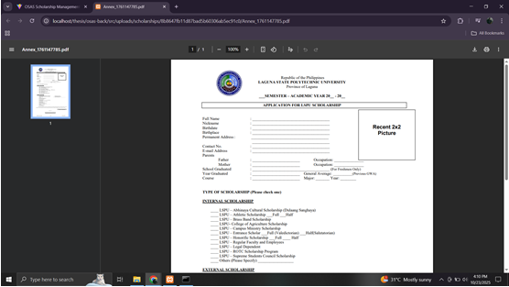
116

The interface that enable students to fill-up and submit their applications directly to their chosen sponsor.

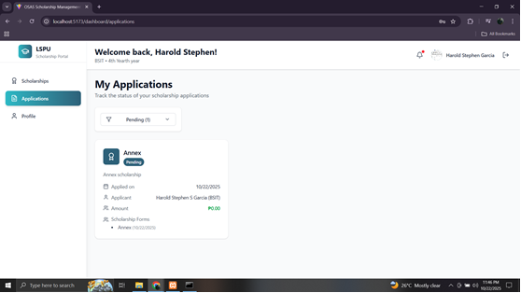

Students could simply see whether their application was received, under evaluation, or approved. This function helped minimize uncertainty while keeping applicants informed every step of the way.

Interface for Administrators
117

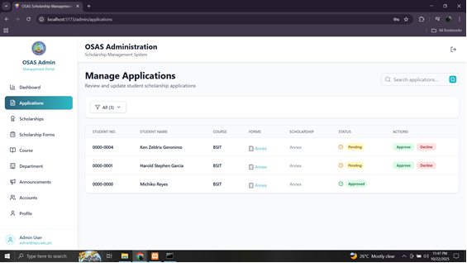

All application data could now be accessed and managed digitally in one secure platform by the administrators. This made it easier for the administrators to monitor application status, categorize submissions, and track applicant progress

Administrators can easily view and manage important details submitted by student applicants, such as their school ID, certificate of registration, certificate of indigency, and other required forms. Each application entry is neatly organized, making it simple to track the progress and verify the completeness of documents.
118
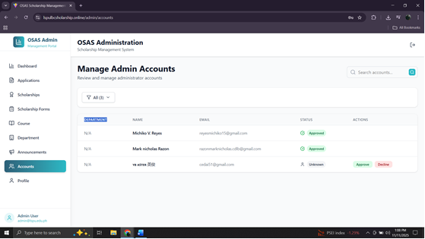

The main administrator can easily approve or decline pending admin account requests to ensure that only authorized personnel gain access to the system. This promotes security, accountability, and proper access control within the scholarship management process.

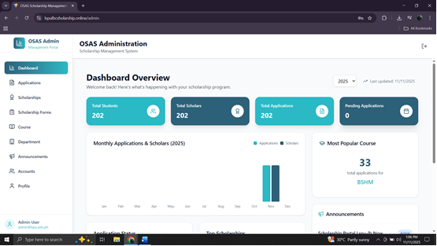

The system’s data analytics feature that can provides administrators with a clear, visual summary of key metrics such as the total number of students, scholars, applications, and pending applications. These data points are displayed in real time, helping administrators quickly assess the overall status of scholarship operations.

119
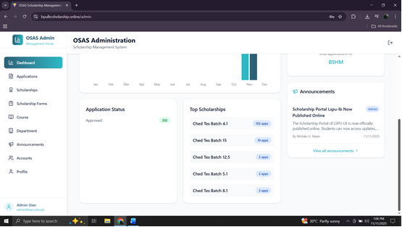

Visual overview of scholarship applications. On the left side, the Application Status panel summarizes the total number of approved applications. On the right side. the Top Scholarships panel ranks the most active scholarship programs based on the number of applicants.

120

Appendix F
Curriculum Vitae

