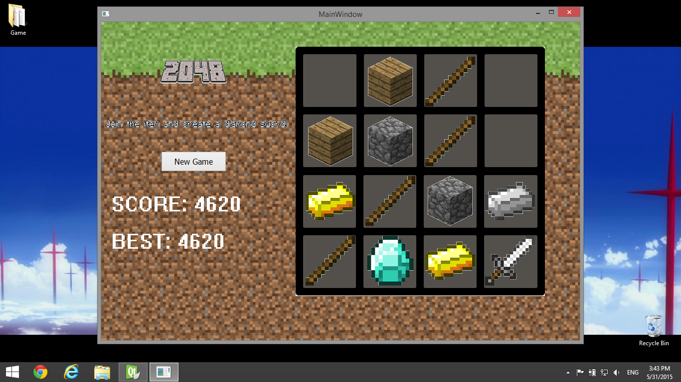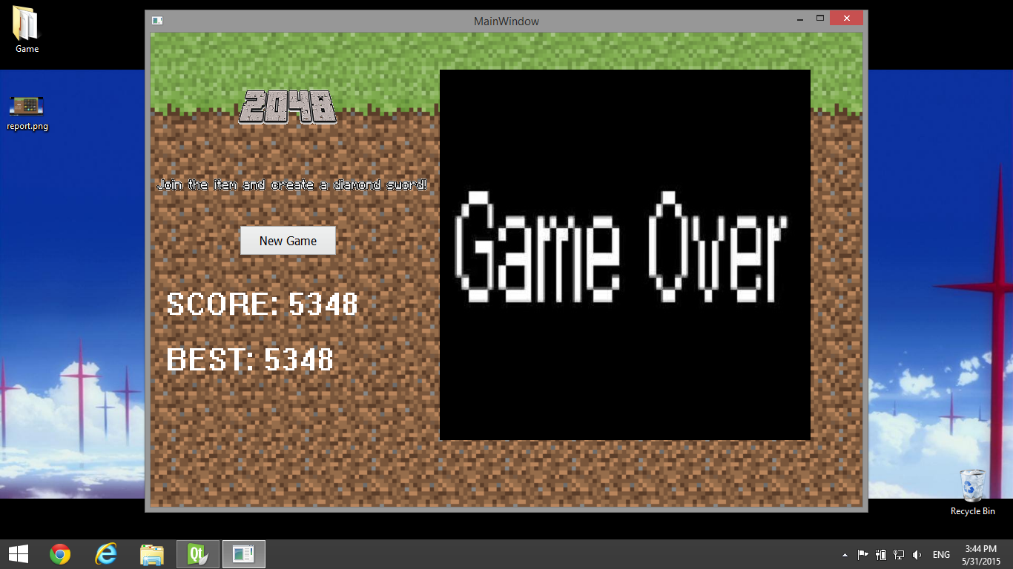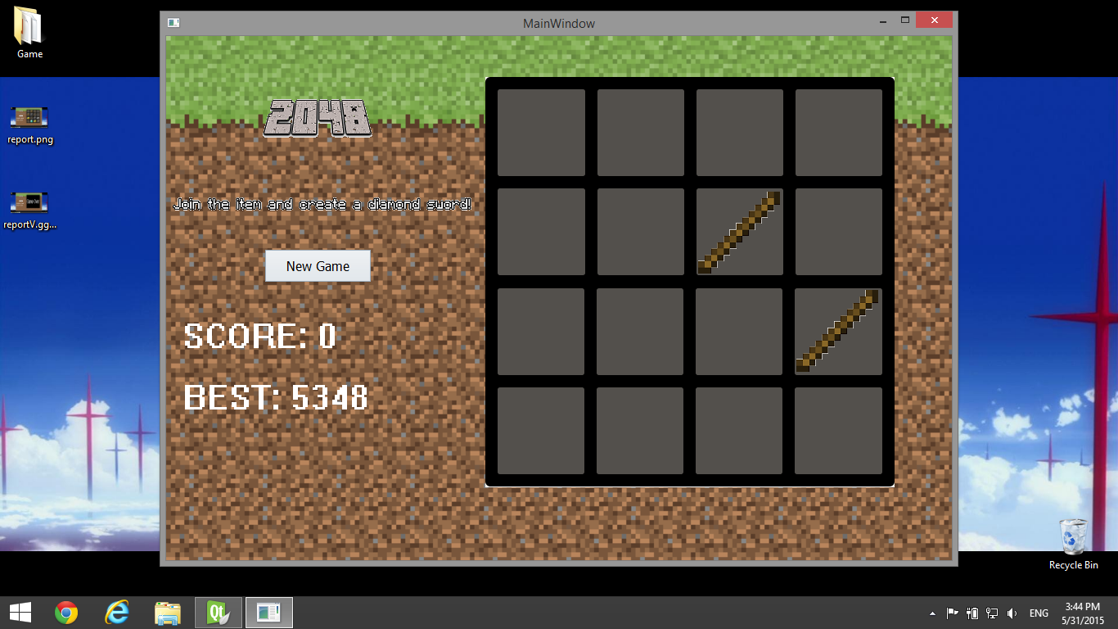

|  |
| --- |
| Main Window |
| + best: static int |
| - board[4][4]: int |
| - boardp[4][4]: QLabel * |
| - score: int |
| + start(): void |
| + end(QLabel *): bool |
| + win(QLabel *): bool |
| + clearboard(): void |
| + setboard(int, int, int): void |
| + mergeRandNum(): int |
| + pickRandPlace(): int |
| + checkEmpty(int, int): bool |
| + createNewNum(): void |
| + setImage(QLabel *): void |
| + setboardp(Qlabel *, QLabel *, …): void |
| + ActionRight(int (&[])): void |
| + ActionLeft(int (&[])): void |
| + ActionDown(int (&[])): void |
| + ActionUp(int (&[])): void |

By the way, my computer is a little bit naughty that the signals of the arrow keys are off. Which is why I designed the game to use W, A, S, D keys for playing instead. Sorry for all the inconvenience.