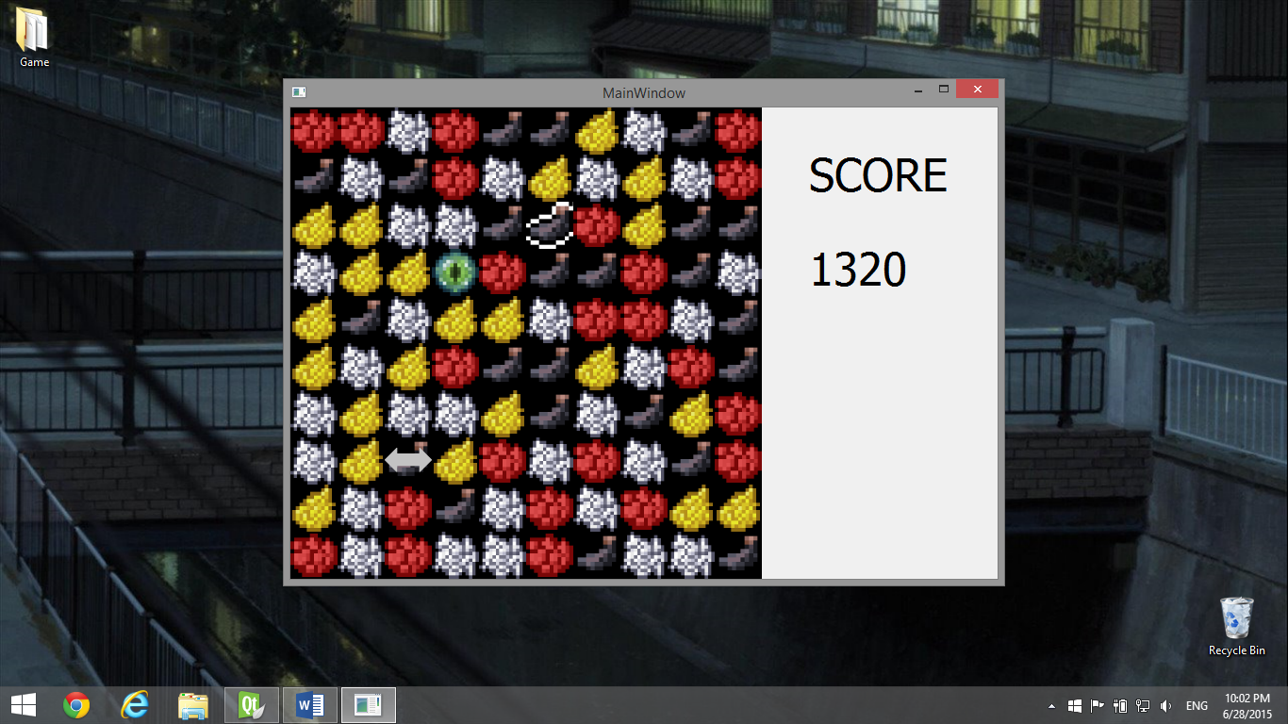

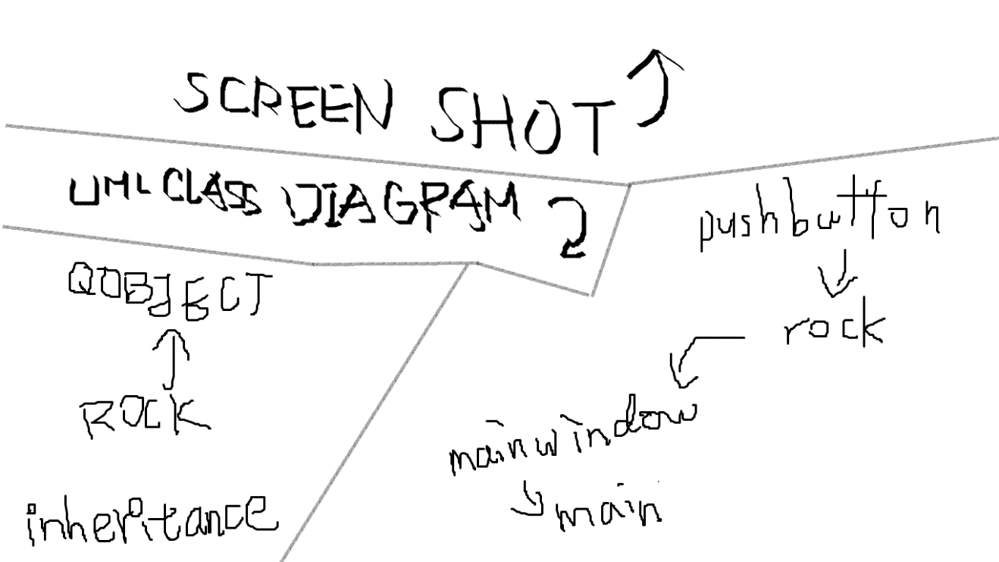

|  |
| --- |
| Main Window |
| - step: int |
| - board[10][10]: Rock * |
| - star: int |
| - score: int |
| - movement: int |
| - prex: int |
| - prey: int |
| + game(): void |
| + end(): bool |
| + arrange(int, int): void |
| + neighbor(int, int): bool |
| + genRock(int, int): Rock * |
| slots |
| + button_clicked(int, int): void |
| signals |
| quit(int, int) |
| Rock |
| + button: QPushButton |
| + x: const int |
| + y: const int |
| + color: int |
| + type: int |
| + selected: bool |
| + paint(): void |
| slots |
| + act(): void |
| signals |
| signal (int, int): void |

That’s it.