**Hyperlink graph:**

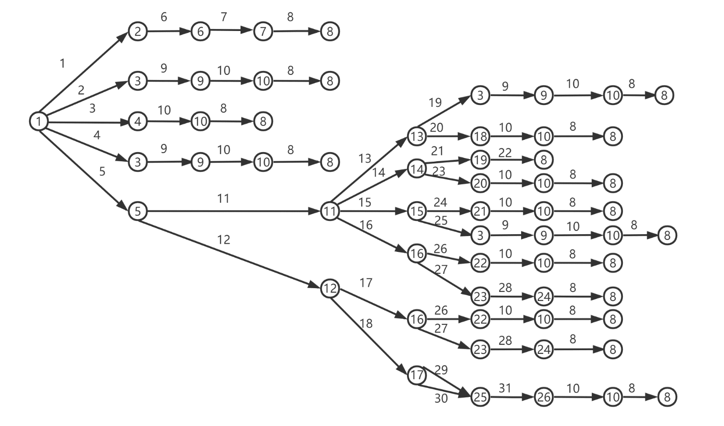

**Nodes:**

1: brookes.ac.uk

2: A popup search bar in the top right of the home page

3: Interface of Undergraduate courses, url: [Undergraduate - Oxford Brookes University](https://www.brookes.ac.uk/study/courses/undergraduate/)

4: Search for a course – Undergraduate, the search bar is in the middle of the home page

5: A popup menu showing each category

6: Generated relevant search results in a drop – down menu dynamically

7: Site search’s webpage which displays search results, url: [computer science bsc, Oxford Brookes Search, Funnelback Search](https://search.brookes.ac.uk/s/search.html?collection=oxford-brookes-search&query=computer%20science%20bsc)

8: The webpage shows the detail information about computer science course, url: [BSc (Hons) in Computer Science at Oxford Brookes University](https://www.brookes.ac.uk/courses/undergraduate/computer-science)

9: Drop – down menu displays relevant search results dynamically

10: Course Finder showing search results, url: [computer science, Oxford Brookes Course Finder, Funnelback Search](https://search.brookes.ac.uk/s/search.html?collection=oxford-brookes-course-finder&query=computer%20science)

11: Each category inside the Study menu

12: Each category inside the International menu

13: Study webpage, url: [Study - Oxford Brookes University](https://www.brookes.ac.uk/study/)

14: Subject areas webpage, url: [Subject areas - Oxford Brookes University](https://www.brookes.ac.uk/study/subject-areas/)

15: Courses webpage, url: [Courses - Oxford Brookes University](https://www.brookes.ac.uk/study/courses/)

16: International students webpage, url: [International students - Oxford Brookes University](https://www.brookes.ac.uk/study/international-students/)

17: Courses of internation students, url: [Courses - Oxford Brookes University](https://www.brookes.ac.uk/study/international-students/courses/)

18: Course Finder – Undergraduate in the study webpage

19: Computing, Mathematical Sciences and Digital Technologies webpage, url: [Computing, Mathematical Sciences and Digital Technologies - Oxford Brookes University](https://www.brookes.ac.uk/Study/Subject-areas/Computing-Mathematics-and-Digital-Technologies)

20: Relevant search results displayed dynamically in the drop-down meun in the subject areas webpage

21: Drop – down menu displays relevant search results in the courses webpage

22: Relevant search results displayed dynamically in the drop-down meun in the international students webpage

23: Courses A-Z showing 182 courses results, url: [!showall, Oxford Brookes Courses A-Z, Funnelback Search](https://search.brookes.ac.uk/s/search.html?profile=_default&query=%21showall&collection=oxford-brookes-courses-az&f.Study+level%7CcourseLevel=undergraduate)

24: List of courses displaying title starting witch C

25: Undergraduate courses of international students webpage, url: [Undergraduate courses - Oxford Brookes University](https://www.brookes.ac.uk/Study/International-students/Courses/Undergraduate-courses)

26: Drop – down menu displays relevant search results in the search bar of the Undergraduate courses of international students webpage

**Edges:**

1: Search button in the top right of the home page

2: “Explore our courses” button

3: Undergraduate + computer science + enter

4: “Undergraduate courses” button

5: Menu button in the top right of the home page

6: Enter keyword - computer science

7: Computer science in the menu

8: Computer Science hyperlink

9: Enter computer science in the search bar of Undergraduate courses webpage

10: Search button in the right of the whole search bar

11: Study button in the Menu

12: International button in the Menu

13: Study button in the Study menu

14: Subject areas button in the Study menu

15: Courses button in the Study menu

16: International students in the Study menu

17: International button in the International menu

18: International courses button in the International menu

19: Undergraduate button in the below of the Study webpage

20: Undergraduate + computer science + enter in the search bar of the Study webpage

21: Computing, Mathematical Sciences and Digital Technologies button in the below of the Subject areas webpage

22: Computer Science (BSc (Hons)) hyperlink in the Course title of Undergraduate

23: Undergraduate + computer science + enter in the search bar of the Subject areas webpage

24: Undergraduate + computer science + enter in the search bar of the Courses webpage

25: Undergraduate button in the below of the Courses webpage

26: Undergraduate + computer science + enter in the search bar of the International students webpage

27: Undergraduate button in the left of the International students webpage

28: Entry in **September 2023** + Course title starts with **C**

29: Undergraduate courses button in the webpage of Courses of internation students

30: Undergraduate courses hyperlink in the top of the webpage of Courses of internation students

31: Undergraduate + computer science + enter in the search bar of the Undergraduate courses of international students webpage

**Calculation of test adequacy:**

Matrix which represents nodes:

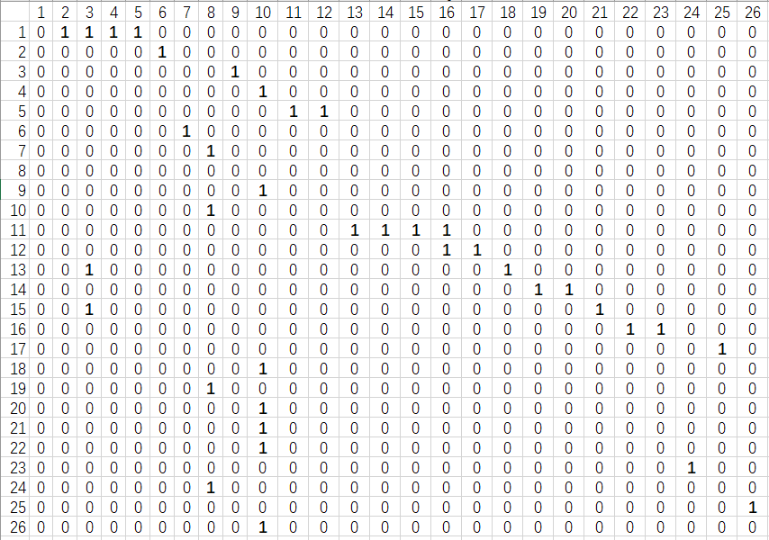

Matrix which represents the hyperlinks:

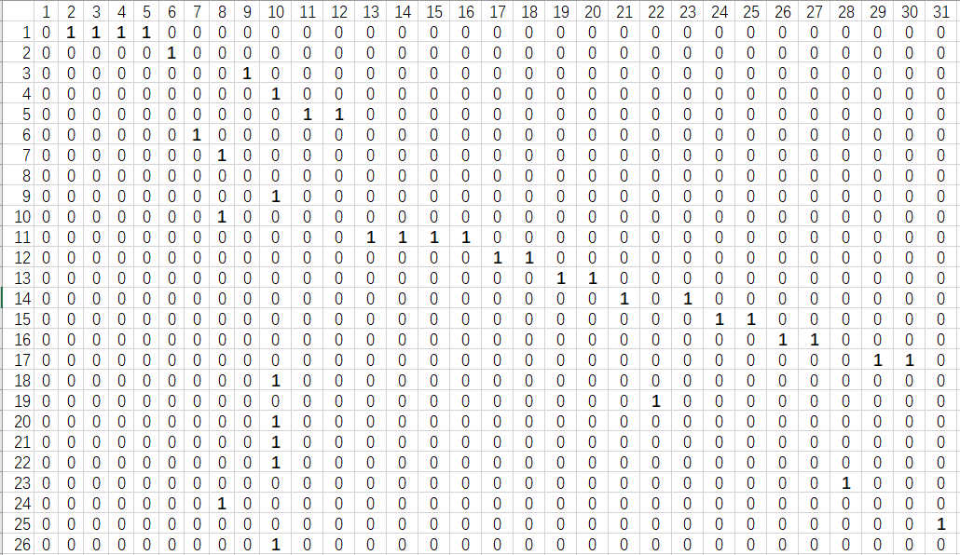

For Test case1 – scenario 4: Path: 1-5-11-13-18-10-8:

Node coverage: 7 / 26 ≈ 26.92%

Hyperlink coverage: 6 / 31 ≈ 19.35%

For Test case2 – scenario 5: Path: 1-5-11-13-3-9-10-8:

Node coverage: 8 / 26 ≈ 30.77%

Hyperlink coverage: 7 / 31 ≈ 22.58%

For Test case3 – scenario 14: Path: 1-5-12-17-25-26-10-8:

Node coverage: 8 / 26 ≈ 30.77%

Hyperlink coverage: 7 / 31 ≈ 22.58%